<https://www.youtube.com/watch?v=moBhzSC455o&t=529s>

Title: Build a Responsive Grid CSS Website Layout From Scratch

To include the Fontawesome script tag ...

Go to: <https://fontawesome.com>

and click "Get Started" on top navigation bar ....

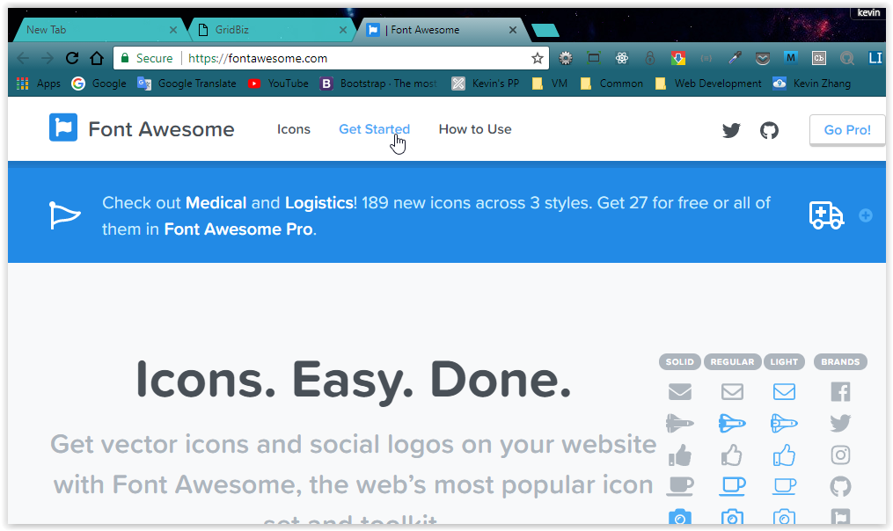

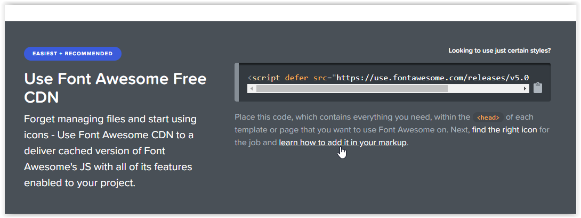

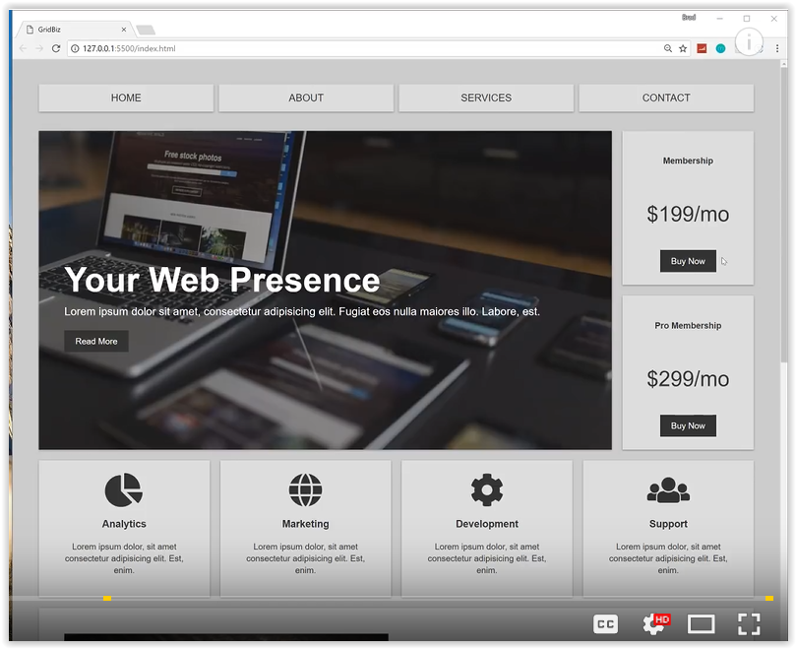

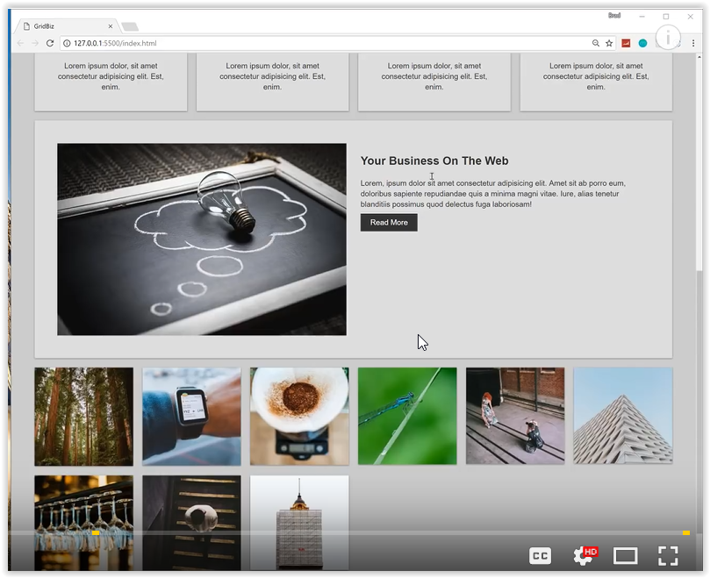

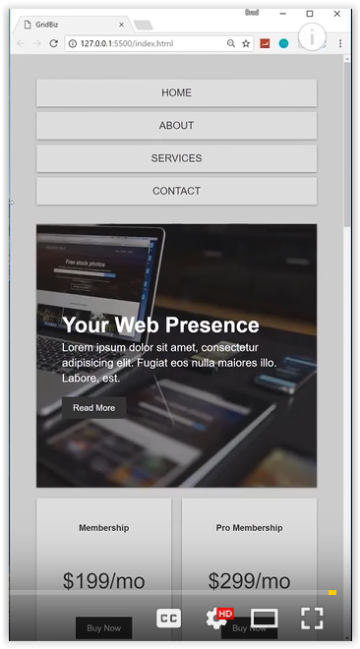

Explanation of:

*.top-container*{

display: grid;

grid-gap: 20px;

grid-template-areas:

'showcase showcase top-box-a'

'showcase showcase top-box-b';

}

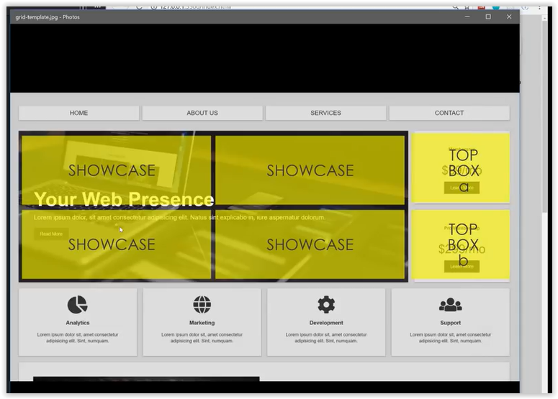

Explanation of:

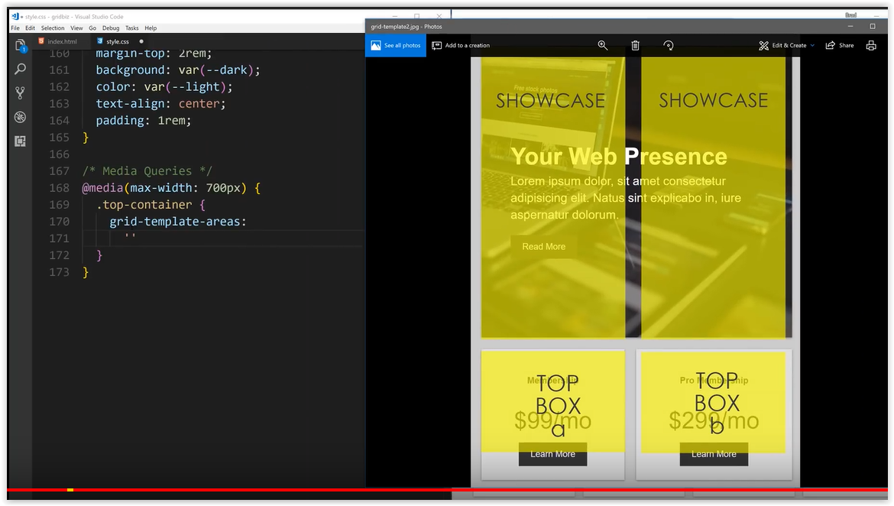

Explain to when screen size is 500px or less

