|  |  |
| --- | --- |
| Name | Value |
| Youtube Source | <https://www.youtube.com/watch?v=SSDED3XKz-0> |
| Youtube Title | Node.js & Pusher Real Time Polling Apps |
| Github | <https://github.com/bradtraversy/pusherpoll> |
| Finish file |  |
|  |  |
| Thumnail |  |
|  |  |

Things Learned:

|  |  |
| --- | --- |
| Category | Skill |
| Pusher.com |  |
| CSS |  |
|  |  |

## Pusher Setup:

[www.pusher.com](http://www.pusher.com)

and login via your github account

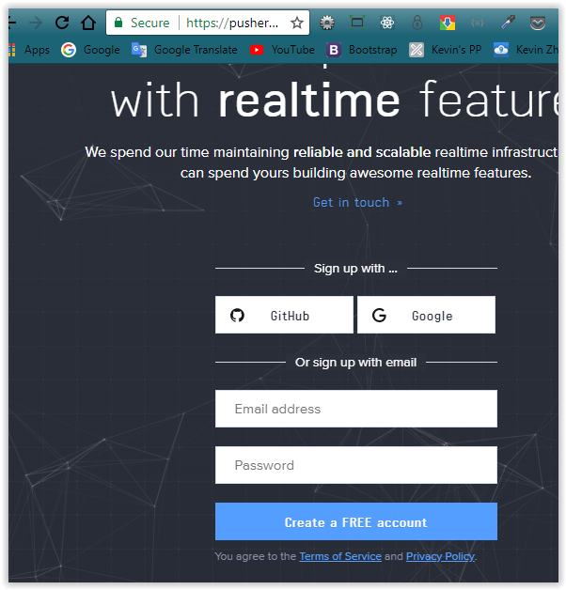

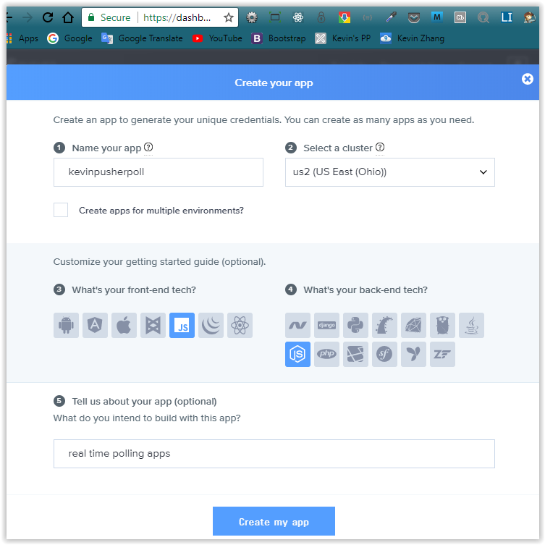

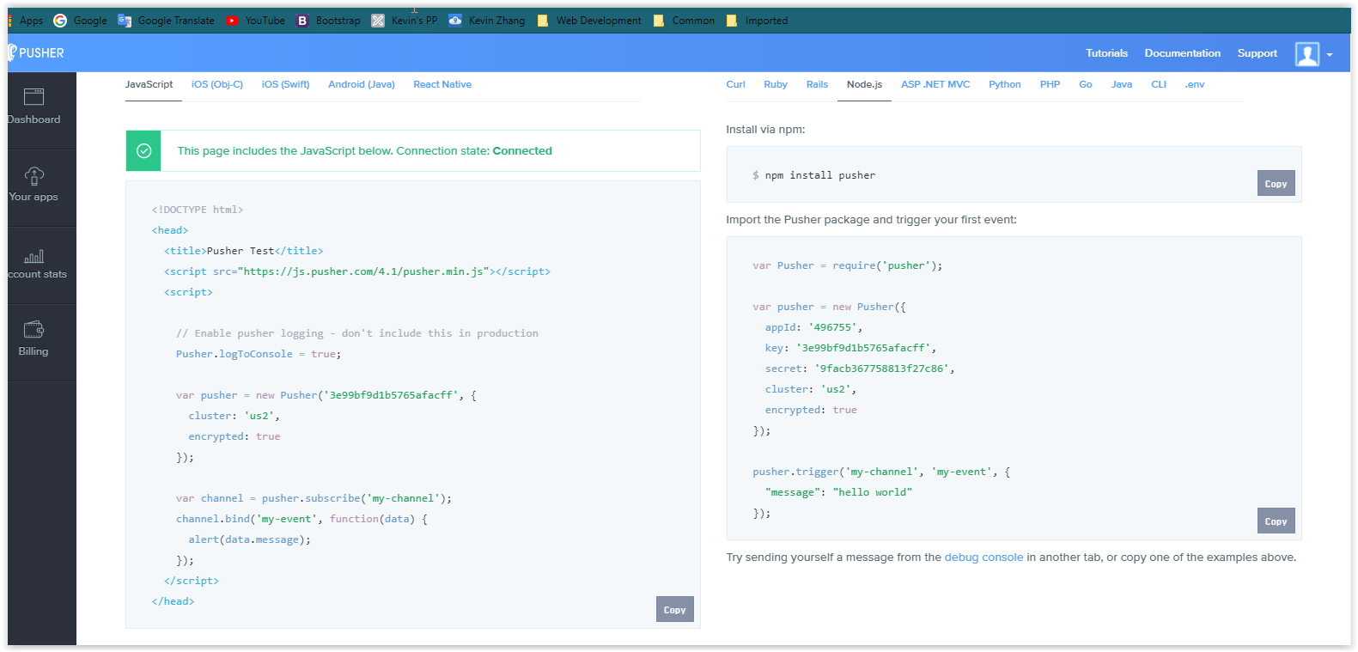

## Project NPM Setup

### >npm init

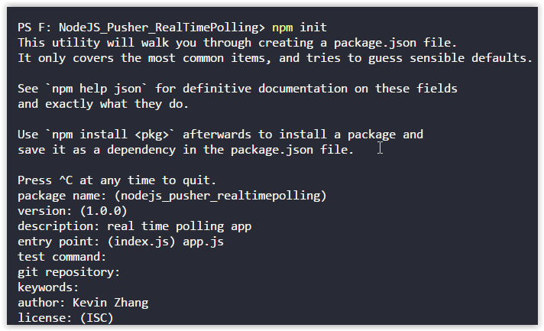

### > npm install express body-parser pusher cors mongoose

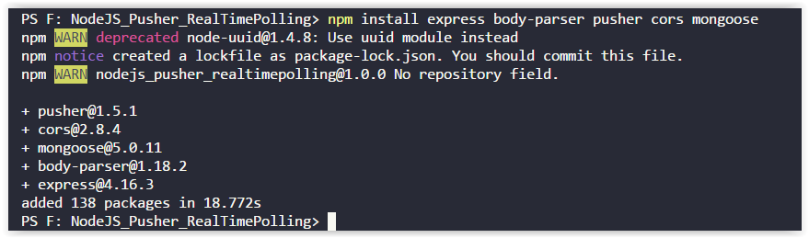

### >npm install --save-dev nodemon

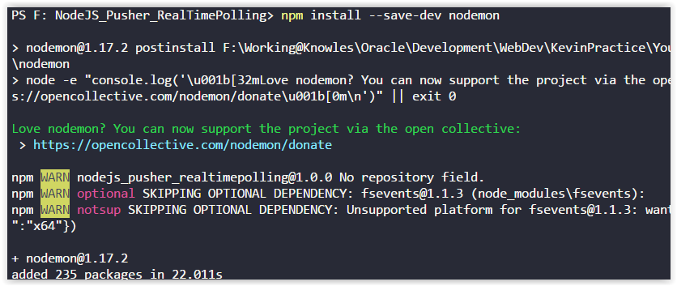

### >edit package.json

Red-line is the change

{

"name": "nodejs_pusher_realtimepolling",

"version": "1.0.0",

"description": "real time polling app",

"main": "app.js",

"scripts": {

"start": "node app.js",

"dev": "nodemon app.js"

},

"author": "Kevin Zhang",

"license": "ISC",

"dependencies": {

"body-parser": "^1.18.2",

"cors": "^2.8.4",

"express": "^4.16.3",

"mongoose": "^5.0.11",

"pusher": "^1.5.1"

},

"devDependencies": {

"nodemon": "^1.17.2"

}

}

### >Create app.js

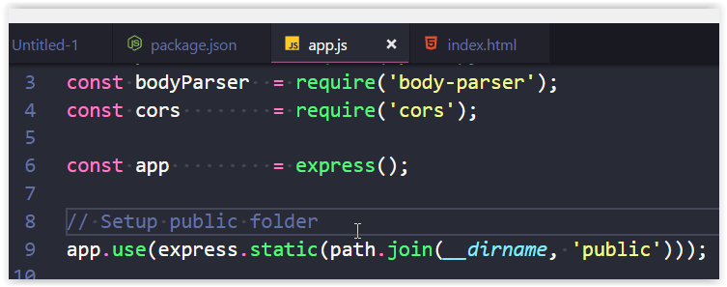

### >npm run dev

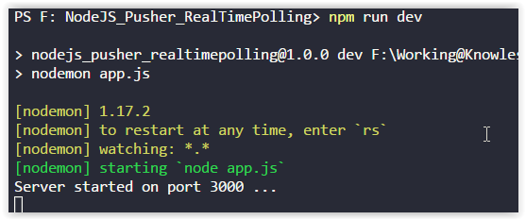

Open chrome: http://localhost:3000

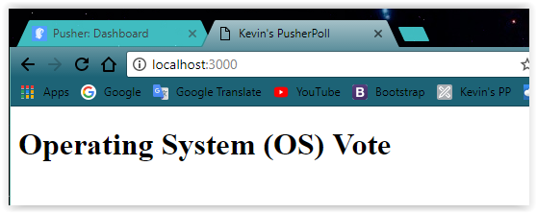

## MLAB Setup:

<https://mlab.com>

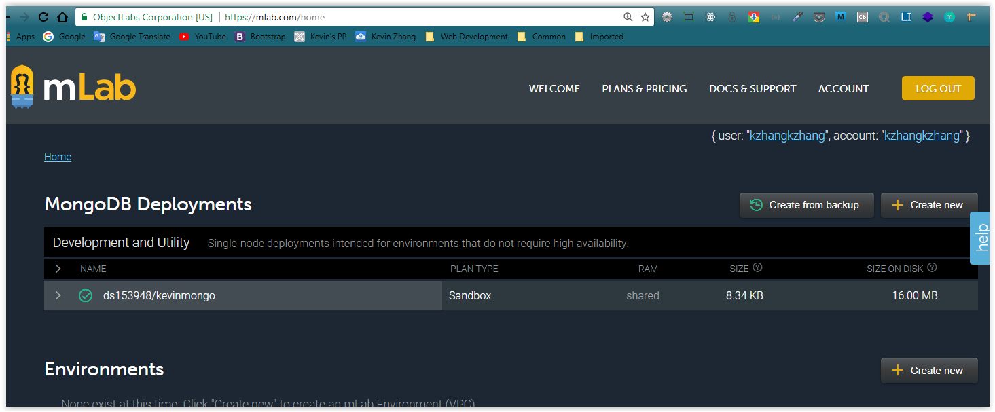

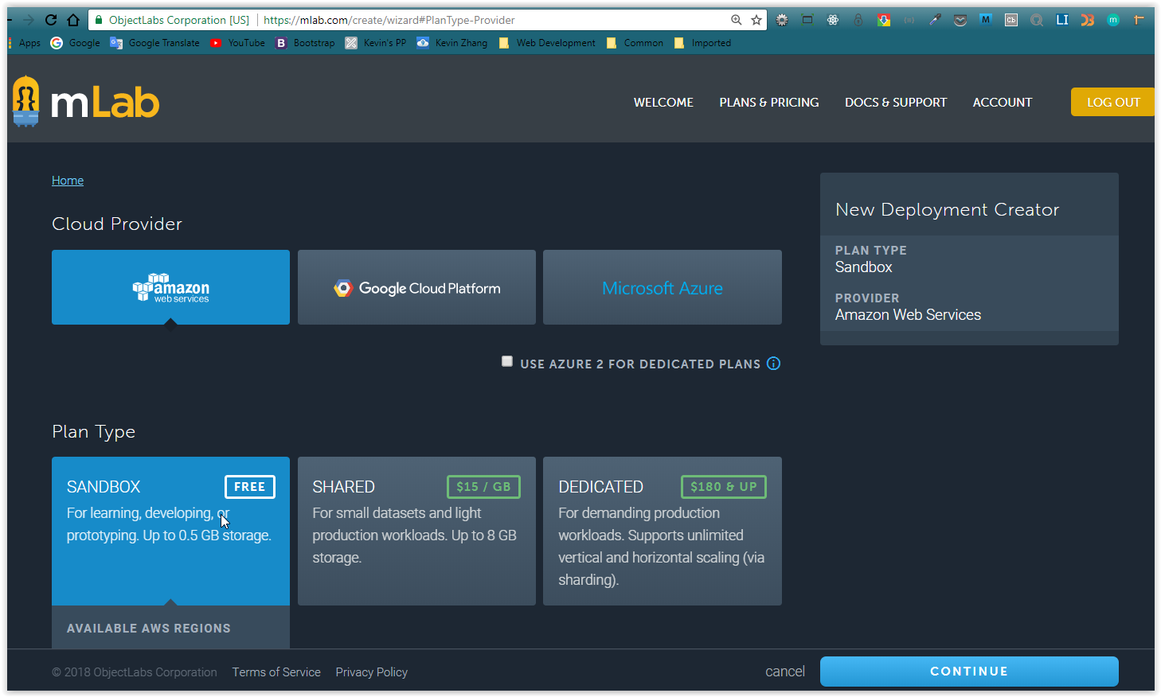

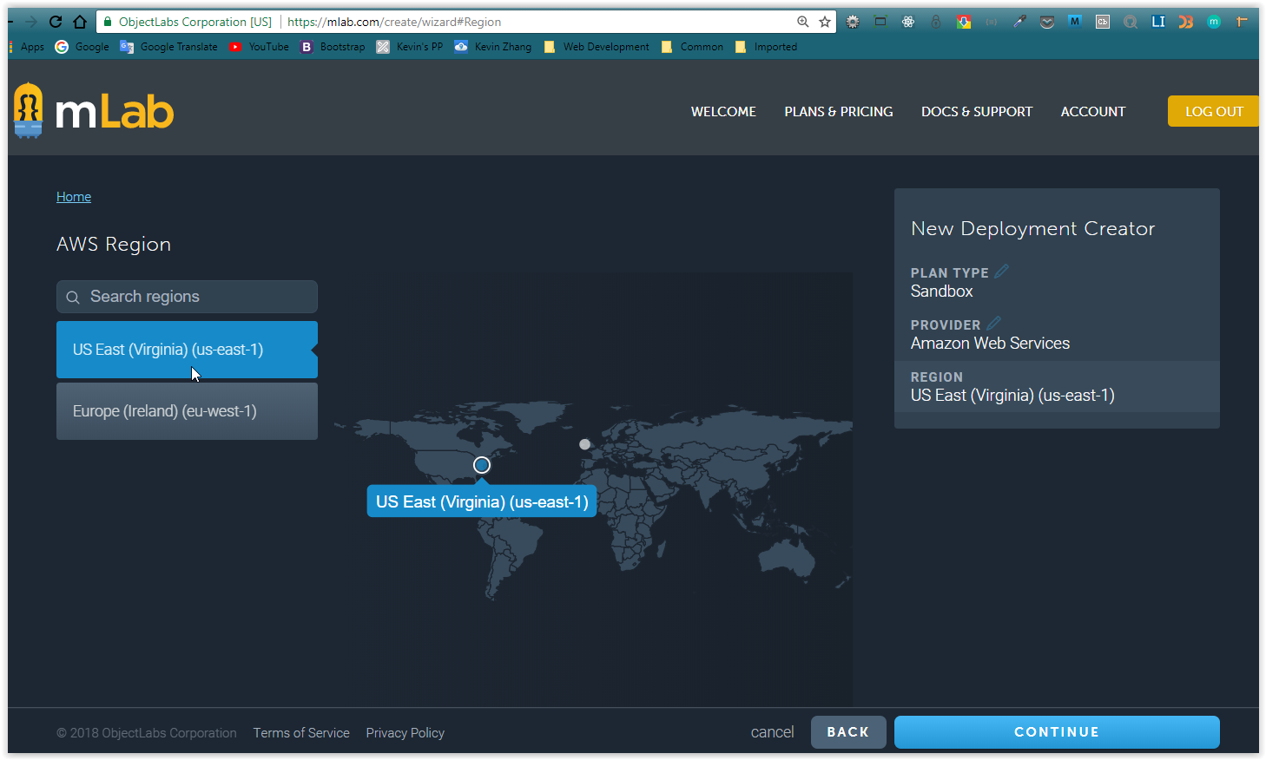

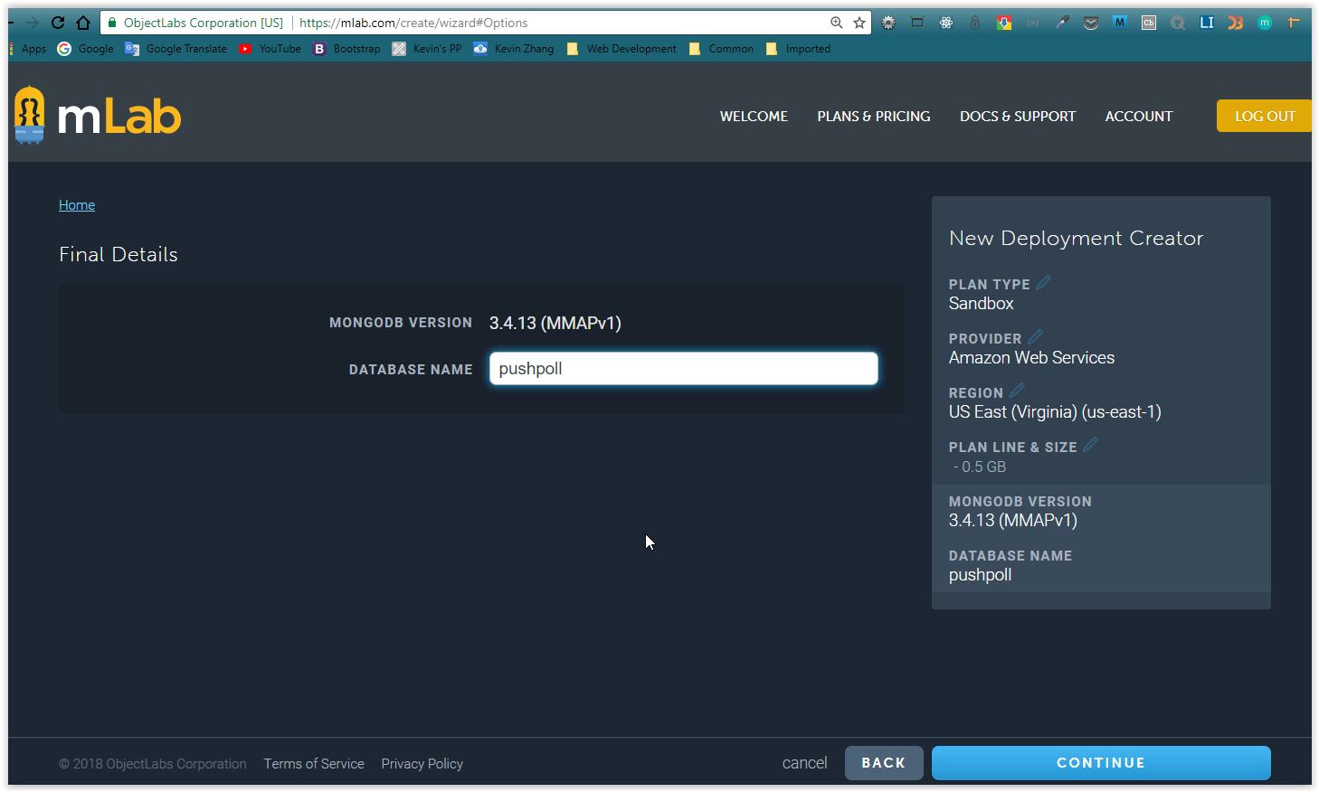

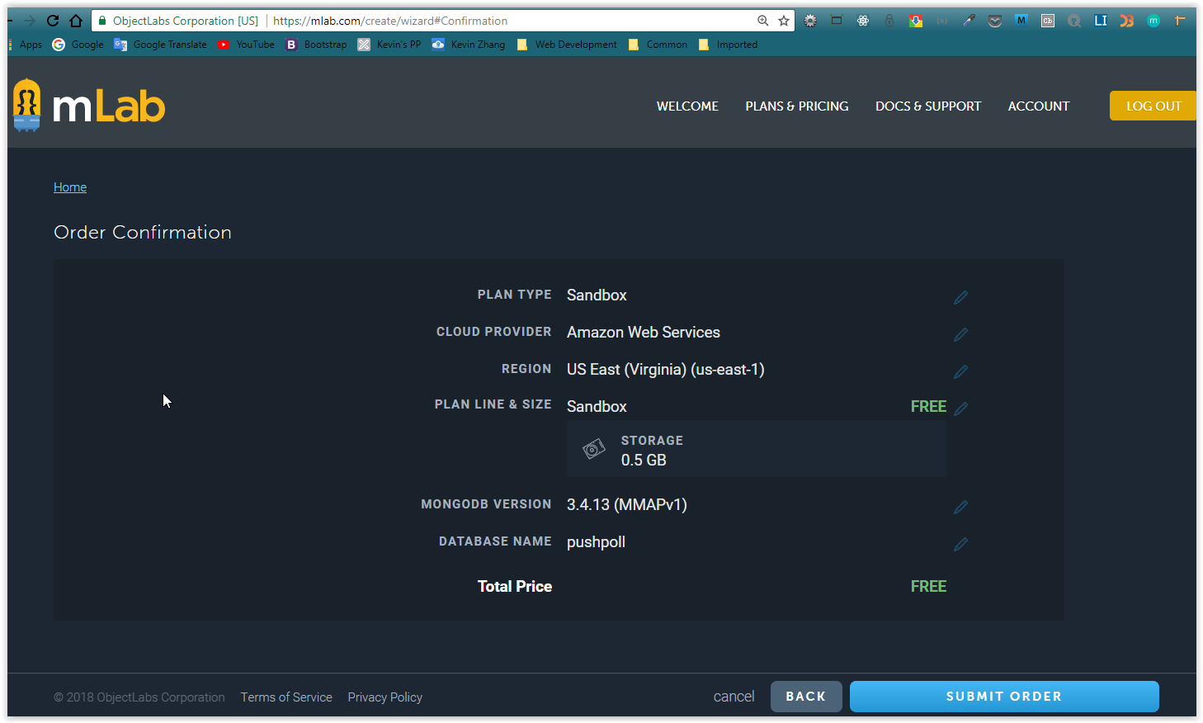

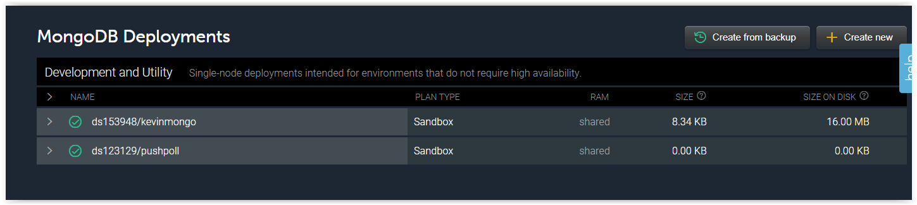

Now, we need to create a user for above new database

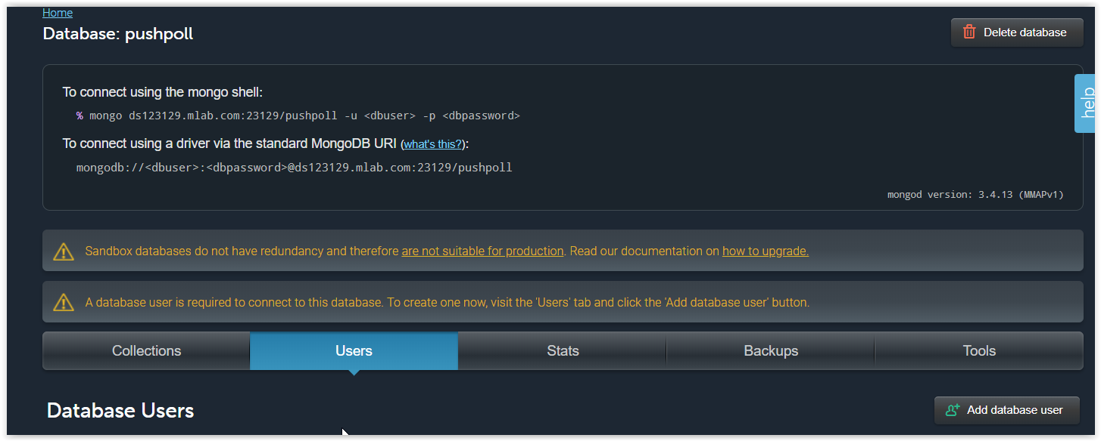

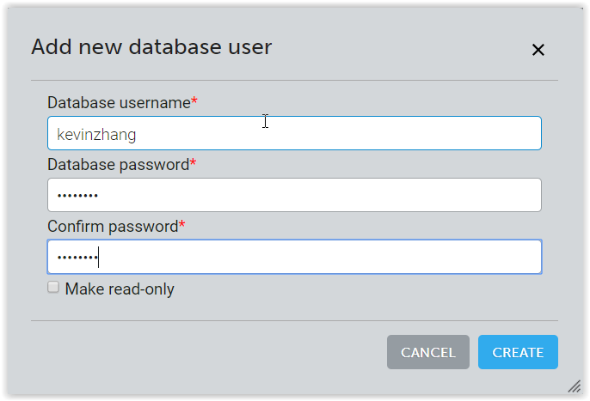

Password: check your password file