Home Integration Vehicles: Bringing Pets from Nothing

Kevin Zielke

https://github.com/kzilk/Database-Systems-Project

Windows SQL Environment

Too often, old hoarder cat women accrue large numbers of pets that they cannot take care of before they croak. These cats are normally hard to integrate to new homes and often have bonded to each other and developed poor habits. That is why we are introducing Home Integration Vechicles, cheap, transportable pet environments that can be set up in virtually any location as a transition point from the hoarder environment to being adopted into new homes. No longer will you need to be concerned about the innocent cats left behind at the weird smelling house with the horrible lawn, we are there to help!

These homes will be made of hinged sheet metal frames, layered with corrugated cardboard inside, with blankets for comfort areas. The sheet metal will be sourced from used prison lunch trays and junkyards, the cardboard will come from warehouse recyclables and Brazilian logging companies, and the blankets will be manually sourced from homeless shelters and daycare centers. Our primary office will be in Seattle WA, with other offices in San Francisco CA, New York NY, and Austin TX to account for la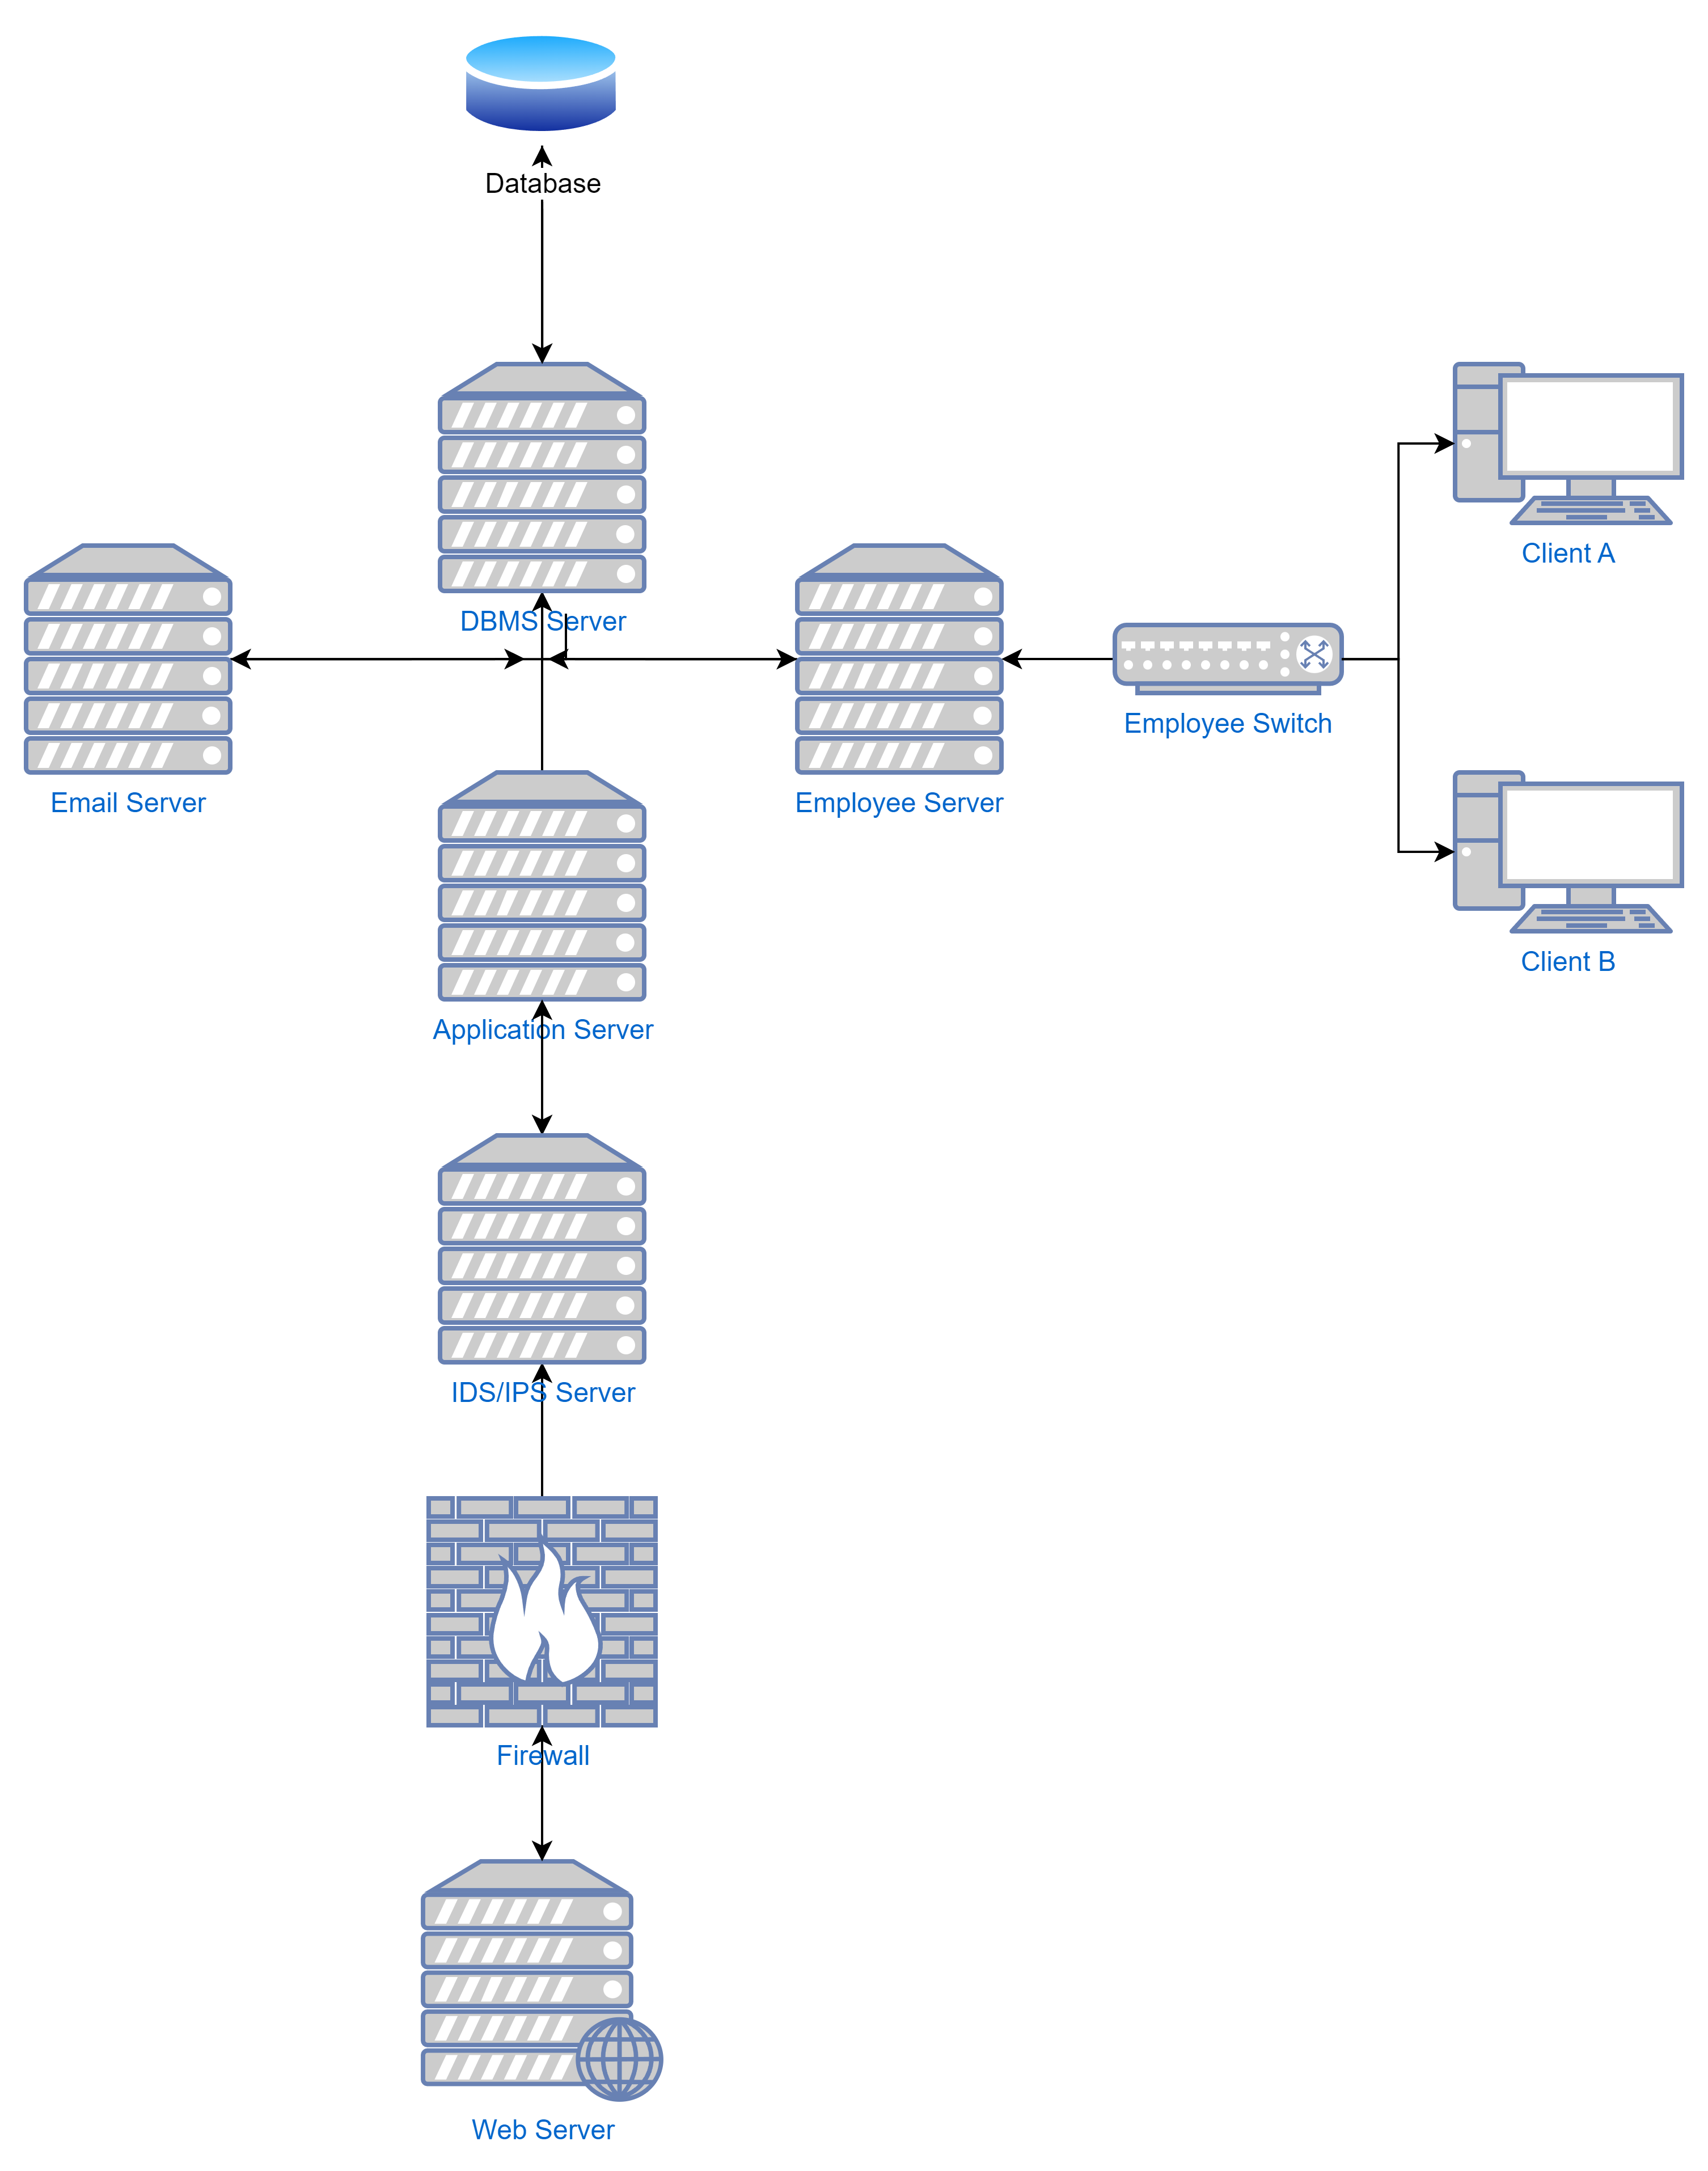rger populations where we believe our services may be most needed.

Week 2 – Attributes and Entities

Home Integration Vehicles – the primary tool used for retraining and rehoming pets

Tracks Base Office ID, Warehouse ID, Assigned Pet Aid ID, Repair Status, and Vehicle Number

Pet Aids – Trained employees that work with the animals and work with the Home Integration Vehicles

Tracks Employee ID, Base Office ID, and Assigned Vehicle Number

Repair Technician – employees that handle repairs to Home Integration Vehicles and construct new ones as needed

Tracks Employee ID, Base ID, Active Assignment Status

Office Managers – regional handlers to run business operations and plan distribution/use of aids and repair technicians

Tracks Employee ID, Department, Base Office ID

Warehouse Base – place to store excess materials and construct new Home Integration Vehicles

Tracks Base ID, Metal Sheet Inventory, Cardboard Inventory, Blanket Inventory, and Active Projects

Week 3

UML Physical Model:

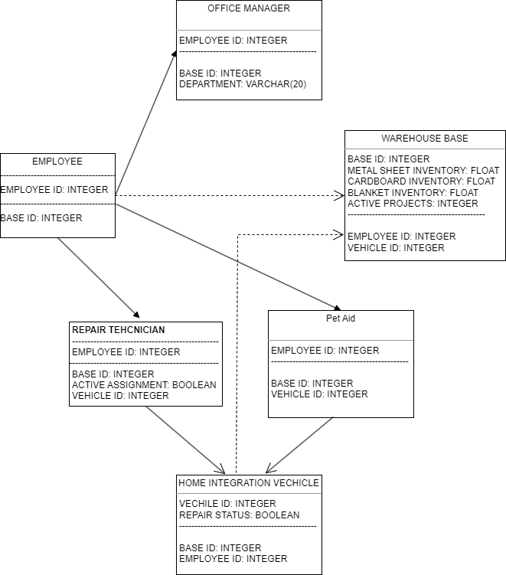

In this diagram, we show that the Pet Aid, Repair Technician, and Home Office Manager entities all have an inherited relationship from the Employee entity to show they are all employees and contain the primary key Employee ID and the foreign key Base ID.

The Employee entity has a dependency on Warehouse Base entity as every employee is assigned to a warehouse base where the Base ID comes from.

Both the Repair Technician and Pet Aid entities have associations with the Home Integration Vehicle entity to show that they both may be assigned to a vehicle.

And finally, the Home Integration Vehicle has a dependency with the Warehouse Base as each vehicle must be assigned to a base.

Crow’s Foot Logical Model:

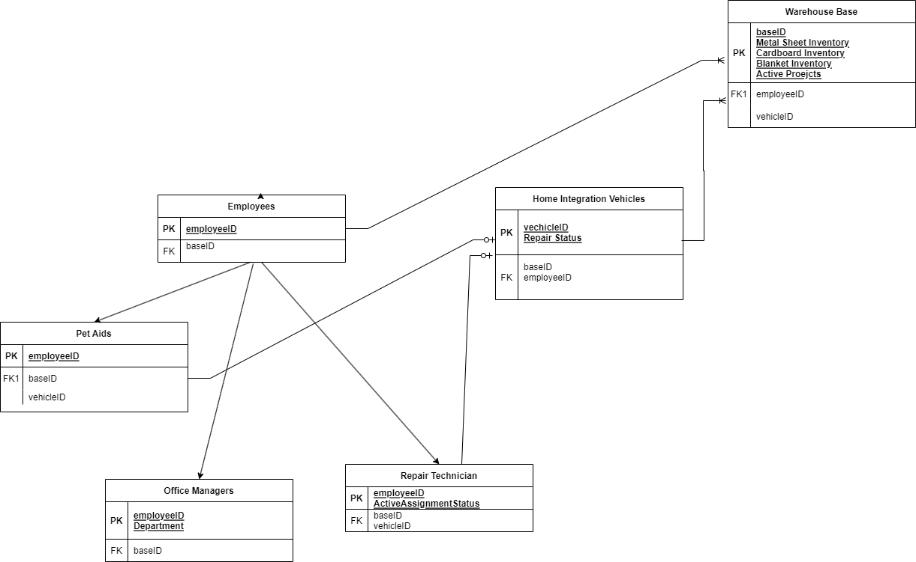

In this diagram, we show the first major relationship is that the Employee entity has three subclasses of Pet Aids, Office Managers, and Repair Technicians that all inherit the primary key employeeID and the foreign key baseID.

The Employee entity has a 1 to many relationship with the Warehouse Base entity as each employee is assigned to a warehouse/base and each of those bases has multiple employees assigned.

The Pet Aids and Repair Technician entities both have zero to 1 relationships with the Home Integration Vehicle entity, as either type of employee may or may not be assigned to a vehicle.

And Home Integration Vehicles are a one to many relationship with Warehouse Bases, as each base can have multiple vehicles, but each vehicle can only have one base assigned.

Week 4

Parts 1 and 2: On our Office_Warehouse_Base table, we have added the column ‘rating’ with the ENUM datatype to indicate the average customer rating of the company services in the region. The choices are ‘poor’, 'low', 'average', 'good', or 'great'.

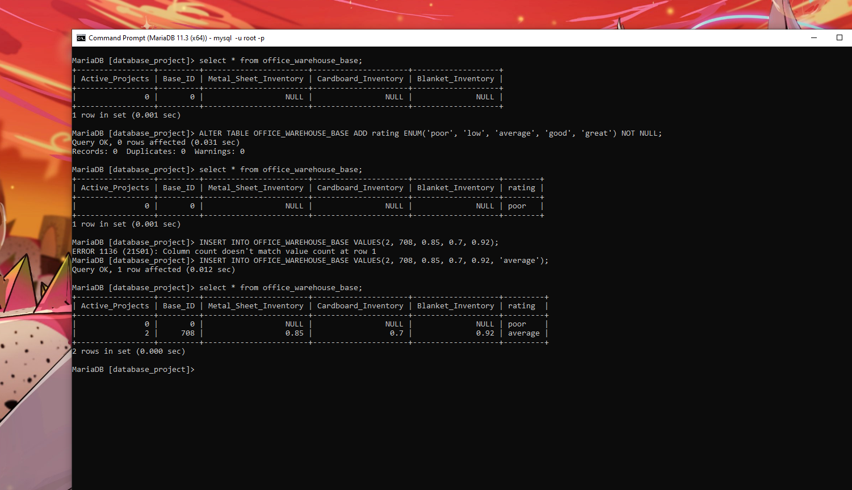

Part 3: For example, we uploaded a record to this table to indicate that at this location, with Base_ID 708, there are 2 active projects, the inventory levels for metal sheets, cardboard, and blankets are at 0.85, 0.7, and 0.92 respectively, with an ‘average’ customer rating. We can update this record to having only 1 active project, for inventory to be reduced to 0.8, 0.6, and 0.87 respectively, and for the rating to increase to ‘good’. This would simulate using on site inventory materials to complete an active project at the location and the rating increasing as a result of improved capabilities.

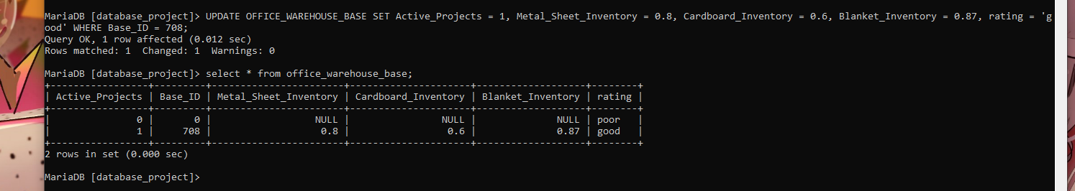

Part 4: Below, we demonstrate deleting the previously updated record using the ‘where’ clause to ensure only this instance is selected.

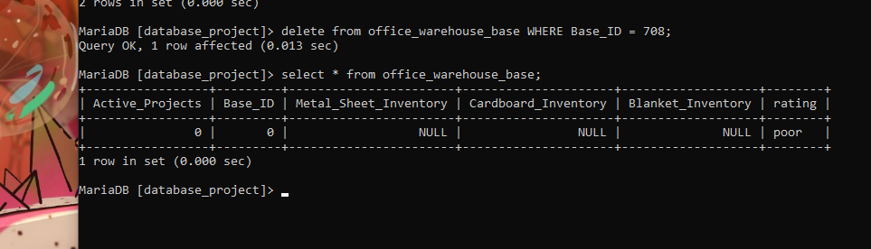

Part 5: Here, we have adjusted the Repair_Technician table so that it’s primary key, Employee_ID, auto increments with new data instances being added to the table. You can see with the new records that each is given a generated value that is not needed to be inputted during the use of the ‘insert’ clause.

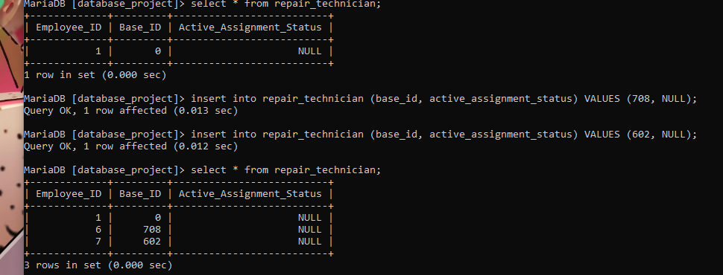

Part 6: Finally, we will do the same but now we are adding a new column with default values. This column, like the one we created earlier for the Office_Warehouse_Base table, is an ENUM that shows the standing the repair technician has at the company. We have set the default to ‘average’ and can see that for each new case added, the values in this column all are auto-generated as ‘average’.

