Library Manual in
Computer Programming

for
Students of Computer Science
University of Nebraska at Omaha
Omaha, Nebraska

by
Turk Alnashwan
Matt Cavanagh
Judd Shea
Kevin Zink

Sept 29, 2003



9/17/03
To: All Computer Science Students
From: CSGroup
Matt Cavanagh
Turk Alnashwan
Judd Shea
Kevin Zink
Subject: Memo

Have you ever been looking on the Internet for hours and hours and not found any useful information for that computer science report? Could you have better spent that time playing video games? So have we! Because of this, we have decided to compile a research manual for computer science students that focuses on programming languages. This manual will help the students to utilize the university library to its full potential.

Most computer science students believe firmly that the internet is the only way to find useful information. This belief is not only false, it is downright foolish. The internet does have a lot of information available. However, much of this information is flawed, biased, and hard to understand. Many of the books in the library, on the other hand, are written by accredited writers. Another misconception that computer science students have is that the library is only full of old, beaten-up books, collecting dust and cobwebs. This is simply not true. Many of the books we found, while preparing this manual, were very new, if not brand new. Another complaint that computer science students have about the library is that it requires them to leave their homes. For what its worth, a lot of the information in the library cannot be found on the Internet, so, ultimately, it is worth the effort.

We spent many hours compiling the information contained in this manual for your benefit. Using our manual will allow you to utilize many resources that you may not have known existed. As fellow computer science students, we have some of the same goals as you do. We also would like to get a degree and a good job. We are simply helping you to achieve this goal.

In addition to the library resources described in this manual, there is also help for using the internet. There is a guide to evaluating web sites for content, integrity, and reliability. Rest assured that when you use our manual, you will be capable of receiving better grades, with less effort, and have more time to play video games.

i

Table of Contents

Informational Abstract ----------------------------------------------------------- 1

Library Presentation -------------------------------------------------------------- 2

Faculty Interview ------------------------------------------------------------------ 4

Books --------------------------------------------------------------------------------- 6
C/C++ Books ------------------------------------------------------ 7
Java Books --------------------------------------------------------- 8
Perl Books --------------------------------------------------------- 9
PHP Books --------------------------------------------------------- 10
SQL Books --------------------------------------------------------- 11
Visual Basic Books ----------------------------------------------- 12

Internet Sources ------------------------------------------------------------------ 13
Sample Analysis --------------------------------------------------- 14
C/C++ Websites --------------------------------------------------- 15
Java Websites ------------------------------------------------------ 16
Perl Websites ------------------------------------------------------ 17
PHP Websites ------------------------------------------------------ 18
SQL Websites ----------------------------------------------------- 19
Visual Basic Websites -------------------------------------------- 20

Online Databases ----------------------------------------------------------------- 21

Final Words ------------------------------------------------------------------------ 22

Informational Abstract

Programming languages can be a very difficult subject to research. Many programming languages continuously change with technology, and, to further complicate things, each language has its own list of specific syntactical and semantic facets. This comes as a problem to UNO students in the computer science major because they are required to study at least a few different programming languages. Thus, the specific intent of this manual is to assist students in researching programming languages by helping them evaluate and collect resources. The languages this manual focuses on are primarily the languages that are currently being taught here at UNO: C/C++, Java, Perl, SQL, Php, and Visual Basic. More specifically, this guide contains resources pertinent to each of these languages via books, websites, and online databases. There are also sections about evaluating the integrity of internet sources, a general overview of the library, and an interview with the John Clark—an esteemed C/C++ instructor at UNO.

1

Library Presentation

As a class, we attended a presentation in the library by a library faculty member. She taught us of many of the tools that the library has to offer. The following is a brief summary of what we learned during this presentation.

During our Library Presentation we gained knowledge and information about the Library that we either did not previously know or knew but forgot. We were shown how to choose reliable web sources, what steps to take, and how to implement those steps. In addition to learning about web based research tips, we were shown the many diverse and useful databases available to us, the students. We were also shown the advanced search functions of the Library and how to use them. I will go into further detail of what we learned on our Virtual Tour of the Library.

When the presentation began, the Reference Librarian introduced herself as Dorothy Willis. She then proceeded to take us on a virtual tour of the library, highlighting the main parts of the library. She highlighted such locations as the reserve desk, copy machines, audio and video peripherals, journal locations, government documents, and the reference desk. She also walked us through how to register our Student ID. This is useful because, without it, you cannot check out books, or access certain functions of the library, such as accessing databases off campus, and interlibrary loans.

Next, the reference librarian assigned each student a web site and we were to evaluate whether or not it is a reliable source. This taught us whether or not a web site is a good enough source for information when doing a research project. She highlighted such points as purpose, authority, scope, and audience.

2

Thirdly, Dorothy revealed to us the many databases that the UNO Library offers us, as students. She drove home the fact that we already pay for them, so we should make use of them. She also stated that there are databases available for each plan of study, and no matter what the subject matter, we will find something in our area of expertise. Lastly, she showed us how to research the databases and how to use their advanced search functions, which is useful if you are seeking very precise subject matter.

To conclude, the library tour was very useful and informative; it showed us the many tools and resources the library has to offer and how to effectively and efficiently utilize them (perhaps ways many of us were unaware of). Already, we have been able to effectively utilize the library the way it was meant to be used.

3

Faculty Interview

For your help, we included in this manual an interview with one of the UNO faculty members who teaches programming languages. Mr. John Clark has been a faculty member of the College of Information Science and Technology since 1998. He has written code in over 18 different languages; however, he mainly teaches C and C++. Hundreds of UNO students have taken a class with him. In this interview, we are revealing his insights into the programming language resources that are available to students.

Since C++ and C are the two required languages for all students who are in the College of Information Science and Technology, we focused the interview mainly on those two languages. However, if any more information is needed about other languages, students should contact the appropriate faculty member listed below.

In our interview with Mr. Clark, he provided several resources that students can use and on which they can rely. These resources include authors, books, websites, usenet groups and other faculty members. He recommended several authors like Bjarne Stroustrup, Plauger, Scott Meyers and Nicolai Josuttis. These authors have books that are written about C++, C and other various languages. Their work is reliable, complete and easy to read. Mr. Clark also recommended some books for students who are looking for some C++ and C references. Those books were
- The Standard C++ Library by Nicolai Josuttis
- The C++ Programming Language (Special Edition) by Bjarne Stroustrup
- Design Patterns by Gamma et al
- Effective C++ by Scott Meyers
- More Effective C++ by Scott Meyers
- Effective STL by Scott Meyers
4

These books include an overview of C and C++ history, sample codes, and C and C++ references. Also, Mr. Clark recommended students who are researching Java to use Java books by SUN press.

In addition to the books, Mr. Clark provided some online references that the students can use. Student could visit websites like:
- http://www.cppreference.com
- http://www.cplusplus.com
These websites include trustworthy resources and were created for people who want to learn more about C and C++. Also, another online resource is usenet groups like ACM. Students can use these usenet groups to exchange information with people who are more knowledgeable and experienced in the field.

Finally, Mr. Clark encouraged students to get help from their instructors and faculty members. He provided a list of some of the faculty members that students can visit with to get help in specific areas. Those faculty members are:
- Robert Fulkerson for Perl
- Raj Dasgupta for Java
- Paul Kenyon for C
- Victor Winter for Programming Languages history and development
The best advice Mr. Clark could give to students who want to learn a programming language is to practice writing code. Also, students should be cautious when using online resources because they could be unreliable or biased. Lastly, he encouraged students to learn how to use library research techniques because they are important in saving time and eliminating frustration.

5

Books

The following pages list a few of the books that we think would be most beneficial to you while researching for programming languages. The books are categorized by programming language to make it easier. The languages included are C/C++, Java, Perl, PHP/SQL, and Visual Basic. There is a selection of about 3 books per language, with a short summary of what each book details.

Most, if not all, of the computer science books are located in the same section of the third floor of the library. In case you do not know your way around the library, below is a map of the third floor with the area of Computer Science books circled in red. This is where you will be able to find all of the books listed in this manual.
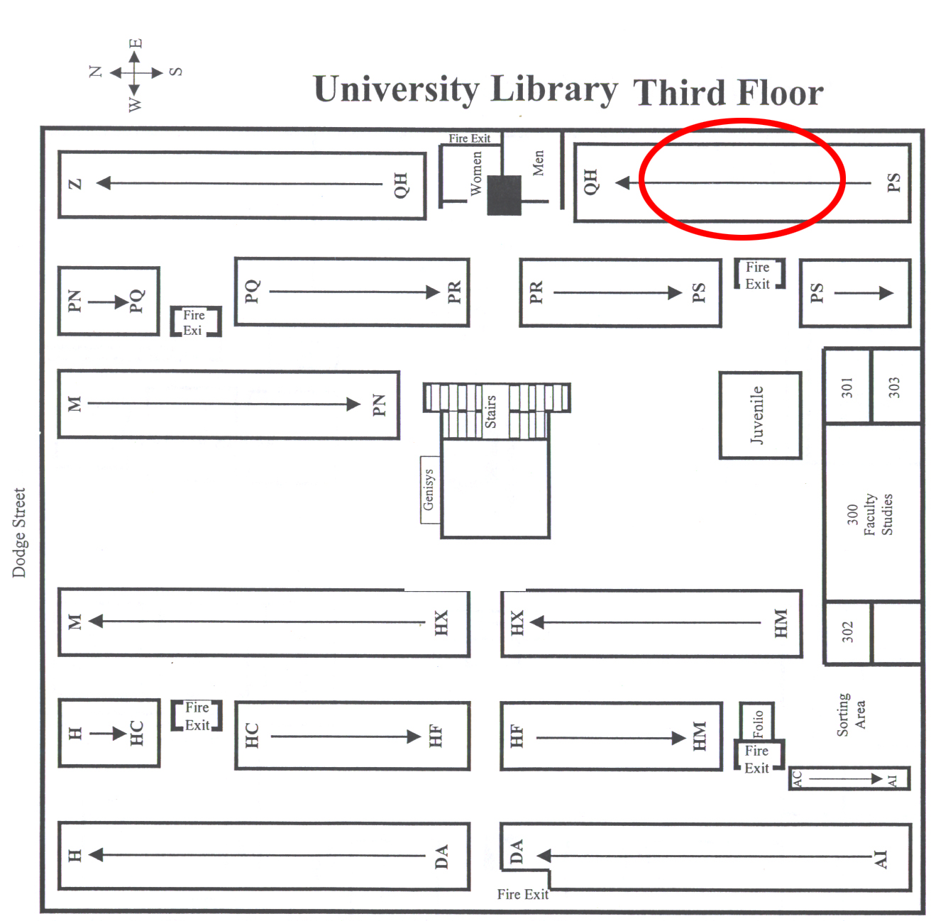

6

C/C++ Books

Title: Jamsa’s C/C++/C# Programmer’s Bible 2nd Edition
Call Number: QA 76.73 C15 J375 2002
Author: Kris Jamsa, PhD, MBA
Description: Written by best-selling author Kris Jamsa, this book is a must-have reference and guide for all upper-level programmers or even for those who are learning the language for the first time. It’s really the most complete C++ programmer's reference guide that you can currently get.

Title: C++ In Plain English
Call Number: QA 76.73 C155 0853 1996
Author: Brian Overland
Description: This book is a great reference guide for beginning and intermediate programmers. In addition to hundreds of valuable techniques and practical tips, you get clear, concise definitions of basic C++ keywords, functions, and terms. It also provides in-depth coverage of ANSI C++ features, classes, operators, and virtual functions.

Title: Using the STL
Call Number: QA 76.73 C153 R625 1998
Author: Robert Robson
Description: This book provides a comprehensive introduction and guide to the STL pitched at the level of readers already familiar with C++. It presents a thorough overview of the capabilities of the STL, detailed discussions of the use of containers, descriptions of the algorithms and how they may be used, and how the STL may be extended. An appendix provides an alphabetical reference to the entire STL. As a result, students coming to the STL for the first time will find this an extremely useful hands-on text.

7

Java Books

Title: Java 2: By example
Call Number: QA 76.73 C15 J375 2002
Author: Jeff Frieson
Description: Coverage of this book includes Java basics, the language, and the class library. It is a nice book because each chapter includes many small examples, and concludes with a larger example. Source code is available on a Web site hosted by the author. This book assumes the reader to have little programming experience and thus is a very good guide for java beginners.

Title: J2EE The Complete Reference
Call Number: QA 76.73 J38 K46 2002
Author: Jim Keogh
Description: This book is really for advanced Java programmers. It focuses mainly on building web services, but it is also fully up-to-date, covers areas of Java databases, and Java interconnectivity. This is ideal for any student who has to work with J2EE.

Title: Java Developer’s Guide
Call Number: QA 76.73 J38 J39 1996
Author: Jamie Jaworshi
Description: This book is for intermediate and upper-level students. It provides a wealth of examples that demonstrate how to create powerful web applications, covering such topics as adding applets to HTML pages, the HotJava browser, and integrating animation and audio.

8

Perl Books

Title: Mastering Perl/TK
Call Number: QA76. 73 P22 L53 2002
Author: Steve Lidie & Nancy Walsh
Description: This book is for the advance level user of Perl. It covers how to implements graphical user interfaces using Perl. Also, it covers topics like geometry in Perl, GUI components, and how to implement them on the Web.

Title: Perl Developer's Guide
Call Number:QA76. 73 P22 P74 2000
Author: Ed Deschko & DeWolfe
Description: This is an introductory level book. It includes an overview of the history of Perl, a Getting started with Perl section, an advanced Programming in Perl section, Object Oriented Design, and Debugging & code samples.

Title: Perl Annotated Archives
Call Number: QA76.73.P22 B76 1999
Author: Martin Brown
Description: This book demonstrates the use of Perl in real world situations, showing examples and details of codes. It is meant for users who are familiar with Perl but not experts. It covers topics like text processing, networking, World Wide Web and Administrative tools. For Perl students, this book would definitely be useful, but it is a must-have for anyone who really wants to learn an in-depth understanding of Perl in the job market.

9

PHP Books

Title: PHP Programming for Windows
Call Number: QA76.73P22 S74 2002
Author: Andrew Stopford
Description: PHP Programming for Windows is a book aimed towards the Windows based developer. It is beginner level book, but previous programming experience is useful. It covers PHP from beginning to end and takes you from designing and implementing PHP into your projects. It also covers topics such as such as Access and SQL server implementation.

Title: A Programmers Introduction to PHP
Call Number: QA76.73.P224 G55 2001
Author: W.J. Gilmore
Description: A Programmers Introduction to PHP is a book for beginners about PHP 4.0 use. It is geared towards all web developers, new and experienced, familiar or foreign. This book allows readers to easily gain a general understanding of the language. It teaches you the syntax and then goes into more advanced topics such as integration with other web-based databases.

Title: PHP for web Professionals
Call Number: QA76.73.P224 C67 2003
Author: Christopher Cosentino
Description: This book is a very good place to start if you want to learn PHP or if you have a basic understanding of HTML. PHP for Web Professionals contains a very well thought our tutorial which takes small steps, each previous one building on the previous, to gain an understanding of PHP. This book is endorsed by the World Organization of Webmasters and quickly shows you how to get fast, real world results with PHP.

10

SQL Books

Title: SQL from the Ground up
Call Number: QA76. 73 S67 P94 1999
Author: Mary Pye Finch
Description: This book is for introductory level user of SQL. It gives an overview of the SQL language and how it works. Additionally, it describes how to build databases and user interface designs, and it gives sample codes for both PL/SQL and SQL-related programs.

Title: Introduction to SQL
Call Number: QA76. 73 S67 L36 2000
Author: Rick F. Van der Lans
Description: Yet another introductory level book, Introduction to SQL goes over the history of SQL and the applications in which SQL is used. It gives a comparison between SQL and other programming languages (like C++) that are similar. It also shows readers very basic introductory SQL commands and objects.

Title: The SQL Bible
Call Number: QA76. 73 S67 K75 2003
Author: Alex Kriegnd & Boris M. Trukhnov
Description: This is a large book. It would be good for SQL programmers of any level because it covers simple and very complex SQL material. Mores specifically, it covers SQL concepts and principles, data manipulation, retrieving, and security. To boot, the SQL bible has a very detailed overview of SQL development and history.

11

Visual Basic Books

Title: Visual Basic 5.0 Developers Workshop
Call Number: QA 76.73 B3 P49 1997
Author: John Clark Craig and Jeff Webb
Description: This book contains a lot of information about Visual Basic 5.0. It has a section on what has changed since 4.0, as well as programming style guidelines. The book is put together well and is extremely easy to read. Beginning programmers should have no problems understanding this. As a bonus, there is a CD included with this book that includes sample applications in as well as all of the code printed in the book.

Title: Visual Basic .NET Programming
Call Number: QA 76.73 B3 D38 2002
Author: Harold Davis
Description: This book is a complete overview of Visual Basic .NET, the latest version released by Microsoft. It contains useful information on how to write completely object-oriented application in Visual Basic. There is also a section detailing how to migrate programs from VB6 to VB .NET. This book is also very easy to read.

Title: Visual Basic .NET Database Programming
Call Number: QA 76.73 B3 S8343 2002
Author: Rod Stephens
Description: This book informs readers how to manipulate databases in Visual Basic .NET. It has a good section on security of databases, as well as designing databases and structuring programs in VB .NET to utilize the database. This book is intended for readers who have a decent amount of Visual Basic experience; however, no prior database programming knowledge is required.

12

Internet Sources

The Internet is a massive conglomeration of information. There are multitudes of information to be found, but not all of this information is worthy and some of it is completely inaccurate. In order to help you to pick out some of the more reliable sites, we have compiled this quick test of an Internet site. If you follow these steps, you should be on the right track to getting current, reliable information.

1. Figure out what the purpose of the site is.
Ask yourself—can you easily tell what the purpose of the site is just by looking at the first page of it? If not, the site may not be the best source for you to use. Does the site fulfill my purpose? If not, you should try to find a better site. Is the site biased? If it is, then the information that you obtain from this site may not have much validity.

2. Decide whether or not you trust the author.
Does the author have any authority in the subject? If not, they may not know what they are talking about. Has the site existed long? If so, you can usually bet that the site is going to be around for a while longer, and thus is likely a reliable source.

3. Identify who the audience of the site is.
Was the site meant for a specialist? If so, then you may not be able to understand the content of the site well enough to get good information. Does the site have what you were looking for? If it does not, you should go to another site.

On the next page you will find a sample analysis of a website to show how you can apply the aforementioned steps. Following the analysis is a listing of some internet sites that we found that should have most of the information that you are looking for. The sites are listed by programming language. The languages are C/C++, Java, Perl, PHP/SQL, and Visual Basic.
13

Sample Analysis

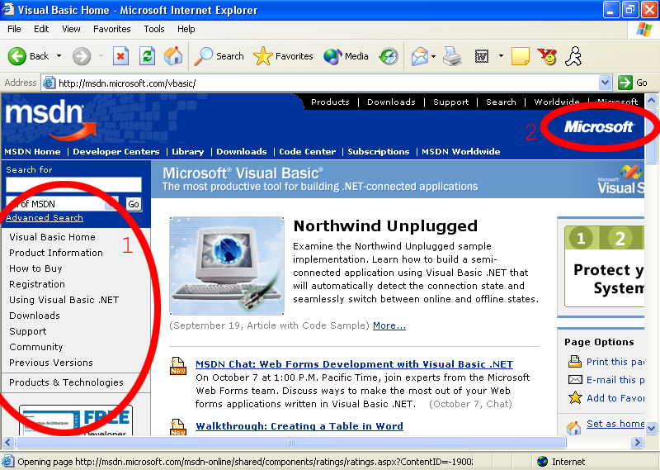

1. Purpose of the site
This site has many purposes. As you can see, the first thing mentioned is information about the product as well as how to purchase it. Also, there is a section about using Visual Basic. This link has sample code, as well as a question and answer page. Under “downloads”, there are updates to the most current version of Visual Basic. Next, there is technical support, and a place to post comments or questions about the Visual Basic programming language. This site seems to have a good purpose and is therefore a good site to visit.

2. Author of the site
The author of the site is a member of the Microsoft Corporation. Microsoft is the creator of Visual Basic, so it is a safe bet that they have a great deal of qualification.

3. Audience (not shown)
The audience of the site, as with every site on the MSDN network, is the general public. There are sites for more advanced users, but they are deeper in the navigation.

14

C/C++ Websites

Title: The Standard Template Library
Address: http://www.sgi.com/tech/stl/
Author: Silicon Graphics - 2003
Description: This website is a must-have for any high-level C++ programming students. It contains virtually everything you need to know about the STL. It’s organized coherently and is always up-to-date.

Title: John Clark’s Web Page
Address: http://arioch.unomaha.edu/~jclark/
Author: John Clark
Description: This is a reference to John Clark’s web page. John is an instructor here at UNO, and his main focus is on C/C++ programming. His web site contains information on using Unix shell accounts, various programming tips, help on how to use the VIM editor, and a multitude of other programming-related subjects.

Title: O’Reilly and Associates
Address: http://cprog.oreilly.com/
Author: O’Reilly and Associates - 2003
Description: O'Reilly's "In a Nutshell" books are renounced as excellent references. Their C/C++ books are very popular and respected in the computer science field. Books can be purchased directly from their website.

15

Java Websites

Title: The source for Java Technology
Address: http://java.sun.com/
Author: Sun Microsystems
Description: This website was created by the makers of the java language. You can find pretty much anything you want to know about the libraries here. It also has code samples, tips, downloads, and forums. This is the epicenter for java-related online information.

Title: Java Programming Resources
Address: http://www.apl.jhu.edu/~hall/java/
Author: Marty Hall
Description: This website was put up by a professor at John Hopkins University. It is a compilation of links to resources to other java-related books and web pages. It contains many links that could be useful for students with uncommon or hard-to-answer questions.

Title: Java Foundries
Address: http://java.foundries.sourceforge.net/
Author: OSDN Open Source Development Network
Description: SourceForge is an open-source developer's site. It can be useful for both hosting programming projects and finding libraries to use.

16

Perl Websites

Title: perl.org
Address: http://www.perl.org
Author: Lisa Wolfisch, Robert Spier, and Bjoern Hansen
Description: Perl.org is an up-to-date website that reveals many new tools and developments in Perl, including the following sections: background Perl information, sample application programs, notable Perl books and articles and Perl community forums.

Title: use Perl
Address: http://use.perl.org
Author: Chris Nandor
Description: This is a website that focuses mainly on the Perl community. It offers sections on new Perl-related events and developments. Other features include links to Perl journals, hot topics, Perl forums and downloadable Perl code.

Title: Perl.com
Address: http://www.Perl.com
Author: Tom Christiansen
Description: Perl.com, most would consider, is the staple web site for the online Perl community. It acts as a starting place for anyone just learning the language, but it also has information for high-level Perl programmers. The sample code that is listed here is very helpful and easy-to-follow. Another notable detail on this site is its resource page, which is a comprehensive guide to online Perl resources, with links pointing to a number of different, credible websites.

17

PHP Websites

Title: PHP.net
Address: http://www.php.net
Author: The PHP Group
Description: This website is the main hub of new and exciting information related to PHP. It has tutorials, code, modifications, downloads, and forums to help you along your way. It is for anybody who is interested in PHP—from beginner to expert.

Title: PHP Builder
Address: http://www.phpbuilder.com
Author: 2003 Jupitermedia Corp
Description: PHP Builder focuses on the developers themselves, and is aimed towards the basic everyday developer. Most everything on the site is written and submitted by visitors of the site. You can even submit your own article to the site to be added to their weekly updated collection of articles. If you are either learning or just starting to learn PHP, this is a good place to look for information.

Title: PHP Freaks- PHP Help
Address: http://www.phpfreaks.com/
Author: PHP Freaks, Inc.
Description: PHP Freaks is a community website used to provide useful information about PHP and MySQL. It is a very well laid out help site with quite a few interactive features to aid programmers. This website is geared towards beginner level coders, but is maintained and updated by fans of the site who are experienced programmers. So, if you are an experienced developer, you are invited to submit tutorials and articles to help the site out. There is a broad range of information on this site that most any programmer could find helpful.
18

SQL Websites

Title: SQL Directory
Address: http://www.wb.livin4.com/sqld.html
Author: Robert Mestre
Description: This is a directory for online SQL resources. It includes links to books, magazines, consultants, news and groups. All links have been described and rated, which makes finding the good links much easier. It has a lot of resources for students who need to be deeply involved with SQL.

Title: SQL.org
Address: http://www.sql.org/online_resources.html
Author: National SQL Organization
Description: SQL.org contains general information about SQL and links to articles and journals. It also provides tutorials, lessons and code examples. The site includes a forum for users to post questions and get help from others. It is very easy to navigate and use.

Title: 1 SQL Street
Address: http://www.1sqlstreet.com
Author: Ian Ippolito
Description: This website is an SQL community website. It includes articles, news events and a lot of code. Interestingly, it has links to professional job opportunities as well as advice provided by professionals in the SQL field. Students can definitely use some of this information, especially if they are seriously interested in SQL.

19

Visual Basic Websites

Title: Visual Basic Home
Address: http://msdn.microsoft.com/vbasic
Author: Microsoft Corporation
Description: This site was made by Microsoft, the creators of Visual Basic. It contains information about how to use the language, including an overview of the Visual Basic .Net application. There is also a lot of information about how to buy the software.

Title: Planet Source Code, Visual Basic
Address: http://www.planet-source-code.com/vb
Author: Exhedra Solutions, Inc.
Description: This site contains hundreds of thousands of lines of code. It has everything from internet programming in VBscript to math functions to coding in direct X. There are even several complete applications available. This type of site is rare because it offers a lot of code, but it is all free.

Title: VBnet Visual Basic Developers Resource Centre
Address: http://www.mvps.org/vbnet/
Author: Randy Birch
Description: This site is aimed at developers in Visual Basic who would like to learn more complex information about the language. There are sample code libraries, a listing of API calls, as well as a comprehensive links page that is constantly being updated and checked for reliability.

20

Online Databases

The UNO Library currently subscribes to several online databases. These databases have a lot of information, from abstracts of articles to full text of books. The databases are accessible from the UNO Library website at http://library.unomaha.edu by clicking on the Research link on the left hand side and then clicking on the Indexes and Databases link. These databases are accessible from the school library or any other computer on campus. You can access them from home, but you must first activate your student ID at the UNO library (if you have not yet done this for the current semester). In order to activate your card, you must simply go to the circulation desk at the library, located near the main entrance. Following is a list of some of the online databases that we felt would best help you find information about programming languages.

Title: ACM Digital Library
Description: This database has information about computer science, information technology, and technology-related disciplines. The database includes full text of articles as well as abstracts.

Title: Cambridge Computer Indexes:
Description: This database focuses on computer information systems and internet and personal computing. The database has abstracts only, but will help you find good articles to read.

Title: Safari Tech Books Online:
Description: There is much information on this site about computer programming languages and also computer science in general. This database has complete textbooks that are fully searchable and printable. Students could even avoid buying textbooks by simply finding the textbooks in this database. Publishers include Addison-Wesley, Prentice Hall, and O'Reilly and Associates.
21

Final Words

Throughout this document, we have given you a detailed look at various resources regarding different programming languages. These languages include: C++/C, Java, Perl, PHP, and Visual Basic. Most of the resources we included were a number of books and websites on each respective programming language, as well as a few databases. However, since you may not be able to find everything from these resources, we also included a website analysis guide, which could help you find your own reliable websites. Furthermore, we included an interview with instructor John Clark, who gave us some insight into his own advice and experience concerning programming languages resources.

Going into writing this guide, none of us thought the library would yield any useful resources. What we found out, though, is that the library can be exceedingly helpful— especially for computer science students. Moreover, we discovered that the library is a veritable treasure trove of programming languages resources. This manual contains what we felt were the best elements the library has to offer for each respective programming language. Our hope is that it will help you research faster and more effectively and ultimately help you get a better grade on that paper, project, or program.

We have included a questionnaire to fill out after you are finished using our manual. This questionnaire will help us to understand which parts of the manual have been beneficial to users and which parts should be re-written. Please, fill out the questionnaire and make your answers as complete as possible.

Thank you for using our manual to help you research and good luck.
The Computer Science Group, Matt Cavanagh (group leader)
Turn Alnashwan
Judd Shea
Kevin Zink
22

Questionnaire

How did you hear about this manual?

On a scale of 1 to 5, with 5 being extremely useful and 1 being not useful at all, how useful did you find this manual?

1-----------------2-----------------3-----------------4-----------------5
Not Somewhat Extremely
Useful Useful Useful

How easy did you find the manual to read?

1-----------------2-----------------3-----------------4-----------------5
Impossible Fairly Easy Extremely
To Read To Read Easy to Read

How likely are you to use this manual for future reports?

1-----------------2-----------------3-----------------4-----------------5
Not Likely Somewhat Extremely
At All Likely Likely

What did you find most helpful about this manual?

What did you find least helpful about this manual?

Would you recommend this manual to a classmate for use?

Yes_______ No_______

