CSCI 3830 Advanced Java Programming

End of Term Design Document

Noah Anderson
Kevin Zink
For Raj Dasgupta

April 8, 2004

1. Introduction

The problem we have chosen to solve is “Option B: Distributed Consensus Problem: Problem Statement.” The premise behind this problem is to create a network of nodes. All of the nodes in this network must be capable of communicating with each other, as well as detecting and repairing connectivity faults within the network. This is quite an interesting quandary because there is no centralized server or program to make this system work; it is, quite literally, self-sufficient. We believe it will be a very good learning experience because of its applicability to many real-life applications that use networking.

2. Solution Methodology

We have chosen to implement Java Aglets to solve this problem. The inherent design of Java Aglets will allow for easy modulization and testing of our code. More specifically, we intend to separate our code into 5 modules.

The first of these modules is the NodeAgent. This class will be an Aglet. It will represent a node, and it will be the primary, driving class for every Tahiti server in the network. The NodeAgent class will be able to: receive and send messages, send and receive message acknowledgements, and repair broken links in the network. To make set up of the nodes easier for the user, we decided NodeAgent will spawn a simple GUI interface upon launch. The NodeAgentFrame class will control this GUI. The GUI will allow the user to add remote sites to its list of known nodes, type and display messages, select the destination for an outgoing message, and start the token (as seen in the Prototype figure). This list of known nodes will need to be populated only once on one of the Tahiti servers, as the TokenAgent class, which is discussed next, will automatically populate all other Tahiti servers’ remote site lists.

The TokenAgent class will also be an Aglet. It will, accordingly, act as the “token” in the system. The user will be able to spawn the TokenAgent through NodeAgentFrame’s GUI, but the system will only allow one instance of TokenAgent class among all of the Tahiti servers. The TokenAgent’s primary purpose is to assure connectivity between nodes. To achieve this, it will be passed from one node to the next automatically. In the case that it fails to arrive at its destination node, the NodeAgent class will detect its absence, causing it to initiate the self-healing process. The TokenAgent will carry with it a list of all known nodes, which the NodeAgent class can access to populate its remote sites list, as well as a time stamp from the last node it visited.

The MessageAgent class will be an Aglet. It will represent a text message that is sent from one node to another. To achieve this, it will contain a message String that the NodeAgent class can read and display in its GUI. It will also contain a String of stamp addresses, which will contain a list of all the nodes the message has visited. Lastly, the message will contain a message ID, which will allow the NodeAgent class to detect if it is a duplicate message. The case of duplicate messages will occur as a result of the message being sent using the flooding technique. Furthermore, to assure a MessageAgent’s delivery, an acknowledgement message will be sent in response to a MessageAgent arriving at its destination.

The AckAgent class will be an Aglet. It will represent an acknowledge message. Like the MessageAgent, this class will contain a message, stamp address, and message ID field. Likewise, it will be sent using the flooding technique. In the case that a NodeAgent does not receive an AckAgent in response to a MessageAgent it had sent, the NodeAgent will resend the original MessageAgent.

3. Description of Major Classes

The following are major classes involved in the solution to “Option B”, the Distributed Consensus Problem. These descriptions may vary from the final implementation.

3.1 NodeAgent
The NodeAgent will be used to represent each individual node in the network presented by the Distributed Consensus Problem. It has the following responsibilities:

- Load and show NodeAgentFrame
- Create instances of the class MessageAgent
- Create instances of the class TokenAgent
- Set appropriate timers for use with MessageAgent and TokenAgent
- React appropriately to issues arising from MessageAgent or TokenAgent related to network failure.

3.2 NodeAgentFrame
The NodeAgentFrame creates a GUI that will allow a NodeAgent to send a message to another. This GUI will have the following components:

- JTextArea within a JScrollPane to display the contents of messages received and to report any issues involving network failure
- JTextField for the contents of a message to be sent
- JList populated with all other known NodeAgents on the network
- JButton to “Send” the message
- JButton to launch a TokenAgent, but only if a TokenAgent is not already present on the network

3.3 MessageAgent
The MessageAgent is sent between NodeAgents to convey a message. It is used to send regular messages or token-inquiries.

3.4 TokenAgent
The TokenAgent traverses the NodeAgents in the network in an attempt to discover network failures and perform self-healing methodologies to correct the issue. Unlike the MessageAgent, the TokenAgent is not flooded, thus it only travels in one direction. At each NodeAgent, it collects a timestamp and informs the node of all other nodes on the network. This allows each NodeAgent to be aware of the other nodes, appropriate for a true distributed network paradigm. Each NodeAgent will also use this information to populate its JList in the GUI for the options of message recipients.

3.5 AckAgent
The AckAgent is similar to a MessageAgent. It is used as a response for when a message is received. AckAgents do not respond to other AckAgents, only to MessageAgents. It will carry the MessageID of the message that was received as confirmation of receipt.

4. Class Interactions
See following figure.

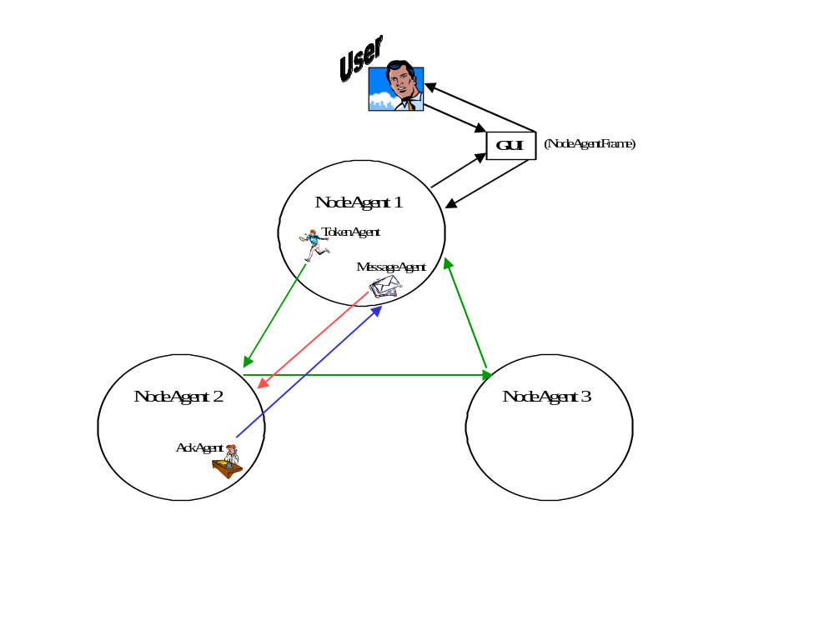

5. GUI Prototype
