ADVENTIST UNIVERSITY OF CENTRAL AFRICA
Master of Science in Big Data Analytics

Smart Energy Grid Monitoring System

Group Members
Mugeni Rebecca — 101208
Ngoga Kwizera Jovite — 101196
Shema Aimable

Course: Big Data Essentials

Date: May 22nd, 2026

1. Introduction
This report documents the implementation of a Smart Energy Grid Monitoring System that demonstrates the performance advantages of TimescaleDB's time-series features. The system simulates 1,000 smart meters publishing readings every 5 minutes via MQTT, stores approximately 8 million rows of historical data, and evaluates the impact of hypertable chunk intervals, compression, and continuous aggregations.

1.1 Technology Stack
Component | Technology
MQTT Broker | EMQX 6.2.0
Database | TimescaleDB 2.27.0 (Docker)
Language | Python 3.10
Dashboard | Streamlit + Plotly

1.2 System Flow
simulator.py (1,000 meters) → EMQX broker → subscriber.py → TimescaleDB → Streamlit dashboard

2. Infrastructure Overview

2.1 EMQX MQTT Broker
EMQX runs on port 1883 (MQTT) and 18083 (dashboard). It decouples the 1,000 meter publishers from the subscriber, preventing direct database overload.
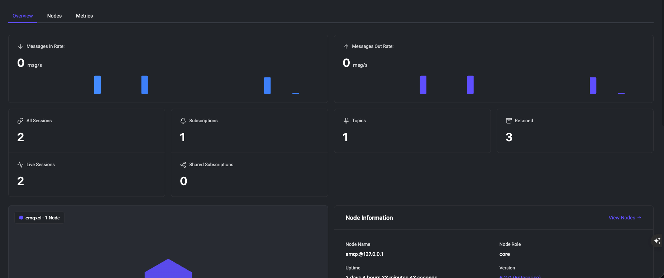
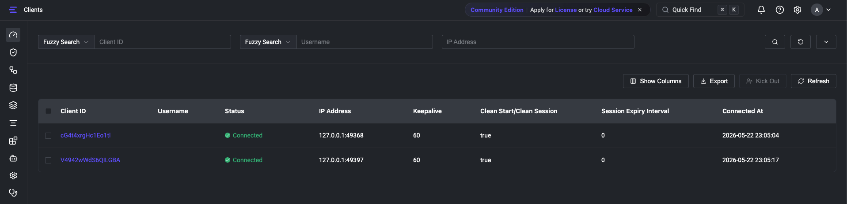
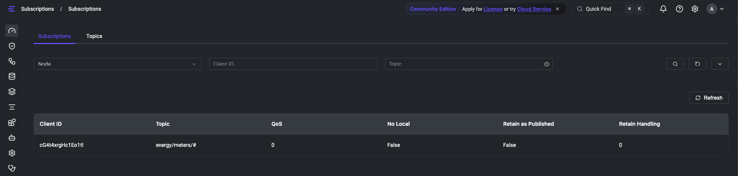

2.2 TimescaleDB
Deployed via Docker on port 5432. The energy_readings table stores 7 fields per reading: meter_id, timestamp, power, voltage, current, frequency, and energy.

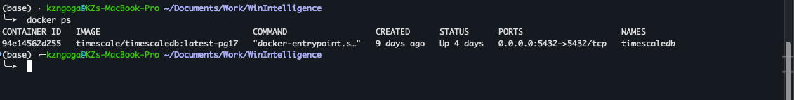

2.3 Pipeline Verification
The pipeline was tested by running simulator.py (--test mode, 10-second intervals) and subscriber.py simultaneously for 2 minutes, confirming that 12,000 rows (equivalent to 1 hour of real data) were stored correctly.
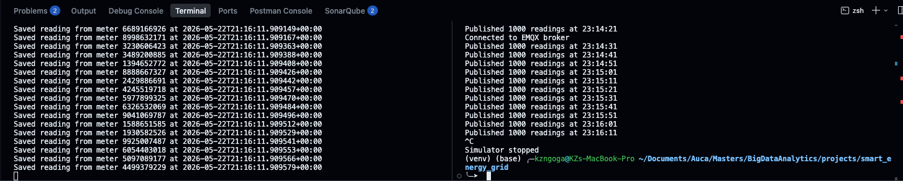
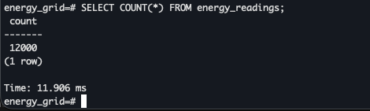

3. Hypertable and Historical Data

3.1 Hypertable Conversion
The energy_readings table was converted to a TimescaleDB hypertable with a 1-day chunk interval, partitioning 8,065,000 rows into 29 daily chunks.
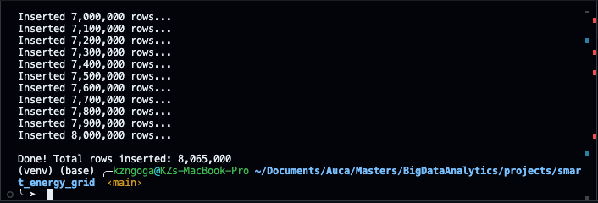

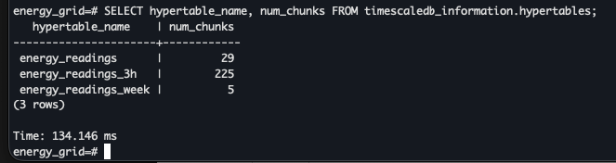
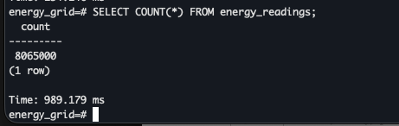

3.2 Baseline Query Performance
Query | Description | Time
Q1 | Hourly avg power today | 19.826 ms
Q2 | Peak 15-min periods — last 7 days | 204.944 ms
Q3 | Monthly energy per meter (full scan) | 2431.713 ms
Q4 | Full dataset: count, avg, max, min | 322.171 ms

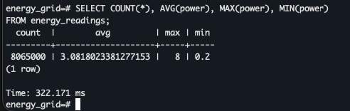

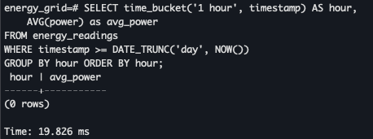
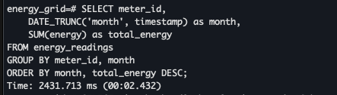

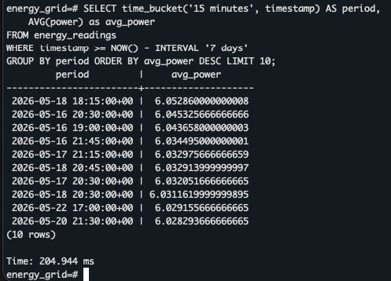

4. Chunk Interval Experimentation

4.1 Chunk Distribution
Table | Chunk Interval | Chunks
energy_readings | 1 day | 29
energy_readings_3h | 3 hours | 225
energy_readings_week | 1 week | 5

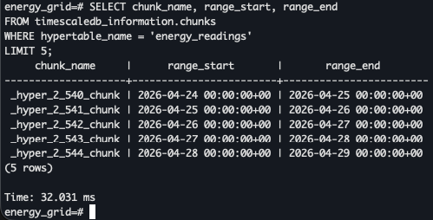
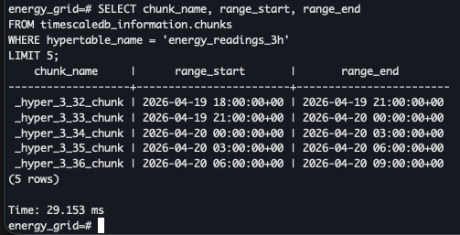
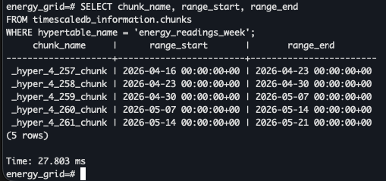

4.2 Query Performance Comparison
Query | 3h chunks | 1-day chunks | 1-week chunks
Q1 — Hourly avg today | 292.465 ms | 19.826 ms | 121.676 ms
Q2 — Peak last 7 days | 769.295 ms | 204.944 ms | 1,810.048 ms
Q3 — Monthly per meter | 16,891.154 ms | 2431.713 ms | 5,314.832 ms
Q4 — Full dataset scan | 611.979 ms | 322.171 ms | 457.101 ms

The 1-day chunk interval performed best overall. The 3-hour interval created excessive chunk overhead (225 chunks), making broad queries significantly slower. The 1-week interval underperformed on 7-day range queries due to poor chunk boundary alignment.

5. Compression

5.1 Storage — Before vs After
Table | Before | After | Saved
energy_readings (1-day) | 780 MB | 407 MB | 373 MB
energy_readings_3h | 791 MB | 410 MB | 381 MB
energy_readings_week | 780 MB | 392 MB | 388 MB

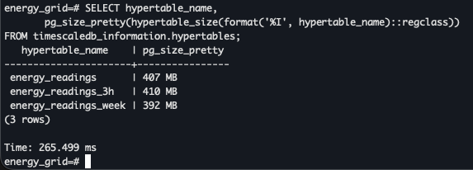

5.2 Query Performance — Before vs After
Query | Before | After | Improvement
Q2 — Peak last 7 days | 1,945.109 ms | 377.494 ms | 80.6% faster
Q3 — Monthly per meter | 18,715.156 ms | 9,131.861 ms | 51.2% faster

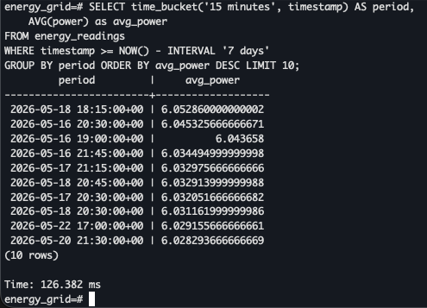
Compression reduced storage by ~50% and improved query performance significantly. Reading compressed data requires fewer disk I/O operations, which outweighs the CPU decompression cost.

6. Continuous Aggregations

6.1 Views Created
View | Bucket | Refresh Interval
energy_readings_15min | 15 minutes | Every 15 minutes
energy_readings_1h | 1 hour | Every 1 hour
energy_readings_1d | 1 day | Every 1 day

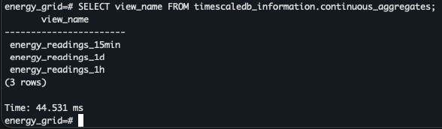

6.2 Performance — Raw vs Aggregated
Approach | Execution Time
Raw energy_readings (8M rows) | 448.925 ms
energy_readings_15min view | 41.379 ms (~10x faster)

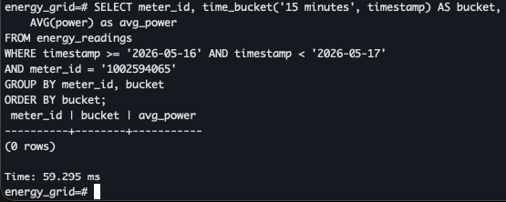
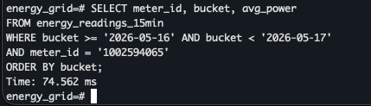

7. Dashboard
A Streamlit dashboard visualizes energy consumption data and performance metrics across 7 panels.

Panel | Description
Real-Time Readings | Avg power per 5-min bucket — last hour
Daily Patterns | Hourly avg power — last 2 days
Weekly Trends | Daily total energy — last 7 days
Regional Usage | Monthly energy grouped by region (first digit of meter ID)
Query Performance | Raw vs continuous aggregation execution times
Compression Savings | Before/after disk usage for all 3 hypertables
Chunk Strategy | Q1–Q4 execution times for 3h, 1-day, 1-week chunks

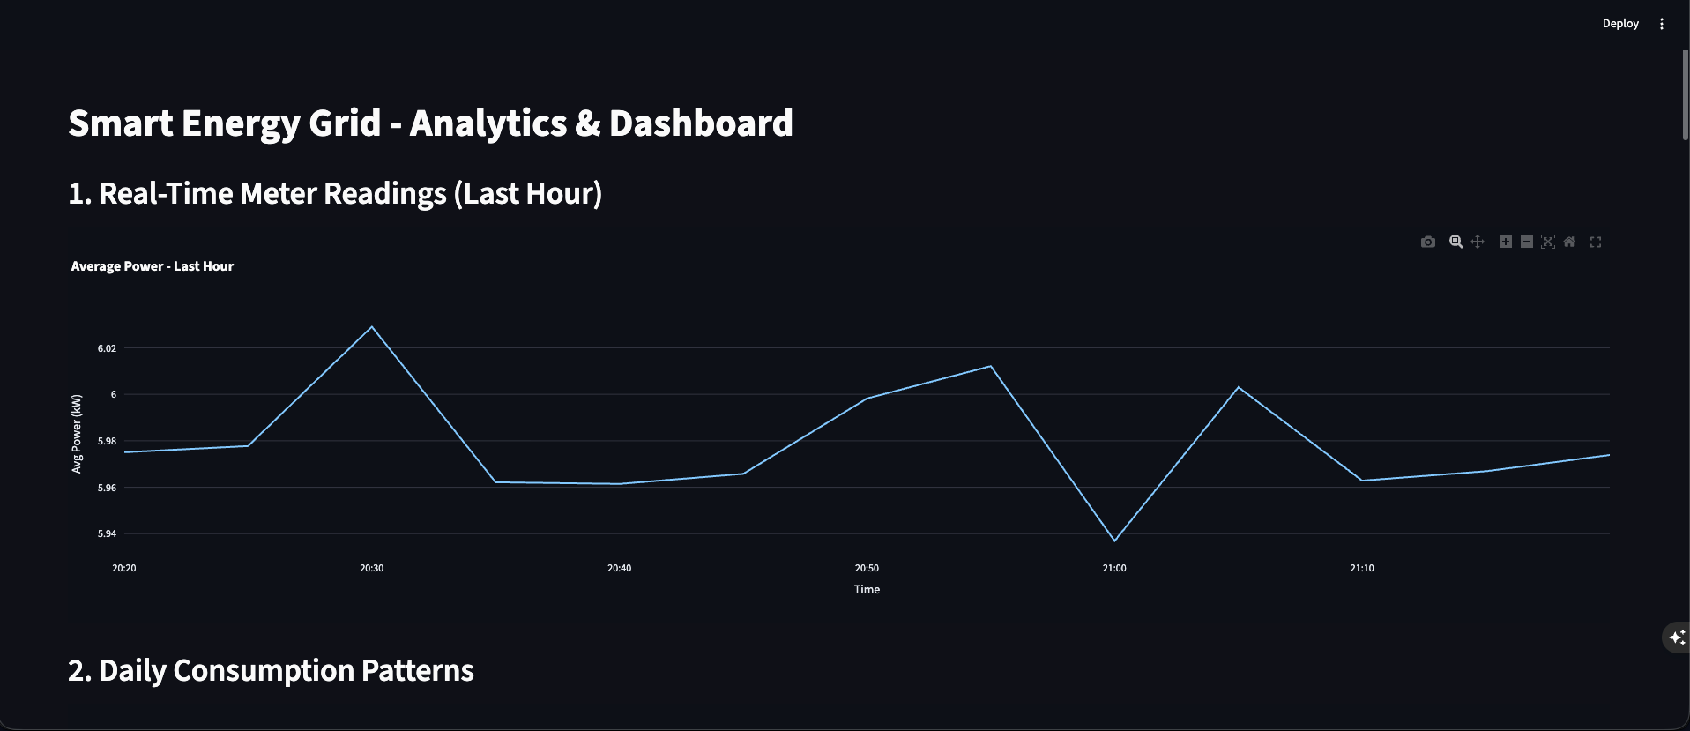
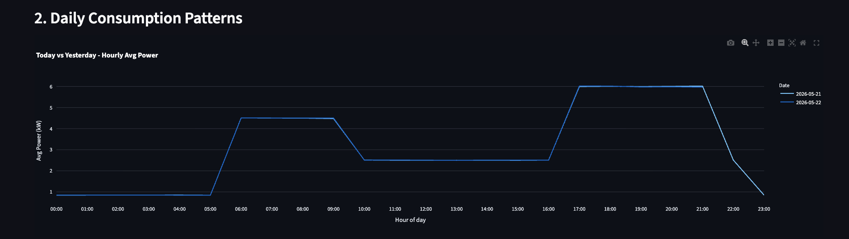
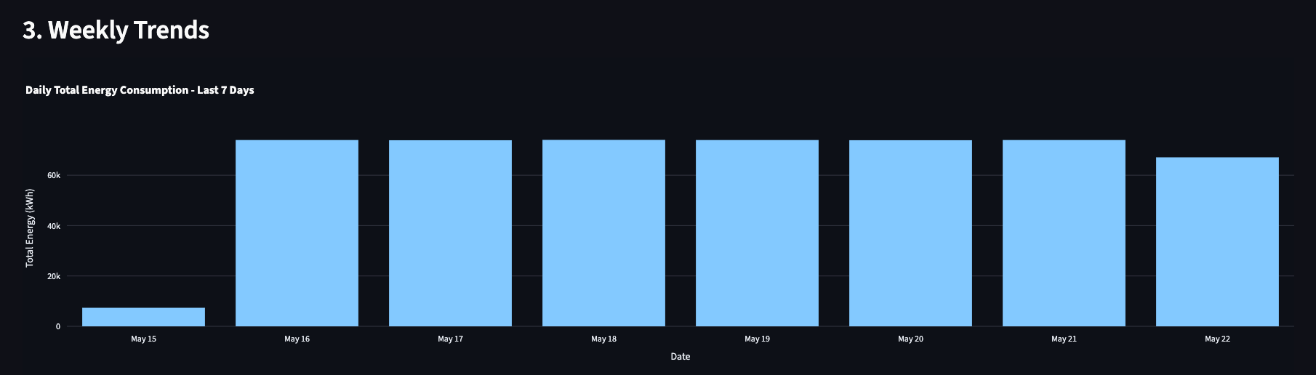
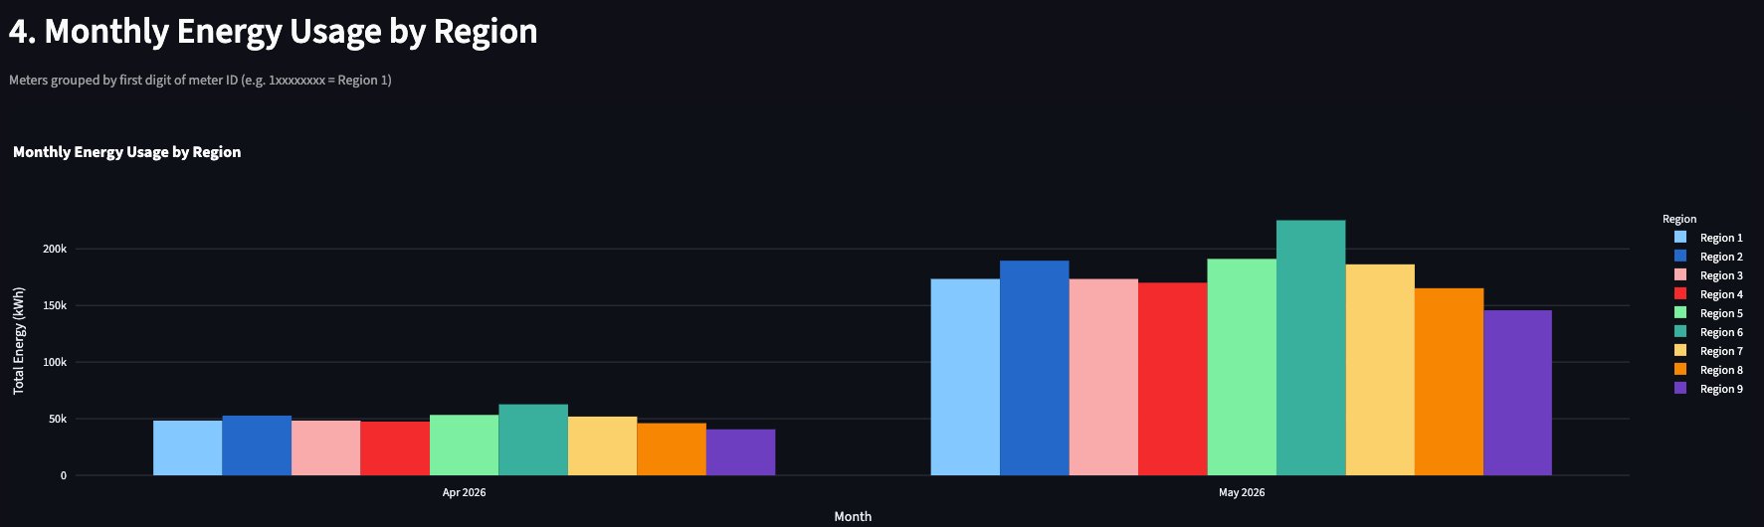

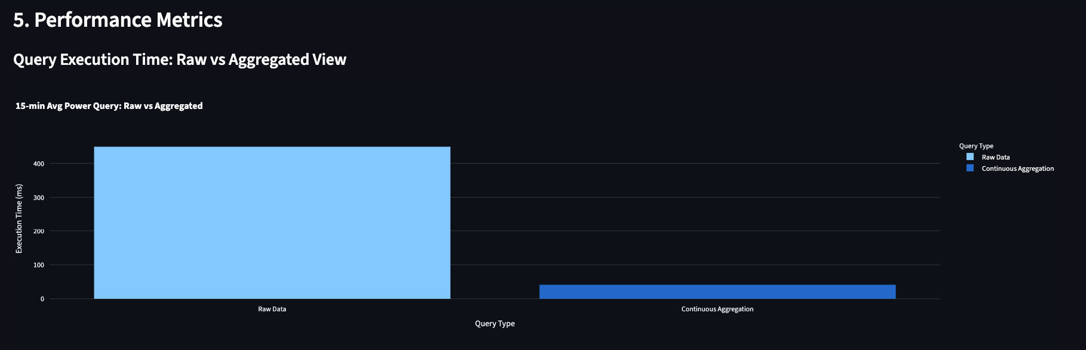
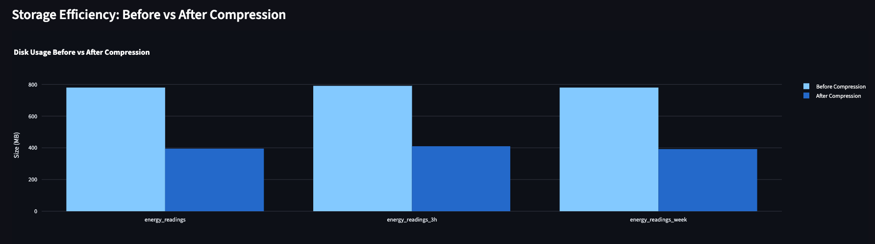
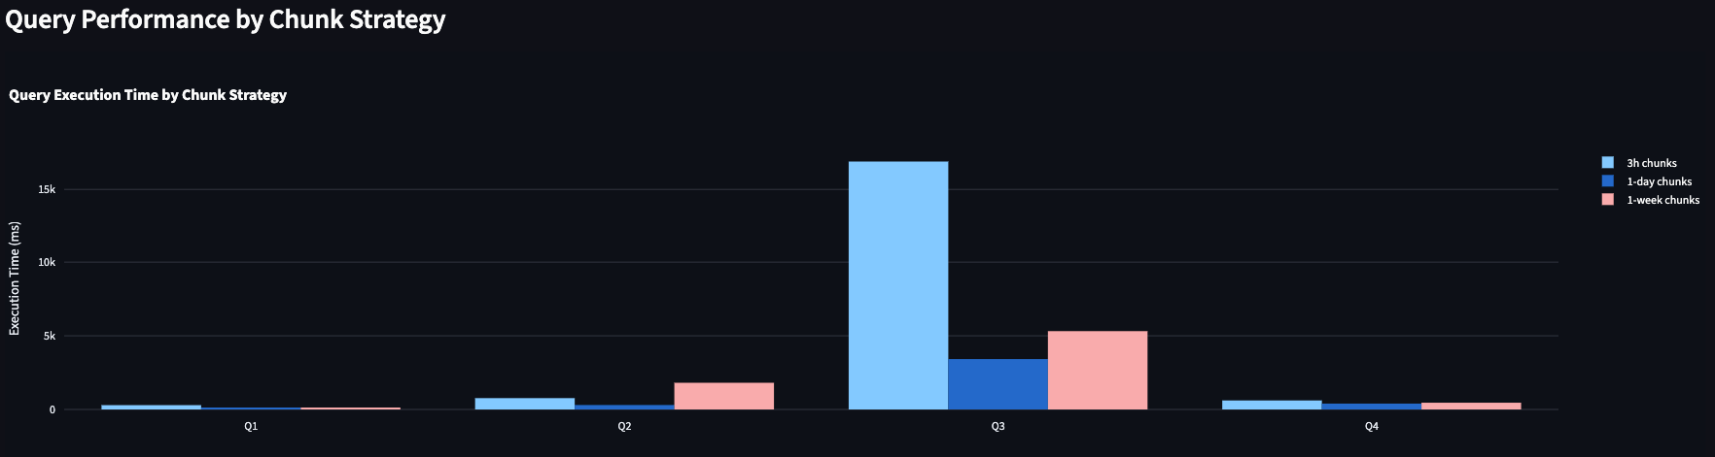

8. Recommendations
Area | Recommendation
Chunk Interval | Use 1-day chunks for 5-minute reporting frequency datasets — balances query performance across daily and weekly patterns
Compression | Enable compression with a 24-hour policy — ~50% storage savings with improved query performance on time-range queries
Continuous Aggregations | Pre-compute 15-min, hourly, and daily aggregations for dashboards — up to 10x query speedup on repeated queries
Bulk Loading | Use executemany() with periodic commits (every 100K rows) for historical data loading — significantly faster than row-by-row inserts

9. Conclusion
This project demonstrated the practical advantages of TimescaleDB for IoT time-series workloads. A 1-day chunk interval consistently outperformed 3-hour and 1-week alternatives. Compression reduced storage by ~50% while improving query performance by up to 80%. Continuous aggregations delivered a 10x speedup for dashboard queries. These results confirm that proper TimescaleDB configuration yields substantial performance gains over standard PostgreSQL for large-scale smart meter datasets.

