Article information

Article title
Comparing Network Indicators and Graphon Distances for Structural Anomaly Detection: A Reproducible Workflow for Directed Weighted Longitudinal Networks

Authors
Zsolt Tibor Kosztyán^{a,b,c,*} (ORCID 0000-0001-7345-8336); Kornél Dénes^{d} (ORCID 0009-0002-9527-6124)
Kornél Dénes's institutional e-mail: morgosz@student.elte.hu

Affiliations
- Business Research Institute for Data-Driven Growth and Economics (BRIDGE), Faculty of Business and Economics, University of Pannonia, Egyetem Street 10, 8200 Veszprém, Hungary
- Department of Quantitative Methods, Institute of Management, Faculty of Business and Economics, University of Pannonia, Egyetem Street 10, 8200 Veszprém, Hungary
- Institute of Advanced Studies, Kőszeg (iASK), Chernel Street 14, 9730 Kőszeg, Hungary
- Faculty of Law, Institute of Political Science, Eötvös Loránd University, Tóth Kálmán Street 10, 1097 Budapest, Hungary

Corresponding author’s email address and Twitter handle
kosztyan.zsolt@gtk.uni-pannon.hu; X: not applicable

Keywords
longitudinal networks; anomaly detection; network indicators; graphon distances; directed weighted networks; block-kernel estimation; comparative method evaluation

Related research article
Kosztyán, Z. T., Hosznyák, A., Király, T., Katona, A. I., Dénes, K., and Hornák, G. Tracking Structural Evolution in Higher Education Application Networks with Graphon Distances: Hungary, 2006–2024. Companion research manuscript; publication details will be inserted when available.

Abstract
Structural anomaly detection in longitudinal networks is difficult because scalar indicators and matrix-level distances retain different information. We present a reproducible method that adapts these existing tools to node-aligned directed weighted snapshots and compares them within one calibrated evidence framework.
• Conventional indicators describe interpretable changes in activity, connectivity, reciprocity, and concentration; graphon-inspired kernel and spectral distances retain coordinated relational structure.
• Raw-weight and unit-mean comparisons separate intensity shifts from structural redistribution, while within-channel anomaly profiles and known-truth simulations prevent heterogeneous scales from being conflated.
• Null-calibrated simulations show complementary sensitivity (maximum false-positive rate 5%); in 19 annual Hungarian higher-education application networks, 2017–2018 produces the strongest six-perspective consensus.
The workflow is designed to reveal agreement and disagreement, not to select a universal winner: convergence supports a broad structural anomaly, whereas divergence helps diagnose its type and scale.

Graphical abstract
Submitted as separate files: FIG00_graphical_abstract.pdf and FIG00_graphical_abstract.png (minimum export size 7200 × 3600 pixels).

Specifications table
Subject area | Computer Science
More specific subject area | Network science; temporal and dynamic network analysis
Name of your method | Calibrated comparison of network indicators and graphon-inspired distances
Name and reference of original method | The workflow customizes established network-summary, graph-distance, and graph-limit methods for directed weighted longitudinal data. Key original sources: Donnat C, Holmes S. Ann Appl Stat. 2018;12:971–1012. https://doi.org/10.1214/18-AOAS1176; Lovász L. Large Networks and Graph Limits. AMS; 2012. https://doi.org/10.1090/coll/060; Lovász L, Szegedy B. J Combin Theory B. 2006;96:933–957. https://doi.org/10.1016/j.jctb.2006.05.002
Resource availability | The complete versioned package is supplied as supplementary material and is prepared for public release at https://github.com/kzst/METHODSX_MOBILITY. It contains R source code, aggregate annual networks, derived validation data, and figure and manuscript-generation code.

Background
Longitudinal network analysis commonly begins with annual indicators such as total weight, density, reciprocity, transitivity, or concentration. These measures are interpretable, but each compresses an entire relational system to a scalar. A transition can therefore rearrange coordinated origin–destination patterns while producing only a modest indicator change. Matrix and graph distances retain more relational information, yet a single distance can be difficult to interpret and may be sensitive to representation, scale, estimator, or resolution [1,3].
The method reported here is a structured adjustment of these existing approaches for node-aligned directed weighted longitudinal networks. It makes four linked modifications. First, it retains conventional indicators as the primary interpretable evidence family instead of replacing them. Second, it fits non-negative directed block kernels and compares both raw intensity and unit-mean shape, separating changes in average magnitude from redistribution. Third, it places heterogeneous indicator, fitted-kernel, spectral, and role-instability channels on comparable within-channel anomaly scales and then summarizes correlated channels into six transparent perspectives. Fourth, it uses known-truth simulations to calibrate channel-specific null thresholds and to identify which change mechanisms each channel can detect.
The fitted-kernel evidence family combines several non-equivalent views. Frobenius distance accumulates aligned cellwise deviations; a reproducible cut-norm search targets a coherent rectangular origin–destination subset; Wasserstein distance compares marginal fitted-intensity distributions; and singular values summarize dominant directed modes of the original adjacency matrices. The fitted non-negative intensity surfaces are block-kernel analogues, not probability-valued graphons, and the analysis does not minimize over node relabelings [2,4]. These restrictions make the estimand explicit and preserve substantive node identity.
The comparison addresses three questions: which evidence channels are sensitive to known forms of change; which consecutive empirical transitions receive convergent support; and, when channels disagree, whether scale, estimator, resolution, or structural mechanism explains the divergence. Convergence across indicator and graphon-inspired perspectives supports a broad structural-anomaly claim. Disagreement is retained as diagnostic information rather than treated as failure. The resulting contribution is a replicable decision workflow for choosing, combining, validating, and interpreting change measures without declaring one universal winner. The illustration uses 19 annual Hungarian higher-education application networks, but the method applies to any sequence with stable node identities and comparable non-negative directed weights.

Method details

Design principles and workflow
The method requires a sequence of non-negative directed weighted adjacency matrices $A_{t}∈R_{≥0}^{n×n}$ with the same ordered node set in every snapshot. Self-loops may be retained as substantive weights, but density and binary transitivity are calculated after removing the diagonal. All preprocessing decisions, including the node universe, time interval, weight definition, and missing-node rule, must be fixed before transition scores are calculated.
Structural change is not a single observable quantity. A transition may alter overall activity, connectivity, concentration, directionality, mesoscale organization, or the roles occupied by individual nodes. Figure 1 presents the method as two evidence families joined by a common anomaly-scoring and decision layer. The resulting profile is interpreted only after known-truth calibration and robustness assessment.
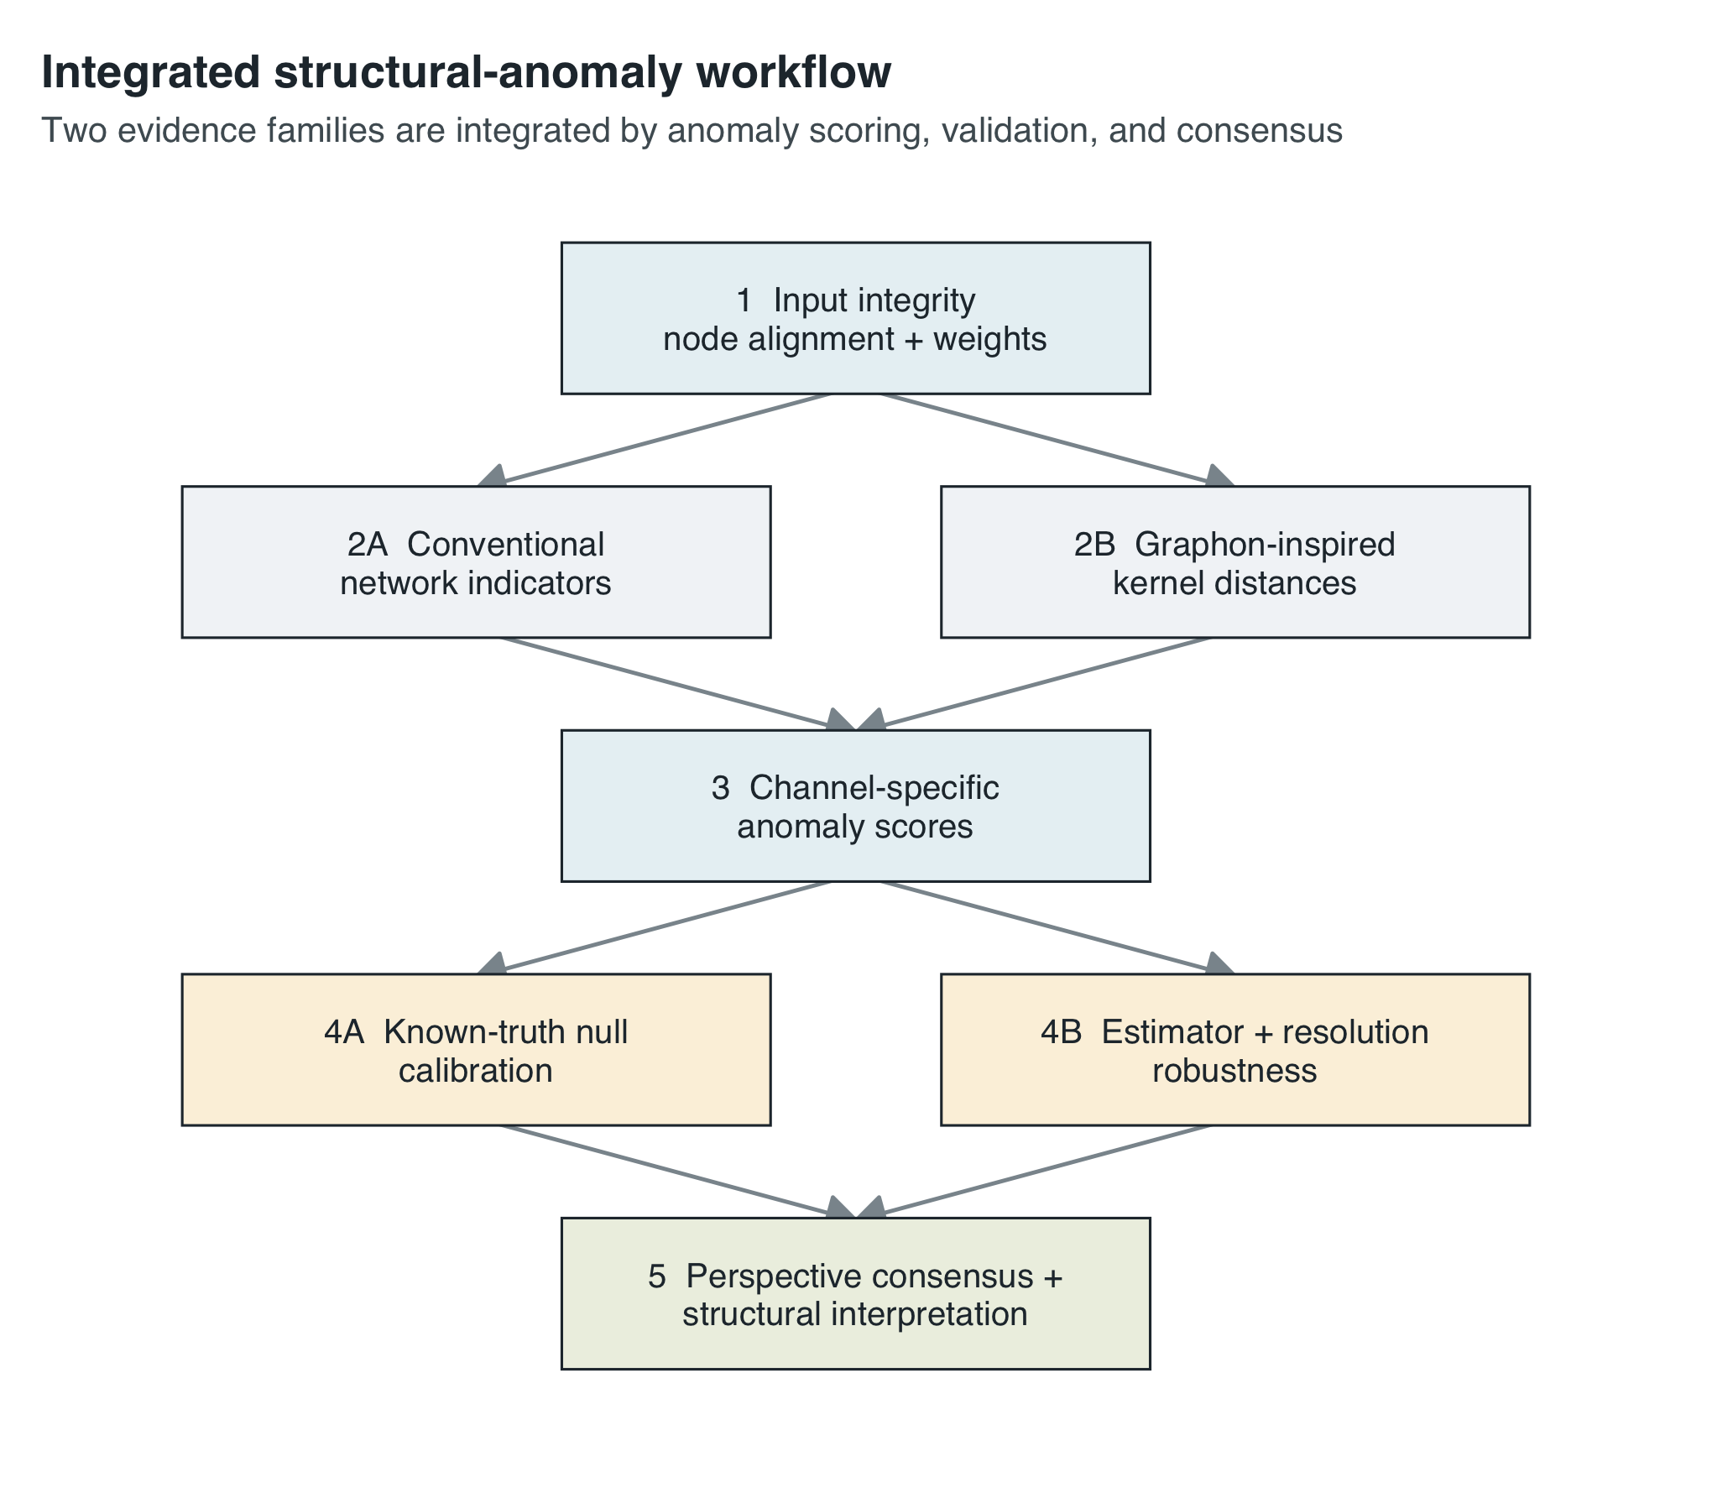
Figure 1: Reproducible workflow for detecting, validating, and interpreting structural anomalies in node-aligned directed weighted longitudinal networks.
Conventional indicators and graphon-inspired distances provide parallel transition evidence. The anomaly layer places their heterogeneous scores on comparable within-channel scales, while simulations establish which mechanisms each channel can detect and specification checks reveal which rankings remain stable. Consensus summarizes convergence without erasing disagreement. Role and flow analysis is used last, to interpret rather than define an anomaly.

Step 1. Construct and verify aligned snapshots
For each time point, convert the edge list to an $n×n$ matrix in the same node order. The included empirical application contains 19 annual snapshots from 2006 through 2024 and 175 nodes in every year. The pipeline verifies the year sequence, matrix dimensions, finite non-negative weights, and two regression anchors: total weight 358,367 in 2016 and 384,035 in 2019. These anchors detect accidental use of the superseded 2016 input or an incorrectly copied annual table.

Step 2. Calculate interpretable annual network indicators
Eight snapshot descriptors provide substantive anchors: total weight, off-diagonal edge density, weighted reciprocity, in- and out-strength Gini coefficients, the entropy-based effective number of destinations, the share of weight received by the ten largest destinations, and binary transitivity. Transition scores are absolute consecutive-year changes; total weight and effective destinations are compared on a $log(1+x)$ scale. These descriptors are not treated as interchangeable tests. Each describes a specific structural dimension that helps explain a distance peak.

Step 3. Fit directed weighted block kernels
At each fixed resolution $K$, nodes are clustered from standardized outgoing strength, incoming strength, outgoing degree, and incoming degree. For the reference block estimator, the fitted block-pair intensity is the mean of the corresponding entries of $A_{t}$. If $z_{t}(i)$ is the block assigned to node $i$ and $W_{t}$ is the fitted $K×K$ block matrix, the node-aligned fitted kernel is [8]
$$M_{t}(i,j)=W_{t}[z_{t}(i),z_{t}(j)].$$
The reference temporal analysis holds $K=13$ constant. It is a common high-resolution comparison scale, not an estimate of a unique true number of roles. Robustness is evaluated with block, smoothed, and spectral estimators at $K=13$, and with the block estimator at $K∈\{2,4,8,13\}$.
The snapshot-specific adaptive-$K$ heuristic is diagnostic only. For $n≤200$, its corrected implementation uses deterministic dense svd(), removes singular values no larger than ${10}^{−8}$ of the leading singular value, and then applies the relative-drop rule. This prevents an iterative singular- value solver’s numerical noise floor from forcing rank-deficient matrices to the $⌊\sqrt{n}⌋$ ceiling. In the present data the corrected diagnostic gives $K=2$ for most years and $K=13$ for 2009–2011; it does not change any fixed-$K=13$ distance reported here.

Step 4. Compare raw intensity and normalized shape
For each adjacent pair, compute every distance twice: on the fitted intensity matrices $M_{t}$ and on their unit-mean versions $S_{t}=M_{t}/\overline{M_{t}}$. The raw comparison retains total scale; the shape comparison removes average intensity and focuses on redistribution.
The normalized Frobenius distance is the root-mean-square aligned cell difference,
$$d_{F}(M_{1},M_{2})=\frac{{\left\|M_{1}−M_{2}\right\|}_{F}}{n}.$$
For $D=M_{1}−M_{2}$, the exact normalized node-aligned cut norm is
d▫aligned(M1,M2)=1n2maxS,T⊆{1,…,n}i∈S, j∈T​Dij.
Exact computation is NP-hard. The implementation therefore reports ${\hat{d}}_{▫}^{aligned}$, the best reproducible lower bound found by alternating maximization on both $D$ and $−D$, starting from three deterministic row subsets and 200 random restarts per sign in publication mode. The best value among 1,000 random subset-pair draws is retained as a floor. This quantity must be described as a cut-norm lower-bound estimate, not as the exact cut norm and not as an unlabeled graphon cut distance.
The empirical one-dimensional Wasserstein distance is
$$d_{W_{1}}(M_{1},M_{2})=\frac{1}{n^{2}}\sum_{r=1}^{n^{2}}{\left|x_{(r)}−y_{(r)}\right|},$$
where $x_{(r)}$ and $y_{(r)}$ are sorted fitted entries. It compares intensity distributions and deliberately discards origin–destination locations [5,6]. Finally, the original adjacency matrices are compared through the root-mean- square difference between their ten leading singular values. This benchmark captures dominant directed modes without relying on possibly complex eigenvalues of a nonsymmetric matrix.

Step 5. Quantify role instability and robustness
Structural-role change is measured as one minus the adjusted Rand index between consecutive fitted partitions [7], so arbitrary block labels do not affect the score. Estimator and resolution robustness are summarized by Spearman correlation of all 18 transition scores and by Jaccard overlap between the two top-five transition sets. Correlation measures overall rank stability; Jaccard overlap tests whether the substantively highlighted transitions remain the same.

Step 6. Construct anomaly profiles and use them as a decision guide
For the empirical sequence, every transition score is converted to its within-channel percentile among the 18 consecutive-year transitions. Correlated channels are then grouped into six perspectives: activity and connectivity, distribution and reciprocity, adjacency spectrum, raw fitted kernel, normalized shape, and structural roles. The mean of the six perspective percentiles is a consensus navigation score, and breadth is the number of perspectives at or above the 75th percentile. Equal weighting at the perspective level prevents a large family of closely related distances from dominating the summary merely because it contains more channels. The 75th-percentile boundary is a descriptive navigation convention, not a significance threshold; the full six-perspective profile remains the primary empirical result. These quantities describe relative anomaly within the observed period; they are not posterior probabilities, formal change-point tests, or causal evidence.
No channel should be chosen only because it produces the largest standardized peak. The research question determines the primary evidence, and at least one channel from the other evidence family, with a different blind spot, should be used as a complement.
Research question | Primary evidence | What a large value supports | Main blind spot | Recommended complement
Did overall activity or connectivity change? | Total weight and edge density; raw distances | A change in aggregate scale or occupied dyads | Cannot separate broad scaling from structured redistribution | Compare raw and unit-mean shape channels
Was change widespread across aligned pairs? | Frobenius distance | Many moderate cell changes or a few large cell changes | Does not identify a coherent affected subset | Cut-norm lower-bound estimate and conventional indicators
Did a coordinated origin–destination subset change? | Cut-norm lower-bound estimate | A strong rectangular signed discrepancy | Lower bound is optimization- and resolution-sensitive | Frobenius distance plus restart and resolution checks
Did the distribution of fitted weights change? | Empirical $W_{1}$ distance | A shift in the marginal intensity distribution | Discards node-pair locations | Node-aligned Frobenius or cut-norm lower-bound estimate
Did dominant directed modes change? | Singular-spectrum distance | A change in leading adjacency-matrix modes | Does not localize nodes or block pairs | Kernel distances and indicators
Did mesoscale roles reorganize? | One minus adjusted Rand index | A label-invariant partition change | Estimated roles can be noisy and low-powered | Kernel distances plus role-flow interpretation
Is a reported transition robust? | Spearman rank agreement and top-five Jaccard overlap | Timing is not tied to one estimator or resolution | Agreement does not validate substantive meaning | Known-truth calibration and domain interpretation

Step 7. Calibrate channel sensitivity with known-truth simulations
The known-truth scenarios in Figure 2 isolate six conceptually different structural interventions. Each simulation uses $n=80$ nodes and four latent roles. Edges are sampled from a block-specific Bernoulli presence model and positive weights from block-specific conditional means with node-level sender and receiver heterogeneity. Publication mode uses 200 replicates for the null and for each small, medium, and large non-null effect. Figure 2 reports the relative change in the expected kernel at the medium effect level before and after unit-mean normalization. It therefore shows, on an interpretable common scale, whether a scenario primarily changes network magnitude or structural shape.
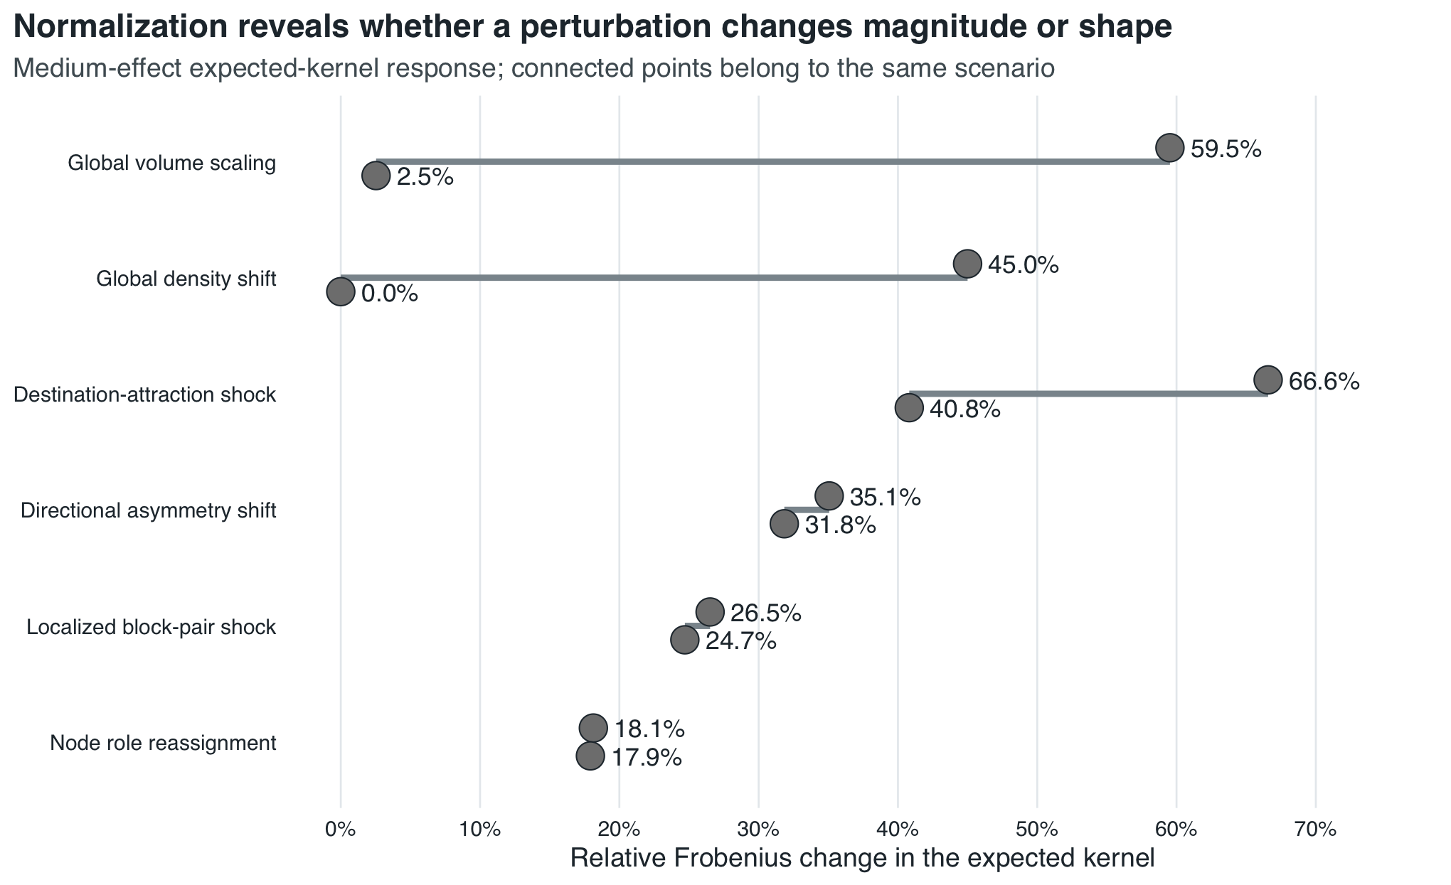
Figure 2: Relative change in the expected weighted kernel under six medium-effect simulation scenarios. Connected points compare raw intensity with unit-mean structural shape; labels report the actual relative Frobenius change rather than a column-normalized color scale.
The paired responses make the scale–shape distinction explicit. At the medium effect, global volume scaling changes the raw expected kernel by 59.5% but its unit-mean shape by only 2.5%; the density intervention changes the raw kernel by 45.0% and leaves the normalized expected shape unchanged. Destination attraction, directional change, local block shock, and role reassignment retain substantial shape responses. Raw and normalized comparisons therefore provide complementary evidence rather than interchangeable versions of one distance.

Reproducibility implementation
The complete workflow is executed by source("run_all.R"). Publication mode uses random seed 20260817, 200 simulation replicates per design cell, 1,000 random cut-search floor samples for empirical comparisons, 128 for simulation comparisons, and 200 alternating-maximization restarts. Diagnostic mode uses smaller values for rapid error detection but writes the same file structure. Every analytical table is checked before rendering. The final output manifest is written only after the HTML manuscript, Word manuscript, and all PDF/PNG figures have been generated, so its sizes and MD5 hashes refer to the current run rather than to previously rendered files.
OpenAI ChatGPT was used in a supportive role for code review, code editing, visualization redesign, and manuscript organization. It did not generate or alter the empirical observations or simulation outcomes. Zsolt Tibor Kosztyán reviewed the AI-assisted changes and verified the reported claims against the scripted outputs. Kornél Dénes will independently validate the software and computational claims before submission. The authors retain full responsibility for the analytical code and manuscript.

Method validation

Known-truth simulation calibration
Figure 3 evaluates sensitivity after calibrating every channel against its own null distribution. Each cell is the proportion of simulated transitions that exceeded the channel-specific 95th-percentile null threshold. The null column therefore checks false-positive control, while the remaining columns reveal which structural changes each evidence channel is capable of detecting.
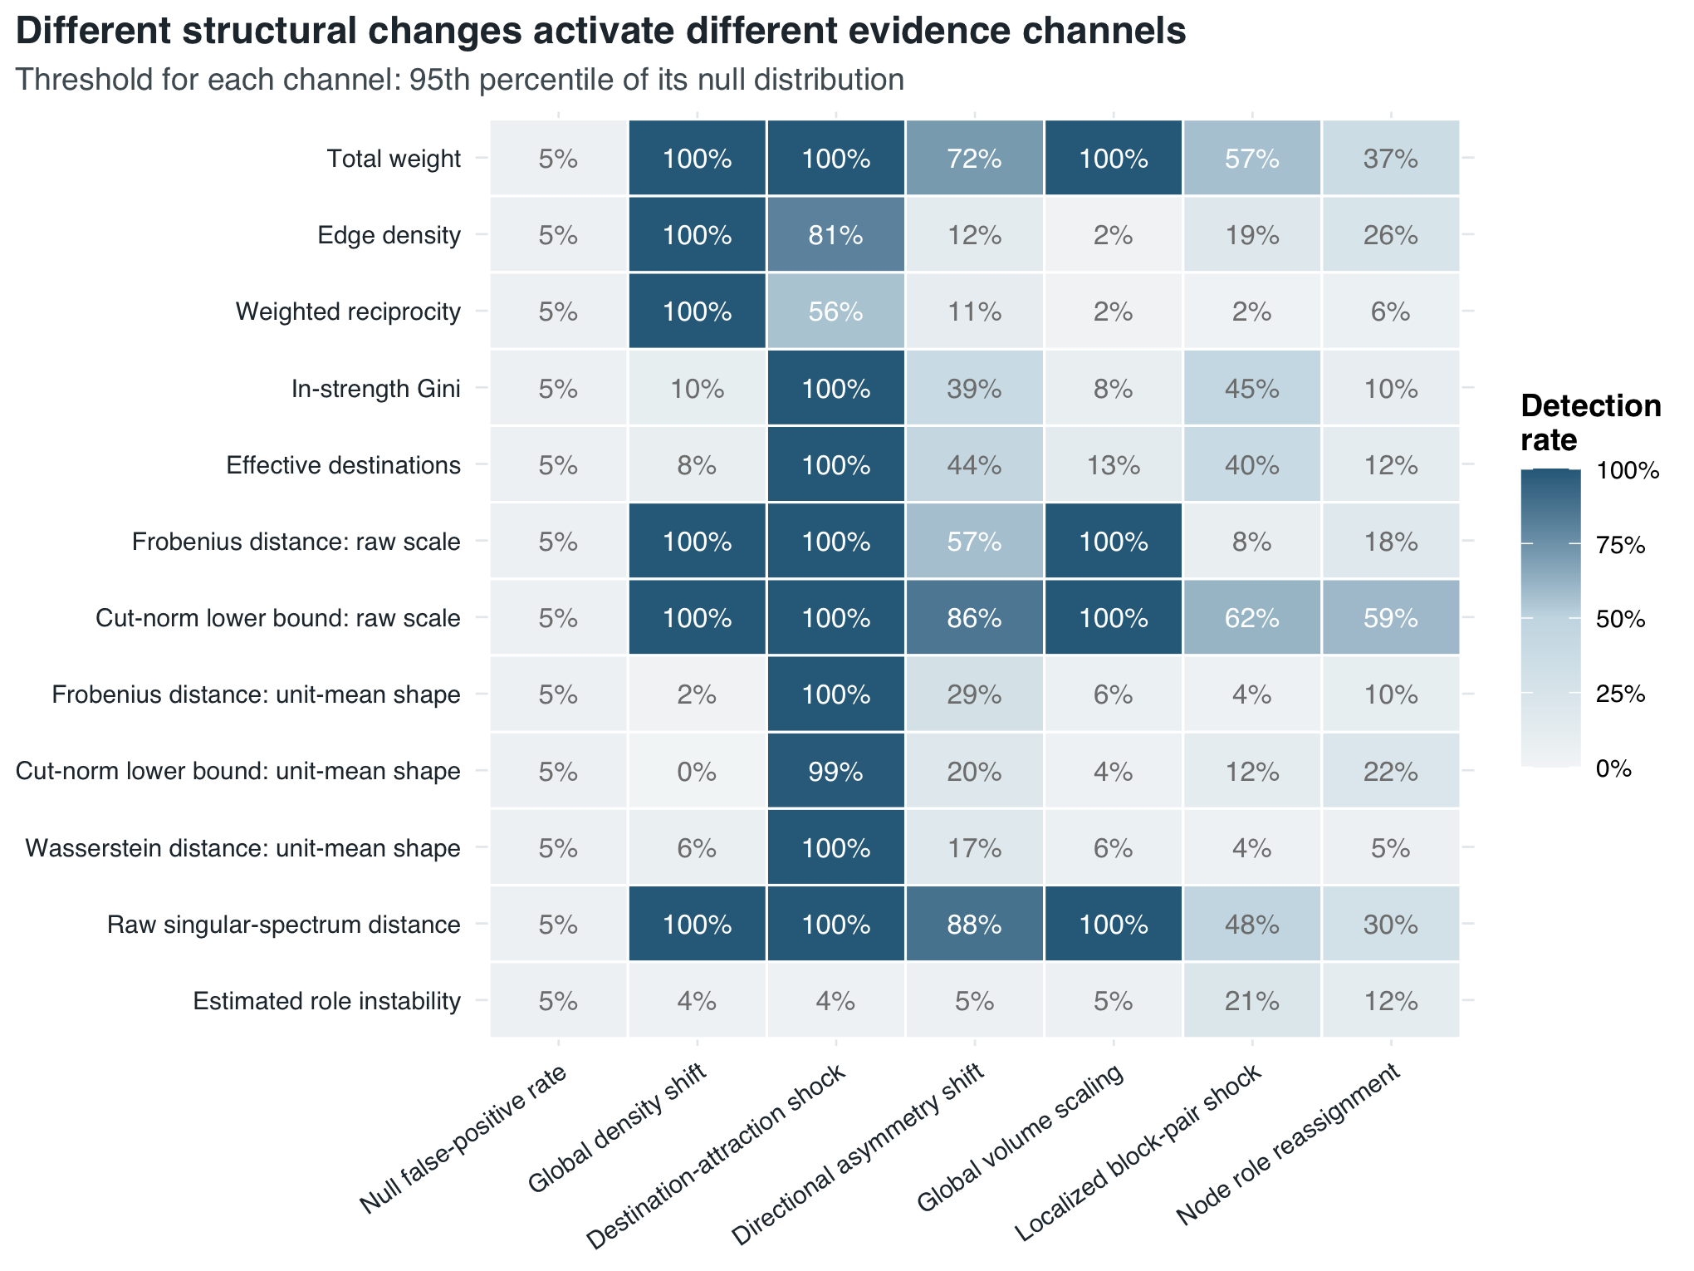
Figure 3: Null-calibrated detection rates by change scenario and evidence channel. Non-null columns show the medium effect level; the null column shows the empirical false-positive rate.
The largest null detection rate is 5%, confirming the intended calibration in this finite simulation. Conventional network indicators provide strong and readily interpretable detection where the intervention targets their own structural dimension. At the medium effect, total weight detects every global scaling, density-shift, and destination-attraction replicate; edge density and weighted reciprocity detect every density shift; and both in-strength Gini and effective destinations detect every destination-attraction replicate.
Graphon-inspired and adjacency-matrix distances add evidence for changes that are less completely summarized by annual indicators. Global scaling is detected in all replicates by raw Frobenius, the raw cut-norm lower-bound estimate, and the raw singular spectrum, while the corresponding unit-mean shape distances remain near their null rates. Directional change is detected by the raw singular spectrum in 88.0% of replicates and by the raw cut-norm lower- bound estimate in 86.0%, compared with 71.5% for total weight and 57.5% for raw Frobenius. For localized block shocks and role reassignment, the raw cut-norm lower-bound estimate reaches 61.5% and 59.5%, compared with 57.0% and 37.0% for total weight; estimated role instability reaches only 21.0% and 12.0%.
The result is complementarity rather than a universal winner. Conventional indicators locate interpretable changes in network-level trajectories; graphon- inspired distances test whether aligned relational patterns change beyond what those summaries reveal; and the anomaly profile records whether the two evidence families converge or disagree.

Empirical anomaly profiles
The empirical illustration in Figure 4 asks a different question: which annual transitions are relatively unusual across several structural perspectives? Unlike the simulation rates, these are descriptive within-channel percentiles, not null-hypothesis rejection probabilities. The first two perspectives retain the conventional annual indicators; the adjacency spectrum, raw fitted kernel, normalized shape, and structural roles add increasingly relational evidence. Transitions are ordered by their mean perspective percentile, and the consensus cell reports how many perspectives place the transition at or above the 75th percentile.
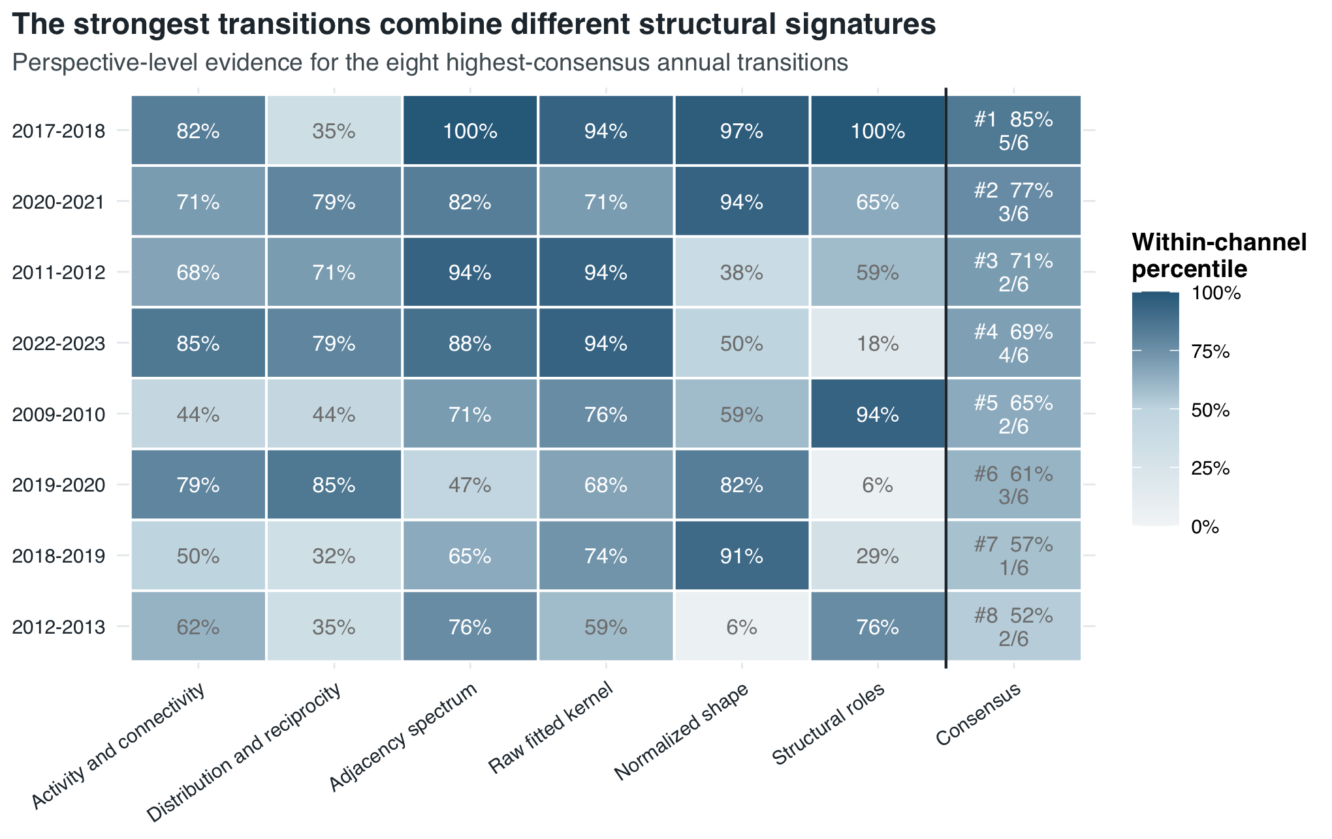
Figure 4: Convergence of empirical transition evidence across six structural perspectives. The eight highest-consensus annual transitions are shown. The consensus cell reports the mean perspective percentile and, below it, the number of perspectives at or above the 75th percentile.
The highest consensus occurs in 2017–2018 (mean perspective percentile 84.8%; five of six perspectives at or above the 75th percentile). The next three are 2020–2021 (77.0%; three of six), 2011–2012 (70.6%; two of six), and 2022–2023 (69.1%; four of six). Their differing column profiles show why the consensus score is a navigation aid rather than a replacement for the component evidence. In 2017–2018, activity and connectivity are high (82.4%), but distribution and reciprocity are not (35.3%); raw kernel, normalized-shape, spectral, and role perspectives all exceed 94%. In 2022–2023, both conventional indicator perspectives and the raw-kernel and spectral perspectives are high, whereas normalized shape (50.0%) and roles (17.6%) are not. These profiles show how graphon distances refine the interpretation of annual indicator changes without displacing them. Importantly, 2015–2016 ranks only eleventh by consensus and is not among the eight transitions displayed. The corrected empirical input therefore does not support treating the transition adjacent to 2016 as a dominant break.

Estimator and resolution robustness
Figure 5 examines whether the empirical ranking of annual transitions depends on the fitted-kernel estimator or the selected fixed resolution. Cell color reports Spearman rank correlation, while the annotation reports both that correlation and the top-five Jaccard overlap. The two measures distinguish overall rank stability from agreement about the most prominent transitions.
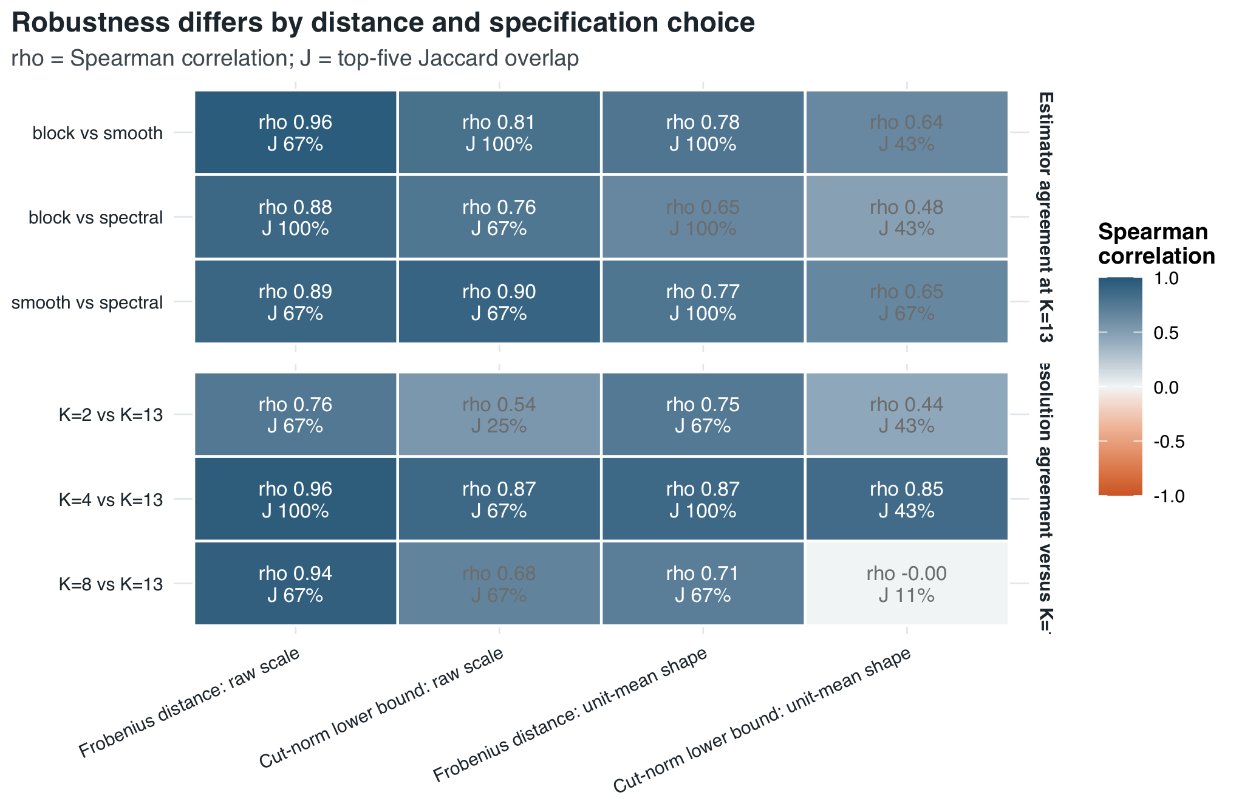
Figure 5: Agreement of empirical transition rankings across fitted-kernel estimators and fixed resolutions. Cell color and the first annotation line show Spearman correlation; the second line shows top-five Jaccard overlap.
Raw-scale Frobenius is the most stable displayed channel: estimator correlations are 0.876–0.963, and correlations with the $K=13$ ranking are 0.756, 0.957, and 0.938 at $K=2,4,$ and 8. The raw-scale cut-norm lower-bound estimate is robust across estimators (0.765–0.899) but more resolution-sensitive (0.542, 0.870, and 0.676). The unit-mean shape cut-norm lower-bound estimate is the clearest warning case: its $K=8$ correlation with $K=13$ is -0.003 and its top-five overlap is 11.1%. The diverging color scale is necessary to display this near-zero negative association rather than suppress it. A transition supported only by the shape-scale cut estimate should therefore be treated as specification-sensitive; convergence across raw, shape, spectral, and indicator perspectives supports a stronger empirical claim.

Structural interpretation through role flows
Figure 6 moves from detecting a transition to interpreting a selected network state. A single role-flow map encodes two non-equivalent quantities: bubble area is a role pair’s share of all observed application weight, whereas fill is the share conditional on its origin role. The design therefore makes systemwide concentration and origin-specific destination choice visible without using separately normalized heatmaps.
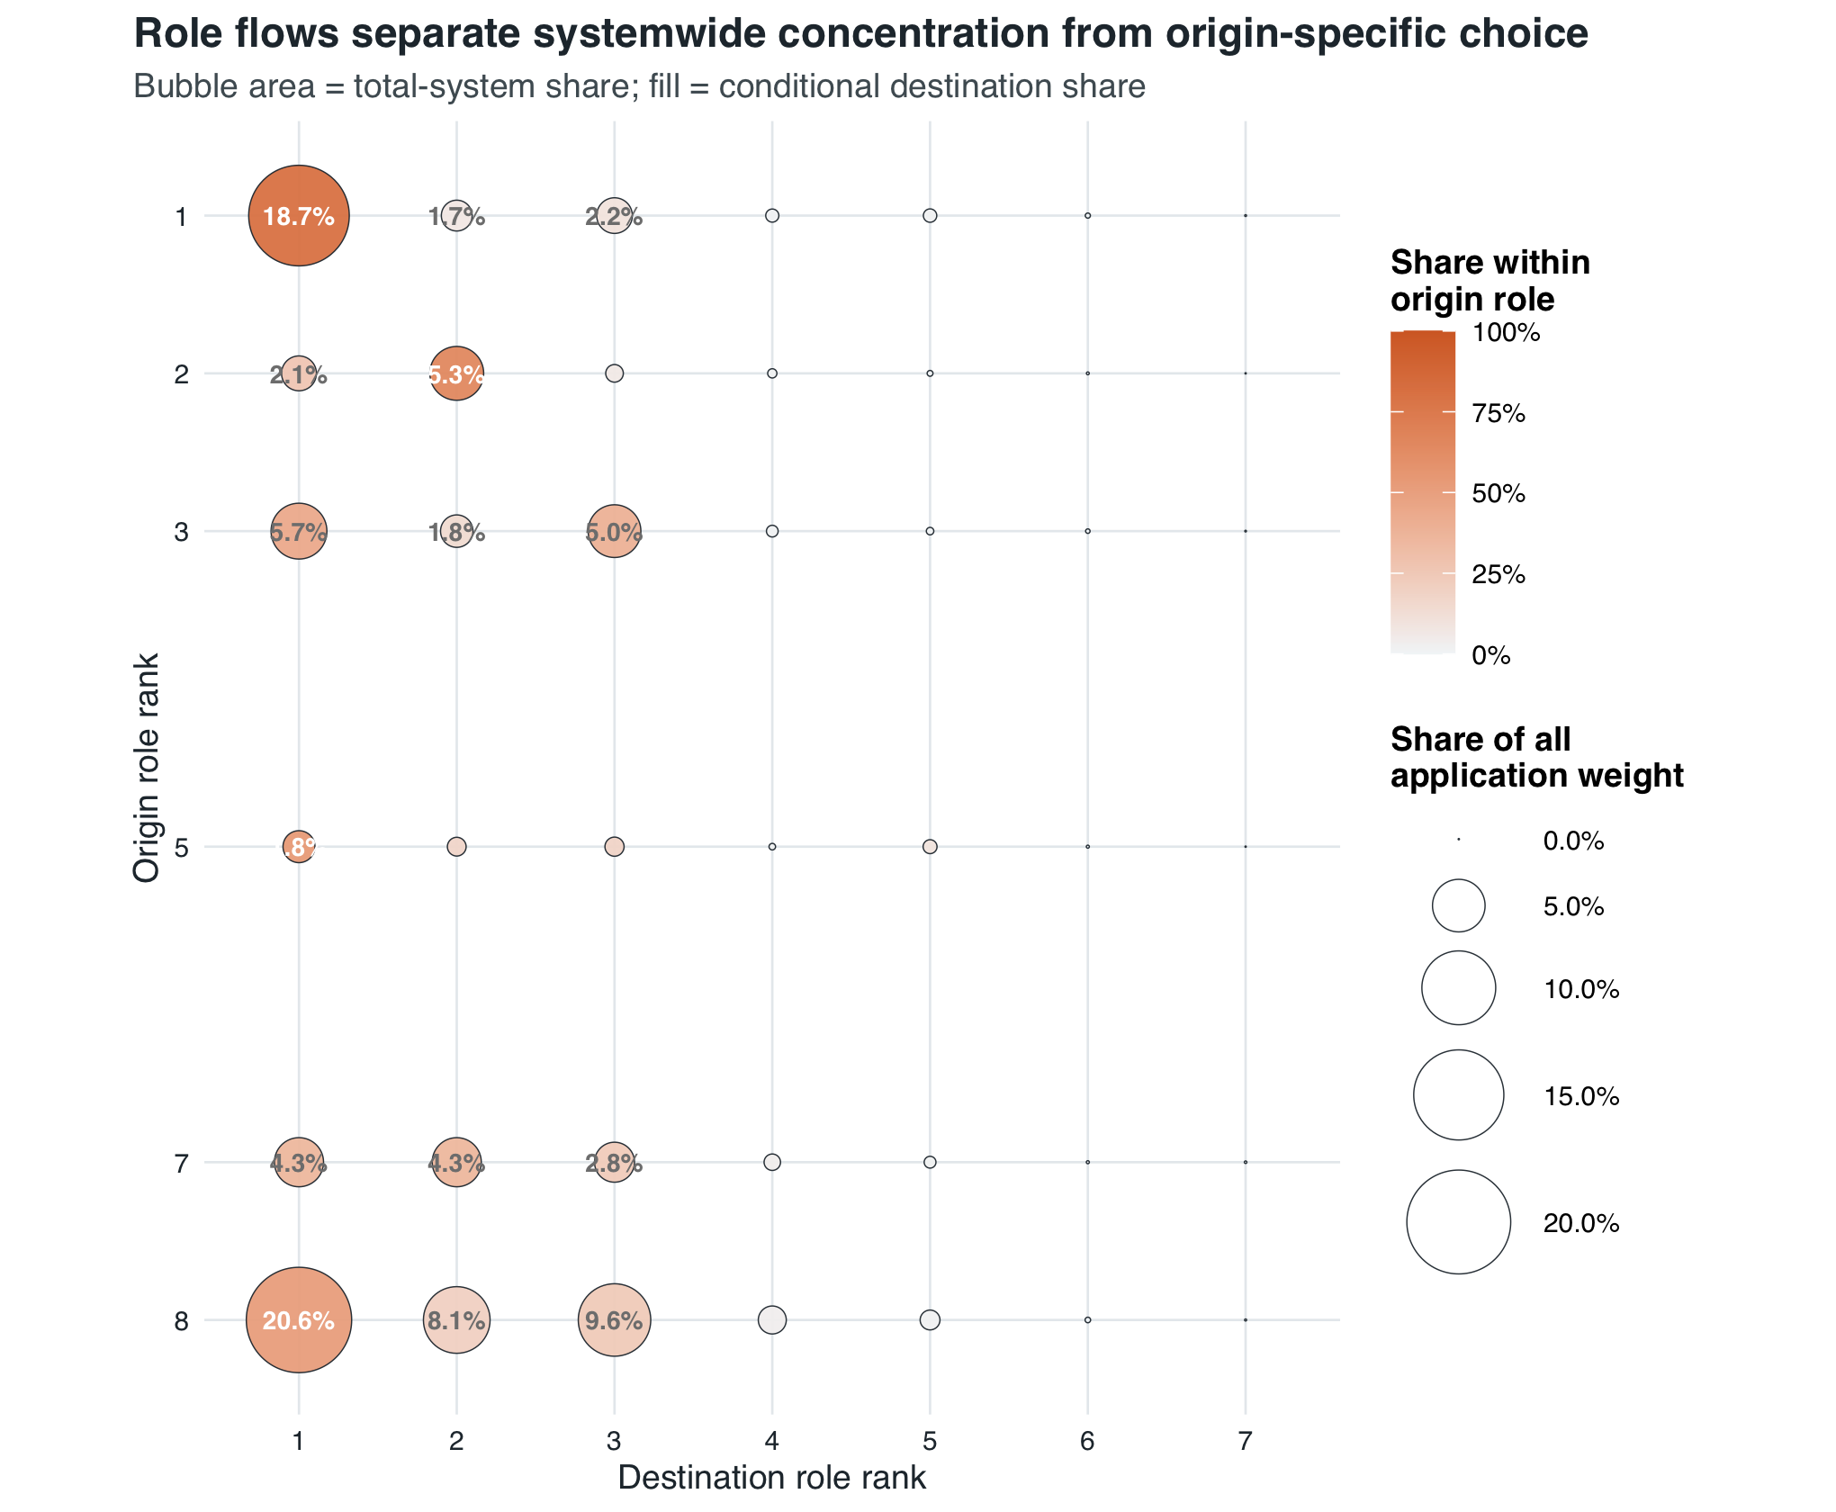
Figure 6: Observed application-weight flow among active fixed-K=13 destination-oriented structural roles in 2018. Bubble area represents each role pair’s share of total system weight; fill represents its share conditional on the origin role. Role rank 1 is the strongest fitted destination role.
The flow structure is strongly concentrated: the three largest destination roles receive 95.9% of all application weight, and the four largest origin–destination role pairs account for 57.1%. The conditional fill nevertheless reveals differences among origin roles that bubble area alone would obscure. This illustrates why role-flow interpretation adds substantive information after a structural transition has been identified; it does not serve as an independent change detector.

Practical interpretation and use
The workflow should be read as a three-part evidence-integration architecture. First, conventional annual network indicators preserve substantive interpretability and show how activity, connectivity, reciprocity, and concentration evolve. Second, graphon-inspired and adjacency-based distances test whether the aligned relational pattern changes in ways that scalar summaries can miss. Third, the anomaly-scoring, simulation-calibration, and consensus layer makes these heterogeneous signals comparable and records the breadth of their agreement. The third part is an integration and validation layer, not another source of network data.
Accordingly, reporting should begin with the annual network-indicator trajectories, then use graphon-inspired distances to refine the type and location-scale of structural change, and finally use anomaly profiles, specification checks, and role flows to assess robustness and interpretation. This ordering prevents a graphon-only reading of the method while also avoiding the opposite mistake of treating annual scalar indicators as a complete description of network evolution.
The known-truth results reject a universal ranking of methods: indicator, kernel-distance, spectral, and role channels respond differently to the same perturbation. The appropriate final claim is therefore conditional. Convergent indicator and graphon-inspired evidence supports a broad structural anomaly; divergence identifies whether the signal is mainly aggregate, relational, scale-dependent, shape-dependent, spectral, or role-based. Researchers should report that profile rather than average away the disagreement.

Limitations
The workflow assumes that node identity and weight meaning are comparable over time. If nodes enter or leave the system, researchers must first define a common universe or use a method designed for unmatched networks. Because the reported distances are node-aligned, they are not invariant to relabeling and should not be described as unlabeled graphon distances.
The cut quantity is a reproducible lower-bound estimate. Alternating maximization can converge to a local optimum, and increasing the number of restarts may increase the reported score. Absolute cut values should therefore be accompanied by the restart count and random-search floor; transition rankings should be checked across resolutions.
Block-kernel results depend on estimator and resolution. A fixed $K$ makes annual distances comparable but does not establish that $K$ is the true latent number of roles. The empirical robustness analysis shows that raw Frobenius is comparatively stable in this application, whereas shape cut can be highly resolution-sensitive. These findings are data-specific and do not establish a universal ranking of distance measures.
The simulations isolate seven deliberately simplified cases, including the null. They evaluate detection under the documented $n=80$, $K=4$ weighted block model and effect schedule; they do not prove sensitivity under every sparse, heavy-tailed, dependent, or node-misaligned process. Researchers should add domain-relevant perturbations when applying the workflow elsewhere.
Empirical within-channel percentiles are descriptive relative anomaly scores over the 18 observed transitions. They are not calibrated $p$-values, do not correct for multiple testing, and do not by themselves establish a formal change point. The equal perspective weights, perspective definitions, and 75th-percentile breadth boundary are transparent analytic choices rather than estimated optimal parameters. Confirmatory use requires an external null model, sensitivity analysis for alternative aggregation rules, or an appropriate time-series change-point procedure.
Structural-role groups describe similarity of directed connection profiles; they are not modularity communities. Role flows are descriptive aggregates and do not identify individual pathways or causal mechanisms. In the empirical application, edges represent applications rather than realized enrollment, so destination-role position is not an institutional quality ranking and annual associations are not causal effects of policy events.

Ethics statements
The method development and reported illustration use aggregate annual micro-region flow counts. The reproducibility package contains no applicant- level records or direct personal identifiers, and no experimental intervention, animal research, or new recruitment of human participants was undertaken for this methods study. Access to and any further use of the underlying administrative records remain subject to the data provider’s authorization and applicable data-protection requirements.

CRediT author statement
Zsolt Tibor Kosztyán: Conceptualization; Methodology; Software; Validation; Formal analysis; Investigation; Data curation; Visualization; Writing – original draft; Writing – review and editing; Project administration.
Kornél Dénes: Software; Validation; Writing – review and editing.

Acknowledgments
The authors thank the colleagues who supported the reconstruction and checking of the annual inputs. Project no. K 142395 was implemented with support provided by the Ministry of Culture and Innovation of Hungary from the National Research, Development and Innovation Fund, financed under the K-22 “OTKA” funding scheme.

Declaration of interests
☒ The authors declare that they have no known competing financial interests or personal relationships that could have appeared to influence the work reported in this paper.
☐ The authors declare the following financial interests/personal relationships which may be considered as potential competing interests:
Not applicable; no competing interests were declared.

Supplementary material and/or additional information [OPTIONAL]
The accompanying reproducibility package contains the R pipeline, aggregate annual edge lists and node metadata, derived empirical and simulation tables, validation reports, session information, output manifests, and publication- quality PDF and PNG figures. Supplementary Figure S1 reports whether the fitted role solutions are approximately nested across adjacent fixed resolutions.
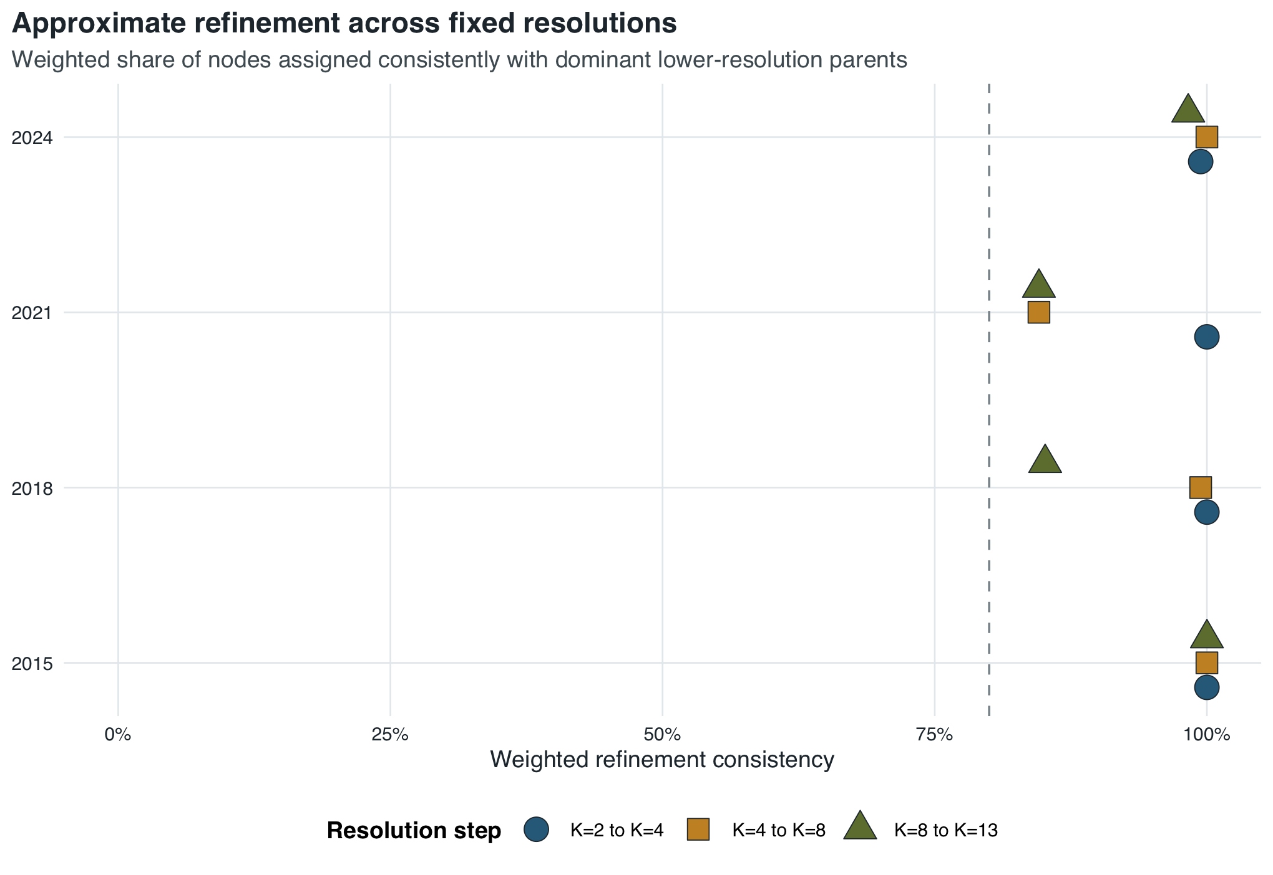
Figure 7: Empirical consistency with coarse-to-fine role refinement across selected years and adjacent fixed resolutions.

Declaration of generative AI and AI-assisted technologies in the manuscript preparation process
During the preparation of this work, the authors used OpenAI ChatGPT to support code review, code editing, visualization redesign, manuscript organization, and English-language revision. After using this service, the authors reviewed and edited the content, verified the computational claims against the reproducible R outputs, and take full responsibility for the content of the published article. No generative-AI system is listed as an author.

References
[1] Donnat C, Holmes S. Tracking network dynamics: A survey using graph distances. Annals of Applied Statistics. 2018;12(2):971–1012. https://doi.org/10.1214/18-AOAS1176.
[2] Lovász L. Large Networks and Graph Limits. Providence, RI: American Mathematical Society; 2012. https://doi.org/10.1090/coll/060.
[3] Wills P, Meyer FG. Metrics for graph comparison: A practitioner’s guide. PLoS ONE. 2020;15(2):e0228728. https://doi.org/10.1371/journal.pone.0228728.
[4] Lovász L, Szegedy B. Limits of dense graph sequences. Journal of Combinatorial Theory, Series B. 2006;96(6):933–957. https://doi.org/10.1016/j.jctb.2006.05.002.
[5] Peyré G, Cuturi M. Computational optimal transport: With applications to data science. Foundations and Trends in Machine Learning. 2019;11(5–6):355–607. https://doi.org/10.1561/2200000073.
[6] Villani C. Optimal Transport: Old and New. Berlin: Springer; 2009. https://doi.org/10.1007/978-3-540-71050-9.
[7] Hubert L, Arabie P. Comparing partitions. Journal of Classification. 1985;2:193–218. https://doi.org/10.1007/BF01908075.
[8] White HC, Boorman SA, Breiger RL. Social structure from multiple networks. I. Blockmodels of roles and positions. American Journal of Sociology. 1976;81(4):730–780. https://doi.org/10.1086/226141.

