MMH MeetingRoom Kiosk System

1. Goal and Benefit
We propose the pilot of a meeting-room availability display: a wall-mounted tablet outside each meeting room that shows, in real time, whether the room is free or occupied and lets anyone book it on the spot. It reads and writes the rooms’ existing Microsoft Outlook / Teams calendars, so it runs alongside the current booking process without changing it.
The goal is to make room availability visible at a glance and to reduce "ghost" bookings — rooms reserved but not used. The application improves on the current situation by:
- Showing live room status at the door (green = free, red = occupied), readable from a distance.
- Allowing instant, on-the-spot booking and — its key value — automatically releasing a room as a no-show if nobody checks in within a grace period.
- Providing an admin interface to add or remove rooms at any time, so the system scales as more rooms are equipped.

2. Problem Statement
Today, room booking is possible only from the Outlook / Teams calendar. This creates recurring friction:
- No visibility at the room itself — staff and visitors cannot see whether a room is free without checking a calendar on a laptop or phone.
- "Ghost" bookings — rooms are reserved and then not used, but stay blocked for everyone else, wasting a scarce resource.
- No quick ad-hoc booking — grabbing a free room for a short, unplanned meeting is cumbersome.
- No simple way to report a room problem (e.g. projector not working) from the room.

3. Business Value
The pilot delivers immediate, practical value with minimal cost, and establishes a foundation that scales:

Better room utilisation
- No-show auto-release frees unused reserved rooms automatically — the single biggest driver of better utilisation.
- On-the-spot booking, extend, and "end early / release" turn every panel into an active booking tool, not just a display.

Better experience and hygiene
- Instant, distance-readable status; book from your own phone via a QR code without touching the shared screen.
- "Private meeting" option hides the subject and organiser on the display (GDPR-friendly).

Scalable and low-maintenance
- Rooms are added or removed from the admin interface at any time — no redeployment needed.
- Built on the same container / VLAN architecture already planned for the MMH Monitoring PoC, reusing existing infrastructure and operational know-how.

4. Technical Architecture
The system adopts the same secure "Enterprise" pattern as the MMH Monitoring platform: a Linux VM with Podman containerisation in the server zone, and kiosk clients isolated on the IoT VLAN.
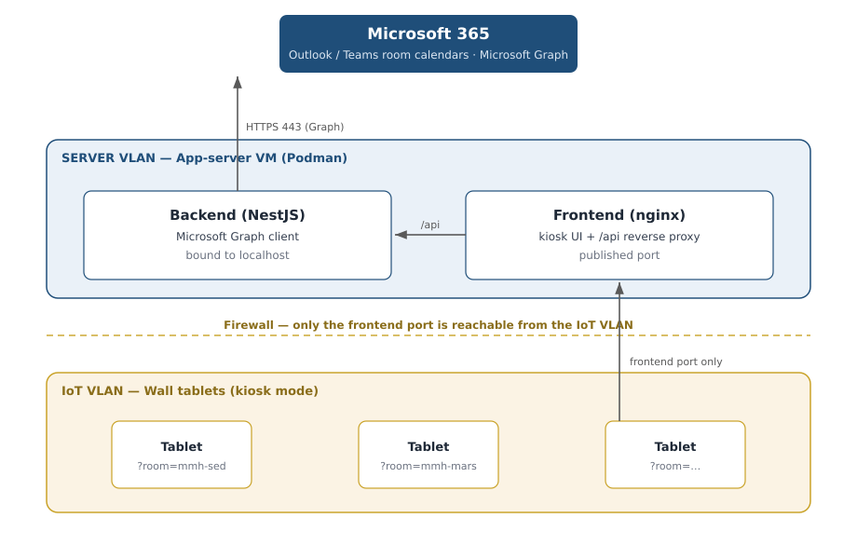
Figure 1 — System architecture: server-zone containers, IoT-VLAN tablets, and Microsoft 365.

Components
- Server zone (corporate VLAN) — the existing internal app-server VM runs two containers: a backend (NestJS) that talks to Microsoft Graph, and a frontend (nginx) that serves the kiosk UI and proxies API calls. The backend is bound to localhost; only the frontend port is published.
- Microsoft 365 — the backend reads/writes each room’s Outlook resource-mailbox calendar via Microsoft Graph, using an Azure AD app registration (application permissions).
- IoT VLAN (client zone) — wall tablets (Android or iPad) run in kiosk mode and open a single room-specific URL. Tablets talk only to the frontend; they need no internet access.

Operation & data flow
- A tablet loads its room’s panel from the frontend; the frontend proxies status/booking calls to the backend.
- The backend queries and updates the room mailbox calendar in Microsoft 365; bookings made on the panel appear in Outlook, and meetings booked in Outlook/Teams appear on the panel within ~15 seconds.
- Firewall rules restrict access: only the frontend port is reachable from the IoT VLAN to the server VLAN; only the server reaches Microsoft Graph outbound (HTTPS 443).

5. Security & Compliance (NIS2 / ISO 27001)
The architecture implements technical controls that support NIS2 and ISO 27001 alignment:
- Network Segregation (A.13): kiosk tablets are isolated on the IoT VLAN; only the frontend port is exposed to them.
- Least-privilege access: the Azure AD app uses certificate-based authentication (no shared secret; Managed Identity on Azure later) and is scoped by an Exchange Application Access Policy to only the meeting-room mailboxes — it cannot access any personal mailbox.
- No personal data: only meeting-room resource calendars are accessed; a "private meeting" option masks subject/organiser on the display.
- Access control: admin functions are protected (shared admin key now, Azure AD SSO planned); booking/panel actions are rate-limited.

6. Cost and Resources
The pilot is deliberately low-cost: the software is open-source and runs on the existing app-server VM, and Microsoft 365 / Graph is already licensed. In practice, only the tablets and wall mounts need to be purchased.
Item | What is needed | Cost / effort
Software / licensing | Open-source stack (NestJS, React, nginx, Podman); Microsoft 365 / Graph already licensed | EUR 0 — no new licences
Server / hosting | Runs in Podman on the existing internal app-server VM; no new server for the PoC | EUR 0 (existing infra)
Tablets (hardware) | One wall tablet + mount per room (Android or iPad); ~6 rooms for the pilot | One-off hardware only
Azure App Registration | Single-tenant, Calendars.ReadWrite (Application), scoped to the room mailboxes | IT effort (Global Admin consent)
Network (IoT VLAN) | Firewall rule: IoT-VLAN tablets -> app-server frontend port; server -> Microsoft Graph | Network team effort
Development effort: the software has been developed as a proof of concept and is functionally complete (unit/integration tested). This request covers the production rollout — live Microsoft Graph integration, deployment on the app-server VM, and tablet provisioning.
Support needed from other teams: we will need the network team (Thomas’s team) to configure the IoT-VLAN firewall rules, and Global IT to create the Azure AD app registration and grant admin consent.

7. Future Roadmap
- Production rollout: live Graph integration (MSAL certificate credentials), deployment on the app-server VM, tablet provisioning via Intune.
- Azure: optional migration to Azure Container Apps with Managed Identity (no stored credentials at all).
- Admin SSO (Azure AD), utilisation analytics, and gradual roll-out to additional rooms via the admin interface.

