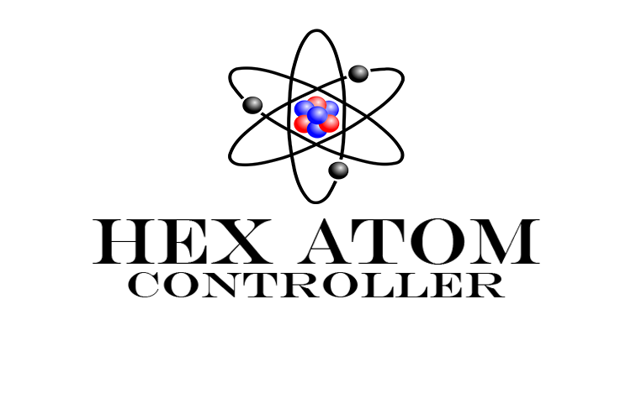

**Hex Atom Controller Manual**

The Hex Atom Controller is an app for the Nexus 7 which is primarily a graphical interface designed to send commands to the Hex Atom Game. This app

was created to increase the ease with which someone can control the Hex Atom

Game. With the Hex Atom Controller there is no need to enter commands and

all of the functions of the Hex Atom Game are able to be adjusted with greater

speed, and with less of a need to be concentrating on the commands. This app is

designed such that the users attention can remain on the Hex Atom Game and the

controller is intuitive enough to not require much attention.

**Requirements:**

In order to run the Android Application, you must first follow the directions in the ReadMe.txt file in order to properly install the HexAtom Android App onto your Android device. Since the current version does not properly adapt to fill smaller screens, it is recommended that you install the application only onto a Nexus 7 tablet or another Android powered device with an equal or higher resolution (1280 X 800). Additional requirements in order to properly run the Application are as follows:

• A HexAtom game/server process must be running on another device (see the HexAtom manual for how to do this)

• The Android device running the HexAtom app must be on the same LAN as the HexAtom server process to receive responses from the server. Otherwise, the HexAtom app will only be able to send data to the HexAtom server process but not receive replies from the server.

When the above requirements are met, you may start the HexAtom Android App on your tablet.

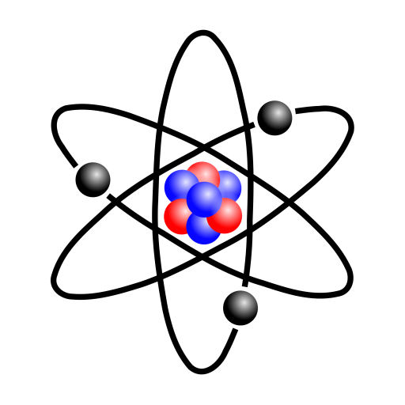**Connecting to the Server:**

To begin the Hex Atom Controller, first find the icon (figure 1) located on the Nexus 7 device.

Figure 1

Upon entering into the Hex Atom Program the user will be greeted with the “Connect to Server” page (figure 2).

* A. The user must enter the IP Address of the server
* B. The user must enter the port being used for the server

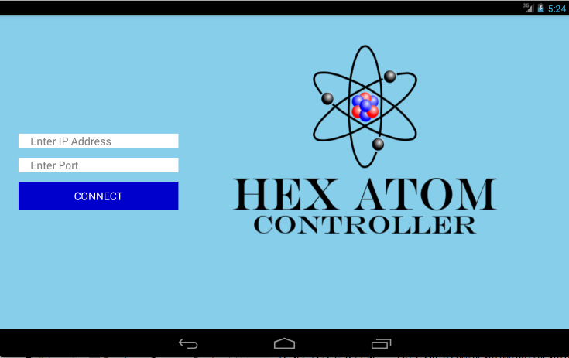

**A**

**B**

Figure 2

**Using the Hex Atom Controller:**

After connecting to the server the user will have two screens available to them. The first screen they will see is the “Atom Generation Page”. This is where the user is able to control both global variables as well as variables that are set for an atom upon generation. The other screen available to the user once they have entered the app is the “Probability Page”. This page is where the user can set the different probabilities associated with each of the twelve different types of atoms that can be generated.

**Atom Generation Page:**

**D**

**B**

**C**

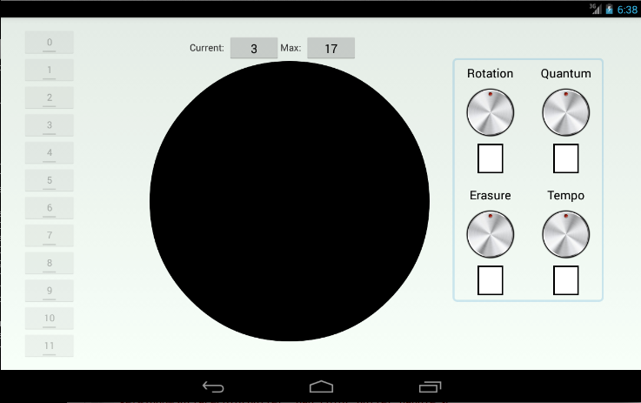

**A**

**E**

Figure 3

The “Atom Generation Page” is where the user is able to control atom generation as well as global variables.

* A. Buttons, which can be toggled on and off, used to determine which atom types will be generated. Any number of these atoms can be selected at one time.
* B. The center circle is used for both atom generation and changing the diameter. To generate an atom the user will place their finger on the circle and swipe in any direction. This will generate an atom for each atom selected from A. The direction that the user swipes will determine the direction of the atom upon generation, the option being: North, South, Northwest, Southwest, Northeast, and Southeast. The diameter is the other function that can be determined on the circle; this is further explained in part D.
* C. The two dials on the top are used in Atom generation. Once set the rotation and quantum will both use their values whenever an Atom is generated. The rotation is in reference to the rotation of newly generated Atoms, and is set between 0° and 360°. The quantum is a value that contributes to the type of shapes that are generated for the atoms. The quantum can be set anywhere between 0 and 7, zero being the basic hexagon that will appear. Double clicking either of these resets the value to 0.
* D. The diameter is displayed in two ways, there is a current diameter which displays the diameter currently displayed in the HexAtom game, and secondly the max diameter which is set by the user. The max diameter is determined as the user pinches or expands on the circle. Any change the user makes will update in the game however when expanding the current diameter will only increase as the Atoms reach the outer limits of the dome.
* E. The bottom two dials are used to apply global variables that affect all Atoms. These two values are the Erase rate and the Tempo. Erase is the rate at which Atoms will be deleted, this appears as a percentage. Tempo is the speed at which the atoms will move along the dome and is set 0-120. To change these values, simply click on the rotary knob. The light will change to green. Then move the dial to the location you wish to set and press again (the light will go off).

**Probability Page:**

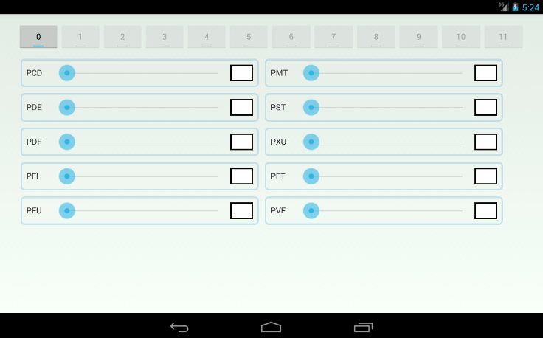

Figure 4

The probability page gives the user control over a number of probabilities that affect each Atom. These probabilities are set for each of the twelve types of Atoms and affect all Atoms of that type once set. The probabilities that can be set are:

* PCD: probability for changing direction
* PMT: probability of making track
* PDE: probability of disappearing at edge
* PST: probability of stopping
* PDF: probability of deflection on collision
* PXU: probability of extending universe
* PFI : probability of fission
* PFT: probability of following track
* PFU: probability of fusion
* PVF: probability of vacuum flux