TLBO for MMKP
Ken Zyma
Procedure:

Initial Population
Initial population was generated randomly, without allowing duplicate results, and only accepting feasible solutions.

Feasibility

Step 1: In the 'raw' solution, convert any bits with a value of -2 or -1 to 0 and convert and bits with a value of 2 to 1.

Step 2: Make sure there is exactly one variable with a value of one in each class (all others should be zero).

By class, if exactly one variable has a value of one, go to the next class.

If all variables are zero, then set the variable with the highest profit to one (in that class).

Else, if more than one variable (in the class) is one, set all variables to zero except the one with the highest profit value. Go to the next class.

Step 3: Obtain feasibility for violated constraints. The maximum difference of 'surrogate values' (%E_r/n), calculated using only violated constraints, are used to quickly obtain feasibility.

Overview of Results- fig. 1

As we can see above (fig.1), TLBO is a competitive method at solving MMKP for the benchmark problems above. Moreover, these problems represent a diverse collection of MMKP with a range of number of class's, class size, number of constraints, and Pearsons r-value between profit/constraint values.
The 13 test problems from Khan et al. (2002) are named “ORLIB” above and contain 13 files named I01 to I13. These are legacy problems which are widely used in the literature, and so, are used to compare TLBO in this work to other heuristic solutions. However, these have been shown by Hiremath and Hill (2013) to not represent the diversity needed to prove robust performance and we agree. Number of classes does vary from small (5 class) to large (400 class) instances, but the number of items and constraints is constant (10) for problems I03-I13. Additionally, as shown in fig. 2, the larger data problems, I07 to I13 represent the same problem structure.

Fig 2: OrLib r-value
The test instances from Hiremath and Hill (2013) include 9 files, 30 problems each, and 11 files containing 10 problems each for a total of 380 problems. For the small problems, MMKP01 to MMKP09, each file uses a different number of classes and number of knapsack constraints, which varies as either 5,10, or 25. The number of items in each class is constant at 10. Problem coefficient's range from weak to strongly correlated (difficult) for each problem as demonstrated below, by figure 3. Figure 3 shows the correlation coefficient for each constraint for all 10 problems in file MMKP15.

Fig. 3
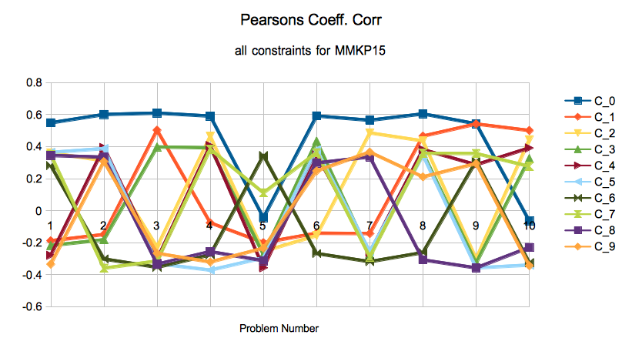

Additionally, we do see a correlation with strong Pearson correlation (r) value and poorer heuristic results as we would expect in these benchmark instances. For Example, fig. 4 demonstrate's TLBO percent deviation from optimal and how this relates with r-value.

Looking again at the legacy problems, I01-I13, we see a similar trend.

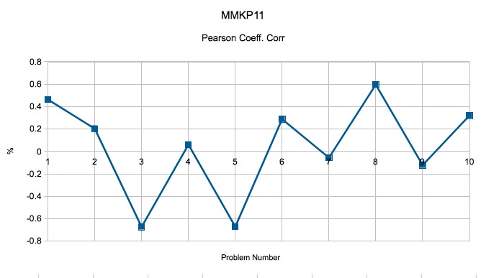
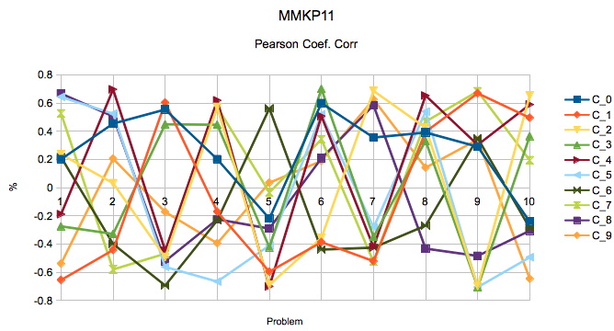
The previous page shows one problem set where TLBO performed rather poor, at 5.64% deviation...

