
12th Floor Trium Square Building Sen. Gil Puyat Ave. Corner Leveriza, Pasay City 1300

CERTIFICATE NUMBER: APAT-«CERTIFICATE_NUMBER»

Certificate of Completion

This certificate is issued to

«FIRST_NAME» «MIDDLE_NAME» «SURNAME»

for having successfully completed the training requirements in

ANTI-PIRACY AWARENESS TRAINING

Conducted on «RELEASE_DAY» «MONTH» «YEAR» at 88 Aces Maritime Services Inc.

and

as per module approved by the Philippine Overseas Employment Administration, pursuant to POEA Governing Board Resolution No.4 and Memorandum Circular No.14, both series of 2009.

Given this «RELEASE_DAY»^{TH} day of «MONTH» «YEAR», at Manila City, Philippines.
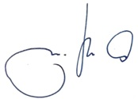
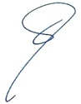

JAY B. ALFARO CAPT. CRISANDO S. BLAS
Accredited Trainor President

