vendor code 1033 oracle

ORACLE initialization or shutdown in progress

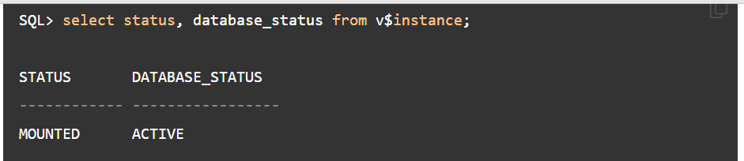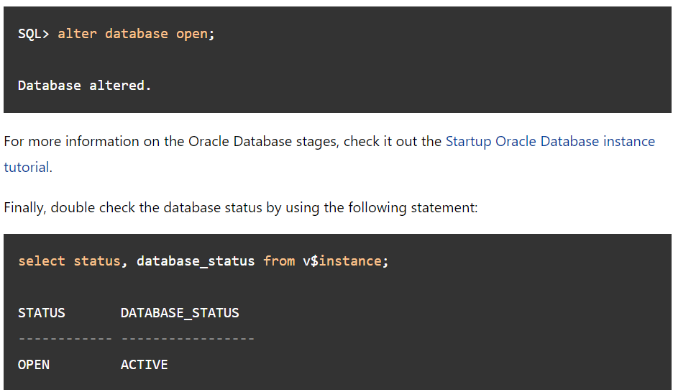

ora-28014 cannot drop administrative users

alter session set "_oracle_script"=true;

drop user APEX_050000 cascade;