1. Read resistance. (Ohmmeter)

Able to read 47, 100, 220, 5k, 10k ohm resistors.

1. Read voltage. (Multimeter)

Able to read greater than 5 V and less than 100 mV.

1. Read current (Ammeter)
2. Generate + and - 5 V
3. Switch from DC to AC signal (Waveform Generator)
4. Move cursors on an oscilloscope to measure the time shift and calculate the phase shift (350 * f * Δt). Need to measure time and frequency and display it on the app. Movable cursors on the app.
5. Measure amplitude of voltage in AC.
6. Generate square wave with f = 20 Hz, duty cycle 50%, offset 1 V and amplitude 1 V.

Generate square wave f = 30 Hz, phase shift = 0, offset 0V, amplitude = 0.5 V.

Generate triangle wave f = 30 Hz, phase shift = 0, offset 0V, amplitude = 0.5 V.

Generate AC sine wave with f = 1 Hz, phase shift = 0, offset 0 V, amplitude = 2 V.

Generate AC sine wave with f = 30 Hz, phase shift = 0, offset 0V, amplitude = 0.5 V.

(Maybe need documentation on how to use wavegen tool)

1. Using the scope tool from AD2, present the input and output waveforms using the scope tool (Oscilloscope). Refer to Appendix C.4.3 for further details on how to use the scope tool.
2. Read 10 uF cap and 100 uF cap. (Maybe)
3. Need to measure τ (tau). Time after the signal goes from flat to the voltage where it is at a certain percent from the max. (Maybe just a cursor)

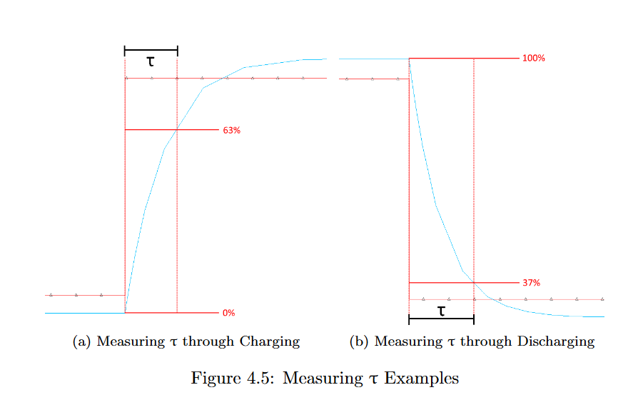

1. Export plots? (Or they can take a screenshot on the phone. Appendix C.7.2 on how to appropriately save the screenshot for submission).
2. Measure RMS voltage. (Use AC RMS measurement option of the logger tool)
3. Change the color of lines in the graph. (In lab manual)
4. Pictures: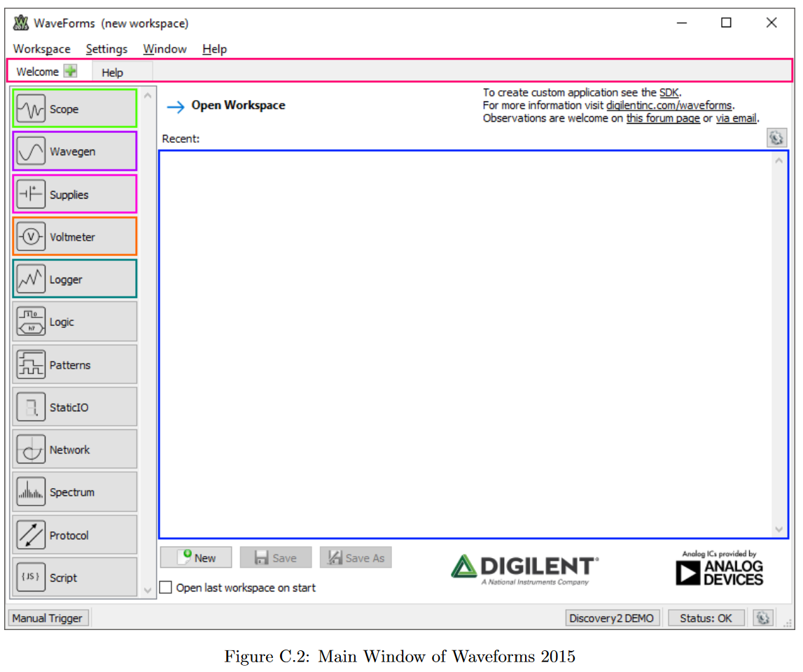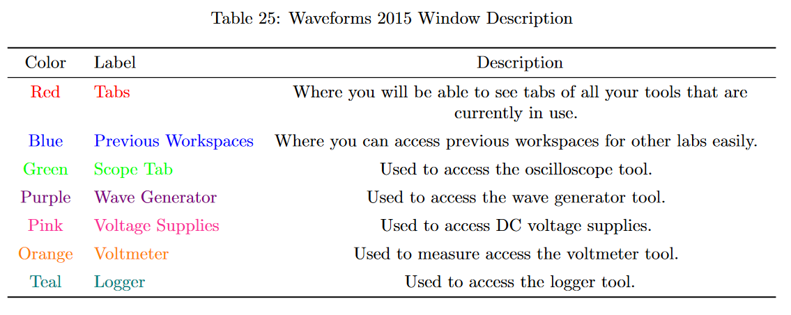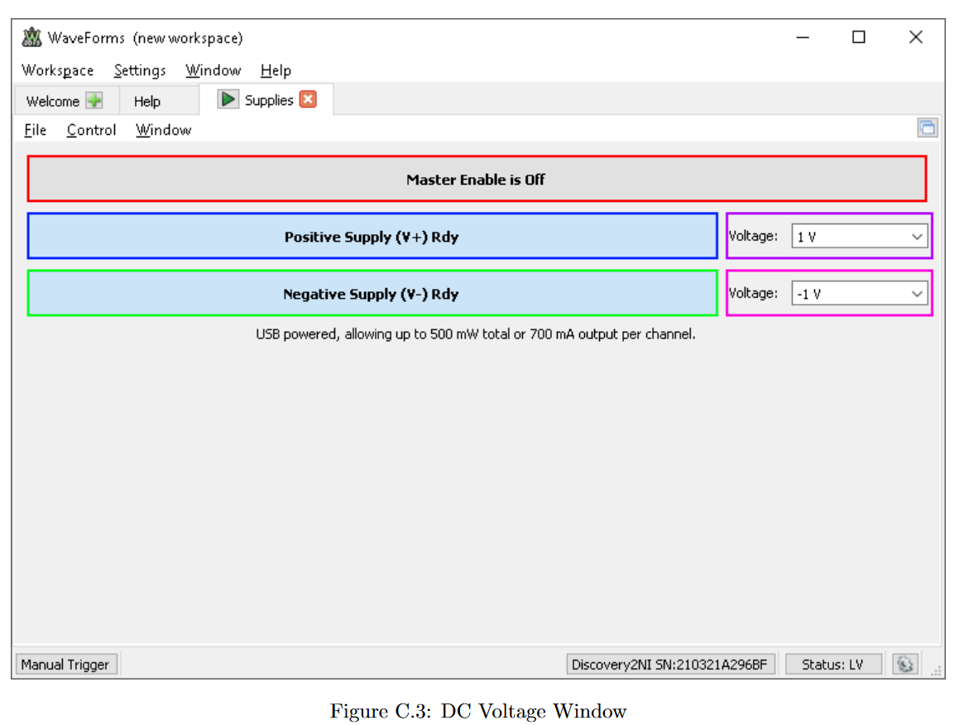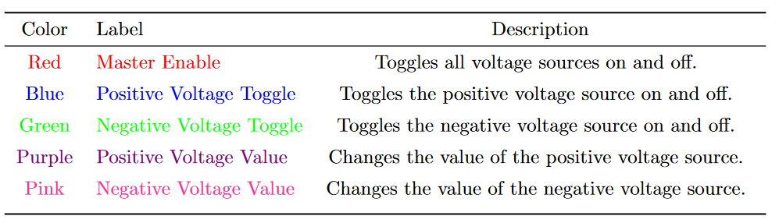

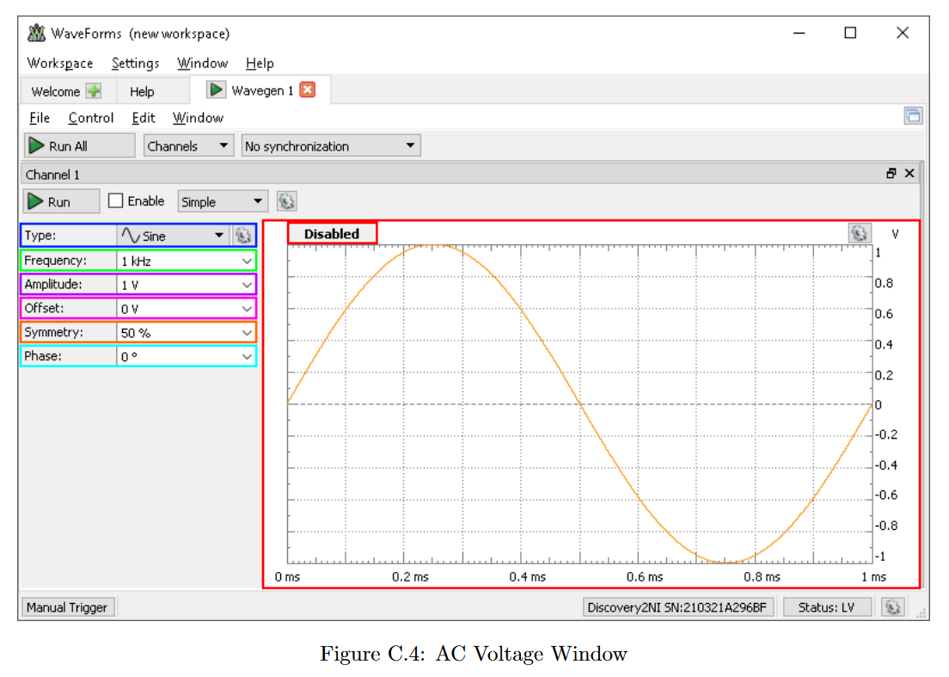

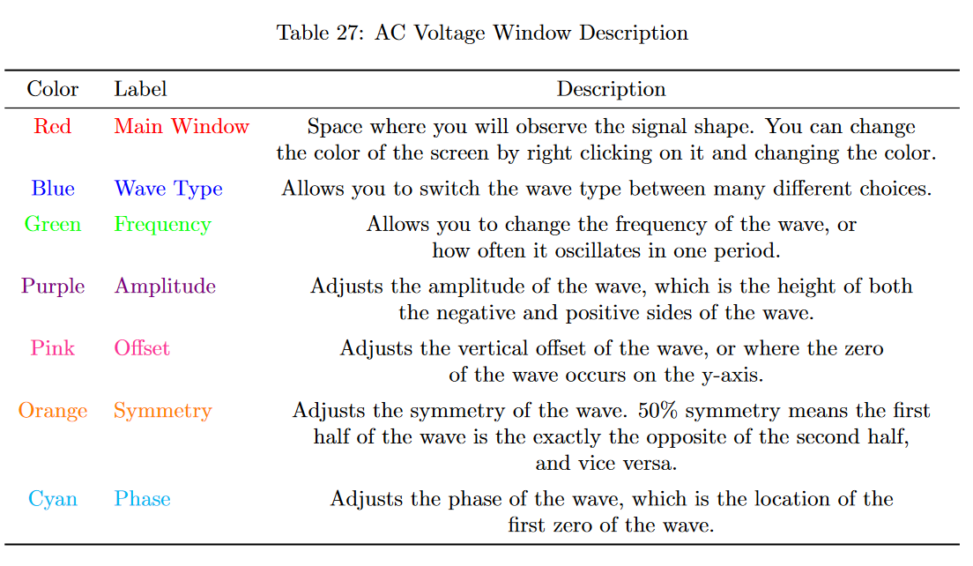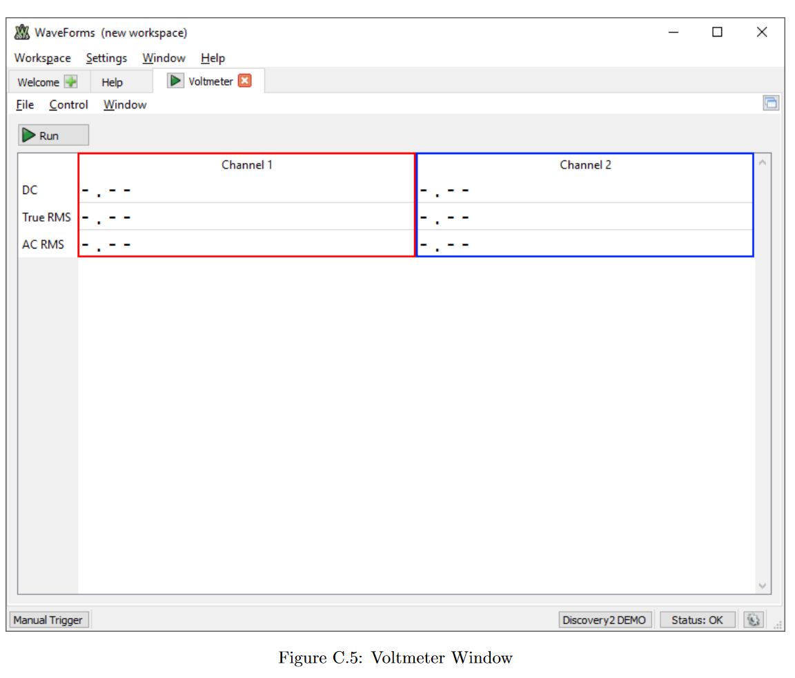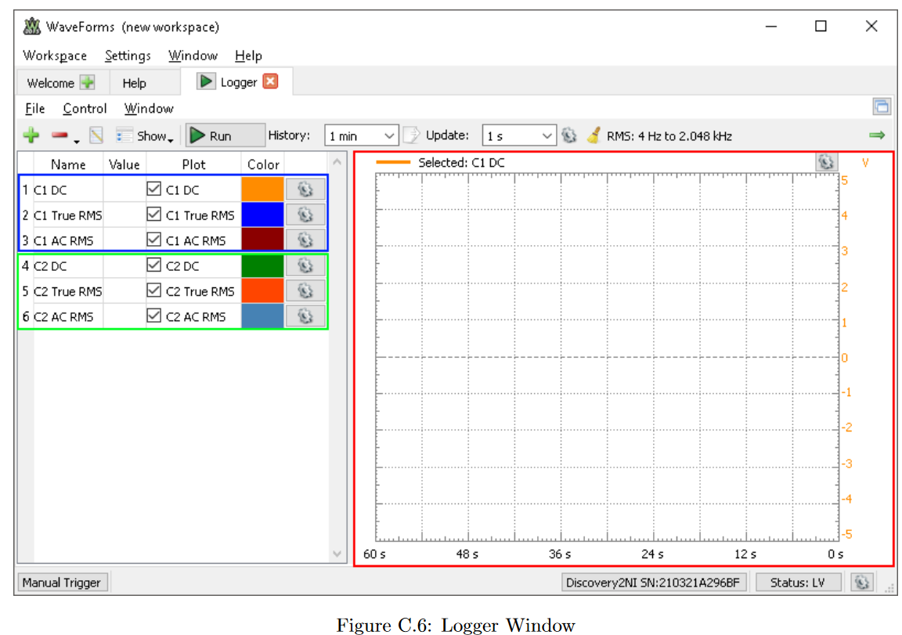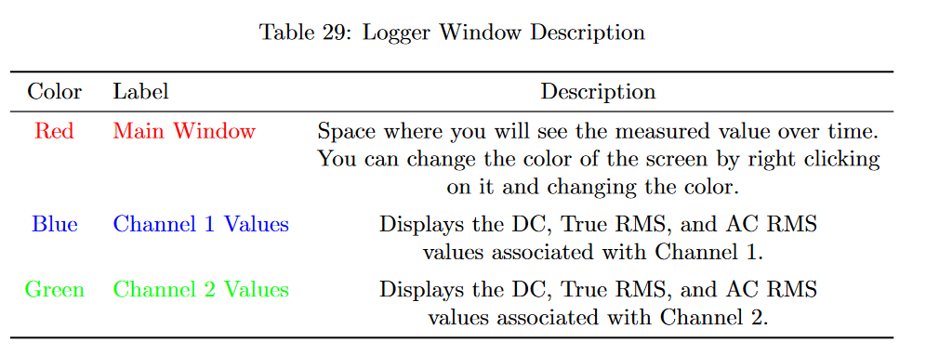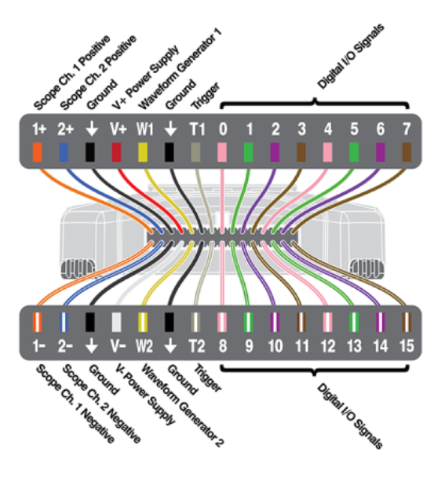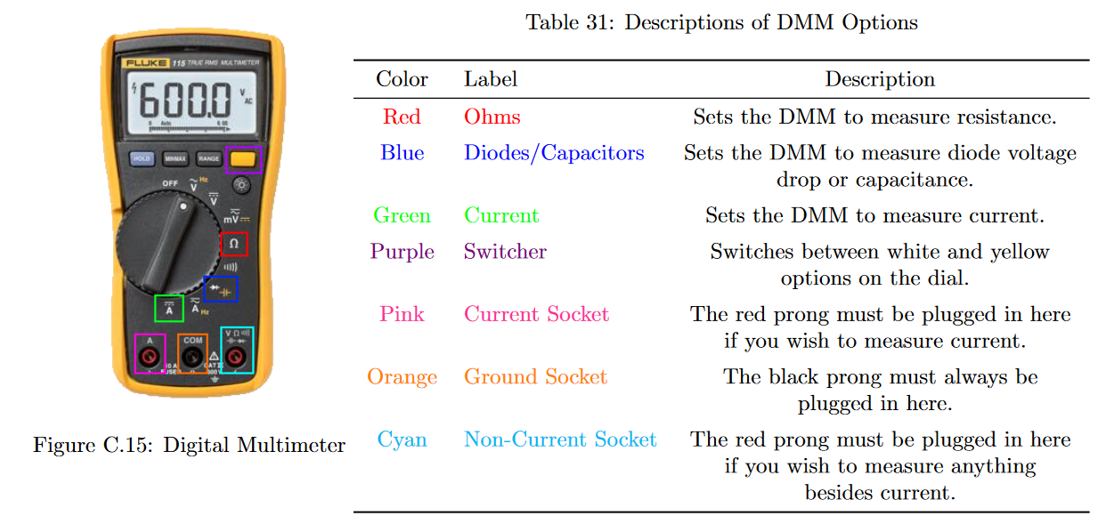

1. Both the AC and DC power supply are able to be on in the background.
2. Logger is multimeter but graphs values over time.

**Oscilloscope**-

Waveform Generator (Shapes: Square, Triangle, Frequencies: 1, 20, 30Hz, Offsets: 0, 1, Amplitudes: 0.5, 1, 2 V) (Probably a chip. How you wire ADC matters.)

ADC - using ten comparators as bits for the digital side (maybe split with firmware?) (Voltmeter should be done if used correctly)

**Firmware**-

Clock

Micro-Controller (Esp 32?)

-Communicate with ADC and waveform generator to create graph

**Power**-

Rectifier- 4 diodes and capacitor to convert from wall outlet, then buck-converter to step to 12

Safety Shut-off (?)

Bluetooth power

Voltmeter (?)

Ammeter

Ohmmeter

**Software**-

App (web app?)

Cursors (Phase Shift)

Visualization of everything (graphs and all that)

Bluetooth integration

**TBD**-

RMS Values

Sigma delta adc will need to sample 30-60x faster

Sampling rate is key

Microcontroller will communicate with the ADC chip and waveform generator, and will communicate with the waveform generator to create a waveform.

Might be easier to use the app and a DAC to change voltage and frequency values than a dial

Questions:

Digital Signal Processing

How to modify waveform frequency by degree

Using chip for waveform generator and ADC? Oscillator

Digitally controlled pacs

Function generator chips

100 hz

Flutter flow

Use a wall port +12 volts

Microcontroller

Esp32

New Roles

**Waveform generator and microcontroller**

**Oscilloscope and adc/dac microcontroller**

**App**

**PCB layout design**

Need to buy:

Waveform gen chip

Wall wart (AC to DC adapter)

ADC

DAC

Esp32

Case for pcb?