Aims and hypotheses

Aim 1: To evaluate the 12-month follow-up effects for TranS-C compared to PE.

* Hypothesis: We hypothesized that TranS-C, relative to PE, will have improved sleep and circadian functioning and decreased risk across five health domains (emotional, cognitive, behavioral, social, and physical) from 6-month to 12-month follow-up and at 12-month follow-up.

Aim 2: To examine the effect of the text messaging intervention on sleep and circadian functioning.

* Hypothesis: We hypothesized that participants in TranS-C (and PE too?) that received PUSH or PULL text messages will have improved sleep and circadian functioning from 6-month to 12-month follow-up and at 12-month follow-up compared to participants that received no text messages.

Aim 3: To examine the effect of the text messaging intervention for participants that improved, deteriorated, or experienced no change from pre-treatment to post-treatment or post-treatment to 6-month follow-up

* Hypothesis: We hypothesized that among participants that deteriorated or experienced no change during treatment, participants in TranS-C (and PE too?) that received PUSH or PULL text messages will have improved sleep and circadian functioning compared to participants that received no text messages.

Questions for lab meeting:

1. The clinical trials protocol for the text messaging study does not include the five health domains. The rationale was that the text messaging intervention is hypothesized to improve memory for treatment. Given that TranS-C, and hence the text messages, focused primarily on sleep, our thinking was that we would most likely see improvement for the sleep and circadian outcomes. Although improvement in sleep is hypothesized to lead to improvement in the health domains, we thought that the health domains may be too distal of outcomes to result in improvement. (Also, as a side note, we received feedback from the clinicaltrials.gov reviewers that there were too many outcomes listed, so this may have also motivated this decision). Given that this paper also reports that 12-month follow-up treatment effects, should we:
   1. Amend the text messaging clinical trials registration to include the health domain outcomes.
   2. Examine health domain outcomes for TranS-C vs. PE, but not for the text messaging conditions.
   3. Report text messaging effects in separate paper and focus only on sleep and circadian outcomes. In this case we could also do test if improvement in sleep or circadian outcomes is mediated by change in free recall (perhaps aim 3). We could also report results from the text messaging evaluation questionnaire (perhaps aim 1).
2. Should the improved/deteriorated/no change analyses be done for treatment effects (TranS-C vs. PE) also, or only the text messaging effects (i.e., aim 3)?

Aim 1: To evaluate the 12-month follow-up effects for TranS-C compared to PE.

YSAS-family. Treatment x time: F= 3.047, p = .049

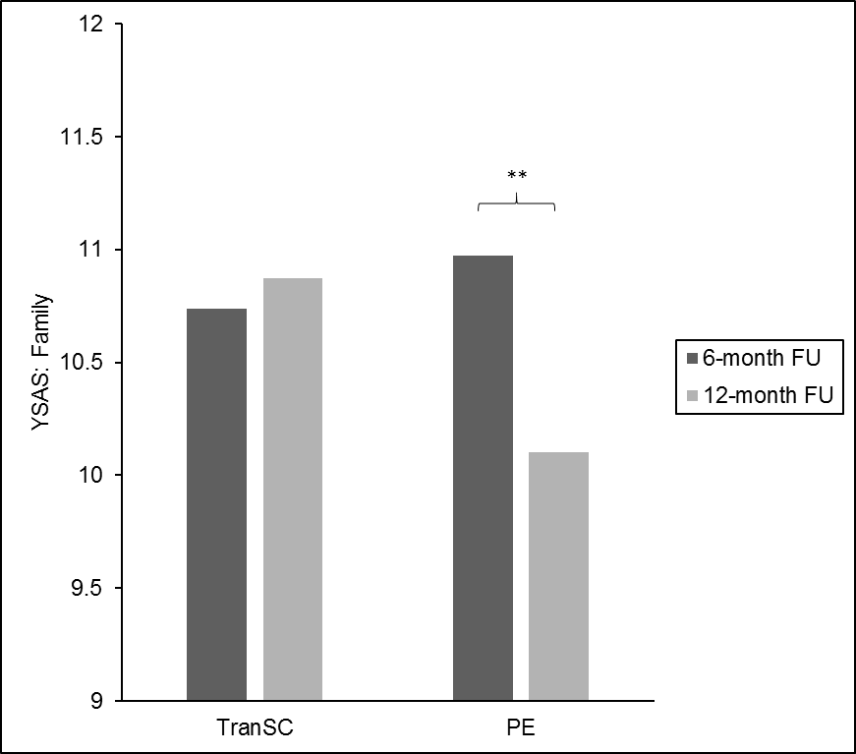

Aim 2: To examine the effect of the text messaging intervention on sleep and circadian functioning.

Weeknight bedtime. Treatment x time x text: F= 3.331, p = .040

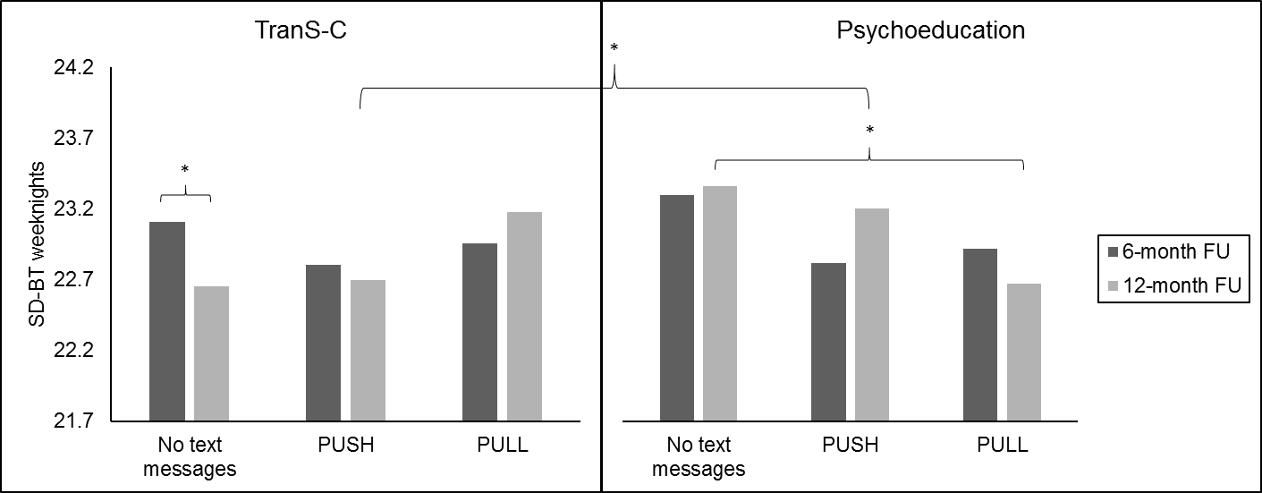

Somatic complaints (CBCL). Treatment x time x text: F=2.658, p = .049

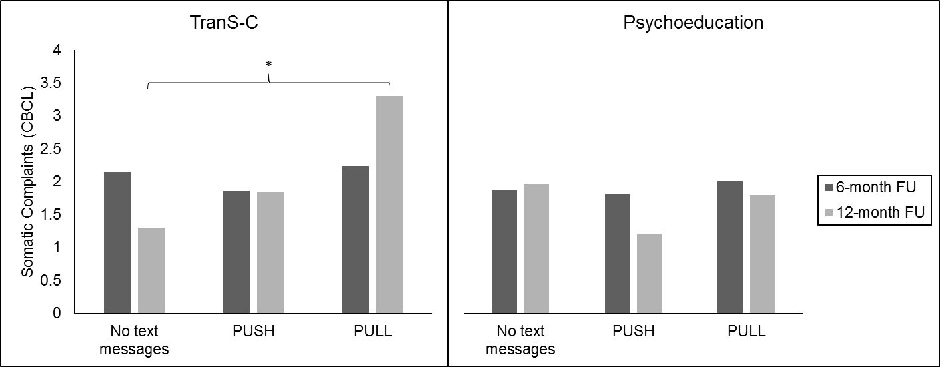

Aim 3: To examine the effect of the text messaging intervention for participants that improved, deteriorated, or experienced no change from pre-treatment to post-treatment or post-treatment to 6-month follow-up

TST weeknight-weekend discrepancy (RCI group: no change). Treatment x time x text: F=4.400, p = .032

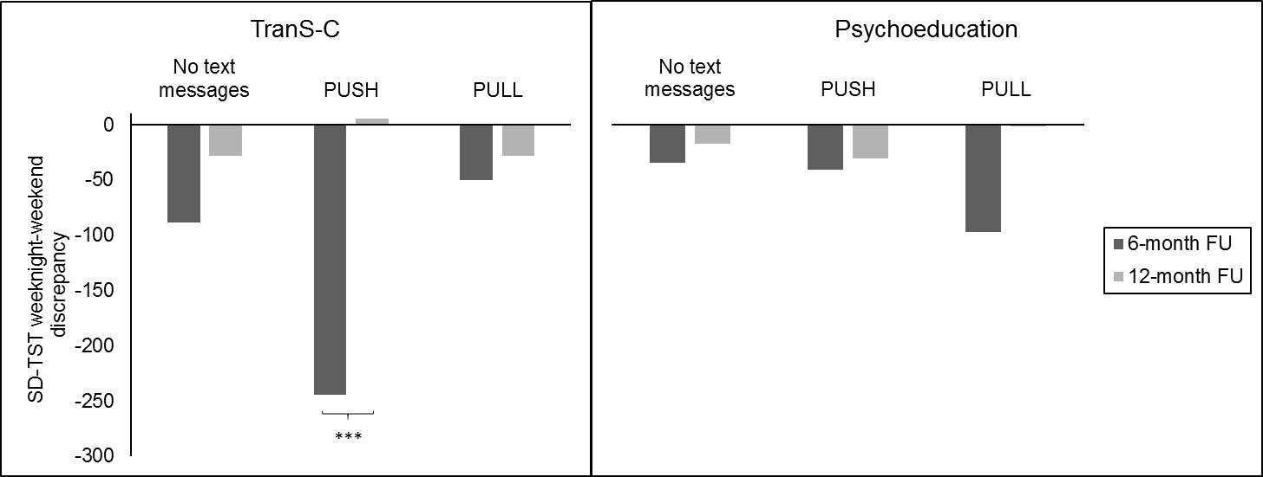

CMEP (RCI group: no change). Treatment x time x text: F=6.955, p = .012

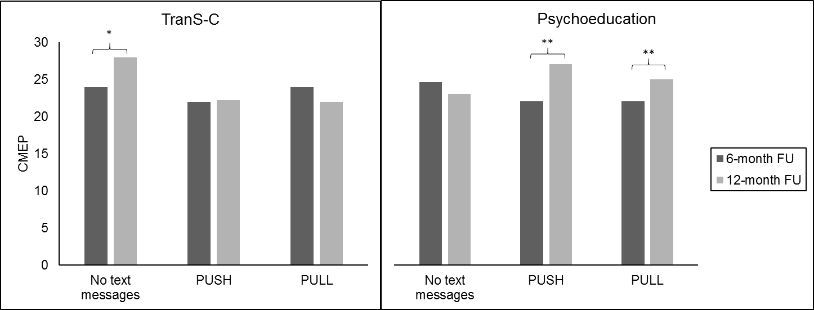

Weeknight TST (RCI group: deteriorated). Treatment x time x text: F=3.401, p = .045

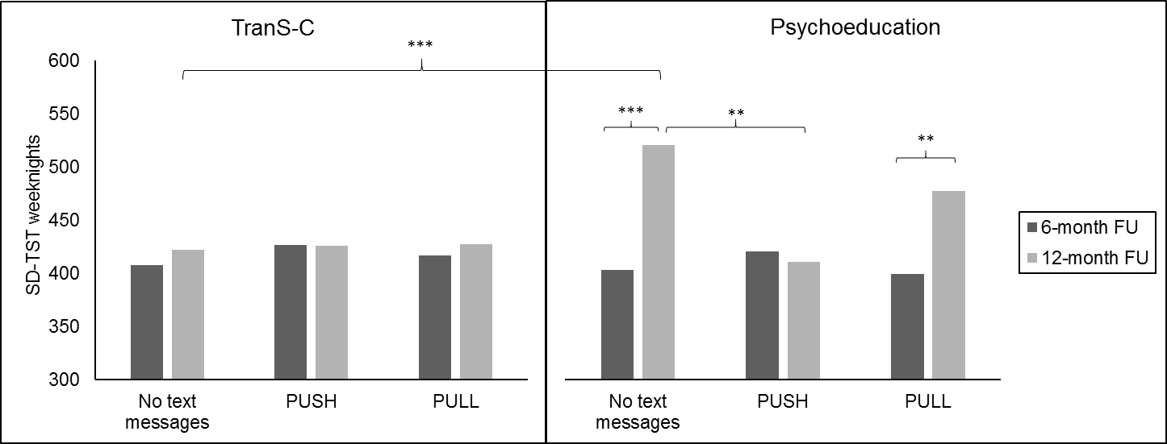

Emotional domain composite. Treatment x time x text: F=5.386, p = .017

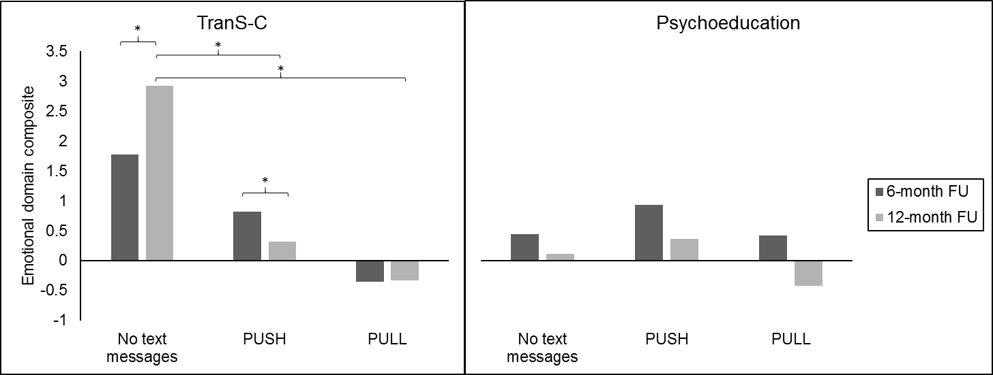

Behavioral domain composite (CBCL). Treatment x time x text: F=5.726, p = .009

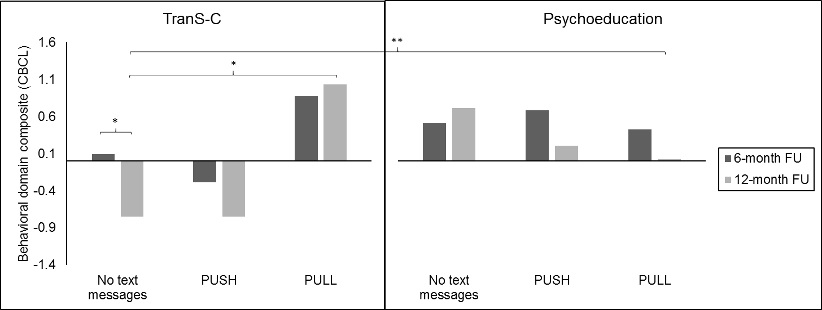

Means and standard deviations for primary and secondary sleep, circadian, and health outcomes in TranS-C and PE at 6- and 12-month follow-up.

|  |  |  |  |  |  |  |  |  |  |  |
| --- | --- | --- | --- | --- | --- | --- | --- | --- | --- | --- |
|  | TranS-C | | | |  | PE | | | | Treatment by time interaction |
|  | 6-month follow-up | | 12-month follow-up | |  | 6-month follow-up | | 12-month follow-up | |
| Outcome | *Mean* | *SD* | *Mean* | *SD* |  | *Mean* | *SD* | *Mean* | *SD* | *p* |
| Sleep and Circadian Outcomes |  |  |  |  |  |  |  |  |  |  |
| SD-TST weeknights* | 430.57 | 60.63 | 438.00 | 63.00 |  | 436.63 | 58.15 | 456.99 | 71.34 | 0.31 |
| SD-BT weeknights* | 22.94 | 0.94 | 22.83 | 1.02 |  | 22.98 | 1.16 | 23.01 | 1.17 | 0.21 |
| SD-TST weeknight-weekend discrepancy | -70.98 | 133.91 | -50.05 | 75.44 |  | -75.12 | 70.78 | -45.11 | 94.46 | 0.81 |
| SD-BT weeknight-weekend discrepancy | -0.55 | 1.89 | -0.79 | 1.36 |  | -0.39 | 0.98 | -0.57 | 0.98 | 0.58 |
| SD-WUP weeknight-weekend discrepancy | -1.78 | 1.38 | -1.72 | 1.41 |  | -1.55 | 1.19 | -1.31 | 1.48 | 0.20 |
| Sleepiness | 4.80 | 4.84 | 4.70 | 4.73 |  | 3.56 | 4.02 | 3.32 | 3.79 | 0.46 |
| PSQI | 6.00 | 3.97 | 5.46 | 3.49 |  | 4.88 | 3.03 | 4.68 | 2.75 | 0.39 |
| CBCL Sleep Composite | 2.11 | 1.95 | 2.03 | 2.14 |  | 2.10 | 2.14 | 2.01 | 2.03 | 0.88 |
| CMEP* | 23.93 | 4.32 | 23.84 | 4.46 |  | 25.33 | 4.77 | 25.49 | 5.32 | 0.97 |
|  |  |  |  |  |  |  |  |  |  |  |
| Youth Self-Report Composite Risk Score* |  |  |  |  |  |  |  |  |  |  |
| *Emotional health:* |  |  |  |  |  |  |  |  |  |  |
| CDRS | 26.63 | 10.08 | 25.99 | 10.14 |  | 25.87 | 7.68 | 25.45 | 8.91 | 0.39 |
| MASC | 40.63 | 18.18 | 41.79 | 16.09 |  | 42.28 | 20.28 | 39.76 | 20.57 | 0.73 |
| Composite | -0.02 | 0.99 | 0.06 | 0.95 |  | 0.02 | 1.02 | -0.05 | 1.05 | 0.78 |
| *Cognitive health:* |  |  |  |  |  |  |  |  |  |  |
| ACS | 52.70 | 10.10 | 50.37 | 8.65 |  | 51.25 | 8.67 | 50.58 | 8.24 | 0.79 |
| YSAS (school/cognitive items) | 10.68 | 3.72 | 10.69 | 3.49 |  | 10.21 | 3.65 | 10.49 | 3.25 | 0.60 |
| Composite | 0.11 | 0.98 | 0.02 | 1.01 |  | -0.11 | 1.02 | -0.02 | 1.00 | 0.70 |
| *Behavioral health:* |  |  |  |  |  |  |  |  |  |  |
| Sensation Seeking Scale | 25.96 | 6.65 | 25.74 | 7.13 |  | 26.50 | 6.45 | 26.44 | 6.87 | 0.79 |
| Alcohol and Substance Use | 5.46 | 7.68 | 6.00 | 7.71 |  | 5.60 | 7.93 | 5.38 | 6.79 | 0.07 |
| Composite | -0.03 | 1.04 | 0.00 | 1.07 |  | 0.03 | 0.97 | 0.00 | 0.93 | 0.19 |
| *Social health:* |  |  |  |  |  |  |  |  |  |  |
| YSAS: Friends | 17.12 | 4.94 | 17.69 | 5.24 |  | 17.22 | 4.21 | 16.31 | 3.64 | 0.12 |
| YSAS: Family | **10.74** | **3.70** | **10.87** | **3.67** |  | **10.97** | **3.29** | **10.10** | **3.05** | **0.05** |
| YSAS: Romantic | 6.80 | 2.36 | 7.11 | 2.26 |  | 6.79 | 2.41 | 7.21 | 2.23 | 0.69 |
| Composite | -0.02 | 1.09 | 0.14 | 1.12 |  | 0.02 | 0.92 | -0.15 | 0.84 | 0.07 |
| *Physical health:* |  |  |  |  |  |  |  |  |  |  |
| MAQ | 3.58 | 3.97 | 4.30 | 5.20 |  | 5.31 | 8.78 | 4.08 | 4.90 | 0.15 |
| PHQ | 6.00 | 5.09 | 6.50 | 4.76 |  | 6.42 | 4.88 | 5.63 | 4.02 | 0.35 |
| Composite | -0.14 | 0.78 | 0.05 | 1.02 |  | 0.14 | 1.17 | -0.05 | 0.98 | 0.08 |
|  |  |  |  |  |  |  |  |  |  |  |
| Parent-Reported Composite Risk Score |  |  |  |  |  |  |  |  |  |  |
| *Emotional Health* |  |  |  |  |  |  |  |  |  |  |
| Anxious/Depressed | 3.36 | 2.88 | 3.39 | 3.59 |  | 2.79 | 3.22 | 2.15 | 2.44 | 0.24 |
| Withdrawn/Depressed | 3.09 | 2.68 | 2.99 | 3.04 |  | 2.57 | 2.88 | 2.10 | 2.52 | 0.19 |
| Composite | 0.10 | 0.95 | 0.19 | 1.12 |  | -0.11 | 1.05 | -0.20 | 0.82 | 0.35 |
| *Cognitive Health* |  |  |  |  |  |  |  |  |  |  |
| Thought problems | 2.92 | 2.63 | 2.59 | 2.86 |  | 2.57 | 2.78 | 2.40 | 2.48 | 0.87 |
| Attention problems | 4.07 | 4.26 | 3.72 | 4.12 |  | 4.03 | 3.86 | 3.51 | 3.71 | 0.64 |
| Composite | 0.03 | 1.02 | 0.03 | 1.07 |  | -0.03 | 0.99 | -0.03 | 0.93 | 0.90 |
| *Behavioral Health* |  |  |  |  |  |  |  |  |  |  |
| Rule-Breaking Behavior | 1.85 | 2.33 | 1.81 | 2.34 |  | 1.97 | 2.31 | 1.61 | 2.19 | 0.68 |
| Aggressive Behavior | 3.69 | 3.85 | 3.36 | 3.67 |  | 3.84 | 4.32 | 3.28 | 3.66 | 0.22 |
| Composite | -0.02 | 0.95 | 0.03 | 1.01 |  | 0.02 | 1.06 | -0.03 | 1.00 | 0.83 |
| *Social Health* |  |  |  |  |  |  |  |  |  |  |
| Social Problems | 1.44 | 1.91 | 1.26 | 1.88 |  | 1.25 | 1.72 | 0.97 | 1.44 | 0.87 |
| Composite | 0.05 | 1.05 | 0.09 | 1.12 |  | -0.05 | 0.95 | -0.09 | 0.86 | 0.92 |
| *Physical Health* |  |  |  |  |  |  |  |  |  |  |
| Somatic Complaints | 1.93 | 2.12 | 2.06 | 2.79 |  | 1.94 | 2.45 | 1.81 | 2.58 | 0.45 |
| Composite | 0.00 | 0.93 | 0.05 | 1.04 |  | 0.00 | 1.08 | -0.05 | 0.96 | 0.33 |