Analysis Question

The RHoMIS dataset I am looking at has a hierarchy as follows:

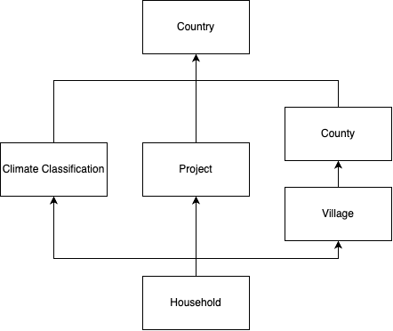

Hierarchy Illustration

Explained in words, this means:

1. Households are nested within projects. Each “project” is nested within a country.
2. Households are also nested within villages, nested within counties, nested within countries.

Importantly, I have chosen this structure because, two projects could cover the same areas. To climate classifications could cover the same villages

If I were to model all levels, I use the following structure:

model <- brm(  
 formula = bf(log_tva ~ 1 +  
 (1 | iso_country_code) + # Country  
 (1 | iso_country_code:gdlcode) + # Country  
 (1 | iso_country_code:gdlcode:village)+ # Village  
 (1 | kg_class_name)+ # climate classification  
 (1 | id_form)) # Project implementing survey  
 ...  
   
)

## Estimates for Group Effects (ie. sd(country), sd(iso_country_code:gdlcode) …)

## VPCs for Group Effects

## MCMC Scatters

## Question

I believe this shows that

Question, how can we seperate between project, location,