Department of Pharmacology and Cell-Biophysics, University of Cincinnati,

College of Medicine, Cincinnati OHIO, 45267, USA.

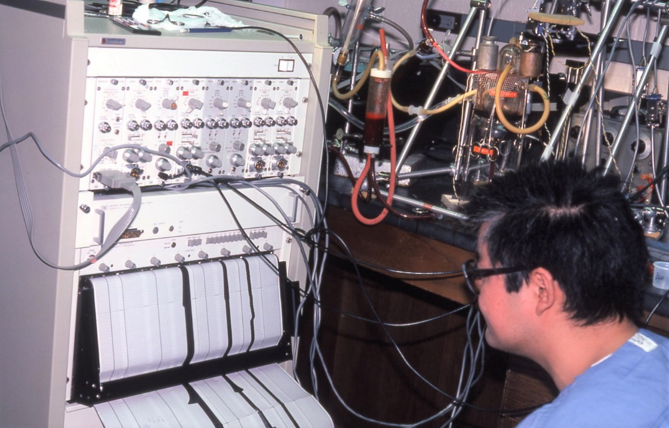Dr. Ronald W. Millard and author in the laboratory (1978).