Mini User Documentation for the sf!ds_text_dir_reader

This program is free software; you can redistribute it and/or modify
it under the terms of the GNU General Public License as published by
the Free Software Foundation; either version 1, or (at your option)
any later version.

This program is distributed in the hope that it will be useful,
but WITHOUT ANY WARRANTY; without even the implied warranty of
MERCHANTABILITY or FITNESS FOR A PARTICULAR PURPOSE. See the
GNU General Public License for more details.

You should have received a copy of the GNU General Public License
along with this code; if not, you can download it from the web:
http://www.gnu.org/licenses/gpl.txt

Author: Holger Schirnick <Holger_Schirnick@yahoo.com> - March 2005

Tools contained in this Module
This module contains two GUIs/Tools that will allow to view, edit, update, and delete data that is stored in the database and resides in two tables:
  - A “directory” table and
  - A “data table.
One tool – sf!ds_text_dir_reader – can read so-called ds text directory structures. Basically a core implementation of a directory structure in the database. Currently the core uses this only to store preference settings from applications.

The second tool – sf!ace_user_data_reader – can be used to retrieve texts used to store user data in the ACE. The core uses the sw_gis!user_data_info and sw_gis!user_data_info tables in the ACE to store text configuration of “unlimited” length.

Launching the sf!ds_text_dir_reader GUI & Parameters

Once the module sf!ds_text_dir_reader has been loaded, the GUI is started from the Magik prompt with this command:

MagikSF> mclib:sf!ds_text_dir_reader.open()
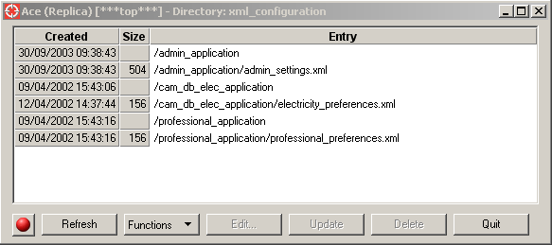

By default the ACE top alternative will be read and the ds text directory xml_configuration is inspected. It is possible to look at any (Smallworld) database and any ds text directory. It is also possible to specify the executable that shall be used to edit the data from an entry of a ds text directory.

The title of the frame will display this information:
- The external name of the database that is inspected
- The current alternative in that database (in square brackets)
- The name of the text directory that is displayed.

The signature of the new() method for the sf!ds_text_dir_reader() class has this signature:
sf!ds_text_dir_reader.new(
_optional a_db_view, a_text_dir_name, an_edit_command )

- A_DB_VIEW
A handle on the database view that is to be used;
defaults to gis_program_manager.ace_top_view.
- A_TEXT_DIR_NAME
A prefix/name for a ds_text_directory; the tables <A_TEXT_DIR_NAME>_dir and <A_TEXT_DIR_NAME>_text must reside in A_DB_VIEW;
defaults to :xml_configuration - which is specified in class constant default_text_dir_name.
The directory name postfixes (_dir and _name) are obtained from the class constant :text_dir_postfixes.
- AN_EDIT_COMMAND
A command that is executed to edit a (text/ASCII) file. By default the actual file path is appended at the end of this string;
defaults to "notepad" (see class constant default_edit_command).

Aside from the application preferences this reader can also be used to look at the cross-dataset join configuration table (or any custom database text directory structure for that matter). Assuming ref is a handle on the dataset that contains this information, you can view the data with this call:

MagikSF> sf!ds_text_dir_reader.open( ref, :super_dd )
Currently the GUI does not provide functionality to navigate the alternative structure of the active database. However, any changes occurring to the active database (either access mode or the current alternative) are noticed by the GUI and will be reflected appropriately.

The functionality of the GUI – which is identical to the other tool – is described in chapter 4 on page 6.

Launching the sf!ace_user_data_reader GUI & Parameters
The GUI for this module is launched from the Magik prompt with this command:

MagikSF> sf!ace_user_data_reader.open()

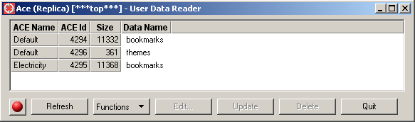

By default the ACE top alternative will be read and the sw_gis!user_data* tables are inspected. It is possible to look at any (Smallworld) database and any ds text directory. It is also possible to specify the executable that shall be used to edit the data from an entry of a ds text directory.

The title of the frame will display this information:
- The external name of the database that is inspected
- The current alternative in that database (in square brackets)
- The name of the text directory that is displayed.

The signature of the new() method for the sf!ace_user_data_reader() class has this signature:
sf!ace_user_data_reader.new( _optional
a_db_view, a_repository_name, an_edit_command )

- A_DB_VIEW:
A handle on an ACE database view;
defaults to gis_program_manager.ace_top_view.
- A_REPOSITORY_NAME:
A prefix-name for data repository tables. The tables <A_REPOSITORY_NAME>_info and <A_REPOSITORY_NAME>_text
must exist in A_DB_VIEW (see class constant repository_postfixes
where the table name postfixes are defined).
Defaults to :sw_gis!user_data.
- AN_EDIT_COMMAND:
A command that is executed to edit a (text) file. By default the actual file name/path is appended at the end of this string.
Defaults to "notepad" (see class constant default_edit_command).

Currently the GUI does not provide functionality to navigate the alternative structure of the active database. However, any changes occurring to the active database (either access mode or the current alternative) are noticed by the GUI and will be reflected appropriately.

The functionality of the GUI – which is identical to the other tool – is described in chapter 4 on page 6.

The GUI Elements – Functionality

This section contains a brief description of the widgets and available actions of the GUI.

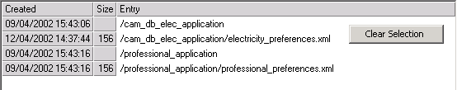

The displayed list is fairly self-explanatory. Size information is only available for node (file) entries in a ds text directory. The third column (Entry) always displays the complete directory entry path.
It is only possible to select a single item in the list.

The right mouse pop-up contains only one action: to clear the current selection.

Button | Functionality
This button displays the current access mode to the chosen database. A read button means: read-only access. By clicking on the button the application tries to switch to write mode. If this is possible, the button will change to - which means the user has write access.
Clicking on a green button would switch back to read-only access, if there are no uncommitted changes.

 | The button re-reads the ds text directory and displays the contents. The GUI does not react on changes in the alternative hierarchy – so this button is useful if alternatives are changed.
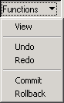 | The functions pull-down offers these actions:  - View the data from the current file/node entry.  The data is simply sent to the !output! stream.  This action is only enabled when a file/node is selected.  - Undo/Redo – the standard functionality to undo/redo the last database change.  These actions are only enabled for long-transaction databases and will do nothing if nothing can be undone/redone (e.g. the amount of changed data was too big to be stored temporarily).  - Commit/Rollback – commit all changes or undo all changes since the last commit.  These actions are always enabled and will do nothing if the database has not been changed.
This button will execute the selected editor command to view/edit the contents of a file/node entry.
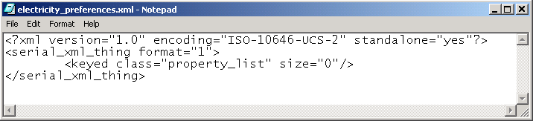

The data that is edited is stored in a temporary file, which is located in the directory referenced by environment variable %TEMP%.

The Edit action is also executed when the user double-clicks on an editable item in the list.

 | This button will get enabled once the Edit… button was selected. The GUI has no idea if anything was actually changed – it will simply take the data from the temporary file and replace the existing entry for the ds text directory node/file.
 | Deletes the selected item from the database. Can be applied to directory entries or nodes/files. If a directory is chosen, all entries in the directory will get deleted too.
Closes the dialog and also deletes all temporary files that were created (when the edit command was executed).
The icon on the frame triggers the same actions as this button.

Known Issues

- You might experience that undo/redo actions do not work as expected. There could be several reasons for this:
  - The value of database parameter :lwt_max_queued is too low
(this parameter should have at least the value 1).
  - The amount of data changed is too big so that the core simply can not store the change information.
Changing the parameter ds_environment.lwt_space might be the only work-around for this. However, this requires to build a new open image (and this setting must be done before the datastores are initialized), because a change in a running image has no effect.
  - If a manually ‘rollforward’ is performed on the inspected database view, all undo/redo information is lost.

