Mini User Documentation for the sf!index_viewer

This program is free software; you can redistribute it and/or modify
it under the terms of the GNU General Public License as published by
the Free Software Foundation; either version 1, or (at your option)
any later version.

This program is distributed in the hope that it will be useful,
but WITHOUT ANY WARRANTY; without even the implied warranty of
MERCHANTABILITY or FITNESS FOR A PARTICULAR PURPOSE. See the
GNU General Public License for more details.

You should have received a copy of the GNU General Public License
along with this code; if not, you can download it from the web:
http://www.gnu.org/licenses/gpl.txt

Author: Holger Schirnick <Holger_Schirnick@yahoo.com> - March 2005

The GUI Elements – Functionality

Once the module sf!index_viewer has been loaded, the GUI is started from the Magik prompt with this command:

MagikSF> sf!index_viewer.display( <database-view> )
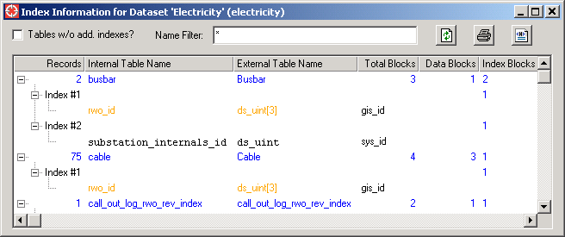

The icon will only be displayed if the module sf!tree_item has been loaded!

The columns in the GUI are shared for different information – which means the header strings are actually only valid for the for line of an entry (e.g. a line that is entirely displayed in blue text).
Let’s analyze what exactly is displayed by the GUI:
- The first line displays what the header strings are saying – so there is not muc hto add here.
- A sub-entry (on the 2nd level) displays an index with a running number in the first (Record) column and the total size of the index in the last column.
If you add the size information from all indexes, you should get the same number that is displayed in the last column of the first line.
- For each index is this displayed on the 3rd level
  - 2nd column: (internal) field name of a field used for the index,
  - 3rd column: storage type for the field,
  - 4th-6th column: data type name (if available/defined).
The data displayed in the 3rd and 4th column (field name and storage type) can be displayed in different colors.
If displayed in black, this is a “normal” index and should not give any reason for concerns.

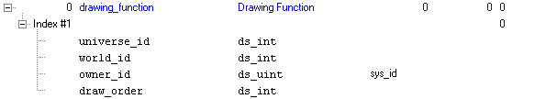

When entries are displayed in orange, the index is defined on an array – which could lead to quick index growth, which might be a reason to be concerned about the choice of index field, if a lot of data will be stored.

Currently there is also a third color in use to warn about a potentially really bad choice of index field. If data is displayed in red, a string field has been indexed – which is usually not a good choice because the index will require “a lot” of storage.

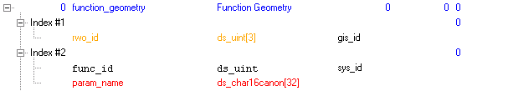

Other GUI Actions

- The right mouse pop-up menu offers these choices:
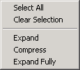
The Expand and Compress actions work on the current selection. If a selected item can not be expanded or compressed, nothing happens.
The Expand Fully action will unfold all tress for the current selection. Sometimes it leaves the display in disarray and the icon has to be pressed to display the screen data nicely. For long lists it may take some time until the operation is finished because the list is redrawn after each step – which is not too efficient (but core functionality of the tree_item).
- By default tables without additional indexes are not displayed (because they are not really of any interest). To get a list of all tables, the toggle can be selected and then all (Smallworld) tables in the database view will be displayed after the icon has been pressed.
This can be useful to get a complete printout of the data and index size information for all (Smallworld) tables in the current database view.
- The icon allows to “print” the data to a text file. The output (in ASCII-form) is less fancy what the GUI displays. Once the creation of the data is completed, a dialog box pops up and informs the user to which file the data has been written to.
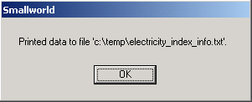
The file will be written to the directory where the environment variable %TEMP% points to. The name of the file will be the (internal) database-view name and the postfix _index_info.txt is added.
The output format uses by this “print” routine is the same that creates the output when the user uses the invoke() method from the Magik prompt to create output.
- If the module sf!tree_item has been loaded, it is also possible to create HTML-output for the data that is displayed by pressing the icon. The data in the HTML file will be very close to what you actually see in the GUI – only the expand/collapse icons and lines between those icons will be missing from the output. Once the file has been created, the user will be informed where the data has been written to.
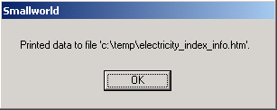
The name of the file will be the (internal) database-view name and the postfix _index_info.htm is added
- The widget allows to display only those table with (internal) names that match the given name pattern(s).
For example, to display only tables where the name either starts with draw or ends on an r, simply enter and press the icon to update the data that is displayed. It is also possible to provide a wildcard for a single character by using a ? in the match string.

