Mini User Documentation for the Magik Method Call Analyzer Module

This program is free software; you can redistribute it and/or modify
it under the terms of the GNU General Public License as published by
the Free Software Foundation; either version 1, or (at your option)
any later version.

This program is distributed in the hope that it will be useful,
but WITHOUT ANY WARRANTY; without even the implied warranty of
MERCHANTABILITY or FITNESS FOR A PARTICULAR PURPOSE. See the
GNU General Public License for more details.

You should have received a copy of the GNU General Public License
along with this code; if not, you can download it from the web:
http://www.gnu.org/licenses/gpl.txt

Author: Holger Schirnick <Holger_Schirnick@yahoo.com> - October 2005

General Usage Comment
The source code provide in this release can be used with Core Spatial Technology version 3.3 and any later version. The functionality does not rely on classic, professional or SWAF architecture and will operate in either environment.

What This Module is Good For
The main goal behind this module is to make it easier to locate code that calls the same method over and over again. The code does not help to optimize or resolve this problem, it simply counts method calls and allows to apply filters to reduce the amount of data that is displayed.

It is not recommended to analyze all code that is used to build an image at once. Analyzing modules or moderately sized products is a more reasonable/suggested way to use this tool. The code is more of a prototype and is rather wasteful (in terms of memory usage) when it comes to storing parsed data. This tool is not intended to be put in an end-user image; it could be included in an administrator image/activity though.

Launching the GUI
Once the module has been loaded, the GUI can be launched like this from the Magik prompt with these two commands:

MagikSF> maf << mclib:sf!method_analyzer_framework.new()
$
MagikSF> maf.activate()
$

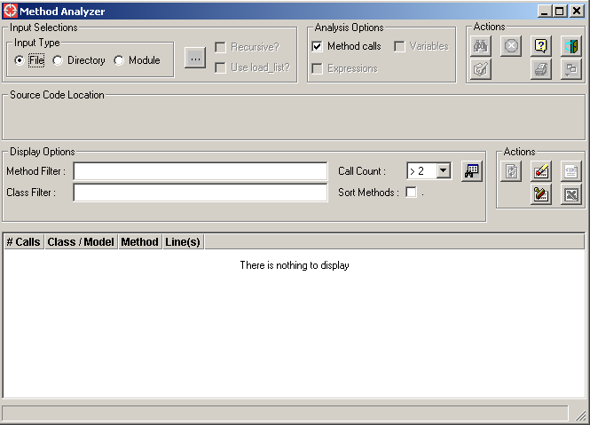

To close the GUI, either click on the -icon on the frame or the button in the Actions group box in the top-right area of the GUI.

How to Use The Tool/GUI
There are three ways to let the tool analyze data. The available options can be found in the top-left section of the GUI:

File | 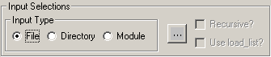  With the -button it is now possible to select the file that should be read/analyzed by the tool. A file selection dialog will be opened that allows to select a file from the file system.
Directory | 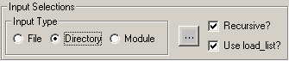  With the -button it is now possible to select the directory that contains the files that should be read/analyzed by the tool. A directory selection dialog will be opened to make a selection from the file system.  By default all Magik files in sub-directories will also be analyzed. To only read files in the selected directory, remove the tick-mark in the Recursive? toggle.  If only the files should be read that are loaded into the image when code is loaded, a tick-mark in the Use Load_list? Toggle must be set.
Module | 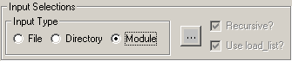  The -button will open a dialog that lists all modules (in alphabetical order) that are currently known in the image.  With this options the code is processed in the same way as when it would be loaded into an image (e.g. files/directories are processed on the order the load_list.txt file(s) specifies).

Once a choice has been made, the icon (in the top-right Actions group-box) is enabled and an analysis can be performed.
Additionally the Source Code Location group box will display the directory from where files will be read.
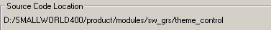

While the tool reads the input file(s), the status bar will display the progress:
.

The analysis can be stopped any time by clicking the icon.
Once processing has been completed, the status bar will display a message similar like this: . If the process was interrupted, the status bar shows a message similar to this: .

Once all files have been read, it will take some time to create the output for the display in the lower section of the GUI. To reduce the amount of time spent on creating and formatting this data, the Call Count filter choice (in the Display Options group box) should not be changed to . This choice will display all method calls in the code. The default setting of will only display two or more identical callbacks in a method.

With a Call Count setting of Any, the output data will display data in the order it was read. The output list will look like this:

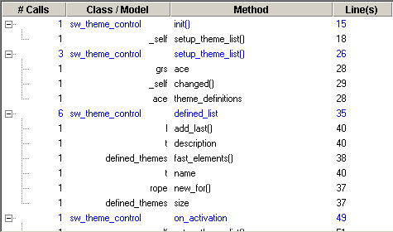

When the call count option is set to a value higher then one, output looks like this:

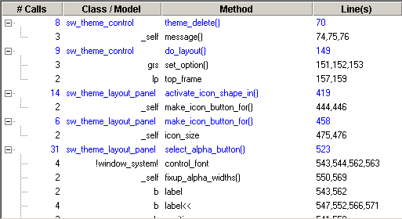

A line in blue provides information about a method. The columns provide this information:
#Calls | How many method calls were found in the method.
Class/Model | The name of the class that defines the method.
Method | The name of the method.
Line(s) | The line in the source file where the method is defined.
Method information is displayed in black. The columns provide this information:
#Calls | How often an identical call was made (e.g. same callback and same model/engine).
Class/Model | The name of the class that executes the callback.
Method | The name of the callback that is performed.
Line(s) | The line(s) in the source file where the callback is performed.

Double clicking on a line in the list will load the file into an Emacs buffer and jump to the first line number present in the last column. It’s also possible to right click on he canvas and choose the View Source Code action to perform this operation.

Using Display Options to Modify Displayed Data

To only display specific classes or methods in the list, patterns can be entered in the method and/or class filter widgets. The user can use wildcard characters (? and *) to define patterns. The entered strings are used literally – e.g. no wildcards are added automatically. Additionally, the user has to click on the -button (in the Actions group box to the right) to refresh the contents of the list once changes were made to either text widget.

The toggle allows to sort the output list by class and method names. By default the data that is displayed reflect the order in which the data was read from the input files.

The -toggle allows to omit predefined model/callback combination from the output. By default this toggle is disabled. When the toggle is enabled, the button is active (in the top-right Actions group-box), which allows to edit the file that defines the model/callback combinations. Once changes have been made to that file, it must be saved and the -button must be pressed to apply the current filters.
Side Notes:
- If the source code uses package-classified class names (e.g. sw:rope instead of just rope), the filter file must include the package-classified name in order to not see the specified class/method combination.
- The file that stores the filter information for classes/methods is a run-time resource (it’s located in the resources\base\data folder). In order to allow updates to this file, it must be writeble.

Action Buttons

Redraws/refreshes the contents of the analysis list.
This button is only available when data/code has been read.
Removes all entries from the Method and Class Filter widgets.
Restores the default settings for the display options – e.g. sets the Call Count choice to ‘> 2’ and clears the Sort Methods toggle.
Exports the displayed data to an HTML file.
This button is only enabled when the analysis list displays data.
The user has to choose a directory and file name to which that data will be written.
Exports the displayed data to a tab-separated text file.
This button is only enabled when the analysis list displays data.
The user has to choose a directory and file name to which that data will be written.
Known Issues and What Might/Should Be Addressed in The Future

- Currently the scanner looks only at methods. Code defined for procedures is ignored.
- If the scanner finds a syntax error, it disregards the code with this error.
- Some group-boxes (with text or label widgets) are too big – not sure why; they looked good in CST 3.3.

Customization Options

There’s not too much that can be changed easily without breaking other code.

- sf!data_displayer.default_call_count
Defines a number (currently between zero and nine) that determines the initial (and default) value in the Call Count choice widget.
The current value is 2.

- sf!data_displayer.show_method_call_details?
Defines a Boolean value that determines if the call details for a method should be displayed when data is refreshed. Sooner or later a user will look at the details, so the default value is _true. However, for large lists it takes a lot of time to display the initial data, so it can be a reasonable option to set the default to _false and apply a few filter options first before details should be shown.

- sf!data_displayer.column_separator
Defines a character (or string) that is used to separate column data when information is written to a CSV file. It is not suggested to use a comma (,) as separator, because the Line(s) column contains comma-separated data.
By default a tab-character (%tab) is used.

- Launching files in an editor that’s not Emacs.
One option is to simply define the environment variable SF!EDITOR_CMD. Its value should refer to an executable that can edit files. The file that is supposed to be edited is simply added to the string that is provided as editor executable.
The code can be found in method sf!file_provider.edit_file.

