Mini User Documentation for the Table Inspector

This program is free software; you can redistribute it and/or modify
it under the terms of the GNU General Public License as published by
the Free Software Foundation; either version 1, or (at your option)
any later version.

This program is distributed in the hope that it will be useful,
but WITHOUT ANY WARRANTY; without even the implied warranty of
MERCHANTABILITY or FITNESS FOR A PARTICULAR PURPOSE. See the
GNU General Public License for more details.

You should have received a copy of the GNU General Public License
along with this code; if not, you can download it from the web:
http://www.gnu.org/licenses/gpl.txt

Author: Holger Schirnick <Holger_Schirnick@yahoo.com> - September 2006

General Usage Comment
The source code provide in this release can be used with Core Spatial Technology version 4.0 and 4.1 (the GUI does not work in CST 3.3). The editor functionality could easily break if CST changes very little in that area. However, collection browse and display functionality are fairly independent of he CST version.

What This Module is Good For
The main goal of this module is to make it easier to look at collections (and the record data) in a dataset. The module also allows to view records and edit record contents. It is also possible to specify which fields of collections should be displayed, e.g. the information from the DD and/or ACE can be overwritten at run-time (in memory).

Launching the GUI
There are two options to launch the GUI. From the Magik prompt these two commands can be used:

MagikSF> ti << mclib:sf!table_inspector.new( :ti, g )
$
MagikSF> ti.activate()
$

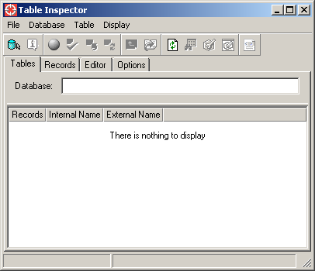

To close the GUI, either click on the -icon on the frame or choose the Close action in the File pull-down.

Another option is to add the sf!table_inspector_plugin class in a config.xml file and add the action activate_table_inspector in a gui.xml file where it’s convenient.
E.g. add this line to a config.xml file:

<plugin name="table_inspector"
class_name="mclib:sf!table_inspector_plugin"/>

And this line to a gui.xml file (for example in the tools menu):

<action name="table_inspector.activate_table_inspector"/>
Functionality Overview - Toolbars

The main GUI has four tabs:
- Tables displays tables from the current dataset.
- Records displays record from a chosen table.
- Editor displays a record from a chosen table.
- Options allows to modify browse and editor displays.

and five toolbars
- to select a dataset and get information about it.
- to make persistent changes to a dataset.
- to navigate in a dataset.
- to refresh and/or inspect data.
- to export currently displayed data to HTML.

Selecting a Dataset
Initially the icon (or the pull-down action Database -> Database…) must be selected to choose a database to operate on. A dialog similar like this will open:

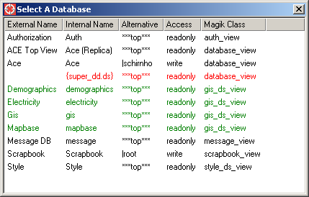

The dialog lists all datasets known to the sw:ds_environment class. The different colors used in the list have this meaning:

- black A system database (e.g. one that comes with CST).
- green An application dataset (not shipped with CST).
- red An internal dataset – usually not visible to end-users.
- blue An external (non-Smallworld) dataset.

Double clicking on one entry will select that dataset as current dataset. E.g. double clicking on the Electricity entry will change the Tables tab in the main window to display all (user) tables in that dataset:

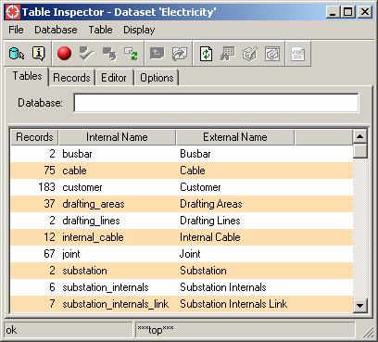

The dialog title will display the name of the current dataset and a few more icons will become enabled. The bottom right status bar will display the current alternative in the active dataset.

Clicking on the icon will (or using the pull-down action Database -> View Database Information) opens a window that display a little more information about the current dataset:

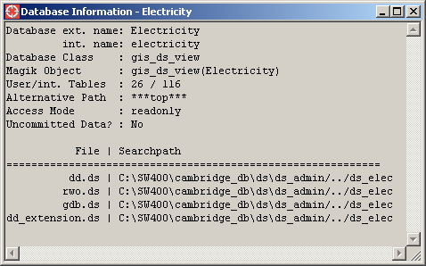

Navigating a Dataset

Once a dataset has been chosen, it’s possible to navigate through the alternative structure. The ‘Select a Subalternative’ icon - - will only be available if alternatives do exist in the current dataset. If only a single subalternative exists, this action will enter the alternative immediately. If several alternatives exist, a pick list will be displayed from which the desired alternative can be chosen.
The ‘Go To Parent Alternative’ icon - - is only active when we’re not in the top alternative.

When the alternative is changed, the bottom right status bar will display the current alternative: .

Making Persistent Changes to a Dataset

There are currently four operations to make changes to a dataset:

- Switch Mode - or
- Commit -
- Rollback -
- Rollforward -

The access mode is displayed by a red (read access) or green (write access) icon. Clicking on the icon will toggle the access mode (if possible).
When in read-only access, the rollforward icon is enabled. When the access mode is write, the rollforward icon is disabled and commit and rollback icons are enabled.

Working with Records

Once a record is selected from the Records tab, the edit icons (edit in embedded editor) and (edit in floating editor) become available. To edit a record in an embedded editor it’s also possible to simply double-click on an entry in the record lister.

The Refresh icon - - is always available and will refresh the contents of the current tab page.

The Browse icon - - becomes available once a collection was selected in the Tables tab. If that icon is selected, some records from that table will be listed in the Records tab. The same can be achieved by double-clicking on a collection in the Tables tab.

The Tables Tab

By default this tab only displays non-empty user-defined collections (e.g. any internal tables from CST are not displayed). If empty and/or system tables should be displayed, the toggles in the Display pull-down should be changed. | 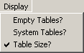

To distinguish system and user-defined tables, the former are displayed in red. Tables from an external dataset will be displayed in blue.

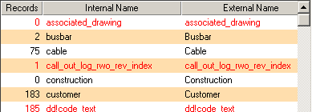

Some convenience reports (which are available from the Magik prompt) can also be requested for a single selected table. They are grouped in the Table pull-down:

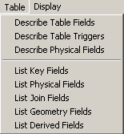 | When a report is chosen, a new window pops up and provides the requested information. For the reports below the separator the output contains two columns: the left side contains the internal field name, while the right side provides the external field name.

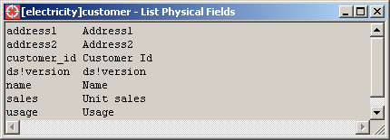

The Records Tab
Below is a screenshot that shows the records of the table that was selected from the Tables tab:

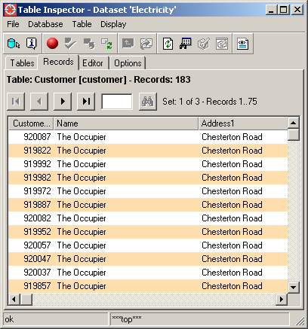

The total number of record in the table is 183. This lister divided the display into three record sets, each has up to 75 records. The size of the sets can be set in the Options tab in the top-most group box:

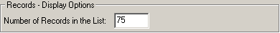

The icon allows to view the next record set, the icon the previous one. and jump to the first or last record set respectively. When a (positive) number is entered in the text widget , it’s possible to jump to the specified record set. The ‘Get Record Set’ icon will only be active when a valid number is entered (the valid range can be seen to the right of the icon).

The Editor Tab

There is not too much to say about this tab, it provides the basic editor functionality provided from CST.

The Options Tab

This tab allows to configure four topics:
- The size of record sets for the record lister.
- Which fields are considered for display in editors.
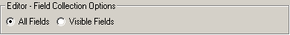
The ‘All Fields’ option will consider all fields that are known at run-time for a collection. The ‘Visible Fields’ option will consider the configured ACE or data dictionary information to provide the fields to process.
- Which fields are actually displayed in an editor.
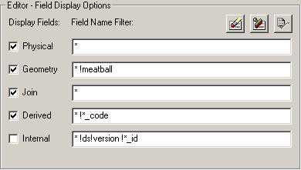
This dialog allows to define patterns that either match an internal field name or patterns that “disqualify” field names. The latter patterns start with an exclamation mark (!). Exclusion patterns take precedence over match patterns.
For example look at the derived field entries: The pattern * means that all derived fields should be displayed. However, the pattern !*_code means that those derived fields with a name ending in _code must not be displayed.
When patterns were changed, the (apply) icon becomes active. When this icon is pressed, the new settings are communicated to active editors and the displayed fields will be updated immediately. The clear () and defaults () icons are always enabled and either clear all fields or reset the default values.

- Which outside event may update the record displayed in an editor.
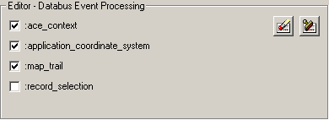

With the default setting any map selection does not affect any editor in the Table Inspector (just the editors in the application the map belong to.
The first three events usually do not affect editor contents, they are just here because all listed events are things the editor manager is interested in.
The clear () and defaults () icons are always enabled and either clear all fields or reset the default values.

XML configuration

There are two sets of XML files:
- for the Table Inspector (config.xml and gui.xml)
- for the embedded editor (sf!inspector_editor_gui.xml and sf!inspector_editor_gui.xml)

The editor XML files will not be discussed here, because they contain a simplified/reduced setup used in the core editors.

The gui.xml file is fairly self-explanatory and we won’t discuss its contents here either. A little more interesting is the config.xml file and we will discuss a few settings.

Plugin sf!database_view_selector

- The values for properties database_sort_field and database_list_fields are not public methods on a database view but values retrieved from a property list created for a database view in method get_property_data_for().
- When the value of property is set to “false”, all entries in the database list will be black. The colors itself are defined in class constant :database_type_to_color_map and the color to use is determined in method determine_database_type().

Plugin sf!table_lister

- The value of properties allow_filtering? and show_stripes? are used in the tree_item of this component.
- The value of property sort_tables_by must refer to a callback on the actual collection.
- The property of value auto_refresh? determines if the list refreshes automatically when a display option is changed. When the value is set to false (which makes sense when external tables are present), the user hat to click on the Refresh icon - - to update the list contents.
- The values of properties show_empty_tables?, show_table_size?, and show_system_tables? provide the default values for the table display options.

Plugin sf!record_lister

- The value of action double_click_action must refer to an action of this class. Currently only one of these tow values can be chosen: edit_object or edit_object_floating.

Plugin sf!table_inspector_options

The values of the properties specified for this class determine (mostly) the default values you will see in the Options tab.

- The value for property field_collection_strategy can either be all_fields or visible_fields.
- The value of property local_editor_manager_name must refer to the editor plugin name used in this config.xml file.
- The databus data type names that should or should not be processed by the local editor manager must be postfixed with a question mark. E.g. while the databus event name is ace_context, the property value needs to be specified for the property named ace_context?.

While it is possible to also add the GUI as an embedded GUI in the application’s work area – by adding the line <plugin plugin_name="table_inspector"/> in the tab_box section of the work_area section - too much functionality is lost, so this is not suggested.
There are only three tabs if the inspector was launched without associated application.

