The Estimator by Minto Spatial Solutions:
Administrator Guide

Version: Core Spatial Technology 4.2.0 (SWAF)

Updated: 2011/04/25

Copyright Information

Copyright © 2005-2011 Minto Spatial Solutions Ltd. All rights reserved.

Trademarks and Registered Trademarks

Smallworld is a registered trademark of General Electric Company

Table of Contents

1 Overview 4
1.1 Supported Versions 4
1.2 Document History 4
2 Installation 5
2.1 Pre-requisites 5
2.2 Database Setup 5
2.3 Changes to Image Build process 8
2.4 Changes to Applications 8
2.5 Addition of New Applications 8
2.6 Related Database Configuration 9
3 Compatible Unit Configuration Menu 10
3.1 CU Properties Tab 13
3.2 CU Groups Tab 15
3.3 Job Types Tab 17
3.4 Macro Units Tab 19
3.5 Cost Groups Tab 21
3.6 Import/Export Tab 23
3.6.1 Exporting CU Definitions 24
3.6.2 Importing CU Definitions 24
3.6.3 Import/Export File Format 24
4 Configuring Facility Definitions 29
4.1 List of Available Operations 29
5 Configuring the Main Work Point Partition 31
6 Configuring the Estimator Environment 32
7 Configuring Toolbox Extensions for the Estimator 38
7.1 Adding CU References to Pointing Rule Definitions 38
7.2 Placing Work Points with the Toolbox 38

Overview
This document provides information required by system administrators to install and configure The Estimator by Minto Spatial Solutions productivity tool.

The document named “The Estimator by Minto Spatial Solutions: User Guide” contains a description of the end-user functionality provided by this tool – as a pre-requisite to installing and configuring this tool, system administrators should be familiar with the contents of that document.

Supported Versions
This document describes the version of The Estimator by Minto Spatial Solutions (commonly referred to simply as the Estimator) that is released as part of the MSS 420 package, and is compatible with the SWAF architecture of Smallworld Core Spatial Technology version 4.2.0.

Document History

Date | Name | Description
2007/02/19 | Tim Minto | - Created (from V4.0 version of document).
2008/05/31 | Tim Minto | - Updated to V4.1.1.
2011/04/25 | Tim Minto | - Updated to V4.2.0.

Installation

Pre-requisites
The source code for the Estimator product should be placed in a directory that is accessible during your image build process. This code is available in the subdirectory named “mss” of the Estimator product zip file. Simply copy this code to a directory of your choice. This directory will be considered to be the “product directory” for the MSS product, and this will be referred to as the <MSS_PRODUCT> directory in various steps below.

The Estimator product requires that the Workspace by Minto Spatial Solutions product is installed. The Workspace product is included in the MSS product directory, and installation instructions are documented separately in the document named “The Workspace by Minto Spatial Solutions: Administrator Guide”.

Database Setup
To perform this step, you must start with an open image, so that the CASE tool can be accessed.

The Estimator makes use of a database named mss_config to store information about Compatible Unit configuration. Additionally, some functionality provided by the Estimator requires that new tables are added to your database partitions that comprise your GIS spatial object controller – depending on your installation, this may include databases such as Land, Gas, or Electric.

The following steps will create this mss_config database, and the mss_config_case database used to store CASE tool information for this database.

Note: if you have installed the Toolbox by Minto Spatial Solutions product, then the mss_config and mss_config_case databases will already exist, and you can skip the following steps which create these databases.

- Get writable access to the TOP alternative in the ACE database, so that information relating to Spatial Object Controller connection parameters can be stored:
  - gis_program_manager.ace_top_view.switch(:write)

- The create_gis_dataset() procedure will be used to create the mss_config database. Note that this procedure takes a number of arguments, and the following notes describe these arguments:
  - 1): DIR_NAME: this should be the directory in which the database will be created. This directory must already exist – if it does not exist, create it.
  - 2): SOC_NAME: this must be :mss_config
  - 3): DATASET_NAME: this must be :mss_config
  - 4): KEYS_AND_VALUES: although not mandatory, it is suggested that the optional parameters for this database should match the optional parameters for your GIS partition. So for example, if your GIS partition has 8 universes, 8 priority bits, and database units of mm, the following list of optional arguments is appropriate: :universes, 8, :default_universe, {“gis”, 1, 8}, :default_world, {“gis”, “gis”, :units, :mm}.
- Here is a sample invocation of this procedure:
  - create_gis_dataset(“c:\mss\ds\mss_config”, :mss_config, :mss_config, :universes, 8, :default_universe, {“gis”, 1, 8}, :default_world, {“gis”, “gis”, :units, :mm})

- The create_case_dataset() procedure will be used to create the mss_config_case database. Note that this procedure takes a number of arguments, and the following notes describe these arguments:
  - 1): DIR_NAME: this should be the directory in which the database will be created. This directory must already exist – if it does not exist, create it. This can be the same directory as was used for the mss_config database.
  - 2): SOC_NAME: this must be :mss_config_case
  - 3): DATASET_NAME: this must be :mss_config_case
- Here is a sample invocation of this procedure:
  - create_case_dataset(“c:\mss\ds\mss_config”, :mss_config_case, :mss_config_case)

- Commit the changes in the ACE database – the procedures used above will have automatically added the necessary Spatial Object Controller connection parameters:
  - gis_program_manager.ace_top_view.commit()

Preparation for CASE applies:

- Quit and restart your Smallworld session. Add the mss product definition, using the following command (where <MSS_PRODUCT> is the directory that contains the product.def file):
  - smallworld_product.add_product(<MSS_PRODUCT>)

- The following commands will load the required data model code, and open the mss_config database in preparation for doing a CASE apply:
  - sw_module_manager.load_module(:mss_cu_data_model)
  - gis_program_manager.open_datasets(:mss_config)
  - gis_program_manager.open_datasets(:mss_config_case)

- Start the CASE application for the mss_config_case database, and perform the following steps within the CASE application:
  - Switch the mss_config_case database to writable mode.
  - Perform the Tools → Load Archive… pulldown function to load a CASE archive. For the archive filename, choose the file named mss_cu.archive, which can be found in the mss_cu_data_model module directory. If you are unsure of the location of this module, it can be determined using the following command: sw_module_manager.module(:mss_cu_data_model).full_directory.
  - Select all newly-created objects – all objects that where the name starts with “mss_”. Note: it is likely that you must edit the case_420 ACE to turn on all objects in the mss_config_case partition in order to see these newly-created objects.
  - Perform the Tools → Apply… pulldown function to apply these objects to the mss_config database.

Warning: the following steps constitute a so-called “hard data model change” to your client-specific database partitions. Therefore, be sure to follow standard procedures required for any hard data model change: refer to the Case Tool Tutorial and Database documents provided with Smallworld Core Spatial Technology for details in this area. Typically, this includes the following high-level steps:
- Before starting, ensure that the results of any previous CASE apply have been merged down to all alternatives and replica databases.
- Resolve any outstanding conflicts in any child alternatives.
- After the following steps are completed, merge the results down to all alternatives and replica databases.

For each client-specific database partition (such as Land, Gas, or Electric) that will contain objects that can be associated with Compatible Units, the following steps must be performed. This will be the same set of client-specific database partitions used by the Workspace, and the most efficient way to perform these CASE applies is to do them at the same time as the Workspace CASE applies. Therefore, be sure to review the document named “The Workspace by Minto Spatial Solutions: Administrator Guide” to coordinate this CASE work.

As described in that document, review the dd_record_mixin.mss_convert_key_to_string() method to ensure that a 48 character complex key is sufficient for your data model. If it is not, then you must increase the size of the complex_key attribute of the mss_cu_reference_complex_key table as appropriate.

- Ensure that the mss_cu_data_model module has been loaded. If you are continuing on from the previous steps, this will already be done. However, if you have quit and restarted your session at a later time, the following will be required:
  - smallworld_product.add_product(<MSS_PRODUCT>)
  - sw_module_manager.load_module(:mss_cu_data_model)

- Start the CASE application for your CASE database that contains the objects that form your standard application-specific data partitions (such as Land, Gas or Electric data), and perform the following steps within the CASE application:
  - Switch the database to writable mode.
    - Important note: this archive is loaded into your own application-specific CASE tool, rather than a separate CASE tool specific to the MSS product. This is done to work around the fact that the CASE tool identifies manifolds primarily by their internal ID in the CASE tool, rather than by name. To ensure that there is no conflict between an MSS manifold and the manifolds in your own data model, they must be placed in the same CASE tool, so that each is given a unique internal ID.
  - Perform the Tools → Load Archive… pulldown function to load a CASE archive. For the archive filename, choose the file named mss_cu_user.archive, which can be found in the mss_cu_data_model module directory. If you are unsure of the location of this module, it can be determined using the following command: sw_module_manager.module(:mss_cu_data_model).full_directory.
  - Special treatment for mss_cu_work_point table (external name Work Point): this table has geometry fields named location, route, extent, and annotation. The database priority for these geometry fields has been set to 63 by default. Ensure that this database priority is not used by any other geometries in the data model for any client-specific database partition that is the subject of this CASE apply. If required, manually alter the database priorities of any (or all) geometry fields to values that do not conflict with other geometries. Additional details on the recommended approach to setting geometry database priority values is provided in Smallworld Core Spatial Technology documentation.
  - Select all newly-created objects – all objects that where the name starts with “mss_”.
  - Perform the Tools → Apply… pulldown function to apply these objects to each of your client-specific database partitions (such as Land, Gas, or Electric) that will be managed by the Estimator.

- For each client-specific database partition, a UVA named :mss_cu_reference must be created. Use the following command for each database partition (where “V” is a reference to that database partition). Note that UVA creation must be done in the TOP version of the database, in writable mode. If your data model uses 64 bit system-generated keys, then use the create_uva64() method; otherwise, use the create_uva() method, as follows:
  - v.create_uva(:mss_cu_reference, "rwo.ds")

At this point, the required database setup is complete, and you can proceed to the next step to build images.

Changes to Image Build process
As part of your image build process, ensure that following steps are performed:

- The MSS product must be added. This can be done using the following code (where <MSS_PRODUCT> is the directory that contains the product.def file):
  - smallworld_product.add_product(<MSS_PRODUCT>)

- The module named mss_workspace must be loaded. This can be done by either making it a prerequisite of any module that you currently load in your application, or by explicitly loading the module using the following code:
  - sw_module_manager.load_module(:mss_cu)

Make the changes described above to your image build process, and ensure that it completes without error. To verify the results, you can confirm that the following exists in your open image:
- The mss_cu_engine class exists.
- The mss_config database is available – this can be checked by ensuring that gis_program_manager.cached_dataset(:mss_config) returns a database.

Changes to Applications
For any application that will use the Estimator, the following changes should be made to the config.xml and gui.xml files for that application:

Changes to config.xml:
- Add the following plugins, which provides access to various Estimator functions. Note that the mss_cu_config_fw_pi is used to provide access to configuration tools, and is not required for regular users (only for administrators).

<plugin name="mss_cu_config_fw_pi" class_name="mss_cu_config_fw_pi"/>
<plugin name="mss_cu_report_fw_pi" class_name="mss_cu_report_fw_pi"/>

Changes to gui.xml:
- To provide access to the Compatible Unit Reporting menu, add the following action to the appropriate pulldown menu in your application:

<action name="mss_cu_report_fw_pi.activate_mss_cu_report_framework"/>

- To provide access to the Compatible Unit Configuration menu, add the following action to the appropriate pulldown menu in your application:

<action name="mss_cu_config_fw_pi.activate_mss_cu_config_framework"/>

Addition of New Applications
The previous section describes how to add a new pulldown menu item to activate the Compatible Unit Configuration menu as a dialog within a pre-existing application. An alternate approach to providing access to that menu is to add it as a separate top-level application, so that it is accessible directly from the Smallworld Application Manager menu.

This is accomplished by loading the following module as part of your image build process:
- sw_module_manager.load_module(:mss_cu_config_application)

Note that if your image build process calls smallworld_product.clear_application_definitions() at any point, then the above module should be loaded after that call – otherwise, it will not be accessible in the Smallworld Application Manager menu.

Once this module is loaded, a new application named “MSS Compatible Unit Configuration” will be available to system administrators (and to any other auth groups that you choose to grant access to this application).

Related Database Configuration
In any ACE which will be used to update and/or view Estimator data, be sure that the following objects in your main Work Point partition are accessible, and that their geometries are turned on at appropriate scales. Note: refer to section 5 for a discussion of the main Work Point partition.
- Work Point

The new Work Point object should have appropriate styles created for all geometries. You are free to define any style that you wish; or, you may use the following process to load default styles:
- Load the following module:
  - sw_module_manager.load_module(:style_dump_and_load_engine)
- Switch the style view to writable mode:
  - gis_program_manager.style_view.switch(:write)
- Create a style_loader object:
  - z99 << style_loader.new(gis_program_manager.style_view)
- Perform the style load, and commit the style database:
  - z99.load_style_tables(<filename>)
  - gis_program_manager.style_view.commit()
- In the above call, the <filename> parameter is the file named mss_cu_user.style, which can be found in the mss_cu_data_model module directory. If you are unsure of the location of this module, it can be determined using the following command: sw_module_manager.module(:mss_cu_data_model).full_directory.
- Note that this process will create styles at the “auto” scale, and you should then copy these styles to all appropriate scales using standard Smallworld style editing tools.

For any authorisation group which should have update and/or view access to Estimator data, be sure that all tables in the mss_config partition have view access enabled in the Auth database (for regular users), or update access enabled (for administrators).

Also, be sure that the following tables in all client-specific partition have update and/or view access enabled in the Auth database:
- CU Reference
- CU Reference Complex Key
- Work Point

At this point, you are ready to start your application with Estimator functionality enabled.

Compatible Unit Configuration Menu
This menu contains various functions that allow you to configure pointing rules. It is activated using the mss_cu_config_fw_pi.activate_mss_cu_config_framework action (as described in the setup of your config.xml file in section 2.4 above), or as its own top-level application (as described in section 2.5 above). Here is a screen shot of this menu:

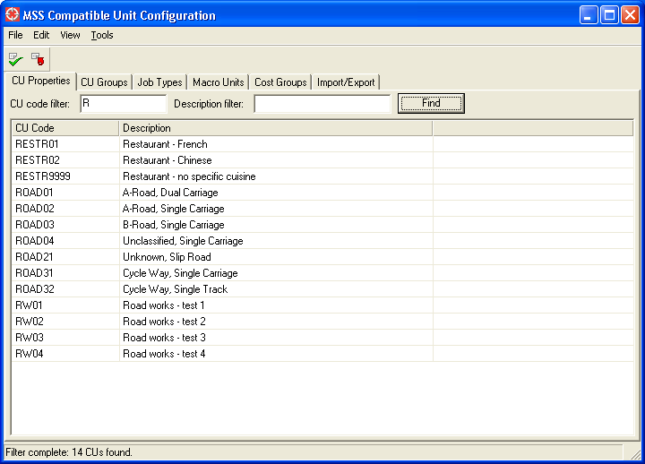

This menu consists of the following components:
- The Pulldown menu functions and Toolbar are at the top of the menu. All of these functions are described below.
- The main body of the menu consists of several tabs, each of which is responsible for configuring a specific aspect of the Compatible Unit environment. Each tab is described in more detail in a subsequent section.
- The Status Bar at the bottom of the menu provides status updates for various operations performed by this menu.
The following Pulldown menu functions are available:

Function name | Button | Description
File Pulldown
Versions… |  | Open a Version Management dialog for the mss_config database.
Commit |  | Commit the mss_config database.
Rollback |  | Rollback the mss_config database.
Import CU Definitions… |  | Prompts for an input file, and then imports CU definitions from that file. Refer to section 3.6 for details about this file format.
Export CU Definitions… |  | Prompts for an output file, and then exports CU definitions to that file. Refer to section 3.6 for details about this file format.
Close |  | This closes the Compatible Unit Configuration menu.
Edit Pulldown
Undo |  | Undo the most recent database update.
Redo |  | Redo the most recent database update that was undone with the Undo function.
Edit CU Definitions… |  | Activate an object editor for the CU Definition table.
Edit CU Groups… |  | Activate an object editor for the CU Group Definition table.
Edit CU Job Types… |  | Activate an object editor for the CU Job Type table.
Edit CU Cost Groups… |  | Activate an object editor for the CU Cost Group table.
Edit Selected CU Definition… |  | If a CU Definition has been selected on the CU Properties tab, this activates an object editor for that record.
Edit Properties For Selected CU… |  | If a CU Definition has been selected on the CU Properties tab, this activates the CU Properties dialog for that record (see section 3.1 for details about this dialog).
Edit Selected CU Group… |  | If a CU Group Definition has been selected on the CU Groups tab, this activates an object editor for that record.
Edit Selected CU Job Type… |  | If a CU Job Type has been selected on the Job Types tab, this activates an object editor for that record.
Edit Selected CU Cost Group… |  | If a CU Cost Group has been selected in the cost group pick-list on the CU Groups tab, this activates an object editor for that record.
Clone Selected CU Definition… |  | If a CU Definition has been selected on the CU Properties tab, this creates an identical copy of that CU with “_n” appended to the name (where “n” is the next available number to form a unique name for the CU).
View Pulldown
Refresh |  | Refreshes the CU information displayed on the current tab.
Tools Pulldown
Explorer… |  | Activates the Smallworld Explorer tool to allow general queries of CU configuration tables.  Note: to make full use of the Explorer, you should configure your Default ACE to provide access to all CU configuration tables, and/or provide a customized version of the explorer_model_config.xml configuration file in the mss_cu_config_gui module. Details of customizing the Explorer are described in Smallworld Core Spatial Technology documentation.

CU Properties Tab
This tab allows individual CUs to be inserted, updated, and deleted. For a screen shot of this tab, refer to section 3 above.

To use this tab to query for existing CU definitions:
- Enter a substring of the CU code to be searched for in the CU code filter input field (or leave it blank to query for all CU definitions). The value entered here is automatically wild-carded at the end – for example, simply entering “R” will find all CU definitions where the CU code starts with “R”.
- Optionally, also enter a substring of the CU description in the Description filter input field.
- Press the Find button to populate the CU list with all matching results.

To edit the attributes of any CU definition, select it in the CU list, and then perform the “Edit Selected CU Definition” function (accessible from the Edit pulldown menu or the right-mouse popup menu). This will activate a standard object editor to display this record.

Note that a CU definition also has an extended set of properties to define what operations are valid for that CU, and to define what facilities and attribute values in your data model should be associated with that CU. To activate a dialog to allow editing of these properties, either double-click the entry in the CU list, or select it in the CU list, and then perform the “Edit Properties For Selected CU” function (accessible from the Edit pulldown menu or the right-mouse popup menu). This will display the following dialog:

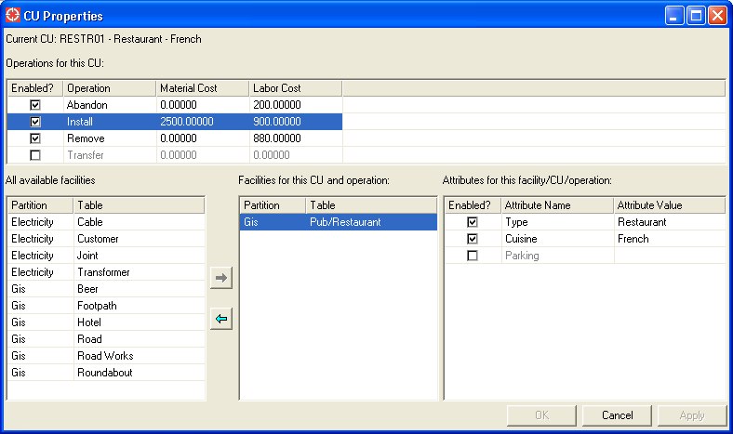
The following functions are available on this dialog:
- In the Operations for this CU list, any operation can be enabled or selecting the Enabled? checkbox for it.
  - Enabling an operation means that users will be able to perform this type of operation for this CU. In the example screen shot, the Abandon, Install, and Remove operations have been enabled for the CU named RESTR01. However, the Transfer operation has not been enabled. This means that a user can add the CU named RESTR01 to their design with an operation value of Abandon, Install, or Remove – but not Transfer.
  - Once enabled, a Material Cost and/or Labor Cost can be entered by typing in the corresponding cell in the list.
- When an enabled operation is selected in the Operations for this CU list, the All available facilities list will populate will all potential facility types that you have defined as being CU-enabled, and the Facilities for this CU and operation list will populate with all facility types that are already associated with this CU.
  - Refer to section 4 for how to define a facility type as being CU-enabled.
  - Select an item in the Operations for this CU list and press the right-arrow button to transfer it to the Facilities for this CU and operation list.
  - Select an item in the Facilities for this CU and operation list and press the left-arrow button to remove it from that list.
- When a facility type is selected in the Facilities for this CU and operation list, the Attirbutes for this facility/CU/operation list will populate with all defined attributes for this facility type.
  - Refer to section 4 for how to define attributes for a facility type.
  - Selecting the Enabled? checkbox for any attribute in this list will allow you to type in a corresponding attribute value in the Attribute Value cell.
- Once a desired set of changes has been performed, press the OK button to update the database with these changes and dismiss the dialog; press the Apply button to update the database with these changes and keep the dialog open; or press the Cancel button to discard these changes.

In the sample screen shot above, the following configuration exists for the RESTR01 CU:
- The Abandon, Install, and Remove operations are enabled.
- When it is added to a design with an operation of Install, the material cost will be $2500, and the labor cost will be $900.
- For the Install operation, it is associated with the Pub/Restaurant facility, so it will be a candidate for the list of CUs when the “By Facility” type of query is performed using the Compatible Unit Query tool (refer to the Estimator user guide for information about that tool).
- For the Install operation, it has associated attributes of Type = Restaurant, and Cuisine = French. So, when this CU is associated to a Pub/Restaurant object with an operation of Install, those attributes will be automatically set on the Pub/Restaurant object.

CU Groups Tab
This tab allows individual CUs to be organized into groups, to provide a logical grouping of CUs on the Compatible Unit Query tool (refer to the Estimator user guide for information about that tool). Here is a screen shot of this tab:

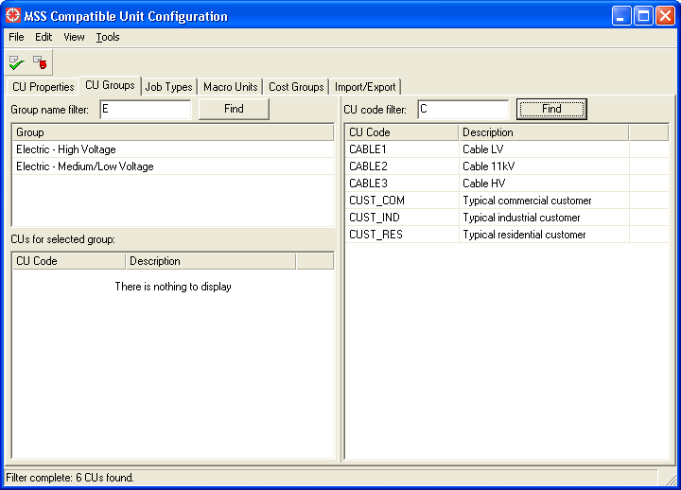

To use this tab to query for existing CU group definitions:
- Enter a substring of the group name to be searched for in the Group name filter input field (or leave it blank to query for all CU group definitions). The value entered here is automatically wild-carded at the end – for example, simply entering “E” will find all CU group definitions where the name starts with “E”.
- Press the Find button to populate the Group list with all matching results.
- Selecting an entry in the Group list will cause the CUs for selected group list to show all CU definitions that exist in the selected group.

To edit the attributes of any CU definition, select it in the Group list, and then perform the “Edit Selected CU Group” function (accessible from the Edit pulldown menu or the right-mouse popup menu). This will activate a standard object editor to display this record.

To add a new CU definition to the selected group:
- Use the right portion of the menu to set a CU code filter, and perform a query to populate the Candidate CU list. Note that the usage of this filter is the same as for the CU definition query described for the CU Properties tab above.
- Select one or more CU definitions in the Candidate CU list to be added to the selected group.
- Right-click in the Candidate CU list, and perform the Add CUs To Group function.

To remove a CU definition from the selected group:
- Select one or more CU definitions in the CUs for selected group list to be removed from the selected group.
- Right-click in the CUs for selected group list, and perform the Remove CUs From Group function.

Job Types Tab
This tab allows individual CUs to be assigned to job types, to provide a logical grouping of CUs on the Compatible Unit Query tool (refer to the Estimator user guide for information about that tool). Here is a screen shot of this tab:

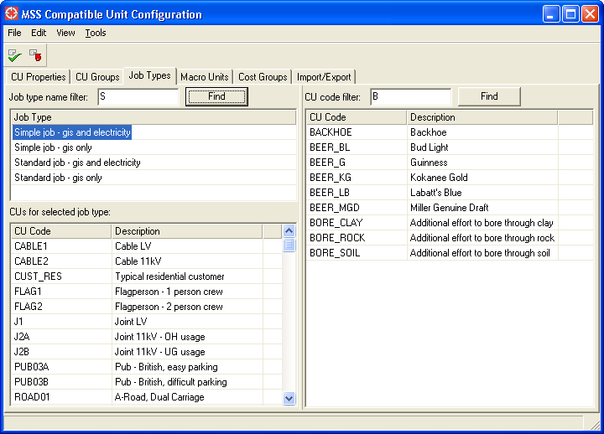

To use this tab to query for existing CU job types:
- Enter a substring of the group name to be searched for in the Job type name filter input field (or leave it blank to query for all CU job types). The value entered here is automatically wild-carded at the end – for example, simply entering “S” will find all CU job types where the name starts with “S”.
- Press the Find button to populate the Job type list with all matching results.
- Selecting an entry in the Job type list will cause the CUs for selected job type to show all CU definitions that exist in the selected job type.

To edit the attributes of any CU job type, select it in the Job type list, and then perform the “Edit Selected CU Job Type” function (accessible from the Edit pulldown menu or the right-mouse popup menu). This will activate a standard object editor to display this record.
- Note that in addition to the Name attribute, CU job type records have attributes named Material Cost Multiplier and Labor Cost Multiplier.
- These multipliers will be used as part of the calculation of costs for CUs added to a design with a job type that corresponds to this CU job type records.
  - See the mss_cu_engine.cu_job_type_for_workspace_job_type() method in section 6 for a discussion of how the job type for a design relates to a CU job type record.
- If no overriding values are desired for a given job type, then both multipliers should be set to 1.0.
- Note that this mechanism allows labor costs to be stored in either of the following ways:
  - The labor cost for a given CU and operation may represent the actual dollar cost, or,
  - The labor cost for a given CU and operation may represent the number of hours associated with a CU, and the CU job type can be used to represent an average hourly labor cost by setting the Labor Cost Multiplier to equal that average hourly labor cost.

To add a new CU definition to the selected job type:
- Use the right portion of the menu to set a CU code filter, and perform a query to populate the Candidate CU list. Note that the usage of this filter is the same as for the CU definition query described for the CU Properties tab above.
- Select one or more CU definitions in the Candidate CU list to be added to the selected group.
- Right-click in the Candidate CU list, and perform the Add CUs To Job Type function.

To remove a CU definition from the selected job type:
- Select one or more CU definitions in the CUs for selected job type to be removed from the selected group.
- Right-click in the CUs for selected job type list, and perform the Remove CUs From Job Type function.

Macro Units Tab
This tab allows individual CUs to be organized into Macro Units (MU). A Macro Unit is a top-level CU definition that is related to one or more child CU definitions. When the user chooses to add a Macro Unit in a design, it is automatically expanded out into the child CUs that comprise the Macro Unit. Here is a screen shot of this tab:

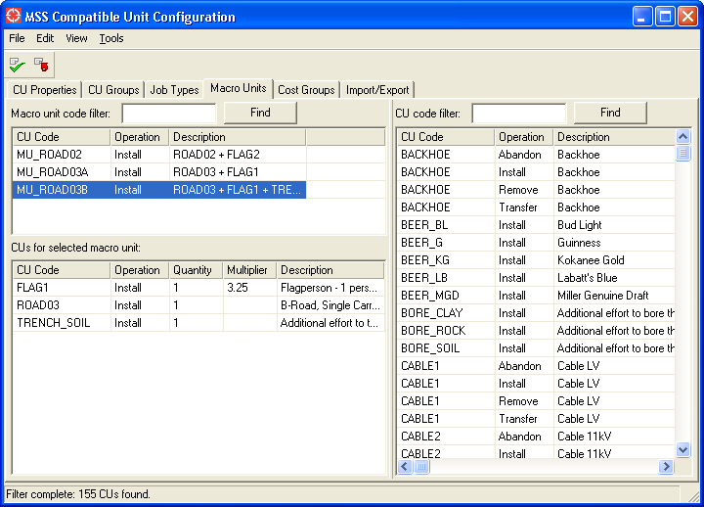

To use this tab to query for existing Macro Unit definitions:
- Enter a substring of the CU code to be searched for in the Macro unit code filter input field (or leave it blank to query for all Macro Units). The value entered here is automatically wild-carded at the end – for example, simply entering “E” will find all CU group definitions where the name starts with “E”.
  - Note: in order for a CU to show up in this list, its Usage attribute must be set to Macro Unit. This can be done by editing any CU definition using the functions described on the CU Properties tab above.
  - Also, one or more operations must be defined for the Macro Unit. These operations are displayed in the resulting Macro Unit list.
- Press the Find button to populate the Macro Unit list with all matching results.
- Selecting an entry in the Macro Unit list will cause the CUs for selected macro unit list to show all CU definitions that exist in the selected Macro Unit.

To add a new CU definition to the selected Macro Unit:
- Use the right portion of the menu to set a CU code filter, and perform a query to populate the Candidate CU list. Note that the usage of this filter is the same as for the CU definition query described for the CU Properties tab above.
- Select one or more CU definitions in the Candidate CU list to be added to the selected group.
- Right-click in the Candidate CU list, and perform the Add CUs To Macro Unit function.
- When added, the new CU reference will default to a Quantity of 1 and a blank Unit Multiplier. It is possible to change either of these values by double-clicking on the entry in the CUs for selected macro unit list, which will activate an object editor for the CU-MU relationship record.
  - Note that it is not appropriate to define a Unit Multiplier for many types of CUs – for example, a CU that is costed on a “per meter” basis should not have a Unit Multiplier specified here, and instead the user should be able to set the Unit Multiplier based on the actual length of the feature they are creating in their design.
  - However, it is appropriate in some cases – for example, if the installation of a given facility will require the use of two bucket trucks for 7.5 hours each, it is suitable to set the Quantity value to 2, and the Unit Multiplier value to 7.5.

To remove a CU definition from the selected Macro Unit:
- Select one or more CU definitions in the CUs for selected macro unit list to be removed from the selected Macro Unit.
- Right-click in the CUs for selected macro unit list, and perform the Remove CUs From Macro Unit function.

Cost Groups Tab
This tab allows alternate cost groups to be created and maintained. An alternate cost group provides a different set of material and/or labor cost information for an CU, which will override the default cost information set up on the CU Properties tab. Usage of alternate cost groups is described in the Compatible Unit Reporting section of the Estimator user guide document.

Here is a screen shot of this tab:

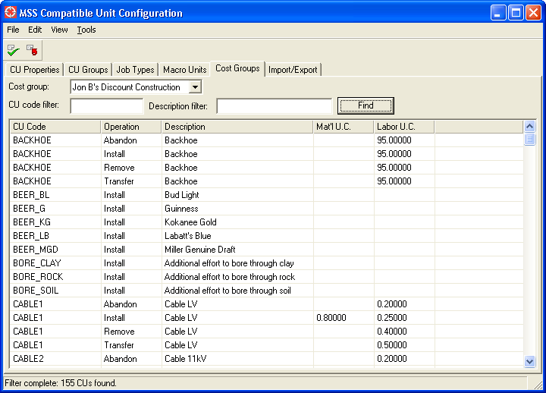

To use this tab to query for existing cost group definitions:
- Select a cost group in the Cost group pick-list. Note that if there are not any cost groups in your database, they can be created using the Edit → Edit CU Cost Groups… pulldown function.
- Enter values in the CU code filter and/or Description filter input fields – this functionality is the same as for the CU Properties tab described above.
- Press the Find button to populate the Cost group item list with all matching results.
  - Items which have an overriding cost value for either the material unit cost or the labor unit cost will have that value shown in the corresponding cell.
  - Items which do not have an overriding cost value will have a blank value in the corresponding cell.

To set the cost override information for any CU listed here:
- Double-click the item to be edited in the Cost group item list. This will activate an object editor for the CU Cost Group Item table.
  - If there was previous overriding cost information, the editor will be pre-populated with these values for material cost and labor cost. In this case, enter the updated values for these costs and press the Update button.
  - If there was no previous overriding cost information, the values for material cost and labor cost will be blank. In this case, enter the values for these costs and press the Insert button.

Import/Export Tab
This tab is used to specify which information should be exported using the File → Export CU Definitions… pulldown function. Here is a screen shot of this tab:

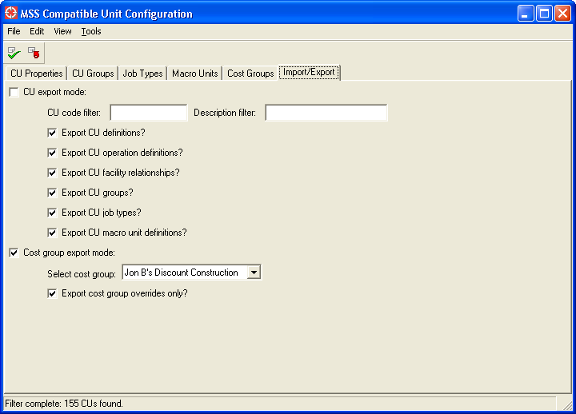

Here is a description of the functions available on this tab:
- CU export mode: selecting this checkbox will cause CU definitions to be exported. Note that this is mutually exclusive with the Cost group export mode checkbox. When this is selected, the following options can be specified:
  - CU code filter and Description filter: these input items allow the export to be limited to only those CU definitions that match this filter – if not entered, all CU definitions will be exported. Usage of these fields is the same as described on the CU Properties tab above.
  - Export CU definitions?: if this is selected, CU definitions will be exported.
  - Export CU operation definitions?: if this is selected, CU operation definitions will be exported.
  - Export CU facility relationships?: if this is selected, CU facility relationships will be exported.
  - Export CU groups?: if this is selected, CU groups will be exported.
  - Export CU job types?: if this is selected, CU job types will be exported.
  - Export CU macro unit definitions?: if this is selected, Macro Unit definitions will be exported.
- Cost group export mode: selecting this checkbox will cause the selected CU cost group to be exported. Note that this is mutually exclusive with the CU export mode checkbox. When this is selected, the following options can be specified:
  - Select cost group: use this to specify which cost group is to be exported.
  - Export cost group overrides only: if this is selected, then only those CUs that have an overriding cost entered will be exported. Otherwise, all CUs will be exported. Note that choosing to export all CUs is a good way to get a blank sheet of information that can be edited to fill in cost override data when creating a new cost group.

Exporting CU Definitions
Once a suitable set of parameters has been specified on this tab, perform the File → Export CU Definitions… function to create an export file. The format of this file is a Comma Separated Vector (CSV) file, and therefore it can be easily edited using tools such as Microsoft Excel, and it is also suitable for data exchange with other systems (such as a Work Management System which may contain the master version of your CU configuration).
- Editing note: some editing tools (such as Microsoft Excel) may automatically add formatting to some data – for example, a CU code such as “012345” may be interpreted as a number by the editing tool, and it may therefore convert it to an integer – resulting in the loss of the leading zero. Therefore, caution should be used when editing these values manually, and you may need to use a simple text-based editor such as Emacs in order to preserve data as-is (without unwanted automatic formatting).

Importing CU Definitions
The file produced by the Export CU Definitions can be manually edited with updated values, as described in the following section – or, a completely new file can be created and imported, as long as it complies with the format described below. Use the File → Import CU Definitions… function to specify an import filename, and to read in data from that file to insert/update/delete various pieces of CU configuration information.

If errors are encountered during the import process, a description of the error is reported to the terminal. If more than a certain number of errors are found (based on the value of mss_cu_import_export_config_plugin.import_max_errors), the import process is stopped.

Import/Export File Format
The format of the import/export file is as follows: each line of the CSV contains a keyword as the first item, and related data as the second and subsequent items. The related data will be different for each keyword, and the following sections describe each different keyword and its related data.

Keyword: CU_EXPORT
- This is used to identify a given file as a CU data file, and it must be the first line in the file.
- Related data:
  - Column 2: version information. Currently, this must be “1”.
  - Column 3: file creation date/time.

Keyword: CU
- This is used to insert/update a CU definition. The CU code is used to try to identify an existing entry – if a matching record is found, it is updated; otherwise, a new record is inserted. The related data contains attributes of the CU definition.
- Related data:
  - Column 2: CU code
  - Column 3: Description
  - Column 4: Usage
  - Column 5: Dimensionality
  - Column 6: Effective Date (in mm/dd/yyyy format).
  - Column 7: Obsolete Date (in mm/dd/yyyy format).

Keyword: CU_RENAME
- This is used to change the CU code of an existing CU definition.
- Related data:
  - Column 2: Old CU code
  - Column 3: New CU code

Keyword: OP
- This is used to insert/update a CU definition operation. The CU code and Operation are used to try to identify an existing entry – if a matching record is found, it is updated; otherwise, a new record is inserted. The related data contains attributes of the CU operation definition.
- Related data:
  - Column 2: CU code
  - Column 3: Operation
  - Column 4: Material cost
  - Column 5: Labor cost

Keyword: FAC
- This is used to insert/update a CU facility relationship. The CU code, Operation, Partition Name and Table Name are used to try to identify an existing entry – if a matching record is found, it is updated; otherwise, a new record is inserted. The related data contains attributes of the CU facility relationship.
- Related data:
  - Column 2: CU code
  - Column 3: Partition Name (this is the internal name, such as “gis”)
  - Column 4: Table Name (this is the internal name, such as “pub_rest”)
  - Column 5: Operation
  - Column 6+: subsequent columns are interpreted as three-item groups to define attributes, as follows. There may be multiple groups, to define multiple attributes.
    - Column N: the keyword ATTR
    - Column N+1: Attribute Name (the internal name in your data model)
    - Column N+2: Attribute Value

Keyword: CU_GROUP
- This is used to insert/update a CU group definition. The name is used to try to identify an existing entry – if a matching record is found, it is updated; otherwise, a new record is inserted. The related data contains attributes of the CU group definition.
- Related data:
  - Column 2: Name
- Note that once this is encountered, all subsequent of CU_GROUP_ITEM and CU_GROUP_ITEM_DELETE keywords will refer to this CU group definition.

Keyword: CU_GROUP_RENAME
- This is used to change the name of an existing CU group definition.
- Related data:
  - Column 2: Old name
  - Column 3: New name

Keyword: CU_GROUP_END
- This marks the end of a CU_GROUP definition. All CU_GROUP_ITEM and CU_GROUP_ITEM_DELETE changes that relate to a particular group should occur between the CU_GROUP and CU_GROUP_END keywords for that group.

Keyword: CU_GROUP_ITEM
- This is used to add a CU definition to a group.
- Related data:
  - Column 2: CU code to be added to the group.

Keyword: CU_JT
- This is used to insert/update a CU job type. The name is used to try to identify an existing entry – if a matching record is found, it is updated; otherwise, a new record is inserted. The related data contains attributes of the CU group definition.
- Related data:
  - Column 2: Name
  - Column 3: Material Cost Multiplier
  - Column 4: Labor Cost Multiplier
- Note that once this is encountered, all subsequent of CU_JT_ITEM and CU_JT_ITEM_DELETE keywords will refer to this CU job type.

Keyword: CU_JT_RENAME
- This is used to change the name of an existing CU job type.
- Related data:
  - Column 2: Old name
  - Column 3: New name

Keyword: CU_JT_END
- This marks the end of a CU_JT definition. All CU_JT_ITEM and CU_JT_ITEM_DELETE changes that relate to a particular job type should occur between the CU_JT and CU_JT_END keywords for that job type.

Keyword: CU_JT_ITEM
- This is used to add a CU definition to a job type.
- Related data:
  - Column 2: CU code to be added to the job type.

Keyword: CU_MU
- This is used to insert/update child units related to a Macro Unit definition. The CU code and operation attributes are used to identify a CU operation definition – this CU operation definition must exist already (c.f. the CU and OP keywords), and the usage attribute of that CU definition record must be Macro Unit.
- Related data:
  - Column 2: CU code
  - Column 3: Operation
- Note that once this is encountered, all subsequent of CU_MU_ITEM and CU_MU_ITEM_DELETE keywords will refer to this Macro Unit definition.

Keyword: CU_MU_END
- This marks the end of a CU_MU definition. All CU_MU_ITEM and CU_MU_ITEM_DELETE changes that relate to a particular Macro Unit should occur between the CU_MU and CU_MU_END keywords for that Macro Unit.

Keyword: CU_MU_ITEM
- This is used to add a CU operation definition to a Macro Unit (or to update the relationship data for an existing CU-MU relationship, based on matching CU code and operation fields).
- Related data:
  - Column 2: CU code to be added to the Macro Unit
  - Column 3: Operation to be added to the Macro Unit
  - Column 4: Quantity
  - Column 5: Unit Multiplier

Keyword: COST_GROUP
- This is used to insert/update a CU cost group. The name is used to try to identify an existing entry – if a matching record is found, it is updated; otherwise, a new record is inserted. The related data contains attributes of the CU cost group.
- Related data:
  - Column 2: Name
- Note that once this is encountered, all subsequent of COST_GROUP_ITEM and COST_GROUP_ITEM_DELETE keywords will refer to this CU cost group.

Keyword: COST_GROUP_RENAME
- This is used to change the name of an existing CU cost group.
- Related data:
  - Column 2: Old name
  - Column 3: New name

Keyword: COST_GROUP_END
- This marks the end of a COST_GROUP definition. All COST_GROUP_ITEM and COST_GROUP_ITEM_DELETE changes that relate to a particular group should occur between the COST_GROUP and COST_GROUP_END keywords for that group.

Keyword: COST_GROUP_ITEM
- This is used to add a CU cost group item to a group (or to update existing information, based on matching CU code and operation values).
- Related data:
  - Column 2: CU code
  - Column 3: Operation
  - Column 4: Material cost
  - Column 5: Labor cost

Keyword: CU_DELETE
- This is used to delete an existing CU definition.
- Related data:
  - Column 2: CU code to be deleted.

Keyword: OP_DELETE
- This is used to delete an existing CU operation definition.
- Related data:
  - Column 2: CU code for which an operation is to be deleted.
  - Column 3: Operation to be deleted.

Keyword: FAC_DELETE
- This is used to delete an existing CU facility relationship.
- Related data:
  - Column 2: CU code for which a facility relationship is to be deleted.
  - Column 3: Partition Name (this is the internal name, such as “gis”)
  - Column 4: Table Name (this is the internal name, such as “pub_rest”)
  - Column 5: Operation for which a facility relationship is to be deleted.

Keyword: CU_GROUP_DELETE
- This is used to delete an existing CU group definition.
- Related data:
  - Column 2: Name of CU group definition to be deleted.

Keyword: CU_GROUP_ITEM_DELETE
- This is used to remove a CU definition from the current group (c.f. the CU_GROUP keyword).
- Related data:
  - Column 2: CU code to be removed from this group.

Keyword: CU_JT_DELETE
- This is used to delete an existing CU job type.
- Related data:
  - Column 2: Name of CU job type to be deleted.

Keyword: CU_JT_ITEM_DELETE
- This is used to remove a CU definition from the current job type (c.f. the CU_JT keyword).
- Related data:
  - Column 2: CU code to be removed from this job type.

Keyword: CU_MU_ITEM_DELETE
- This is used to remove a CU operation definition from the current Macro Unit (c.f. the CU_MU keyword).
- Related data:
  - Column 2: CU code to be removed from this Macro Unit.
  - Column 3: Operation to be removed from this Macro Unit.

Keyword: COST_GROUP_DELETE
- This is used to delete an existing CU cost group.
- Related data:
  - Column 2: Name of CU cost group to be deleted.

Keyword: COST_GROUP_ITEM_DELETE
- This is used to remove a CU operation definition from the current cost group (c.f. the COST_GROUP keyword).
- Related data:
  - Column 2: CU code to be removed from this cost group.
  - Column 3: Operation to be removed from this cost group.

Configuring Facility Definitions
A facility definition represents information to inform the Estimator application that a given table in a given partition is “CU-enabled” – that is, it is possible to relate CUs to records in this table so that a given CU can automatically set attributes for its associated record.

As system administrator, you are responsible for configuring these facility definitions through the use of Magik code. The classes and methods described in this section allow you to do this.

mss_cu_facility_definition.new(table_code, partition_name, table_name, attribute_names)
- Creates a new mss_cu_facility_definition object with the following parameters:
- TABLE_CODE: a unique integer. It does not matter what value you choose, but it must be unique.
- PARTITION_NAME: a symbol which is the partition name that holds the table being defined as CU-enabled.
- TABLE_NAME: a symbol which is the name of the table being defined as CU-enabled.
- ATTRIBUTE_NAMES: a vector of symbols which represent the individual attributes of this table which can have attribute values set by a CU.

mss_cu_facility_definition.clear_cache()
- Clears all mss_cu_facility_definition records defined in your image.

Typically, these facility definitions can be managed with a single Magik code file which performs a mss_cu_facility_definition.clear_cache() at the start, followed by multiple mss_cu_facility_definition.new() calls to create one facility definition for each table of interest.

The values defined here form an integral part of your CU configuration information.
- There is no practical reason to change a TABLE_CODE value, and once defined for a particular table, this value should never be changed (unless you also perform corresponding manual edits to the mss_cu_facility_relationship table in the mss_config database, which makes use of this information).
- It is permissible to add new facility definitions at any time (with corresponding unique TABLE_CODE values).
- It is permissible to delete facility definitions – although there is no method that does this directly, it is effectively accomplished by simply removing the corresponding mss_cu_facility_definition.new() call from your Magik code file described above, and recompiling it (the call to clear_cache() will remove it, and it will not be recreated). However, before doing so, you should delete all facility relationships in your CU configuration which refer to this facility definition. This can be done using either the GUI tools or the import/export functions described in section 3.

List of Available Operations
The Estimator product is pre-configured with the following types of operations:
- Install
- Abandon
- Remove
- Transfer

It is possible for you to add to this list, update values in this list, or remove values from this list. However, it does require changes to multiple tables in multiple partitions – therefore, it is recommended that you decide on the list of operations that are suitable for your data model and installation at an early stage.

Once that is decided, you must change the following enumerators in various CASE tools, and perform applies to the partitions indicated.
- mss_cu_facility_relationship.operation
- mss_cu_operation_definition.operation
  - These tables are part of the Estimator data model in the mss_config_case CASE tool, and they use an enumerator named mss_cu_operation_type.
  - That enumerator should be changed as appropriate, and a CASE apply performed to the mss_config partition.
- mss_ptdef_cu_reference.operation
  - This table is part of the Toolbox data model in the mss_config_case CASE tool, and it uses an enumerator named mss_ptdef_cu_operation_type.
  - That enumerator should be changed as appropriate, and a CASE apply performed to the mss_config partition.
- mss_cu_reference.operation
  - This table is part of the Estimator data model in your application-specific CASE tool (such as for Gas, Land, or Electric data), and it uses an enumerator named mss_cu_operation_type.
  - That enumerator should be changed as appropriate, and a CASE apply performed to all client-specific database partitions which can contain CUs (such as Gas, Land, Electric, etc).

Configuring the Main Work Point Partition
It is possible that during the initial database setup of the Estimator (and Workspace) functionality, multiple database client-specific partitions were enabled for storing Compatible Unit information (c.f. the database setup described in section 2.2). This means that the tables named mss_cu_reference, mss_cu_reference_complex_key, and mss_cu_work_point now exist in multiple partitions.

The CU references for any object are always stored in the same partition as that object, and therefore it is normal for records to exist in any and all partitions that have the mss_cu_reference and mss_cu_reference_complex_key tables.

However, Work Points are always stored in a single partition. This is done to simplify the end-user process for creating Work Points, and to provide a consistent approach for auto-numbering Work Points and ensuring the uniqueness of Work Point Number values within a single design. Therefore, you must nominate a single partition as being the “main” partition for storing Work Point information.

From a technical standpoint, this is simple:
- Define the shared constant mss_cu_engine.work_point_view_name to be the name of the partition you choose.
- Perform related ACE/auth configuration to ensure that only this instance of the mss_cu_work_point table is available to end-users, and hide and/or deny access to the corresponding table in other partitions.
- Configure your workflows (as described in the Workspace administrator guide document) to ensure that this partition is a part of all workflows.

However, there are various factors which should be considered when making this decision:
- If it is not technically possible to use a pre-existing database partition, you may have to create a new one that is devoted solely to managing Work Points. This is a rather heavy-handed solution, but it is an option. An example where this may be required is if you cannot otherwise configure your workflows so that one database partition is always available (i.e. you have an Electric workflow that only gets writable access to the electric partition, and a Gas workflow that only gets writable access to the gas partition).
- What strategy is preferred for managing Work Points after a design is completed? A typical approach is to have a workflow state transition function that deletes Work Points at a late stage in the design process (i.e. during as-built updates). If there is a need to have them persist after the design is complete, then you may need to manage Work Point data in other ways to ensure that there is not a proliferation of design-specific Work Point data in the top version of your databases. For example:
  - Make them non-visible in all ACEs except for the ACE that your Workspace/Estimator users use.
  - Assign a custom draw method so that they are not visible if there is no active design.
  - Use a separate dedicated partition to store Work Points, and configure your Workspace application so that this partition is not posted to top (that is, the Work Point data will only be available when working in the design that it was created in).

Configuring the Estimator Environment
There are a number of configurable Magik methods that control various aspects of the Estimator environment for your users. Administrators should become familiar with the various methods described in this section. Note that this serves as an overview only - refer to the public comments available in the class browser for full details on all available methods.

dd_record_mixin.mss_cus_allowed?()
- Return true if a given record is permitted to have CU references associated with it.
- Default is to return true for any non-internal table that has the mss_cu_reference table in its database partition.

dd_record_mixin.mss_cu_default_install_facility_relationships?
- Default value is false.
- If this is set to true, then whatever facility relationships are defined for the default install operation (typically "Install") will automatically be applied to all other operations that are valid for a given CU.
- Setting this operation to true is a convenient way to reduce the overall configuration effort, since only the facility relationship (and associated attributes) for the “Install” operation must be maintained. However, when it is set to true, it is not possible to set different attributes for any other operation (for example, to have a given CU drive a different set of attributes for a “Remove” operation vs. an “Install” operation).

dd_record_mixin.mss_proposed_values_for_cu_definition(cu_def, operation)
- Return a property list of attribute names and values which should be set when adding a CU for the given mss_cu_definition record CU_DEF and OPERATION value to self.
- This probably does not need to be changed, as it is derived based on the CU configuration that you set using the Compatible Unit Configuration menu.
- However, there may be cases where it is useful to subclass this method to perform certain specific actions that are applicable to your data model.

dd_record_mixin.mss_custom_proposed_values_for_cu_facility_relationship(
fac_rel, operation, pl)
- Called by the mss_proposed_values_for_cu_definition() method, this can be used to set additional attribute values in property list PL based on the mss_cu_facility_relationship record FAC_REL and OPERATION.
- A typical usage would be to set the status attribute of self appropriately, based on the operation being performed.

dd_record_mixin.mss_cu_point_geometry(_optional prop_geoms)
- This is used by processing which tries to automatically select a work point, based on a point-type of geometry of self.
- Default is to simply return the first point-type geometry found in PROP_GEOMS (which may be a property list of proposed values), or to return the first point-type geometry of self directly.
- May be subclassed to only examine specific geometry fields, or to derive a geometry from a related record.

dd_record_mixin.mss_cu_chain_geometry(_optional prop_geoms)
- Same as mss_cu_point_geometry(), except it looks for chain geometries.

dd_record_mixin.mss_cu_area_geometry(_optional prop_geoms)
- Same as mss_cu_point_geometry(), except it looks for area geometries.

dd_record_mixin.mss_cu_geometry(geom_category, _optional prop_geoms)
- This is the internal method call by all of the above methods to locate geometries of the given GEOM_CATEGORY (:point, :chain, or :area), and it may be subclassed/redefined in conjunction with those methods.

dd_record_mixin.mss_cu_work_point_candidate(_optional prop_geoms)
- Return a candidate mss_cu_work_point record to use for associating new CU references to self. PROP_GEOMS may be a property list of proposed geometry values.
- Default logic is as follows (subclass/redefine as necessary for your data model):
  - If there is a location geometry of a Work Point within a tolerance of self’s point geometry, use that.
  - If there is a route geometry of a Work Point within a tolerance of self’s chain geometry, use that.
  - If there is an extent geometry of a Work Point that surrounds of any of self’s geometry, use that.

dd_record_mixin.mss_cu_work_point_scan_tolerance(a_geometry)
- Used by the mss_cu_work_point_candidate() method to provide a tolerance distance to use when scanning for Work Points.
- Default is 20 m.

dd_record_mixin.mss_cu_work_point_candidate_for_point(point_geom)
- Performs spatial scanning for the nearest Work Point location geometry to the point geometry POINT_GEOM.

dd_record_mixin.mss_cu_work_point_candidate_for_chain(chain_geom)
- Performs spatial scanning for the nearest Work Point route geometry to the chain geometry CHAIN_GEOM.

dd_record_mixin.mss_cu_work_point_candidate_surrounding(a_geom)
- Performs spatial scanning for the Work Point area geometry to the surround the input geometry A_GEOM.

dd_record_mixin.mss_cu_unit_multiplier_for_definition(mss_cu_def)
- Return a default unit multiplier value to use for the mss_cu_definition records MSS_CU_DEF.
- If the dimensionality of that CU definition is Per Meter or Per Foot, and if self’s mss_cu_chain_geometry() isn’t unset, then return the length of that geometry in meters or feet (as appropriate).
- If the dimensionality of that CU definition is Per Square Meter or Per Square Foot, and if self’s mss_cu_area_geometry() isn’t unset, then return the area of that geometry in square meters or square feet (as appropriate).

dd_record_mixin.mss_process_cu_state_transition(cu_rec, a_transition)
- This method is designed for use in a state transition in a workflow (c.f. the Workflow administrator guide document).
- The purpose is to update the given mss_cu_reference CU_REC appropriately for the state transition A_TRANSITION.
- The default processing is the blank out the Operation value for Install-type CUs, and to delete all other CUs.

mss_cu_engine.view_name
- This shared constant defines the name of the database partition containing CU configuration information.
- Default is mss_config.

mss_cu_engine.spatial_object_controller_name
- This shared constant defines the name of the spatial object controller containing CU configuration information.
- Default is mss_config.

mss_cu_engine.default_install_operation
- This is used to identify the operation code which corresponds to installing new facilities. This has some level of importance for a few internal processes, because the install operation is going to be the most common operation for most design work, so it can be used to set default values accordingly.
- Default is “Install”.

mss_cu_engine.facility_require_all_attributes?
- This setting is used by the mss_cu_engine.cus_for_facility() method.
  - If it is false, then for a CU to be returned by that query, it is considered to PASS any attribute test for which it does not have a mss_cu_facility_attribute record defined.
  - If it is true, then it is considered to FAIL any attribute test in that case.
- For example, suppose a query for poles is done, where ATTR_FILTERS includes material="Wood". Also, suppose that the CU named PGENERIC does not have any attribute information associated with it for the material attribute.
  - If this is set to false, then PGENERIC would be included in the results of a material="Wood" query.
  - If it is set to true, then PGENERIC would not be returned.
- Default setting is true.

mss_cu_engine.macro_unit_usage_value
- The name of the value in the Usage enumerator of the mss_cu_definition table used to identify a Macro Unit.
- Default is “Macro Unit”.

mss_cu_engine.work_point_view_name
- The name of the database view used to store mss_cu_work_point records.
- Default is :gis.

mss_cu_engine.active_job_type(optional cur_design, mode)
- Return the CU job type (mss_cu_job_type) record to use for the design CUR_DESIGN – if not provided, that defaults to the active design.
- MODE may be :cu_cost (the default) for determining a type for CU cost estimating purposes, or :cu_query for determining a type for CU querying purposes.
- The default behavior is to simply call the cu_job_type_for_workspace_job_type() method described below.

mss_cu_engine.cu_job_type_for_workspace_job_type(wjt)
- This method is used to convert a MSS Workspace job type (mss_job_type) record given by WJT to a corresponding CU job type (mss_cu_job_type) record.
- By default, this is done simply by matching the name of the mss_job_type to the name of the mss_cu_job_type, thus resulting in a one-to-one correspondence.
- This method may be overridden to relate these records in any manner that is appropriate for your installation.

mss_cu_engine.mss_wp_auto_anno_offset(wp)
- Return a length value used to provide an offset for creating annotation.
- Used by the mss_cu_engine.mss_wp_multi_create() method, which creates multiple Work Points in a single operation.
- Default is 5.0 m.

mss_cu_summary_engine.export_raw_results(f)
- Used to export CU information in a given design in a raw form to output stream F.
- This is designed to export CUs to an external system, and therefore it may be redefined to suit the particular needs of any external system.
- Default is to simply create one line of information per CU in a comma-separated format.

mss_cu_report_plugin.excel_field_formats
- A property list of field formatting information used to set Excel column properties in the spreadsheet generated by the Compatible Unit Reporting menu.

mss_cu_report_plugin.excel_pagesetup_formats
- A hash table of page setup formatting information used to set Excel page setup properties in the spreadsheet generated by the Compatible Unit Reporting menu

mss_cu_report_plugin.excel_filename_for_design(ad)
- The filename to use when exporting CU data for the design AD to Excel.
- Default is to return unset, indicating that no filename will be used automatically – in this case, the user must choose to save the resulting Excel report if they intend to permanently keep that information.
- May be redefined to either derive a standard name based on the job/design name, or to prompt the user for a name.

mss_cu_general_config_plugin.max_to_report
- This shared constant controls the maximum number of records to be displayed in various lists managed by the Compatible Unit Configuration menu.
- Default is 500.

mss_cu_import_export_config_plugin.csv_date_format
- This shared constant controls the date format used to import/export date information.
- Default is “#m/#d/#Y”.

mss_cu_import_export_config_plugin.csv_separator
- This shared constant controls the character used to delimit fields in the CSV file.
- Default is %, (the comma character).

mss_cu_import_export_config_plugin.csv_quote_char
- This shared constant controls the character used as the quote character in the CSV file. If any output field contains the separator character or the quote character itself, then the whole field is enclosed with quote characters.
- Default is %” (the double-quote character).

mss_cu_import_export_config_plugin.import_max_errors
- This shared constant controls the number of import errors permitted before import processing stops.
- Default is 10.

mss_cu_import_export_config_plugin.import_check_attribute_match_for?(fd)
- By default, when importing any ATTR keyword, the actual attribute value is validated to ensure that it exists in the enumerator (if the field is enumerated).
- This may be redefined to return false for any field descriptor FD. This may be required if, for example, you have complex match_string() methods which take into consideration the values of multiple fields on a given record, in which case trying to validate the enumerator value for a single attribute at a time may fail.

mss_cu_import_export_config_plugin.format_cu_code_for_export()
mss_cu_import_export_config_plugin.format_cu_code_for_import()
- These methods may be used to provide additional formatting for a CU code value as it is being exported and imported.
- The intended use is to work around auto-formatting features in Microsoft Excel which can cause data to be changed unexpectedly.
- The default processing is to put a single-quote character in front of any CU code that starts with the zero character, so that it is not interpreted as a numeric value (thus causing the leading zero to be lost). This may be redefined as appropriate for your CU configuration.

mss_cu_import_export_config_plugin.format_facility_attribute_for_export()
mss_cu_import_export_config_plugin.format_facility_attribute_for_import()
- These methods may be used to provide additional formatting for a facility attribute value as it is being exported and imported.
- The intended use is to work around auto-formatting features in Microsoft Excel which can cause data to be changed unexpectedly.

mss_cu_operation_definition.material_cost_decimal_places
mss_cu_operation_definition.labor_cost_decimal_places
- These shared constants control the number of decimal places used in various GUIs to display the material cost and labor cost information for CU operation definition records.

mss_cu_holder.standard_sort_proc
- The procedure to use for sorted collections that contain mss_cu_holder records.
- This probably does not need to be redefined, but it may be done in conjunction with redefining various other sort-related methods described below.

mss_cu_holder.list_display_tree_column_widths()
mss_cu_holder.list_display_tree_column_headings()
mss_cu_holder.as_list_display_tree()
- This group of methods controls the display appearance of mss_cu_holder records being displayed in a simple list (such as the list of CUs in the Object Editor, or in the Compatible Unit Query tool).

mss_cu_holder.list_sort_key()
- A structure used by mss_cu_holder.standard_sort_proc to sort mss_cu_holder records being displayed in a simple list (such as the list of CUs in the Object Editor, or in the Compatible Unit Query tool).
- Default is to sort first based on CU code, then on Operation.

mss_cu_holder.report_display_tree_column_widths()
mss_cu_holder.report_display_tree_column_headings()
mss_cu_holder.as_report_display_tree()
- This group of methods controls the display appearance of mss_cu_holder records being displayed in the Compatible Unit Reporting menu.

mss_cu_holder.report_sort_key()
- A structure used by mss_cu_holder.standard_sort_proc to sort mss_cu_holder records being displayed in the Compatible Unit Reporting menu.
- Default is to sort first based on Report Work Point Number, then on CU code, then on Operation.

mss_cu_holder.report_work_point_number
- Return a work point number value to display on the Compatible Unit Reporting menu.
- By default, this is simply the work_point_number value, but this can be changed to use a derived value of some sort.

mss_cu_holder.work_point_number_sort_key()
- Used to define a structure used for sorting work points.
- Default is to break it into a vector of strings and numbers, and to sort based on the individual elements of that vector. This allows for numeric sorting if you choose to use numeric Work Point Number values, and string-based sorting otherwise.

mss_cu_holder.cu_code_sort_key()
- Used to define a structure used for sorting CU code values.
- Default is to simply treat it as a string – may be redefined in numeric sorting (or if combined string-number sorting) is more appropriate for your CU environment.

mss_cu_work_point.derived_work_point_number()
- Return a string to construct the work_point_number attribute.
- By default, this is the concatenation of the prefix and number attributes for a mss_cu_work_point record.

Configuring Toolbox Extensions for the Estimator
If your application uses the Toolbox by Minto Spatial Solutions, then the module named mss_cu_ptrule_extensions should be loaded as part of your image build. This module is provided in the mss_cu subdirectory of the MSS product.

By loading this module, various additions and changes are performed to core Toolbox functionality to allow the placement of Compatible Units to be integrated with your placement rules.

Adding CU References to Pointing Rule Definitions
The Toolbox data model already has support for working with Compatible Units, but there is no code in the core Toolbox product that uses that part of the data model. Loading the mss_cu_ptrule_extensions module will enable the use of any CU references that you define for any pointing rule definition.

Creating a CU reference for a pointing rule definition is done using the Pointing Definition Configuration menu – refer to the Toolbox administrator guide for details about that menu. To add a CU reference for any pointing rule definition:
- Activate the editor for the desired pointing rule definition.
- Click on the “CU References” join field, and use the join field editor to activate the editor for the “Ptdef CU Reference” table.
- Enter the various attributes (CU Code, Operation, Quantity, and Unit Multiplier.
- Press the Insert button on the editor.

Once these CU references are created, those CUs will automatically be the default set of CUs to be associated with any record placed with the corresponding pointing rule. Users can change these defaults using the “Edit CUs” function on the Toolbox Attribute Prompter (see the Estimator user guide for additional details on this topic).

Placing Work Points with the Toolbox
You may choose to include a set of pointing rules to automate the placement of Work Points. This is described in more detail in the section of the Estimator user guide named “Placing Work Points with the Toolbox”.

An example set of pointing rules to accomplish this is provided in the following file in the mss_cu_work_point_ptrule module: resources\base\data\workpoint_pointing_rules.xml. Use the Pointing Definition Configuration menu to import this XML file into your pointing definition database. Refer to the Toolbox administrator guide for details about using the Pointing Definition Configuration menu.

