The Estimator by Minto Spatial Solutions:
User Guide

Version: Core Spatial Technology 4.2.0 (SWAF)

Updated: 2011/04/25

Copyright Information

Copyright © 2005-2011 Minto Spatial Solutions Ltd. All rights reserved.

Trademarks and Registered Trademarks

Smallworld is a registered trademark of General Electric Company.
Microsoft Excel is a registered trademark of Microsoft Corporation.

Table of Contents

1 Overview 4
1.1 Document History 4
2 Working with Compatible Units 5
2.1 Changes to Object Editors 5
2.2 Compatible Unit Query Tool 8
2.3 Toolbox Attribute Prompter 11
3 Working with Work Points 12
3.1 Placing Work Points with the Toolbox 12
4 Compatible Unit Reporting 14
4.1 Working with Cost Groups 17
4.2 Assigning Work Points to Compatible Units 18

Overview
The Estimator by Minto Spatial Solutions is a productivity tool that simplifies the process of recording the units of work that comprise a proposed design. With an approach based on the use of Compatible Units, you can use the Estimator to gather the Compatible Units for a design, and perform any of the following functions:
- Produce standardized Compatible Units reports.
- Export these Compatible Units to a Work Management System to perform detailed cost estimating.
- Perform basic cost estimating entirely within the Estimator application.
- Analyze different cost scenarios – such as the use of alternate designs or cost tables associated with different contractors – to minimize the total cost of a design.

The Estimator is designed as an extension to the Workspace by Minto Spatial Solutions. Therefore, by using this tool, you can automatically build upon the job, design, and workflow life-cycle management that is provided by the Workspace.

The various functions described in this document are available when working with Smallworld Core Spatial Technology 4.2.0, using the Smallworld Application Framework (SWAF) environment.

Document History

Date | Name | Description
2007/02/20 | Tim Minto | - Created (from V4.0 version of document).
2008/05/31 | Tim Minto | - Updated to V4.1.1.
2011/04/25 | Tim Minto | - Updated to V4.2.0.

Working with Compatible Units
The Estimator provides tools that allow Compatible Units (CUs) to be easily associated with any feature in a design in the Workspace application. Within the Estimator application, a Compatible Unit represents a unit of work that has material or labor cost associated with it. A CU has the following properties:
- A CU code to uniquely identify it. For example, the CU code “P301” may be used to designate a 30 foot, class 1 pole.
- An operation, such as Install (for installing a new pole), or Remove (for removing an existing pole).
- A quantity. For example, a 75 kVA three-phase transformer installation may consist of 3 individual single phase units with CU code “XFM25”, and in this case the quantity is 3. Note that in most cases, CUs will have a quantity of 1.
- A unit multiplier. Many CUs represent a per-unit cost – for example, the cost for a CU representing a distribution pipe may be expressed as a cost per meter. In this case, the unit multiplier represents the length (in meters) of the distribution pipe – the longer the pipe, the more it will cost.
- A cost per unit. For example, a 60mm diameter distribution pipe will typically have a lower cost per unit than a 88m diameter pipe. A CU cost may have a material component, a labor component, or both.
- A set of CUs may be grouped by Work Point – refer to section 3 for a discussion of this topic.

As an example, consider the case of a pole replacement activity, which may have the following CUs:
- A CU for the new pole itself. For example, if installing a new 35 foot class 1 pole, this may be “P351 Install”.
- A CU for the removal of the old pole. For example, if replacing a 30 foot class 1 pole, this may be “P301 Remove”.
- A Labor CU for the install and/or removal (depending on your system configuration, the labor costs may be grouped with the material CUs, or there may be separate CUs for labor costs).
- Additional install CUs to represent crossarms, guy wires, and anchors for the new pole.
- A labor CU for a flagperson needed to divert traffic for 2 hours.

In the above example, each CU will have an associated cost, and the estimated total cost for a design can be determined by summarizing all of the CUs for that design.

Note that the complete list of available CUs will be determined by your system administrator. For details on how to configure available CUs, refer to the document named “The Estimator by Minto Spatial Solutions: Administrator Guide”.

Changes to Object Editors
The following screen-shot shows the changes to Object Editors in your application to enable the use of Compatible Units:

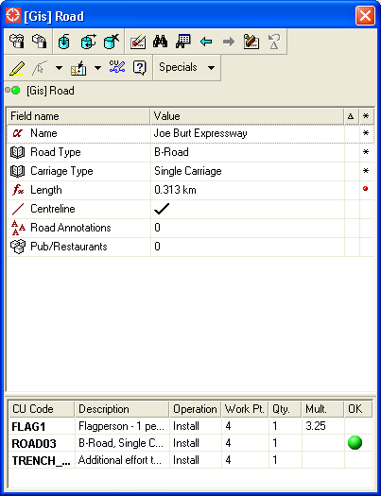

There are two notable additions:
- The toolbar has an Edit Compatible Units icon button - . Pressing this button will activate the Compatible Unit Query tool (described in section 2.2).
- The lower section of the editor contains a CU List that shows all CUs that are associated with the current object in the editor.
  - Note that your system administrator may place these additional components elsewhere within the Object Editor GUI – for example, the CU List may be placed on a separate tab.

The CU List has the following notable properties:
- CUs that have been added in the active design are shown in bold. Pre-existing CUs (that is, CUs that have been added in a previous design) are shown with a normal font.
- The Operation, Work Point, Quantity, and Unit Multiplier attributes can be modified either by typing directly in the corresponding cell in the CU List, or by activating the Compatible Unit Query tool.
- The CU Code attribute can only be changed using the Compatible Unit Query tool – in addition to the icon button described above, this can be activated by double-clicking any row in this list.
- In many cases, the Unit Multiplier can be automatically calculated if its value is left blank. For example, for a distribution pipe that has a “per meter” CU, its cost can be automatically calculated based on the geometric length of the route geometry for the pipe. Alternatively, you may choose to enter an explicit Unit Multiplier value if the geometric length does not exactly match the length of pipe that should be allocated for the design.
- Your system administrator will configure some CUs to also automatically set attributes of the object being edited. For example, when editing a new pole, adding the “P301 Install” CU may automatically set the height attribute to 30, and the class attribute to 1.
  - In this case, the OK attribute will display a green circle if the attributes of the record being edited match the attributes of the CU
  - It will display a red circle if the attributes are in conflict. For example, if the “P301 Install” CU is associated with a height attribute of 30, and the editor has been used to set the height of the pole being edited to 35, then this is a conflict.
  - If the CU does not drive any attributes of the object being edited, then the OK attribute is simply left blank.

Note that any changes that are made in the CU List are only proposed changes, and the database is not actually updated until the Insert or Update button is pressed on the Object Editor.

Compatible Unit Query Tool
After performing the Edit Compatible Units function from the Object Editor, the following menu is displayed:

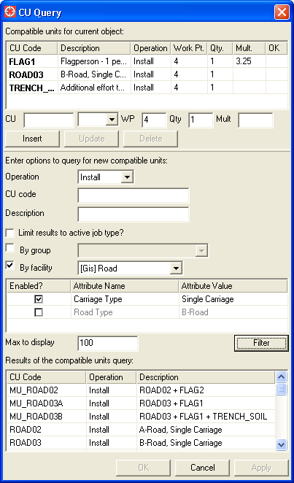
This menu consists of the following components:
- The top portion of the menu is the CU List. When the menu is initially activated, this will display the current list of CUs for the object being edited. This list of CUs can be changed using the functions described below.
- The middle portion of the menu contains the Query Parameters: a set of input fields that allow CUs to be queried in a variety of ways.
- The lower portion of the menu contains the Query Results of the most recent CU query.

To perform a CU query, any of the following values may be specified in the Query Parameters:
- Operation: the results of the query will be limited to only those CUs that are applicable to the operation selected here.
  - Your system administrator will define the allowable operations – typical values include Install, Abandon, Remove, and Transfer.
  - Some operations will not be applicable for some CUs. For example, depending on your system configuration, it may not be permissible to Abandon a transformer bank (although it may be permissible to Remove it instead).
- CU code: a substring of the CU code value may be entered here.
  - This value is automatically wild-carded at the end: for example, entering “P3” here will allow P301, P302, and P351 to be returned in the results of the query.
- Description: a substring of the CU description value may be entered here.
  - As for the CU code field, his value is automatically wild-carded at the end.
- Limit results to active job type?: your system administrator may organize CUs by job type, and if this check box is selected, then the job type for your active design will be used to limit the query results to only include CUs associated with that job type.
- By group: your system administrator may organize CUs by group, and this pick-list can be used to limit the query results to the group that you select here.
- By facility: your system administrator may organize CUs by facility, and this pick-list can be used to limit the query results by facility type.
  - If this option is selected, then the Attribute List (immediately below the By facility pick-list) will become enabled.
  - All attributes that your system administrator has defined for this facility type will be displayed. Selecting the Enabled? checkbox will allow you to also select an Attribute Value for the selected Attribute Name, and this value will be used to further limit the query.
  - In the above screen-shot, note that the Carriage Type attribute has been enabled, with a value of Single Carriage. Also note that the Query Results for this query only displays roads that are Single Carriage roads.
- Max to display: the number of results shown in the Query Results list will be limited to this number of records.
- Filter: after entering all desired Query Parameters, press the Filter button to perform the query and populate the Query Results list.

To insert, update, or delete Compatible Units for the current object being edited, the CU List upper portion of the menu includes input fields for the following CU attributes:
- CU Code
- Operation
- Work Point
- Quantity
- Unit Multiplier

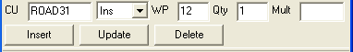

To insert a new Compatible Unit for the current object being edited:
- Enter the CU Code and Operation attributes. This can be done either by typing in values into these fields, or by double-clicking the desired CU in the Query Results list.
  - Usage note: the CU Code attribute must be entered. It is permitted to have a blank value for the Operation, but doing this is considered to be a “data maintenance” type of activity (i.e. to correct missing data). If a CU does not have an Operation value, then it also does not have any cost associated with it, and it does not normally show up in reports unless specifically requested (see section 4 for further details about CU reporting).
- Optionally, enter Work Point, Quantity, and Unit Multiplier values.
- Press the Insert button.

To update a Compatible Unit for the current object being edited:
- Select the CU to be updated in the CU List. This will cause the field values for the various input fields to be set to the current values for this CU.
- Update any fields that you wish to change. As for the insert functionality described above, double-clicking the desired CU in the Query Results list will cause the CU Code and Operation to be set automatically.
- Press the Update button.

To delete a Compatible for the current object being edited:
- Select the CU to be deleted in the CU List.
- Press the Delete button.

Once you have finished manipulating all CUs, perform any of the following functions (located at the bottom of the menu):
- OK: this transfers the proposed CU changes back to the CU List of the Object Editor, and closes the Compatible Unit Query tool.
- Cancel: this closes the Compatible Unit Query tool without making any proposed CU changes.
- Apply: this transfers the proposed CU changes back to the CU List of the Object Editor, and leaves the Compatible Unit Query tool open for making further changes.

Toolbox Attribute Prompter
If your application uses the Toolbox by Minto Spatial Solutions, then the attribute prompter used by the Toolbox will also include a CU List section, as seen in the following screen shot:

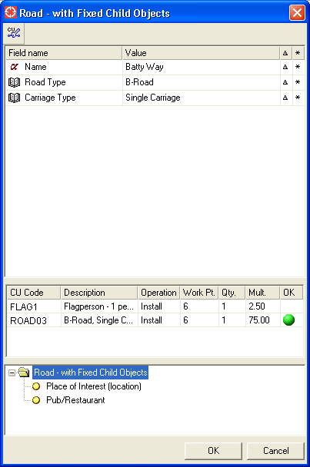

The usage of this CU List is identical to the usage described for Object Editors in section 2.1. Note that your system administrator may create Toolbox pointing rules that are pre-configured with common combinations of CU values.

Working with Work Points
Many Work Management System (WMS) applications have the capability to organize Compatible Units into a series of Work Points. For example, if a design job requires the placement of five new poles, then the CUs associated with each pole may be placed at Work Points numbered from 1 to 5 respectively. If there is also a span of conductor being placed from the first to last pole, the CUs associated with that conductor may be placed at Work Point 6.

The use of Work Points is optional: it is possible to simply leave the Work Point attribute blank for all CUs that are placed in a design. However, if you do choose to make use of Work Points, this section describes how they can be used within the Estimator application.

One approach is to simply manually enter Work Point values for each CU that is placed in a design. This is done by typing in the Work Point attribute in any of the various CU List input items described in sections 2.1 (Object Editors) 2.2 (Compatible Unit Query tool), and 2.3 (Toolbox Attribute Prompter).

Another approach (which may or may not be enabled by your system administrator) is to create Work Point objects as part of your design. These Work Point objects have the following properties:
- Prefix (an optional 4 character field).
- Number (a 16 character field which is typically numeric, but which does not have to be).
- Work Point Number (the concatenation of the Prefix and Number fields).
  - The Work Point Number must be unique within a design.
- Location geometry (for point-type Work Points).
- Route geometry (for chain-type Work Points).
- Extent geometry (for area-type Work Points).
- Annotation geometry (to annotate the Work Point Number on construction plots).

Work Point objects may be created by the Object Editor. If your application uses the Toolbox by Minto Spatial Solutions, then a set of Toolbox pointing rules may also be defined that allow easy creation of a series of Work Points with a single operation. See section 3.1 for details.

Once Work Points have been created, CUs that are created during the design process will automatically be associated with a nearby Work Point. Also, updating the Work Point Number attribute of any Work Point will automatically update the Work Point attribute of any CU associated with that Work Point.

The precise rules for how CUs are automatically associated with Work Points will depend on the setup provided by your system administrator. Typically, these rules will confirm to guidelines such as these:
- When placing a point-type of feature such as a pole, the CU will be associated with the nearest Work Point with a location geometry found within a tolerance distance of the location for the point-type feature.
- When placing a chain-type feature such as a conductor, the CU will be associated with the nearest Work Point with a route geometry found within a tolerance distance of the midpoint for the chain-type feature.
- If the above rules do not locate a Work Point, then look for a Work Point with an extent geometry that surrounds the feature being placed.

Placing Work Points with the Toolbox
If your application uses the Toolbox by Minto Spatial Solutions, then your system administrator may include any (or all) of the following pointing rules in your Toolbox configuration:
- Work Point – extent geometry
- Work Point – point geometry
- Work Point – route geometry
  - These rules may be used to place a single Work Point.
  - When using any of these rules, the Custom tab on the Toolbox menu will display the following panel:

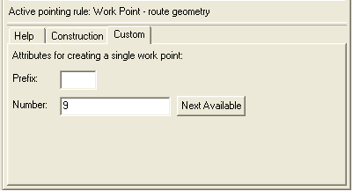

  - Use this panel to type in the Prefix and Number attributes for the Work Point you are creating.
  - Use the Next Available button to automatically calculate the next available Number value, to ensure that no Work Points in the current design have the same Work Point Number value. You may enter a numeric value in the Number field before performing this function, and the search will be limited to Work Point Numbers above that value.
    - For example: suppose the current design has work points numbered 1, 2, 3, 10, 11, and 12. Leaving the Number field blank, or entering a value of 1, 2, or 3, will cause the Next Available function to return 4. Entering a value of 4 to 9 will cause the Next Available function to simply leave that value unchanged. Entering a value of 10, 11, or 12 will cause the Next Available function to return 13.

- Multi Work Point (multiple points, multiple spans)
- Multi Work Point (multiple points, no spans)
- Multi Work Point (multiple points, single span)
- Multi Work Point (no points, multiple spans)
  - These rules may be used to place a set of Work Points with a single action.
  - These rules will use the trail to create the following:
    - Work Points with a location geometry: one per trail vertex if a “multiple points” pointing rule is used.
    - Work Points with a route geometry: one between each trail vertex if a “multiple spans” pointing rule is used; or one between the first and last trail vertices if a “single span” pointing rule is used.
  - When using any of these rules, the Custom tab on the Toolbox menu will display a panel similar to the one described above for placing single Work Points. One key difference is that these multi-placement rules will automatically choose the next available Work Point Number for each Work Point created.

Compatible Unit Reporting
At any point during the design process, the Compatible Unit Reporting menu can be used to review a summary of the CUs that comprise the design. Your system administrator will typically provide access to the Compatible Unit Reporting menu using a pulldown menu function in your main GIS application. Here is a screen shot of this menu:

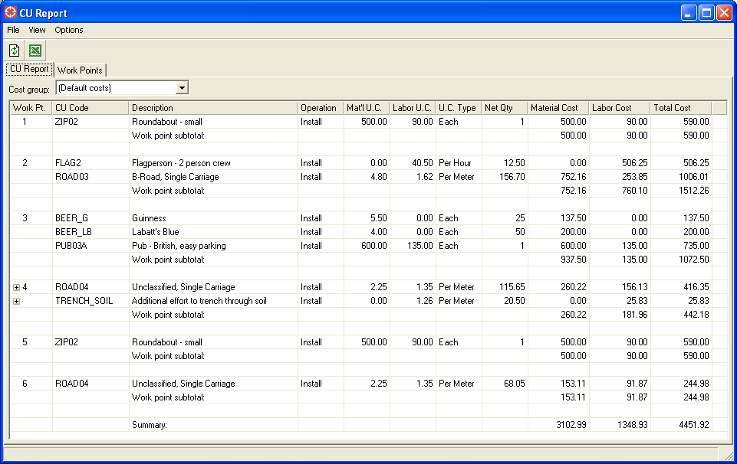

This menu consists of the following components:
- The Pulldown menu functions and Toolbar are at the top of the menu. All of these functions are described below.
- Immediately below the toolbar, the Cost group pick-list allows alternate cost group information to be used. Usage of alternate cost groups is described in section 4.1.
- The body of the menu includes the following tabs:
  - The CU Report, which displays all CUs in the design.
    - The default format and ordering of the columns that comprise this list will be determined by your system administrator. You can change the columns displayed by right-clicking in the header of this list, and you can change the ordering of columns by dragging a header to a different position.
    - Double-clicking on any entry in this list will activate the editor for the associated facility, so that you can edit the properties of that facility and/or the CUs associated with that facility.
  - The Work Points tab contains functions to assist in automatically assigning Work Point values to CUs: see section 4.2 for details.
The following Pulldown menu functions are available:

Function name | Button | Description
File Pulldown
Export to Excel |  | Produces a formatted report to transfer the contents of the CU Report to Microsoft Excel.
Close |  | This closes the Workspace Manager menu.
View Pulldown
Refresh |  | Recalculates the CU Report, based on all CUs in the current design, and on the parameters specified in the Options pulldown menu.
Options Pulldown
Combine Similar CUs? |  | Selecting this option will cause all CUs with the same CU Code and Work Point Number values to be grouped into a single line-item in the CU Report.  In this case, the group is shown with a “+” indicator in the CU Report, and the individual CUs that comprise this group can be viewed by pressing the “+” indicator to expand the list. An example of this is seen for Work Point Number 4 in the screen shot above.
Include CUs With No Operation Value? |  | Selecting this option will cause all CUs with a blank operation value to be listed in the report. Normally, they are not shown (since there is no cost values associated with CUs that do not have an operation). However, this may be useful to assist in finding data errors (such as a CU which should have an operation of “Install”, but which was instead left blank).
Include Parent Designs? |  | Selecting this option will cause all CUs for all parent designs to also be included in the report.
Work Point Subtotals? |  | Selecting this option will cause a subtotal cost to be written out to the CU Report for each different Work Point Number

If you make any changes in your design which affect the CUs and cost, simply perform the Refresh function to see the impact of those changes. Examples of this may include:
- Deleting or adding CUs to the design.
- Updating a CU Code value – for example, to review the cost difference between using a 60mm pipe compared to an 88mm pipe.
- Updating the properties of a CU – for example, lengthening the proposed route of pipe from 20 meters to 22 meters, which will increase the total cost of a “per meter” type of CU by 10%.
As an example of how these various options and display columns can be easily reformatted, here is a screen shot of the same design with the following changes:
- De-select the Combine Similar CUs? option.
- De-select the Work Point Subtotals? option.
- Hide the Description and Unit Cost Type columns (by right-clicking on the header).

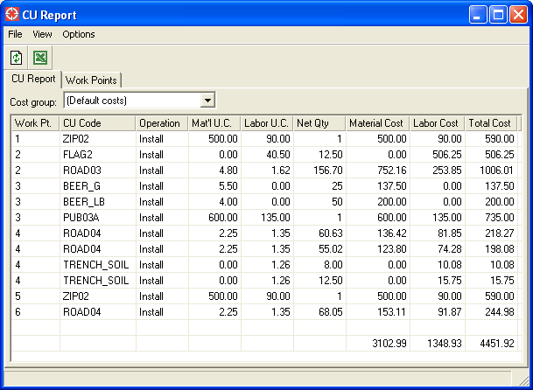

Working with Cost Groups
Your system administrator may choose to define different cost groups so that alternate cost scenarios can be reviewed. Examples of this may include:
- Different cost groups for different fiscal years.
- Different cost groups for different contractors.

If any alternate cost groups have been defined, you can simply change the Cost group input field to a different value, and the results will be automatically updated. For example, consider the impact of using the “Jon B’s Discount Construction” group (as compared to the default costs of doing this construction in-house):

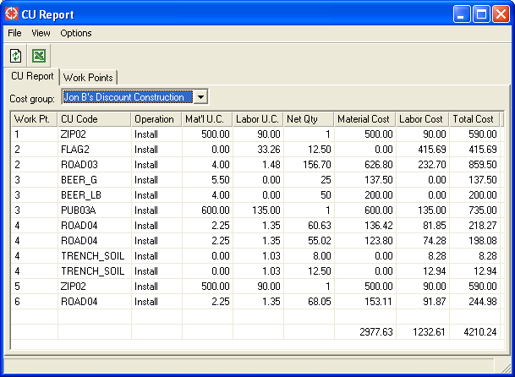

Note that “Jon B’s Discount Construction” is able to provide a lower cost for some items such as “FLAG2” and “TRENCH_SOIL”. As a result, the total estimated design cost is lowered from $4451.92 to $4210.24.

Assigning Work Points to Compatible Units

Section 3 of this document describes how CUs are automatically associated with Work Points when features with CUs are created. However, the functionality described in that section assumes that Work Point features have already been created by the designer. Different utilities may have different business practices when working with Work Points – some may choose to only assign Work Point values after a design has been laid out. To enable this approach, the following functions have been created on the Work Points tab of the Compatible Unit Reporting menu:

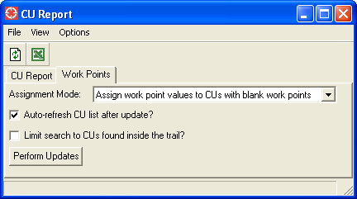

The Assignment Mode input item has two options:
- Assign work point values to CUs with blank work points
  - In this mode of operation, all Compatible Units found in the active design with a blank Work Point Number value will have their Work Point Number calculated, based on the rules described in section 3.
- Clear work point values for CUs.
  - In this mode of operation, all Compatible Units found in the active design will have the Work Point Number value set to blank, so that they can be re-assigned by the function described above.

Other options include the following:
- Select the “Auto-refresh CU list after update?” checkbox to automatically refresh the contents of the CU Report tab after the update is completed.
- Select the “Limit search to CUs found inside the trail?” checkbox to limit the results of this update to only include features that are completely or partially inside the current trail.
  - Note that your system administrator will define the rules to determine what features exist inside the trail – for example, it is possible to define rules so that the CU for a Transformer Unit (which may not have any geometry at all) is analyzed based on the location geometry of the owning Transformer Bank.

Once the various options have been selected, press the Perform Updates button.

