Quality Assurance by Minto Spatial Solutions:
User Guide

Updated: 2011/04/25

Copyright Information

Copyright © 2005-2011 Minto Spatial Solutions Ltd. All rights reserved.

Trademarks and Registered Trademarks

Smallworld is a registered trademark of General Electric Company

Table of Contents

1 Overview 4
1.1 Supported Versions 4
1.2 Document History 4
2 Quality Assurance Tool 5
2.1 Working With QA Errors 9
3 Administrator Notes 11
3.1 Changes to Image Build Process 11
3.2 Changes to Applications 11
3.3 How to Define QA Checks 12
3.4 How to Write QA Check Methods 14
3.5 How to Write Auto-Fix Methods 15
3.6 How to Run QA Using Magik Code 15

Overview
Quality Assurance by Minto Spatial Solutions (also referred to in this document as the Quality Assurance tool) is a productivity tool that allows errors in your GIS data to be easily identified and automatically fixed. It includes the following features:
- Select records to be analyzed in a variety of ways: based on a trail, the Smallworld scrapbook, or by reviewing all incremental changes in an alternative.
- Select which specific checks should be performed: different user groups may have different checks available.
- Review any warnings or errors found in a standardized display, with the ability to goto, highlight, or edit any individual record.
- In some cases, the tool will be able to automatically fix the error, allowing you to review the before-and-after results.

Supported Versions
This document describes the version of this software that is released as part of the MSS 420 package, and is compatible with the SWAF architecture of Smallworld Core Spatial Technology version 4.2.0.

Document History

Date | Name | Description
2007/02/20 | Tim Minto | - Created (from V4.0 version of document).
2008/05/31 | Tim Minto | - Updated to V4.1.1.
2008/07/13 | Tim Minto | - Report enhancements:  - Display a large list of errors on multiple pages.  - Display XY coordinate information in error list.  - Export to Excel functionality.  - View enhancements:  - Allow multiple objects to be selected for Goto, Highlight, and Select operations.  - QA Check Management enhancements:  - Groups tab allows multiple checks to be enabled or disabled with one click.  - Added “Entire Database” input mode.
2011/04/25 | Tim Minto | - Updated to V4.2.0.

Quality Assurance Tool
Your system administrator will typically define an action on a pulldown menu in your application which activates the Quality Assurance tool. Here is a screen shot of this menu:

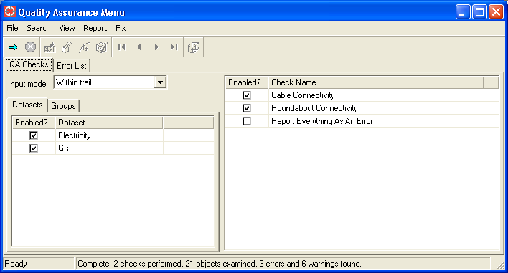

This menu consists of the following components:
- The Pulldown menu functions and Toolbar are at the top of the menu. All of these functions are described below.
- The QA Checks tab contains various input items that allow selection of the objects to be examined, and the checks that will be applied to those objects:
  - The Input mode choice item may be set to one of the following values:
    - Within trail: this will examine all records with any geometry completely or partially inside the current trail.
    - Scrapbook: this will examine all records that are currently in the Smallworld Scrapbook.
    - Changes in this alternative: this will examine all records that have been inserted or updated in your current database alternative.
    - Entire database: this will examine all records in the database.
  - The Dataset list – on the Datasets tab – allows the checks to be limited to specific datasets. The contents of this list will depend on the dataset available at your site. By default, all datasets are selected.
  - The Groups list – on the Groups tab – allows multiple QA checks to be formed into groups, so that all checks in a group can be enabled or disabled with a single click. The contents of this list will depend on the groups that have been defined by your system administrator.
  - The QA check list allows specific checks to be selected. The contents of this list will depend on the rules that have been defined by your system administrator.
- The Error List tab contains the results of the QA run – all errors and warnings will be displayed in this scrollable list.
- The Status bar at the bottom of the menu contains progress information while the QA run is taking place, and a summary of the number of records examined and errors found once the QA run is complete.

The following Pulldown menu functions are available:

Function name | Button | Description
File Pulldown
Close |  | This closes the Quality Assurance menu.
Search Pulldown
Run QA |  | This causes the QA checks selected in the QA check list to be applied to all records identified by the Input mode choice item.
Interrupt |  | The Run QA function can take a long time to run if a large volume of data is selected. Performing this function will cause that long-running process to be interrupted.
View Pulldown
Goto Objects |  | Zoom the map window to display the objects selected in the Error list. In some cases, this may zoom to a specific position along that object: for example, if an error indicates that a cable is disconnected at one end, your system administrator may configure this to zoom to that disconnected endpoint, rather than to the entire cable.
Highlight Objects |  | Highlight the objects selected in the Error list in the map window.
Select Objects |  | Select the objects selected in the Error list in the map window, so that its geometries become the currently selected geometries in that map window.
Edit Object |  | Edit the object selected in the Error list in the map window.
Copy to Scrapbook |  | Copies the objects selected in the Error list to the Smallworld scrapbook.
Report Pulldown
First Page |  | If a large number of errors are reported, they will be separated into multiple pages. (By default each page will contain up to 1000 errors, but this may be changed by your system administrator). These four functions change the page of errors being displayed in the Error list.
Previous Page
Next Page
Last Page
Export to Excel |  | Exports all errors displayed in the Error list to Excel. If there are multiple pages of errors, then all pages are exported.
Fix Pulldown
Auto-Fix |  | This requires that one or more records are selected in the Error list, with an Auto-Fix value of “Pending”. Performing this function will cause all of those records to be automatically fixed, if possible.  After this is performed, the Auto-Fix value of each selected record will be changed to “OK” if the fix was successful, or “Failed” if it was not.  Note that this feature will only be enabled for certain checks, where your system administrator deems that a given error can be automatically repaired.

Working With QA Errors
The specific types of errors that will be reported by this tool will depend on the QA checks that are defined by your system administrator. Typically, this will include things such as the following:
- Attribute checks: for example, ensuring that a Date Installed value is set on a span of pipe before it is posted to the top alternative of your database.
- Connectivity checks: for example, ensuring that a valve is connected to exactly two pipes.
- Compound attribute/connectivity checks: for example, ensuring that a reducer is connected to exactly two pipes, and that the diameter attributes of those pipes are different.
- Business rule validations: for example, ensuring that a new high-pressure pipeline has appropriate permit records associated with it.

The examples provided in this document are based on a simple set of rules provided for the Smallworld Cambridge Database, which validate the connectivity of cables and roundabouts in that data model.

Once a QA run is complete, all of these errors will be displayed on the Error list tab, as shown in the following example:

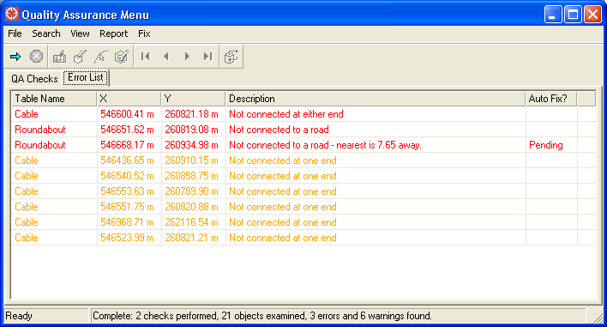

Items that your system administrator considers to be warnings are shown in orange; items that are considered to be errors are shown in red. When any item is selected in this list, the functions for Goto Objects, Highlight Objects, Select Objects, and Edit Object will become enabled.

Note that in the above example, there are two errors reported for the roundabout table. The first one simply reads “Not connected to a road”, and it does not have any auto-fix information. The second one also specifies that the distance to the nearest road is a short away from the roundabout, and it indicates that the auto-fix status is “Pending”. This means that the system administrator has decided that any roundabouts within a certain tolerance distance of a road can be automatically repositioned so that they connect to that road.

If that roundabout record is selected in this list and the Auto-Fix function is performed, this will result in that roundabout being moved so that it does connect to the nearest road. Also, the Error list will be updated as shown here, to indicate that is has been successfully fixed:

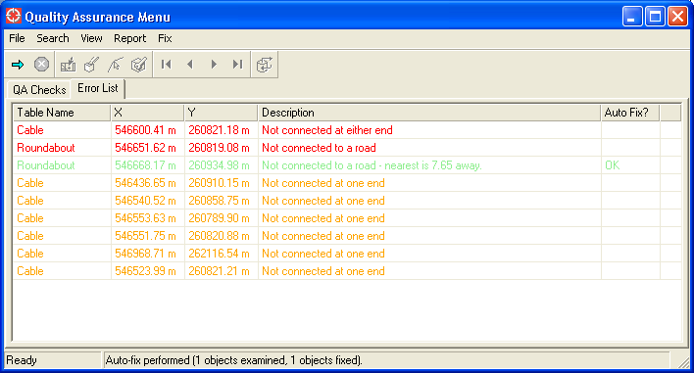

Administrator Notes

Changes to Image Build Process
The source code for this product should be placed in a directory that is accessible during your image build process. This code is available in the subdirectory named “mss” of the product zip file. Simply copy this code to a directory of your choice. This directory will be considered to be the “product directory” for the MSS product, and this will be referred to as the <MSS_PRODUCT> directory in various steps below.

Ensure that the latest TSB patches are installed before proceeding with an image build. If you do not have these TSB patches installed, contact the Smallworld help-desk for assistance.

As part of your image build process, ensure that following steps are performed:
- The MSS product must be added. This can be done using the following code (where <MSS_PRODUCT> is the directory that contains the product.def file):
  - smallworld_product.add_product(<MSS_PRODUCT>)
- The module named mss_qa must be loaded. This can be done by either making it a prerequisite of any module that you currently load in your application, or by explicitly loading the module using the following code:
  - sw_module_manager.load_module(:mss_qa)

Changes to Applications
For any application that will use this product, the following changes should be made to the config.xml and gui.xml files for that application:

Changes to config.xml:
- Add the following plugin, which provides access to the Quality Assurance menu:

<plugin name="mss_qa_processor_fw_pi" class_name="mss_qa_processor_fw_pi"/>

As for many other GUI frameworks, this supports the following properties: config_definition_module_name, config_definition_file_name, gui_definition_module_name, and gui_definition_file_name. So, you can also specify a module that contains a different configuration, such as with the following example code:

<plugin name="mss_qa_processor_fw_pi" class_name="mss_qa_processor_fw_pi">
<properties>
<property name="config_definition_module_name" value="cam_mss_qa"/>
<property name="config_definition_file_name" value="config.xml"/>
</properties>
</plugin>

In the above example, the module named cam_mss_qa can have a config.xml file that configures the default QA checks available to users of this application, as follows. Note the following aspects of the mss_qa_engine class which can be configured in this XML:
- managed_checks
  - The managed_checks stanza allows the checks available to the end user to be configured. Each check which can be displayed on the menu is listed in this stanza, along with whether or not the check is to be enabled by default.
  - If no managed_checks stanza is defined, then the menu will display all checks defined in the image, and all will be enabled by default.
- managed_groups
  - The managed_groups stanza allows groups of checks to be defined. All groups defined here will be displayed in the Groups list (on the Groups tab).
  - If no managed_groups stanza is defined, then no groups will be listed.

<config base="mss_qa_gui.config">
<plugins>
<plugin name="mss_qa_engine" class_name="mss_qa_engine">
<managed_checks>
<check name="mss_qa_cable_connectivity" value="true"/>
<check name="mss_qa_roundabout_connectivity" value="false"/>
<check name="mss_qa_everythings_an_error" value="false"/>
</managed_checks>
<managed_groups>
<group name="All Checks">
<check name="mss_qa_cable_connectivity"/>
<check name="mss_qa_roundabout_connectivity"/>
<check name="mss_qa_everythings_an_error"/>
</group>
<group name="Cables and Roundabouts">
<check name="mss_qa_cable_connectivity"/>
<check name="mss_qa_roundabout_connectivity"/>
</group>
</managed_groups>
</plugin>
</plugins>
</config>

Changes to gui.xml:
- To provide access to the Quality Assurance menu, add the following action to the appropriate pulldown menu in your application:

<action name="mss_qa_processor_fw_pi.activate_mss_qa_processor_framework"/>

How to Define QA Checks
In order to understand how QA checks are defined, it is helpful to refer to the examples provided in the cam_mss_qa module, which is designed for use with the Smallworld Cambridge example database.

Definition of QA checks is accomplished using Magik code. Calls to the various methods described below should be placed in a Magik file in a module that is loaded as part of your image build process.

mss_qa_check_definition.new(check_name, method_name)
- Creates and returns a new QA check definition named CHECK_NAME, which must be a symbol.
- The method named METHOD_NAME will be performed on each object that is to be examined by this QA check. Refer to section 3.4 below for additional details on this topic.
- The external name for this check is defined by adding a message key named CHECK_NAME to the mss_qa_check_definition message handler.
- Names must be unique; to redefine a check, it must first be removed using the mss_qa_check_definition.remove_qa_check_definition() method.

mss_qa_check_definition.add_table_info(partition_name, table_name, _optional geom_names)
- This instructs the QA check to consider records in the given table when determining which objects to check. For example, when running the Quality Assurance tool with an input mode of “Within trail”, there will inevitably be a heterogeneous mix of objects inside that trail (including things such as cables, roads, and roundabouts in the Smallworld Cambridge database). Use this method to limit the check to examine a specific table.
- The PARTITION_NAME and TABLE_NAME define that database partition and table to be considered. The GEOM_NAMES attribute (if entered) defines the names of geometries that will be scanned for when using the “Within trail” input mode (which determines the objects of interest based on spatial geometry scanning).
- This method can be called multiple times, to define multiple different tables as being subjects of this QA check.

mss_qa_check_definition.set_parameter(key, value)
- This defines a parameter for this QA check named KEY, with a value of VALUE.
- The meaning of this parameter is completely application-specific: for example, it may be a property list of tolerance values to use when deciding if a given feature is erroneous. Once set, the parameter value can be examined within the QA check method (see section 3.4) by using the get_parameter() method.

mss_qa_check_definition.set_pre_run_method_name(meth_name)
- This instructs the QA engine that is coordinating the QA check (which is an instance of the mss_qa_engine class) to perform the method named METH_NAME before individual records in that QA check are examined. METH_NAME must be defined on the mss_qa_engine class.

mss_qa_check_definition.set_post_run_method_name(meth_name)
- This instructs the QA engine that is coordinating the QA check (which is an instance of the mss_qa_engine class) to perform the method named METH_NAME after individual records in that QA check are examined. METH_NAME must be defined on the mss_qa_engine class.

dd_record_mixin.mss_qa_records_for(mode, qa_engine)
- This method is related to the process of defining QA checks – however, unlike the various methods described above, it is associated with objects in your data model and applies to all QA checks, rather than being associated with any specific check.
- By default, when a record is under consideration by a QA check (based on the input mode of “Within trail”, “Scrapbook”, or “Changes in this alternative”), the QA check in question is run on that individual record only.
- This method may be subclassed to also include additional records in the QA check. For example, if you intend to run a given QA check on some (or all) features within a substation whenever that substation is undergoing a QA check, you can subclass this method to return the set of all cables and switches related to that substation.
- Refer to the public comments of this method for details about the input parameters and return data format.

Here is an example (taken from the example cam_mss_qa module for the Smallworld Cambridge database) that defines two QA checks for examining roundabout connectivity and cable connectivity:

_block
_local qa

mss_qa_check_definition.remove_qa_check_definition(:mss_qa_roundabout_connectivity)
qa << mss_qa_check_definition.new(:mss_qa_roundabout_connectivity,
:|mss_qa_roundabout_connectivity()|)
qa.add_table_info(:gis, :roundabout, {:location, :annotation})
qa.set_parameter(:tolerance, 20000.0)

mss_qa_check_definition.remove_qa_check_definition(:mss_qa_cable_connectivity)
qa << mss_qa_check_definition.new(:mss_qa_cable_connectivity,
:|mss_qa_cable_connectivity()|)
qa.add_table_info(:electricity, :cable, {:centreline})
qa.add_table_info(:electricity, :internal_cable, {:centreline})
qa.add_table_info(:electricity, :substation, {:location, :annotation})
_endblock

How to Write QA Check Methods
When a QA check is defined using the mss_qa_check_definition.new() method, the name of the method that will be performed on each record examined by that QA check is defined. This section describes considerations for how that method should be written.

The method will take two parameters: the QA engine (mss_qa_engine class) that is coordinating the execution of the QA checks, and the QA check (mss_qa_check_definition) itself.

The QA engine may be used to examine the state of the overall process – in particular, it has a slot named user_data that is a property list which is reinitialized at the start of each check. In coordination with the ability to define a pre-run and/or post-run method for each check, this could be used to allow all data gathered during the course of a QA check to be analyzed (in addition to the record-by-record analysis that takes place during the normal course of a QA check).

The QA check may be used to extract additional information that is part of the QA check definition (c.f. the mss_qa_check_definition.set_parameter() method that can be used when the QA check is defined, and the mss_qa_check_definition.get_parameter() method that can be used to retrieve this data).

For each error that is found while executing the QA Check method, this should be communicated back to the QA engine by raising a mss_qa_information condition. This condition should include the following keys and values:
- :string – a string that describes this error. This will be displayed in the Error list in the Quality Assurance menu.
- :record – the record that is in error. This will be used for the various goto / highlight / select / edit functions when a row is selected in the Error list in the Quality Assurance menu.
- :severity – this may be :error (for an error condition), or :warning (for a warning condition). If not supplied, it defaults to :error.
- :error_code – a symbol that represents the category of error.
- :error_sub_code – a symbol that represents the subtype of error (within the :error_code described above).
  - The values provided for :error_code and :error_sub_code are application-specific, and the specific values chosen do not matter to the QA engine.
  - However, these are used for uniqueness validation, to ensure that the same error is not reported more than once. The combination of :record, :error_code, and :error_sub_code must be unique. If two or more conditions are raised with the same combination of values, only the first one will be reported.
- :locating_geometry – this is an optional parameter. If provided, it should be a real or pseudo geometry that will be used for performing the Goto Object function in the Quality Assurance menu. An example of where this could be used is to identify a specific endpoint of a chain geometry which is in error.
- :auto_fix_data – this is an optional parameter. If provided, it should be a property list that defines the auto-fix information needed to repair this error. Refer to section 3.5 for additional details about writing auto-fix methods. This property list must include the following keys and values at a minimum; other application-specific keys and values can also be added, and they will be passed through to the auto-fix method:
  - :record – the database record that the auto-fix method will be performed on.
  - :method – the name of the auto-fix method that will be performed.

The following is an example of raising such a condition to signify that the location geometry for a roundabout is not set:

condition.raise(:mss_qa_information,
:string, "Location is not set - cannot validate connectivity",
:record, _self,
:severity, :error,
:error_code, :roundabout_connectivity,
:error_sub_code, :no_location,
:locating_geometry, _unset,
:auto_fix_data, _unset)

How to Write Auto-Fix Methods
The previous section describes how errors are identified using the mss_qa_information condition. When this condition includes the :auto_fix_data key, then that particular error is a candidate for the auto-fix process, and it will show up in the Error list with an auto-fix status of “Pending”.

If the user selects this error and performs the Auto-Fix function, the data in the :auto_fix_data key is examined. As noted above, this must include (at a minimum) the record that the auto-fix method will be performed on, and the method that will be called.

When the auto-fix method is performed, it is passed the data in the :auto_fix_data key as a parameter. This method should have the following characteristics:
- It should return _true to indicate that the auto-fix completed successfully.
- It should return any other value to indicate that the auto-fix did not complete successfully.
- It should be bombproof (if appropriate for your requirements): when called from the QA engine, it is possible that multiple records have been selected for auto-fixing, and error handling is only done on the entire transaction, not on a per-record basis. This means that an error when auto-fixing a single record will cause the entire transaction to fail. If you intend to have an error within an auto-fix method to be continuable, you must explicitly handle those errors within your auto-fix code.
- Care should be taken to deal with changed or invalid data; it is possible that other data update operations (which could include manual updates by the user or other auto-fix operations) could change or even delete the data that originally raised the error condition.

How to Run QA Using Magik Code
In addition to the various menu-based capabilities described in this document, it is possible to run QA checks in any piece of Magik code. For example, if you are using the Workspace by Minto Spatial Solutions tool, you may wish to perform QA checks as part of a transition to an “Approved” type of state in your workflow. To do this, use the following guidelines:

Create a new instance of a QA engine:
- qa << mss_qa_engine.new()

Define the checks to be run:
- pl << property_list.new_with(<check_name_1>, _true, <check_name_2>, _true)
- qa.set_managed_check_names(pl)

Define the input mode:
- qa.set_option(:input_mode, <new_mode>)
- In this case, <new_mode> can be :trail, :scrapbook, :difference_stream, or :entire_database.
- If <new_mode> is :trail, then the area to search must also be defined via the following Magik code, since there is no map manager available to obtain the trail from:
  - qa.set_option(:input_area, <a_pseudo_area>)
  - In this case, <a_pseudo_area> must be a pseudo_area object. It is important that the world property of this pseudo_area is set to indicate the world that you intend to examine.

Optionally, you can instruct the QA engine to simply return a true/false value, where the first error found produces a false (failed) result. Note that if this is not done, then the run_qa() method described below will run to completion and will report all errors.
- qa.set_option(:stop_on_qa_error?, _true)

Perform the QA checks:
- qa.run_qa()

Upon completion, the :results option will include a summary of the results, and the raw_errors slot will be an equality hash table where each key is a database record, and each value is a rope of mss_qa_information condition objects that represent each error raised during QA check processing.
- print(qa.get_option(:results))
- print(qa.raw_errors)

