The Workspace by Minto Spatial Solutions:
User Guide

Version: Core Spatial Technology 4.2.0 (SWAF)

Updated: 2011/04/25

Copyright Information

Copyright © 2004-2011 Minto Spatial Solutions Ltd. All rights reserved.

Trademarks and Registered Trademarks

Smallworld is a registered trademark of General Electric Company

Table of Contents

1 Overview 4
1.1 Document History 4
2 Available Functionality 5
3 Workflows 7
4 The Workspace Manager 9
4.1 New Job and Design Dialog 11
5 Overlay and Aggregate Designs 13
5.1 Copy Overlay Design Data 14
5.1.1 Usage Scenario: Partial Post 15
5.1.2 Usage Scenario: Build From Another Design – With Connectivity 16
5.1.3 Usage Scenario: Build From Another Design – No Connectivity 17
5.2 Aggregate Selected Designs 17
6 Editing Jobs and Designs 18
6.1 Show History 18
6.2 Related Documents 19

Overview
The Workspace by Minto Spatial Solutions is a productivity tool that simplifies the process of managing the workflow of any data creation and maintenance activities in your Smallworld database.

Each unit of planned new construction or data maintenance work can be assigned to a job in the Workspace application. Each job may consist of multiple designs, which represent alternative ways of accomplishing that job. As jobs and designs progress in their life cycle, the state of those jobs and designs are regularly updated – a typical workflow will start in a new state, and will progress through its life cycle to design, approval, construction, and completion.

For each step in the workflow, business rules are enforced – for example, approvals may only be granted by authorized users, or may require an automated quality assurance check in order to proceed. As jobs near completion, a design for that job may be published from a user’s private workspace to the top version of your database, so that the design data can be seen by all users.

The Workspace by Minto Spatial Solutions coordinates all of these tasks in a manner that is easy to understand for typical users, yet powerful with a variety of configurable capabilities for system administrators. This ensures that the business rules and workflows that exist in your organization can be effectively managed within your Smallworld application.

Document History

Date | Name | Description
2007/02/19 | Tim Minto | - Created (from V4.0 version of document).
2008/05/31 | Tim Minto | - Updated to V4.1.1.
2011/04/25 | Tim Minto | - Updated to V4.2.0.

Available Functionality
The Workspace is based upon the Professional application provided as part of the Smallworld Core Spatial Technology product. In addition to the rich set of functionality provided by the Professional application, the Workspace provides the following additional functions. All of these functions are typically accessible from the File pulldown menu of the Professional application, although your system administrator may choose to rearrange this:

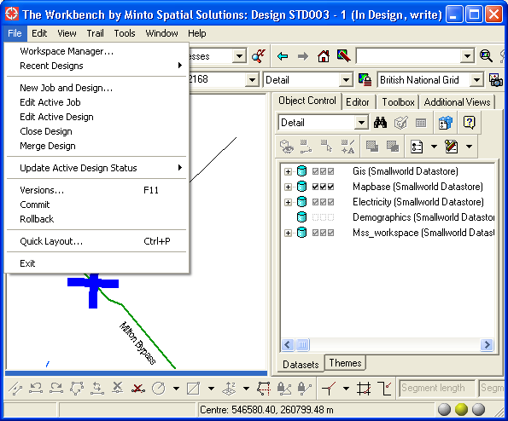

- Workspace Manager…: this activates a separate menu to provide access to several functions related to managing your jobs and designs. Details are provided in section 4.
- Recent Designs: this pulldown menu lists the designs that you have opened most recently. This is similar to the “recent documents” type of function that is typically available in word processor and spreadsheet applications.
- New Job and Design…: this activates a dialog that allows a new job and design to be created, in order to start the design process. Details are provided in section 4.1.
- Edit Active Job, Edit Active Design: this activates the standard Smallworld object editor to display attributes about the job and design that you are currently working on. Special editing functions related to jobs and designs are described in section 6.
- Close Design: this closes the design that you are currently working on. This is similar to the “close document” type of function that is typically available in word processor and spreadsheet applications.
- Merge Design: this merges any changed data in the “Design Top” alternatives of your database into your active design. This is similar to the Merge Changes function available on the Versions dialog in the Professional application. However, the Merge Design function takes care of coordinating this across multiple database partitions and multiple levels of your alternative hierarchy.
  - Note that there is no separate function to allow you to post a design to the “Design Top” alternatives. The reason is that this capability is controlled by your workflow: data will be posted automatically, once a design reaches appropriate states in this workflow.
- Update Active Design Status: this pulldown menu lists the available status values for the next steps in the workflow of the active design. For example, if the active design is in the state named “In Design”, it may be possible to move it forward to the “Approved” state (once the customer approves the planned work), or it may be possible to move it to the “Cancelled” state (if the customer determines that the planned work is too expensive). Full details about the workflow process are described in section 3.

Workflows
A workflow represents a sequence of steps required to complete a job or a design. Your system administrator may set up multiple workflows to correspond to the various business processes in use at your organization.

A simple example of a workflow may consist of the following steps, in sequence:
- New: the job is created.
- In Design: a design for the job is in progress. Possibly, there could be multiple designs in this state.
- Approved: a single design for the job has been approved.
- Released For Construction: the actual construction work has been scheduled.
- Constructed: construction has completed, and minor updates are performed to reflect the way that the design was actually built in the field.
- Complete.

In addition to that sequence of steps, state values of “On Hold” or “Cancelled” may also exist. Also, the workflow does not always progress in the same manner for each project – for example, an Approved project could revert to the Design stage if the customer changes their mind. This is shown in the following flow chart:

New
In Design
Approved
Released For Construction

On Hold
Cancelled
Constructed
Complete

Similar workflows could exist for the following cases:
- Fast-track service installations: such a workflow would have a shorter sequence of steps from start to finish.
- Large jobs – for example, to design a complete new subdivision – may involve a more complex workflow, with additional steps to represent the various stages of approval required for environmental assessment, municipalities, and other third parties.
- Survey or maintenance activities: for example, a task that involves reviewing all compressor stations in a region on a regular interval (i.e. monthly). In this case, there may not be a “Complete” type of state at all – when one survey is done, it may be cycled back to an earlier state in preparation for the next survey, rather than finishing the job with a Complete state.

Each job and design in the Workspace application has a status attribute that defines where it is in its workflow life-cycle (i.e. New, In Design). For a job with a single design, these will normally be synchronized – but, if a job has multiple designs, eventually one design will be Approved, while the other designs are On Hold or Cancelled.

Your system administrator will define these workflows, and will also define what additional actions take place at each step in the workflow. In the sample workflow described above, this may include the following:
- As part of the transition from Design to Approved, ensure that all other designs for that job are moved to an On Hold or Cancelled status – disallow multiple designs in the Approved state.
- As part of the transition from Approved to Released For Construction, the contents of the design is posted to the “Design Top” alternative. This publishes the data in its “Proposed” state.
- As part of the transition from Released For Construction to Constructed, convert the status of all “Proposed” objects in the design to “Existing”, and permanently delete all objects in the design for which the status is “Removed”.
- Only allow super-users to perform the Constructed to Complete transition, so that they can ensure that related close-out processing is performed in your organization’s Work Management System. Also, when this step is done, post the data to the “Design Top” alternative once again (to publish the fact that all “Proposed” data for this design is converted to “Existing”).

The Workspace Manager
The Workspace Manager menu provides access to several functions related to managing your jobs and designs. Here is a screen shot of this menu:

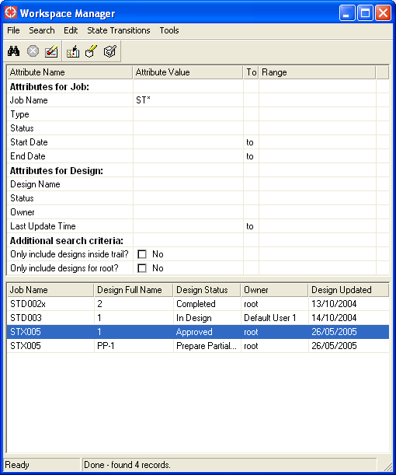

This menu consists of the following components:
- The Pulldown menu functions and Toolbar are at the top of the menu. All of these functions are described below.
- The upper portion of the menu is the Search criteria list. This allows searches of jobs and designs to be easily performed based on any common combination of attributes.
- The lower portion of the menu is the Search result list. This displays the results of the most recent search. Many of the Pulldown menu functions described below will act of the job or design that is selected in this list.

The following Pulldown menu functions are available:

Function name | Button | Description
File Pulldown
New Job and Design… |  | Activate a dialog to create a new job and design. See section 4.1.
New Job… |  | Activate a dialog to create a new job only (without a design). See section 4.1.
New Top-Level Design… |  | Activate a dialog to create a new top-level design for the selected job. See section 4.1.
New Sub-Design… |  | Activate a dialog to create a new sub-design for the selected design. See section 4.1.
Open Design |  | Opens the selected design, so that you can start creating and/or maintaining data within that design. Note that the data for any design is stored in database alternatives below the “Design Top” alternative, and performing this function will automatically navigate to those alternatives.
Close Design |  | Closes the selected design, so that no design is currently active. This is equivalent to going to the “Design Top” alternatives in your database in read-only mode.
Close |  | This closes the Workspace Manager menu.
Search Pulldown
Perform Search |  | Performs the search to locate all jobs and designs that match the field values that you have specified in the Search criteria list.
Interrupt |  | Interrupt the search that is currently running.
Clear |  | Clears all input fields in the Search criteria list, and clears all results displayed in the Search result list.
Edit Pulldown
Goto Selected Design |  | Updates your current map view to display the extent of the selected design.
Highlight Selected Design |  | Highlights the extent of the selected design in your current map view.
Edit Selected Job |  | Displays the selected job in an object editor of your application. Depending on how your system administrator has configured your editors, this may appear as a tab embedded in your main application window, or as a separate window.
Edit Selected Design |  | Displays the selected design in an object editor of your application.
Delete Selected Jobs |  | Deletes the selected jobs. Note that in order to delete a job, you must have sufficient authority to delete all of the designs for that job (this authority will be granted by your system administrator).
Delete Selected Designs |  | Deletes the selected designs. Note that you must have sufficient authority to perform this operation (this authority will be granted by your system administrator). Also, you cannot delete a design that is open – you must first close the design.

State Transitions Pulldown
Update Job Status |  | This pulldown menu will display all potential subsequent states for the selected job. Selecting any value in this pulldown menu will cause the status of the selected job to be updated to that value.
Update Design Status |  | This pulldown menu will display all potential subsequent states for the selected design. Selecting any value in this pulldown menu will cause the status of the selected design to be updated to that value.
Tools Pulldown
Overlay Selected Design |  | Overlays the design data for the selected design on top of your regular map view. This is discussed in more detail in section 5.
Clear Overlay Design |  | Clears the overlay design data, to revert your regular map view to displaying only the data in the active design.
Copy Overlay Design Data… |  | Activate a dialog to allow selected data in the overlay design to be copied into the active design. See section 5.1.
Aggregate Selected Designs |  | Aggregate the design data for the selected designs into the active design. See section 5.2.

New Job and Design Dialog
When the New Job and Design function is performed, the following dialog will be launched to gather information about the job and design. The specific attributes that are displayed on this dialog will be controlled by your system administrator:

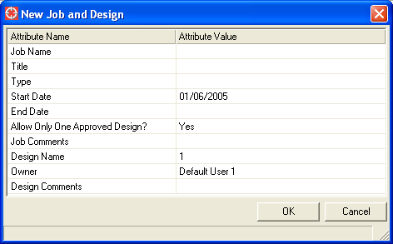

To create a new job and design, simply fill out the attributes, place a trail to define the extent of the design area that you will be working within, and press the OK button.

Most attributes on this dialog are self-explanatory. One attribute of special importance is the “Type” attribute: the type of job that you select will determine the workflow for the job, and for all designs associated with that job. Your system administrator will define a suitable set of job types and workflows that are appropriate to your organization.

The same basic dialog is also shared for the New Job, New Top-Level Design, and New Sub-Design functions. Although the New Job and Design function is likely to be the one that is most commonly used, you may choose to use the other dialogs under the following circumstances:

New Job:
- Creates the job record only, but does not create a design for it.
- This may be used if a piece of work needs to be recorded for future planning purposes, but that piece of work has not been assigned to any planner to start work on.

New Top-Level Design:
- Creates a new design record for an existing job.
- This may be used if two or more alternative approaches to designing a particular job are to be considered. For example, the construction of a new main may take place down either Oak Street or Elm Street, but it is not immediately obvious which option is the best. Both designs can be created, and then reviewed in more detail in order to make that decision.
- This may also be used if a particularly large job will be done in phases. In this case, a separate design can be created for each phase of the work.
  - In this case, also set the job attribute named “Allow Only One Approved Design” to be false. This means that multiple designs can be approved for the job. Normally, rules within the Workspace application will ensure that only a single design for any job may be approved.

New Sub-Design:
- Creates a new design record as the child of an existing design..
- This may be used if two or more alternative approaches to designing a portion of a particular job are to be considered. For example, parent design may specify a run of overhead primary conductor to supply a new customer. From there, two separate sub-designs could be created to consider either overhead or underground service conductor as a possible solution for serving the customer from that newly-planned primary.
- Note that this will result in creation of database alternatives that are two (or more) levels below the “Design Top” alternative. This is in contrast to top-level designs, which are always a single level below the “Design Top” alternative. In this case, the Workspace application will automatically take care of merging data down multiple levels of the alternative hierarchy whenever you perform a Merge Design function (described in section 2).

Overlay and Aggregate Designs
The Tools pulldown menu of the Workspace Manager includes various functions to allow the data from a different design to be displayed as an overlay on top of the active design, or aggregated into the active design.

Performing the Overlay Selected Design function on the Workspace Manager menu will cause the following changes to be made to the map window:
- Any changed geometry in that overlay design will be drawn in an overlay color. The overlay color defaults to light blue, and it may be changed by your administrator.
- The Object Control menu will display additional datasets that correspond to the overlay design. For example, if the design being overlaid has datasets named “gis” and “electricity”, then two datasets will be added to Object Control named “mss_overlay_gis_1” and “mss_overlay_electricity_1”.

The following screen shot shows an example of this:

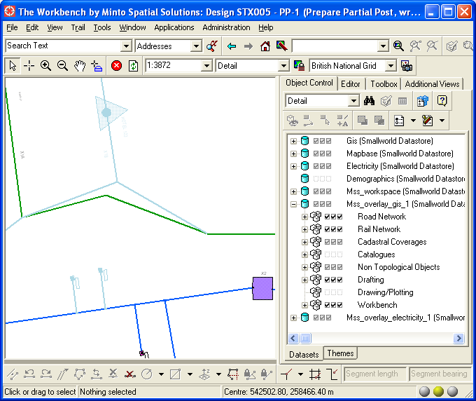

Once displayed in this manner, the data from an overlay design can be accessed and manipulated in the following ways:
- The visibility, hittability, and selectability of geometry in the overlay datasets can be controlled using standard Object Control functionality. The initial default settings will match the default settings of the datasets configured in the ACE by your administrator.
- Selecting any geometry from the overlay design will allow you to activate the Object Editor for it, so that its attributes can be reviewed in more detail. However, note that the overlay datasets are always read-only, so that this data cannot be updated.
- If the hittability of an overlay geometry has been enabled, then it is possible to snap the trail to that overlay geometry.

To return the display to normal, perform the Clear Overlay Design on the Workspace Manager menu.

Copy Overlay Design Data
Performing the Copy Overlay Design Data function on the Workspace Manager menu will activate the following dialog:

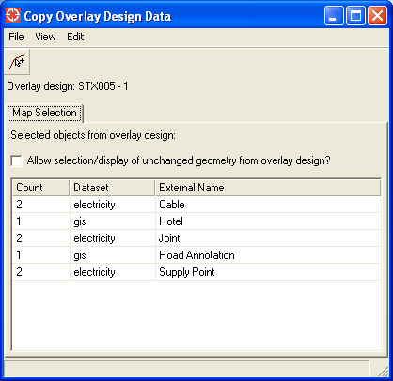

This menu consists of the following components:
- The Pulldown menu functions and Toolbar are at the top of the menu. All of these functions are described below.
- The Map Selection tab displays a list of all objects selected in the map window which are from the overlay design.
  - Normally, only changed geometry from the overlay design is selectable and visible in the overlay color. Enabling the Allow selection/display of unchanged geometry from overlay design? toggle will allow all data from the overlay design to be visible and selectable.
  - Note that enabling this setting will generally cause two instances of features to be displayed right on top of each other – one from the overlay design, and one from the active design. Therefore, it is not normally required. However, if you intend to copy non-graphic data from the overlay design which exists as related records to a graphic record, this option is useful. An example of this usage is to copy (non-graphic) transformer unit records based on the selection of the location geometry for the transformer bank that owns those units.
- The Status Bar displays the progress of performing a copy function.

The following Pulldown menu functions are available:

Function name | Button | Description
File Pulldown
Close |  | This closes the Copy Overlay Design Data menu.
View Pulldown
Refresh |  | Refresh the contents of the menu.
Edit Pulldown
Copy Map Selection |  | Copy all objects selected in the map window from the overlay design into the active design.

In order to copy data from the overlay design to the active design, the state values for each of those designs must match values that are defined by your administrator. For example, your administrator may choose to set up your workflow states so that it is only possible to copy data from an overlay design in the “Approved” state, but not from an overlay design in the “In Design” state.

There is an important reason for imposing this limitation: once data has been copied from the overlay design to the active design, there is a substantial possibility that conflicts will arise between data in the two designs, and so your administrator may impose these limits in order to minimize the chance of conflicts.
- In most cases, an attempt to update the copied data in either the overlay design or the active design will result in a conflict.
- This means that once the data is posted from one of these designs, when it is merged into the other design, the Smallworld Conflict Viewer may be activated to alert you to this situation.
- If that occurs, use the standard functionality provided by the Conflict Viewer will allow you to resolve the conflict – either by choosing the version of the data from the overlay design; from the active design; or by editing the data further to combine the changes appropriately.

Usage Scenario: Partial Post
The Copy Overlay Design Data menu may be used to perform a “partial post” of design data. This is useful for a large design which is to be constructed in two or more phases, where each of those phases should be posted up to the “Design Top” alternative of your database when it is complete.

In this case, your administrator will define additional states in your workflow to support the “partial post” process. For example, there may be a state named “Prepare Partial Post” (which is intended to be used for selecting the data to be partial-posted), and a state named “Partial Post Pending” (which is used to actually post the data to the “Design Top” alternative). The following scenario assumes that this workflow configuration has been set up; and that the design named D1 is in an “Approved” state, and contains the design data that is to be partial-posted. To perform a partial post, follow these steps:
- Create a new design – for this scenario, call this design D2.
  - This design can either be associated with the same job as design D1, or it can be part of a different job. Normally, a “partial-post” design D2 would be considered to be part of the same job as D1, but the following functionality will work in either case.
- Perform the necessary state transition(s) to move this design D2 to the “Prepare Partial Post” state.
- In the Workspace Manager menu, select the design D1, and perform the Overlay Selected Design function. This will cause the design data for D1 to be displayed as an overlay.
- Activate the Copy Overlay Design Data menu, and use the map view to select the overlay design data from D1 that you intend to partial-post. On this menu, use the Copy Map Selection function to copy the data from D1 (the overlay design) to D2 (the active design).
  - Note 1: this step can be performed as many times as needed – when dealing with a large set of data to be partial-posted, it is easier to only select a single feature (or small handful of features), and perform the Copy Map Selection for each one.
  - Note 2: if any of this copied data needs to be updated further, it may be done now. However, note that there is a likelihood that this will cause conflicts later (as described in the previous section).
- Once all data to be partial-posted has been copied from D1 to D2, move the design to the “Partial Post Pending” state, so that it can be posted to the “Design Top” alternative.
  - Note that if your administrator is using the MSS Scheduler product to perform merges and posts for designs, then the results may not be immediately available in the “Design Top” alternative, but they will be available as soon as the MSS Scheduler processes the merge and post task.
- Once the data has been posted to the “Design Top” alternative, open design D1.
- Perform the Merge Design function for this design – this will ensure that data is synchronized with the “Design Top” alternative, so that further work can be performed without the risk of causing conflicts.
  - Note 3: if any conflicts are reported during this Merge Design operation, this is likely due to any additional changes that were made when working in design D2 (as described in Note 2 above). Any such conflicts can generally be resolved in favor of the parent alternative, which represents the changes made in D2.
- The partial post process is now complete – design D2 can now be deleted.

Usage Scenario: Build From Another Design – With Connectivity
The Copy Overlay Design Data menu may be used to allow one design to be built off of another design that has not yet been posted to the “Design Top” alternative. The following scenario assumes that design D1 contains the proposed work for a new 3-phase feeder extension, and that a new design D2 is being built to tap a 1-phase lateral from this proposed 3-phase feeder.
- Create the new design D2.
  - This design can either be associated with the same job as design D1, or it can be part of a different job.
- Perform the necessary state transition(s) to move this design D2 to the “In Design” state.
- In the Workspace Manager menu, select the design D1, and perform the Overlay Selected Design function. This will cause the design data for D1 to be displayed as an overlay.
- Activate the Copy Overlay Design Data menu, and use the map view to select the overlay design data from D1 that represents the 3-phase conductor takeoff point for the 1-phase lateral tap. On this menu, use the Copy Map Selection function to copy the data from D1 (the overlay design) to D2 (the active design).

Once this has been completed, you can now digitize the 1-phase lateral tap so that it connects seamlessly to the span of 3-phase conductor that has been copied into the design.
- Note that depending on how you perform this connection, there is still a possibility of conflicts.
- Specifically, if you connect to the end of the 3-phase conductor (thus sharing an existing node), this does not cause a conflict.
- However, if you connect mid-span (thus creating a new node and therefore altering the topology of that 3-phase conductor), this will cause a conflict, which will eventually have to be addressed using the Smallworld Conflict Viewer described in previous sections.
- To minimize these conflicts, follow these guidelines:
  - Only copy the minimum amount of data required in order to perform the takeoff: for example, just copy a single span of conductor and a single pole, rather than copying all conductors and poles from the 3-phase feeder design D1.
  - If possible, perform the 3-phase conductor split in the design D1 so that the 1-phase lateral tap in D2 can connect to the end of a 3-phase conductor in D1, rather than requiring a mid-span tap.

Usage Scenario: Build From Another Design – No Connectivity
Note that if you intend to build a design from another design, but you do not need to actually connect to that design (or to form relationships to objects in that design), then you do not need to use the Copy Overlay Design Data menu at all. An example of this is a situation where one design D1 contains the proposed layout for a stretch of poles, and design D2 will create the conductor that is mounted on those poles.

In this case, there is no connectivity or relationship between the poles in D1, and the conductor in D2. All that is required is that the poles in D1 are “hittable”, so that the conductor in D2 can be placed exactly on those poles (or offset by a fixed amount, depending on your drafting standards). So, it is sufficient to simply use the Overlay Selected Design function on the Workspace Manager menu to show the poles from D1 while laying out the conductor design in D2.

Aggregate Selected Designs
Performing the Aggregate Selected Designs function on the Workspace Manager menu will cause all design data in those designs to be permanently copied into the active design.

Typically, this function is used to create an “analysis-only” type of design to allow multiple designs to be brought together for further analysis (for example, to create future-view plots for an area, or to perform network/load analysis for the facilities on those designs). Therefore, your system administrator will configure your MSS Workspace environment so that this function can only be performed at a limited set of states in your workflow.

Editing Jobs and Designs
The object editors for jobs and designs are substantially the same as for any other object editor in your application. However, note that they have the following restrictions and special functions:
- Jobs and designs cannot be inserted or deleted using the object editor. These functions are instead controlled by the Workspace Manager menu.
- The status attribute of jobs and designs cannot be updated directly. Instead, use the State Transition functions available in either the Workspace Manager menu, or from the File pulldown of your main application window.
- When a job or design is the active record in an object editor, the “Specials” pulldown menu will include additional functions, as described below.

Show History
This function is accessible from the “Specials” pulldown menu when editing a job or design. Performing this function will list a history of all updates which affect certain key attributes (including name, owner, and status):

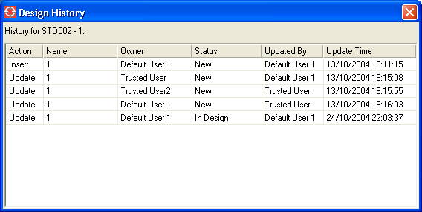

Related Documents
This function is accessible from the “Specials” pulldown menu when editing a job or design. Performing this function will list all external documents that are related to the job or design that is active in the editor.

Note that whenever you use the Layout Designer application to save a layout document to an XML file, that document is automatically associated with the active design (if your system administrator has enabled this functionality).

Here is a screen shot of this menu.

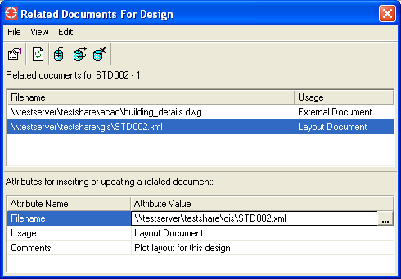

This menu consists of the following components:
- The Pulldown menu functions and Toolbar are at the top of the menu. All of these functions are described below.
- The upper portion of the menu is the Document list. This displays all documents related to the current job or design.
- The lower portion of the menu is the Attribute list. This displays attributes about the document selected in the Document list. It is also used to key in new values to insert or update a new related document reference. This includes the following attributes:
  - Filename: the name of the related document.
  - Usage: this may be one of the following:
    - External Document: any general type of external document – for example, this could be a text file, a Word document, or a website.
    - Layout Document: a saved plot layout document in XML format, which is created by the “Layout Designer” application in Smallworld.
  - Comments: free-form comments that describe the document.

The following Pulldown menu functions are available:

Function name | Button | Description
File Pulldown
Close |  | This closes the Related Documents menu.
View Pulldown
Display Selected Related Document |  | Launches a viewer to display the document selected in the Document list.  If the Usage attribute is External Document, this will simply launch whatever viewer is registered for that type of document – for example, it will launch Microsoft Word to display a Word document.  If the Usage attribute is Layout Document, this will launch the Layout Designer application within the Smallworld environment to display the corresponding plot layout.
Refresh |  | Refreshes the contents of all lists displayed on this menu.
Edit Pulldown
Insert Related Document Reference |  | Inserts a new related document reference, using the values entered in the Attribute list.
Update Selected Related Document Reference |  | Updates the related document reference selected in the Document list, using the values entered in the Attribute list.
Delete Selected Related Document Reference |  | Deletes the related document reference selected in the Document list. Note that this only removes the reference to that document – the document itself is still left intact. If you intend to permanently delete a document, use standard Windows tools such as the File Explorer.

