**###3. Cutadapt和FASTX-Toolkit去除低质量read和接头**

mkdir cutadapt

nohup bash rna.sh > cutadapt.log 2>&1 &

sh文件代码（

file_path=~/SRP200940/

indir=${file_path}/fastq

outdir=${file_path}/cutadapt

for file in `ls $indir | grep 1.fastq.gz`;

do

a=${file%_1.fastq.gz*};

echo ----------

echo ${a};

cutadapt -a AGATCGGAAGAGCACACGTCTGAACTCCAGTCA -o $outdir/${a}_1.clean.fastq.gz $indir/${a}_1.fastq.gz --discard-trimmed --max-n 0.05 --cores=32

done done

）

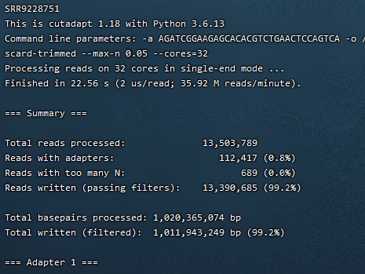

去除接头和N比例过高的read

接着去除低质量read

mkdir clean_fastq

nohup bash rna.sh > fasttoolkit.log 2>&1 &

file_path=~/SRP200940/

indir=${file_path}/cutadapt

outdir=${file_path}/clean_fastq

fastq_quality_filter=~/software/bin/fastq_quality_filter

for file in `ls $indir | grep 1.clean.fastq.gz`;

do

a=${file%_1.clean.fastq.gz*};

echo -------------;

echo ${a};

gunzip -c $indir/${a}_1.clean.fastq.gz | $fastq_quality_filter -q 19 -p 85 -z -o $outdir/${a}_1.clean.fastq.gz -v -Q33

done

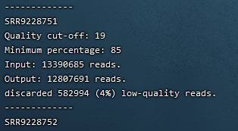

最终得到clean fastq文件

