11

Styled features and long documents
While you are designing, styles constantly prove their worth. However, styles don’t stop giving you advantages when the template is finished. In Writer, paragraph styles also make advanced features more efficient, especially in academic and formal documents.
Tasks such as outlining, navigating documents, adding cross- references, or creating tables of contents are possible without the use of paragraph styles. However, without styles, such features are so much more laborious that doing them manually is a waste of time, except in a few cases where they are unavoidable.
This chapter begins with Writer’s advanced features, focusing on both how paragraph styles
enhance them, and how you can use them to customize your documents and give them a professional touch. You might say that the chapter is mostly about the unexpected dividends that taking the time to use styles can pay you.
The rest is about the tools for designing long and academic documents. Some of these tools do not rely heavily on styles (if at all), but you may need to be aware of their quirks as you design.

Using outline levels
If you have noticed Tools > Outline Numbering, you may have assumed that it is a manual method of creating outlines.
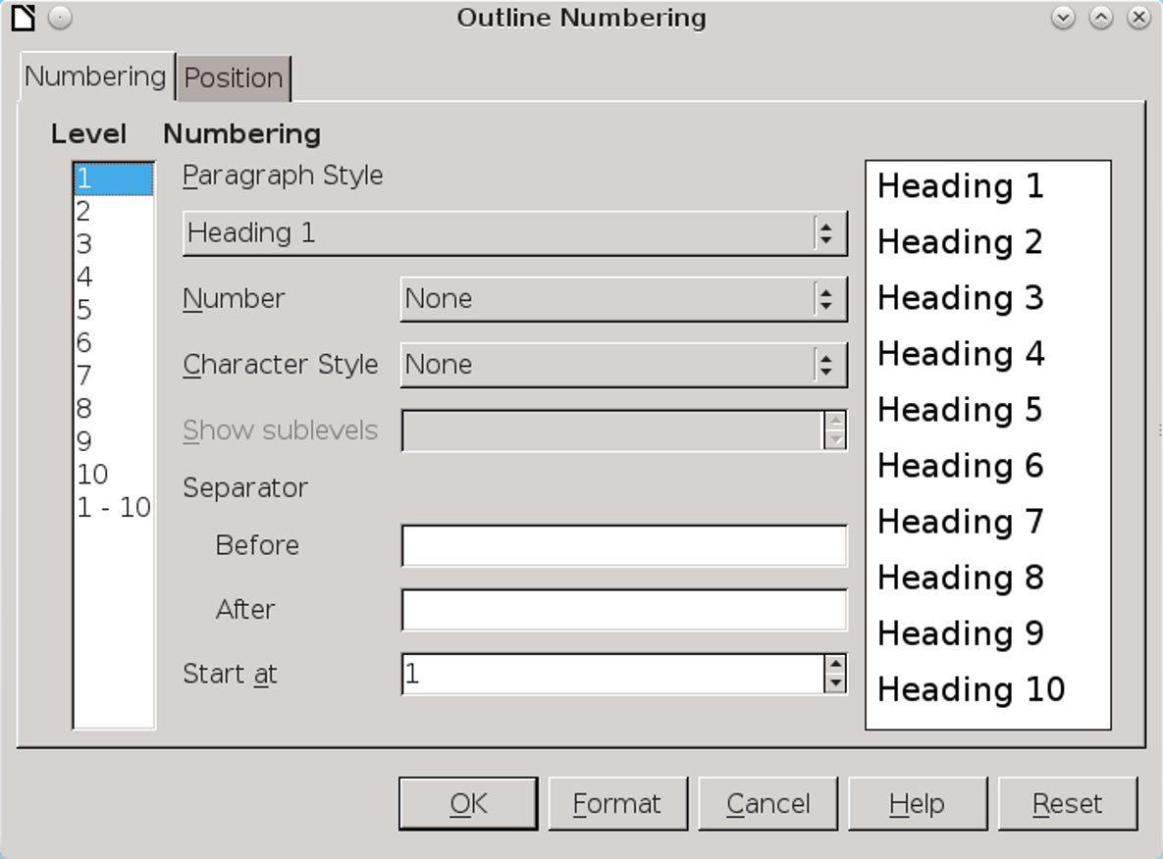
The Outline Numbering dialog window is used for more than just formatting outlines.

However, outlines are only the most basic use of outline numbering. More importantly, outline numbering also defines the paragraph styles used for each level. These styles are picked up by other Writer tools to simplify your work.
By default, each outline level is assigned a heading paragraph style, with Heading 1 assigned to outline Level 1, and so on with each heading style corresponding to the same outline level. However, what most users never notice is that you can assign any other paragraph style to any outline level, by using the Outline level field on the Outline & Numbering tab for a paragraph style. You can also change the default style for an outline level by editing the Paragraph Style field in Tools > Outline Numbering.
Once a paragraph style is assigned to an outline level, it can be used for:
- Writing an outline.
- Outlining in the Navigator.
- Setting up cross-references in the most efficient manner.
- Creating tables of contents and formatting indexes and bibliographies.

Writing an outline
You can outline using heading paragraph styles with a list style attached to them, or a single paragraph style with an outline list style attached.
However, the most obvious method is to use Tools > Outline Numbering. The settings for this tool
resemble the choices on the Options tab of a list style. The formatting can be customized separately for each outline level, or for all levels at once.
See “Error: Reference source not found,” page Error: Reference source not found.

Outlining in the Navigator
The Navigator is one of the most under-used features of LibreOffice. However, the longer the document, the more useful it becomes as you edit and revise
To open the Navigator, select View > Navigator, or press the F5 key, or select the Navigator in the sidebar.
On the simplest level, the Navigator lists all of a document’s objects, including outline levels – headings by default, other paragraph styles as well if you edit outline levels. Clicking a list item in the Navigator jumps to it in the editing window.
However, what may be less apparent is that the headings listed in the Navigator can help to restructure a document.
- Tip
Tables, frames, and other objects are most useful for navigation if you give them descriptive names rather than accepting defaults like Table6 or Image12. One choice is to give all pictures the same name as their original files. That way, finding the files becomes easier.
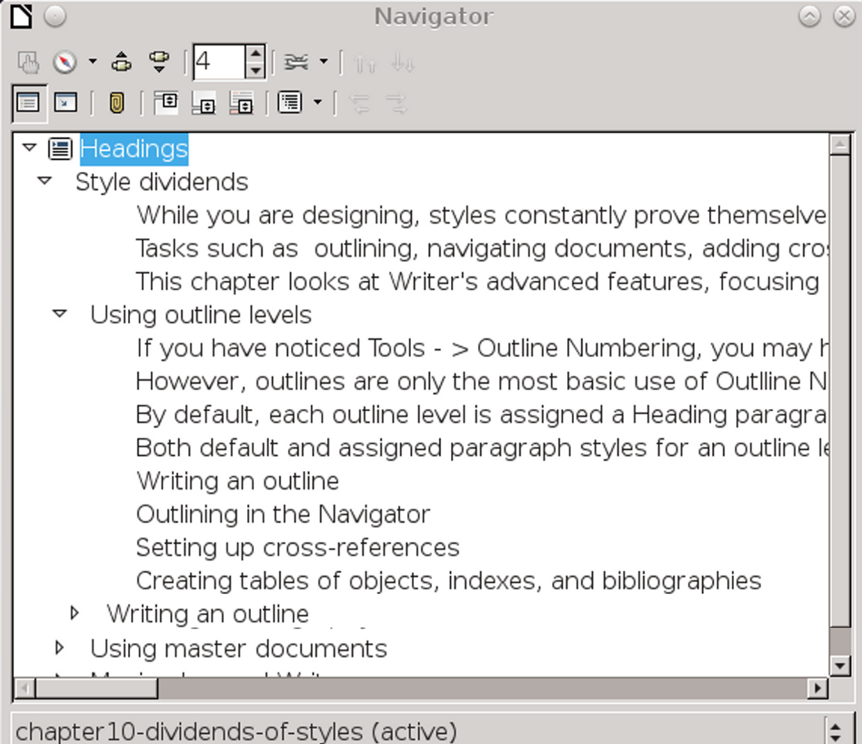
The Navigator becomes a more powerful outlining tool if you set an Outline Level to show the Text Body paragraph style.

Changing outline levels using the Navigator
Headings should be hierarchical, so that the topic in a Heading 3 paragraph style is contained by the Heading 2 paragraph style directly above it. For example, the heading “The Human Body” might have sub-headings below it of “The Heart” and “The Lungs.” This structuring strengthens the internal logic of a document, and helps readers find sections when they scan.
Such relationships are essential to the structure of a document. If you see a heading that should be raised or lowered in the hierarchy, highlight it and then click either Promote Level or Demote Level, the buttons on the bottom right of the tool bar.
Each time you click, the currently selected heading will be raised or lowered one level in the hierarchy. So will any outline levels subordinate to it, so that promoting a Heading 2 outline level to Heading 1 also promotes all Heading 3 outline levels between it and the next Heading 2.

Moving material using the Navigator
Similarly, as you work, you may find that part of the contents belongs somewhere else in the document.
Instead of cutting and pasting, you can click either Promote Chapter or Demote Chapter, the buttons on the top right of the tool bar, to move a heading and the text beneath it to a new place in the document.
- Tip
In the Navigator, “chapter” refers to the part of the document between one heading and the next. “Promoting” moves the chapter closer to the start of the document, “demoting” moves it closer to the end.
All subordinate headings and any other paragraph styles underneath the selected heading will also move, keeping the same position in relation to each other, but changing their group position in the document.
In effect, the Navigator replaces ordinary copying and pasting. However, it is more effective than copying and pasting, because it provides a visual image of your actions.
Just as importantly, if you are interrupted, with the Navigator there is no danger of losing content because you have forgotten about it.

Using cross-references
Cross-references are updatable fields that refer to another part of a document. In online documents, they are links for easy navigation to the reference.
Manual cross-references would be difficult to maintain – especially their page references—so LibreOffice keeps them automatically updated as you add and delete material and close and open documents. You can also manually update by clicking Tools > Update > Fields.
To add a cross-reference, you need two elements: the Selection or source, and the Reference or target. The selections are chosen either from the contents of outline levels or from bookmarks or markers added manually.
Usually, you should add cross-references as your document is being finished. That way, you avoid breaking links and having to re-create them as you move passages around or rename files. Also, you can keep the cross-reference dialog window open and do all cross-references in one effort.
- Tip
If you plan to use cross-references for tables, images, and other elements, give each element a caption, then assign the Caption paragraph style to an outline level.
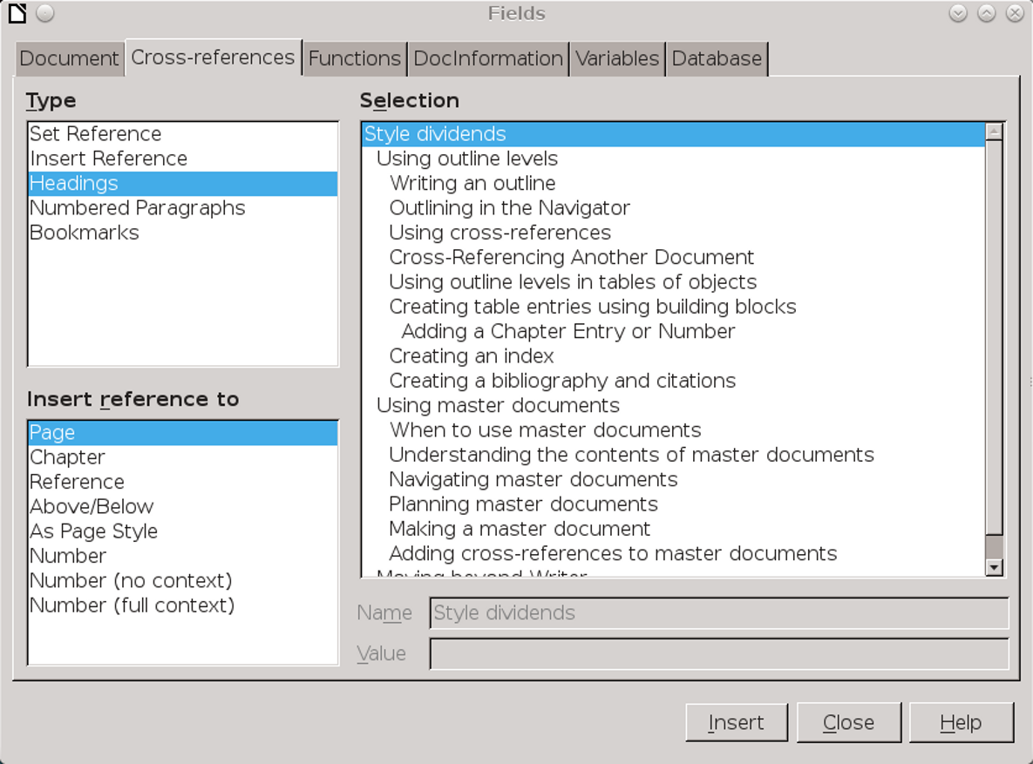
Outline levels simplify adding cross-references. The alternative is to set references, either manually or as bookmarks.

Cross-referencing within one document
Outline levels provide automatic markers to use with cross-references. Add headings as you write, then follow these steps when you add cross-references:
- Place the cursor in the position for the first cross-reference.
- Select Insert > Cross Reference. The Fields dialog window opens on the Cross-References tab.
- From the Type pane, select the sort of source to use. Use Headings whenever possible, since you are adding them anyway and they tend to be
- relatively short. Otherwise, consider Numbered Paragraphs or Bookmarks.
When all else fails, you can use Set Reference to manually create a source. However, this method is so cumbersome and slow that it should be avoided if at all possible.
- Choose the source from the Selection pane.
- Choose the format for the reference from the Insert reference to pane. Click the Insert button to insert the cross-reference into your document. The Fields dialog window remains open.
- Tip
Above/Below are informal, and should be avoided in academic or legal documents. Avoid using them unless the document is nearly completed, in case you move passages around and change their relationship.
- In the document, add the words to introduce the cross-reference. For instance, if the structure you are using includes the chapter and page number, the cross-reference dialog inserts only the actual chapter and page number.
The complete reference may require something like, “See Chapter 6, page 79.” Alternatively, you might want to mention the heading.
- Tip
You can add the wording around the text as AutoText. For instance, you could have one AutoText entry or Custom field for “See Chapter “ and another for “, page “ (notice the spaces at the end of both).
Repeat for all the other cross-references. Close the dialog window when done.
- Tip
Cross-references work differently in master documents. See “Adding cross-references between sub-documents,” page 36.

Cross-referencing to another file
Adding a cross-reference to another document is a different process from adding a cross-reference within a single document, even if both the source and the target document are in the same master document.
The two basic methods involve using Set Reference or hyperlinking using styles. Both methods are done manually.
Using styles saves time when you are cross-referencing another file. In fact, using Set Reference to create a manual reference is sufficiently confusing that I recommend avoiding it altogether.
To add a hyperlink using styles, follow this procedure:
- Open the target document for the cross-reference. The target document is the one which contains the cross-reference.
- Open the Navigator by selecting View > Navigator, or pressing the F5 key, or selecting it in the sidebar.
- Select the source document (the document which you are referencing) from the drop-down list at the bottom of the Navigator.
- Set the Drag Mode tool to Insert As Hyperlink.
- Drag the heading you are referencing into the target document.
A hyperlink to the heading is placed in the target document. The hyperlink is active and can be used online to jump to the source document.
- Tip
If you want the hyperlink to resemble regular text, edit the Internet Link and Visited Internet Link character styles to remove the colors and underlining. This change will affect all hyperlinks, not just cross-references.
- If necessary, add:
- The introductory text. You can define fields or AutoText to avoid having to type it.
- The page number. It must be added and updated manually.
- The document name. Add it manually, or by dragging and dropping the title of the source document.
- Tip
The text displayed for a hyperlink is not automatically updated in the target document when the source document changes. Use Tools > Update to update manually.

Using outline levels in tables and indexes
“Indexes and Tables” is the term LibreOffice uses to describe fields that are generated from the contents of a document.
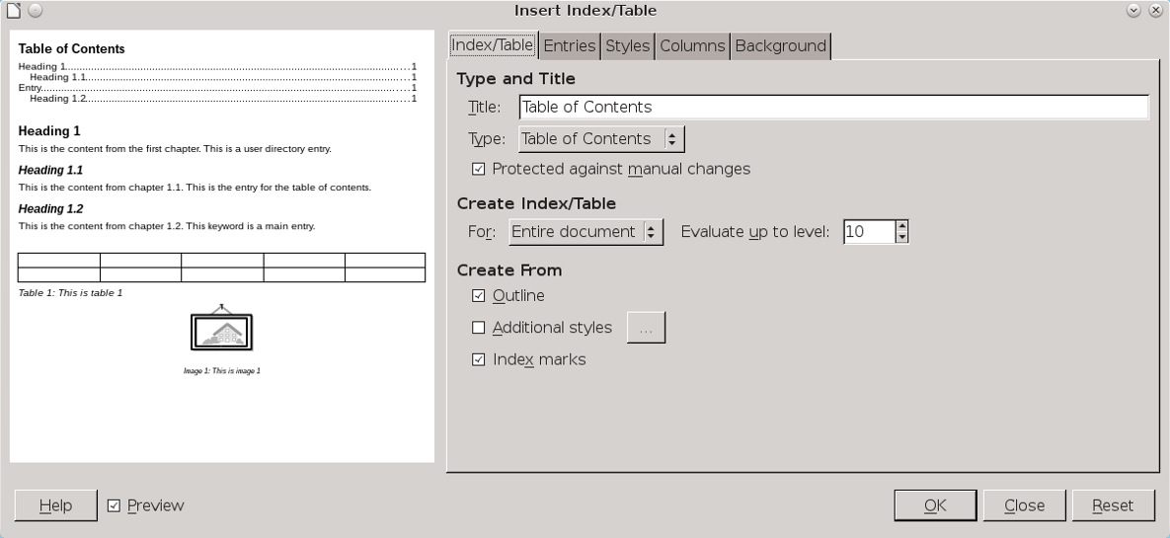
Insert Index/Table includes tools for extensive customization of tables of contents and similar tables.
The most common are a table of contents (TOC), which is created from outline levels. and tables of
illustrations and tables, which are created from captions.
However, you can create all sorts of indexes and tables, such as:
- Alphabetical Index: A list of keywords and their appearances in the text – in other words, a regular index.
- Table of Illustrations: A list of images, generated from caption categories.
- Table of Tables: A list of tables, generated from caption categories.
- Table of Objects: A list of other elements, such as charts.
- Bibliography: A list of reference materials used in the document.
You can also add user-defined index marks to create other tables.

Creating a table of contents
Each kind of table has its own list of customized features. However, the procedure for building most of them is similar to the one for creating a table of contents:
- If necessary, customize a page style for the table, and add it to the document.
- Go to Insert > Indexes and Tables > Indexes and Tables > Index/Tables > Type and select the type of table. Your selection determines both the default title and
- some of the advanced options. However, many of the advanced options may be unnecessary.
- Select Index/Tables > Additional Styles to add additional paragraph styles to the table of contents. Any selection you make does not add styles to the outline levels.
- Tip
Styles already assigned to outline levels cannot be given different outline levels.
- If your table entries are single words or phrases of a few words, you might be able to save space by setting 2–4 columns on the Columns tab.
- On the Entries tab, customize the table entries using the building blocks in the Structure field.
- Tip
Keep the LS (Link Start) at the beginning of the Entry field, and the LE (Link End) at the end of the field.
These two links make the entire entry a hyperlink to the text, that you can use in an online document or when editing.
Other fields appear in the tab as you make selections. The preview pane on the left shows what your design will look like on the page.
- Click the OK button to add the table. You can right-click the table to edit or update it later.
- Edit the paragraph styles for each table entry. These styles consist of a heading paragraph style (for instance, Contents Heading for a table of contents), and styles for each outline level of table entry (such as Contents 1-10 for Index/Tables).
Usually, you can model the Contents Heading paragraph style on the document’s Heading 1 or 2 style, and the entry styles on Text Body, using the Inherit from field on the Organizer tab. There is no need to use different font sizes or colors to distinguish the style for each entry level – the left indent is enough.
An alphabetical index will have an index separator style for the alphabetical delimiters at the start of each section.

Structuring table entries with building blocks
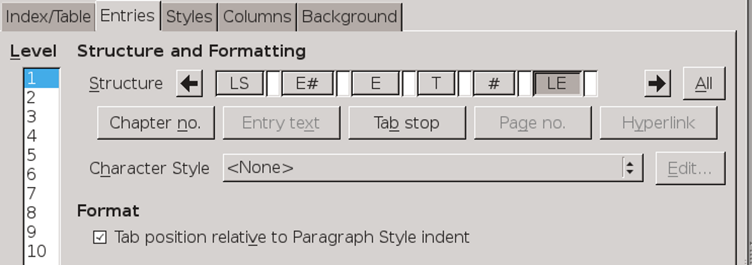
Use building blocks to customize tables of contents.
Unlike most word processors, LibreOffice provides the tools for customizing each entry for a TOC or
similar table. These tools are located at Insert > Indexes and Tables > Indexes and Tables > Entries. You can also modify indexes and tables by customizng their paragraph styles.
The tools consist of a Structure field in which you can arrange building blocks such as Page Number and Chapter Number, characters, and spaces to create a standard entry.
Below the field are the unused building blocks. When you add a block to the field, it may become grayed out and unselectable.
Similarly, when you delete a block from the field, it reappears in the unused list below the Structure field.
When a building block is selected, it looks sunken in the Structure field. In addition, formatting choices for the building block appear in the window.
Each outline level can be customized separately, or together by pressing the All button on the right side of the window. If the levels have common elements, format them together, then edit each level separately for unique features.
As you design, remember:
- Use the LS (Link Start) at the beginning of the Entry field and the LE (Link End) at the end of the field to make the entire entry a hyperlink.
- The spacing of all tabs is added to the Before text indentation on the Indents and Spacing tab for each entry’s paragraph style (Contents 1-10). To avoid difficulties, leave the Before text field set to 0.
- You can reliably use only one tab in the Entry field. Otherwise, spacing can become erratic.
- You can add manual spaces and text as well as building blocks to an entry. Manual spaces are inelegant, but can sometimes be a workaround to the one-tab limit.

Avoiding the default TOC design
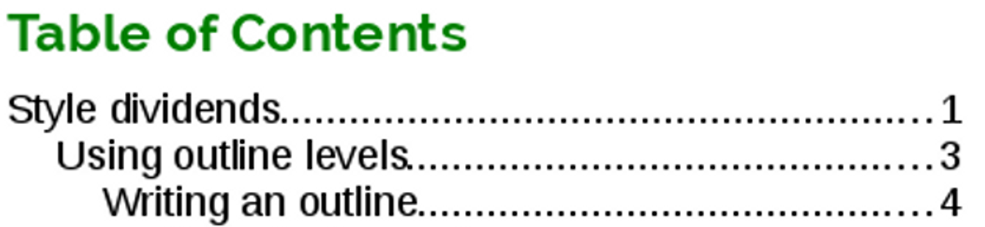
The standard word-processor design for a Table of Contents. Its need for crutch-like leader dots between the text entry and the page number is enough to prove it a crippled design.
TOCs in LibreOffice default to a format that has become standard in many word processors. In this style, each entry consists of text and a page number placed by a tab on the right margin. In between are fill characters, usually a period.
If you have regularly generated TOCs using word processors, you might not see anything wrong with the default TOC design in Writer. Probably, you have seen the design too many times to be bothered by it.
However, to anyone with design knowledge, the result is a failed design. Starting the TOC entry at the left margin and placing the page number against
the right margin disassociates them, and the leader dots are needed to try to reconnect them.
The result is ugly. It is also clumsy. Since periods are used to indicate a stop, not a continuation, the periods do not lead the eye across the page. A design that does not disassociate the text entries and the page number in the first place is far more efficient, and simpler as well.
Fortunately, while LibreOffice defaults to this design, you can work with the building blocks and paragraph styles to create a more functional design in any number of ways. For instance:
- Reduce the space between the entry text and the page number using the paragraph style.
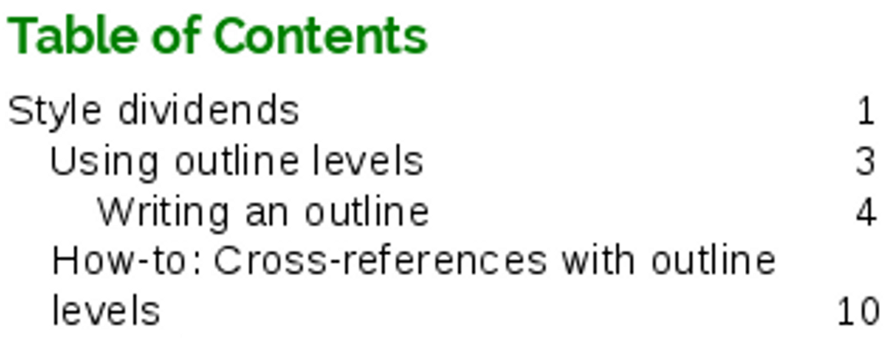
Larger fonts and no leader dots improves the design. But watch for entries that spill over on to another line, spoiling the symmetry of the design for no reason.
- Select the # (Page no.) block and give its character style a larger font size and/or a color to make it stand out more. The larger page number helps to keep the association between the text entries and page numbers.
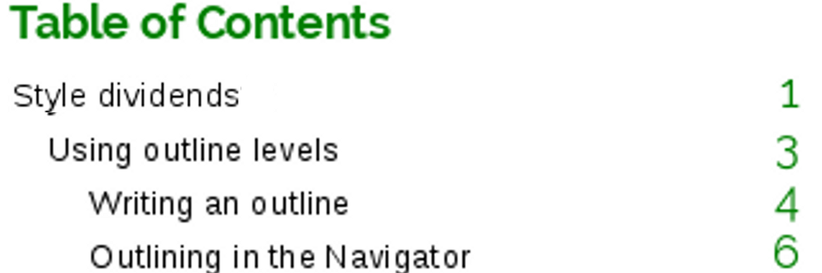
Increasing the size of the page number helps some, but the basic problem remains: The distance from some page entries still makes the table of contents harder to read than necessary.
- Click on the T (Tab) block. Fields for the fill character and tab stop position appear below the list of unused building blocks. Replace the fill character with an underscore, and at least your eye is guided continuously across the page, which is an improvement on leader dots. However, having a fill character at all still seems like a needless addition.
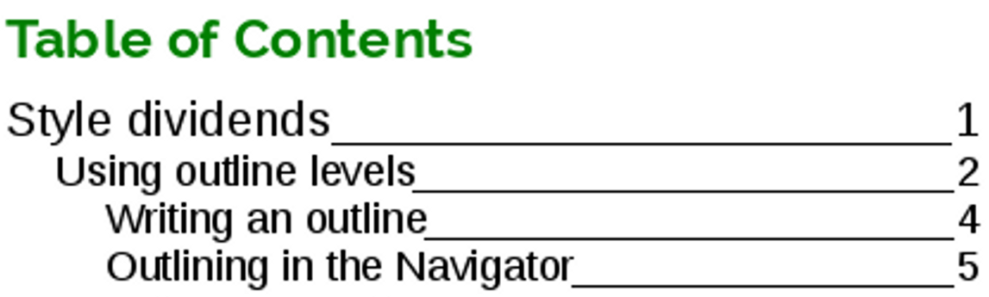
An underscore leads the eye across the page, but still tends to separate the text entries from the page numbers.
- Go to Insert > Indexes and Tables > Indexes and Tables > Columns and set the table to use two columns. This solution shortens the distance between the text
- entry and the page number, but may be impractical if any entry text is more than a few words long and spills over onto another line.
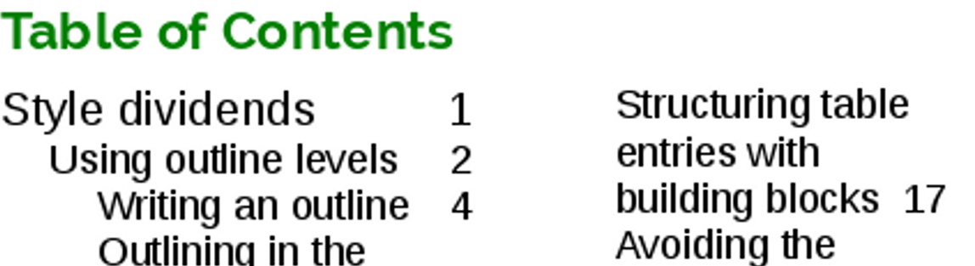
A two-column table of contents lessens the space between text entries and page numbers. However, to work without the problem of long entries taking up two lines, it requires short text entries, or perhaps a landscape oriented page with columns.
- Delete the Tab block and manually add spaces between the E (Entry text) and # (Page no.) blocks. Manual spaces are generally not a good way of laying out design elements, but in this one case, they do not create any problem beyond the need to keep count. They are inelegant, but work.
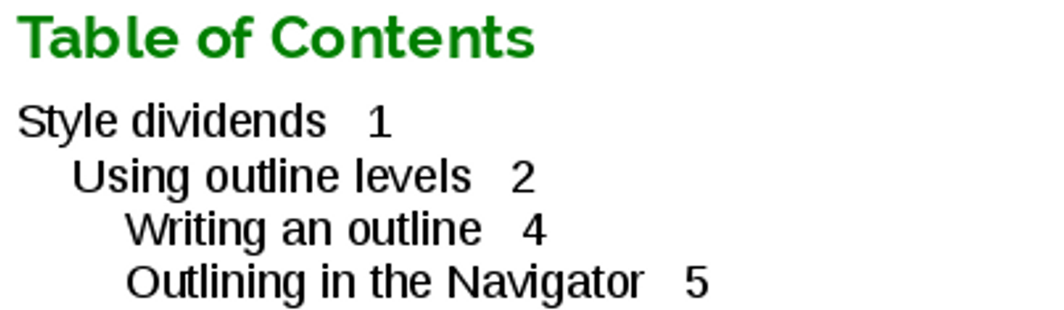
A ragged right table of contents keeps text entries and page numbers together so that they can be easily read. However, two ragged margins looks cluttered.
One way to avoid ragged right looking cluttered is to format the Contents paragraph styles so that all entries have the same margin on the left. However, this solution hides the hierarchal structure of the headings.
- Reverse the order of the text entries and the page numbers, with a tab or a couple of manual spaces between them.
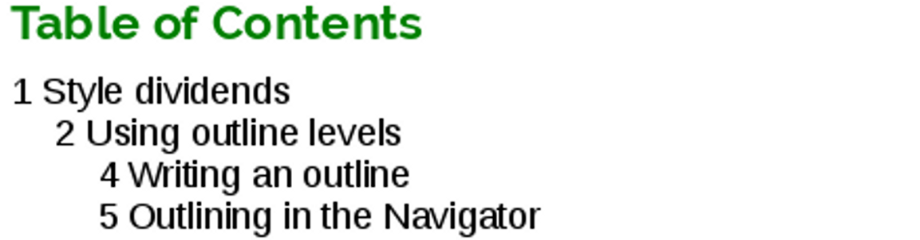
Placing the page numbers before the text entries keep their relation clear and gives the most space for long text entries.
- Tip
You can also add a special character or dingbat between the text and page number.

Adding a chapter number
In Writer, you can add chapter numbers to page numbers in the body of a document (see “Error: Reference source not found,” page Error: Reference source not found). However, although the building blocks on the Entry tab include a chapter number, your ability to add chapter numbers in a table of contents is limited.
The chapter number building block can only be used in the top level entry in the table of contents. The building block draws its information from the top outline level (usually, the Heading 1 paragraph style) if the outline level or the paragraph style includes numbering. In the same circumstances in a master document, each top outline level continues the numbering from the previous heading at the same outline level.
Other outline levels cannot display the chapter number, even if you add the building block to its structure on the Entries tab.
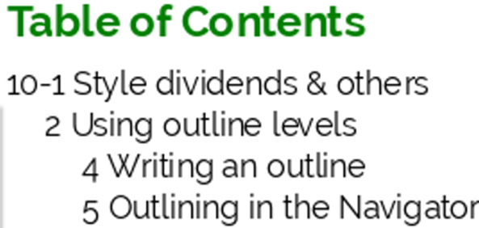
A table of contents that adds the chapter number as a prefix.
As an alternative, ignore the building blocks and attach a list style to the Contents 1 paragraph style. The list style could also be used to add the word “Chapter” before the number.

Creating an index
An index is created in much the same way as a table of objects. The main difference is that it is built from tags of individual words or phrases, rather than from paragraph styles, which would not provide the type of information that an index requires. These tags display in the document as fields.

Adding index entries
The simplest way to add an entry is by selecting words or phrases and marking them with Insert > Indexes and Tables > Index Entry. However, it is laborious and time-consuming.
Instead, you can automate the creation of index entries by selecting Apply to all similar texts to add other occurrences of an entry in the document. Use Match case and Whole words only to modify the selection of similar texts.
No matter how you prepare them, indexes can have a main entry, and up to two sub-entry levels. Any more sub-entries would generally be overly-complicated for writers to maintain and readers to follow.
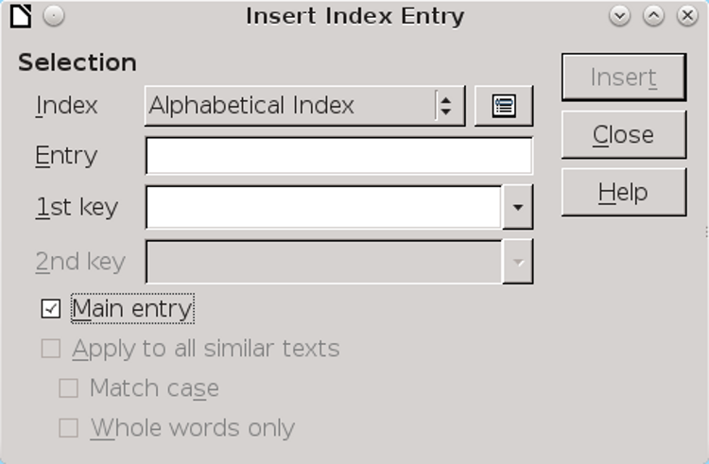
0
The Insert Index Entry dialog window stays open after you insert an entry, letting you move on immediately to the next entry.

Generating an index
After all the entries are created, open the Insert Index/Table dialog window to generate the index.
- Tip
A standard index is called an Alphabetical Index on the Type field in the Insert Index/Table dialog window. Since this is a non-standard usage, you might modify the title to “Index.”
If your entries are short, you can save pages by clicking Insert > Indexes and Tables > Indexes and Tables > Index/Tables > Columns, and setting the index to use two columns.
If you want to add headings with letters of the alphabet, select Insert > Indexes and Tables > Indexes and Tables > Index/Tables > Entries > Alphabetical Delimiter. Alphabetical delimiters are sub-headings, with one for each letter of the alphabet.
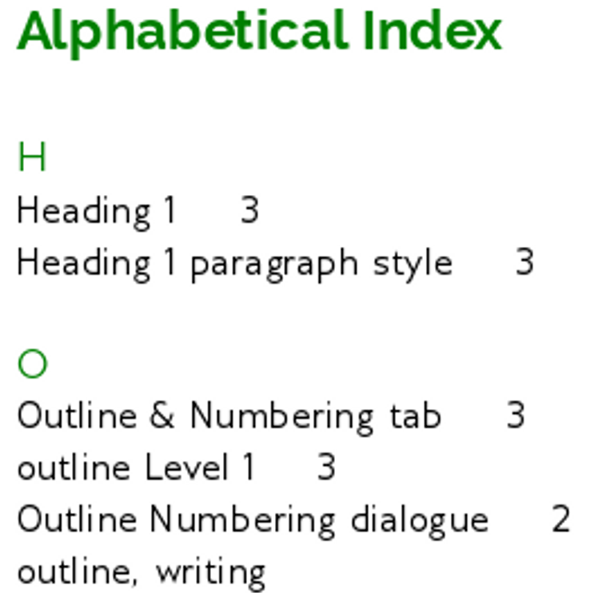
A selection from an alphabetical index.

Creating a concordance
A more systematic way to create an index is to use a concordance file. A concordance is a file that lists words to add to the index. It is a plain text file with one word or phrase defined on each line.
Each line has a strict structure, consisting of seven fields, separated by a semi-colon:
Search term; Alternative entry;1st key;2nd key;Match case; Word only
No space is entered between the semi-colon and a field’s contents. A key is a higher level heading that a search term is placed beneath. For instance, if your search term is “styles,” you might want to use the keys “LibreOffice” and “office applications.”
If you choose not to have an alternative entry, a first key or a second key, leave the field blank, so that one semi-colon immediately follows another.
The last two fields are structured somewhat differently. If you want only entries that have the same upper or lower case letters as your entries, enter 1 in the second to last field. Similarly, entering 1 in the last field sets the index to only include instances where the entry is a whole word, and not part of a larger one. You can also just leave the last two fields blank, as you can with any of the others.
For example, entering:
Macaw;Ara;Parrots;;0;0
Would produce an entry for “macaw” with
- A listing under “macaw.”
- An alternate listing under “ara” (the scientific name).
- A listing of “Parrots, Macaw.”
- No second key (notice the two semi-colons).
- Inclusion of instances that start with a lower or upper case letter (both “macaw” and “Macaw”).
- Inclusion of instances in which the term is a whole word or part of a longer word.
Whether creating a concordance is faster than adding entries manually is debatable since the tasks are so different. However, a concordance is certainly more systematic and possibly less tedious.
The disadvantage of a concordance is that it can produce an index that includes instances of common words that are irrelevant for your purposes. In many cases, a useful index may require a combination of manual entries and a concordance.

Creating citations and bibliographies
Like tables of contents and indexes, bibliographies are generated with the Index/Table dialog window. However, the contents are based upon citations that refer to entries in the Tools > Bibliography Database.
The bibliography database has to cover many different media and circumstances, which is why it contains so many fields. It also includes fields such as ISBN that no citation style uses, but might be useful to you as you do your research.
In practice, however, any single entry in the bibliography needs only about half a dozen fields filled in, no matter what citation format you use. What differs is the fields needed for each type of source material and the order of the fields in each citation style.
However, all citations use the Identifier field (first on the left) to set the format for a citation in the document. In this column, you can add the citation in the correct form for the citation style.
For example, in the APA style, a citation to this book would use “Byfield” in the text and follow the information cited with (2015).
All necessary information, including the Identifier field should be entered before any citation is created. In theory, you can add a citation manually by highlighting text, but doing so makes consistency much more difficult.
- Tip
Writer has a single bibliography database for all documents. Since formatting entries can be tedious, consider creating a template with citations for each type of source material .
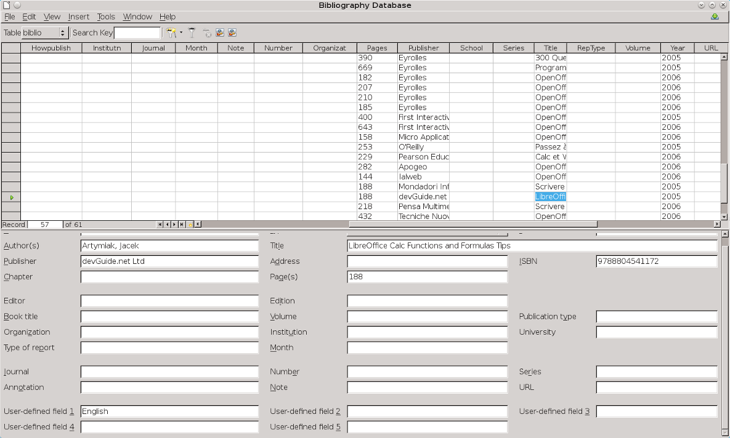
The bibliography database is the source for citations in the text, no matter what citation style you use.
- Caution
Confusingly, the Identifer column and the Short Name field below the table are the same field, and should have the same content.
To complicate matters even more, the sample entries for both the Identifer column and the Short Name field are meaningless, although they have been in OpenOffice.org and LibreOffice for over a decade.
Replace them with the proper format for the citation style you are using.

Building citations and bibliographies
This procedure is an overview of the steps in creating citations and bibliographies. More detailed information follows:
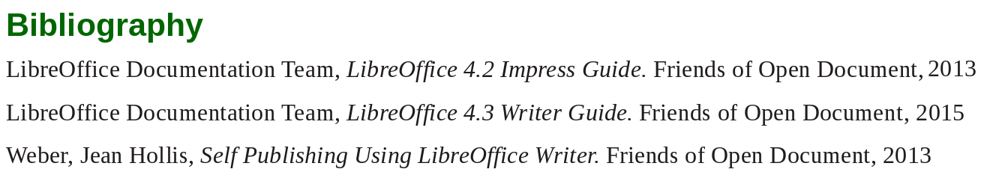
A short bibliography generated by Writer. The book titles use a character style so they appear in italics.
- Enter the correct information for each source you are using. For example, a reference to a journal article requires different information from a reference to a book.
- Add the format for citations in the Identifer column and the Short Name fields.
- Position the cursor in the text and click Insert > Indexes and Tables > Bibliography Entry. Use the drop-down list in the Short Name Field to chose the citation from the ones you have prepared in the bibliography database, then click the Insert button. The Insert Bibliography Entry dialog window remains open, so you can insert citations without having to re-open the dialog for each one.
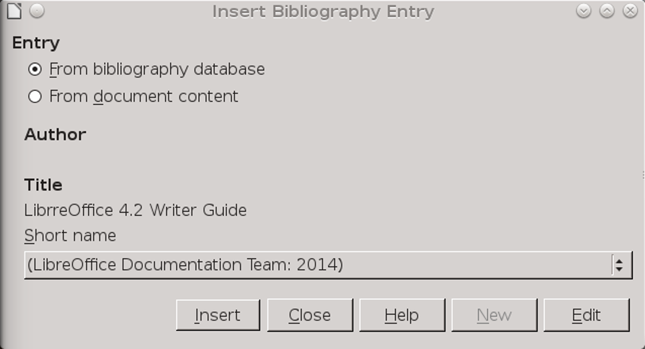
By collecting references in the bibliography database, you can add consistent citations to your document.
- Tip
Make a note of the different types of sources you use. You will need this information in the fifth step.
- Place the cursor where you want the bibliography to appear in the text, and select Insert > Indexes and Tables > Indexes and Tables. Usually, a bibliography appears at the end of a document.
- Format the bibliography. At a minimum, you will need to:
- Set the Type field to Bibliography on the Index/Table tab. The Type refers to the kind of source, such as a periodical or a web page.
- Use the Position field on the Entries tab to structure each type of source used in the document.
- On the Entries tab, set Sort By. In most modern citation styles, you will want Content (alphabetical
- descending order), but you can add other sorting criteria, or use ascending alphabetical order.
- Tip
On the Entries tab, you can define a character style so that book and journal titles are in italics or bold.
- Caution
The formatting options on the Entries tab have some unusual defaults.
For example, the default is to arrange a bibliography in the order in which citations appear in the document, rather than alphabetical.
Similarly, the Structure field begins by default with the Short Name for each item, which is not needed.
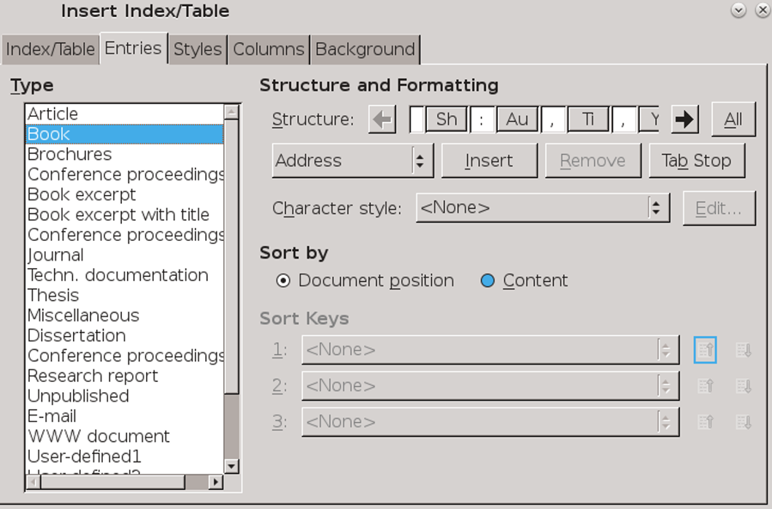
Create a structure for each type of source material used in the document.
- Adjust the Bibliography paragraph styles. Usually, they will be similar to the Text Body styles.

Preparing bibliographic formats
Before adding citations, you need the correct information for the citation style you are using. Similarly, you need to have the correct information for each bibliography entry.
Most citations styles developed in different fields of academic study. They are a matter of convention, since they all give similar information.
There are five main styles. If you are taking a class or writing for a journal, ask your teacher or editor which format they prefer. Otherwise, use the format for your field of study:
- APA (American Psychological Association): Psychology, education, and other social sciences.
- MLA (Modern Languages Association): Literature, art, and humanities.
- Chicago: History and specific publications.
- Turabian: A variation of the Chicago style for general use by university students.
- AMA (American Medical Association): Medicine, health, and biology.
Citations within the text require entries in different fields in the bibliography database, and different presentations in the text.
Today, all except the AMA style favor parenthetical citation, in which minimal information is presented in parentheses in the text. Parentheses are less distracting when you read and keep citations from being an exact duplication of the bibliography.
The AMA style uses footnotes or endnotes instead.
The following table shows what fields to use for three common sources: books, articles, and web pages. Fields are arranged from top to bottom in the order that they appear.
- Caution
LibreOffice’s bibliography database has not been updated for years. Meanwhile, citation styles have changed dramatically, many becoming simpler. For this reason, in case of conflict, use the information and
order given here or online in preference to the defaults on the Entries tab.
Format | Book | Journal | Web page
APA | Author(s)  Year  Title  [City]  Publisher | Author(s)  Year  title  Journal  Number/series  Page(s) | Author(s)  Year or [date]  Title  Retrieved from:  [Webpage]  URL
MLA | Author(s)  Title  [City]  Publisher  Year | Author(s)  Title  Journal  Number/Series  Year  Page(s) | Author(s)  Title  Publisher  Year or [Date]
Chicago | Author(s)  Year  Title  [City]  Publisher | Author(s)  Year  Title  Journal  Number/Series  Page(s) | Author(s)  Year  Title  Publisher  Accessed: Year or [Date]  URL
Turabian | Author(s)  Year  Title  [City]  Publisher | Author(s)  Year  Title  Journal  Number/Series  Page(s) | Author(s)  Year  Title  Publisher  Accessed: Year or [Date]  URL
AMA | Author(s)  Title  [City]  Publisher  Year | Author(s)  Title  Journal  Year  Number/volume  Page[s] | Author(s)  Title  Publisher  Year  Available at: URL  Accessed: Year or [Date]

Preparing citations
Citations in the text need to be prepared beforehand. Edit the Identifier and Short Name (which are different names for the same field) using the format indicated in the table below. Fields are listed from the top in the order in which they should appear:
Format | Datab. | Citations | Other
APA | Year | (Year) | Mention the author at the start of the sentence that includes the citation.
MLA | Author | (Author pages) | Add title if different sources are used by the same author.
Chicago | Author  Year | (Author, Year, pages) | Older version uses footnotes or endnotes.
Turabian | Author  Year | (Author, Year, pages)
AMA | – | Footnote or endnote | Footnote or endnote.
The bibliography database fields need for in-text citations, and the citation formats.

Creating footnotes and endnotes
Parenthetical citations have the advantage of letting you view them without losing your place in the text. However, footnotes and endnotes are still used for citations in the AMA format as well for personal preferences.
To use the bibliography database for footnotes and endnotes, set up the citation in the Identifier column of the bibliography database. The citation may be much longer than most parenthetical citations, but you can still use the column.
To position a footnote or endnote, click Insert > Footnote/Endnote. After the number, complete the footnote or endnote by selecting the citation from the drop-down list for Insert > Indexes and Tables > Bibliography entry > Short name.

Using master documents
Master documents are meta-documents: documents made from a collection of Writer documents. Like many advanced aspects of Writer, they work best with a consistent use of templates and styles.
You view the structure of a master document through a specialized version of the Navigator that you can toggle on and off on the tool bar’s left.
A master document contains links to its sub-documents. When sub-documents are opened, they are reformatted according to the master document’s template. You can print from a master document, and edit text created in one, but all sub-documents must be opened separately to edit them.
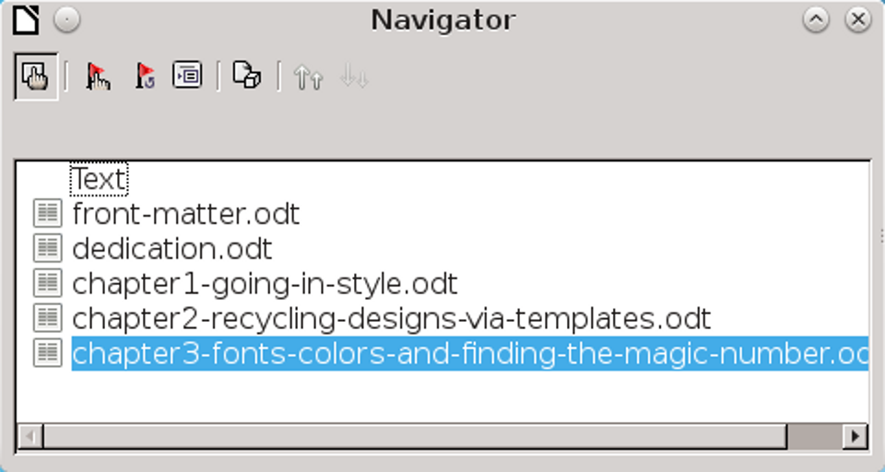
The Navigator includes a special view for the contents of master documents.

- Tip
The reformatting applies only within the master document. If the sub-documents use their own template, they format differently when opened separately.

When to use master documents
Consider using master documents when:
- Your computer’s memory is limited, so you are working with small documents.
- Material is used in different places. A sub-document can be included in more than one master document.
- A document (such as a book) has multiple authors. Authors can work on sub-documents (such as chapters) by themselves, then you use the master document for assembling the complete document.
- You want to produce two or more documents that are similar except in some parts. You can add all the files for all the sub-documents, then hide or unhide individual sections.

Understanding master documents’ contents
Master documents are built from three sources:
- Sub-documents: Smaller, individual files. You can edit one by selecting it in the Navigator, and selecting Edit from the right-click menu. Sub-
- documents help multiple authors to work on the same master document at the same time.
- Indexes and tables of objects inserted into text areas of the master document. Like any text, they can be replaced by sub-documents.
- Text: Areas between sub-documents that are part of the master document. In Navigator’s master document view, each text area is only labeled as Text, so their use should be minimized to avoid confusion. You might find the parts of the master document easier to keep track of if you avoid text and use sub-documents instead.

Navigating master documents
Master documents have a special view in the Navigator. To toggle the view, click the Toggle button in the upper left of the tool bar. A new set of icons appears in the toolbar.

The Navigator icons for the master document view.
- Tip
The Navigator only inserts items above the current one, You can rearrange items after adding them.

Planning master documents
To use master documents efficiently:
- If possible, use the same template to create the master document and all its sub-documents. A sub-document with a different template may have formatting problems when you switch between using it by itself and using it as a sub-document. If you are using a sub-document in more than one master document, ignore this advice and hope for the best.
- Place a master document and all of its sub-documents in the same directory.
- Ordinarily, you probably want each part of a master document to start on a separate page. You can set this format up automatically using the Breaks section on the Text Flow tab of paragraph styles to start a new page after the paragraph style that begins all the sub-documents, such as Heading 1..
- The convention is to start each new part of a long document on a right, odd-numbered page. The reason is that most readers’ eyes fall on the right page first. If you want a page to be a right page, add a blank text in the master document. Do not uses spaces to add another page, or you may run into difficulties.
- Aside from tables and indexes and page breaks, minimize the content that is added to the master document directly, rather than to sub-documents. The more content that is added directly to the master document, the more likely it is likely to crash.
- Use page styles and/or manual page breaks to use different numbering for different parts of the master document. For example, one common format is use lower case roman numerals for front matter such as copyright pages and tables of contents, and Arabic numbers for the main text. Often, too, numbering is restarted with the main text.
- Caution
Currently, master documents can have problems with page breaks. If you have difficulties, assemble long files by copying and pasting.

Creating master documents
Master documents can be fragile to work with. Creating one in this order should minimize problems:
- Create the sub-documents as you can, even if they are blank. The sub-documents should all use the same template. You can create master documents from sub-documents with different templates, but you might have formatting problems.
- Use the same template to create the master document. Click File > Send > Create Master Document and save. You can use a blank document, or a sub-document. If you use a sub-document, then it
- will be first in the master document, and will not be deletable.
- Tip
Master documents all have an .odm extension. However, you can start the name with “master-document” for quicker identification, at least while you are working.
- Caution
Unless your default template is the one that the master document uses, do not create a master document from File > New > Master Document. You want to ensure that you are dealing only with the template you want.
Unless the master document and sub-documents share the same template, the sub-documents reformat each time you use the master document, increasing the chances of corruption.
- The Navigator is open when you finish saving the master document. Use its features to add and position all the sub-documents (as described above).
- Add any tables of contents, indexes, and bibliographies directly to the master document when all the sub-documents are complete.

Adding cross-references between sub-documents
Adding cross-references between two sub-documents in a master documents is similar to adding a cross-reference in another document. However, because headings do not display, you must set references manually, in an awkward work-around:
- Open the sub-document you plan to reference (the source document). You can open it by itself, or from the master document.
- Highlight the text for the reference, and click Insert > Cross-Reference > Set Reference.
The Fields dialog window opens to the Cross-references tab. The selected text is entered in the Value field.
- Enter a name for the reference. Then click the Insert button. In the text, the selected text now has the gray shading that marks a field.
Choose a name that is unique not only in the current sub-document, but all other sub-documents. The easiest way to ensure uniqueness is to make the name and the value identical. You can also keep a separate note of each name in a spreadsheet.
- Tip
To view the reference, change to the Navigator's view of the master document and look under References.
- Save the source sub-document with the reference.
- Open the target document and select Insert > Cross References > Insert Reference.
- The Fields dialog window opens to the Cross-references tab.
- Caution
Because the reference is in another document, it is not listed in the Selection pane.
- Type the reference’s name in the target document.
- Make a selection from the Insert reference to pane. Chapter is the chapter number, Reference the text of the reference.
- In the target document, enter the lead text, then select the format followed by the Insert button.
Because the target sub-document cannot find the reference in the source sub-document, the message Error: Reference Source not found displays.
- Caution
This error message may cause problems with pagination when the sub-document is open by itself. You can ignore the problems if the sub-document is only going to be used in the master document.
- Save the target sub-document with the cross-reference. When you re-open the master document, it will be able to locate the reference, and the cross-reference will now display instead of the error message. Pagination problems due to the error message are also corrected.
If you open the sub-document with the cross-reference from outside the master document, the cross-reference fields show the error message again.
- Caution
Cross-references are based on the names of sub-documents. If you change a sub-document’s name – for instance, to indicate a draft – you have to re-insert any cross-references to it.

Moving beyond Writer
After ten chapters, the importance of styles in Writer should be proved beyond any doubt. When you do not use styles, you waste time and limit your possible actions. It’s that simple.

