14

Drawing Object styles and charts
Drawing Object styles (also known as Image styles and formerly as Graphic styles) define the characteristics of a drawing object in Draw or Impress. They are not available in any other LibreOffice application, even though you can use the Drawing tool bar to add manually many types of drawing objects in Writer and Calc. Typically, you apply them after inserting a shape.
- Caution
The Drawing tool bar has icons in Draw and Impress that it does not have in Writer and Calc. In particular, the Draw and Impress version has Connectors and Arrows.
Another point to be aware of: Drawing styles are for formatting only. They do not affect shape or size. That means, for example, that the pre-defined Object with Shadow style can format both a rectangle and shapes that are identical except for dimensions.
This chapter concludes with a discussion of how to design graphs and charts using LibreOffice’s Chart sub-system. Available in most LibreOffice applications, Chart remains one of the few tools in the entire office suite that uses manual formatting only. All the same, charts remain important in business, academic or scientific documents, and are highly customizable.

Planning graphic styles
Like other LibreOffice applications, Draw includes pre-defined styles. Some of these are for graphic text, but others are for general categories of drawing objects, such as Object with arrow. Most are not for specific shapes, sizes, or purposes, except for Dimension Line.
Often, however, creating your own styles is more convenient, even if you start by modifying a pre-defined style. The best way to begin is by breaking down the diagram into its basic elements. Then assign one graphic style per element.
For instance, if you are building an organizational chart, you might have a style called Position Boxes to indicate each job. If you want to apply this style somewhat differently – perhaps
using different colored shapes to indicate different departments or the project lead – use the Inherit from and Next fields on the Organizer tab to create subordinate styles with names like Position Box or Project Lead.

Applying graphic styles
Unlike styles in Writer, graphic styles can only be applied after a shape is added to a document. Insert one of each of the shapes your document uses, then choose the style to apply from the Styles and Formatting window.
Once you have added the style to one type of object, you can copy and paste to create others of the same type, or else use Edit > Duplicate.
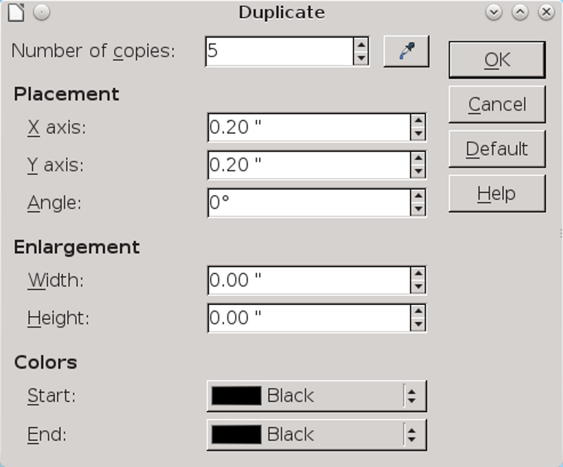
Edit > Duplicate saves copying and pasting shapes.
Besides copying, the Duplicate window can enlarge and color copies, and offset them, so you can make a copy as you need it. When working in
Draw or Impress, you might get into the habit of replacing Ctrl+C with Shift+F3 for copying.

Formatting drawings
Shape choices determine each object’s features. Many are similar to those found in other styles, but in a diagram they become more important.
For example, you may have few needs for a border or background in most Writer styles, but in Draw such characteristics (named line and area) become a primary concern.
As you work with shape characteristics, you will soon find that many of the available settings apply only to certain shapes. Others you may choose to ignore, either because the defaults are good enough for your purposes or because your drawing has nothing that could be affected by the setting. For example, if your drawing has no text, any text setting is irrelevant.
- Tip
For detailed information about the Alignment, Font, Font Effects, Indents & Spacing, and Tabs tabs, see Chapters 3-5. Details about style features unique to graphic styles follow in this chapter.

Setting line formatting
Lines distinguish the outline of a shape from the area. They are approximately equivalent to Borders
in other LibreOffice applications, although the features are not identical.
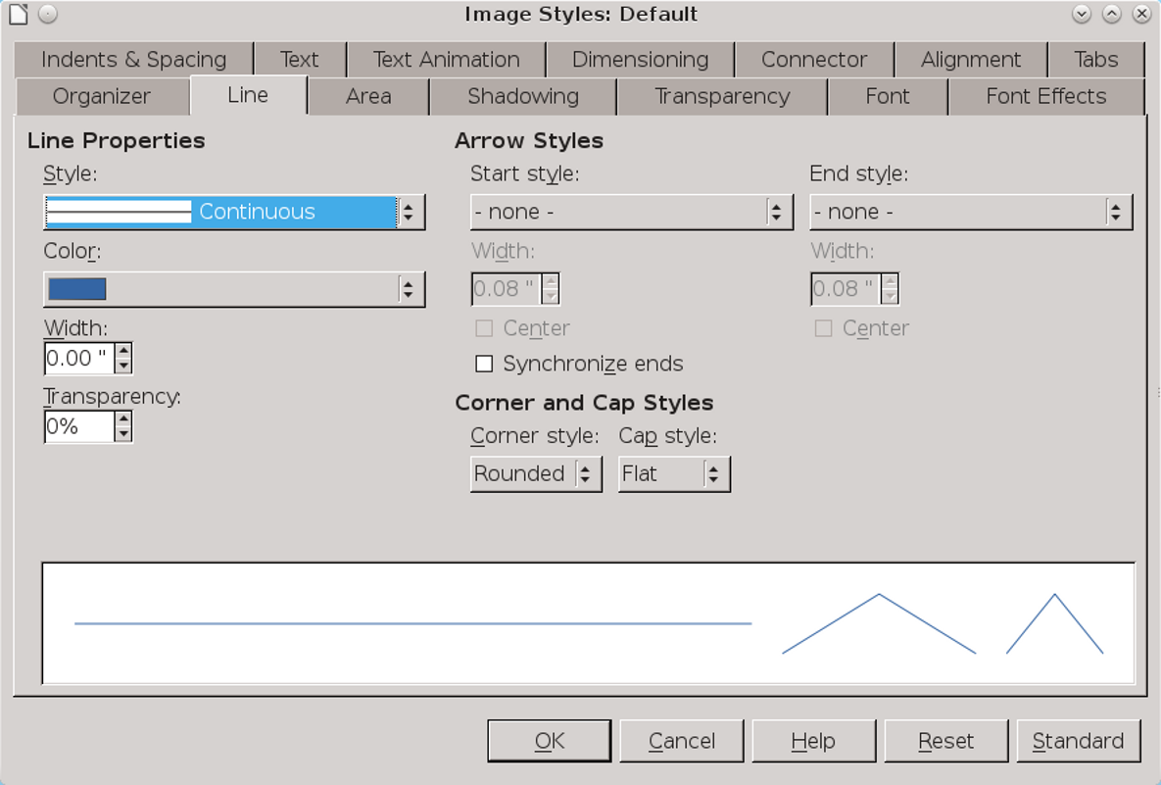
The Line tab is analogous to the Borders tab in the styles for other applications.
If lines are irrelevant to your design, set the Line Style to None, and you only need to be concerned about area formatting.
In addition to choosing the color and thickness of an object’s outline, the Line tab also includes options for arrows and line ends for both ends of a line. By default, arrows and line ends have the same proportions as the line itself, but you can make them thinner or thicker as you choose.
- Tip
The Drawing tool bar also has block arrows that you can group with a line.
Customized lines are stored in the /user/config directory of your personal configuration path. The .sod file contains custom line formats, the .soe file custom arrows.

Setting dimension lines
You can modify dimensions lines from the Dimensioning tab of a graphic style. The Line fields let you adjust the dimension line and the guides in relation to each other, although you will probably have little need to change the defaults.
You are more likely to want to change the legend, or measurement, positioning it in one of the ten default position shown in the right column of the Dimensioning tab.
- Tip
The AutoVertical check box centers the legend vertically, the AutoHorizontal horizontally. Both must be turned off if you want to position the legend anywhere except the default central position.
- Tip
If unit measurements are displayed, changing the unit may be a convenient way of changing the scale of a
drawing. The alternative is to use Tools > Options > LibreOffice Draw > General > Scale > Drawing Scale.
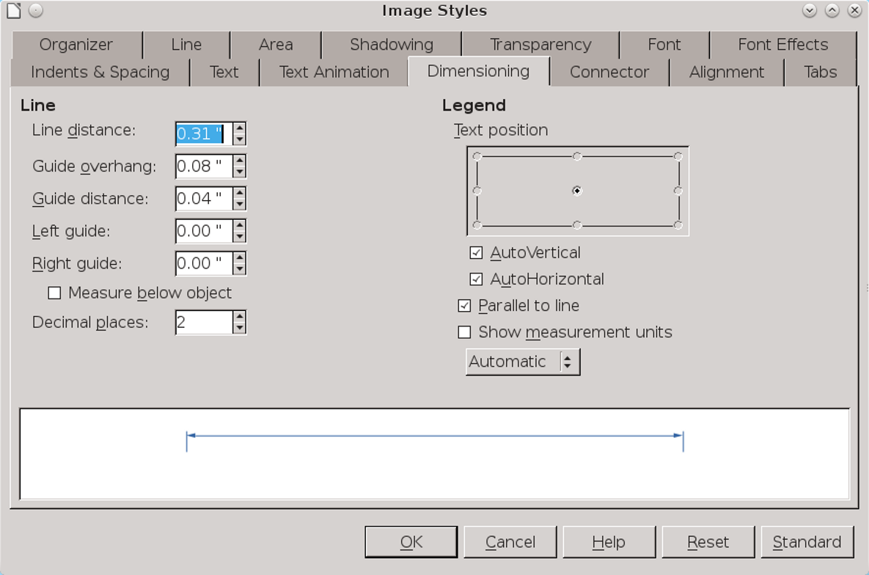
To draw a dimension line, click the Lines and Arrows button on the Drawing tool bar (the ninth from the left), and select Dimension Line from the available tools.

Setting connectors
Connectors join shapes together. When you move an object that has connectors, the connectors are modified to keep them attached to the objects at the other end.
Objects at the other end of the connector remain in place unless you select both objects, which drags the objects and the connectors between them as though all elements were grouped.
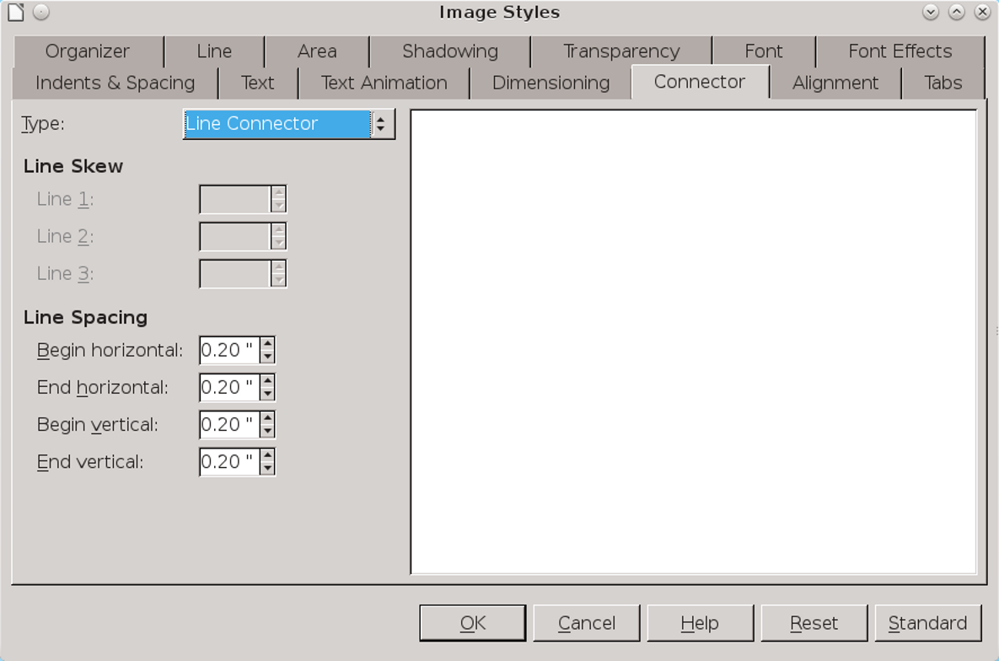
Connectors are lines attached to two objects by means of glue points. They keep objects attached to each other even when one is moved.
To add a connector, click the Connector button on the Drawing tool bar (the eighth from the left). You can choose between four kinds of connector:
- Standard: A connector with horizontal and vertical lines, possibly with one right angle in it. A Standard connector is useful in crowded hierarchical diagrams, in which several objects are subordinate to one above them, such as directors below executive officers in a company chart.
- Line: A connector with a small segment at each end for adding a change of direction. Use Line connectors in diagrams that are even more crowded than the ones in which you use Standard connectors.
- Straight: A connector that consists of a single vertical or horizontal line. Straight connectors are by far the easiest ones to use, but you may not always have the space for them. Extend a connector to the center of one side of a shape, and it immediately converts to a Straight connector.
- Curved: A connector with one curved line. Curved connectors are most suitable when you want an informal look to a diagram, perhaps to suggest that the relationships you are illustrating are approximate.
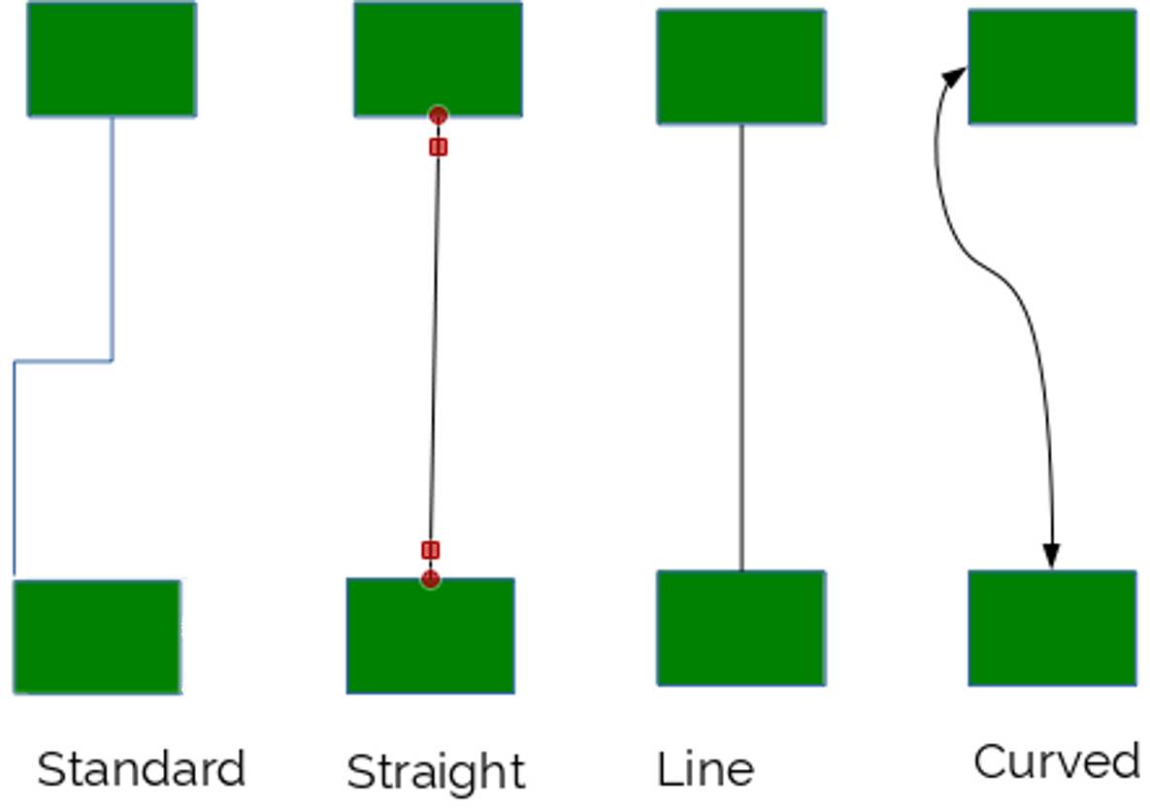
The four types of connectors.
All connectors can end with an arrow or an open or filled circle. You can adjust the shape of a connector by selecting it and dragging on its handle,
or by moving one of the objects to which it is attached. You can also select the Glue Point button on the Drawing tool bar.
To adjust a connector, go to the Connector tab of a graphic style. For a Line or Straight connector, you can also adjust the line skew – that is, the length of the line segments included – and the horizontal and vertical space for the line segments.
These settings are especially useful when repositioning has twisted connectors out of shape, or when you are adding the final touches to a diagram and trying to make everything consistent and uncluttered.
Even so, you may sometimes save time by deleting existing connectors and adding new ones.

Setting area options
The area of a drawing object can be formatted with Colors, Gradients, Hatchings, and Bitmaps. You are restricted to the fills already defined in LibreOffice. However, you can use Draw to define custom fills.
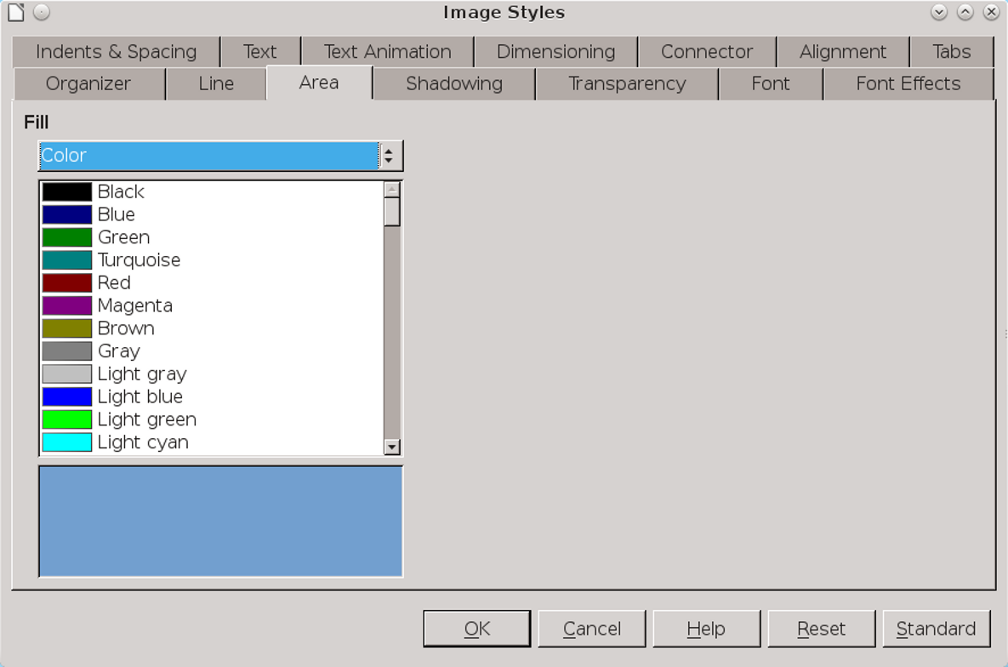
The Area tab for graphic text is roughly equivalent to the Background tab in some other types of styles. Formatting an object's area means choosing a fill for it.

To add a fill, go to Format > Area, and select the tab for the type of fill you want to add. See Chapter 13 for more details.

Setting shadows
Shadowing was popular in the early 1990s in graphic design. It is less common today, but can still be useful in creating a quick illusion of three dimensions.
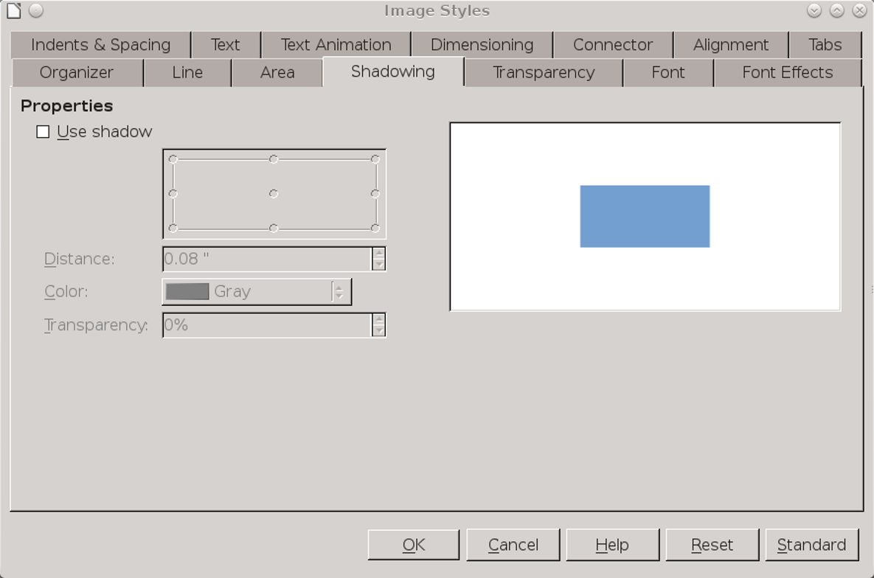
Shadows are easy to over-use, but can create a 3D look.
The Shadowing tab lists settings to help customize a shadow. In many cases, all you need is to check the Use shadow box. However, you can also set the shadow’s farthest distance from the object, the position of the shadow in relation to the object, and the color and transparency of the shadow for a subtler touch. Generally, a shadow’s color should be black or a shade of gray.
- Tip
The default position for the shadow is the lower right, assuming a light source in the upper left. If you change the shadow’s position, use the same position for other shadows throughout the document.

Setting transparencies
Transparencies are useful for creating matching shades based on the same color, as well as for creating complex designs with overlapping layers.
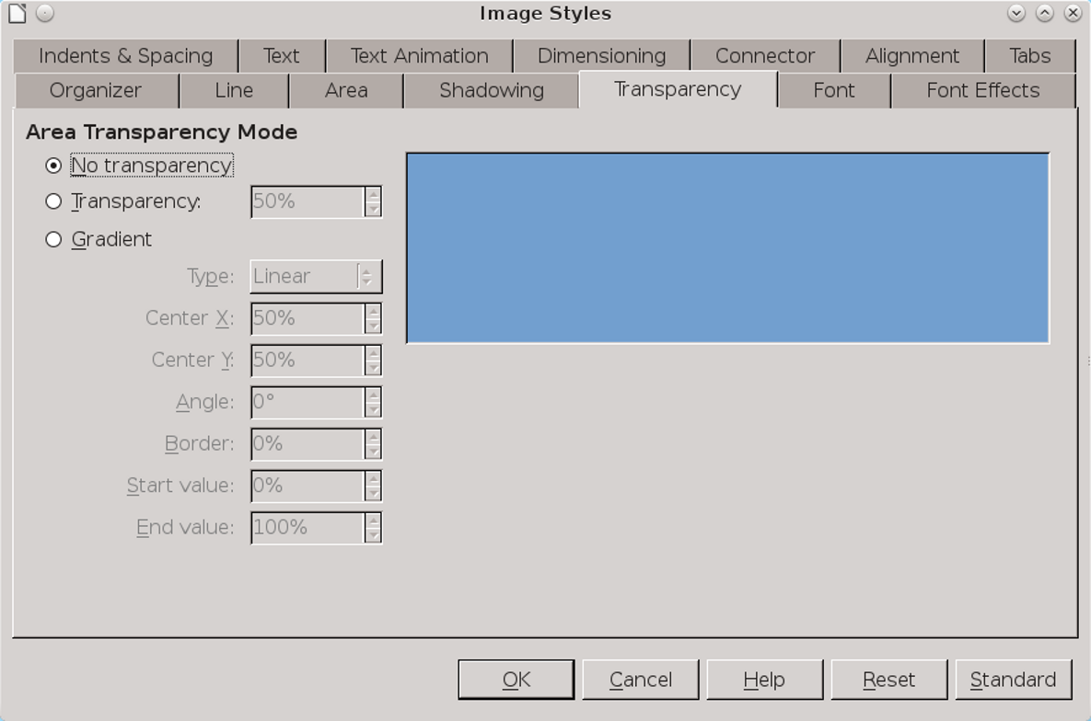
Transparencies expand your range of color.
The Transparency tab expresses transparency as a percentage, with 0 being an unmodified or solid color, and 100% being completely transparent.
The Transparency tab also includes options for creating a gradient, duplicating the options at Format > Area > Gradient (see above). In terms of graphic styles, the tab’s gradient control allows you to customize gradients, while the Area tab only lets you choose pre-defined gradients.

Setting text characteristics
The characteristics of graphic text are mostly the same as for text documents, with a few minor changes. Regardless of whether you are using regular or graphic text, the typographical conventions remain much the same.
For Tab | See | Notes
Alignment | “Error: Reference source not found,” page Error: Reference source not found. | No options in Draw for last Justified line.
Fonts | “Error: Reference source not found,” page Error: Reference source not found. | Choose fonts at least the size of body text, if not slightly larger for diagrams.  Sans serifs often make for clarity. If possible, use a font used elsewhere in the document.
Font Effects | “Error: Reference source not found,” page Error: Reference source not found. | In most cases, ignore all except Font color.
Indents & Spacing | “Error: Reference source not found,”page Error: Reference source not found. | Use indentations, especially for the first line, instead of tabs.
Tabs | “Error: Reference source not found,” page Error: Reference source not found. | Awkward with graphic text, and not really needed with the right spacing. Consider alternatives, such as tables, especially when the design is frequently changing.

Using text animation
From the Text Animation tab in a graphic style, you can set LibreOffice’s equivalent of the Blink and Marquee HTML tags, either making text blink off and on, or scroll in one of several ways in the text frame. The tab includes settings for the direction of scrolling, the number of repetitions, and other settings.
However, LibreOffice users should learn from web designers’ experience and avoid text animation in almost every circumstance. Blinking and scrolling are usually the antithesis of everything that a design element is supposed to do – instead of enhancing content, they distract readers’ attention from it. In fact, they have little purpose except to call attention to themselves.
If you must use text animation, be merciful and set it to run only a few times before stopping. Having readers disagree with the opinions you express can be a natural consequence of writing, but annoying readers with your design is simply a poor tactic. Why undermine yourself?
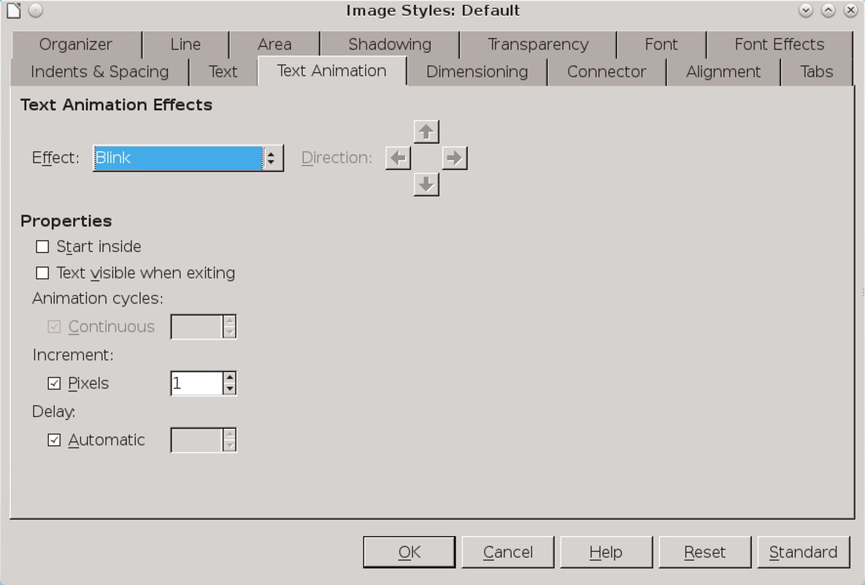
Avoid text animations as obsolete.

- Creating a flow chart
Flow charts appear to have been invented several times between 1850–1930. They are meant to be informal documents, but you can vastly improve their look if you use basic design principles such as repetition and alignment to organize them.
As with any diagram, you can plan a flow chart by placing elements outside the margin of the document until you are ready to use them. However, sketching the design on a piece of paper might be just as easy.
Either way, when you are finished planning, turn on View > Grid > Select Grid and Snap to grid, and follow these steps:
- Decide what basic shapes you need, and create a style for each. In this case, I needed a style for:
- Flow chart objects (Decision, Action, and Start/Finish). I only need one style, because drawing styles are not concerned with shape. I borrowed rounded rectangles from the tool bar’s Rectangle button.
- Text.
- Lines starting with an arrow.
- Lines ending with an arrow.
- Lines starting and ending with an arrow.
Styles should include settings for font effect, lines, area, and possibly transparency.
- Create one each of the basic flow chart elements. Using the grid, size and position each shape and apply the style.
- Tip
Expect to have to reposition objects, and possibly resize as well. In either case, you may come to appreciate the advantages of styles.
- Copy and position each flow chart element as needed, making one column for Decisions (diamonds) and another for Actions (large rounded squares). Use the grid to help keep elements horizontally and vertically aligned.
- Add text to each object. In LibreOffice versions prior to 4.4, adding text requires creating text boxes and positioning them inside the flow chart elements, grouping them for convenience. In 4.4 or higher, simply start typing inside each element.
- Add lines with arrows and their captions. Keep the line length and position as regular and as few as possible, unless you are trying for an informal look.
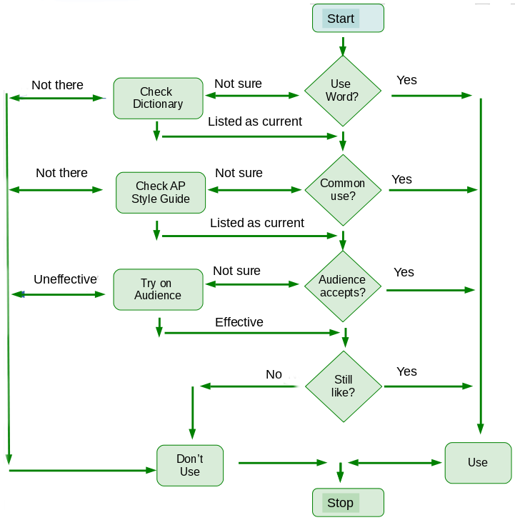
A flow chart for deciding whether to use an idiomatic word.

Adding charts and graphs
A chart or graph is a visual comparison of two or more pieces of data, such as the unemployment rate over time, or the distribution of results by population.
Charts and graphs are created in LibreOffice with the Chart sub-system. You can use charts in Writer by selecting Insert > Object > Chart from the main menu, or in other LibreOffice applications by selecting Insert > Chart.
In Calc, adding a chart opens a wizard that guides you through formatting a chart. Unfortunately, in Writer, Draw, and Impress, you
must format manually without styles or much of anything else to help you.
Except in Calc, the Chart sub-system works much like the one for Fontwork. When you select Insert > Chart, LibreOffice adds a default chart to your document – specifically, a 2d bar graph.
The chart uses the default chart colors, which you can adjust in Tools > Options > Charts > Default Colors or by right-clicking on the chart. By changing the colors used in a chart, you can make the chart fit with other decisions about color in the document, or reflect corporate or project branding.
All features in a chart are editable, but LibreOffice supplies no means to save formatting choices. If you want a chart to look similar to another one, you must copy and paste.

Formatting charts
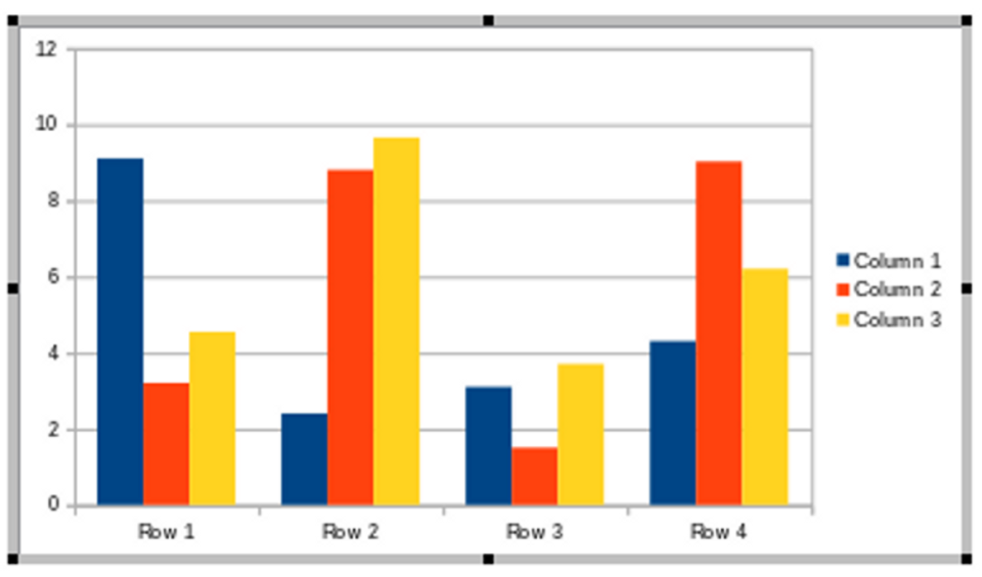
A chart is ready to edit when it has a gray border.

To edit the look and structure of a chart, click twice until the chart is outlined by a thick gray border.
- Tip
When the gray border does not show, you can edit the separate elements of the chart, but not the general structure.
The default chart can be repositioned and resized by dragging on its handles. You can insert your own data by selecting Chart Data Table from the right-click menu.
- Tip
The default chart includes three Y axis values. However, many charts only require one.

Selecting chart types
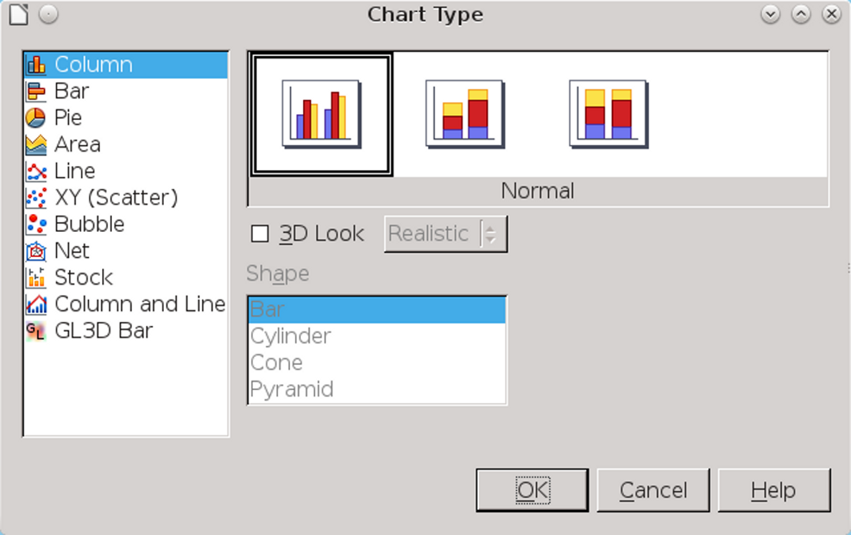
Charts are available in eleven types, many in both 2D and 3D.
You can change the default chart type by selecting Chart Type from the right-click menu, and choosing from the graphs shown.
The available charts are:
- Column: The data displays in vertical columns.
- Bar: The data displays in horizontal columns.
- Pie: Chart data is depicted as wedges in a round shape. This chart type is popular for financial data and business reports.
- Line: A graph of data points. If the data points are meant to show a progression (for instance, over time), then the points are usually connected.
- Area: A line graph with several lines, and the space between lines shaded in with colors.
- XY (Scatter): A type of chart for comparing the results of two or more trials of an experiment.
- Bubble: A graph that displays three dimensions: the X and Y axis and the size of the bubble that depicts the data point. Bubble graphs are a variation of an XY chart.
- Net: A chart in which every X axis has a separate Y axis. As a result, results are not a point or a line, but an enclosed shape. This type of chart can be difficult to read for an audience not accustomed to it.
- Stock: As the name implies, a graph often used to show changes in stock values. It is described technically as a depiction of changes in the values of the X axis.
- Column and Line: A chart that offers both a column and line representation of the same data.
- GL3D Bar: A bar graph that uses OpenGL for rendering three dimensional graphs. This choice only works when your video driver has hardware acceleration, which some Linux installations will not have.
Most of these types of charts have sub-types as well. Often, the differences in the sub-types are subtle, so you may have to look twice to see the difference. The same is also true for the three dimensional options for most types of graphs, which can have a Simple or Realistic rendering.
Stick with the chart types you understand – if you don’t know the uses of a graph, or are unable to see what is useful about a sub-type, you shouldn’t be using it. The majority of users will probably use the Column, Bar, Pie, or Line formats for comparing data along two axes.

Choosing 2D or 3D
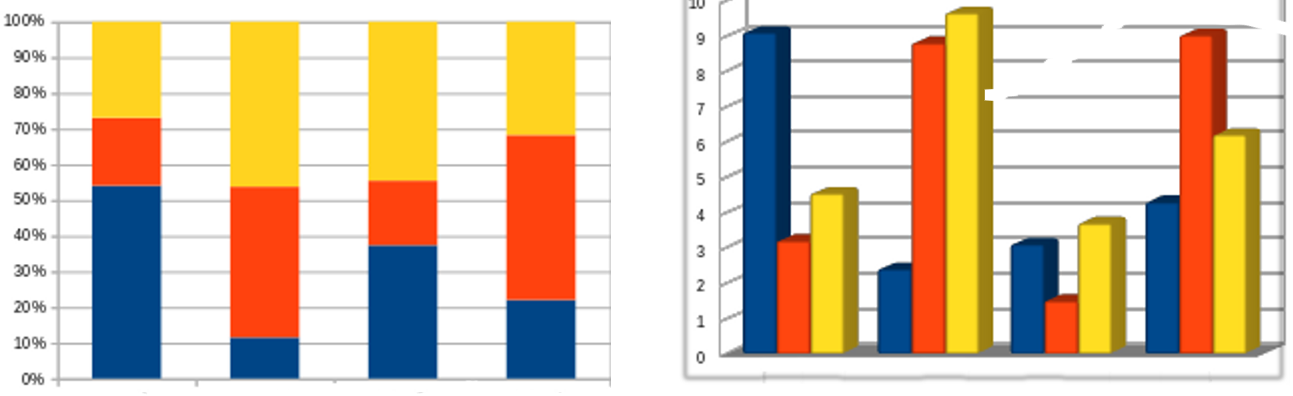
Two-dimensional and three-dimensional charts.
Three-dimensional charts were a new feature in early office suites. For a time, they completely replaced two-dimensional charts, just as justified alignment replaced left alignment, simply because they were new and seemed sophisticated.
However, in the last decade or so, a reaction has set in. Part of the reaction is a fad for two-dimensional icons and widgets on mobile devices, and part is that 3D graphics are no longer a novelty.
Whatever the reason, in many circles today, 3D graphs are seen as a sign of slickness that offers nothing that a 2D graph does not. An audience of developers may see a 3D chart as proof that style has triumphed over substance, while an audience of
marketers might see a 2D chart as a lack of sophistication.

Editing graphs and charts
By clicking on a part of the graph or opening the right-click menu, you can manually edit all of its pieces.
The pieces differ with the type of graph, but may include:
- Legend: The key that describes what the colors refer to.
- Wall: The background.
- Grid: The lines against the wall that make values in the axes easier to read.
- Axes: The horizontal and vertical values.
- Title: The name of the whole graph.
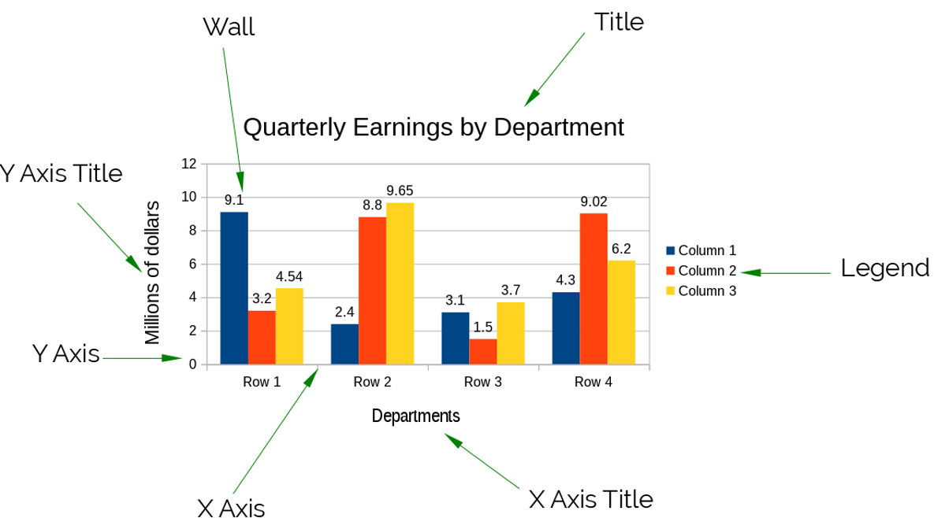
Editable parts of a chart.

Charts has no means of saving designs for later use, so copy and paste instead. If you use charts regularly, consider a template with samples of the charts you are most likely to use.
- Creating a chart
In Calc, creating a chart is easy; adding a chart opens a wizard that lets you work through the stages of formatting.
However, in the rest of LibreOffice, creating a chart can be confusing at first, because the options change with how you click on the chart.
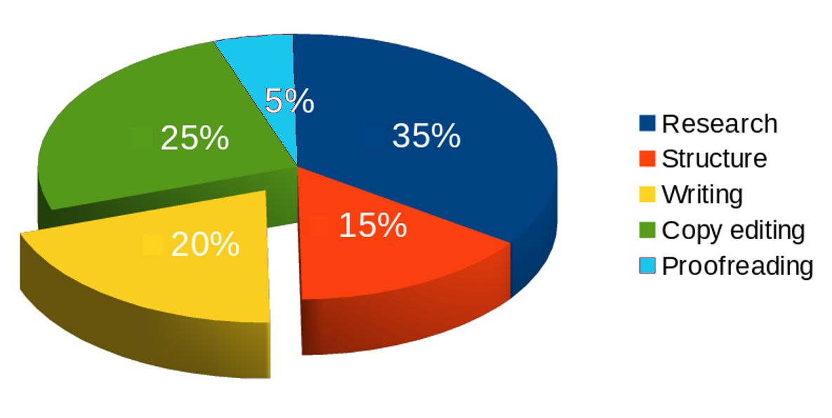
A 3D pie chart. The time spent writing is cut from the rest of the pie in order to emphasize it.
Following these steps should help minimize confusion:
- Either accept the default colors, or change them at Tools > Options > Charts > Default Colors. LibreOffice uses the colors in the order they are listed under Default Colors.
- Caution
If you are printing in black and white, test colors for contrast.
- Select Insert > Chart in Calc, Draw, or Impress, or Insert > Object > Chart in Writer. LibreOffice adds a 2D bar chart.
- Click twice on the chart so that it is surrounded by a gray border, then open the right-click menu to select Chart Type and choose the chart design to use.
- Right-click on the chart when the gray border is visible and select Chart Data Table to enter the data points for the chart.
- With the gray border still visible, click an element to edit. When an element is selected, the right-click menu contains a menu item for formatting it, such as Format Legend.
- Click on the chosen elements or data series to edit their appearance.
- With some chart types, you can select a data series, then right-click to select Arrangement. For example, if you are using a pie chart, you can select a data series and drag it out of the pie.
- Click the chart so that the gray border disappears and the object handles appear. You can drag on the handles to move or resize the chart, or right-click to change features such as alignment, or edit the Line to create a border or Area to change the background.

Separating analysis and creativity
Using styles for diagrams means finding a new way to work. Instead of plunging directly into designing, it requires taking time first to think about what you need.
At first, this new work flow may make you impatient. However, by taking more time to plan before you begin, you will save time if – as seems likely – you modify your design while you work.
Even more importantly, planning styles first helps to separate the analytic aspects of work from the creative ones. If you try to structure as you create, you are trying to think in two different ways at once, which means that you are probably doing both inefficiently. By contrast, starting with styles helps you to separate these two ways of thinking – and, chances are, do each more efficiently.
If you have any doubts of the advantages of this work method, try it several times. Then try creating a complicated diagram manually, or even a chart. Once you are used to the new way of thinking, you are likely to have far fewer false starts than if you design manually – and, probably, wish that Chart was designed for styles, too.

