16

Putting everything together
Using styles, templates, and the tools associated with them makes formatting and writing a document easier. However, the last edit before you finish a document is also an important part of the design and composition processes.
By the time you finish designing and writing even a short document, you have probably lost perspective on it. You may be so familiar with the document that you are unable to notice if you have expressed everything you meant to say. In extreme cases, you may loathe the sight of the document – a stage which many professionals take as a sign that it is almost ready.
Yet regardless of how you feel, you need to regain perspective so you can do the final edit.
One way to regain perspective is to get a second opinion from someone who is interested in your
topic and willing to take the time to read thoughtfully and respond honestly.
However, in practice, such people are rare. You might have to settle instead for reading your document aloud, reading it from a printout, or leaving it alone for several days. All these possibilities can help to distance you from your work enough to criticize it.
Start your final edit systematically, focusing first on content, then moving on to structure and design. The headings in this chapter will give you a checklist of steps to follow.

Checking copy
Ask yourself: Is your discussion complete? Are there opposing views you could include? Counter-arguments that you could answer? Terms, assumptions, procedures, or background that you have left out?
Are paragraphs the right length? If you are publishing online, then paragraphs should be no more than four or five sentences long for easy comprehension. In hard copy, paragraphs can be longer, but only if you need the extra length for a detailed argument. A paragraph that takes up more than half a page should usually be divided up regardless of the publishing format, because extremely large paragraphs can make readers skip them.
Check, too, for clarity. The ultimate test is to read a passage out loud at a regular, medium-quick pace. If you have trouble reading the passage, or a listener has trouble understanding it, you may want to reword or shorten sentences.
As you get down to the word level, consider whether every piece of jargon is necessary. Does a word convey precisely what you mean, or could you use a better one? Are you using the type of language and jargon that your readers would use?

Your favorite things
All writers have their favorite words and expressions. As you work, develop a list of yours, and watch for each of them as you edit copy. Consider alternatives so that they do not become too noticeable.
You may also find that you have become proud of some expressions or a single passage. Some writers believe that “a writer’s best friend is the waste basket” and delete anything they are too proud of because they cannot be objective about it. That is probably extreme in some cases, but you should certainly consider the possibility.

Checking structure
How does your document develop? If you suspect that readers may not read the whole thing, you will want your most important points first, so they at least are read. By contrast, if you can count on readers to finish the document, you can put your
most important point last, building up to it with less important points first.
- Tip
If the document uses headings, select View > Navigator or press the F5 key.
Using the Navigator's controls, you can move headings and the sections of body text below them anywhere in the document much more quickly than you can copy and paste.
If you change the position of points, their opening and closing sentences and transitions may need rewording.
More formal documents will probably have an opening paragraph or passage that sets up the topic and gives a little background. They will also have a conclusion that emphasizes the main points or what readers should get from your discussion.
This exercise can show you the value of choosing accurate headings. The more accurately that a document’s headings reflect its contents, the more easily you should see the order in which passages should go. When the order looks clear to you, the chances are that it will be logical to readers, too.
One more point: LibreOffice automatically names headings, images, and other elements with unimaginative names like Heading 1 or Table11. A counsel of perfection would be to give each element
a distinctive name to help clarify the structure of the document.
However, giving names to every element is hard work. You may decide to give distinctive names to only key elements. Often, those key elements should be headings, because they are useful in many other ways. However, if a document does not include headings, choose another prominent element instead.
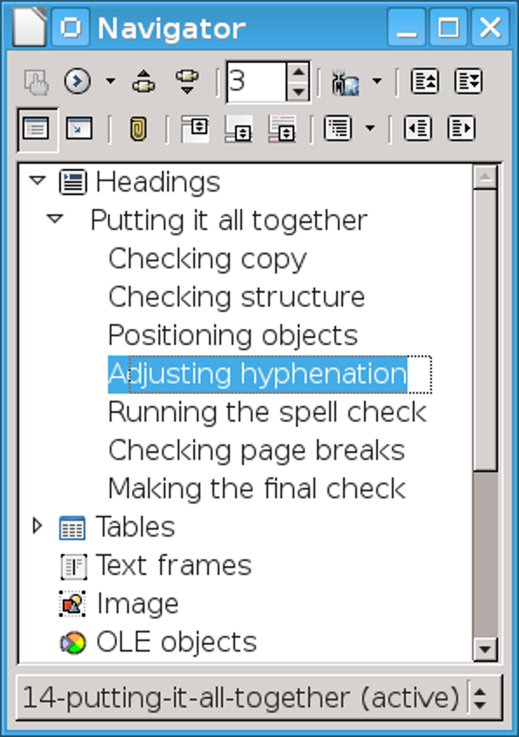
The Navigator is an ideal tool for restructuring material if your document has headings or descriptively named objects.

Checking design
Either print out a copy or use File > Print Preview. Better still, do both. No matter how carefully you have developed and modified your template, it is
still easy to miss problems in the design unless you look at pages as a whole – or, better, in a two-page spread.
Among the things you should check are that:
- Page styles follow in the order that you intend.
- Page numbering and different page numbering styles begin where you intended.
- New chapters start on a right page. Try not to be confused by the fact that Page Preview does not display two-page spreads accurately.
- Footers and headers arrange information in the intended order. For example, page numbers will be more noticeable if placed by the outer margin of each page.
- Paragraph styles for tables of contents or indexes, which you may have only created as a final step, are compatible with the rest of the design.
- When documents have been added to a master document or pasted together, the numbering of the first numbered list in each document may need to be restarted manually.

Positioning objects
Graphics, tables, charts, and other objects should be positioned as closely as possible to the text to which they refer.
Check, too, that formatting such as the structure of captions and the space above and
below objects is consistent throughout. The most common trouble spots are cases where a paragraph with space below is followed by a paragraph with space above, which results in more spacing than you may have intended.
Use the Navigator so that you go through the objects systematically, and you can recognize departures from the formatting conventions you have set.

Adjusting hyphenation
If you decide to hyphenate the body text, LibreOffice does the best it can while you work. But by the time you are finished editing and making changes, this on-the-fly hyphenation can be far from the best job that LibreOffice can do.
As you make your final check of the document, click Tools > Language > Hyphenation. This tool lets you choose where each line will break and what syllable each hyphen will follow.
- Caution
Some versions of LibreOffice include spelling dictionaries, but not hyphenation dictionaries, so you may have to download and install a hyphenation dictionary before you run a check.
You will need a separate hyphenation dictionary for each language or locale in a document.
- Caution
Running the hyphenation tool will add hyphens, even if none of your styles are set to use hyphens. Skip this step if you want to avoid all hyphenation and keep a ragged right margin.
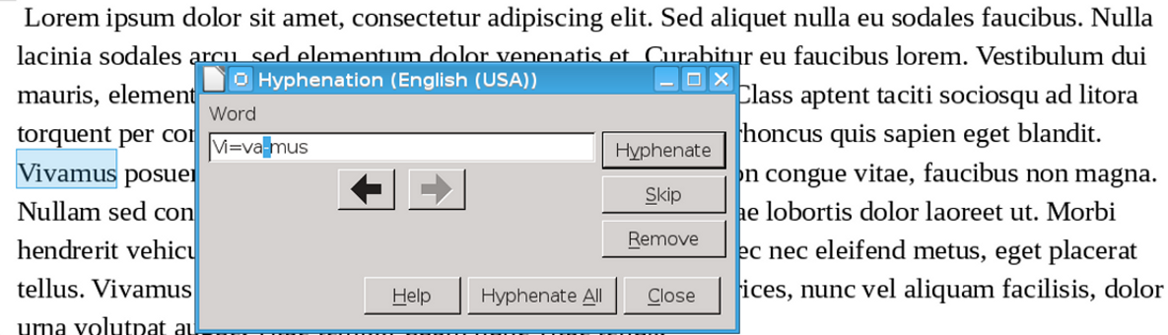

Running the Hyphenation Tool fine-tunes the hyphenation created in a work in progress.

Checking the spelling
Run the spell check in the Tools menu for each language used in the document. You can check the languages by looking at the Fonts tab of all your paragraph styles. LibreOffice also checks some grammar and layout, such as enforcing one space after a period instead of two.
However, always remember that a spell check is not a substitute for your own judgment. Not everything Writer flags is mis-spelled, and the grammar check is far from complete.
What the spell check can do is reduce the drudgery of catching typos and routine errors. Never think, though, that you have caught all the
problems when you have run it. Spell checking should always be followed by at least one manual check.
As you spell check, make a note of your regular typos, and use Edit > Find & Replace to help you correct every instance of it. Finding and replacing common mistakes is much faster than spell checking, and allows you to see more of the context in which the mistake occurs.
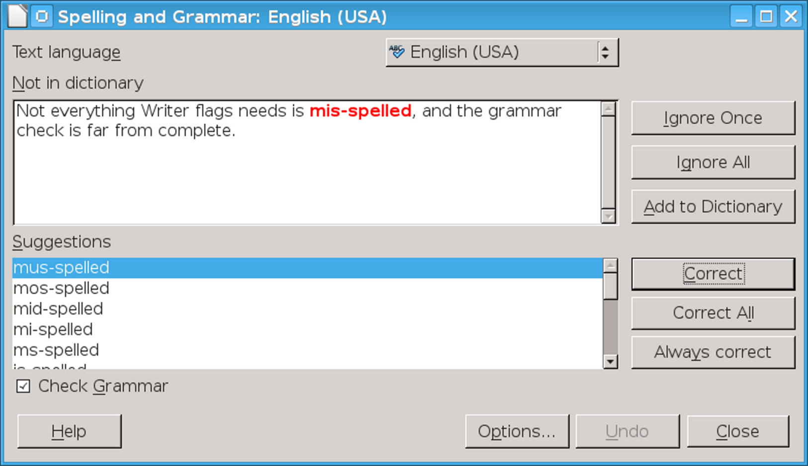
Check the spelling once for each language used in the document.
- Tip
If you have any last-minute additions, highlight the new material, and the spell check will review only it.

Checking page breaks
Reduce the zoom to 75% or less, and see where pages end. No matter how you format, thanks to graphics, tables, and other objects, you are likely to have pages that end more than a few lines before the bottom of the page.
Often, you can improve the page breaks by rearranging elements such as images and tables, or by dividing paragraphs so that another line or two are used. Perhaps you may decide that a comment you omitted is worth adding after all, or that a paragraph can be cut, although changing the content only to improve the design is a case of misplaced priorities.
In extreme cases, you might even add manual page breaks. However, like any manual formatting, the more you add, the harder the document is to maintain.
You will be extremely lucky (or painstaking) if every page breaks exactly at its final line. Instead, be satisfied with being 4 or fewer lines from the bottom of every page. The more manual changes you make, the more you are likely to require in the next editions of the document.

Problems with master documents
In the most recent versions of LibreOffice, master documents present some problems:
- Master documents can paginate differently from a stand-alone sub-document. You can sometimes
- see this problem by printing a range of pages to PDF first from the sub-document and then from the master document, and comparing the page breaks.
- If you have cross-references between two sub-documents, the target sub-document shows the message “Error: Reference not found” when you open the sub-document. The cross-reference only displays correctly from the master document.
- When you have a cross-reference between two sub-documents, the error message in the target sub-document can be much longer than the cross-reference in the master document. This discrepancy can cause the page break to change between the sub-document and the master document.
To overcome these problems, avoid tight pagination, leaving a line or two empty. Alternatively, use a master document when it is convenient in long documents or in group projects, and copy and paste a single long document at the very end of your final editing.

Updating
Select Tools > Update > Update All to ensure that all fields are up to date. This check is especially important for cross-references, which may have been repositioned as you edited.

Making the final check
Before you publish, set your zoom to 75% or select File > Print Preview and take one last high-level look at the document.
At this point, you should see very few problems. If you do see problems, consider repeating the final editing process. However, if you have already done so several times, ask yourself at some point if you are tinkering in the hope of an impossible perfection.
- Caution
In some releases of LibreOffice, Print Preview shows the borders around a table even if you have turned them off entirely. These borders do not print, but to view the tables properly, uncheck Table Boundaries on the right-click menu.
When you see nothing to change, you know that your document is ready to print or post online. Be prepared to make some tweaks since working with a template reveals its shortcomings, and you may find situations that you never anticipated.
However, at this point, your work is ended and so is this book (or very nearly).

