3

Recycling using templates
No one has time to design a document every time they sit down to write. It’s inefficient. Nor do you want everyone working on a project to design their own documents. The solution to both these problems is templates – files to store formatting and structure to re-use or share.
Templates are handled differently from ordinary documents. Before you use them, they need to be registered, so that LibreOffice is aware of them. They also have their own menus and menu items that normal files do not use.
Mostly, templates store formatting. However, they can also store structure, either in the form of outlines, or of fields that automatically fill in standard information or indicate with placeholders what kind of information should be added.
This structural use of templates tends to be under-emphasized. However, you can find examples of it in some releases of LibreOffice or OpenOffice in the Impress templates entitled “Introducing a New Strategy” and “Recommendation of a Strategy.”
Both these templates include not only formatting, but a standard set of slides for developing a presentation with certain goals in mind. You can develop equally detailed structural templates to automate your work.
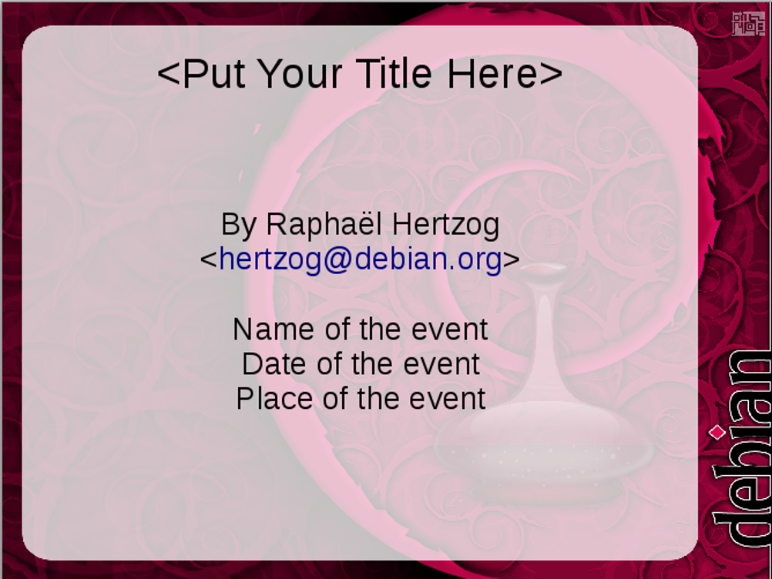
An Impress slide with a formal placeholder for the title and informal ones for other information. Placeholders help you to rough out a design without requiring specific information.
- Tip
If you are a long-time user of office suites, you may be wary of templates because of how easily they became
corrupted in Microsoft Word when you made any changes or tried to mix templates.
If so, don't worry. LibreOffice templates are designed to eliminate the problems that caused the corruption in Word. Mostly, they succeed, although sometimes at the cost of restricting what you can do with templates.

When to use templates
As with styles, the short answer is, “Whenever possible.” Not only are templates more efficient than designing from scratch, but using them consistently helps you get used to the concepts behind them.
Over the years, I have heard users claim that templates are impractical because every document they do is different.
However, when I probe such claims, I usually find that the problem wasn’t that every document was different, but that the person making the claims didn’t think in terms of structure. Nor did they realize that a consistent general format can be part of corporate or personal branding.
A more plausible reason for not using templates is that setting them up takes time. Yet even that excuse fails to survive scrutiny.
- Example
The all-purpose template I first designed in 2002 took several hours to design, and maybe another two to fine-tune.
Since then, I have used that all-purpose template for hundreds of documents. Each time I used it, I could start to write immediately and without worrying about how it was formatted.
At a minimum of three hours per template design, I have easily saved over a month’s time thanks to that one template alone.
Other templates I have made over the years have seen less use. But always, the initial hours lost to template design have still been regained countless times over the years.
Using templates does mean planning ahead. But this new work flow rapidly repays the effort to change your work habits.

How templates work
Unlike Microsoft Word, LibreOffice does not display a Normal template anywhere in its menus. This omission eliminates the possibility of a document being corrupted by too much editing of the Default template.
The only way that you can alter LibreOffice’s default formats without using templates is to change the font settings in Tools > Options > LibreOffice Writer > Basic Fonts (Western). Default formatting such as page and list styles cannot be edited at all.
However, you can also design a template with far more formatting information as default. Its settings will be used for every document when you select File > New, unless you specifically select another template.

Linking templates with documents
Whichever template you use, it must be properly registered before you can use it.
Only one template can be applied at one time to a document. This policy avoids the tendency to corruption that used to plague MS Word (and may still do, for all that I know).
- Caution
Two styles of the same name in separate documents can have different formats.
If the template changes, the next time you restart LibreOffice and open the document, you are prompted to update the document. Styles shared by the template and the document are updated, but styles that are only in the document are not.
If you choose Update Styles, then the document continues to be linked to the template. However, remember to save the document after updating.
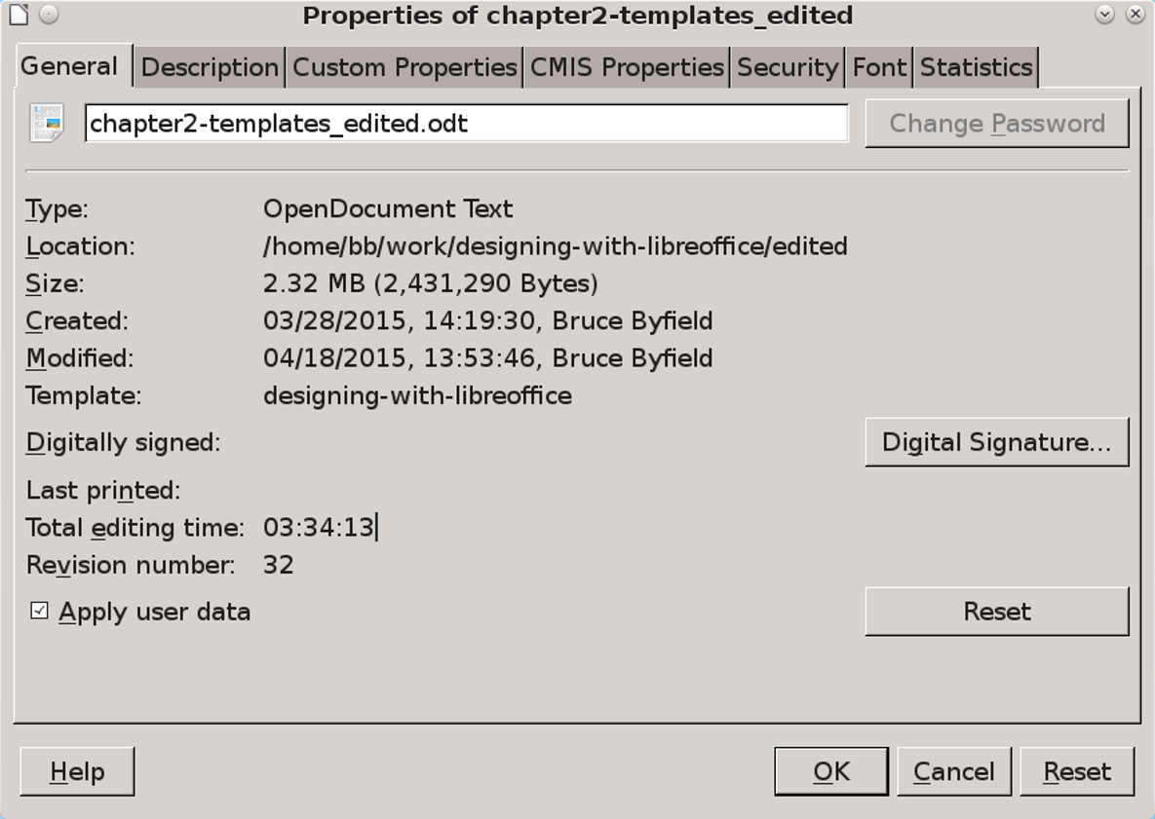
Files > Properties > General lists the template upon which the document was originally based. The layout of this tab is different in LibreOffice before release 4.3, with the template at the bottom of the window.
By contrast, if you choose Keep Old Styles, it is unlinked from the template, and you are not prompted for further updates when the template changes again. However, the Properties window continues to list the template, even though it is irrelevant.
- Tip
Documents whose templates have been edited are not always updated when closed and reopened. You may have to restart LibreOffice for the change to take effect.
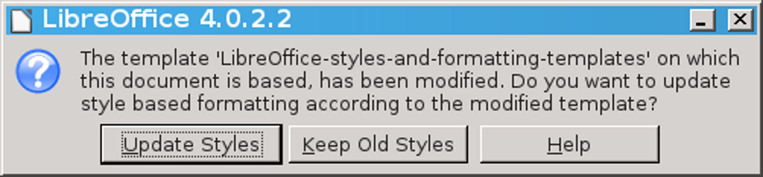
When you open a document, you are warned that its template has been edited.
Generally, you want to avoid detaching documents from their templates. Since the whole point of using templates is to make uniform design easier, the best practices are usually:
- Change the formatting only on the template.
- Always keep documents connected to their templates.
- Never make any formatting changes in a document. Even deleting or adding a style can detach a document from its template.
- As soon as you make changes to the template, close and reopen the documents that use the template as soon as possible. This practice may disturb your work, but it means that you won’t have to remember what changed, or wonder if you made an accidental change when you receive notice of the change the next time that you open the file.

Re-attaching styles
Macros and extensions are sometimes available for re-attaching styles to a document. Currently, Template Changer extension is available, but it has
not had a release for some time. At any rate, any attempt to swap templates raises the possibility of corruption, so test the extension using duplicate files until you are confident that it works.
A more reliable solution is usually to copy and paste the file contents to a blank file created from the original template.
- Caution
Any changes visible with Edit > Track Changes > Show Changes are lost when you copy and paste.
By contrast, any comments or fields are copied.

Identifying a template
You can always identify a LibreOffice template file, because the second letter in its extension is always a “t.” This pattern is used in both Open Document Format and the obsolete OpenOffice.org 1.0 format:
Application | ODF Format | OOo Format
Writer | .ott | .stw
Calc | .ots | .stc
Impress | .otp | .sti
Draw | .otg | .stf
Template extensions for Open Document Format and the older OpenOffice.org format.

Using the Template Manager
LibreOffice does not display template directories directly. Instead, it creates a virtual view of the contents of all the template directories listed in Tools > Options > Paths > Templates in the Template Manager window.
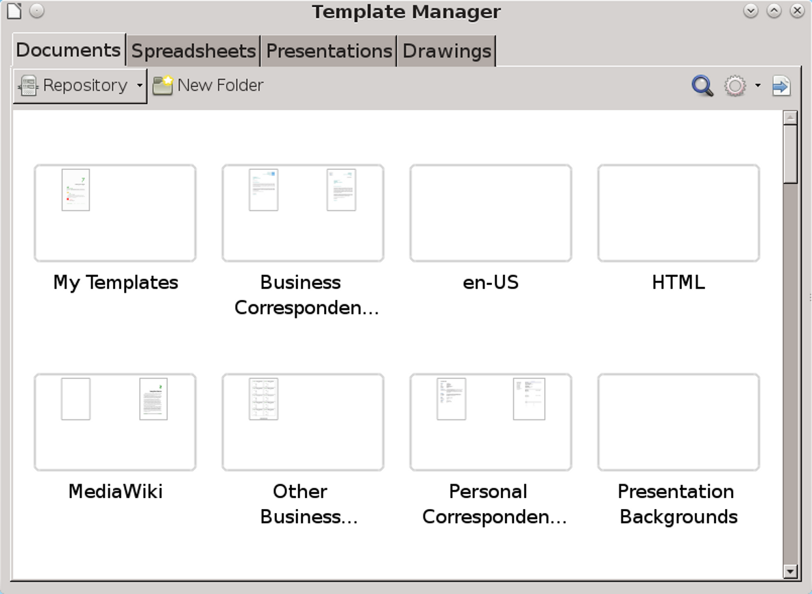
The Template Manager, showing sub-folders for different categories.
The Template Manager opens from several places in the menu. One is File > New > Templates. Depending on the version and operating system, it may also open from:
- File > Save as Template (not available in Apache OpenOffice or some operating systems).
- The Templates link on the introductory splash screen.
- File > Templates > Manage or File > TemplateMenu, depending on the operating system and version.
- Caution
Each view of the Template Manager shows only the icons that apply to whatever is selected. For example, in Linux when you save from TemplateMenu, you can only save, search, and view.
The Template Manager is divided into tabs for different types of templates: Documents, Spreadsheets, Presentations, and Drawings. Within each tab, sub-folders of the templates are shown as rectangles, and referred to as “categories.”
As shown above, you might have sub-folders such as EN-US and EN-CA for templates that use American and Canadian English locales for dictionaries.
Other options might be sub-folders named for a client or project or specific themes, such as light or dark backgrounds – whatever works best for you. Click on these rectangles to zoom in on the available templates and select from them.
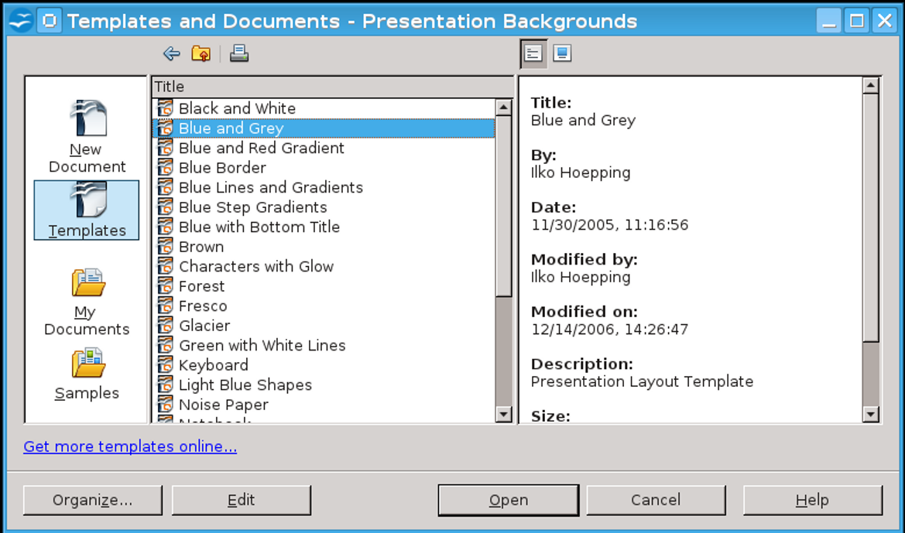
OpenOffice’s Template Manager and versions of LibreOffice before 3.3 have an older design that is functionally equivalent.

Planning a template library
Whether you create or download your templates, start by assessing the types of documents you create regularly. Although you might be tempted to download or design every template available, installing or designing more templates than you generally need will only make finding the ones you actually use harder.
Begin your planning by considering what your general layout will be. If you work for a company, does it have corporate colors that you will constantly use? If so, begin by creating the colors in Tools > Options > Colors so they are available for uses such as table borders and headings in color documents.
Are particular fonts part of your personal or corporate branding? Do you prefer a particular font
size? All such items can go into an all-purpose template that can be the starting point for others. Call the result something like General or Standard.
Become more specific by recalling what documents you have written in the past. If you can’t remember them:
- Open File > Recent Documents.
- Check the attachments in emails that you have sent.
- Keep a diary of the documents you produce over a week or a month and how often you write the same kind.
A carefully selected template can last you for years, so taking the time to classify your work is worth the effort.
- Example: Assessing template requirements
Imagine that you are a financial account executive. You want your all-purpose template to use your company's branding.
After some consideration, you find that you are regularly writing one-page memos, short official letters, and longer monthly internal reports. You also write quarterly reports for the company newsletter, whose editor wants copy in HTML, and the occasional personal letter, whose design should make clear that you are not speaking officially for the company.
Basically, in planning your template library, you are answering the question: What documents do I regularly produce in LibreOffice?
If you are like most people, you will probably come up with at least three or four different templates that you will need regularly. If you don't download them, create them gradually as the need arises. Unless some of your templates are extremely similar, you probably won't want to design more than one at a time.

Naming templates
Like style names, template names should be as descriptive as possible. Descriptive titles are simply easier to find in a menu.
However, another practical reason for choosing template names carefully is that, if you copy a file to another computer, you might have a naming conflict. If that happens, your document will not be seen how you meant it to be seen. If you forgot to make a copy, you could have a lot of re-formatting to do.
To avoid such problems, make your template names as specific as possible. For instance, instead of letter.ott, call your template personal-letter – or, better yet, something long and exact like personal-letter-formal-structure. The more specific the template’s name, the easier it will be to find when you want it.

Readying templates for use
Once you have figured which templates you need, you can get the templates you need in several ways:
- Downloading and installing templates made by others, perhaps with minor modifications.
- Creating your own templates using LibreOffice’s wizards as a guide.
- Designing your own templates from scratch.
Regardless of how you obtain templates, they must be registered before LibreOffice can take full advantage of them. See “Saving and registering templates,” page 15.

Downloading templates
If you prefer not to design your templates from scratch, you can use pre-existing templates instead, modifying them as necessary. Appendix A lists some of the larger sites for templates.
Almost all the templates that you find online are released under free licenses, so you can generally modify them freely.
The disadvantage of using others’ templates is that you have to sort through them to find what you want. At times, you may download two templates from different websites, only to discover that they are the same template with different names.
Often, too, you have to modify downloaded templates to get the exact design you want. In the
end, you may not save time so much as exchange the time spent designing for searching and tweaking templates.
Another problem with these official sites is that each template must be downloaded and installed separately.
However, you can find extensions like the Professional Template Pack II that will install multiple templates together from Tools > Extension Manager after you download them. Using such extensions can save several hours of effort.
You can also open Microsoft Office templates and convert them to Open Document Format. This is an ideal solution for presentation backgrounds, but less so for word processor documents, especially those with complex formatting, which may not import or export well.
- Caution
Using Microsoft Office templates is illegal if you do not have a copy of Microsoft Office. To avoid any legal difficulties – however remote – avoid using templates designed for Microsoft Office except for personal, non-commercial use.

Creating templates with wizards
If designing your own templates is too large a step, start by using the wizards that LibreOffice installs.
These wizards illustrate the kinds of decisions that you make when designing, and can give you a sense of the sorts of decisions you need to make when designing your own templates.
In addition, they are good examples of how to add structure to templates. However, despite their best efforts to provide variety, the wizards do tend to create unimaginative, outdated results.
Wizards are available from the File > Wizards sub-menu. Some of the wizards give you the option of using a LibreOffice Base database or the address book of an email client for filling in fields, which is convenient for mass mail-outs.
When you are finished setting options for the template, the wizard defaults to saving the resulting template to a subdirectory of your personal template directory, registering them for immediate use.
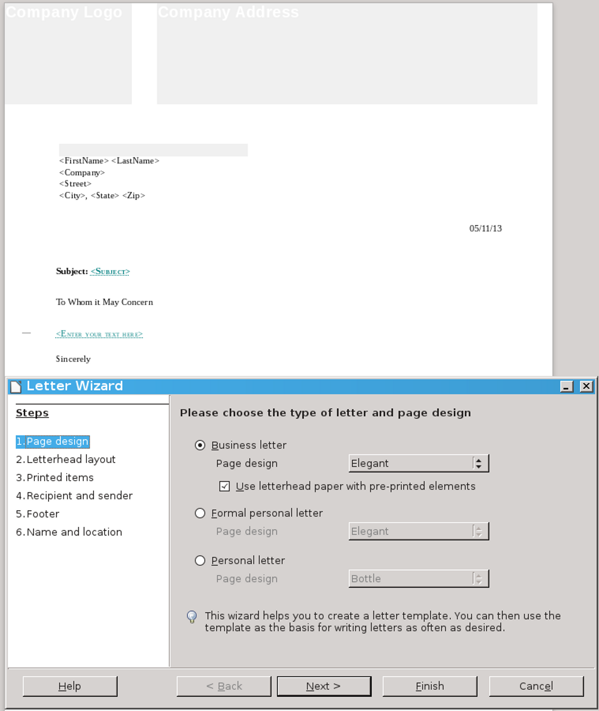
LibreOffice’s letter template wizard. Although often more elaborate than strictly necessary, these wizards can give you a starting point to studying templates.
The Presentation template is particularly useful. It is designed as a wizard to guide you through the basic formatting and structural decisions for building a slide show.
Once, Impress opened in its template wizard. It remains a useful reminder of the structural decisions you need to make.
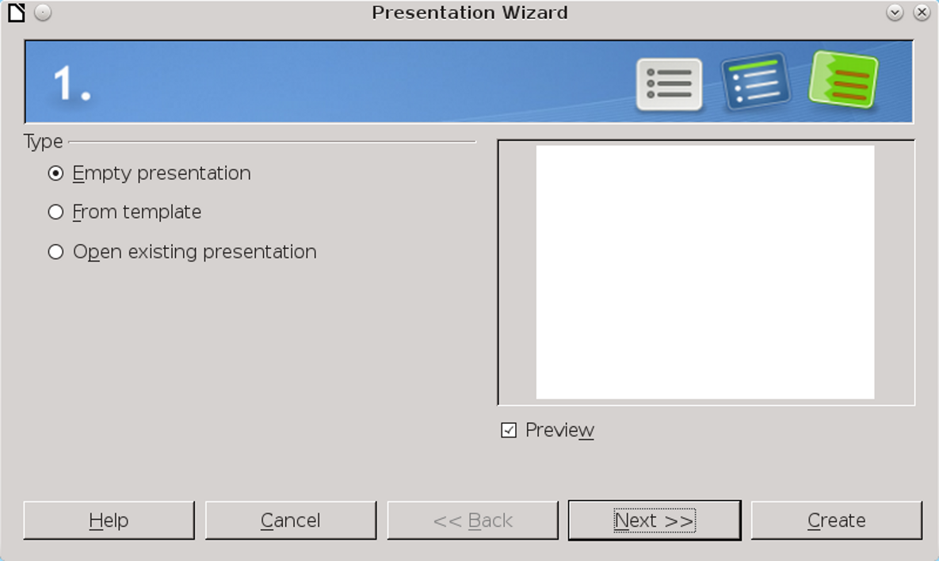
The Presentation Wizard in Impress.

Saving and registering templates
A regular file only needs to be saved in order to be ready for use. By contrast, each template must be registered with LibreOffice before you can use it, just as databases and address books must be.
What this means is that you cannot simply save a template.
True, if you save a file using File> Save or File > Save As, you can select a LibreOffice template from the drop-down list of formats in the Save dialog window. This approach is useful for such purposes as saving a template so you can install it on another computer, or give a copy to a friend.
However, a conventional Save does not register and activate the new template for use on your
system. To make a template available, follow these steps:
- Save it with File > Save as Template, File > Templates > Save as Template, or File > TemplateMenu > Save as Template (all these options may not be available in all versions of LibreOffice).
In each case, the Template Manager opens, offering a virtual depiction of the templates saved for all users on the system and for your personal use only. The rectangles are sub-folders of the main directories listed in the paths.
You can either click down through the window or use the icons in the upper right to search and sort by name. If you have recently made several templates, you might need to click Refresh to have all existing templates display.
- Click a sub-folder in the display if you want to specify where the template displays in the Template Manager.
- Caution
If you do not select a sub-folder, the template is saved to the appropriate tab for its file format, rather than to a sub-folder.
- Click the Save icon at the top left, and give the new template a name. If necessary, you can overwrite an existing template.
The newly saved template is now available for use.

Saving multiple templates
If you have downloaded a large number of templates, you can register a large number of them by moving them to one of the directories listed in the Paths section of Tools > Options. Alternatively, select from the template manager tool bar Repository > Local or Repository > New repository.

Setting a new default
The default template for each module in LibreOffice is based on several assumptions. It assumes that most users want a generic font, like Times New Roman or Liberation Serif. It assumes that a connection exists between language locale and paper size, so that an installation that defaults to American English will use letter-sized paper, while one that defaults to United Kingdom English will use A4 paper.
These are reasonable assumptions. However, if they don’t serve your needs, you can avoid making changes to every generic document that you start by changing the default template.
To change the default template:
- Create and register the replacement template.
- Open the Template Manager. Select the replacement default template.
- Click the Set as Default button.
Now, each new document will use the default template unless you specifically choose another template. LibreOffice reverts to its original Default template (the default Default) if you delete the replacement default.

Storing template structure
Discussions of templates usually emphasize storing formats in them. However, templates can store everything from return addresses to standard boilerplate such as corporate backgrounders – any information that you re-use but do not care to reinvent or type again. Instead, you can begin writing similar documents either immediately or with only minor modifications.
Such information is especially easy to store in Impress, in which each piece of information can be placed on one slide and easily deleted or rearranged.

Using placeholders
Placeholders are fields that mark the type of information needed at a certain spot, but leave you to fill in the details by clicking them.
Impress has built-in placeholders for slide titles, body text, and inserted objects.
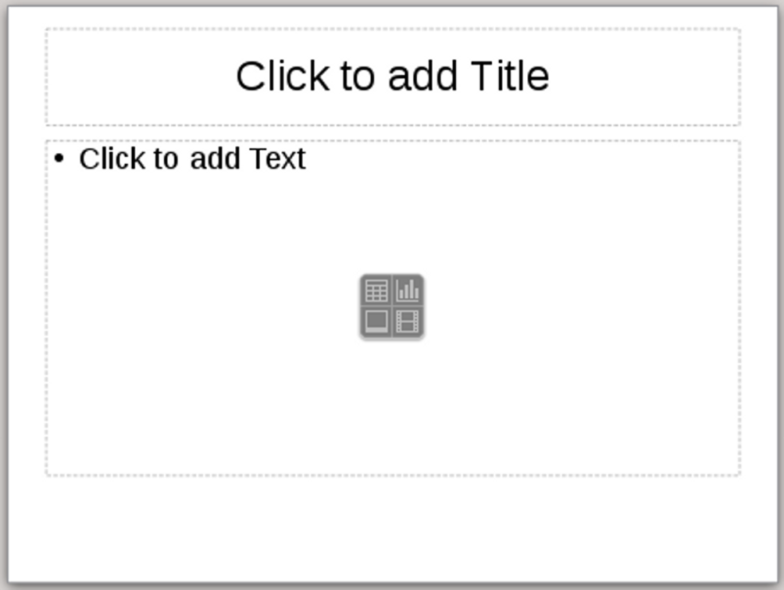
An Impress slide, with placeholders for the title and text, and a generic placeholder for tables, charts, images, and movies in the middle.
Placeholders are fields that mark the type of information needed at a certain spot, but leave you to fill in the details by clicking them.
Impress has built-in placeholders for slide titles, body text, and inserted objects.
However, you can also use placeholders for text and objects in Writer from Insert > Fields > Other > Functions. Select Format, then give the placeholder a name in the Placeholder field. The Reference field can be ignored.
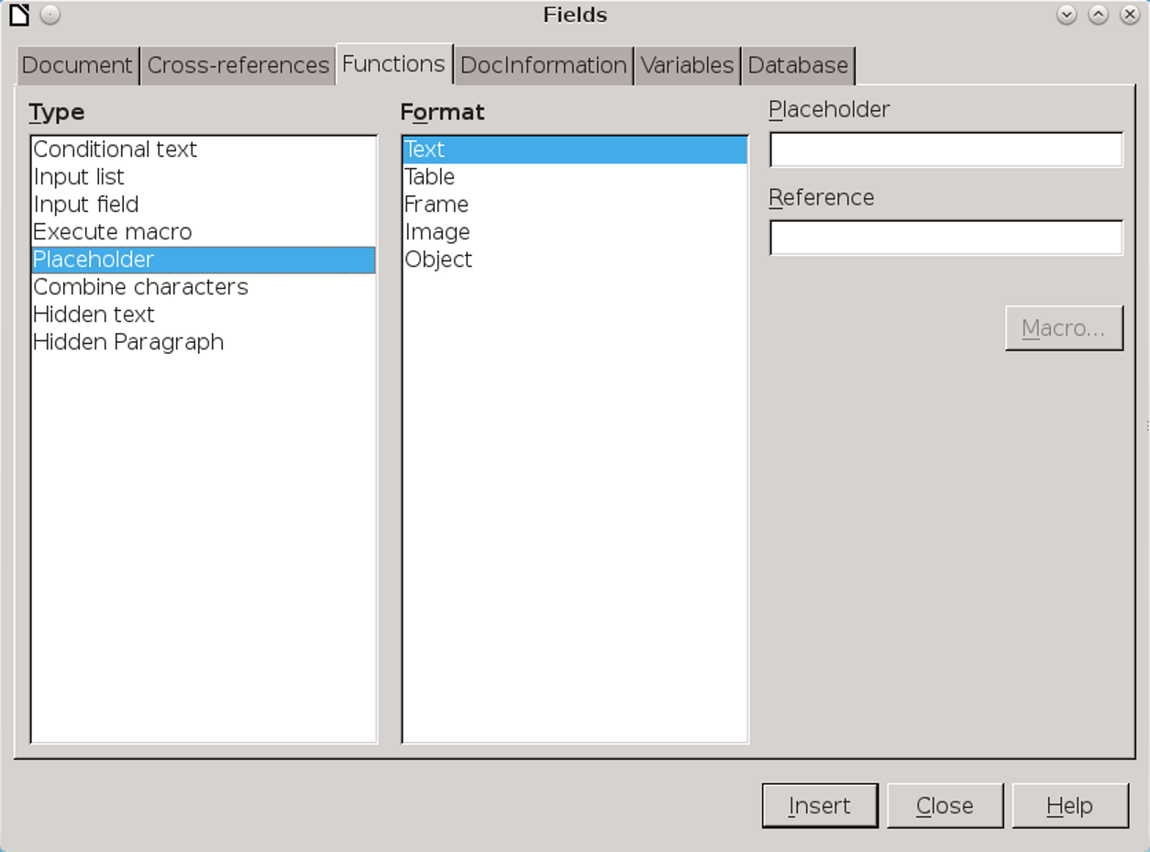
The Fields dialog window for adding placeholders in Writer.
The placeholders are added as fields in the document. When you are ready to insert the information, click the placeholder field to replace it.
<Salutation> <Title> <Last Name>
Placeholder fields in Writer for the opening of a letter.
- Tip
Placeholders have their own character style, which makes them easy to find using Edit > Find & Replace.

Using fields in templates
Fields are another way to store information in templates. Four kinds of fields are likely to be useful:
- System information, such as date and time.
- General user information, stored in Tools > Options > LibreOffice > User Data.
- Document information, stored or displayed in File > Properties.
- Document statistics, generated as you create the document. They include page numbers, page counts, and other information commonly placed in the header or footer.
As this information changes, the fields in the template will also change, updating each time that you open the document without you having to change it manually.
- Tip
Date and time fields are of two kinds. Fixed fields add the current information and never change. By contrast, variable fields always update to the current date and time when anyone opens a document or update the fields.
Both have uses. For example, you could place a fixed date field beside a witness' signature, and a variable date field at the top of a letter template.
Date and time fields also support a number of formats, defaulting to the one listed for the current language.
LibreOffice offers no way to change the default formats permanently.
Although a Month-Day-Year format is common in the United States, increasingly international use favors a consistent sequence – either Year-Month-Day or, less frequently, a Day-Month-Year format. All these formats can have two or four digits for the year.
- Example: Using placeholders & fields
LibreOffice includes a tool for designing do-it-yourself business cards. The tool is designed so that you add information on one sample card, then add the information automatically to the rest.
To create the sample card:
- Go to File > Business Cards, and select the label sheet to use. Click the New Document button to continue.
- Adjust the zoom so you can work comfortably on the sample card.
- Create two frames of equal width and height from Insert > Frame. One is for a graphic on the left, and the other for text on the right.
- Place the cursor in the left hand frame and select Insert > Fields > Other > Functions > Placeholder.
- Create an Image placeholder and call it Graphic. Click the Insert button to continue. You do not have to close the Fields dialog window to continue.
- Place the cursor in the right hand frame and create one placeholder per line for Author, Position, Company, Email, and Phone.
- Tip
The Author field is filled automatically with the name entered in the User Data for LibreOffice’s general use.
- Give each line a right alignment. You can further adjust the look of the placeholders by editing the Placeholder character style.
- Save the document. The Business Card template is now ready for any user to complete by clicking on each placeholder and replacing it with actual information.
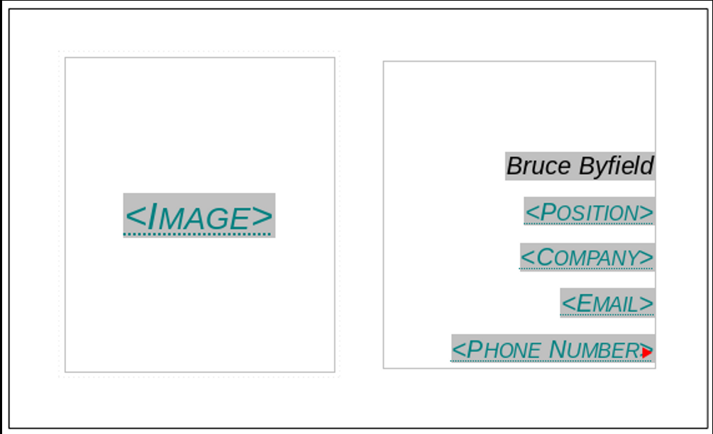
A basic business card template. Placeholders are used for information, and the name is filled in using the Author field, which borrows information from Tools > Options > LibreOffice > User Data > First / Last Name.

Editing templates
Unless you are extremely well-organized or lucky, you won’t make a perfect template in one sitting. Instead, the first few times you use a template, you are likely to find countless ways to improve it so that it meets your needs without requiring endless manual adjustments.
To open a template for editing, select File > Templates > Manage to open the Template Manager, select a template, and click Edit on the tool bar above the templates.
Once a template is open, you can edit it exactly the same as any other document. However, remember to register your changes by saving with File > Templates > Save As Template.

Deleting templates
You can delete custom or imported templates. You cannot delete templates installed with LibreOffice, through an extension, or for the entire system, although you can delete the extension from Tools > Extension Manager.
From within the Template Manager, select the template to delete, then click the Delete button.
- Caution
The Template Manager does not include confirmation dialogs. A selected file is deleted as soon as you click the Delete button. Nor can the deletion be undone.

Exporting templates
You can export a template from the Template Manager. Select the template to export, then click the Export button. Exporting a template takes a copy of the template, de-registers the copy, and saves it to the directory of your choice.

Changing templates
Except with Template Changer or another extension, you cannot directly change which template is used by a document. Nor is there any means to apply multiple templates to the same document. However, you can use three workarounds.
The first is to open a document based on another template, then copy and paste into it. This method works best when all styles in both documents have the same names, because the styles in the original document will take on the formatting of the new document.
- Tip
If you experience some problems with graphics, try copying and pasting a few pages at a time instead of all at once.
In addition, any custom-named styles in use in the original document are copied over to the new document. By contrast, custom-named styles that
are defined but not in use, as well as tracked changes, will not appear in the new document.
A second method is to create a new master document with a different template. If you import the template-less document into the master document, it will be reformatted while being used from within the master document. When not opened from the master document, it will revert to its original formatting.
The third and most practical method is to transfer styles between documents.
Transferring styles is convenient when two people have been working on a document, but made their own changes to the template (something that happens, although you shouldn’t encourage it).
You might also use the feature to transfer manual formatting of a document to its template, although making changes to the template is generally a more reliable practice.
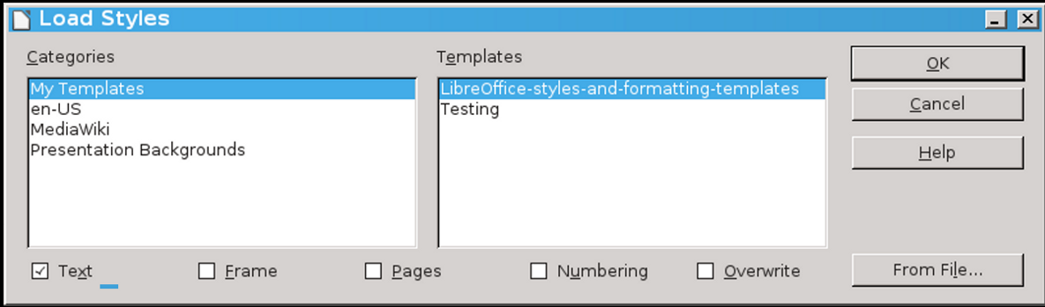
Transferring styles between documents. Paragraph and Character styles are listed together under Text. Click Overwrite to replace existing styles of the same name.
To transfer styles between documents:
- Press F11 to open the Styles and Formatting window.
- From the pull-down menu at the far right of the icon bar, click Load Styles.
The Load Styles window opens. The Categories pane shows the sub-folders in the Template Manager, while the template pane shows the templates of the current sub-folder.
- Either select one of the templates in the Template pane or click the From File button and select a document template using the file manager.
- Select the types of styles to import by selecting the boxes along the bottom of the Load Styles window.
- Tip
The Load Styles window uses Text to refer to both Paragraph and Character styles.
- If you want to replace any styles in the current document that have the same name as the ones in the template or document from which you are importing styles, click the Overwrite button.
- Caution
Carefully check styles that were supposed to be overwritten. They may not be consistently overwritten
if you have large documents and a computer with limited memory.
If you do not want to replace styles, leave the Overwrite box unselected. You will import only styles that have names not found in the current document.
- Click the OK button on the top right. You receive no confirmation, but the importing is complete in a matter of seconds.
- Tip
Transferring styles does not change the template listed in File > Properties > General. If you are unsure whether a document is still associated with a template, make a minor change in the template and see if the document updates the next time that you open LibreOffice.

Working with templates in a file manager
LibreOffice includes all the features you need to interact with templates. Sometimes, however, you may want to deal with templates from outside LibreOffice, either because LibreOffice is not open or because you are dealing with more than one template at a time. Or perhaps you want to organize your installation by adding sub-folders to the main template directories.
In these cases, you can interact with templates through a file manager. The storage directory for
templates varies with the operating system and software release, but you can find which directories your installation is using by going to Tools > Options > Paths > Templates.
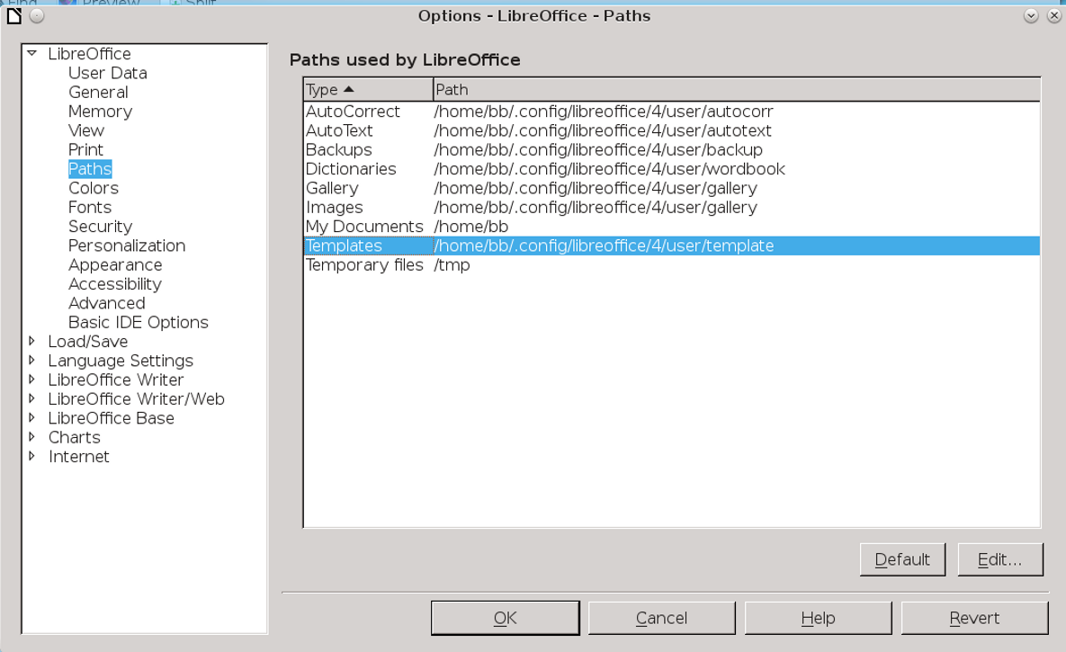
The directory (or directories) where templates are stored is listed in Tools > Options > LibreOffice > Paths. The exact path differs with operating systems and LibreOffice releases.
You can add directories to the template path, separating them from each other with a semi-colon. If you want to make directories accessible to all users on the system, log in as root or administrator and go to the directory in which LibreOffice was installed. For example, if you downloaded a Linux version directly from The Document Foundation, this directory will be in something like /opt/libreoffice4.4/share/template. In other cases, the top two directories may be different, but the bottom two should be the same.
If you are installing a large number of templates, placing them all in one directory, adding to the path, and re-starting LibreOffice is the quickest way of registering them.

The complete basics
If you have read Chapter 2, you should now have a general sense of how styles and templates work. Neither is difficult in theory, although some of the ways that templates work may seem needlessly complicated until you realize that they exist to prevent file corruption.
The next few chapters explain the points you need to consider to design useful and beautiful styles and templates.

