9

Getting in the frame
Frame styles are the least understood type of style in LibreOffice. Often, you don’t need to understand them, because Writer adds frames automatically to contain objects such as images.
In many ways, frame styles are as much for Writer’s automatic formatting as they are for users. Most of the time, they are so completely in the background that users have a hard time distinguishing frames from the images and other objects they enclose.
Another reason for uncertainties surrounding frames is that keeping images where you place them can be difficult. Generally, images stay anchored to the page, paragraph, or character to which you assign them, and some users never have problems.
At the same time, almost as many find that Writer in particular is notorious for spontaneously switching images so they are move on the page for no apparent reason. Changing anchors, moving objects, copying and pasting – sometimes any editing whatsoever seems to send objects shifting out of control.
For this reason, this chapter includes both how things are supposed to work (and should work for you, with any luck), and the precautions and work-arounds you may need. Although the work-arounds may give you fewer formatting options, they do keep images where you put them.
- Tip
LibreOffice currently prefers the word “images,” but you sometimes find the terms “graphics” and “picture” used instead. In the most recent versions of Writer, the Insert menu uses Media as well.

How frame styles work
When an object is added to Writer, it is automatically enclosed in a frame of a pre-determined type. The frame sets how the object is placed on the page, as well as how it interacts with other elements in the document.
You can edit the frame by modifying the frame style it uses, but you should avoid manual overrides whenever possible.
Unfortunately, however, elements not included in any frame style, such as an image’s anchor, alignment, stacking, and wrap usually have to be edited separately for each frame, making this advice easier to give than to practice.
- Caution
If you are having trouble positioning something, the first thing you should do is check whether you are editing the image instead of the frame, or the frame instead of the image.

Understanding pre-defined frames
Because of the problems that sometimes occur with frame styles, creating custom styles is best avoided. Instead, stick with editing the pre-defined frame styles. Often, they will be all you need anyway.
The names of some pre-defined frame styles are self-explanatory, such as Graphics, Labels, and Formula.
Others require clarification:
- Frame: Both a general frame and a text frame specifically. This is the default style.
- Marginalia: Frames that sit on the left side of the main text frame, creating the effect of notes in the margin. See “Creating marginalia and sideheads,” page 25.
- OLE: The term is technically obsolete, but now refers to a document nested within a document,
- including charts. In this way, a document can be easily updated, and used in different situations.
- Watermark: Frames that position a graphic behind text. You will need to prepare the graphic for use before you add it. See “Creating watermarks,” page 26).

Planning frame use
The addition of graphics and other objects is often an after-thought of writing, done with minimal thought about layout.
However, you can improve your layout by choosing a general strategy. Tactics to consider include:
- Placing images on separate pages from the text. In this case, you may want a separate page style whose use automatically creates a new page.
- Using no text wrap, so that there is text above and below the frame, but not to its left or right. If you lack time, this is always a low-maintenance tactic to use anyway, and is common in technical manuals. While not always ideal, it generally provides an adequate layout unless you are adding extremely small images, which tend to get lost in all the white space to their left and right.
- Deciding how much space to place around the frame. The space should be a multiple of the line-spacing.
- Using either a border or extra white space when images have the same background as the pages of your document.
Before you design, sketch out the alternatives for positioning multiple images on the same page.

Preparing images
You can adjust how an image displays with the tools on the Image and Crop tabs, which are available when you select Image Properties from its right-click menu.
These tools do not affect the image itself, only its display. The Image tab has no undo function, but you can easily change the settings until you revert to the original.
On the Image tab, you can flip an image vertically or horizontally. You can further refine the editing by setting which pages the image is flipped upon. Using these settings, you could add dingbats or perhaps decorative scroll work twice in a two-page spread so that they formed a mirrored image.
In the File name field, adding a path changes the image from an embedded image that is part of the document file to a linked, separate file. Changing the path replaces the image. See “Choosing linking or embedding,” page 9.
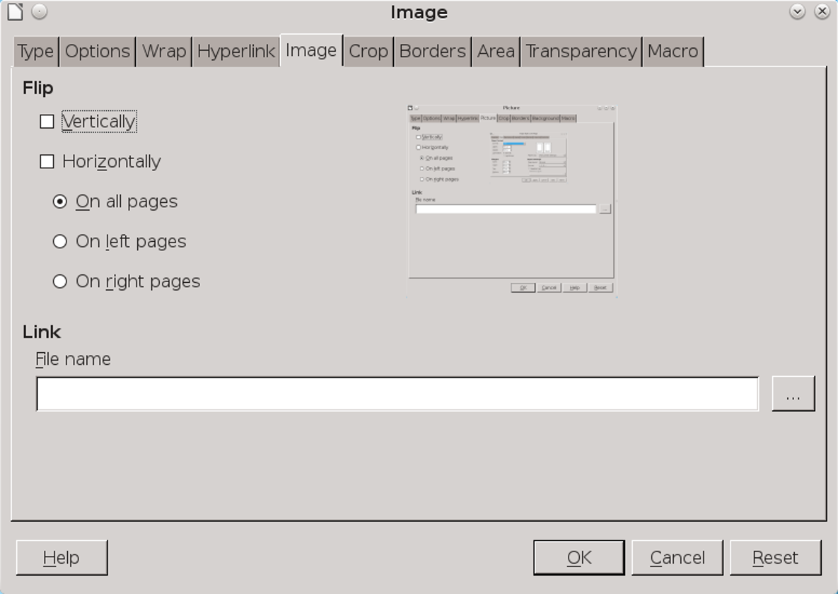
The Image tab edits how an image displays in LibreOffice, not the image file itself.
Cropping is the displaying of only part of an image. Cropping helps readers to focus on the relevant part of an image, but at the risk of losing context. On style tabs and dialog windows, you can easily crop so tightly that readers have little idea where the items displayed actually are.
On the Crop tab, you can change the overall dimensions of an image, or display only part of the image. If you display only part of the image, you can select Keep image size or else scale the newly cropped image to a percentage of its original size. You can undo such changes by clicking the Original Image size button.
All these tools can be handier than opening a graphics editor to make changes. However, given
the potential instability of frames, the tools on the Image and Crop tabs are just extra things that might go wrong. If you are having trouble with graphics staying in place, avoid these tabs. See “Using cropping or indicators ,” page 8.
Another consideration is that LibreOffice’s editing tools are less versatile than many third party graphics editors.
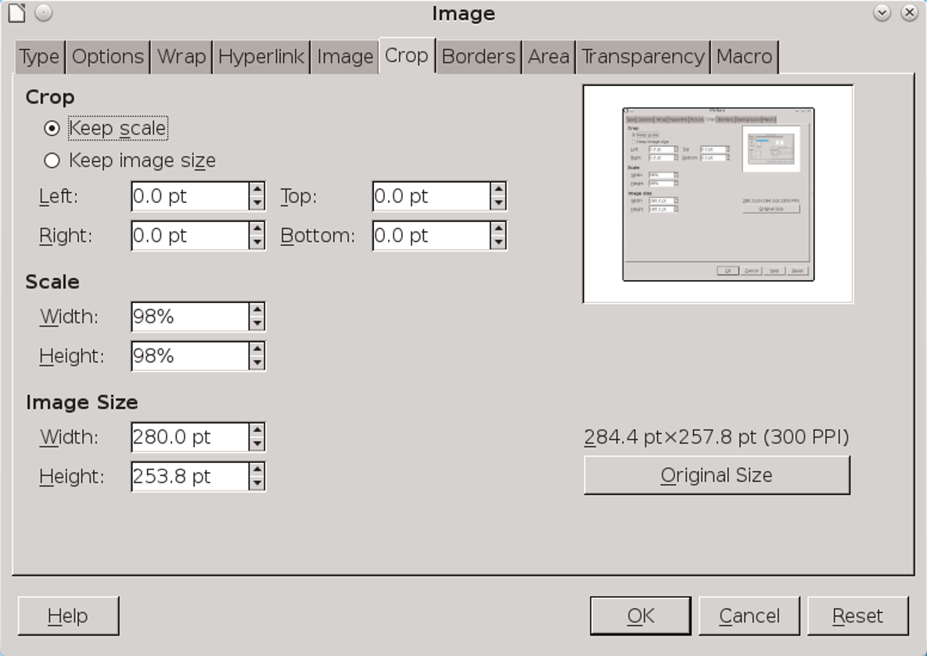
The Crop tab is a misnomer. It includes not only fields to crop the display, but also fields to adjust the display size.

Preparing images in graphics editors
Graphics editors can be a more versatile and reliable way of preparing images than the tools that LibreOffice itself provides. Editors such as GIMP and
Krita are free to download for all the operating systems that LibreOffice runs on.
Before editing images, measure the distance between the left and right (or inner and outer) margins on all pages where images might display. You can determine this distance by subtracting the vertical margins from the page width given on the Page tab of each page style. You will need this measurement when sizing images. If some images are too large to display legibly at this size, consider adding a landscape page style for them.
You can open images in other applications by right-clicking and selecting Edit with External Tool, or directly from the graphics editor. If the image is already open, right-click to copy it, then paste it in a new file in the graphics editor.
Graphics editors allow you to change the size and colors of an image, and do many other operations besides. However, the four operations necessary for every image are:
- Setting the image’s resolution and print size.
- Deciding to crop the image or to add indicators to point to features.
- Setting natural borders.
- Cleaning up the image.

Setting image resolutions
For an online document, a resolution of 96 dpi (dots per inch) is usually enough. For hard copy, use
a minimum of 300 dpi, or 600 dpi or higher for quality printing.
Resolution is best set in a graphics editor. Many graphic editors will show an actual size and a printed size, displaying each in a number of different formats, including pixels, points, inches, and percentage. Getting the highest resolution is a tradeoff: the higher the resolution, the smaller the actual or printed size of the image. Most images can be enlarged by 50%, but few can be increased to 200% without becoming badly distorted unless they are very simple. Experiment to find the best compromise.
Most editors work at the screen display of 96 dpi. If you are making original graphics, one solution is to make everything three times the size you need, then reduce it so that it is the right size at 3oo dpi.

Using cropping or indicators
Editing a graphic helps readers know what to focus on. You have two main choices: cropping or adding indicators.
Cropping is the reduction of the image to whatever is essential. Leave some context so readers can locate what you are discussing.
Some writers put jagged edges around a cropped image, as though it were torn from a page, which is a vivid effort, but a time-consuming one.
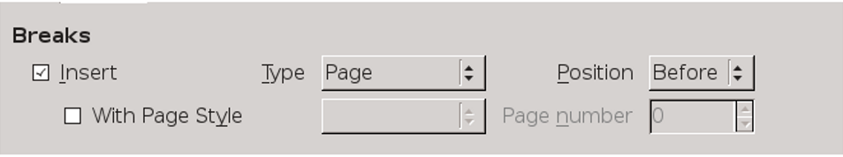
A cropped image of the Text Flow tab for a paragraph style.
By contrast, indicators draw attention to parts of the image by their bright colors and the fact that they obviously do not belong.
Types of indicators include bars, arrows, and an oval. Bars and arrows are quickest to insert, while adding an oval usually involves making its fill area transparent so that the part of an image it encircles is visible.
Choose one type of indicator, and note its colors and dimensions so that you can use them consistently.
- Tip
You can also add indicators such as arrows, lines, boxes, or callouts within the graphics editor, or by using View > Toolbars > Drawing.
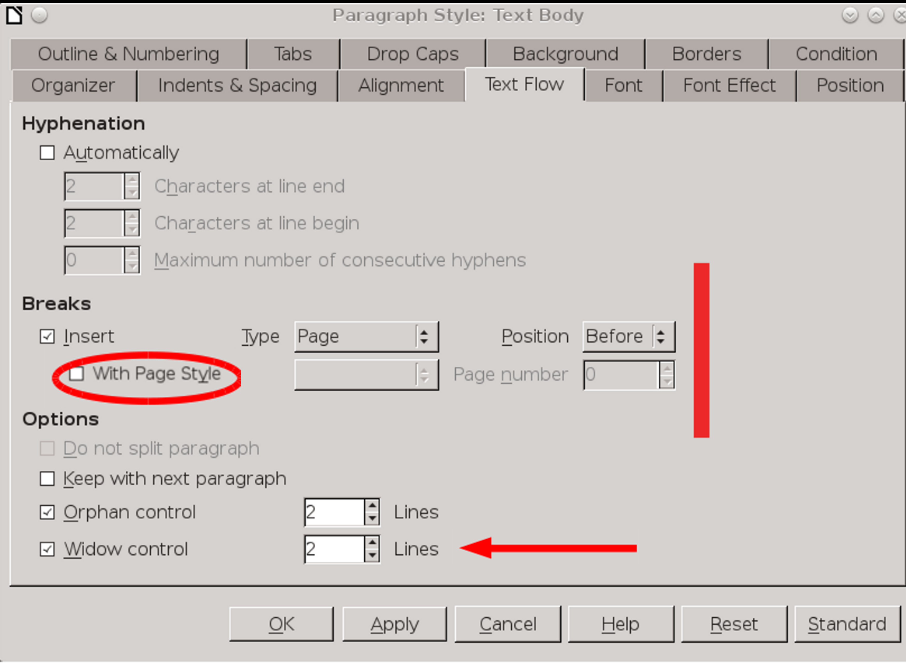
Indicators call attention to elements that you want readers to find easily as they follow your discussion.

Setting natural borders
You can add a border to an image in LibreOffice. However, a natural border can be just as effective. If possible, crop the image so that all its edges are a different color from the document’s background.
For example, some operating system or desktop themes place a shadow around dialog windows. Include the shadow and you have a natural border that needs no further attention.

Cleaning up the image
As a final step in image editing, remove any unnecessary clutter. For example:
- If you take a screen shot of a menu, white out any irrelevant text and dialogs in the background.
- Check for details in the background that might accidentally violate someone’s privacy.
- Crop any blank space in an image if possible.
- See if you can improve the contrast of an exceptionally dark or light image.
- Experiment with image size, making it no larger than necessary for legibility.

Inserting images
Throughout LibreOffice, frames are usually less trouble if you follow these best practices:
- Add objects when the formatting and writing is done. The objects are less likely to move around.
- If possible, format the frame style, not individual frames.
- Adjust objects immediately after you add them, not later. If necessary, experiment with the exact settings first, making notes of all the settings. Then delete the experiment and add the frame again, applying the settings as the frame is added.
- Never copy and paste frames or objects. Delete a frame and start from scratch if you want to move an object.
- Never drag an object to resize or reposition it. Use the right-click menu.
- Never use spaces or empty lines to position objects. Instead, always use styles.
- Avoid putting two or more images one after the other, unseparated by text. The workaround suggested in this chapter is more reliable for placing two or more images together. See “Using the table workaround,” page 22.
These precautions seem to work more reliably in Writer than in Calc, Draw, or Impress.

Choosing linking or embedding
When you select an image from the file manager using Insert > Image, LibreOffice defaults to embedding the image as part of the document file.
However, in some versions of LibreOffice, you have the option to use the Insert as Link box in the bottom left corner of the file manager. If you select this option, your document will use the image’s original file each time it loads.
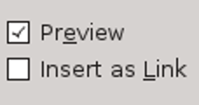
Located at the bottom left of the Insert Image window, the Insert as Link option is easy to overlook.
The fact that LibreOffice defaults to embedding images suggests that its original programmers saw embedding as the easiest solution. In fact, professional writers and designers argue all the time about these two approaches. Both embedding and linking have pluses and minuses. Which you
prefer is not so much right or wrong as a matter of how you prefer to work and how others prefer to receive your work.
Pluses and minuses to consider include:
Embedding | Linking
- Document size is bigger, because images are included. | - Document size is smaller, without images.
- Images cannot be lost, because they are part of the document at all times. | - Images can be easily lost, so create orderly directories to reduce the possibility.
- When you share, you know the document is complete. There are no additional files to find. | - When you share a document, you have to send image files as well.
- Images can be edited from within LibreOffice, which is more convenient. | - Images must be edited in a graphics editor, which gives more options.
- Images are updated by selecting Change Image from their right-click menu. | - Images are updated by overwriting the existing separate image file with a new one. If you do not use Tools > Update > Update All, Writer updates the image the next time the document opens.

- Tip
Change Image may not work if you have try to swap in an image with the same name as the original. Instead, delete the original image and then insert the replacement.

Formatting frames and images
The right-click menu includes items for both frame and image. Although you can modify many features from the right-click menu, some observers suggest that using the dialog windows seems to help keep objects where you placed them.
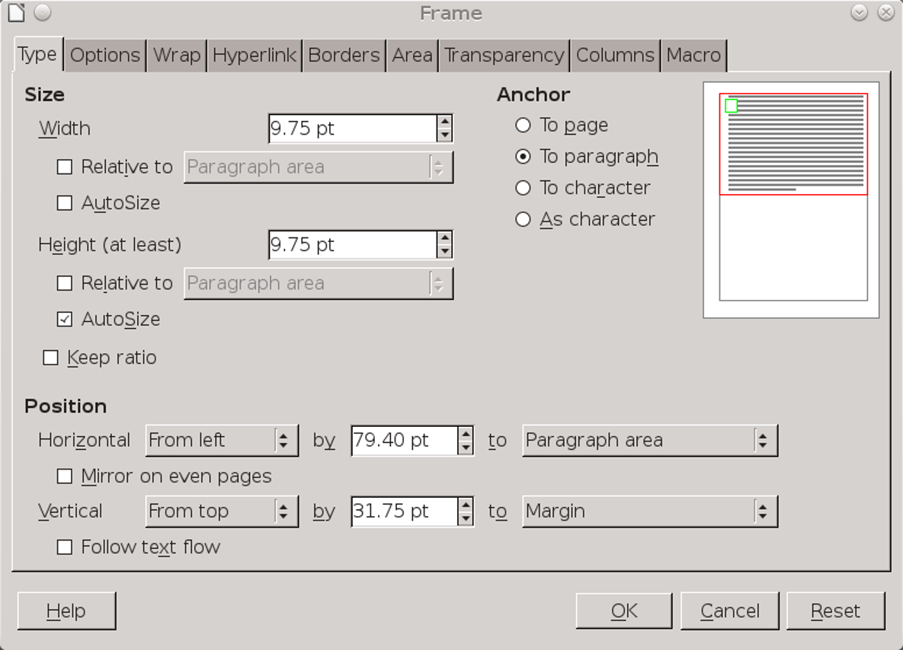
Frames and images share an almost identical dialog window. The main difference is that the window for frames includes a Columns tab. Be sure that you select the one you intend to modify.

Resizing frames and images
Resize frames and images on the Type tab of the dialog window. You have several options for resizing:
- Set Width and Height separately. This choice can easily distort the image, so you are better off with other alternatives.
- Select Keep ratio, then add either the Width or Height. The other dimension will change automatically to remain proportional, saving you calculations.
- Use the Relative fields to set a Width and Height that is a percentage of the paragraph’s or page’s width and height.
- Select Autosize for Width and Height when first adding a frame. This option may have no effect if you edit the frame dimensions later.
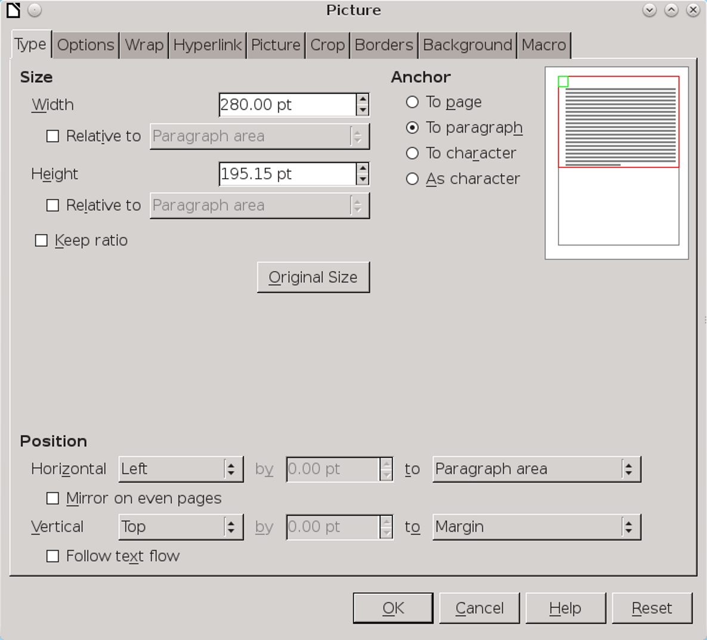
The Type tab includes various options for resizing, anchoring, and positioning images.
To help keep images in place, make any adjustments when first adding an image. If necessary, experiment first, making notes about the
size you want, then delete your experiments and add the image again.

Positioning frames on the page
The Position options on the Type tab are the equivalent of the horizontal and vertical Alignment options on the right-click menu. You should adjust these as you are adding an image, reserving the right-click menu for experiments.
The horizontal options are Left, Right, Center, and From Left (which works with an indent field called By).
Each of these alignments can be relative to various reference points. Usually, the most useful reference point is Left Page Border.
By contrast, in many cases, you should use Entire Page only if the document is intended for on-line use or your printer is capable of bleeds (that is, printing to the very edge of the page).
The vertical options are Top, Bottom, Center, and From Top (which also includes a space above field called By). Usually, the most useful reference point will be Margin, the least useful Entire Page.
- Caution
Do not use the Follow Text Flow option. It is included for compatibility with old OpenOffice.org documents, not for use today.

Setting anchors
An anchor is a reference point for positioning frames and images. You set the anchor on the Type tab for an image or frame.
The Type tab offers four options for the anchor: To Page, To Paragraph, To Character, and As Character. The first three choices indicate what an object is positioned in relation to.
By contrast, As Character indicates that the object is treated as a character. This choice means that the line that an object is placed upon has a height that is tall enough to display it fully. Usually, any problems with As Character can be solved by setting the line spacing for a paragraph style with At Least.
Writer defaults images to To Paragraph when you insert an image. However, setting the anchor to As Character seems the choice least likely to have objects shift spontaneously.
By contrast, if you keep To Paragraph, the image will be positioned relative to the anchor’s paragraph, but can flip above the anchor sometimes.See “Using the Haugland workaround,” page 20.

Choosing text wrap
Text wrap refers to how body text is positioned in relation to a frame. Text wrap features set how exterior text moves around the frame, and the spacing between exterior text and the frame. Usually, generous spacing improves the look of the page.
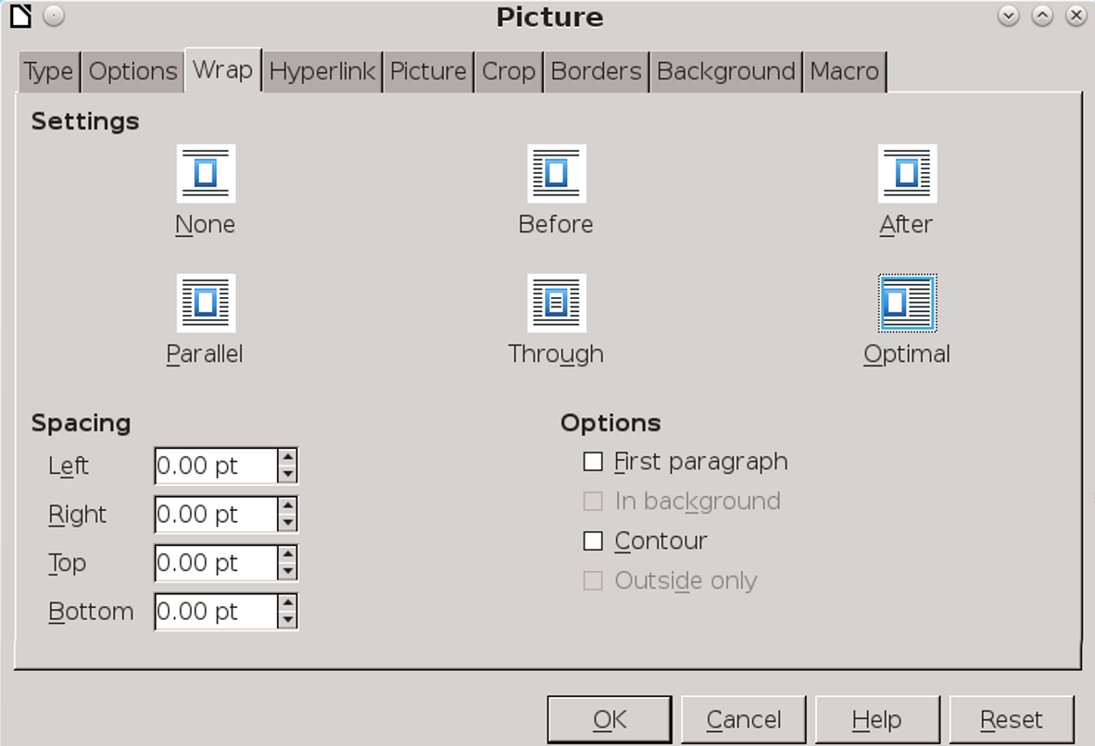
Image > Wrap positions an object in relation to the text around it.
Writer has six settings on the Wrap tab for both frames and images:
- None: The frame interrupts the text, so there is no text to the left and right of the frame. This is a favorite strategy in technical manuals, because it requires minimal time positioning. However, it can make small images look even smaller because of the white space beside them. It is a good, average choice, but not always ideal.
- Before: Text wraps above, below, and to the left, leaving white space on the right. This setting is especially useful for frames against the right margin.
- After: Text wraps above, below, and to the right, leaving white space on the left. This setting is
- especially useful for frames against the left margin.
- Parallel: Text wraps equally on all sides of the frame, starting on the left, then jumping across the image to the right. Unless the text is very short, avoid this wrap, because most readers will have to concentrate to read the text.
- Through: The frame is placed on top of the text, hiding it. If you use this option, you should also select Wrap > Options > In Background so that the text is visible. You might also make the image partly transparent so that the text is more readable.
- Optimal: Automatically wraps text on all sides of the frame. If the frame is less than 2 centimeters from any margin, the text is not wrapped on that side.
Generally, Optimal makes a reasonable default setting if one side of the frame is close to the left or the right margin. However, if the frame is centered, it requires readers’ eyes to jump continually across the frame and should be avoided.
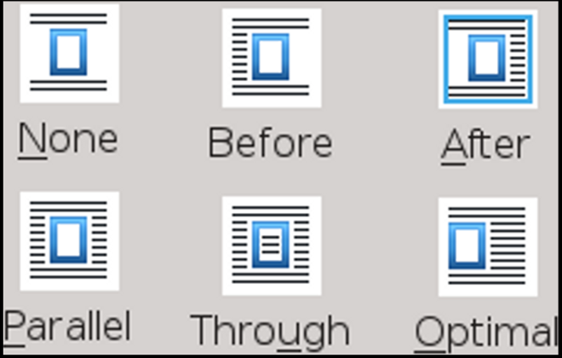
The six types of text wrap available in Writer.
- Tip
Most of the text wrap settings leave a very even gap between the frame and body text. Select Wrap > Options > Contour if you want the text wrap to conform more closely to the shape of the object in the frame.

Setting white space around a frame
The Wrap > Spacing fields set the white space on each side of the frame. These settings are often ignored, but they are as important as the text wrap setting. Too little spacing and the page looks cramped, while too much spacing weakens the association of the frame’s contents with the body text around it.
As a general rule, the minimal white space around a frame should be half the line height in the body text. As much as three times the line height may also work, but anything more usually looks sparse.

Developing a white space policy
Consistency is essential to design. For this reason, you need to decide exactly how images and other objects fit into the text.
The basic space above and below is easy. However, what happens when the space above an image is added to the space below a heading? The result is too much white space. Even worse, the result can be that the heading, which you carefully set up so that it sat closer to what was below it than above, is now carefully poised midway between. To prevent such problems, you may decide that, in certain cases, an image should use less white space than usual.
- Example: Developing a white space policy
Here is a sample policy that was used in one draft of this book (the final one is somewhat different):
- Images, tables and paragraphs all have a minimum of 8 points of white space above and below them.
- If another heading or other element gives enough additional white space above or below, then an element may not add any white space itself. The point is to be consistent and not to have any large gaps.
- The default width of all images is 280 points, the width between the margins.
- Images may be less than the complete page width when a dialog window is smaller than usual or is cropped.
- Images below a bullet or numbered item, or an indented paragraph, will align with the start of the text above them. This rule means making images 8 points narrower than normal, and setting the tables used to be indented 16 points From Left in the Table tab.
- Large images or tables will be on separate pages, introduced by a heading that forces a new page break.

Setting other wrap options
In addition to the basic text wrap choices, the Wrap tab includes several settings that modify how the settings work:
- First paragraph: Starts a new paragraph below the frame if you press the Enter key. Since this choice adds space according to the size of the object, you will have more control if you ignore this setting and adjust the white space exactly using the Spacing fields.
- In background: Available with the Through text wrap setting only. Treats the frame as an object in a stack of objects, sending its contents to the back so that the body text is at the front. This option is the equivalent of right-clicking on the contents and selecting Arrange > Send to back.
- Contour: Wraps the text more closely to the shape of the object in the frame than choosing a text wrap setting alone can. This setting can give a
- more exact wrap, but it can also give the page a distractingly busy look, especially when the frame is small or has a complicated shape.
- Only outside: Like Contour, but ignores blank spaces in the object. It cannot be used with frames (that is, Text Frames), presumably because text is too regular for it to make any difference in the wrap.

Setting frame and image borders
Novice designers can be obsessive about frame borders, adding them everywhere. The result is usually cramped and awkward-looking.
Although the Borders tab contains numerous options, borders are mostly useful when at least one edge of an image is the same color as the page background, so that one blends into the other.
Even then, extra space around the image can be just as effective.

Setting frame backgrounds
While the dialog windows for frames and images include a Background tab, often a background has no useful function.
A carefully selected background color might prevent an image blending into the page background, but a border or extra space is often an easier solution.

Setting general options
The ambiguously named Options tab in the Image dialog window contains miscellaneous options to do with editing and printing. Often, you can ignore these settings:
- Name: For the frame or image. Writer adds an automatic name, such as Frame15, but a more descriptive name is useful if you use the Navigator to jump around in a document. Using the file name for an image’s name can help you stay organized.
- Protect: Prevents editing of Content, Position, and Size. These options are useful when a document has multiple editors. Protect does not help an image stay in place.
- Editable in read-only document: Allows editing in a restricted document.
- Print: Includes frame or image when you print.
- Text direction: Applies only to non-Western European languages within a frame. Ignore this setting in English or other Western European languages.
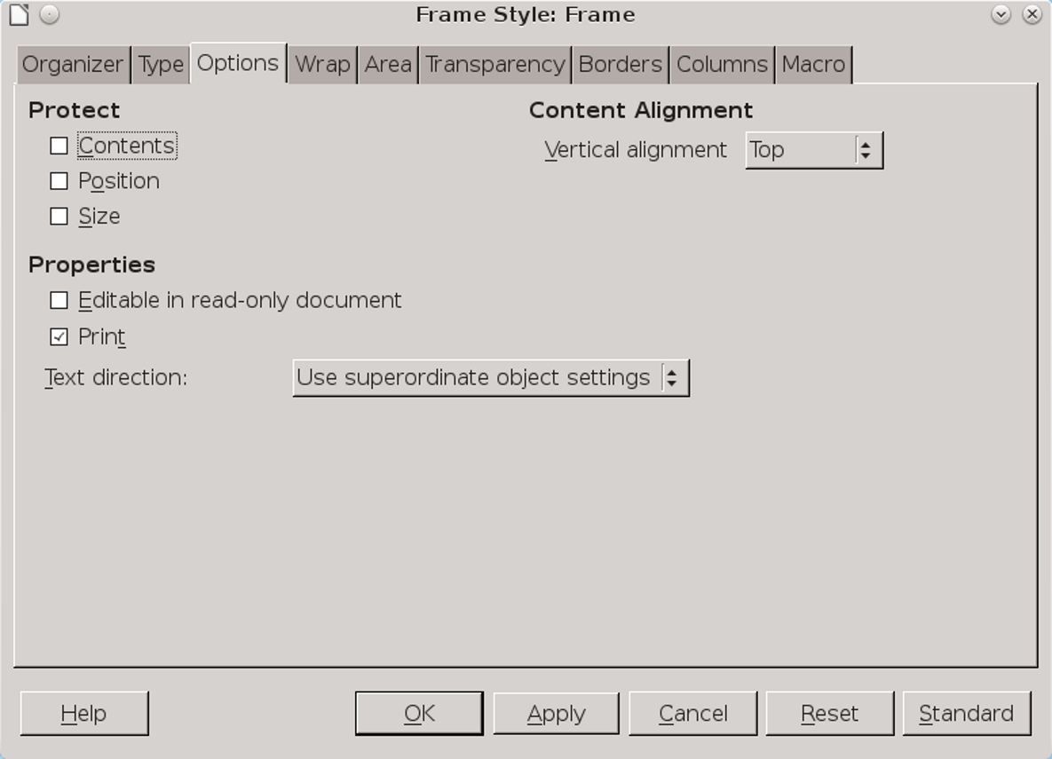
The Options tab for frame styles.

Adding columns
You can set multiple columns for a text frame on the Columns tab in the dialog window.
You may prefer to insert a section from Insert > Section... instead, since sections have more options than frames.

Adding hyperlinks and macros
In online documents, you can add hyperlinks (links) and macros that run when you click a frame or image.
You need the frame name from the Options tab to configure a hyperlink.
You can use some pre-defined macros, but to record a macro in LibreOffice, you first need to
select Tools > Options > LibreOffice > Advanced > Optional (unstable) options > Enable macro recording (limited).
- Caution
Remember that the tenth time users hear a sound or see a macro effect, many will wish for a way to turn it off.

Adding captions
The purpose of an image may be clear from the text around it, especially if the paragraph above introduces it with a colon.
However, at times, a caption adds clarity by repeating key words and concepts from the text. A caption may also explain the relevance of the image, or parts of the image whose relevance is not immediately obvious.
Used carefully, a caption may help to give detailed information in less space than it would take in body text. The only trouble may be that readers are not aware of the fact, and might miss key facts by skipping over the image.
Another consideration is that in online documents or when the caption is separated from the text that an image illustrates, the caption might be used as a cross-reference.
When you compose a caption, you may think that it is embarrassingly obvious. Sometimes, that
may be true, and you may want to consider whether to use captions at all.
Most of the time, however, what is obvious to you after you have planned and written is much less obvious to readers. Generally, the worst that can happen is that readers skip over what seems irrelevant to them, without blaming the writer in any way. Under these circumstances, when in doubt, using a caption is always a reliable option.
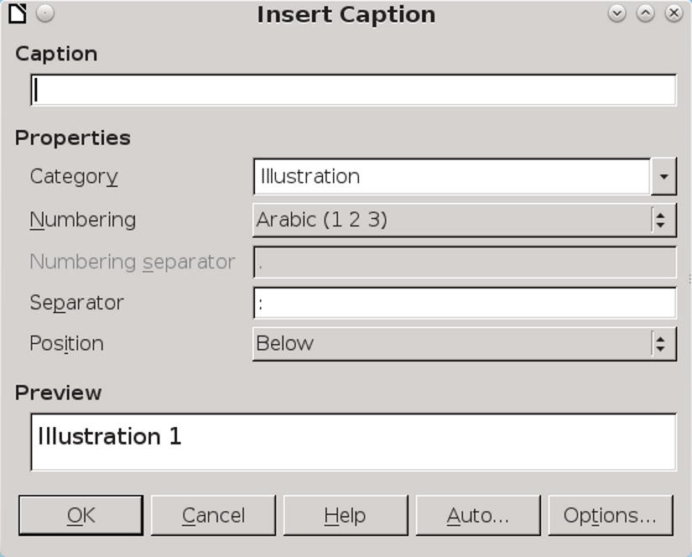
Writer’s caption options are especially useful when you plan on a table of contents for particular types of objects. Captions are automatically detected and used to create the content entries.
To add a caption:
- Right-click anywhere in the image and select Caption from the context menu. The Insert Caption dialog window opens.
- Add the caption to the Caption field.
- Consider whether you want to set the Category and Numbering fields and the separator between the number and the text. These are time-honored features for any objects added to a document, but many modern documents avoid them altogether.
- Tip
You can add categories by typing them into the Category field. Once you add a new category, it is available to use again.
- To prefix the image number with the chapter number, click the Options button and select the Outline Level that includes the chapter number.
You may also want to select a special character style for the chapter number, although usually there is no reason for more than a bold weight.
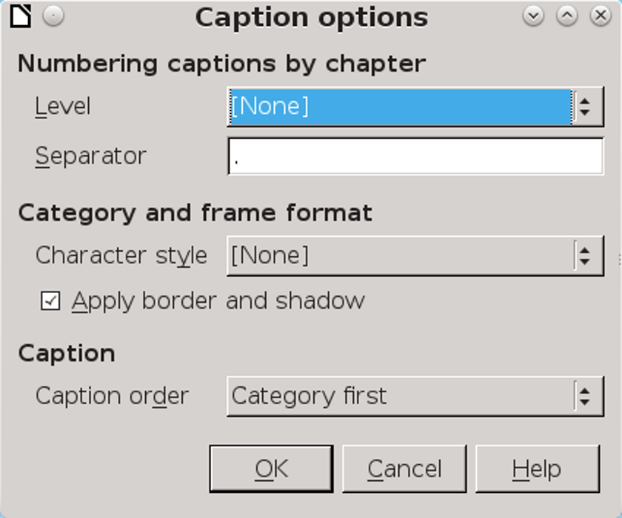
The Caption options window opens off the main Captions dialog window.
- Consider whether to select Apply border and Shadow to the caption in the Options sub-window. Avoid using them if you cannot explain what purpose they serve. Often, you can do without either one.
- Set the caption order, placing either the number (complete with chapter number preface) or the category first.
To add a chapter number, you must assign a numbering style to one paragraph style, and then assign the paragraph style to an outline level. Heading 1 is often used for this purpose.
- Set the caption Position to Above or Below. A caption below an image is more common today, but a caption above may be useful if you need to explain something before readers look at the image.
You can edit the caption directly, or change its formatting by selecting Caption again from the right-click menu.

Formatting captions
Caption paragraphs are formatted using the Caption paragraph style. Contrary to common usage, the Caption paragraph style defaults to italic, but a regular weight is more common.
Similarly, the style does not need to be smaller than the body text. If anything, a smaller font for captions removes much of the convenience of adding the image in the first place. If you want to save space, use a narrow or condensed font style for captions.
In addition, the caption should have less space between it and the image than between it and the text below or above it. Proximity is one of the basic ways that design indicates that two parts of the document are related.

Adding automatic captions
Autocaptions immediately add a caption to all specified objects, using the Caption paragraph style.
To set up Autocaptions, select the types of objects for them, then follow the directions above for adding a caption.
- Tip
You can select multiple Autocaptions to format at the same time.
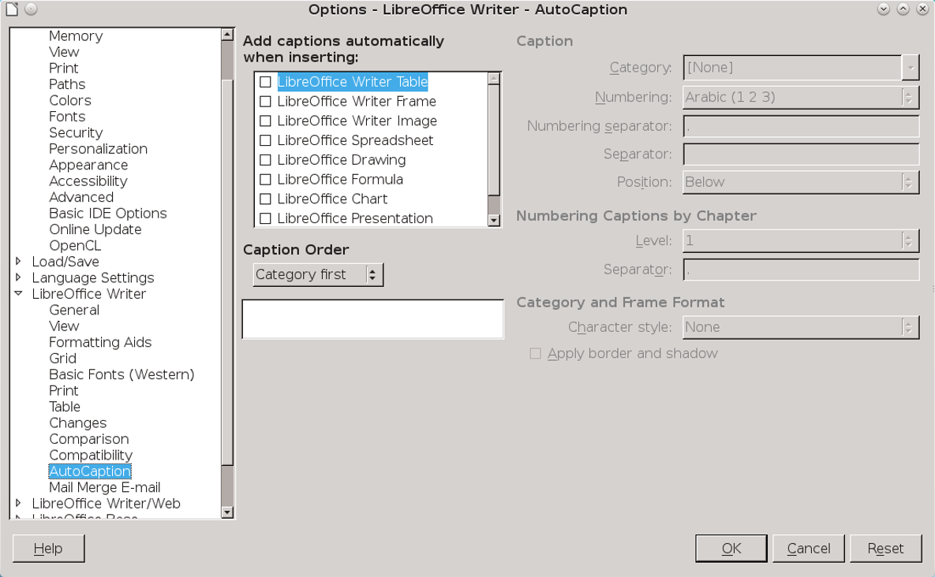
Set the objects to which you automatically want to add a caption from Tools > Options > LibreOffice Writer > AutoCaption.

Making images stay in place
Many people have no trouble with graphics. Many others find that they shift constantly. Although no one has suggested a reason for these different experiences, they may be due to the different work habits of users, or to the operating system or LibreOffice version being used.
However, two work-arounds are known for Writer – but not, unfortunately, for other LibreOffice
applications: the Haugland work-around and the table work-around. Since the table work-around limits some options, use it only after the Haugland workaround fails.

Using the Haugland workaround
In 2009, Solveig Haugland, one of the first people to write about OpenOffice.org, devised a solution for making images “reasonably manageable.” Her solution is still the most reliable anyone has found.
Haugland’s workaround works mostly with the Type tab in the Image dialog window.

Here is Haugland’s solution, reworded and slightly reworked:
- Create a new line, and click Insert > Image to add the image.
- Click Image from the right-click menu and go to the Type tab. If the frame is visible, you can select Frame > Type instead.
- Adjust the width and height of the image, using the Size fields on the Type tab. You will probably want to select the Keep ratio check box, to avoid distorting the image.
- Using the right-click menu, set the anchor to As Character. This choice lets Writer treat the image the same way it would a letter or number.
- Set the horizontal and vertical alignment if necessary. The vertical alignment rarely needs adjustment, while the horizontal alignment can generally remain on the left side.
- Make any other formatting changes, and close the Image dialog window.
- If you find you need to make changes later, the safest approach is to delete the image and add it again with the changes.

Using the table workaround
If you continue to have problems with frames and objects staying where you placed them, try
replacing them with tables. In effect, the table acts as a frame, except that for some reason images in a table are less likely to move around. This solution is similar to using tables for layout on a web page.
This workaround only gives you the option of wrapping text above and below the table. However, that limitation can free you to do things like putting the caption in a row to one side of the image to reduce the space occupied by the image.
To use the table workaround:
- Create an Image Spacer paragraph style with Indents & Spacing > Line spacing set to Fixed, and a line spacing of 0 points.
- Check that tables are turned off in Tools > Options > LibreOffice Writer > AutoCaption.
- Place the cursor on a blank line. If necessary, change the paragraph style to Default Style to eliminate unnecessary numbers, bullets, or indentations.
- Select Table > Insert Table, and make a table with these characteristics: 1 column and 2 rows (or 1 column and 1 row if you are not using captions).
- Before inserting, unselect Heading and Border and select Don't split table over pages.
- Caution
The boundaries of the table are not the same as its borders. In some versions of LibreOffice, or with some
settings, the boundaries may be visible in the editing window, but they will not print.
In others, the boundaries may show even in File > Print Preview. To see how the table looks, right-click within it and unselect Table Boundaries.
- With the cursor in the table, right-click and select Table Properties to add the space above and below the table.
Like most measurements, these should usually be multiples of the line spacing. However, if the paragraphs above or below have spacing, adjust the table spacing to eliminate extra spacing.
- If you want an indentation from the left, set the Alignment to From Left, and set the indentation in the Spacing > Left field.
This formatting aligns the image with indented text, which is a useful way of showing what text the image is connected to.
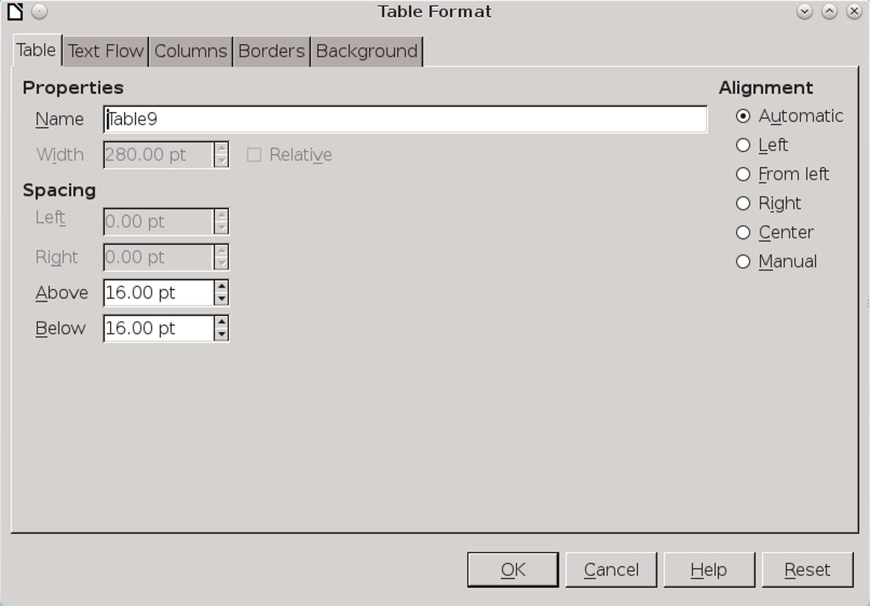
Use the Alignment and Spacing settings to place the table that will contain the graphic.
- Place the cursor in the top row of the table and click Insert > Image to add the image.
- Right-click on the image, and click Image > Wrap. Set the Top and Bottom spacing to 0 to place the image in the upper left corner of the table. In this way, you only have to move the table, and can forget about the image.
- Below the image in the top row, apply the Image Spacer paragraph style. The bottom of the image is now aligned with the bottom side of the top row.
- Using the Caption paragraph style, add the caption in the second row. Be sure that your formatting positions the caption closer to the image than to the text below the table. Do not use automatic
- captions (see “Adding automatic captions,” page 20).
Although full wrap options are unavailable with this work-around, you can use two columns, instead of two rows, and place the second column to the left or right of the image.
- Tip
If you have multiple images to place together, put one image in each row or column.

Advanced uses of frames
The basic formatting of frames is straightforward. However, some of the advanced uses of some types of frames are less obvious. This section covers some of them.
- Caution
These advanced uses may not work if frames are not staying in place.

Creating marginalia and sideheads
Once formatted, most frames are applied automatically. A major exception are marginalia – headings that are placed to the left of a body of text in a second column. Marginalia can give plenty of white space to a page, creating an inviting and original design, all of which outweigh the fact that
marginalia usually take up more pages than a more conventional layout.
Marginalia were first named during the Middle Ages, when paper was so expensive that none of it was wasted. Instead of taking notes on a new piece of paper, clerks would add comments or even drawings in the margins. In Writer, marginalia are technically not placed in the margins – they just give the appearance of being so. That means that you can often get away with a narrower left margin than usual, since marginalia leave plenty of white space.
The main disadvantage of marginalia is that each one must be added manually. However, you may think the results are worth the final effort, since marginalia make headings easier to find.
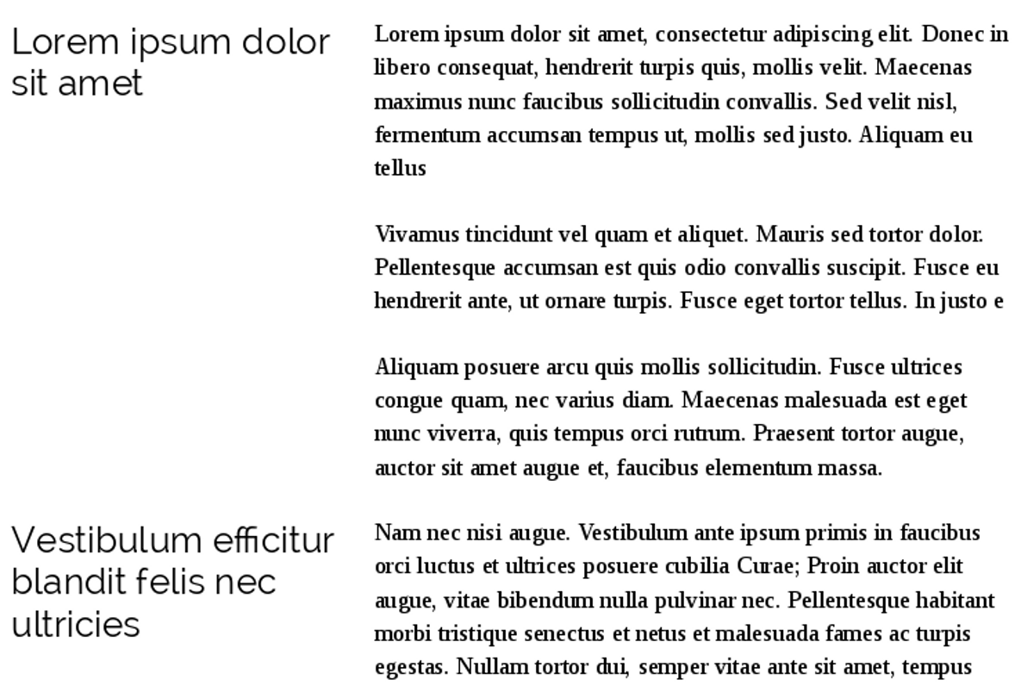
Marginalia frames used to create sideheads to replacing normal headings.

To add sideheads:
- Set Indents & Spacing > Before Text in the Text Body paragraph style so that the text will begin to the right of the marginalia frame. Be sure to leave a generous gap between the frame and the text.
- Add the main text to the document.
- Select Insert > Frame to add a text frame. Use the following format:
- Anchor it To paragraph.
- Make the frame borderless. The boundary of the frame will be visible when editing but it will not print, nor will it be visible in File > Print Preview.
- Set the frame style to Marginalia.
- Adding the frame adds the Frame Contents paragraph style. Edit the Frame Contents style to format the contents of the marginalia frames.
- Give each marginalia frame the same width as the first one.
- Add images and other objects so that they align with the start of the text.
- Tip
Marginalia frames can also be used for commentary, or even as a high-maintenance alternative to footnotes. However, for each of these purposes, the setup is the same.
- Tip
If a work-around is necessary, try using a table, adding a two-column row whenever you want a side-head, and using the From Left alignment in the second row to separate the text from the side-head.

Creating watermarks
Originally, a watermark was a logo that identified the manufacturer of paper.
Today, it refers to a faint image in the background of a page. Sometimes a modern watermark is a logo or a graphic relevant to the text, while at other times it is a short text that gives the status of the text – for instance, “Draft” or “Confidential – Your Eyes Only.”
The text and objects in the document appear over top the watermark. The Watermark frame style positions a graphic frame for use as a watermark.
To create a watermark:
- Create a frame and add an image or text to it.
- Tip
You may want to create the image in a graphics editor first, and make it semi-transparent so that the text will be more visible.
- Set the frame to use the Watermark frame style.
- On the Wrap tab, select Settings > Through and Options > In Background.
- Tip
Two other ways exist to add a watermark. The first is to add a basic frame with text or an image, and select from the right-click menu Arrange > Send to Back.
The second is to add a bitmap as the Area for a paragraph, then lighten it using the transparency tab. In this case, the watermark does not underlie the entire page.
If you need a work-around, create a transparent graphic with the dimensions of the space between the margins. Then add it to a page style as a background.
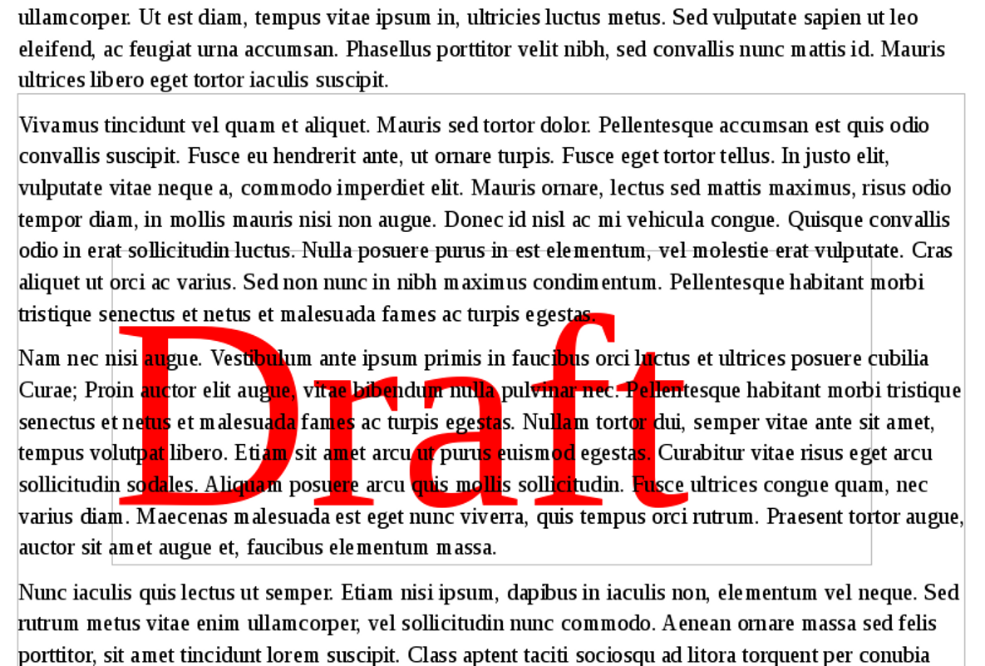
A watermark used to indicate that a document is a draft.

- Tip
Whenever possible, do not insert a watermark that you will need to edit later. If you do need to edit a watermark, select it and click Format > Arrange > Bring to Front.
Use the Navigator if you have trouble selecting the watermark or its frame.

Setting text flow between frames
In advanced layouts, using multiple text frames can be easier than using sections or columns. For example, if you create a brochure on a single piece of paper, the inside pages (pages 2-3) are two connected frames.
To have text flow from one frame to another:
- Create two or more frames using Insert > Frame, leaving both empty.
- Select the first frame.
- Click the Link Frames icon on the Frames tool bar. The tool bar displays only when a frame is selected.
- Select the target frame (the one that text will flow into from the first frame).
When the frames are connected, a blue line runs between them when one frame is selected.
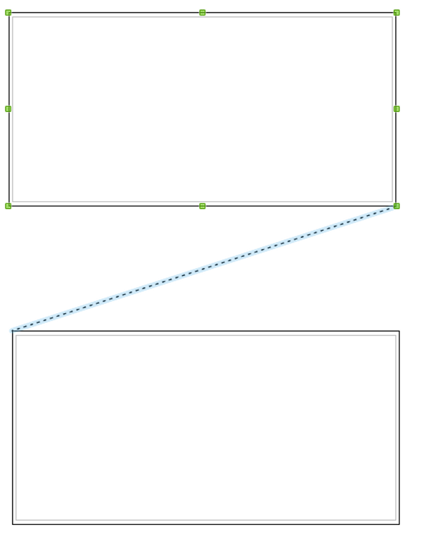
The diagonal blue line indicates that the two frames are connected. In other words, text from the first frame will flow automatically into the second frame.
- Edit the frames as needed – for example, making them borderless, or coloring the borders or background.
- Tip
If you anchor two text frames in the header of a page style, then position the frames on the page and link them, the same arrangement of frames appears on every instance of the page style.

Troubleshooting the connection of frames
If you are having trouble linking, the reason could be:
- The target frame has contents.
- The target frame is already linked from another frame. A frame can only receive text from one frame and flow into one other frame.
- The two frames are in different sections, or in different headers or footers.
- One frame is nested in the other.
- Tip
If you need a work-around, try using tables.

Working around the problems
If you think working with frame styles or images is needlessly complex – you are right. Part of that complexity is because LibreOffice offers more options than your average word processor, but the largest part is the difficulty of keeping images where you place them.

