Customer Shopping Behavior
CCDS 321 – Data Mining
Milestone 4

Contributions |  | Members
Task 1 & Task 3- Part 1 |  | Lamees Alharthi
Task 2 & Task 3- Part 2 |  | Joudi Abdulhadi
Task 2 & Task 3- Part 2 |  | Layan Abdullah
Task 1 & Task 3- Part 1 |  | Hala Alsubaie

Contents
Dataset Description 3
Data Preprocessing 3
Task 1 4
1. Evaluation Approach 4
2. Summary of Results 5
3. Evidence of Experimentation 7
Different Combination 10
Task 2 11
1. Generate 4 Segmentations 11
2. Generating Best 4 DTs 14
Task 3 17
DT For Cluster Analysis 17
Conclusion 19

Dataset Description
This dataset describes customer shopping behavior, with 5,050 observations and 17 attributes, which contains 13 categorical and 4 numerical, covering customer information in detail such as age, gender, and location. In addition, it contains purchase details such as category, item purchased, and purchase amount, as well as behavioral attributes such as subscription status, purchase frequency, and payment method.

Data Preprocessing
- Missing Data Handling
The dataset had 5,050 records. Missing values in numerical variables (Purchase Amount, Review Rating, Previous Purchases) were replaced with the mean. Missing values in the categorical variable (Size) were replaced with the mode ("M"). After imputation, all missing values were filled, no rows were deleted, and original values remained unchanged.
- Duplicate Records Handling
The dataset was checked for fully duplicate records. A total of 50 duplicate rows were found and removed. After removing duplicates, the number of rows changed from 5,050 to 5,000, while the original non-duplicate records remained unchanged.
- Inconsistent Values
The categorical variables were checked for repeated labels with the same meaning. In the Season variable, Autumn was replaced with Fall. In the Frequency of Purchases variable, Fortnightly was replaced with Bi-Weekly, and Every 3 Months was replaced with Quarterly. This made the categories more consistent before modelling.
- Outlier Detection and Removal
Outliers were checked using the Purchase Amount variable. High purchase amount values were mainly found in shirts, Shoes, and watches. These outliers were removed using filter rows. After removing 132 outliers, the final dataset contained 4,868 rows.

Task 1
Percentages: Training: 70, Test: 30, Validation: 30, Method: Stratified
Splitting Criterion | CHAID
Splitting Criterion | Entropy
Splitting Criterion | Gini
Splitting Criterion | Information gain ratio
Minimum Number of Observations per Leaf (Leaf Size) | 3.5% = 119
Minimum Number of Observations per Leaf (Leaf Size) | 6% = 204
Maximum number of branches: | 2
Maximum number of branches: | 4

Evaluation Approach
Measure | Description | Definition of Value Function | Weight | Threshold
Accuracy | Overall proportion of correct predictions made by the model on the test partition | Accuracy Score = Accuracy | 0.60 | 0.70
Simplicity | Measures tree complexity based on the size of the tree (number of leaves) | Simplicity Score = 1 – (Leaves – Min Leaves) / (Max Leaves – Min Leaves) | 0.05 | -
Lift | Measures the model's power at the 2nd decile compared to a random guess | Lift Score = (Lift Value − Min Lift) / (Max Lift − Min Lift) | 0.20 | -
Stability | Measures the consistency of the DT performance between Training and Test sets for target event Subscription status | Stability Score = 1 if MR_Training – MR_Testing <= 0.05  0, Otherwise | 0.15 | 1

Composite Performance Score Formula:
Overall Score $=0.60×V_{\text{Acc}}+0.05×V_{\text{Simp}}+0.20×V_{\text{Lift}}+0.15×V_{\text{Stab}}$

Summary of Results
DT Label/ Description | Performance Measures |  |  |  |  |  |  |  | Overall Score
DT Label/ Description | Accuracy |  | Simplicity |  | Lift |  | Stability |  | Overall Score
DT Label/ Description | % Error | Score | No of Leaves | Score | Value | Score | Score | Justification | Overall Score
DT CHAID 3.5% 2 | 23.15% | 0.7685 | 2 | 1 | 1.8918 | 0 | 1 | MR difference is 0.0048, below threshold of 0.05. Model is stable. | 0.6611
DT1 CHAID 3.5% 4 | 23.15% | 0.7685 | 5 | 0.6 | 1.8918 | 0 | 1 | MR difference is 0.0048, below threshold of 0.05. Model is stable. | 0.6411
DT2 CHAID 6% 2 | 23.15% | 0.7685 | 2 | 1 | 1.8918 | 0 | 1 | MR difference is 0.0048, below threshold of 0.05. Model is stable. | 0.6611
DT3 CHAID 6% 4 | 23.15% | 0.7685 | 2 | 1 | 1.8918 | 0 | 1 | MR difference is 0.0048, below threshold of 0.05. Model is stable. | 0.6611
DT4 Entropy 3.5% 2 | 23.68% | 0.7632 | 6 | 0.3 | 1.9743 | 0.54 | 1 | MR difference is 0.0238, below threshold of 0.05. Model is stable. | 0.730
DT5 Entropy 3.5% 4 | 23.68% | 0.7632 | 10 | 0 | 2.0135 | 0.54 | 1 | MR difference is 0.0238, below threshold of 0.05. Model is stable. | 0.716
DT6 Entropy 6% 2 | 23.15% | 0.7685 | 5 | 0.6 | 1.9743 | 0.54 | 1 | MR difference is 0.0090, below threshold of 0.05. Model is stable. | 0.749
DT7 Entropy 6% 4 | 23.15% | 0.7685 | 5 | 0.6 | 2.0444 | 1 | 1 | MR difference is 0.0090, below threshold of 0.05. Model is stable. | 0.841
DT8  GINI 3.5% 2 | 23.68% | 0.7632 | 7 | 0.3 | 1.9743 | 0.540 | 1 | MR difference is 0.0238, below threshold of 0.05. Model is stable. | 0.730
DT9  GINI 3.5% 4 | 23.68% | 0.7632 | 10 | 0 | 2.0135 | 0.797 | 1 | MR difference is 0.0238, below threshold of 1. Model is stable. | 0.767
DT10  GINI 6% 2 | 23.15% | 0.7685 | 5 | 0.6 | 1.9743 | 0.540 | 1 | MR difference is 0.0090, below threshold of 0.05. Model is stable. | 0.749
DT11  GINI 6% 4 | 23.15% | 0.7685 | 5 | 0.6 | 2.0444 | 1 | 1 | MR difference is 0.0090, below threshold of 0.05. Model is stable. | 0.841
DT12  INFO GAIN 3.5% 2 | 23.68% | 0.7632 | 7 | 0.3 | 1.9743 | 0.540 | 1 | MR difference is 0.0238, below threshold of 0.05. Model is stable. | 0.730
DT13  INFO GAIN 3.5% 4 | 23.68% | 0.7632 | 7 | 0.3 | 1.9743 | 0.540 | 1 | MR difference is 0.0238, below threshold of 0.05. Model is stable. | 0.730
DT14  INFO GAIN 6% 2 | 23.15% | 0.7685 | 5 | 0.6 | 1.9743 | 0.540 | 1 | MR difference is 0.0090, below threshold of 0.05. Model is stable. | 0.749
DT15  INFO GAIN 6% 4 | 23.15% | 0.7685 | 5 | 0.6 | 1.9743 | 0.540 | 1 | MR difference is 0.0090, below threshold of 0.05. Model is stable. | 0.749

The decision trees were evaluated using performance measures such as Accuracy, Simplicity, Lift, and Stability. The Lift values show that Entropy and Gini have the highest Lift value and CHAID has a lower value. However, the DT7 and DT11 get the best overall score of 0.841.

Evidence of Experimentation

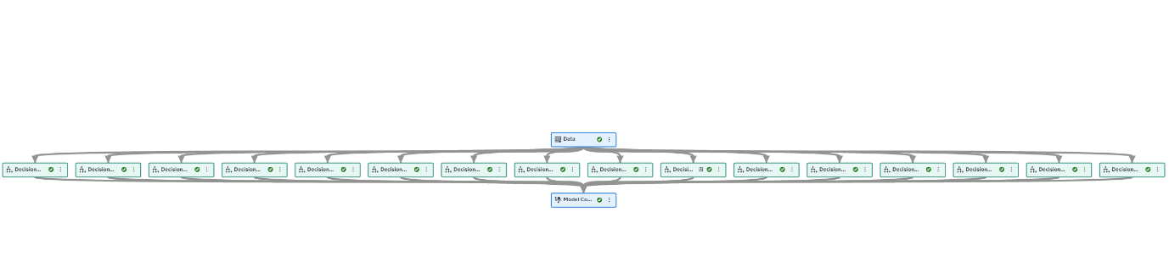

Figure 1 - Process Flow Diagram

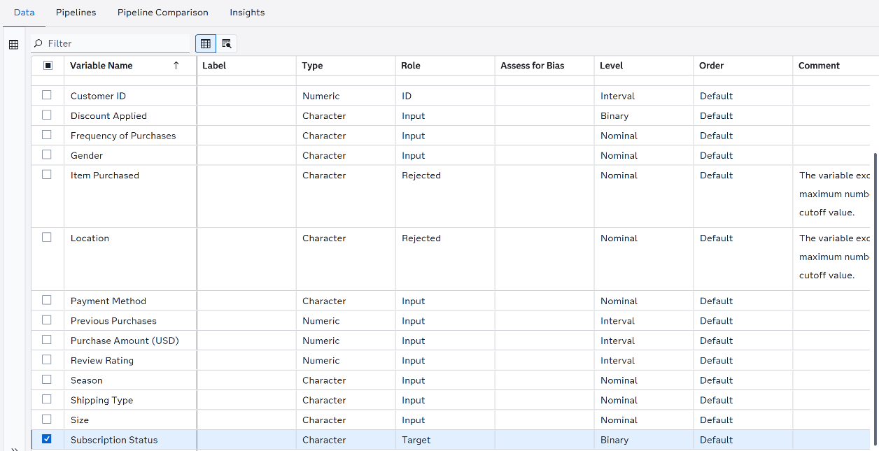
Figure 2 - Variables Tab

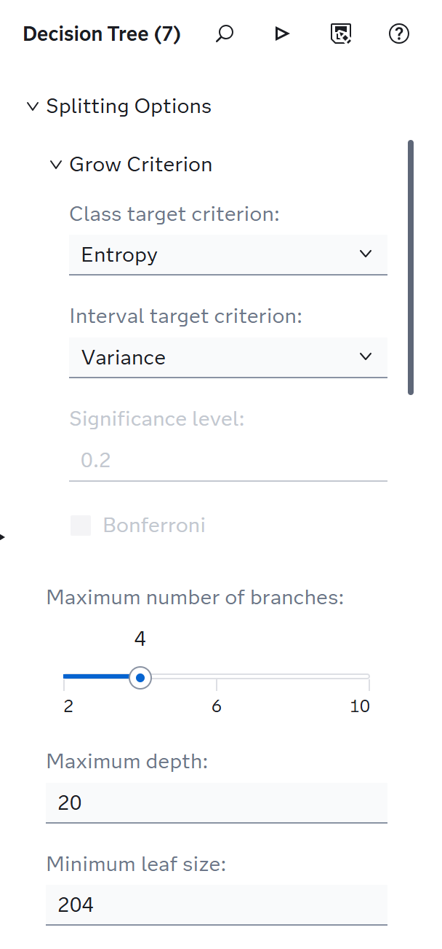
Figure 3 - Tree Node Parameters

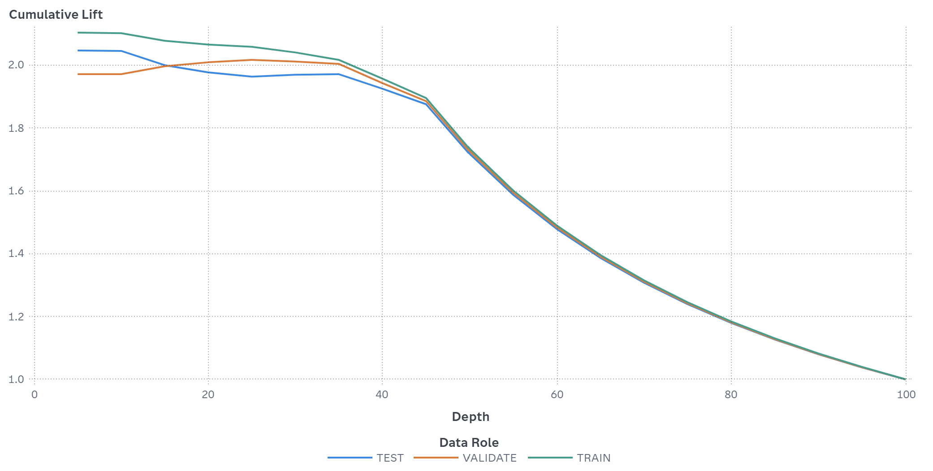
Figure 4 - Non-Cumulative %Lift Chart of Decision Tree 7

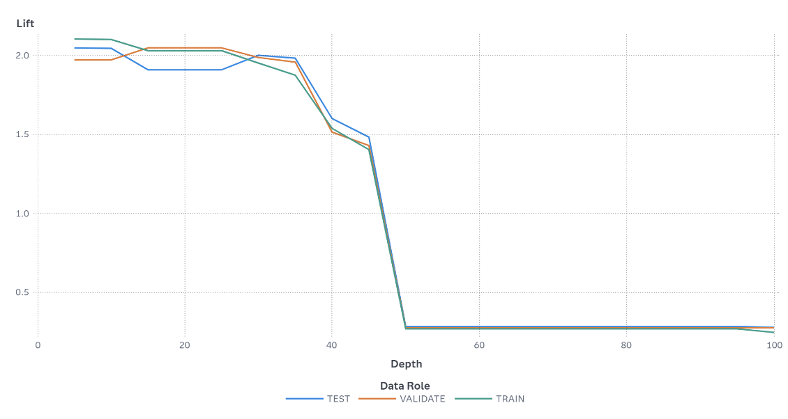

Figure 5 – Lift of Decision tree 7

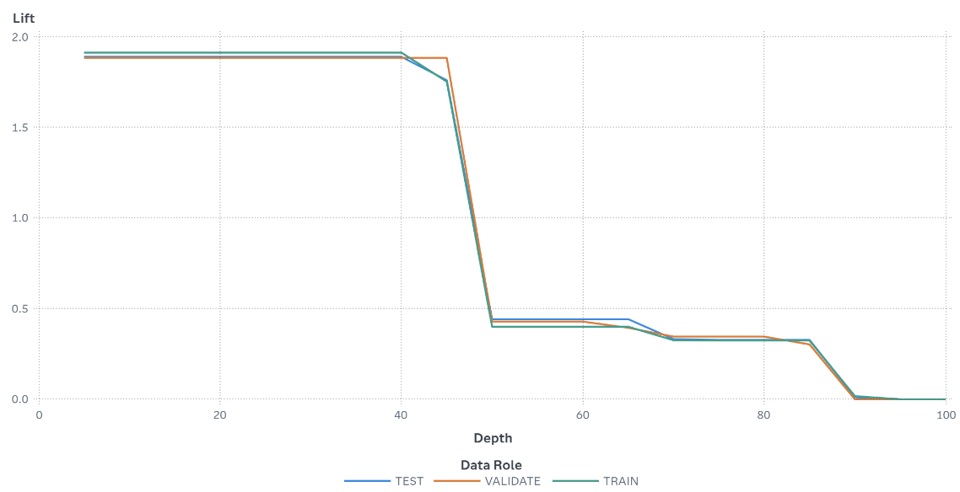

Figure 6 - Lift of Decision Tree 1

The lift chart above compares DT1 and DT7 for the target event Subscription Statues. At the 2nd decile (depth of 20%), in DT1 the TRAIN partition has a Lift of 1.91, meaning there are 1.91 times more subscribers than random selection. Meanwhile, DT7 The TRAIN partition has a Lift of 2.1 at the same percentile, meaning there are 2.1 times more subscribers captured. In addition, DT7 shows consistent and stable Lift performance compared to DT1, which DT7 is a more stable model than DT1.

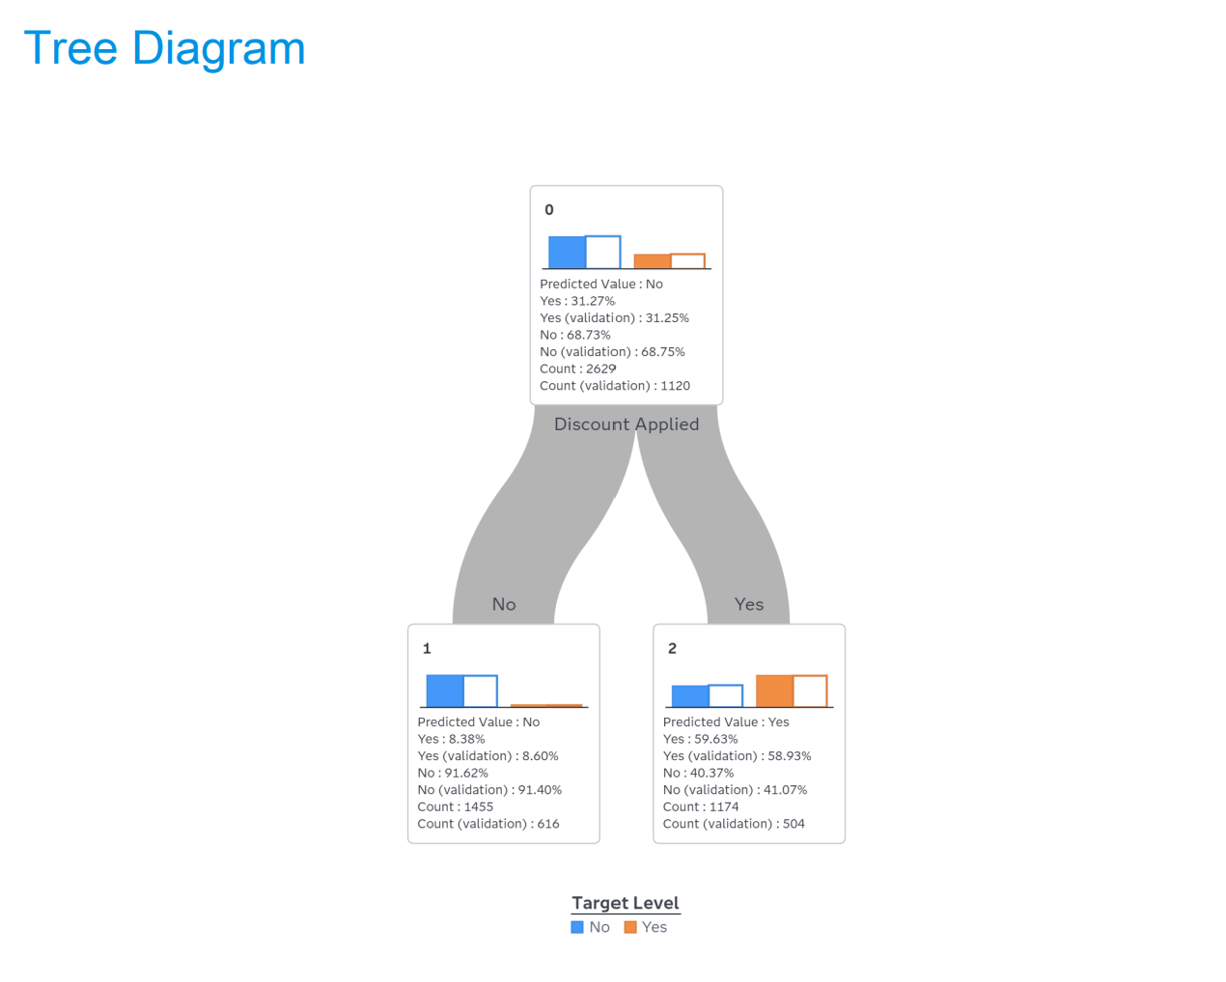
Figure 7 - Decision Tree Diagram 7

Different Combination
To find a better combination, a custom Decision Tree was built using:
- Splitting Criterion: GINI
- Maximum Number of Branches: 2
- Maximum Tree Depth: 4
- Minimum Leaf Size: 100
After calculating all metrics according to the defined value functions, we obtained the following results:
- Accuracy Score = 0.7694
- Simplicity Score = 0.9688
- Lift Score = 1.494
- Stability Score = 1
Overall Score = (0.60 x 0.7694) + (0.05 x 0.9688) + (0.20 x 1.0) + (0.15 x 1.0) = 0.860
Therefore, after applying this new combination, we achieved a better overall score (0.860) compared to the previous best model (0.841), making this the best performing model overall.

Task 2

Generate 4 Segmentations
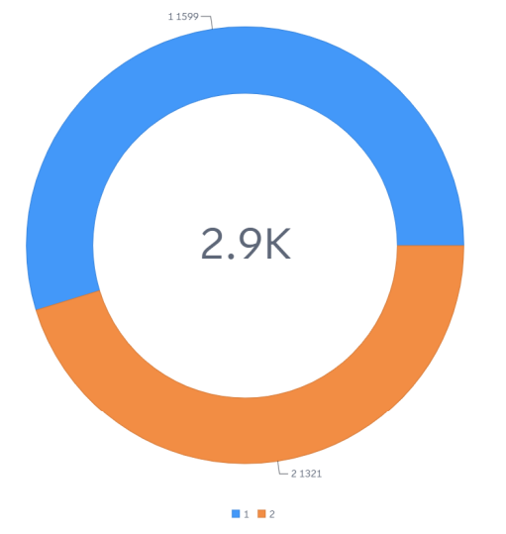
km_2 Segmentation:

Cluster | Size
Cluster 1 | 1599
Cluster 2 | 1321

The km_2 segmentation divided the customers into two clusters. Cluster 1 contains 1599 customers, Cluster 2 contains 1321 customers. The clusters are relatively balanced in size.

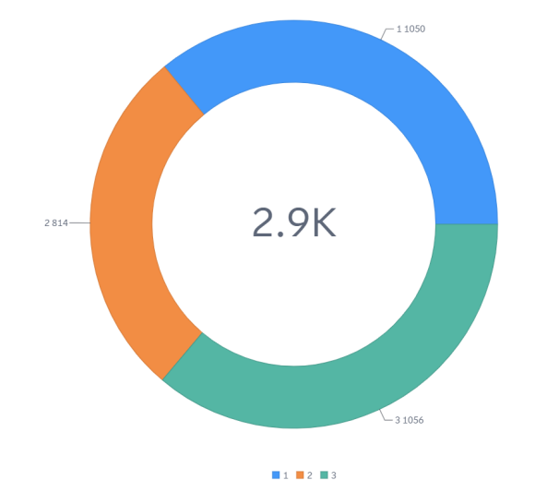
km_3 Segmentation:

Cluster | Size
Cluster 1 | 1050
Cluster 2 | 814
Cluster 3 | 1056

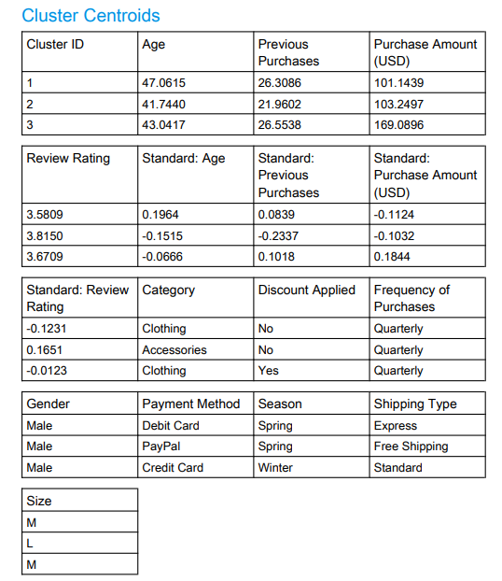

all clusters are more than 10% of the dataset, so there is no outlier cluster, and the smallest cluster is Cluster 2 with 814 customers, and it is greater than 10% of the dataset.

Variable | Cluster 1 | Cluster 2 | Cluster 3
Age | Highest | Lowest | Medium
Previous Purchases | High | Low | High
Purchase Amount | Low | Low | Highest
Review Rating | Medium | Highest | Medium
Category | Clothing | Accessories | Clothing

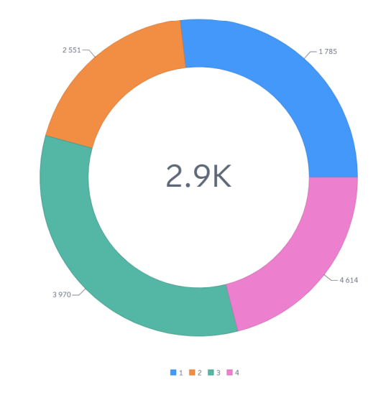
km_4 Segmentation:

Cluster | Size
Cluster 1 | 785
Cluster 2
  551
Cluster 3 | 970
Cluster 4 | 614

The km_4 divided the customers into four clusters with different cluster sizes

km_5 Segmentation:
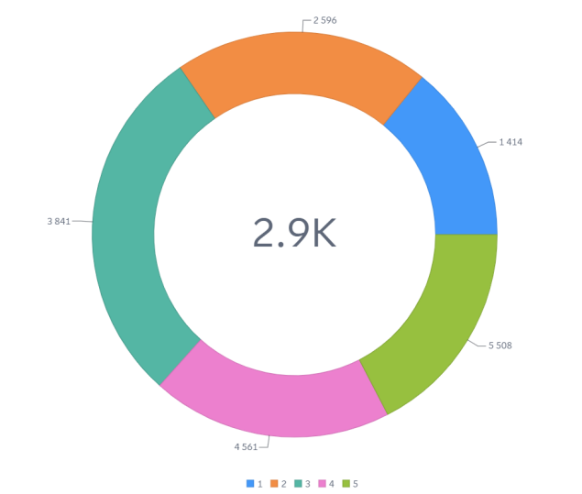
Cluster | Size
Cluster 1
  414
Cluster 2
  596
Cluster 3
  841
Cluster 4 | 561
Cluster 5 | 508

The km_5 divided the customers into five clusters with different cluster sizes.
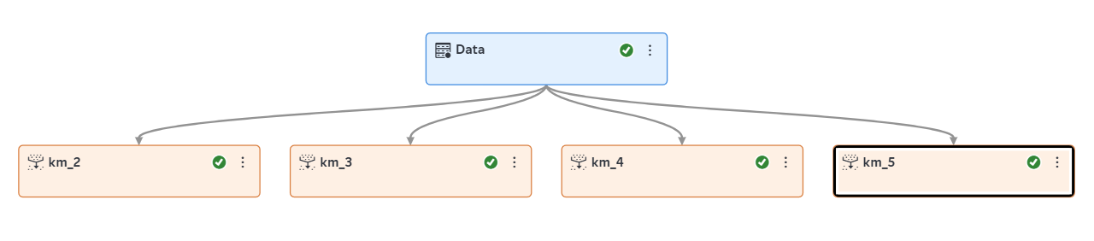

Segmentation Label | Number of Clusters | Cluster Sizes | Size of Smallest Cluster | Outlier
km_2 | 2 | 1599, 1321 | 1321 | No
km_3 | 3 | 1050, 814, 1056 | 814 | No
km_4 | 4 | 785, 551, 970, 614 | 551 | No
km_5 | 5 | 414, 596, 841, 561, 508 | 414 | No

Generating Best 4 DTs
Data Partition Node: | Percentages | Cross Validation 10 folds
Data Partition Node: | Method | Stratified
Tree Node | Splitting Criterion | CHAID
Tree Node | Splitting Criterion | Entropy
Tree Node | Splitting Criterion | Gini
Tree Node | Splitting Criterion | Information gain ratio
Tree Node | Minimum Number of  Observations per Leaf | 30% of smallest cluster = 244 observations
Tree Node | Maximum number of branches: | 2
Tree Node | Maximum number of branches: | 4

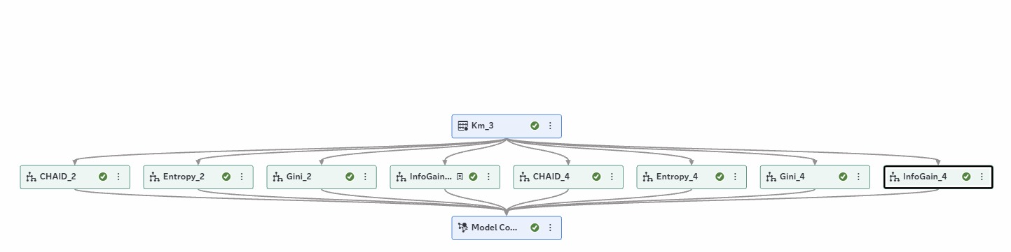 Figure 8 - Decision Tree and Model Comparison Pipeline

Decision Tree Comparison
- The decision trees were compared using accuracy and simplicity.
- Accuracy was weighted as 0.60 and simplicity was weighted as 0.40.
- The number of leaves after pruning was used to measure simplicity.

Decision Tree (CHAID_2):
Accuracy Score = 0.9466
Simplicity Score = 1.0000
Overall Score = 0.9680
Decision Tree (Entropy_2):
Accuracy Score = 0.9466
Simplicity Score = 0.5000
Overall Score = 0.7680
Decision Tree (Gini_2):
Accuracy Score = 0.9466
Simplicity Score = 1.0000
Overall Score = 0.9680
Decision Tree (InfoGain_2):
Accuracy Score = 0.9466
Simplicity Score = 0.7500
Overall Score = 0.8680
Decision Tree (CHAID_4):
Accuracy Score = 0.9466
Simplicity Score = 0.7500
Overall Score = 0.8680
Decision Tree (Entropy_4):
Accuracy Score = 0.9466
Simplicity Score = 0.0000
Overall Score = 0.5680
Decision Tree (Gini_4):
Accuracy Score = 0.9466
Simplicity Score = 0.2500
Overall Score = 0.6680
Decision Tree (InfoGain_4):
Accuracy Score = 0.9466
Simplicity Score = 0.7500
Overall Score = 0.8680

Based on the overall score comparison, the best-performing models are CHAID_2 and Gini_2, both achieving the highest overall score of 0.9680. These models had the lowest number of leaves while keeping the same accuracy score as the other models. This shows that CHAID_2 and Gini_2 gave a good balance between accuracy and simplicity

Variable | Cluster_0 | Cluster_1 | Cluster_2 | Explanation
Previous Purchases | Medium | Low | High | This was the most important variable. Cluster 2 has the highest previous purchases, while Cluster 1 has the lowest.
Review Rating | Low | High | Medium | Cluster 1 has the highest review rating, while Cluster 0 has the lowest.
Purchase Amount (USD) | Low | Medium | High | Cluster 2 has the highest purchase amount, while Cluster 0 has the lowest.

s
InfoGain_2, Entropy_2, Gini_2, and InfoGain_4 achieved the highest overall score of 0.8503. These models gave a good balance between accuracy, lift, simplicity, and stability. The most important variables were Previous Purchases, Review Rating, and Purchase Amount. These variables helped separate the customer clusters based on shopping behavior
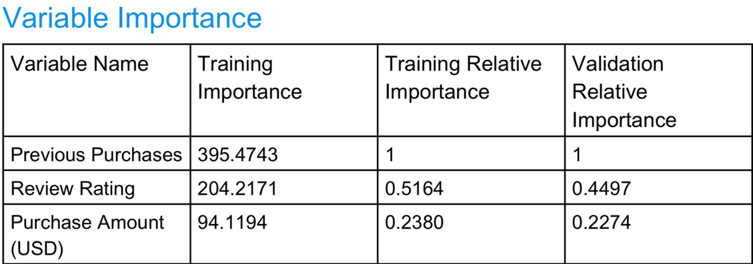
Figure 9 - Variable Importance of the Best Decision Tree

Task 3
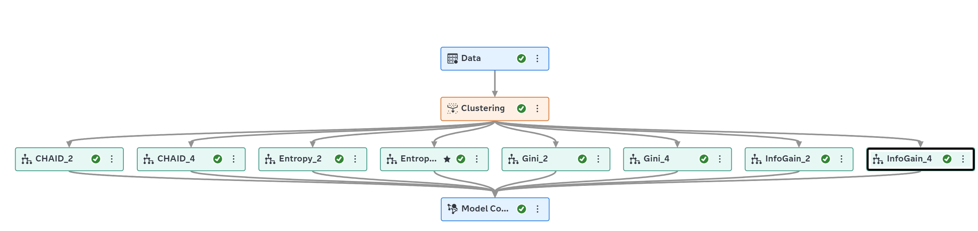
Figure 8 - Decision Tree Cluster Flow
We generated eight different decision tree models to compare performance under varying numbers of branches. This was done because the number of branches differs between the models (specifically 2 and 4 branches), and a minimum leaf size of 244 observations was used.

DT For Cluster Analysis
Decision Tree(CHAID_2):

Accuracy Score = 0.7864
Simplicity Score = 1.0
Lift Score = 0.0
Stability Score = 1
Overall Score = 0.6718

Decision Tree (CHAID_4):

Accuracy Score = 0.7864
Simplicity Score = 1.0
Lift Score = 0.0
Stability Score = 1
Overall Score = 0.6718

Decision Tree (Entropy_2):

Accuracy Score = 0.7782
Simplicity Score = 0.6667
Lift Score = 1.0
Stability Score = 1
Overall Score = 0.8503

Decision Tree (Entropy_4):

Accuracy Score = 0.7782
Simplicity Score = 0.0
Lift Score = 0.5426
Stability Score = 1
Overall Score = 0.7254

Decision Tree (Gini_2):

Accuracy Score = 0.7782
Simplicity Score = 0.6667
Lift Score = 1.0
Stability Score = 1
Overall Score = 0.8503

Decision Tree (Gini_4):

Accuracy Score = 0.7782
Simplicity Score = 0.0
Lift Score = 0.5426
Stability Score = 1
Overall Score = 0.7254

Decision Tree (InfoGain_2):

Accuracy Score = 0.7782
Simplicity Score = 0.6667
Lift Score = 1.0
Stability Score = 1
Overall Score = 0.8503

Decision Tree (InfoGain_4):

Accuracy Score = 0.7782
Simplicity Score = 0.6667
Lift Score = 1.0
Stability Score = 1
Overall Score = 0.8503

Based on the overall score comparison, the best-performing models are Decision Tree (7), Decision Tree (2), Decision Tree (4), and Decision Tree (6), all achieving the highest overall score of 0.8503, indicating a strong balance between accuracy, lift, simplicity, and stability.

Comparison with Task 2
In Task 2, all DT achieved the same accuracy of 0.9466.In Task 3, CHAID_2 and CHAID_4 achieved the highest accuracy of 0.7864.so,This shows that the DTs in Task 2 achieved higher accuracy than the DT from Task 3.
Task | Models | Accuracy Score | Result
Task 2 | All DT | 0.9466 | High accuracy
Task 3 | CHAID_2, CHAID_4 | 0.7864 | High accuracy

Conclusion
In conclusion, the project aims to implement data mining techniques to show the customer behaviour based on Subscription status. In task 1, we generated sixteen decision trees with different splitting criteria and leaf sizes. The best decision trees are DT7 and DT11, which achieved the highest overall score of 0.841. In task 2, customer segmentation was generated using K-Means clustering with different cluster numbers. The clusters were compared based on customer behavior, purchase amount, and review rating. The KM_3 model gave balanced clusters and helped identify different shopping behavior patterns without generating outlier clusters. Finally, in task 3, We created four segmentations and focused on KM_3 to describe the clusters. The results showed that the clusters were balanced, and no outlier was found. Also, Task 2 gave higher accuracy than Task 3. eight trees were generated based on the cluster number and compared using the combination function, the best-performing models are Decision Tree (7), Decision Tree (2), Decision Tree (4), and Decision Tree (6), all achieving the highest overall score of 0.8503.

