Title Is Here

Author Name

A thesis submitted for the degree of  
YOUR DEGREE NAME

The Australian National University

May 2012

© Author Name 2011

Except where otherwise indicated, this thesis is my own original work.

Author Name

2 May 2012

Draft Copy - 2 May 2012

Draft Copy - 2 May 2012

Acknowledgments

Who do you want to thank?

**vii**

Draft Copy - 2 May 2012

Abstract

Put your abstract here.

**ix**

Contents

**Acknowledgments vii**

**Abstract ix**

1. **Introduction 1**
   1. Thesis Statement 1
   2. Introduction 1
   3. Thesis Outline 1
2. **Background and Related Work 3**
   1. Motivation 3
   2. Related work 3
   3. Summary 3
3. **Design and Implementation 5**
   1. Smart Design 5
   2. Summary 5
4. **Experimental Methodology 7**
   1. Software platform 7
   2. Hardware platform 7
5. **Results 9**
   1. Direct Cost 9
   2. Summary 9
6. **Conclusion 11**
   1. Future Work 11

**Bibliography 13**

List of Figures

1. Hello world in Java and C  8
2. The cost of zero initialization 10
3. Processors used in our evaluation  7

Introduction

1. Thesis Statement

I believe A is better than B.

1. Introduction

Put your introduction here. You could use \fix{ABCDEFG.} to leave your comments, see the box at the left side.

You have to rewrite your thesis!!!

1. Thesis Outline

How many chapters you have? You may have Chapter 2, Chapter 3, Chapter 4, Chapter 5, and Chapter 6.

Background and Related Work

At the begging of each chapter, please introduce the motivation and high-level pic­ture of the chapter. You also have to introduce sections in the chapter.

Section 2.1 xxxx.

Section 2.2 yyyy.

1. Motivation
2. Related work

You may reference other papers. For example: Generational garbage collection [Lieber](#bookmark138)­[man and Hewitt, 1983;](#bookmark138) [Moon;](#bookmark139) [Ungar, 1984] is perhaps the single most important advance in garbage collection since the first collectors were developed in the early 1960s. (doi: "doi" should just be the doi part, not the full URL, and it will be made to link to dx.doi.org and resolve. shortname: gives an optional short name for a conference like PLDI '08.)

1. Summary

Summary what you discussed in this chapter, and mention the story in next chapter. Readers should roughly understand what your thesis takes about by only reading words at the beginning and the end (Summary) of each chapter.

Design and Implementation

Same as the last chapter, introduce the motivation and the high-level picture to read­ers, and introduce the sections in this chapter.

* 1. Smart Design
  2. Summary

Same as the last chapter, summary what you discussed in this chapter and be the bridge to next chapter.

Experimental Methodology

1. Software platform
2. Hardware platform

Table 4.1 shows how to include tables and Figure 4.1 shows how to include codes.

|  |  |  |  |
| --- | --- | --- | --- |
| Architecture | Pentium 4 | Atom D510 | i7-2600 |
| Model | P4D 820 | Atom D510 | Core i7-2600 |
| Technology | 90nm | 45nm | 32nm |
| Clock | 2.8GHz | 1.66GHz | 3.4GHz |
| Cores x SMT | 2x2 | 2x2 | 4x2 |
| L2 Cache | 1MB x 2 | 512KB x 2 | 256KB x 4 |
| L3 Cache | none | none | 8MB |
| Memory | 1GB DDR2-400 | 2GB DDR2-800 | 4GB DDR3-1066 |

Table 4.1: Processors used in our evaluation.

*Experimental Methodology*

1. **int** main(**void**)
2. {
3. printf("Hello_1World\n");
4. **return** 0;
5. }

(a)

1 **void** main(String[] args)

2{

1. System. out. println( "HellO-.World");
2. }

(b)

Figure 4.1: Hello world in Java and C.

**Chapter 5**

Results

1. Direct Cost

Here is the example to show how to include a figure. Figure 5.1 includes two subfigures (Figure 5.1(a), and Figure 5.1(b));

1. Summary

Zeroed memory/burst trans Zeroing cycles

Core2 Quad i

Phenom II i

i7-2600

0.45

0.4

0.35

0.3

0.25

0.2

0.15

0.1

0.05

0

Core2 Quad i

(b) BytesZeroed / BytesBurstTransactionsTransferred

(a) Fraction of cycles spent on zeroing

Figure 5.1: The cost of zero initialization

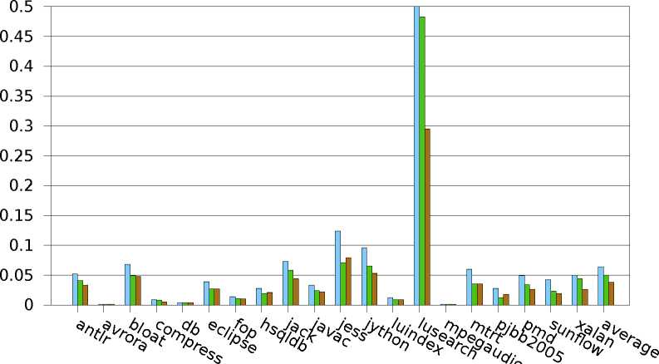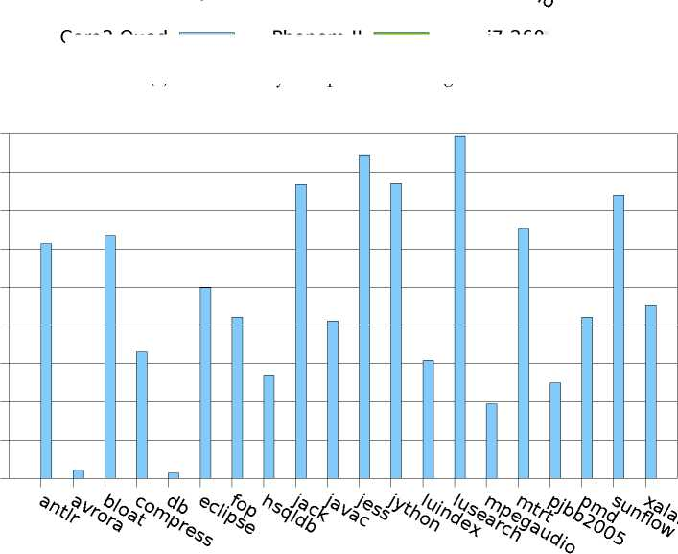

**Chapter 6**

Conclusion

Summary your thesis and discuss what you are going to do in the future in Sec­tion 6.1.

6.1 Future Work

Good luck.

Bibliography

Lieberman, H. and Hewitt, C., 1983. A real-time garbage collector based on the lifetimes of objects. *Communications of the ACM,* 26, 6 (Jun. 1983), 419-429. [doi:](http://dx.doi.org/10.1145/358141.358147) [10.1145/358141.358147.](http://dx.doi.org/10.1145/358141.358147) (cited on page 3)

Moon, D. A., 1984. Garbage collection in a large LISP system. In LFP '84: *Proceedings of the 1984 ACM Symposium on LISP and Functional Programming* (Austin, Texas, USA, Aug. 1984), 235-246. ACM, New York, New York, USA. [doi:10.1145/800055.](http://dx.doi.org/10.1145/800055.802040) [802040.](http://dx.doi.org/10.1145/800055.802040) (cited on page 3)

Ungar, D., 1984. Generation scavenging: A non-disruptive high performance stor­age reclamation algorithm. In SDE 1: *Proceedings of the 1st ACM SIGSOFT/SIG- PLAN Software Engineering Symposium on Practical Software Development Environ­ments* (Pittsburgh, Pennsylvania, USA, Apr. 1984), 157-167. ACM, New York, New York, USA. [doi:10.1145/800020.808261.](http://dx.doi.org/10.1145/800020.808261) (cited on page 3)