 | Unit 17  Ridge Way  Donibristle Industrial Estate  Dunfermline, Fife  KY11 9JU  Tel. 0131 459 8800  Fax 0131 479 8321
OpenEstate AuthAPI
Component Specification

Change details (for historical detail refer to previous issues)
Date | Detail | Author
20/06/04 | Initial creation | D Polishchuk
03/09/04 | Rework | D Ivanov

Copyright in the whole and every part of this document/drawing belongs to Ingenico UK. It may not be used, sold, transferred, copied or reproduced in whole or in part in any manner or form except with the prior written consent of Ingenico UK or as permitted by applicable law. Any copies or reproduction of this document/drawing (in whole or in part) made by any method must include a copy of this legend.
This document is subject to security of information rules as defined within DTI document URN 96/938, and fully described in Ingenico UK document 5990-9100.
Any copies of this drawing/document made by any method must also include a copy of this legend.
This document is supplied without liability for errors or omissions

Additional Contact Information:
Dmitry Polishchuk e-mail: dp@nemesis.ingenico.co.uk
di@nemesis.ingenico.co.uk
Security status: Unrestricted / Confidential / Highly Confidential
Distribution control: Unrestricted / Internal only / External by Authorisation only

Contents
0 General Idea 3
1 Abbreviations and Terminology 3
2 References 3
3 Document structure 4
4 Introduction 4
5 Component overview 4
6 Standards 5
6.1 APACS Standard 30/40/60 5
6.2 ISO-8583 5
7 Requirements 5
7.1 Overall understanding 5
7.2 Common Requirements 5
7.2.1 Standards Conformance (STD) 5
7.2.2 Documentation (DOCS) 6
7.3 Payment API requirements 6
7.3.1 Design Requirements (DSGN) 6
7.3.2 Usability Requirements (USBL) 6
7.3.3 Portability (PORT) and Scalability (SCAL) Requirements 6
7.4 Payment API implementation requirements 7
7.4.1 Design Requirements (DSGN) 7
7.4.2 Usability Requirements (USBL) 7

Abstract
This document underlines the functional context and the technical specification of OpenEstate Gateway Host component (hereinafter the OEGW) within OpenEstate project.
Software developers responsible for delivering the source code, presumably will be using the specification as guidelines.
It may also be of assistance for other stakeholders involved in the OpenEstate project development.
- General Idea
The OpenEstate Gateway (OEGW) is a further evolution of the IRPC Gateway which had been successfully tested and proven previous Ingenico UK design considerations. So matter fact, OEGW developers must re-use the IRPC architecture and technical solutions as much as possible.
- Abbreviations and Terminology
All abbreviations and terms are outsourced into the global OpenEstate project glossary Error: Reference source not found.
- References
Ref | Document Title | Document Identifier
 | OpenEstate Architecture document | oe/docs/OpenEstateArchitecture.doc
 | OpenEstate Project Glossary | oe/docs/oe-glossary.txt
- Document structure
Section Introduction describes component purpose and provides generic requirements for it.
Section Component overview provides vision of the components and describes the position of the components in the whole architecture. Also the section describes future vision of the components.
The requirements follow the component overview chapter.
- Introduction
Payment component consists of the following parts:
- Payment API
- Payment dummy implementation
Payment API declares interface for any implementation of Payment component.
Payment dummy implementation needs only to emulate the interaction between TML Payment Application and Acquirer Host.
- Component overview
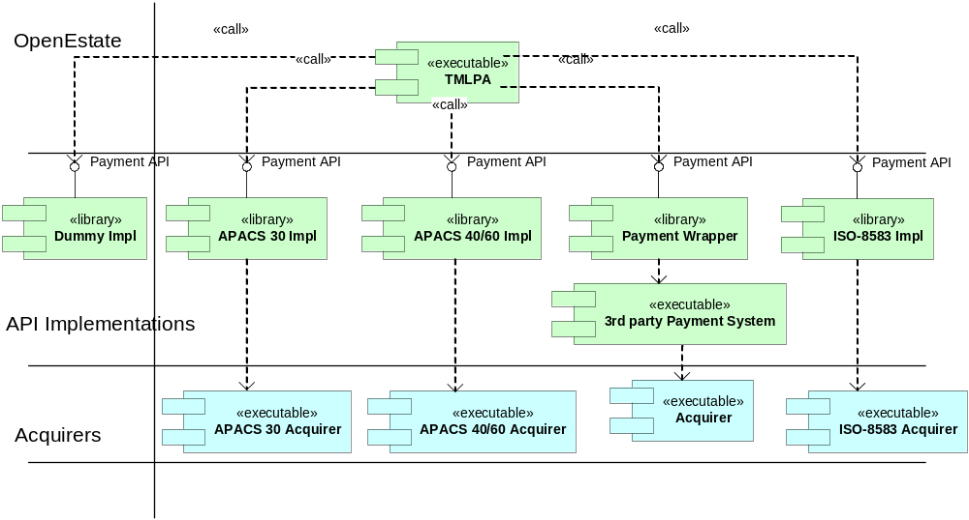
Figure 1 component diagram

TMLPA is a Terminal Markup Language Payment Application – dynamic part of it. In OpenEstate v1.0 it is web application implemented on Servlet technology that listens for terminal payment requests.
The following is to be implemented in OpenEstate v1.0 corresponding to payment authorisation:
- Payment API
- Dummy implementation of payment API
- Standards
  - APACS Standard 30/40/60
UK APACS payment standards should be followed as closely as possible.
  - ISO-8583
It should be taking into account that in the next releases of OpenEstate the support of ISO-8583 may be required.
- Requirements
  - Overall understanding
It is important to note that the developers should be closely familiar with "Error: Reference source not found OpenEstate Architecture".
Deep knowledge of APACS standards 30,40,60 is required for the implementor.
  - Common Requirements
    - Standards Conformance (STD)
      - OE-010-STD
Payment API and Payment API implementations must provide to end-user the functionality of APACS Standard 30,40,60 protocols except the restrictions mentioned below.
      - OE-020-STD
For the simplification purposes there are a few restrictions of the APACS implementation.
The following APACS Std 30 transactions are not supported:
APACS Std 30, section 2.2.2:
- “2.2.2.2 Authorisation of A Cash Advance”
- “2.2.2.4 Authorisation of An Account Funding”
- “2.2.2.7 Authorisation of A Cheque Guarantee”
Transaction types enumerated in the section 2.2.2 of APACS Std 30, but not listed above must be supported.
    - Documentation (DOCS)
      - OE-030-DOCS
Source code distribution package of the Payment API and Payment API implementation includes the set of development documentation:
- Release notes
- Configuration control document
- Architecture document or HLD (High Level Design) document
  - Payment API requirements
    - Design Requirements (DSGN)
      - OE-040-DSGN
Payment API must hide the differences between various APACS standards.
      - OE-050-DSGN
Payment API must provide easily extend/change data messages that go between TMLPA and Payment engine.
      - OE-060-DSGN
Payment API must provide data messages that conform to APACS functionality the component must support (see requirement ii).
    - Usability Requirements (USBL)
      - OE-070-USBL
Payment API must contain set of typical errors (exceptions in java language) that are reflect to corresponded APACS error situations.
    - Portability (PORT) and Scalability (SCAL) Requirements
      - OE-080-PORT
Payment API and Payment API Implementation components must comply with the portability and scalability requirements given in "Error: Reference source not found OpenEstate Architecture document".
      - OE-090-PORT
Payment API and Payment API Implementation must run on JDK 1.4 (or higher) and be portable among the platform where the JDK 1.4 can be installed.
  - Payment API implementation requirements
    - Design Requirements (DSGN)
      - OE-100-DSGN
Payment API dummy implementation must be able to process several requests simultaneously.
    - Usability Requirements (USBL)
      - OE-110-USBL
Payment API dummy implementation must be able to emulate work of Payment engine and interaction with Acquirer Host via delay (the value of delay should be configured via configuration file).
      - OE-120-USBL
Payment API dummy implementation must be able to emulate work of Payment engine in part of replying to authorisation requests via random procedure. The results of authorisation requests must be as positive as well as negative.

