Consent Form (User Testing)

Title of Project: Navigation within a parameter space for creative activity

Name of Project Student: Libby Athill

Initial the box if you agree with the statement to the left
1 | I confirm that I have read and understand the information sheet dated [11/04/24] explaining the above project and I have had the opportunity to ask questions about the project. | X  X  X  X  X
2 | I understand that my participation is voluntary and that I am free to withdraw at any time without giving any reason and without there being any negative consequences. In addition, should I not wish to answer any particular question or questions, I am free to decline. I can contact Libby Athill at sc21la@leeds.ac.uk if I have further questions.
3 | I understand that my responses will be kept strictly confidential.  I understand that my name will not be linked with the project materials, and I will not be identified or identifiable in the report or reports that result from the project.
4 | I agree for the data collected from me to be used in future research.
5 | I agree to take part in the above project and will inform the project student should my contact details change.

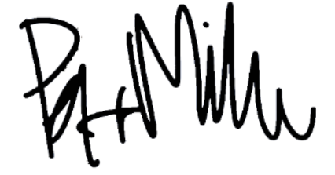
Petr K. Milev 11/04/24
Name of participant Date Signature
(or legal representative)

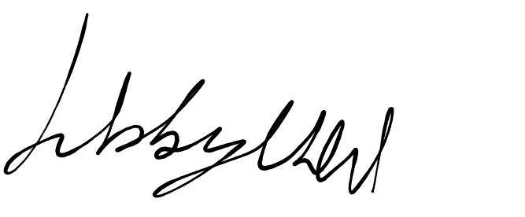
Libby Athill 11/04/24
Project student Date Signature
To be signed and dated in presence of the participant

