Assignment

MAD

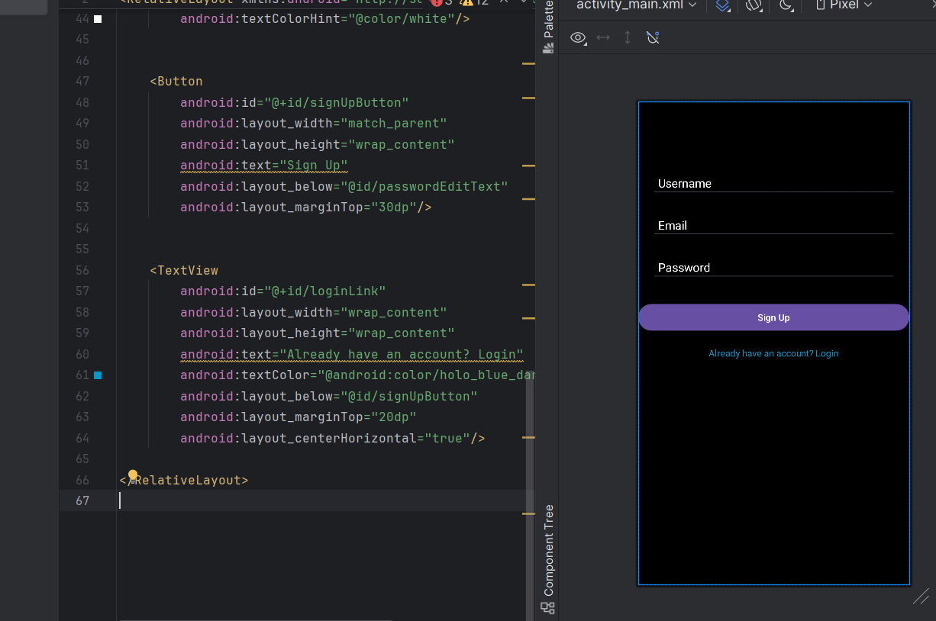

<?xml version="1.0" encoding="utf-8"?>  
<RelativeLayout xmlns:android="http://schemas.android.com/apk/res/android"  
 android:layout_width="match_parent"  
 android:layout_height="match_parent"  
 android:background="@android:color/black">  
  
 <EditText  
 android:id="@+id/usernameEditText"  
 android:layout_width="match_parent"  
 android:layout_height="wrap_content"  
 android:hint="Username"  
 android:layout_marginTop="100dp"  
 android:layout_marginStart="20dp"  
 android:layout_marginEnd="20dp"  
 android:padding="10dp"  
 android:inputType="text"  
 android:textColorHint="@color/white"/>  
  
 <EditText  
 android:id="@+id/emailEditText"  
 android:layout_width="match_parent"  
 android:layout_height="wrap_content"  
 android:hint="Email"  
 android:layout_below="@id/usernameEditText"  
 android:layout_marginTop="20dp"  
 android:layout_marginStart="20dp"  
 android:layout_marginEnd="20dp"  
 android:padding="10dp"  
 android:inputType="textEmailAddress"  
 android:textColorHint="@color/white"/>  
  
  
 <EditText  
 android:id="@+id/passwordEditText"  
 android:layout_width="match_parent"  
 android:layout_height="wrap_content"  
 android:hint="Password"  
 android:layout_below="@id/emailEditText"  
 android:layout_marginTop="20dp"  
 android:layout_marginStart="20dp"  
 android:layout_marginEnd="20dp"  
 android:padding="10dp"  
 android:inputType="textPassword"  
 android:textColorHint="@color/white"/>  
  
  
 <Button  
 android:id="@+id/signUpButton"  
 android:layout_width="match_parent"  
 android:layout_height="wrap_content"  
 android:text="Sign Up"  
 android:layout_below="@id/passwordEditText"  
 android:layout_marginTop="30dp"/>  
  
   
 <TextView  
 android:id="@+id/loginLink"  
 android:layout_width="wrap_content"  
 android:layout_height="wrap_content"  
 android:text="Already have an account? Login"  
 android:textColor="@android:color/holo_blue_dark"  
 android:layout_below="@id/signUpButton"  
 android:layout_marginTop="20dp"  
 android:layout_centerHorizontal="true"/>  
  
</RelativeLayout>

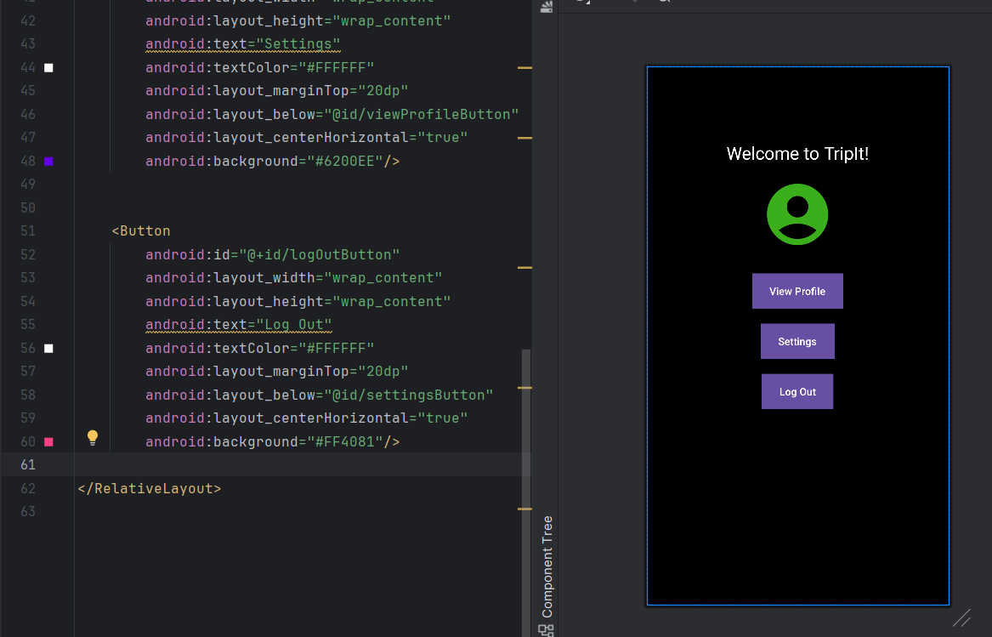

<?xml version="1.0" encoding="utf-8"?>  
<RelativeLayout xmlns:android="http://schemas.android.com/apk/res/android"  
 android:layout_width="match_parent"  
 android:layout_height="match_parent"  
 android:background="@android:color/black">  
  
 <TextView  
 android:id="@+id/welcomeMessage"  
 android:layout_width="wrap_content"  
 android:layout_height="wrap_content"  
 android:text="Welcome to TripIt!"  
 android:textSize="24sp"  
 android:textColor="#FFFFFF"  
 android:layout_marginTop="100dp"  
 android:layout_centerHorizontal="true"/>  
  
  
 <ImageView  
 android:id="@+id/profileImage"  
 android:layout_width="100dp"  
 android:layout_height="100dp"  
 android:src="@drawable/baseline_account_circle_24"  
 android:layout_marginTop="150dp"  
 android:layout_centerHorizontal="true"/>  
  
  
 <Button  
 android:id="@+id/viewProfileButton"  
 android:layout_width="wrap_content"  
 android:layout_height="wrap_content"  
 android:text="View Profile"  
 android:textColor="#FFFFFF"  
 android:layout_marginTop="30dp"  
 android:layout_below="@id/profileImage"  
 android:layout_centerHorizontal="true"  
 android:background="#6200EE"/>  
  
  
 <Button  
 android:id="@+id/settingsButton"  
 android:layout_width="wrap_content"  
 android:layout_height="wrap_content"  
 android:text="Settings"  
 android:textColor="#FFFFFF"  
 android:layout_marginTop="20dp"  
 android:layout_below="@id/viewProfileButton"  
 android:layout_centerHorizontal="true"  
 android:background="#6200EE"/>  
  
  
 <Button  
 android:id="@+id/logOutButton"  
 android:layout_width="wrap_content"  
 android:layout_height="wrap_content"  
 android:text="Log Out"  
 android:textColor="#FFFFFF"  
 android:layout_marginTop="20dp"  
 android:layout_below="@id/settingsButton"  
 android:layout_centerHorizontal="true"  
 android:background="#FF4081"/>  
  
</RelativeLayout>

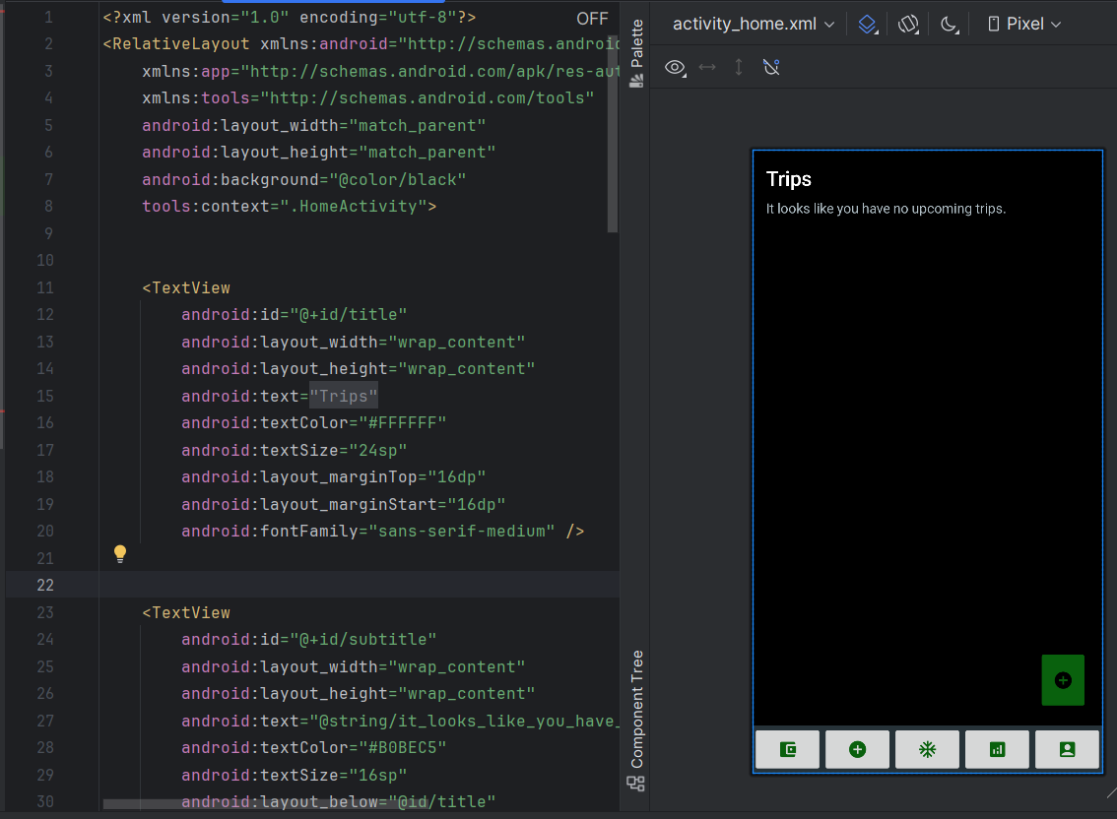

<?xml version="1.0" encoding="utf-8"?>  
<RelativeLayout xmlns:android="http://schemas.android.com/apk/res/android"  
 xmlns:app="http://schemas.android.com/apk/res-auto"  
 xmlns:tools="http://schemas.android.com/tools"  
 android:layout_width="match_parent"  
 android:layout_height="match_parent"  
 android:background="@color/black"  
 tools:context=".HomeActivity">  
  
  
 <TextView  
 android:id="@+id/title"  
 android:layout_width="wrap_content"  
 android:layout_height="wrap_content"  
 android:text="@string/trips"  
 android:textColor="#FFFFFF"  
 android:textSize="24sp"  
 android:layout_marginTop="16dp"  
 android:layout_marginStart="16dp"  
 android:fontFamily="sans-serif-medium" />  
  
  
 <TextView  
 android:id="@+id/subtitle"  
 android:layout_width="wrap_content"  
 android:layout_height="wrap_content"  
 android:text="@string/it_looks_like_you_have_no_upcoming_trips"  
 android:textColor="#B0BEC5"  
 android:textSize="16sp"  
 android:layout_below="@id/title"  
 android:layout_marginTop="8dp"  
 android:layout_marginStart="16dp"  
 android:fontFamily="sans-serif" />  
  
 <ImageButton  
 android:id="@+id/fab_add"  
 android:layout_width="58dp"  
 android:layout_height="71dp"  
 android:layout_alignParentEnd="true"  
 android:layout_alignParentBottom="true"  
 android:layout_marginStart="16dp"  
 android:layout_marginLeft="16dp"  
 android:layout_marginTop="16dp"  
 android:layout_marginEnd="17dp"  
 android:layout_marginRight="16dp"  
 android:layout_marginBottom="74dp"  
 android:backgroundTint="#09610D"  
 android:contentDescription="@string/add_button"  
 android:src="@drawable/ic_add" />  
  
 <LinearLayout  
 android:id="@+id/bottom_navigation"  
 android:layout_width="match_parent"  
 android:layout_height="56dp"  
 android:orientation="horizontal"  
 android:layout_alignParentBottom="true"  
 android:background="#263238"  
 android:gravity="center">  
  
  
 <ImageButton  
 android:id="@+id/nav_trips"  
 android:layout_width="0dp"  
 android:layout_height="match_parent"  
 android:layout_weight="1"  
 android:contentDescription="@string/trip"  
 android:src="@drawable/ic_trips"  
 app:tint="#09610D"  
 />  
 <ImageButton  
 android:id="@+id/nav_trips"  
 android:layout_width="0dp"  
 android:layout_height="match_parent"  
 android:layout_weight="1"  
 android:contentDescription="@string/trip"  
 android:src="@drawable/ic_add"  
 app:tint="#09610D"  
 />  
  
 <ImageButton  
 android:id="@+id/nav_pro"  
 android:layout_width="0dp"  
 android:layout_height="match_parent"  
 android:layout_weight="1"  
 android:contentDescription="@string/pro"  
 android:src="@drawable/ic_pro"  
 app:tint="#09610D" />  
  
 <ImageButton  
 android:id="@+id/nav_unfiled"  
 android:layout_width="0dp"  
 android:layout_height="match_parent"  
 android:layout_weight="1"  
 android:src="@drawable/ic_unfiled"  
 android:contentDescription="@string/unfiled"  
 app:tint="#09610D" />  
  
 <ImageButton  
 android:id="@+id/nav_trips"  
 android:layout_width="0dp"  
 android:layout_height="match_parent"  
 android:layout_weight="1"  
 android:contentDescription="@string/trip"  
 android:src="@drawable/ic_account"  
 app:tint="#09610D"  
 />  
  
 </LinearLayout>  
</RelativeLayout>

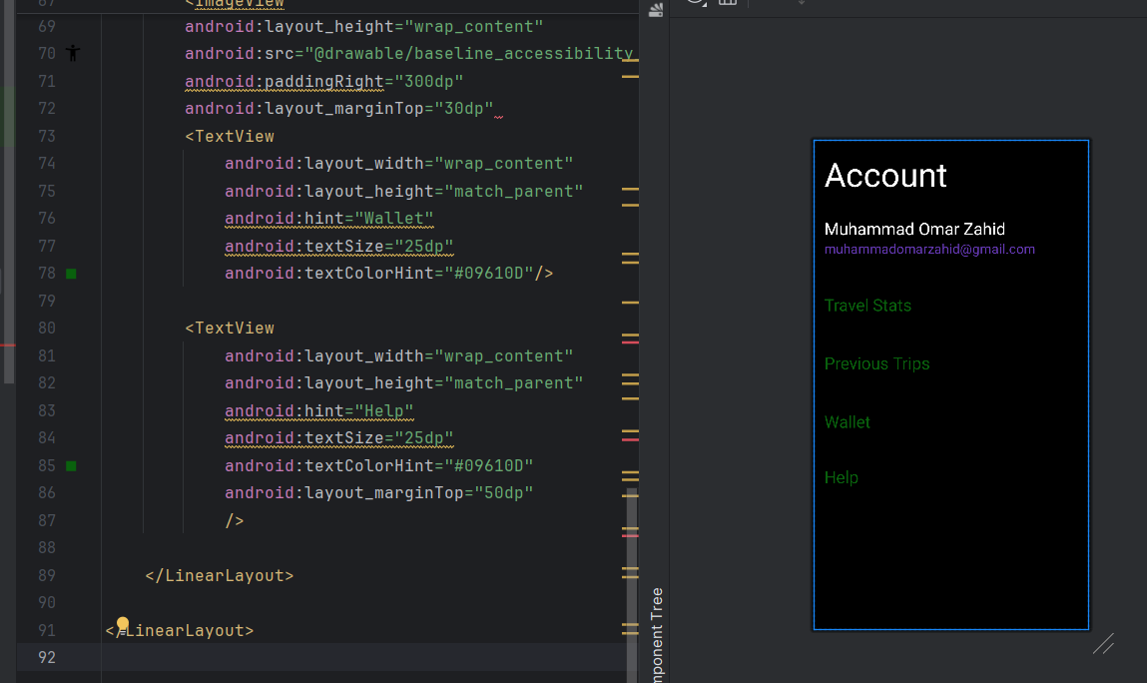

<LinearLayout  
 xmlns:android="http://schemas.android.com/apk/res/android"  
 android:layout_width="match_parent"  
 android:layout_height="match_parent"  
 android:orientation="vertical"  
 android:background="@color/black">  
  
  
 <TextView  
 android:id="@+id/titleTextView"  
 android:layout_width="wrap_content"  
 android:layout_height="wrap_content"  
 android:text="Account"  
 android:textColor="#FFFFFF"  
 android:textSize="50dp"  
 android:layout_margin="16dp" />  
  
  
 <LinearLayout  
 android:layout_width="match_parent"  
 android:layout_height="wrap_content"  
 android:orientation="vertical"  
 android:padding="16dp">  
  
 <TextView  
 android:id="@+id/notificationTitleTextView"  
 android:layout_width="wrap_content"  
 android:layout_height="wrap_content"  
 android:text="Muhammad Omar Zahid"  
 android:textColor="#FFFFFF"  
 android:textSize="25dp" />  
  
 <TextView  
 android:id="@+id/notificationMessageTextView"  
 android:layout_width="wrap_content"  
 android:layout_height="wrap_content"  
 android:text="muhammadomarzahid@gmail.com"  
 android:textSize="20dp"  
 android:textColor="#673AB7"  
  
  
 />  
 <ImageView  
 android:layout_width="match_parent"  
 android:layout_height="wrap_content"  
 android:src="@drawable/baseline_area_chart_24"  
 android:paddingRight="300dp"  
 android:layout_marginTop="30dp"  
 <TextView  
 android:layout_width="wrap_content"  
 android:layout_height="match_parent"  
 android:hint="Travel Stats"  
 android:textSize="25dp"  
 android:textColorHint="#09610D"/>  
 <ImageView  
 android:layout_width="match_parent"  
 android:layout_height="wrap_content"  
 android:src="@drawable/baseline_attractions_24"  
 android:paddingRight="300dp"  
 android:layout_marginTop="30dp"  
 <TextView  
 android:layout_width="wrap_content"  
 android:layout_height="match_parent"  
 android:hint="Previous Trips"  
 android:textSize="25dp"  
 android:textColorHint="#09610D"/>  
 <ImageView  
 android:layout_width="match_parent"  
 android:layout_height="wrap_content"  
 android:src="@drawable/baseline_accessibility_new_24"  
 android:paddingRight="300dp"  
 android:layout_marginTop="30dp"  
 <TextView  
 android:layout_width="wrap_content"  
 android:layout_height="match_parent"  
 android:hint="Wallet"  
 android:textSize="25dp"  
 android:textColorHint="#09610D"/>  
  
 <TextView  
 android:layout_width="wrap_content"  
 android:layout_height="match_parent"  
 android:hint="Help"  
 android:textSize="25dp"  
 android:textColorHint="#09610D"  
 android:layout_marginTop="50dp"  
 />  
  
 </LinearLayout>  
  
</LinearLayout>