ICA1 Supporting Materials
Roll Number: 3003
ICA1 Supplementary Methods
Supplementary methods word count: 485

Data and recording selection
The supplied oxytocin spike-time spreadsheet was filtered with tools/prepare_selected_dap_data.py, exporting the selected recordings to data/selected_dap_recordings.csv. For each column, the longest monotonic spike-time segment was retained to remove recording resets. I then reproduced the workshop 5 ms histogram, hazard and IoD analyses used in the supplied framework and oxytocin-model validation [1,2]. MAL11E was used as the main result cell and CBA1R8C1 as validation.

Model implementation
The core code is in spikemod.py. The baseline retained stochastic PSP input, membrane integration, HAP, AHP and the secretion model (secB, secE, secC, secX, secPlasma). I implemented two DAP variants. The simple DAP was a spike-triggered afterpotential with kDAP and halflifeDAP, following published oxytocin DAP descriptions and intrinsic depolarising mechanisms [3,4,6]. The NMDA model added a slower second PSP pathway (pspmag2, psprate2, halflifePSP2, nmdaSync) plus a simple voltage-dependent term to reflect reports that NMDA-dependent excitation can promote spike clustering [5]. I also added optional scheduled PSP-rate input so psprate and psprate2 could vary over time while preserving the original fixed-input behaviour when no schedule was supplied.

Headless analysis workflow
The main reproduction entry point is tools/generate_ica1_results.py. It loads the selected recordings, runs the frozen parameter sets and writes outputs to analysis/. These parameter sets were chosen during exploratory fitting and frozen before final figure generation, so the reported comparisons were run without extra per-figure tuning. Baseline + AHP, simple DAP and NMDA-only variants were run with the same random seed for each recording. The fit score was:
0.25 * freq_error + 0.30 * hist_error + 0.20 * haz_error + 0.25 * iod_error
Lower values indicate better agreement. Histogram and hazard error used the first 40 bins (0-200 ms at 5 ms resolution), and IoD error used the first seven points. Each RMSE term was normalised by the maximum absolute target value. Exploratory baseline fitting used a two-stage search: stage 1 matched rate, histogram and hazard, and stage 2 added IoD before the final long run [1,2].

Secretion and varying-input protocols
For the secretion sweep, MAL11E-derived baseline + AHP, baseline without AHP and simple DAP models were run for 240 s at PSP rates 150, 200, 250, 300, 330, 360, 390 and 420. Stable plasma concentration was the mean secPlasma over the final 60 s. For the varying-input protocol, MAL11E-derived baseline and simple DAP models were run for 750 s using PSP-rate steps of 160, 240, 360, 240 and 180. Segment firing rate came from spike counts within each epoch, and late-segment plasma from the final 60 s, or the whole segment if shorter. These readouts were chosen because the oxytocin secretion model is sensitive to facilitation and fatigue driven by spike density [1,7,8].

Code and reproducibility
All code needed to reproduce the submitted figures and tables is included in this repository. The key scripts are listed in README.md, and the main outputs used in the report are ica1_figure1_spike_fits.png, ica1_figure2_system_outputs.png, ica1_model_comparison.csv, ica1_secretion_sweeps.csv, ica1_varying_input_summary.csv and ica1_parameter_sets.json. Supporting display items provide the component-wise fit-score breakdown and exact numeric summaries for the secretion sweep and varying-input protocol.

References
1. Maicas-Royo J, Leng G, MacGregor DJ. A predictive, quantitative model of spiking activity and stimulus-secretion coupling in oxytocin neurons. Endocrinology. 2018;159(3):1433-1452.
2. MacGregor DJ. CMML3 Week 5 workshop materials: HypoMod spike fitting and secretion modelling. Course material, 2025-26.
3. Brown CH, Leng G, MacGregor DJ. Oxytocin neurones: intrinsic mechanisms governing the regularity of spiking activity. J Neuroendocrinol. 2016;28(4):e12366.
4. Teruyama R, Armstrong WE. Enhancement of calcium-dependent afterpotentials in oxytocin neurons of the rat supraoptic nucleus during lactation. J Physiol. 2005;566(Pt 2):505-518.
5. Gagnon A, Walsh M, Okuda T, Choe KY, Zaelzer C, Bourque CW. Modulation of spike clustering by NMDA receptors and neurotensin in rat supraoptic nucleus neurons. J Physiol. 2014;592(19):4177-4186.
6. Brown CH, Bains JS, Ludwig M, Stern JE. Physiological regulation of magnocellular neurosecretory cell activity: integration of intrinsic, local and afferent mechanisms. J Neuroendocrinol. 2013;25(8):678-710.
7. Bicknell RJ, Brown D, Chapman C, Hancock PD, Leng G. Reversible fatigue of stimulus-secretion coupling in the rat neurohypophysis. J Physiol. 1984;348:601-613.
8. Maicas-Royo J, Leng G, MacGregor DJ. The spiking and secretory activity of oxytocin neurones in response to osmotic stimulation: a computational model. J Physiol. 2019;597(14):3657-3671.

ICA1 Supporting Display Items

Supplementary Figure S1
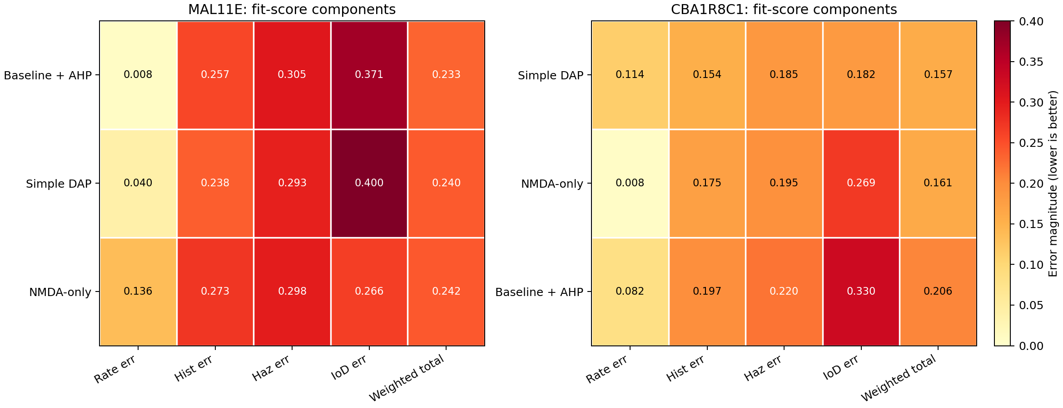

Figure S1. Component-wise breakdown of the model-comparison score for MAL11E and CBA1R8C1. Cells report the relative firing-rate error, normalised histogram RMSE, normalised hazard RMSE, normalised IoD RMSE and final weighted fit score. Lower values indicate better agreement, so the best-supported model in each cell appears as the lightest row overall.

Supplementary Figure S2
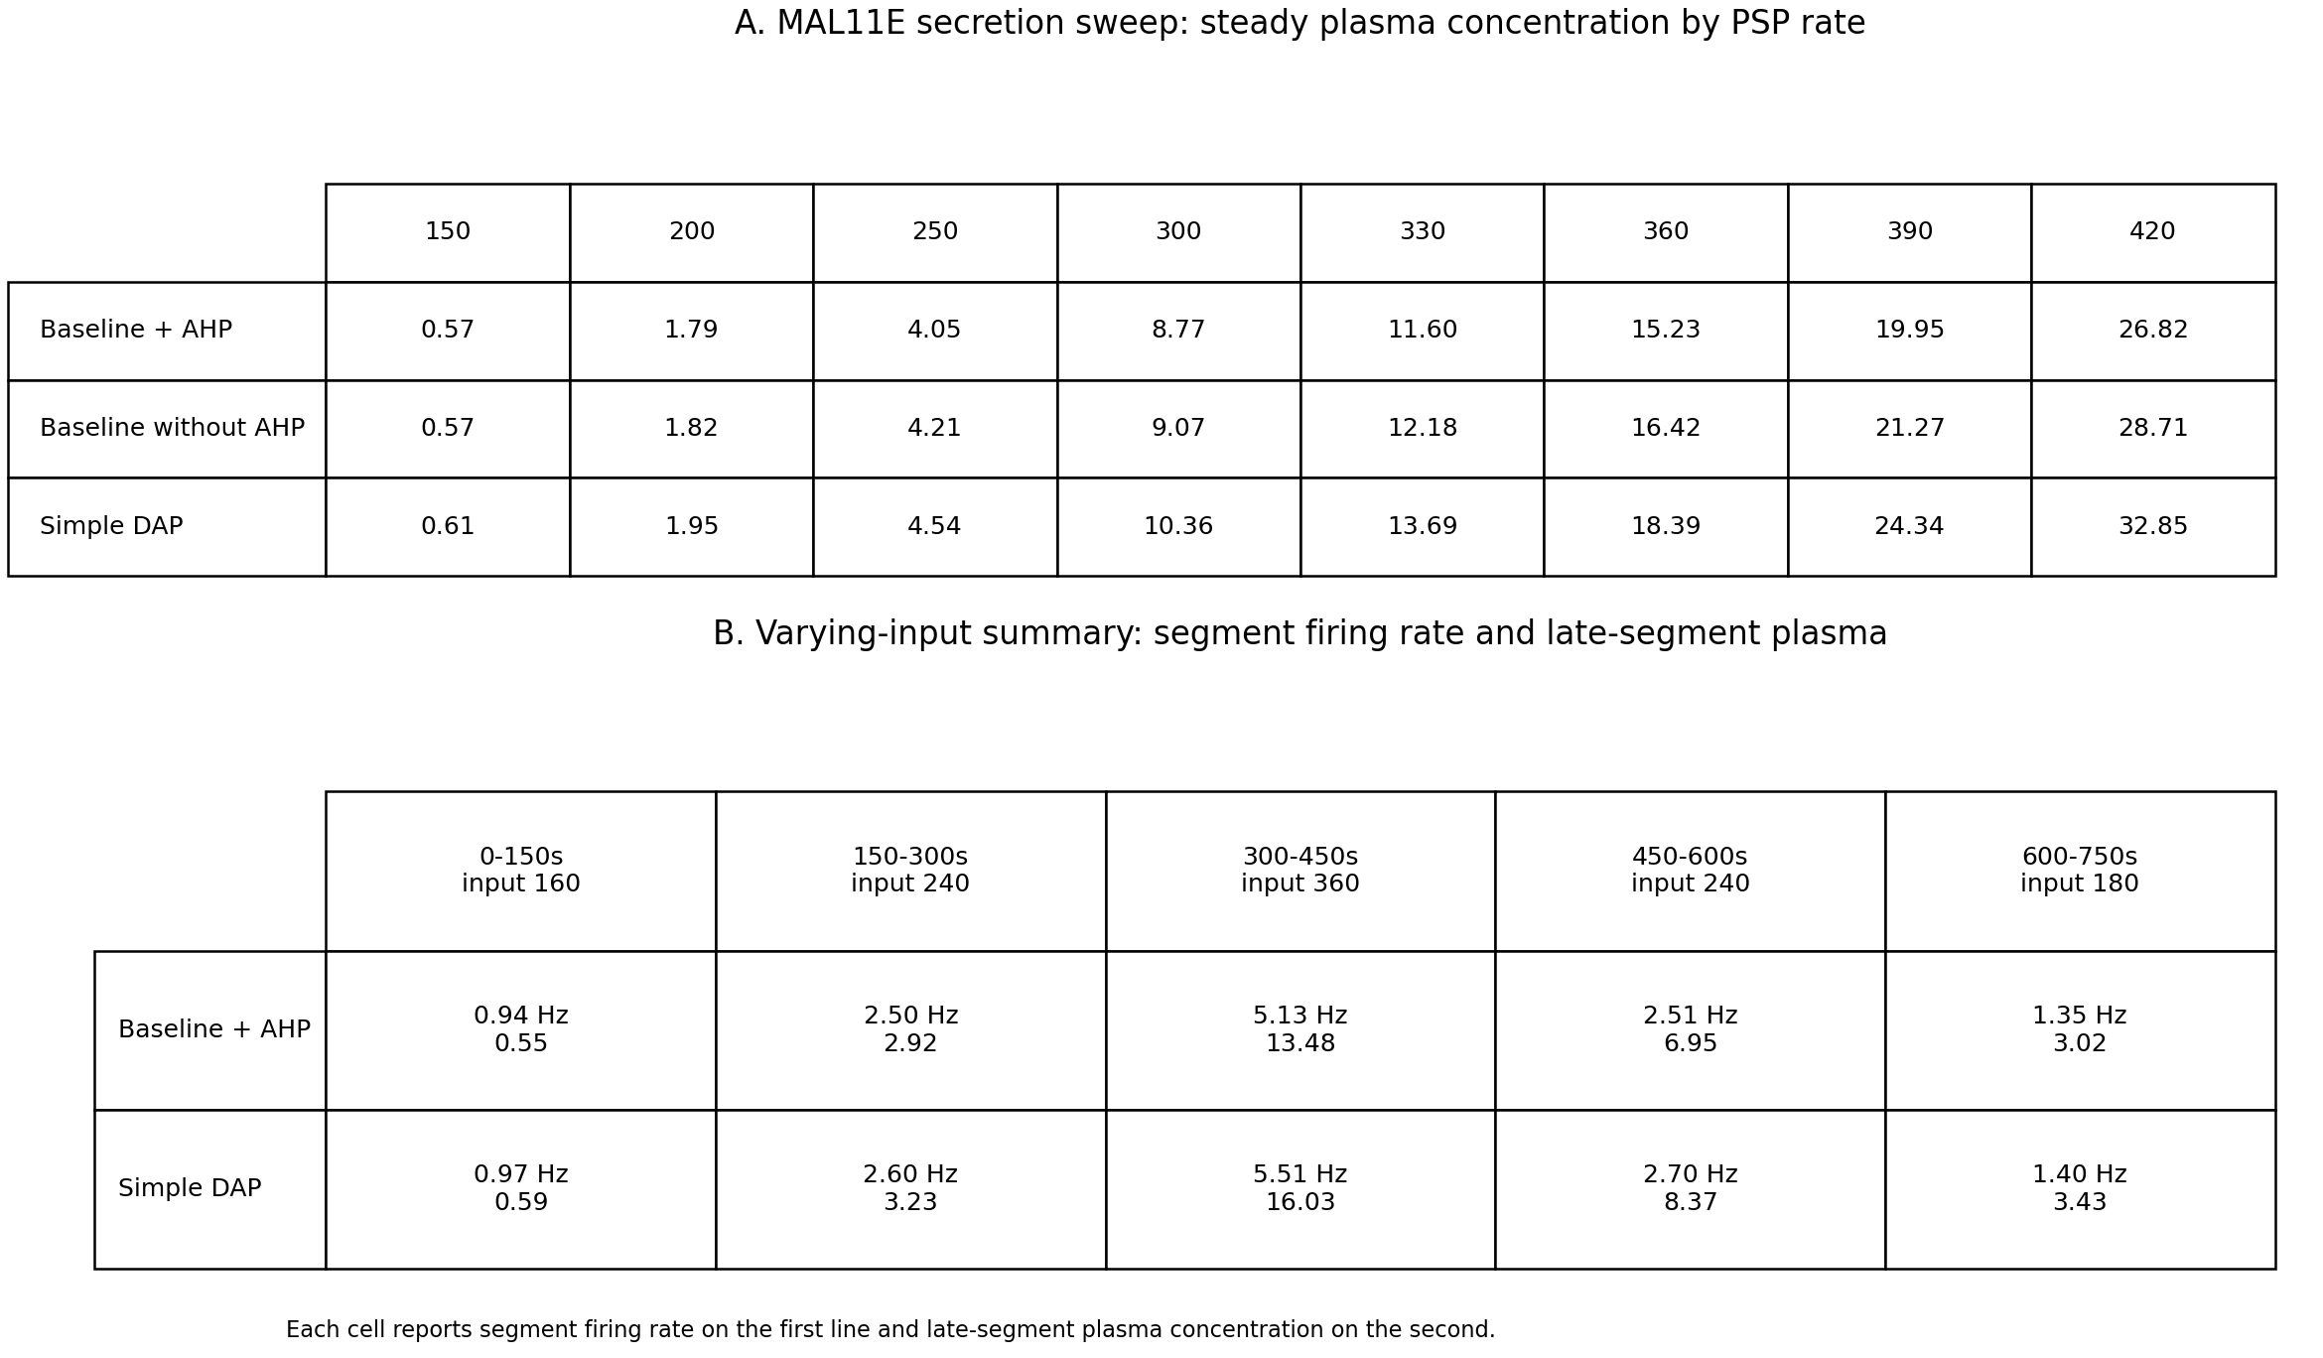

Figure S2. Exact numeric summaries used to support Figure 2. Top, steady plasma concentration across the MAL11E secretion sweep. Bottom, varying-input segment summaries, where each cell reports segment firing rate on the first line and late-segment plasma concentration on the second.

ICA1 Reflection
Reflection word count: 155
This project showed me that autonomy in computational modelling means making and justifying decisions, not only running a supplied model. The Week 5 fitting workflow, hazard/IoD analysis and secretion module were especially helpful because they gave me a principled baseline that I could extend, test and then question. Moving from exploratory GUI tuning to a script-based workflow was the most useful step, because it let me compare mechanisms reproducibly rather than defend a favourite fit.

My main action points are now clearer. First, I would replace manual parameter freezing with formal optimisation plus a held-out dynamic protocol, so fitting and evaluation are separated. Second, I would test more recordings to check whether the simple DAP result generalises or whether hybrid intrinsic-plus-NMDA models are needed. Third, I would report uncertainty more explicitly by repeating runs across random seeds. This ICA increased my confidence in using course material independently to build, criticise and iterate mechanistic models.

