CHAPTER 4
Communication Architecture and Functional Operation of the Ethernet-Based Multi-Channel Electronic Switch Matrix
Internship Report
Human Space Flight Centre (HSFC), Indian Space Research Organisation (ISRO)
Analog Circuit Design for Aerospace Applications
Lokesh L
USN: 1MS23EC064
Department of Electronics and Communication Engineering
M S Ramaiah Institute of Technology, Bengaluru

Chapter 4: Communication Architecture and Functional Operation of the Ethernet-Based Multi-Channel Electronic Switch Matrix

4.1 Introduction
The Human Space Flight Centre (HSFC), Indian Space Research Organisation (ISRO), develops and integrates various electronic subsystems for the Crew Module and associated payloads. These subsystems require reliable power distribution and controlled switching during assembly, integration, validation, and functional testing. Since multiple subsystem power lines must be independently controlled, monitored, and verified, an electronic switching system capable of remote operation becomes an essential component of the test infrastructure.
Traditional manual switching techniques involve physical relays, mechanical switches, and extensive wiring, which become increasingly complex as the number of controllable channels increases. These approaches present several limitations, including increased wiring complexity, reduced scalability, slower switching speed, higher maintenance requirements, and limited capability for centralized monitoring. To address these challenges, a microcontroller-based electronic switch matrix has been developed to remotely control multiple high-power subsystem lines using Ethernet communication.
The developed electronic switch matrix provides a centralized and scalable architecture in which an operator can control multiple subsystem channels from an Industrial Personal Computer (Industrial PC) through a Graphical User Interface (GUI). The commands generated by the GUI are transmitted over an Ethernet network to the embedded controller, where they are processed and executed. The embedded controller communicates with multiple MCP23S17 SPI-based GPIO expanders, each controlling sixteen digital output channels. These GPIO outputs drive discrete MOSFET-based electronic switching circuits that control the power supplied to the intended subsystem loads.
Unlike conventional architectures that directly connect every switching channel to the microcontroller, the proposed design employs multiple MCP23S17 devices connected to a common SPI bus. This significantly increases the number of available digital outputs without requiring additional microcontroller GPIO pins. Each MCP23S17 supports 16 programmable GPIO pins, organized into GPIOA and GPIOB ports, and provides hardware addressing through the A2, A1, and A0 address pins, allowing multiple devices to coexist on the same SPI bus. The GPIO architecture, SPI interface, hardware addressing mechanism, and register organization are described in the MCP23S17 datasheet.
Communication between the Industrial PC and the embedded controller is established using Ethernet technology. Ethernet was selected because it provides reliable high-speed communication, robust error detection through Frame Check Sequence (FCS), and compatibility with industrial automation systems. After receiving a valid Ethernet frame, the embedded controller extracts the application command, verifies its integrity, identifies the destination MCP23S17 device, updates the appropriate GPIO output through SPI communication, verifies the operation by reading back the output register, and finally transmits an acknowledgement to the Industrial PC.
The overall communication architecture consists of the following major functional blocks:
- Industrial PC with Graphical User Interface (GUI)
- Ethernet Communication Interface
- RJ45 Physical Interface
- Ethernet Module
- Microcontroller (SPI Master)
- SPI Communication Bus
- Multiple MCP23S17 GPIO Expanders
- Discrete MOSFET Electronic Switches
- High-Power Subsystem Loads
The modular architecture improves scalability, simplifies maintenance, reduces PCB complexity, and provides reliable control of multiple subsystem channels. Since each command undergoes several stages of verification -- including Ethernet frame validation, application-layer checksum verification, SPI communication, GPIO read-back, and acknowledgement generation -- the architecture ensures deterministic and fault-tolerant operation suitable for aerospace subsystem testing.

Figure 4.1: Overall communication architecture of the Ethernet-based multi-channel electronic switch matrix developed for remote control of Crew Module subsystem power lines.

Table 4.1 Major Functional Components
Component | Primary Function
Industrial PC | Generates switching commands through GUI
Ethernet Network | Transfers command packets
RJ45 Connector | Physical Ethernet interface
Ethernet Module | Receives and forwards Ethernet frames
Microcontroller | Processes commands and controls SPI communication
SPI Bus | Communicates with multiple MCP23S17 devices
MCP23S17 | Expands GPIO channels and controls MOSFET gates
MOSFET Electronic Switch | Switches high-power DC loads
Subsystem Load | Receives controlled power from the electronic switch

4.2 Objectives of the Electronic Switch Matrix
The primary objective of the proposed electronic switch matrix is to provide a reliable, scalable, and remotely operable platform for controlling multiple high-power subsystem lines used during testing and validation of the Crew Module. The system replaces conventional manual switching methods with an Ethernet-based embedded architecture capable of independently controlling numerous output channels while ensuring safe and deterministic operation.
The specific objectives of the proposed system are:
- To enable remote switching of multiple subsystem power lines using an Industrial PC.
- To establish reliable communication between the Industrial PC and the embedded controller through an Ethernet interface.
- To expand the available digital output channels using multiple MCP23S17 SPI-based GPIO expanders.
- To minimize the number of GPIO pins required from the microcontroller by utilizing SPI communication.
- To individually control each electronic MOSFET switch without affecting the state of other output channels.
- To provide scalable architecture that can accommodate future expansion of subsystem channels.
- To implement acknowledgement-based communication for reliable command execution.
- To verify every switching operation through read-back of the GPIO status before generating the acknowledgement frame.
The implementation of these objectives results in a modular architecture suitable for aerospace electronic test systems, where reliability, maintainability, and scalability are critical design requirements.

4.3 Need for the Electronic Switch Matrix
Modern spacecraft and crew module testing involve simultaneous evaluation of multiple electronic subsystems. Each subsystem requires independent control of its power supply during different stages of assembly, integration, functional verification, and validation. As the number of subsystem channels increases, conventional relay-based switching architectures become increasingly difficult to manage due to excessive wiring, larger panel sizes, higher maintenance requirements, and limited scalability.
The proposed electronic switch matrix addresses these limitations by introducing a centralized embedded controller capable of remotely controlling multiple switching channels through Ethernet communication. Instead of dedicating one microcontroller GPIO pin to each output channel, the architecture employs multiple MCP23S17 I/O expanders connected to a common SPI bus. This approach significantly increases the available digital outputs while reducing PCB routing complexity and conserving valuable microcontroller resources.
The use of Ethernet communication allows switching commands to be transmitted from a centralized Industrial PC over standard network infrastructure. This enables remote operation, centralized monitoring, and integration with automated test software. The embedded controller interprets the received command, selects the appropriate MCP23S17 based on its hardware address, updates the corresponding GPIO output, and drives the gate of the associated MOSFET electronic switch.
Each switching operation is verified through a read-back mechanism before an acknowledgement is returned to the Industrial PC. This layered communication strategy improves system reliability and ensures that the requested operation has been successfully executed.

Table 4.2 Advantages of the Proposed Electronic Switch Matrix
Conventional Switching | Proposed Electronic Switch Matrix
Manual operation | Remote operation through GUI
Large wiring complexity | Reduced wiring using SPI
Limited scalability | Easily expandable
High maintenance | Modular architecture
Relay-based switching | Solid-state MOSFET switching
Limited diagnostics | Read-back verification and ACK
Slow switching | Fast electronic switching
Difficult monitoring | Real-time channel monitoring

4.4 Overall System Architecture
The proposed electronic switch matrix consists of several functional blocks interconnected to provide reliable communication between the Industrial PC and the subsystem loads. Figure 4.2 illustrates the overall hardware architecture adopted in the present work.

Figure 4.2: Overall functional architecture of the Ethernet-based electronic switch matrix employing multiple MCP23S17 GPIO expanders.
The architecture is organized into three functional layers:
1. Communication Layer
This layer includes the Industrial PC, Ethernet network, RJ45 interface, and Ethernet module. It is responsible for transmitting application commands from the operator to the embedded controller. Ethernet communication provides high-speed data transfer, robust error detection using the Frame Check Sequence (FCS), and compatibility with industrial automation systems.
2. Embedded Control Layer
The embedded control layer comprises the microcontroller and the SPI communication interface. The microcontroller receives the application command from the Ethernet module, validates the command, constructs the SPI Control Byte, selects the target MCP23S17, performs register-level operations, verifies the output status, and generates an acknowledgement frame.
3. Power Switching Layer
The power switching layer consists of multiple MCP23S17 GPIO expanders, discrete MOSFET electronic switches, and subsystem loads. The GPIO outputs generated by the MCP23S17 control the MOSFET gate terminals, enabling or disabling power delivery to the respective subsystem channels.

Table 4.3 Functional Description of Major Hardware Blocks
Hardware Block | Function
Industrial PC | Generates switching commands through the GUI
Ethernet Network | Transfers Ethernet packets between the PC and controller
RJ45 Connector | Provides the physical Ethernet interface
Ethernet Module | Receives Ethernet frames and passes payload to the microcontroller
Microcontroller | Processes commands and controls SPI communication
SPI Bus | Serial communication interface between the microcontroller and MCP23S17 devices
MCP23S17 | Provides 16 programmable GPIO outputs for each device
MOSFET Driver Circuit | Drives high-power switching elements
Electronic Switch | Controls power supplied to subsystem loads
Crew Module Subsystem | Receives switched power for testing and validation

4.5 MCP23S17 Functional Block Diagram
The MCP23S17 is the key I/O expansion device used in the electronic switch matrix. It provides sixteen programmable GPIO pins through two 8-bit ports (GPIOA and GPIOB), supports SPI communication, and includes configurable registers for GPIO direction, pull-up resistors, interrupts, and output latches. The device also supports hardware addressing through the A2, A1, and A0 pins, enabling multiple devices to share a common SPI bus. These architectural features are illustrated in the functional block diagram provided in the MCP23S17 datasheet.
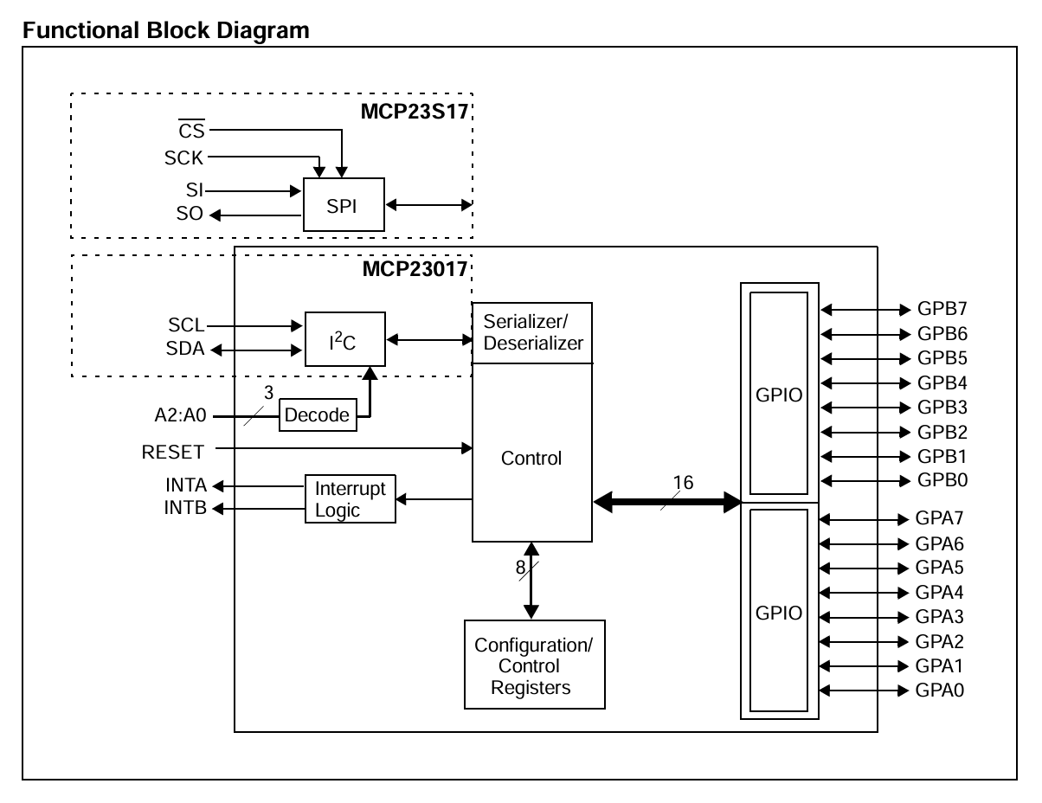

Figure 4.3: MCP23S17 Functional Block Diagram. Source: MCP23S17 Datasheet (DS20001952C), Functional Block Diagram, Page 2.

4.6 Functional Description of System Components
The proposed electronic switch matrix comprises several hardware modules that work together to achieve reliable remote switching of high-power subsystem lines. Each module performs a dedicated function in the communication chain, beginning with command generation at the Industrial PC and ending with switching of the subsystem load through the electronic MOSFET switch. The functional relationship between these hardware blocks is illustrated in Figure 4.4.

Figure 4.4: Functional block diagram of the proposed Ethernet-based multi-channel electronic switch matrix.

4.6.1 Industrial PC
The Industrial Personal Computer (Industrial PC) acts as the Human-Machine Interface (HMI) of the electronic switch matrix. It provides a graphical user interface (GUI) through which the operator monitors and controls the subsystem power channels.
The Industrial PC performs the following functions:
- Displays all available subsystem channels.
- Allows the operator to select the desired channel.
- Generates the application command frame.
- Encapsulates the command into an Ethernet frame.
- Transmits the command to the embedded controller.
- Receives acknowledgement (ACK) frames.
- Displays the execution status of each channel.
The Industrial PC does not directly control the switching hardware. Instead, it acts as the command source while the embedded controller performs all switching operations.

4.6.2 Ethernet Communication Network
The communication between the Industrial PC and the embedded controller is established through an IEEE 802.3 Ethernet network.
Ethernet was selected because it offers:
- High communication speed
- Reliable packet transmission
- Long communication distance
- Excellent immunity to electrical noise
- Industrial compatibility
- Built-in error detection using the Frame Check Sequence (FCS)
The Ethernet protocol is responsible only for transporting the application command between the operator and the embedded controller. The interpretation of the command is performed by the firmware executing on the microcontroller. The Ethernet frame consists of: Preamble, Start Frame Delimiter (SFD), Destination MAC Address, Source MAC Address, Length/Type, Payload, and Frame Check Sequence (CRC). The payload contains the custom application command frame developed for the electronic switch matrix.
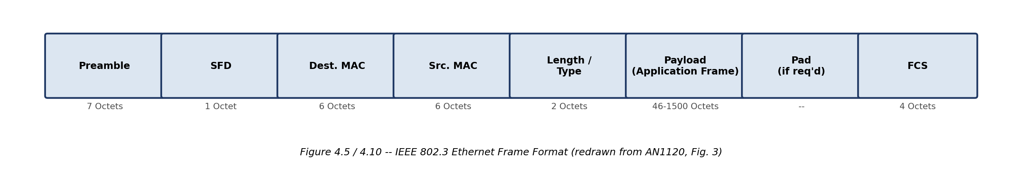
Figure 4.5: Ethernet Frame Format (IEEE 802.3), redrawn based on Microchip Application Note AN1120.

4.6.3 RJ45 Connector
The RJ45 connector serves as the physical interface between the Ethernet cable and the embedded controller. It provides the electrical connection required for transmitting and receiving Ethernet packets.
The connector includes:
- Four differential signal pairs
- Link and activity indication
- Standard CAT5/CAT6 compatibility
- Mechanical locking mechanism for reliable connection
The RJ45 connector is passive and does not process Ethernet packets; its function is limited to providing the physical communication medium.

4.6.4 Ethernet Module
The Ethernet module acts as the communication gateway between the Ethernet network and the embedded controller.
Its primary functions include:
- Receiving Ethernet frames.
- Verifying the Frame Check Sequence (CRC).
- Removing Ethernet headers.
- Extracting the application payload.
- Forwarding the application frame to the microcontroller.
Only Ethernet frames that pass CRC validation are forwarded for processing. Corrupted or incomplete packets are discarded to prevent unintended switching operations.

Table 4.4 Functions of the Ethernet Module
Function | Description
Frame Reception | Receives Ethernet packets from the RJ45 interface
CRC Verification | Checks frame integrity using the Frame Check Sequence
Payload Extraction | Extracts the application command from the Ethernet frame
Data Transfer | Sends the validated command to the microcontroller

4.6.5 Microcontroller (SPI Master)
The microcontroller is the central processing unit of the electronic switch matrix. It receives validated application commands from the Ethernet module, decodes the command fields, selects the target MCP23S17 device, performs SPI communication, updates the GPIO output, verifies the switching operation, and generates the acknowledgement frame.
The firmware running on the microcontroller performs the following sequence:
- Receive the application command.
- Verify the checksum.
- Decode the Device ID and Channel ID.
- Identify the target MCP23S17.
- Construct the SPI Control Byte.
- Select the corresponding Chip Select (CS) line.
- Perform a Read-Modify-Write operation on the appropriate OLAT register.
- Read back the GPIO register for verification.
- Generate an ACK frame.
- Transmit the ACK to the Industrial PC.
The microcontroller communicates with all MCP23S17 devices through a common SPI bus, operating as the SPI Master. Only one MCP23S17 device is accessed at a time by activating its corresponding Chip Select signal.

4.6.6 SPI Bus Architecture
The Serial Peripheral Interface (SPI) provides communication between the microcontroller and the four MCP23S17 I/O expanders. The SPI bus consists of four common communication signals:
- SCK -- Serial Clock generated by the microcontroller.
- MOSI (SI) -- Data transmitted from the microcontroller to the MCP23S17.
- MISO (SO) -- Data transmitted from the MCP23S17 to the microcontroller.
- CS -- Chip Select signal used to enable a specific MCP23S17.
In the proposed architecture, the SCK, MOSI, and MISO lines are shared by all four MCP23S17 devices, while each device is selected individually through its dedicated CS line. Each MCP23S17 is also assigned a unique hardware address using the A2, A1, and A0 pins. The SPI communication protocol, control byte format, and addressing mechanism are described in the MCP23S17 datasheet.
Note: Although the project documentation refers to the MCP23S17 devices as being connected in a “daisy chain,” the MCP23S17 itself supports a shared SPI bus (multi-drop) architecture with common SCK/MOSI/MISO lines and device selection using CS and hardware addressing. The hardware chapter should describe the actual implemented topology explicitly to avoid confusion with the SPI protocol described in the datasheet.

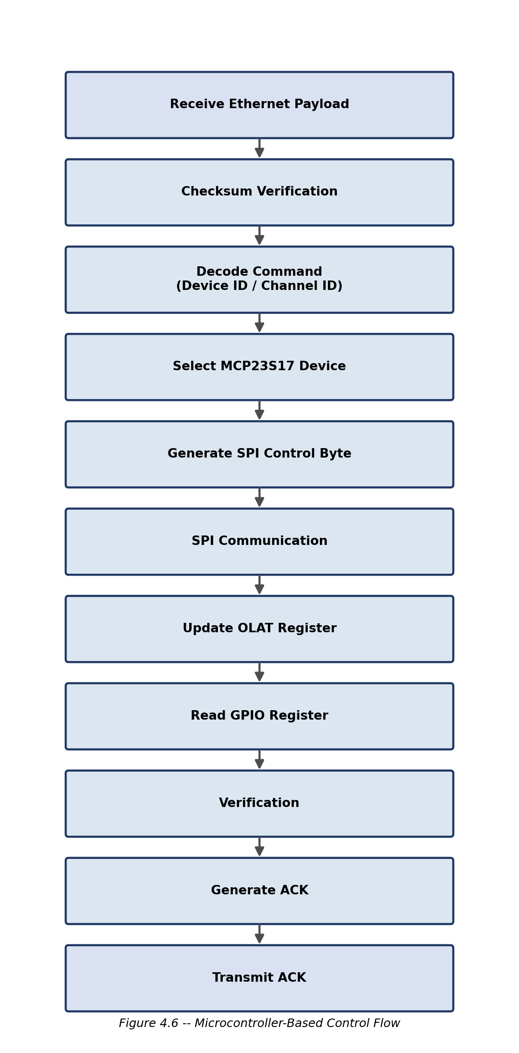
Figure 4.6: Internal command-processing sequence executed by the microcontroller.

\
Figure 4.7: SPI bus architecture showing the microcontroller connected to MCP0-MCP3 with common SCK, MOSI, and MISO lines and separate CS lines (A2:A1:A0 = 000, 001, 010, 011).

Part 2: Communication Protocol and Data Flow Architecture

4.7 Communication Architecture Overview
The electronic switch matrix uses a layered communication architecture to establish reliable communication between the operator interface and the subsystem power switching hardware. The communication path begins at the Industrial PC, where the user generates switching commands through the GUI. These commands are transmitted through an Ethernet network to the embedded controller, which processes the received information and controls the required switching channel.
Industrial PC -> Application Command Frame -> Ethernet Interface -> Ethernet Frame -> Ethernet Module -> Payload Data -> Microcontroller -> SPI Communication -> MCP23S17 GPIO Expander -> GPIO Output -> MOSFET Electronic Switch -> Subsystem Load (Acknowledgement Frame returned from Microcontroller to Industrial PC)
Figure 4.8: End-to-end communication sequence of the electronic switch matrix.
The architecture follows a master-controlled communication approach where the Industrial PC acts as the command master, while the microcontroller acts as the embedded processing unit responsible for command execution.

4.8 Application Layer Communication
Although Ethernet provides reliable packet transfer, a dedicated application-layer protocol is required to define the switching command structure. The application frame enables the microcontroller to identify:
- Which MCP23S17 device has to be accessed.
- Which channel has to be switched.
- The required output state.
- Whether the command is valid.
- Whether the operation was successfully executed.
The application frame is transmitted inside the Ethernet payload.

4.8.1 Application Command Frame Format
The proposed application frame consists of the following fields:
Field | Size | Function
Start of Frame (SOF) | 1 Byte | Identifies beginning of command
Command ID | 1 Byte | Defines switching operation
Device ID | 1 Byte | Selects MCP23S17 device
Channel ID | 1 Byte | Selects output channel
Data | 1 Byte | Defines ON/OFF condition
Sequence Number | 1 Byte | Command tracking
Reserved | 1 Byte | Future expansion
Checksum | 1 Byte | Data validation

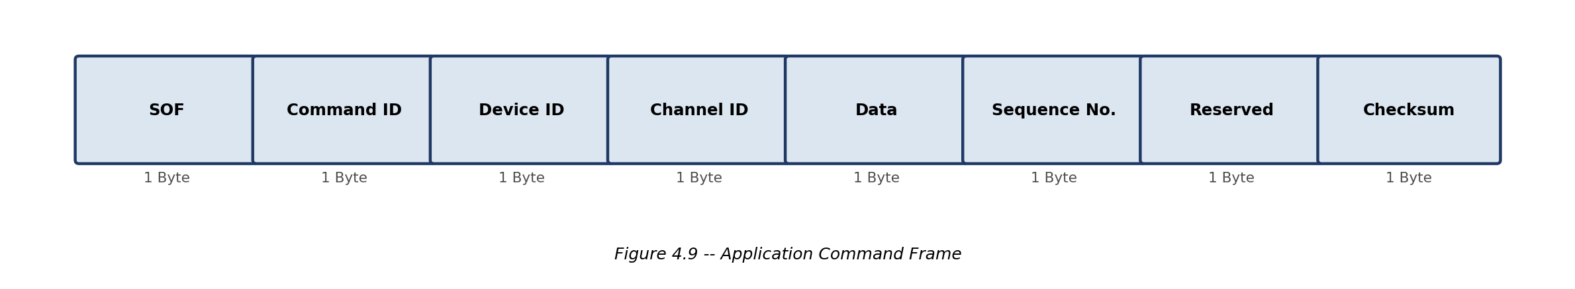
Figure 4.9: Application command frame used for channel control.

4.8.2 Example Command Frame
Consider the following switching command:
Requirement: Select MCP23S17 Device 2; Turn ON Channel 9.
The generated command frame is:
Parameter | Value
SOF | AA
Command ID | 01 (Switch Command)
Device ID | 02
Channel ID | 09
Data | 01 (ON)
Sequence Number | 05
Checksum | Calculated

The microcontroller receives this frame and extracts the required information for further processing.

4.9 Ethernet Frame Communication
The application command frame is embedded inside the Ethernet payload before transmission.
The Ethernet communication layer provides:
- Addressing using MAC addresses.
- Packet synchronization.
- Error detection.
- Data transmission.
The Ethernet frame consists of: Preamble, SFD, Destination MAC, Source MAC, Type, Payload, and FCS, where:
- Preamble: Synchronizes transmitter and receiver.
- SFD: Indicates beginning of frame.
- Destination MAC: Identifies receiver.
- Source MAC: Identifies transmitter.
- Type: Defines protocol.
- Payload: Contains application command.
- FCS: Performs CRC-based error checking.

Figure 4.10: Ethernet communication structure (IEEE 802.3 frame, redrawn from Microchip AN1120).

4.10 Acknowledgement Communication
To ensure reliable switching, the embedded controller sends an acknowledgement frame after executing every command.
The acknowledgement confirms:
- Command reception.
- Command execution.
- Channel status.
- Error condition if any.
The acknowledgement mechanism prevents the operator from assuming that a command was executed successfully without verification.

4.10.1 Acknowledgement Frame Format
Field | Size | Function
SOF | 1 Byte | Frame identification
ACK ID | 1 Byte | Indicates acknowledgement
Device ID | 1 Byte | Selected MCP23S17
Channel ID | 1 Byte | Controlled channel
Status | 1 Byte | Success/Error
Sequence Number | 1 Byte | Matches command
Checksum | 1 Byte | Validation

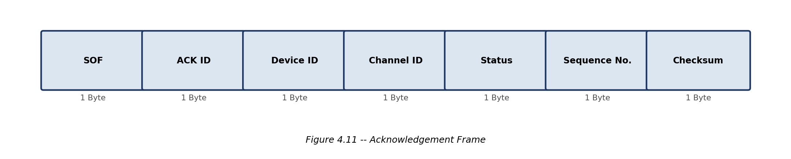
Figure 4.11: Acknowledgement frame.

4.11 Embedded Controller Communication Flow
Step 1: Ethernet Data Reception
The Ethernet module receives the incoming frame and extracts the application payload.
Step 2: Frame Validation
The firmware checks: Start byte, Command ID, Device ID range, Channel ID range, and Checksum.
Command Received -> Checksum Verification -> FAIL -> Generate Error ACK
If the checksum is incorrect, no switching operation is performed.
Step 3: Device Selection
The Device ID determines which MCP23S17 must be accessed. For four MCP23S17 devices:
Device | A2 | A1 | A0
MCP0 | 0 | 0 | 0
MCP1 | 0 | 0 | 1
MCP2 | 0 | 1 | 0
MCP3 | 0 | 1 | 1

The MCP23S17 supports hardware addressing using the A2, A1, and A0 address pins. The address information becomes part of the SPI control byte during communication.

4.12 SPI Communication Between Microcontroller and MCP23S17
The MCP23S17 communicates with the microcontroller using the SPI protocol. The SPI interface consists of:
Signal | Direction | Function
SCK | MCU -> MCP23S17 | Clock generation
MOSI/SI | MCU -> MCP23S17 | Data transmission
MISO/SO | MCP23S17 -> MCU | Data reception
CS | MCU -> MCP23S17 | Device selection

The MCP23S17 SPI communication operation consists of a Control Byte, a Register Address, and a Data Byte. The SPI communication sequence and timing characteristics are described in the MCP23S17 datasheet.

Figure 4.12: SPI write transaction used for updating MCP23S17 registers (redrawn from datasheet DS20001952C, SPI Input/Output Timing, Fig. 1-5 / 1-6, p.8).

Figure 4.13: SPI read transaction used for GPIO verification (redrawn from datasheet DS20001952C, SPI Input/Output Timing, Fig. 1-5 / 1-6, p.8).

Part 3: MCP23S17 Internal Architecture, Register Configuration and Channel Control

4.14 Introduction to MCP23S17 GPIO Expander
The MCP23S17 is a 16-bit General Purpose Input/Output (GPIO) expander developed by Microchip Technology. It is used in the proposed electronic switch matrix to increase the number of controllable digital output channels of the microcontroller.
The microcontroller acts as the SPI master, while MCP23S17 devices operate as SPI slave devices. Each MCP23S17 provides sixteen individually configurable GPIO pins divided into two 8-bit ports: PORTA (GPA0 to GPA7) and PORTB (GPB0 to GPB7). Each GPIO pin can be independently configured as an input or output through internal direction control registers.
The MCP23S17 architecture consists of:
- SPI serial interface
- Control logic
- Address decoder
- Register banks
- GPIO ports
- Output latch registers
- Interrupt control circuitry

Figure 4.11: MCP23S17 Internal Functional Block Diagram. Source: MCP23S17 Datasheet (DS20001952C), Functional Block Diagram, Page 2.

The functional blocks shown in the MCP23S17 architecture perform the following operations:
Block | Function
SPI Interface | Provides serial communication with microcontroller
Address Decoder | Identifies individual MCP23S17 device
Control Logic | Controls register access operations
Register Bank | Stores configuration and GPIO data
GPIO Ports | Provides 16 programmable digital channels
Interrupt Logic | Generates interrupt signals based on input changes

4.15 MCP23S17 Pin Description
The MCP23S17 is connected with the microcontroller through SPI communication lines and external address pins. The important pins used in the electronic switch matrix are:
Table 4.7 MCP23S17 Important Pins
Pin | Name | Function
SCK | Serial Clock | Clock input from SPI master
SI | Serial Input | MOSI data from microcontroller
SO | Serial Output | MISO data to microcontroller
CS | Chip Select | Enables SPI communication
A0 | Address bit 0 | Hardware device addressing
A1 | Address bit 1 | Hardware device addressing
A2 | Address bit 2 | Hardware device addressing
GPA0-GPA7 | Port A GPIO | Eight output channels
GPB0-GPB7 | Port B GPIO | Eight output channels
VDD | Supply | Positive supply voltage
VSS | Ground | Reference ground

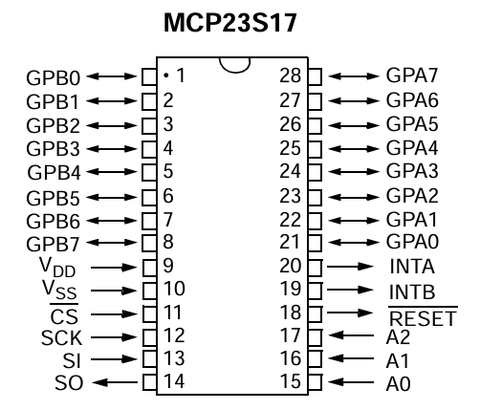
Figure: MCP23S17 28-pin configuration (redrawn from datasheet DS20001952C, Pin Configuration, Page 2).

4.16 MCP23S17 Hardware Address Configuration
Multiple MCP23S17 devices can share the same SPI communication bus by assigning a unique hardware address to each device. The address is determined using the three hardware address pins A2, A1, A0. Each pin can be connected externally to Logic HIGH (VDD) or Logic LOW (GND). The combination of these three bits creates eight possible device addresses. The device address is detected by the MCP23S17 during SPI communication when hardware addressing is enabled.

4.16.1 Hardware Address Detection
The address pins are not automatically sensed continuously. Instead, the MCP23S17 internally reads the logic state present at A2, A1, and A0 during operation.
MCP0: A2=0 A1=0 A0=0 -> Device Address = 000
MCP1: A2=0 A1=0 A0=1 -> Device Address = 001
The firmware includes this address information while generating the SPI control byte.

4.17 SPI Control Byte Generation
Every SPI transaction begins with the transmission of a control byte. The MCP23S17 SPI control byte consists of:
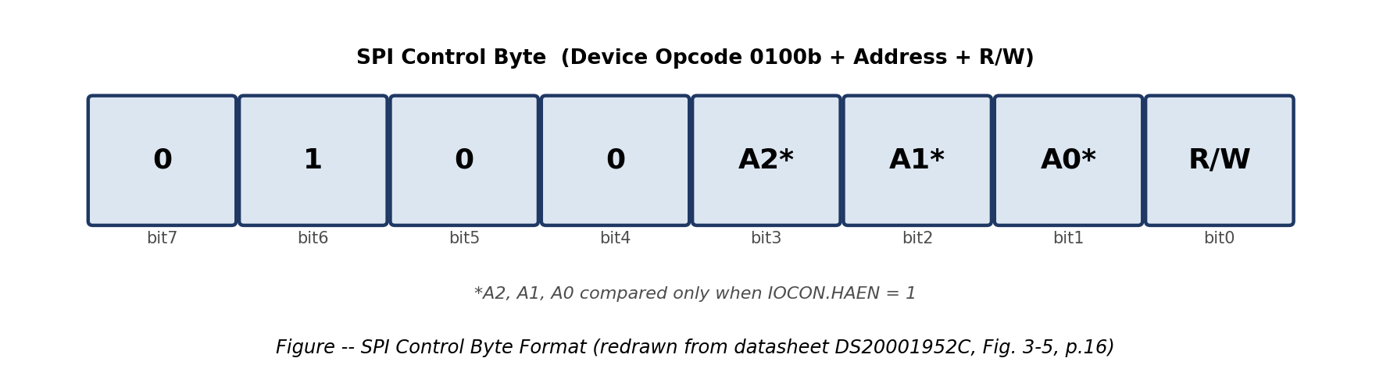
Figure: SPI control byte format -- 0 1 0 0 A2 A1 A0 R/W (redrawn from datasheet DS20001952C, Figure 3-5, Page 16).
Bit | Description
7:5 | Fixed opcode bits
4:2 | Hardware address bits
1 | Reserved
0 | Read/Write selection

Example Calculation
For MCP23S17 device with A2A1A0 = 010: Write operation (R/W = 0) gives control byte 0100 0100 binary, i.e. 44H. Read operation (R/W = 1) gives control byte 0100 0101 binary, i.e. 45H.

4.18 MCP23S17 Register Organization
The MCP23S17 contains multiple internal registers used for configuration and GPIO control. The important registers used in the electronic switch matrix are:
Table 4.8 Important MCP23S17 Registers
Register | Address | Function
IODIRA | 00H | Configures GPIOA direction
IODIRB | 01H | Configures GPIOB direction
IOCON | 0AH/0BH | Configuration control
GPIOA | 12H | Reads GPIOA status
GPIOB | 13H | Reads GPIOB status
OLATA | 14H | Output latch for GPIOA
OLATB | 15H | Output latch for GPIOB

4.19 GPIO Direction Configuration
Before controlling a MOSFET switch, the corresponding MCP23S17 pin must be configured as an output. The direction of each GPIO pin is controlled using the IODIRA and IODIRB registers, where IODIR = 0 configures an output and IODIR = 1 configures an input.
Example
To configure all GPIOA pins as outputs: IODIRA = 00000000 binary = 00H. The SPI transaction consists of the Control Byte, followed by the IODIRA address, followed by the data byte.

4.20 GPIO Output Control Using OLAT Register
The output state of the MCP23S17 GPIO pins is controlled using Output Latch registers: OLATA = 14H for Port A, OLATB = 15H for Port B.
OLAT Register -> GPIO Output Pin -> MOSFET Gate -> Load Switching

4.21 SPI Write Sequence for GPIO Control
The complete SPI write operation consists of three bytes: Byte 1 -- SPI Control Byte; Byte 2 -- Register Address; Byte 3 -- Data Byte.
Example: Writing GPIOA Output
CS = LOW Transmit 44H -> Transmit 12H -> Transmit Data CS = HIGH
The SPI write operation sequence is described in the MCP23S17 datasheet SPI interface section.

4.22 Summary
This section explained the internal architecture and register-level operation of the MCP23S17 GPIO expander used in the electronic switch matrix. The MCP23S17 provides sixteen GPIO channels and enables expansion of the microcontroller output capability through SPI communication. Hardware addressing using A2, A1, and A0 allows multiple devices to operate on a common SPI bus. The firmware selects the required device by generating the appropriate SPI control byte and modifies only the required output channel through register-level operations.

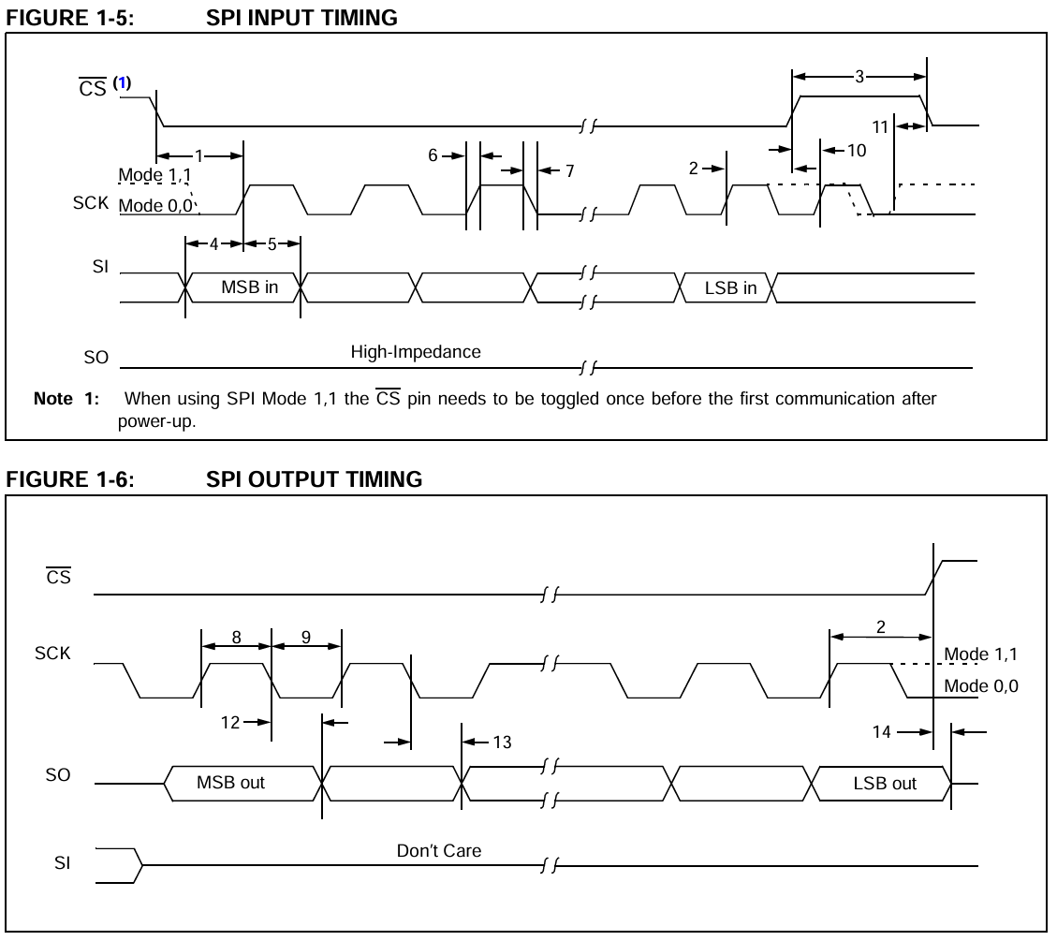

Figure 4.12: SPI write timing diagram (redrawn from datasheet DS20001952C, SPI Timing Characteristics, Page 8).

Part 4: Detailed Channel Activation Process, Register-Level Operation and MOSFET Switching

4.23 Channel Control Operation Overview
The primary function of the electronic switch matrix is to control individual high-power subsystem lines based on commands received from the Industrial PC. Each switching operation involves a complete data flow starting from the application command frame and ending with the activation of the corresponding MOSFET switch.
The complete operation involves the following stages:
- Command generation from Industrial PC.
- Ethernet frame transmission.
- Reception and validation by Ethernet module.
- Command decoding by microcontroller.
- Selection of required MCP23S17 device.
- Selection of required GPIO channel.
- SPI register operation.
- GPIO state update.
- MOSFET gate drive generation.
- Load activation.
- Status verification.
- Acknowledgement transmission.

4.24 Channel Address Mapping
Each MCP23S17 device provides sixteen GPIO channels. The channel distribution for four MCP23S17 devices is:
Table 4.9 Channel Allocation
Device | Hardware Address | Channels
MCP0 | A2A1A0 = 000 | Channel 0-15
MCP1 | A2A1A0 = 001 | Channel 16-31
MCP2 | A2A1A0 = 010 | Channel 32-47
MCP3 | A2A1A0 = 011 | Channel 48-63

Total available switching channels: N = 4 x 16 = 64 channels.

4.25 Example 1: Driving Channel 0 of MCP23S17
Consider the requirement: Turn ON Channel 0 connected to MCP0, where Device = MCP0, A2A1A0 = 000, Channel = GPA0.
Step 1: Identify Device Address
MCP0 address: A2 = 0, A1 = 0, A0 = 0. Therefore Address = 000.
Step 2: Generate SPI Control Byte
The MCP23S17 SPI control byte format is 0 1 0 0 A2 A1 A0 R/W. For MCP0, write operation (R/W = 0) gives 01000000 binary = 40H.

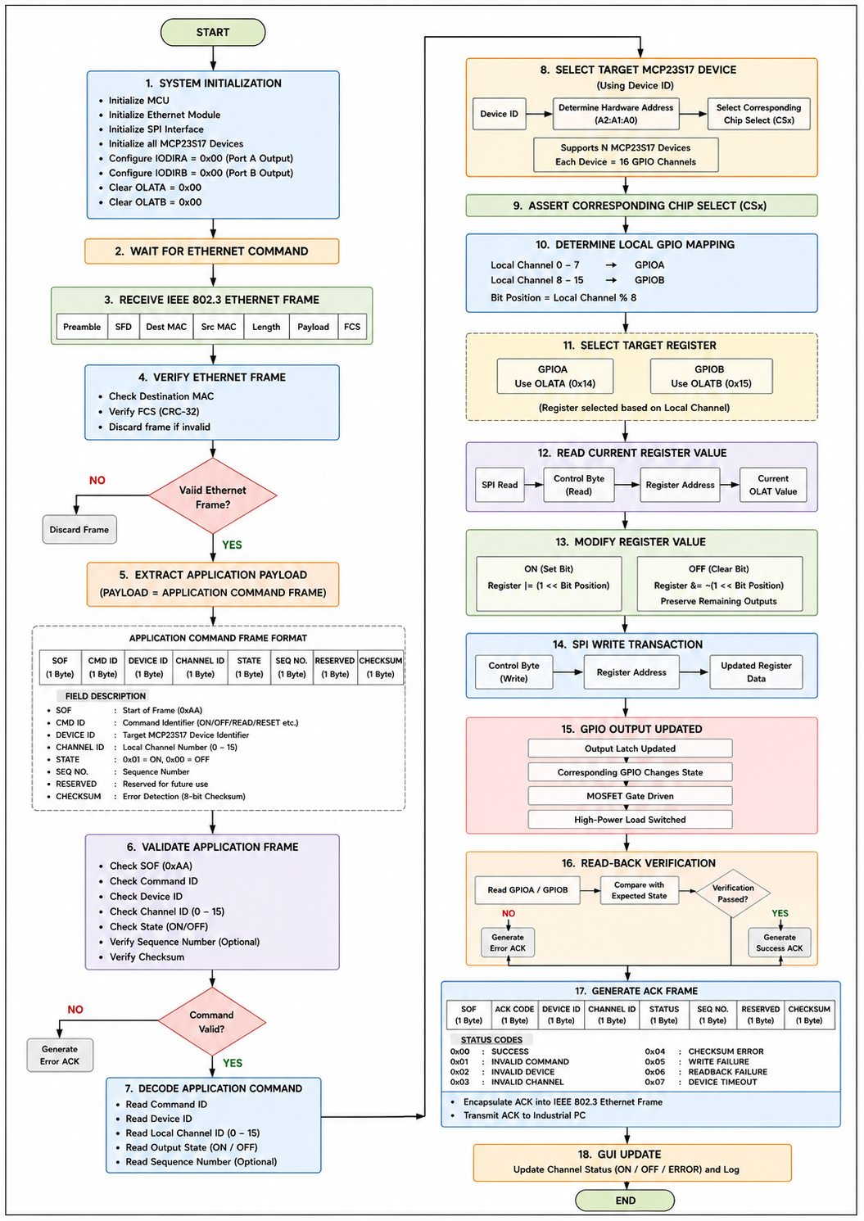
Figure 4.13: Universal channel activation flow.

Step 3: Configure GPIO Direction
Before writing output data, GPA0 must be configured as an output. IODIRA register address = 00H, data = 00000000.
Byte | Value
Control Byte | 40H
Register Address | 00H
Data | 00H

Operation: CS LOW -> 40H -> 00H -> 00H -> CS HIGH. Result: All GPIOA pins become outputs.
Step 4: Write Output Data
GPIOA register = 12H. To turn ON GPA0: binary 00000001 = 01H.
Byte | Data
Control Byte | 40H
Register Address | 12H
Data | 01H

Step 5: GPIO Output Response
After successful SPI write, MCP23S17 GPA0 transitions from LOW to HIGH. The voltage transition drives the MOSFET gate.
Step 6: MOSFET Switching
MCP23S17 GPIO -> Gate Resistor -> MOSFET Gate -> MOSFET ON -> Power Applied to Load

Figure 4.14: Channel 0 switching operation (SPI frame 40H 12H 01H -> GPIOA0 = 1 -> MOSFET gate HIGH -> load voltage ON).

4.26 Example 2: Driving Channel 9 of MCP23S17
Consider Channel = 9. Since each MCP23S17 has GPIOA = Channel 0-7 and GPIOB = Channel 8-15, Channel 9 corresponds to GPB1.
Step 1: Identify Port
Channel | GPIO
0 | GPA0
1 | GPA1
... | ...
7 | GPA7
8 | GPB0
9 | GPB1
Step 2: Select MCP Device
Assume MCP2: A2A1A0 = 010. Control byte for write: 01000100 binary = 44H.
Step 3: Configure GPIOB
IODIRB address = 01H, data = 00000000.
Byte | Value
Control Byte | 44H
Register Address | 01H
Data | 00H
Step 4: Write GPB1 Output
GPIOB register = 13H. GPB1 ON: binary 00000010 = 02H.
SPI frame: 44H 13H 02H

4.27 Read-Modify-Write Operation
In a multi-channel switching system, directly writing the entire GPIO register can unintentionally change the state of other channels. Therefore, a read-modify-write method is preferred.
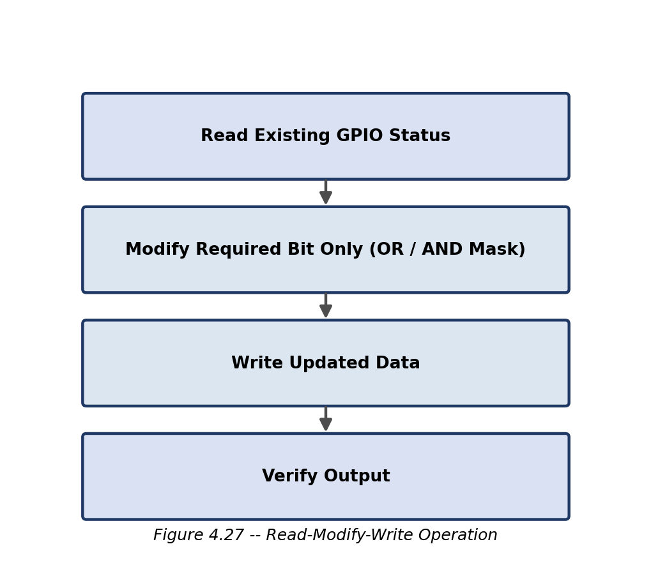
Figure 4.27: Read-modify-write operation sequence.
Example
Existing GPIOB: 10100000. Need to turn ON GPB1, mask = 00000010. Operation: NewData = ExistingData OR Mask = 10100000 OR 00000010 = 10100010. Only GPB1 changes.

4.28 Acknowledgement Generation
After the switching operation, the microcontroller verifies the output state.
Verification process:
- Read GPIO register.
- Compare actual state with requested state.
- Generate acknowledgement.
Table 4.10 Acknowledgement Frame
Field | Description
SOF | Start byte
Command ID | Executed command
Device ID | MCP23S17 address
Channel ID | Channel status
Status | Success/Failure
Checksum | Error verification
EOF | End byte

Example: AA 01 00 00 01 XX 55, meaning: Command executed successfully, MCP0, Channel 0, ON state.

4.29 Timing Relationship of Complete Operation
The switching sequence occurs in the following order:
PC Command -> [Ethernet Delay] -> Ethernet Module -> [Processing Delay] -> Microcontroller -> [SPI Transfer] -> MCP23S17 -> [GPIO Delay] -> MOSFET -> [Switching Time] -> Load Activation -> ACK Returned

Figure 4.15: Complete switching timing diagram.

Summary
This section explained the complete register-level operation required to control individual channels of the electronic switch matrix. The operation begins with Ethernet command reception and ends with MOSFET-controlled subsystem power switching. The MCP23S17 device address, SPI control byte, register address, and output data are calculated according to the intended channel. Channel 0 operation demonstrates GPIOA control, while Channel 9 demonstrates GPIOB control. The read-modify-write mechanism ensures that only the intended channel changes without affecting other subsystem outputs.Part 5: End-to-End System Operation, Power Switching, Fault Handling, and Summary

4.30 End-to-End Functional Operation of the Electronic Switch Matrix
The electronic switch matrix is designed to provide reliable, deterministic, and remotely controlled switching of multiple Crew Module subsystem power lines. The operation begins with command generation at the Industrial PC and concludes with the successful energization or de-energization of the selected subsystem load. Throughout this process, communication integrity is maintained using Ethernet frame validation, SPI communication, GPIO verification, and acknowledgement (ACK) generation.
The complete system operation follows the sequence shown in Figure 4.16.

Figure 4.16: Complete operational flow of the electronic switch matrix from command generation to subsystem load control.

4.31 MOSFET Driver Stage
The GPIO outputs of the MCP23S17 cannot directly switch high-current subsystem loads. Therefore, each GPIO output drives the gate terminal of a discrete MOSFET electronic switch. The MOSFET acts as a high-speed electronic switch capable of controlling the required load current while isolating the GPIO circuitry from the power stage.
The MOSFET driver stage consists of:
- MCP23S17 GPIO output
- Gate resistor
- N-channel MOSFET
- Load
- DC power supply
When the GPIO output is logic HIGH, the MOSFET gate receives sufficient voltage to turn ON the device, allowing current to flow through the subsystem load. Conversely, a logic LOW at the GPIO output turns the MOSFET OFF, disconnecting the load from the power supply.
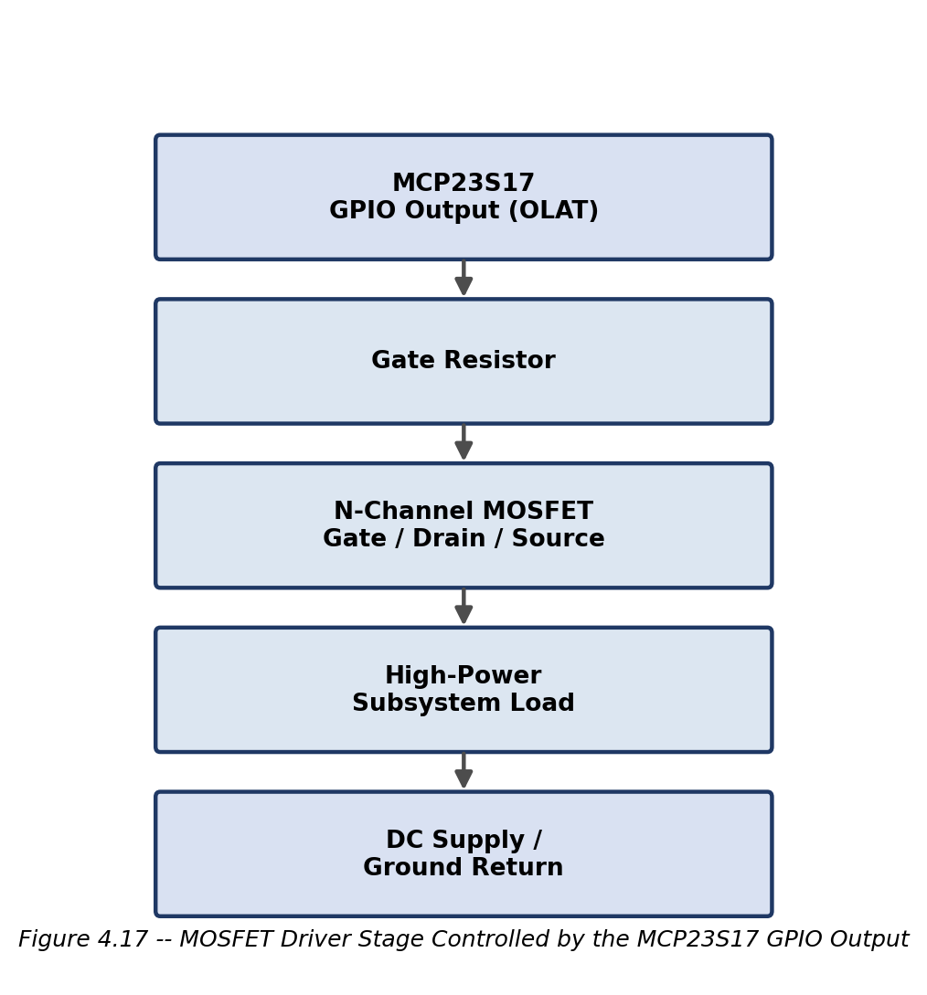

4.32 Signal Timing During Channel Switching
A successful switching operation involves the following signal transitions:
- Ethernet frame transmission from the Industrial PC.
- SPI communication between the microcontroller and the selected MCP23S17.
- GPIO output transition.
- MOSFET gate voltage transition.
- Load voltage activation.
- Acknowledgement transmission.
These events occur sequentially to ensure deterministic operation.

Figure 4.18: Typical timing relationship between Ethernet communication, SPI transfer, GPIO update, MOSFET switching, and acknowledgement generation.

4.33 GPIO and Load Waveforms
GPIO Output Waveform
The GPIO pin changes state only after the corresponding register update is completed.
MOSFET Gate Voltage
When the gate voltage exceeds the MOSFET threshold voltage, the MOSFET enters the ON state.
Load Voltage
The load receives the supply voltage only while the MOSFET remains ON.

Figure: GPIO output, MOSFET gate voltage, and load voltage waveforms.

4.34 Fault Detection and Error Handling
To ensure reliable operation, the electronic switch matrix incorporates multiple verification stages.
1. Ethernet Frame Validation
The Ethernet module verifies the Frame Check Sequence (FCS). Frames with incorrect CRC values are discarded.
2. Application Frame Validation
The microcontroller checks the Start of Frame (SOF), End of Frame (EOF), command identifier, device identifier, channel identifier, and checksum.
3. SPI Communication Verification
SPI communication is monitored to ensure that the correct control byte, register address, and data bytes are transmitted to the intended MCP23S17 device.
4. GPIO Read-Back Verification
After writing to the GPIO register, the microcontroller reads back the GPIO status to confirm that the requested output state has been successfully applied.
5. Acknowledgement Generation
A success ACK is generated only if all verification stages are completed without errors. Otherwise, an error ACK indicating the failure condition is transmitted to the Industrial PC.
Table 4.11 Fault Detection Mechanisms
Stage | Verification | Action on Failure
Ethernet | Frame Check Sequence (CRC) | Discard frame
Application Layer | SOF, EOF, checksum | Reject command
SPI Communication | Control byte and register access | Retry or report error
GPIO Verification | Read-back of output state | Generate error ACK
Load Switching | Output status confirmation | Notify operator

4.35 Advantages of the Proposed Architecture
The proposed Ethernet-based electronic switch matrix provides several advantages over conventional manual switching systems:
- Remote operation from a centralized Industrial PC.
- Scalable architecture supporting multiple MCP23S17 devices.
- Reduced microcontroller GPIO requirements through SPI expansion.
- Modular hardware design simplifying maintenance and future expansion.
- Fast switching using solid-state MOSFETs.
- Read-back verification ensuring reliable channel control.
- Acknowledgement-based communication for improved reliability.
- Suitable for integration into aerospace electronic test systems.

4.36 Summary
This chapter presented the communication architecture and operational methodology of the Ethernet-based multi-channel electronic switch matrix developed for Crew Module subsystem testing.
The architecture integrates an Industrial PC, Ethernet communication, an embedded microcontroller, multiple MCP23S17 SPI-based GPIO expanders, and discrete MOSFET electronic switches to provide reliable control of multiple high-power subsystem lines. The communication process begins with an application command generated by the operator, followed by Ethernet transmission, command validation, SPI communication, register-level GPIO updates, MOSFET switching, and acknowledgement generation.
The use of multiple MCP23S17 devices enables scalable expansion while minimizing the number of microcontroller GPIO pins required. Register-level operations, including configuration of IODIR, GPIO, and OLAT registers, provide precise control of individual output channels. The implementation of read-back verification and acknowledgement mechanisms enhances operational reliability and ensures that only successfully executed commands are reported to the operator.
The combination of Ethernet communication, SPI-based GPIO expansion, and MOSFET switching provides a modular, efficient, and robust solution for remotely controlling multiple subsystem power lines in aerospace electronic test environments.

Appendix A: MCP23S17 Datasheet Cross-Reference Index (DS20001952C)
The following index lists the datasheet section, figure, or register table used as the technical basis for each part of this chapter, together with the corresponding page number in the MCP23S17/MCP23017 datasheet (DS20001952C). Figures reproduced in this chapter are redrawn from the cited datasheet locations for clarity and consistent formatting; they are not scanned reproductions of the original datasheet artwork.
Report Section | Datasheet Section / Figure | Datasheet Page
MCP23S17 Functional Block Diagram | Functional Block Diagram | Page 2
MCP23S17 Pin Diagram | Pin Configuration | Page 2
Device Overview | Section 3.0 Device Overview | Page 12
GPIO Architecture | Section 3.4 GPIO Port | Page 16
SPI Input Timing | Figure 1-5 | Page 8
SPI Output Timing | Figure 1-6 | Page 8
GPIO & Interrupt Timing | Figure 1-7 | Page 9
SPI Interface Description | Section 3.2.3 | Page 15
SPI Write Operation | Section 3.2.3.1 | Page 15
SPI Read Operation | Section 3.2.3.2 | Page 15
Sequential SPI Read/Write | Section 3.2.3.3 | Page 16
SPI Control Byte | Figure 3-5 | Page 16
Hardware Address Decoder | Section 3.3 | Page 16
A2, A1, A0 Addressing | Section 3.3.2 | Page 16
IOCON Register (HAEN bit) | Section 3.5.7 | Page 22
GPIO Pull-up Register | GPPU Register | Page 22
Interrupt Flag Register | INTF Register | Page 22

In addition, the Ethernet frame structure and IEEE 802.3 timing concepts referenced in Sections 4.6.2, 4.9, and 4.10 are based on Microchip Application Note AN1120 (“Ethernet Theory of Operation,” DS01120A).

