
ĐẠI HỌC QUỐC GIA THÀNH PHỐ HỒ CHÍ MINH TRƯỜNG ĐẠI HỌC CÔNG NGHỆ THÔNG TIN KHOA MẠNG MÁY TÍNH & TRUYỀN THÔNG

MÔN MẬT MÃ HỌC

BÀI TẬP THỰC HÀNH 06: Mật mã học

GVHD: Nguyễn Ngọc Tự
Sinh viên thực hiện:
Trần Hồng Quân (23521271)

 Tp. Hồ Chí Minh, 25/06/2025 

*DES:
-CBC:
Input size | OS | Encrypt Time (ms) | Decrypt Time (ms) | OS | Encrypt Time (ms) | Decrypt Time (ms)
1KB | Window | 0.0176 | 0.0173 | Linux | 0.025 | 0.0228
10KB | Window | 0.1646 | 0.1439 | Linux | 0.2066 | 0.1789
100KB | Window | 1.6234 | 1.4079 | Linux | 1.936 | 1.854
500KB | Window | 9.0479 | 12.3188 | Linux | 10.0394 | 9.1391
1MB | Window | 30.6018 | 26.3554 | Linux | 19.7779 | 17.3949
5MB | Window | 81.465 | 67.7323 | Linux | 106.863 | 86.3669

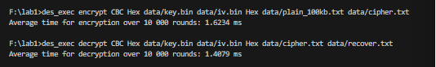
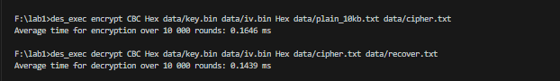
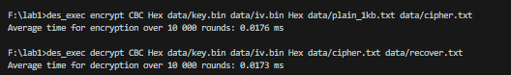
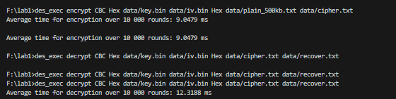
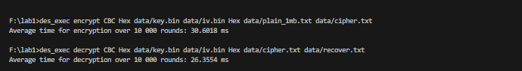
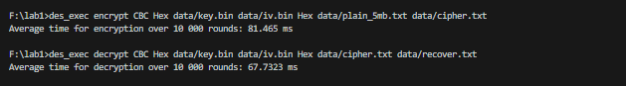
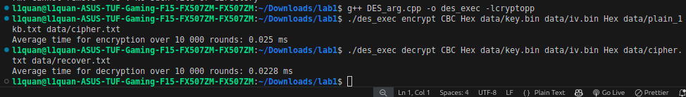
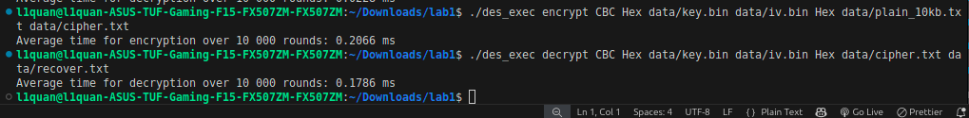
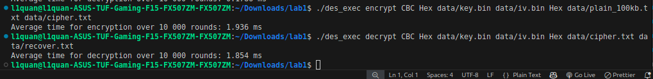
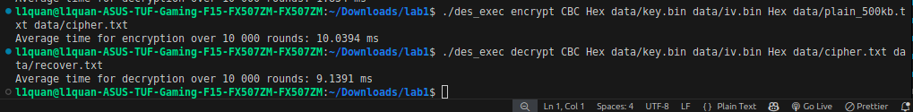
-ECB:
Input size | OS | Encrypt Time (ms) | Decrypt Time (ms) | OS | Encrypt Time (ms) | Decrypt Time (ms)
1KB | Window | 0.0148 | 0.0161 | Linux | 0.024 | 0.0261
10KB | Window | 0.1421 | 0.1294 | Linux | 0.1826 | 0.1978
100KB | Window | 1.3435 | 1.3179 | Linux | 2.0833 | 1.9116
500KB | Window | 7.0186 | 6.5892 | Linux | 9.3897 | 9.3944
1MB | Window | 13.656 | 14.3122 | Linux | 21.9997 | 27.8782
2MB | Window | 27.8738 | 29.3418 | Linux | 44.109 | 46.0688

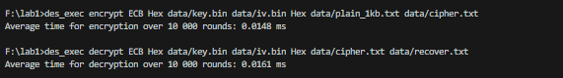
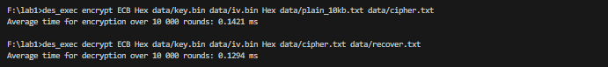
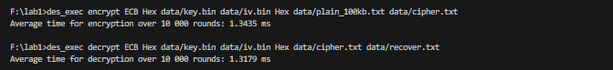
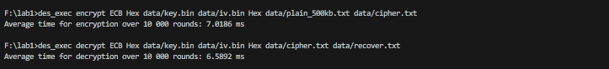
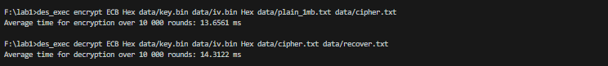
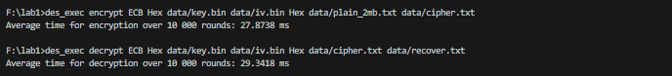
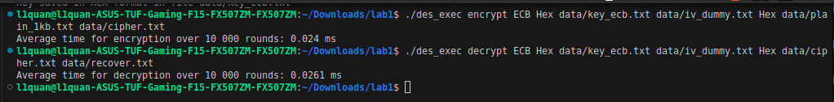
-OFB:
Input size | OS | Encrypt Time (ms) | Decrypt Time (ms) | OS | Encrypt Time (ms) | Decrypt Time (ms)
1KB | Window | 0.0208 | 0.0195 | Linux | 0.0249 | 0.0239
10KB | Window | 0.1762 | 0.1559 | Linux | 0.1958 | 0.2021
100KB | Window | 1.6203 | 1.631 | Linux | 1.9363 | 1.9702
500KB | Window | 8.0949 | 8.3643 | Linux | 9.8611 | 12.887
1MB | Window | 16.9719 | 17.0341 | Linux | 25.6046 | 24.5181
2MB | Window | 32.401 | 31.6228 | Linux | 46.9365 | 47.9532

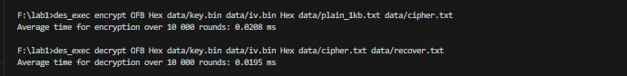
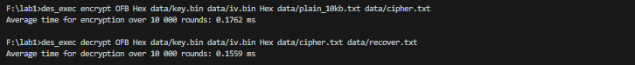
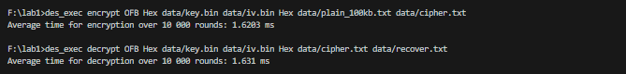
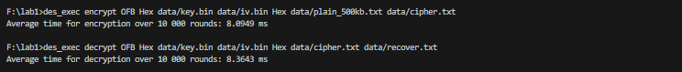
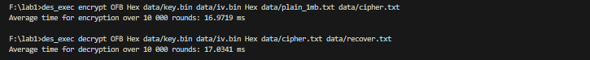
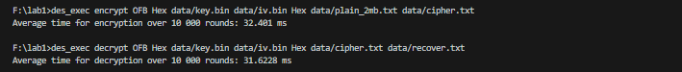

-CFB:
Input size | OS | Encrypt Time (ms) | Decrypt Time (ms) | OS | Encrypt Time (ms) | Decrypt Time (ms)
1KB | Window | 0.0188 | 0.0146 | Linux | 0.0264 | 0.0227
10KB | Window | 0.1742 | 0.1497 | Linux | 0.2116 | 0.2221
100KB | Window | 1.491 | 1.3585 | Linux | 2.1247 | 1.9253
500KB | Window | 7.9338 | 7.1079 | Linux | 12.1284 | 12.7705
1MB | Window | 15.9668 | 14.0543 | Linux | 24.9029 | 18.0097
2MB | Window | 32.2219 | 28.5955 | Linux | 51.3319 | 39.5892

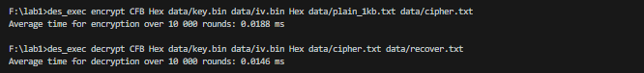
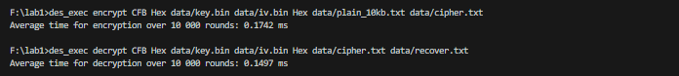
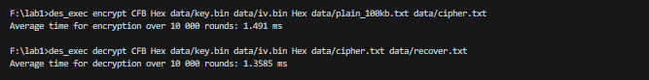
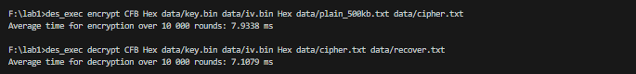
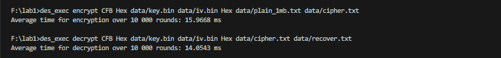
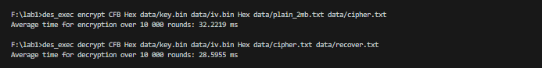
-CTR:

Input size | OS | Encrypt Time (ms) | Decrypt Time (ms) | OS | Encrypt Time (ms) | Decrypt Time (ms)
1KB | Window | 0.0167 | 0.0153 | Linux | 0.0257 | 0.0272
10KB | Window | 1.1581 | 0.1798 | Linux | 0.2224 | 0.2179
100KB | Window | 1.5243 | 1.5858 | Linux | 2.2572 | 2.2581
500KB | Window | 8.3589 | 8.5946 | Linux | 15.1833 | 14.2151
1MB | Window | 16.5838 | 17.1592 | Linux | 31.2448 | 22.71
2MB | Window | 32.8151 | 32.2253 | Linux | 43.8222 | 45.0988

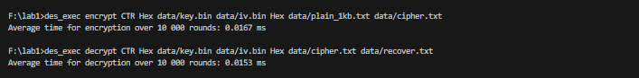
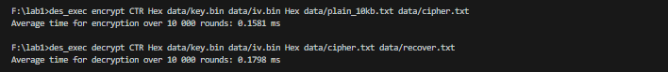
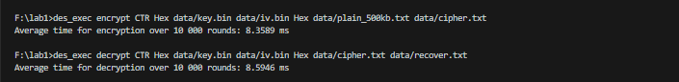
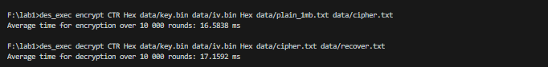
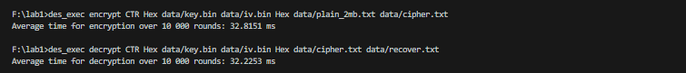

*AES:
-ECB
Input size | OS | Encrypt Time (ms) | Decrypt Time (ms) | OS | Encrypt Time (ms) | Decrypt Time (ms)
1KB | Window | 0.003 | 0.0018 | Linux | 0.0028 | 0.003
10KB | Window | 0.0041 | 0.0039 | Linux | 0.0112 | 0.0094
100KB | Window | 0.0192 | 0.0189 | Linux | 0.0582 | 0.057
300KB | Window | 0.0548 | 0.0547 | Linux | 0.161 | 0.162
1MB | Window | 0.1998 | 0.2049 | Linux | 0.5543 | 0.5554
2MB | Window | 0.421 | 0.4264 | Linux | 1.1131 | 1.0893

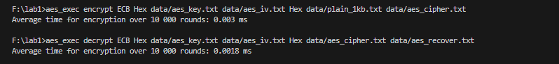
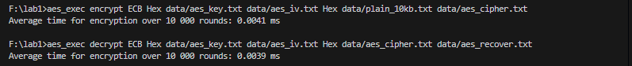
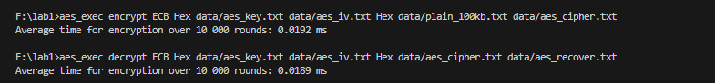
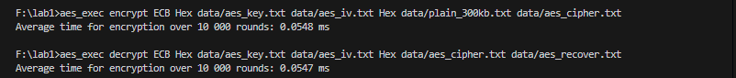
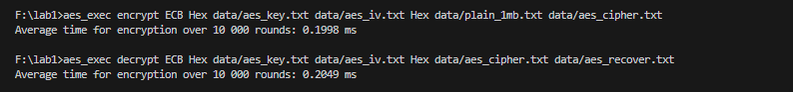
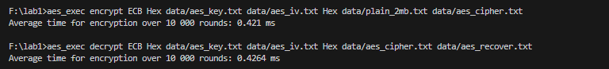

-CBC:
Input size | OS | Encrypt Time (ms) | Decrypt Time (ms) | OS | Encrypt Time (ms) | Decrypt Time (ms)
1KB | Window | 0.0034 | 0.002 | Linux | 0.0042 | 0.0031
10KB | Window | 0.0126 | 0.0039 | Linux | 0.0187 | 0.0092
100KB | Window | 0.1091 | 0.0212 | Linux | 0.2037 | 0.0727
300KB | Window | 0.3373 | 0.059 | Linux | 0.4624 | 0.1161
1MB | Window | 1.4637 | 0.2084 | Linux | 1.7474 | 0.6089
2MB | Window | 2.9926 | 0.5098 | Linux | 3.4379 | 1.2737

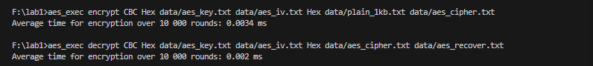
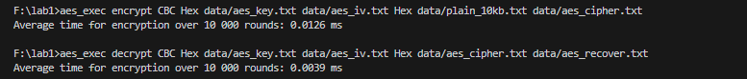
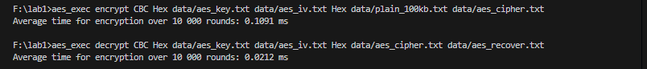
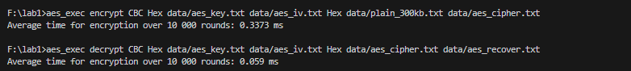
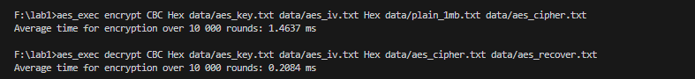
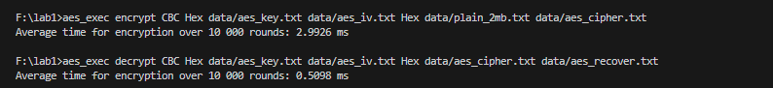

-OFB:
Input size | OS | Encrypt Time (ms) | Decrypt Time (ms) | OS | Encrypt Time (ms) | Decrypt Time (ms)
1KB | Window | 0.0028 | 0.0027 | Linux | 0.0048 | 0.0047
10KB | Window | 0.0123 | 0.0125 | Linux | 0.0202 | 0.0201
100KB | Window | 0.1079 | 0.1082 | Linux | 0.1615 | 0.1596
300KB | Window | 0.3569 | 0.3431 | Linux | 0.4753 | 0.488
1MB | Window | 1.3967 | 1.4064 | Linux | 1.6294 | 1.734
2MB | Window | 2.9486 | 3.6237 | Linux | 3.2977 | 3.2963

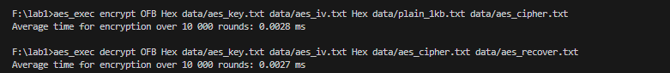
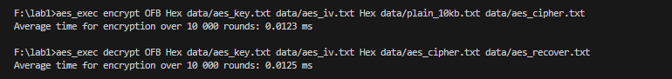
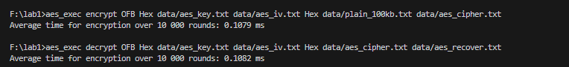
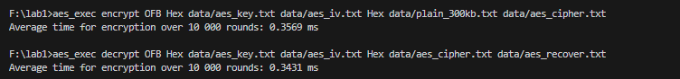
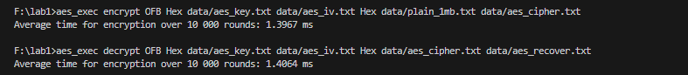
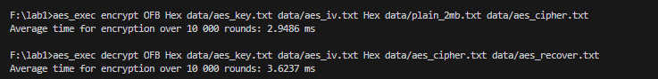

-CFB:
Input size | OS | Encrypt Time (ms) | Decrypt Time (ms) | OS | Encrypt Time (ms) | Decrypt Time (ms)
1KB | Window | 0.003 | 0.0024 | Linux | 0.0042 | 0.0033
10KB | Window | 0.0126 | 0.0054 | Linux | 0.023 | 0.0096
100KB | Window | 0.1103 | 0.0372 | Linux | 0.1604 | 0.0781
300KB | Window | 0.3479 | 0.1055 | Linux | 0.4635 | 0.1814
1MB | Window | 1.4672 | 0.4135 | Linux | 1.7149 | 0.7848
2MB | Window | 3.1055 | 0.9519 | Linux | 3.6412 | 1.4019

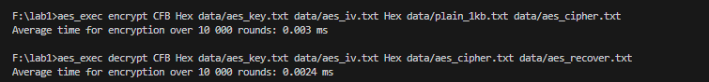
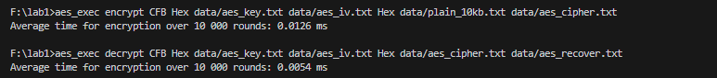
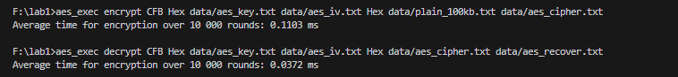
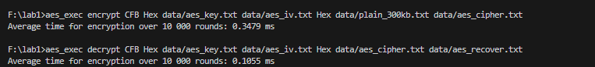
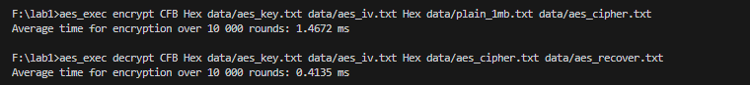
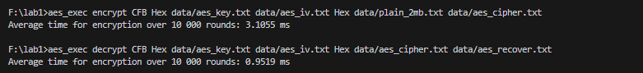
-CTR:
Input size | OS | Encrypt Time (ms) | Decrypt Time (ms) | OS | Encrypt Time (ms) | Decrypt Time (ms)
1KB | Window | 0.0021 | 0.002 | Linux | 0.0029 | 0.0031
10KB | Window | 0.0039 | 0.0039 | Linux | 0.0115 | 0.0087
100KB | Window | 0.022 | 0.0216 | Linux | 0.0591 | 0.0581
300KB | Window | 0.0598 | 0.0585 | Linux | 0.1644 | 0.1665
1MB | Window | 0.2197 | 0.2247 | Linux | 0.6691 | 0.5858
2MB | Window | 0.4875 | 0.5034 | Linux | 1.1416 | 1.2518

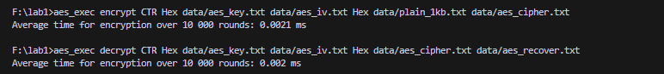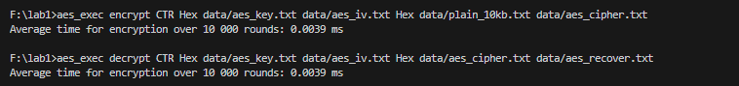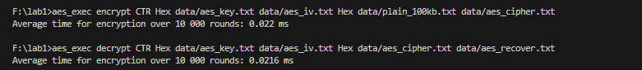
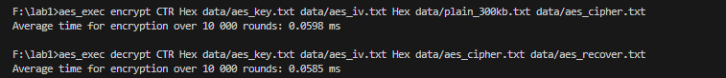
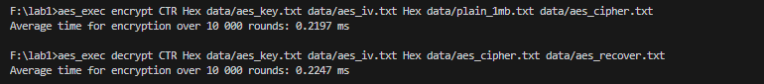
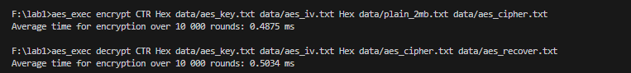
-XTS:
Input size | OS | Encrypt Time (ms) | Decrypt Time (ms) | OS | Encrypt Time (ms) | Decrypt Time (ms)
1KB | Window | 0.0029 | 0.0031 | Linux | 0.0053 | 0.0053
10KB | Window | 0.0118 | 0.012 | Linux | 0.0217 | 0.0218
100KB | Window | 0.1042 | 0.1054 | Linux | 0.1739 | 0.1758
300KB | Window | 0.329 | 0.3395 | Linux | 0.54 | 0.5094
1MB | Window | 1.3358 | 1.5171 | Linux | 1.7341 | 1.9372
2MB | Window | 2.9563 | 3.4957 | Linux | 3.678 | 3.5914

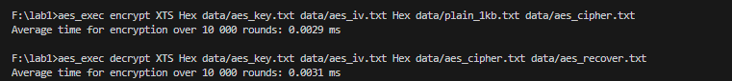
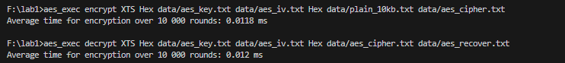
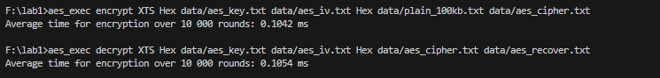
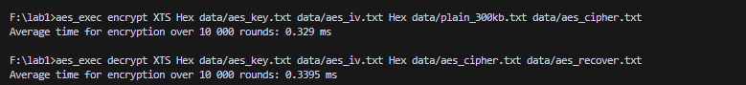
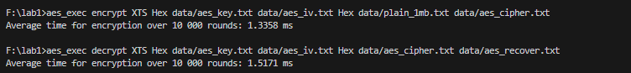
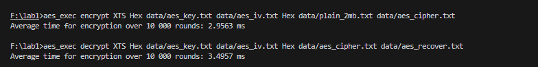

-CCM:
Input size | OS | Encrypt Time (ms) | Decrypt Time (ms) | OS | Encrypt Time (ms) | Decrypt Time (ms)
1KB | Window | 0.0043 | 0.0059 | Linux | 0.0062 | 0.0086
10KB | Window | 0.0155 | 0.0165 | Linux | 0.0376 | 0.0284
100KB | Window | 0.1292 | 0.1321 | Linux | 0.2064 | 0.2778
300KB | Window | 0.4023 | 0.4419 | Linux | 0.6083 | 0.6956
1MB | Window | 1.6463 | 1.7592 | Linux | 2.1813 | 2.2709
2MB | Window | 3.4688 | 4.3719 | Linux | 4.1637 | 4.3842

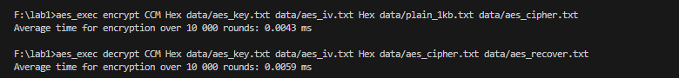
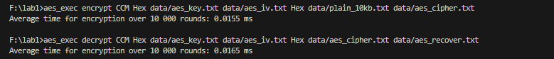
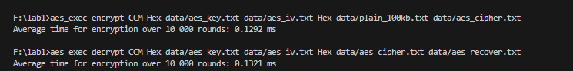
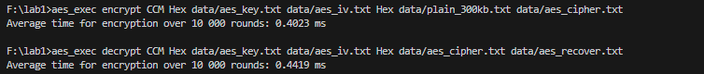
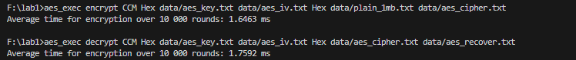
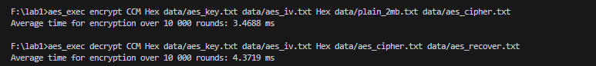

-GCM:

Input size | OS | Encrypt Time (ms) | Decrypt Time (ms) | OS | Encrypt Time (ms) | Decrypt Time (ms)
1KB | Window | 0.0034 | 0.005 | Linux | 0.0051 | 0.0062
10KB | Window | 0.0063 | 0.0074 | Linux | 0.0122 | 0.0138
100KB | Window | 0.0329 | 0.0349 | Linux | 0.0799 | 0.0729
300KB | Window | 0.0979 | 0.0987 | Linux | 0.2599 | 0.2682
1MB | Window | 0.3513 | 0.3513 | Linux | 0.7519 | 0.7986
2MB | Window | 0.8187 | 0.7827 | Linux | 1.5161 | 1.469

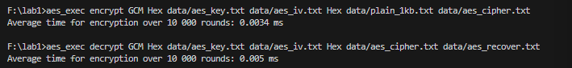
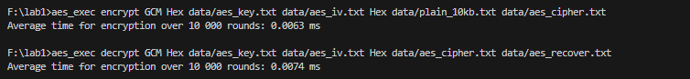
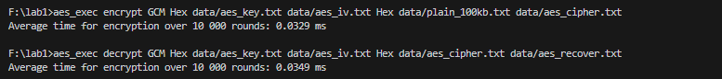
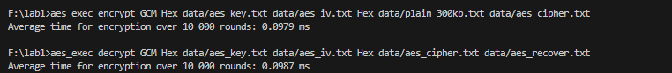
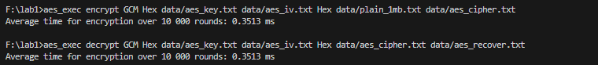
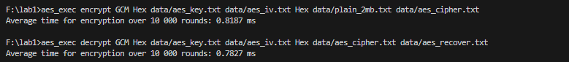

*SO SÁNH VÀ ĐÁNH GIÁ:
Chế độ AES nhanh hơn chế độ DES trong 7 trường hợp thử nghiệm trên cả Windows và Linux.
Thời gian thực thi tăng tương ứng kích thước tệp lớn.
Các chế độ ECB, CTR, GCM có thời gian thực thi nhanh hơn các chế độ khác trong lược đồ AES.
Các tệp có kích thước dưới 100 KB có thời gian thực thi nhanh hơn các tệp từ 100 KB.

