Учреждение образования

«Белорусский государственный университет

информатики и радиоэлектронике»

Кафедра инженерной психологии и эргономики

Отчет по

ЛАБОРАТОРНОЙ РАБОТЕ №6

Написание тестовой документации. Использование Selenium для тестирования веб-приложений.

Подготовил:

Студент гр. 010101

Листванович А.А.

Проверил:

Кабариха В.А.

Минск 2023

**TC_001.py**

from selenium import webdriver

from selenium.webdriver.common.by import By

from cfg import username, password

browser = webdriver.Firefox()

browser.get('http://localhost:8080/login')

username_field = browser.find_element(by=By.ID, value='username')

password_field = browser.find_element(by=By.ID, value='password')

username_field.send_keys(username)

password_field.send_keys(password)

submit_button = browser.find_element(by=By.CSS_SELECTOR, value='button.btn-primary')

submit_button.click()

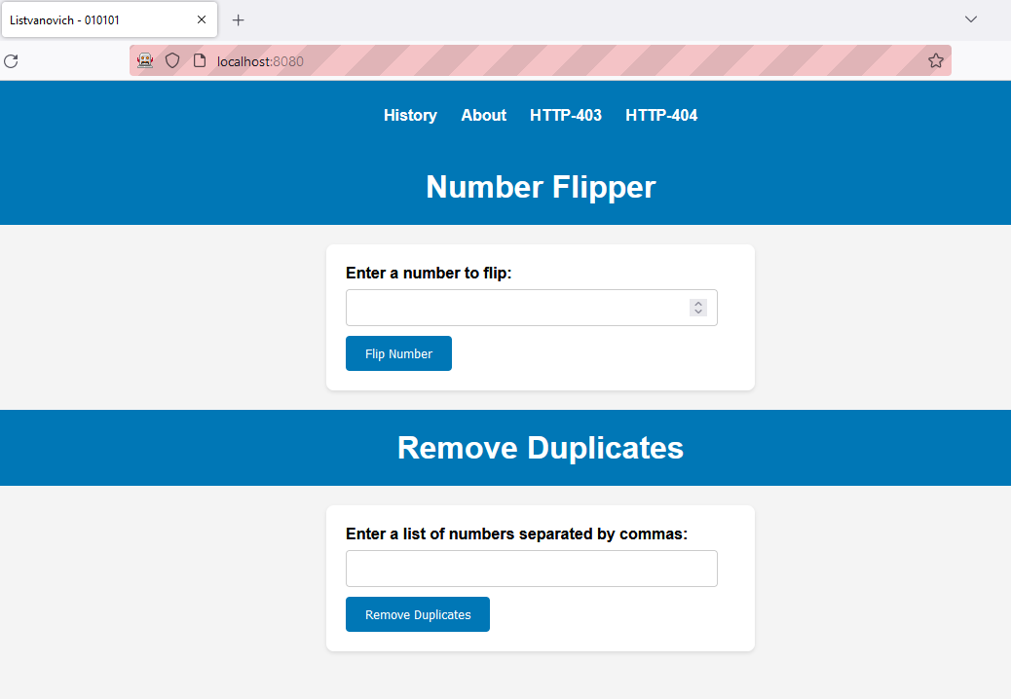

Результат выполнения TC_001.py

**TC_002.py**

from selenium import webdriver

from selenium.webdriver.common.by import By

browser = webdriver.Firefox()

browser.get('http://localhost:8080/login')

username_field = browser.find_element(by=By.ID, value='username')

password_field = browser.find_element(by=By.ID, value='password')

username_field.send_keys("wrong_user")

password_field.send_keys("simpleqwerty")

submit_button = browser.find_element(by=By.CSS_SELECTOR, value='button.btn-primary')

submit_button.click()

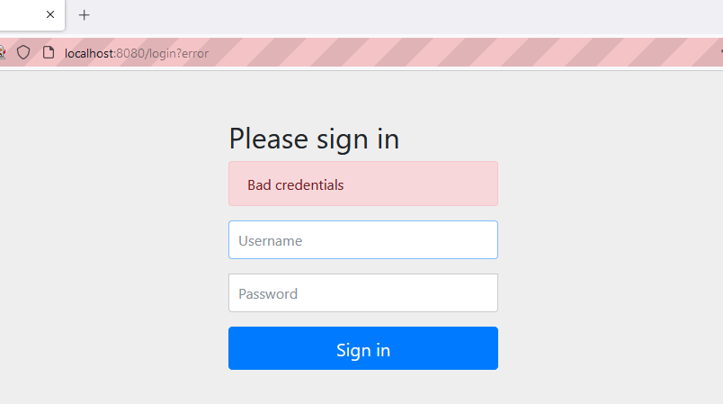

Результат выполнения TC_002.py

**TC_003.py**

from selenium import webdriver

from selenium.webdriver.common.by import By

from cfg import username, password

browser = webdriver.Firefox()

browser.get('http://localhost:8080/login')

username_field = browser.find_element(by=By.ID, value='username')

password_field = browser.find_element(by=By.ID, value='password')

username_field.send_keys(username)

password_field.send_keys(password)

submit_button = browser.find_element(by=By.CSS_SELECTOR, value='button.btn-primary')

submit_button.click()

number_to_flip_input = browser.find_element(by=By.ID, value='numberToFlip')

number_to_flip_input.send_keys('123456')

flip_button = browser.find_element(by=By.ID, value='btn_flipNumber')

flip_button.click()

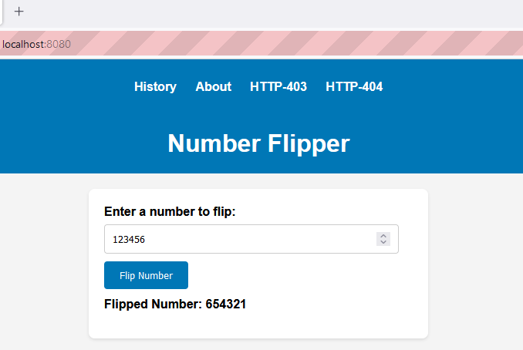

Результат выполнения TC_003.py

**TC_004.py**

from selenium import webdriver

from selenium.webdriver.common.by import By

from cfg import username, password

browser = webdriver.Firefox()

browser.get('http://localhost:8080/login')

username_field = browser.find_element(by=By.ID, value='username')

password_field = browser.find_element(by=By.ID, value='password')

username_field.send_keys(username)

password_field.send_keys(password)

submit_button = browser.find_element(by=By.CSS_SELECTOR, value='button.btn-primary')

submit_button.click()

number_to_flip_input = browser.find_element(by=By.ID, value='numberToFlip')

number_to_flip_input.send_keys(‘9999999999999999’)

flip_button = browser.find_element(by=By.ID, value='btn_flipNumber')

flip_button.click()

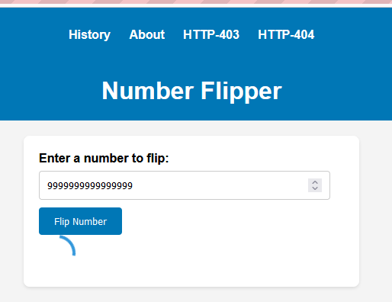

Результат выполнения TC_004.py

**TC_005.py**

from selenium import webdriver

from selenium.webdriver.common.by import By

from cfg import username, password

browser = webdriver.Firefox()

browser.get('http://localhost:8080/login')

username_field = browser.find_element(by=By.ID, value='username')

password_field = browser.find_element(by=By.ID, value='password')

username_field.send_keys(username)

password_field.send_keys(password)

submit_button = browser.find_element(by=By.CSS_SELECTOR, value='button.btn-primary')

submit_button.click()

numbers = browser.find_element(by=By.ID, value='numbers')

numbers.send_keys('1, 1, 2, 3, 4, 4, 5, 2')

flip_button = browser.find_element(by=By.ID, value='btn_removeDuplicates')

flip_button.click()

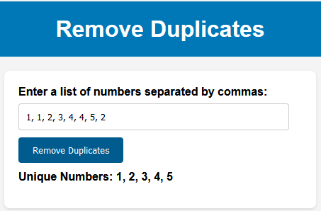

Результат выполнения TC_005.py

**TC_006.py**

from selenium import webdriver

from selenium.webdriver.common.by import By

from cfg import username, password

browser = webdriver.Firefox()

browser.get('http://localhost:8080/login')

username_field = browser.find_element(by=By.ID, value='username')

password_field = browser.find_element(by=By.ID, value='password')

username_field.send_keys(username)

password_field.send_keys(password)

submit_button = browser.find_element(by=By.CSS_SELECTOR, value='button.btn-primary')

submit_button.click()

numbers = browser.find_element(by=By.ID, value='numbers')

numbers.send_keys('random,string')

flip_button = browser.find_element(by=By.ID, value='btn_removeDuplicates')

flip_button.click()

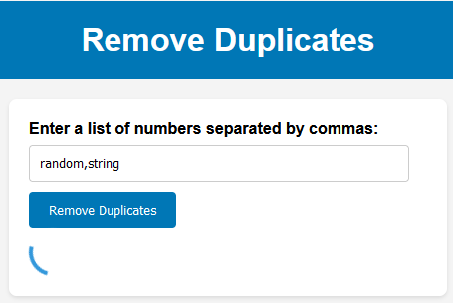

Результат выполнения TC_006.py