Array Code and Teamwork

By Tyler Kehn

**Introduction**

This was the first group project I have ever done, so I got to do something new for a change. I created a code that took user input for ten integers and told the user every combination of picking two random numbers from the given numbers (problem 7.28 in the book).

**Code and Outline**

Here is my code. The outline is given in the beginning.

**import** java.util.Scanner;

**public** **class** problem7_28 {

**static** **int**[] *integers*;

**public** **static** **void** main(String[] args) {

/*Outline

* Ask user to input ten integers

* Read input for the ten ints

* Tell user what all possible combinations

* of picking 2 random numbers from their inputs

* are

*/

// Asking the user for 10 integers.

System.***out***.println("Enter ten integers: ");

// Calling method that gathers user input for integers.

*combo*(*integers*);

}

// This method gathers user input.

**public** **static** **int** combo(**int**[]array){

// Gathers 10 integers from the user and puts them into an array. (integers).

*integers* = **new** **int**[10];

Scanner input = **new** Scanner(System.***in***);

**for** (**int** i = 0; i < 10; i++){

*integers*[i] = input.nextInt();

}

input.close();

// Informing the user of all possible combinations of the provided numbers.

System.***out***.println("All combinations of picking two numbers from the list are: ");

// Calling method to calculate combinations of provided numbers.

*comboGen*();

// Satisfying required return type.

**return** 0;

}

// This method calculates all possible combinations of the provided numbers.

**public** **static** **int** comboGen() {

// first number is the ten ints.

// second number is the ten ints, for each of the first ten ints.

**for** (**int** i = 0; i < 10; i++){

**for** (**int** j = 0; j < 10; j++){

System.***out***.print(*integers*[i] + " and " + *integers*[j] + ", ");

}

System.***out***.println();

}

// Satisfying required return type.

**return** 0;

}

}

**Console Output**

This is an example of an output:

Enter ten integers:

1 2 3 4 5 6 7 8 9 0

All combinations of picking two numbers from the list are:

1 and 1, 1 and 2, 1 and 3, 1 and 4, 1 and 5, 1 and 6, 1 and 7, 1 and 8, 1 and 9, 1 and 0,

2 and 1, 2 and 2, 2 and 3, 2 and 4, 2 and 5, 2 and 6, 2 and 7, 2 and 8, 2 and 9, 2 and 0,

3 and 1, 3 and 2, 3 and 3, 3 and 4, 3 and 5, 3 and 6, 3 and 7, 3 and 8, 3 and 9, 3 and 0,

4 and 1, 4 and 2, 4 and 3, 4 and 4, 4 and 5, 4 and 6, 4 and 7, 4 and 8, 4 and 9, 4 and 0,

5 and 1, 5 and 2, 5 and 3, 5 and 4, 5 and 5, 5 and 6, 5 and 7, 5 and 8, 5 and 9, 5 and 0,

6 and 1, 6 and 2, 6 and 3, 6 and 4, 6 and 5, 6 and 6, 6 and 7, 6 and 8, 6 and 9, 6 and 0,

7 and 1, 7 and 2, 7 and 3, 7 and 4, 7 and 5, 7 and 6, 7 and 7, 7 and 8, 7 and 9, 7 and 0,

8 and 1, 8 and 2, 8 and 3, 8 and 4, 8 and 5, 8 and 6, 8 and 7, 8 and 8, 8 and 9, 8 and 0,

9 and 1, 9 and 2, 9 and 3, 9 and 4, 9 and 5, 9 and 6, 9 and 7, 9 and 8, 9 and 9, 9 and 0,

0 and 1, 0 and 2, 0 and 3, 0 and 4, 0 and 5, 0 and 6, 0 and 7, 0 and 8, 0 and 9, 0 and 0,

**Discussion**

The writing of the code was pretty simple; therefore, I hard-coded the whole thing, although I did use principles from earlier examples from the book. The question did not specify a lot or give an example, so I did the code the way I thought it should be done while maintaining simplicity. It served its purpose—I learned how to use arrays in Java.

**Team Effort Distribution**

I wrote the meat of the code, Riley put my some of my code into a custom method that was referred to in the main method, and Conner changed the code and made it prettier and more efficient.

**github Use**

We used github to exchange our information. After some practice, we all were pretty fluent in exchanging information via github and the command prompt. We used the commands correctly, and we each uploaded a few random test text documents. When we had the technique down, we did our own code and uploaded it, and the other members took our code and added their own code to it and re-uploaded it.

**github Branch**

Here is our network branch from github:

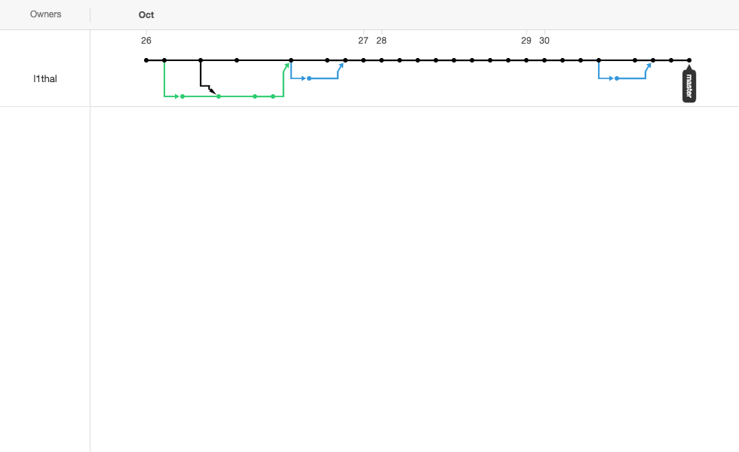

**github commit messages**

Here are our commit messages for github:

|  |  |  |
| --- | --- | --- |
| [Conner](https://github.com/l1thal/CSHomeworkAssignment/tree/master/Conner) | [sorted and finals added.](https://github.com/l1thal/CSHomeworkAssignment/commit/172cfb436b975a6c58776b16228e7cd82fe4799d) | an hour ago |
|  | [Resources](https://github.com/l1thal/CSHomeworkAssignment/tree/master/Resources) | [adding assignment instructions](https://github.com/l1thal/CSHomeworkAssignment/commit/8c59d6e4cb52ea147eed7676fd8152b436149c2c) | 3 days ago |
|  | [Riley](https://github.com/l1thal/CSHomeworkAssignment/tree/master/Riley) | [sorted and finals added.](https://github.com/l1thal/CSHomeworkAssignment/commit/172cfb436b975a6c58776b16228e7cd82fe4799d) | an hour ago |
|  | [Tyler](https://github.com/l1thal/CSHomeworkAssignment/tree/master/Tyler) | [sorted and finals added.](https://github.com/l1thal/CSHomeworkAssignment/commit/172cfb436b975a6c58776b16228e7cd82fe4799d) | an hour ago |
|  | [git](https://github.com/l1thal/CSHomeworkAssignment/blob/master/git) | [another test](https://github.com/l1thal/CSHomeworkAssignment/commit/19ff2fda56a50825b505023d23290e712299557a) | 4 days ago |
|  | [master](https://github.com/l1thal/CSHomeworkAssignment/blob/master/master) | [another test](https://github.com/l1thal/CSHomeworkAssignment/commit/19ff2fda56a50825b505023d23290e712299557a) | 4 days ago |

**Teamwork Reflection**

All in all, I would say we have a pretty good group. Riley and I were both inexperienced, but Conner is a veteran, so he helped us to understand what was going on and what each function does. The only problem that our group had was the time. Our schedules only coincided in small intervals, so we really didn’t have much time to work together. Luckily, we all knew how to use git after one team session, so we could work on our own time after that. Next time, maybe our schedules won’t be so full.