**MODUL 4. KOMBINASI GERBANG LOGIKA**

NIM

: L200180010

Nama

: Virliana

Nama Assisten

: Riza

Tanggal Praktikum

: 20 Maret 2019

**Percobaan 1 : Subtitusi Pengganti Gerbang Logika**

1. Rangkaian

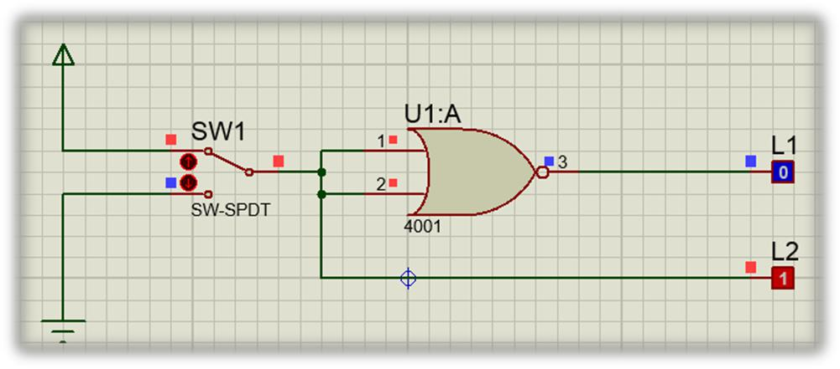

|  |  |  |  |  |  |  |  |  |  |
| --- | --- | --- | --- | --- | --- | --- | --- | --- | --- |
| 2. | Fungsi boolean : L1 = ̅̅̅̅̅̅̅̅̅̅ = ̅̅̅ | | | | | | | | |
| 3. | Tabel kebenaran | | | |  |  |  |  |  |
|  |  |  |  |  |  |  |  |  |  |
|  |  | **SW 1** | |  | **L2** | | **L1** | |  |
|  |  |  |  |  |  |  |  |  |  |
|  |  | 0 |  |  | 0 |  | 1 |  |  |
|  |  |  |  |  |  |  |  |  |  |
|  |  | 1 |  |  | 1 |  | 0 |  |  |
|  |  |  |  |  |  |  |  |  |  |
| 4. | Diagram waktu | | | |  |  |  |  |  |
|  |  |  |  | |  |  |  |  |  |
|  |  | L2 | | | 0 |  | 1 |  |  |
|  |  |  |  |  |  |  |  |  |  |

L1 1 0

5. Kesimpulan :

Gerbang NOR pada percobaan 1 membentuk logika dari gerbang **NOT .**

**Percobaan 2 : Subtitusi Pengganti Gerbang Logika**

1. Rangkaian

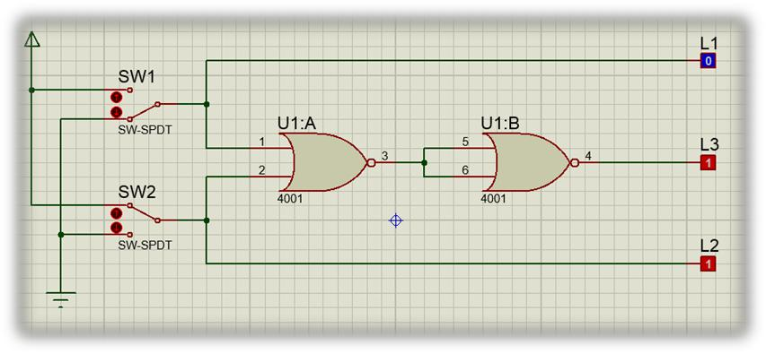

1. Fungsi boolean : L3 = **̅̅̅̅̅̅̅̅̅̅** = L1 + L2
2. Tabel kebenaran

|  |  |  |  |  |
| --- | --- | --- | --- | --- |
| **SW 1** | **SW 2** | **L1** | **L2** | **L3** |
|  |  |  |  |  |
| 0 | 0 | 0 | 0 | 0 |
|  |  |  |  |  |
| 1 | 0 | 1 | 0 | 1 |
|  |  |  |  |  |
| 0 | 1 | 0 | 1 | 1 |
|  |  |  |  |  |
| 1 | 1 | 1 | 1 | 1 |
|  |  |  |  |  |

|  |  |  |  |  |
| --- | --- | --- | --- | --- |
| 4. Diagram waktu |  |  |  |  |
|  |  |  |  |  |
| L1 | 0 | 1 | 0 | 1 |
|  |  |  |  |  |
|  |  |  |  |  |
| L2 | 0 | 0 | 1 | 1 |
|  |  |  |  |  |
|  |  |  |  |  |
| L3 | 0 | 1 | 1 | 1 |
|  |  |  |  |  |
|  |  |  |  |  |

5. Kesimpulan :

Gerbang NOR pada percobaan 2 membentuk logika dari gerbang **OR.**

**Percobaan 3 : Subtitusi Pengganti Gerbang Logika**

1. Rangkaian

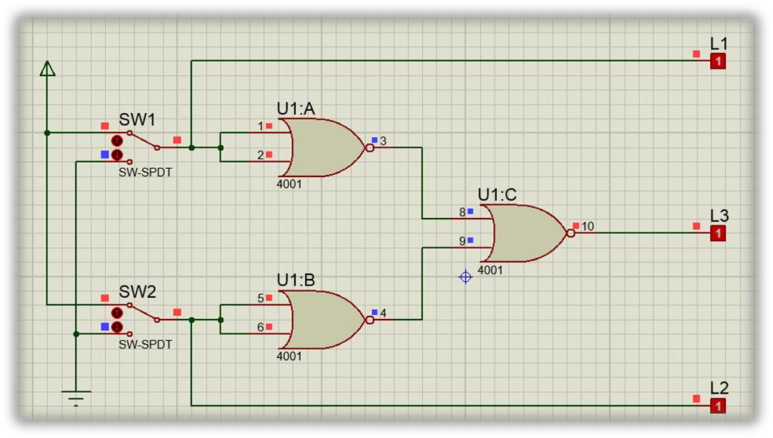

1. Fungsi boolean : L3 = ̅̅̅̅̅̅̅̅̅̅ = L1L2 atau L1.L2
2. Tabel kebenaran

|  |  |  |  |  |
| --- | --- | --- | --- | --- |
| **SW 1** | **SW 2** | **L1** | **L2** | **L3** |
|  |  |  |  |  |
| 0 | 0 | 0 | 0 | 0 |
|  |  |  |  |  |
| 1 | 0 | 1 | 0 | 0 |
|  |  |  |  |  |
| 0 | 1 | 0 | 1 | 0 |
|  |  |  |  |  |
| 1 | 1 | 1 | 1 | 1 |
|  |  |  |  |  |

|  |  |  |  |  |
| --- | --- | --- | --- | --- |
| 4. Diagram waktu |  |  |  |  |
|  |  |  |  |  |
| L1 | 0 | 1 | 0 | 1 |
|  |  |  |  |  |
|  |  |  |  |  |
| L2 | 0 | 0 | 1 | 1 |
|  |  |  |  |  |
|  |  |  |  |  |
| L3 | 0 | 0 | 0 | 1 |
|  |  |  |  |  |
|  |  |  |  |  |

5. Kesimpulan :

Gerbang NOR pada percobaan 3 membentuk logika dari gerbang **AND .**

**Percobaan 4 : Subtitusi Pengganti Gerbang Logika**

1. Rangkaian

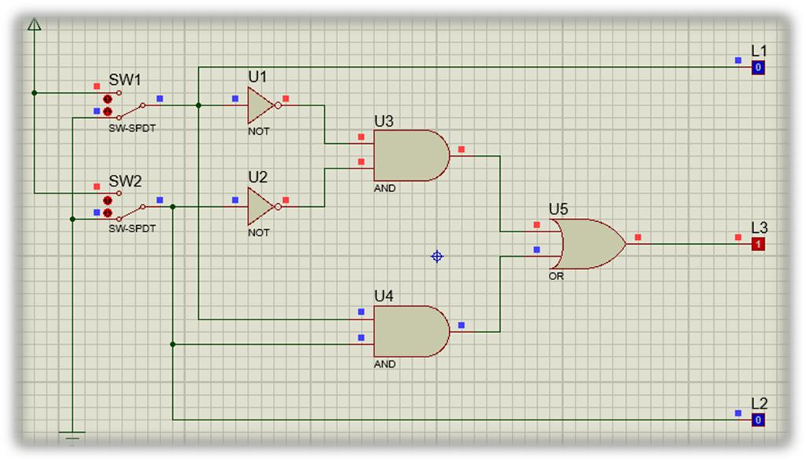

1. Fungsi boolean : L3 = ̅̅̅̅̅̅̅ + L1 L2 = ̅̅̅̅̅̅̅̅̅̅̅̅
2. Tabel kebenaran

|  |  |  |  |  |
| --- | --- | --- | --- | --- |
| **SW 1** | **SW 2** | **L1** | **L2** | **L3** |
|  |  |  |  |  |
| 0 | 0 | 0 | 0 | 1 |
|  |  |  |  |  |
| 1 | 0 | 1 | 0 | 0 |
|  |  |  |  |  |
| 0 | 1 | 0 | 1 | 0 |
|  |  |  |  |  |
| 1 | 1 | 1 | 1 | 1 |
|  |  |  |  |  |

|  |  |  |  |  |
| --- | --- | --- | --- | --- |
| 4. Diagram waktu | |  |  |  |
|  |  |  |  |  |
| L1 | 0 | 1 | 0 | 1 |
|  |  |  |  |  |
|  |  |  |  |  |
| L2 | 0 | 0 | 1 | 1 |
|  |  |  |  |  |
|  |  |  |  |  |
| L3 | 1 | 0 | 0 | 1 |
|  |  |  |  |  |
|  |  |  |  |  |

5. Kesimpulan :

Gerbang NOR pada percobaan 4 membentuk logika dari gerbang **XNOR .**

**Percobaan 5 : Subtitusi Pengganti Gerbang Logika**

1. Rangkaian

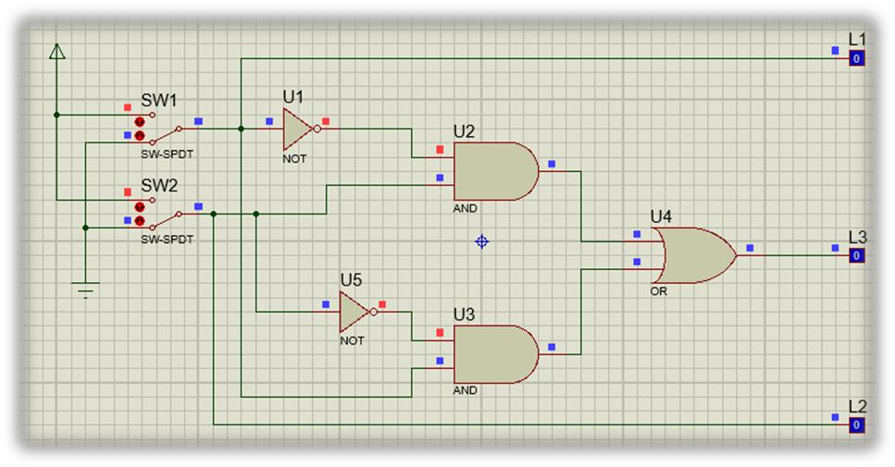

|  |  |  |  |  |  |  |  |  |  |  |  |  |  |
| --- | --- | --- | --- | --- | --- | --- | --- | --- | --- | --- | --- | --- | --- |
| 2. | Fungsi boolean : L3 = ̅̅̅ L2 + L1 ̅̅̅ = L1 | | | | | | | | | |  | L2 |  |
| 3. | Tabel kebenaran | | | | |  |  |  |  |  |  |  |  |
|  |  |  |  |  |  |  |  |  |  |  |  |  |  |
|  |  | **SW 1** |  | **SW 2** | |  | **L1** |  | **L2** |  | **L3** | |  |
|  |  |  |  |  |  |  |  |  |  |  |  |  |  |
|  |  | 0 |  | 0 | | 0 | | 0 | |  | 0 | |  |
|  |  |  |  |  |  |  |  |  |  |  |  |  |  |
|  |  | 1 |  | 0 | | 1 | | 0 | |  | 1 | |  |
|  |  |  |  |  |  |  |  |  |  |  |  |  |  |
|  |  | 0 |  | 1 | | 0 | | 1 | |  | 1 | |  |
|  |  |  |  |  |  |  |  |  |  |  |  |  |  |
|  |  | 1 |  | 1 | | 1 | | 1 | |  | 0 | |  |
|  |  |  |  |  |  |  |  |  |  |  |  |  |  |
| 4. | Diagram waktu | | |  |  |  |  |  |  |  |  |  |  |
|  |  |  | |  |  |  |  |  |  |  |  |  |  |
|  |  | L1 | |  | 0 |  | 1 |  | 0 |  |  | 1 |  |
|  |  |  | |  |  |  |  |  |  |  |  |  |  |
|  |  |  | |  |  |  | |  | |  |  | |  |
|  |  | L2 | |  | 0 | 0 | |  | 1 |  | 1 | |  |
|  |  |  | |  |  |  | |  |  |  |  | |  |
|  |  |  | |  |  |  | |  | |  |  | |  |
|  |  | L3 | |  | 0 |  | 1 | 1 | |  |  | 0 |  |
|  |  |  |  |  |  |  |  |  |  |  |  |  |  |
|  |  |  |  |  |  |  |  |  |  |  |  |  |  |

5. Kesimpulan :

Gerbang NOR pada percobaan 5 membentuk logika dari gerbang **XOR.**