NIM :L200180017 Nilai Praktek :  
Nama : Virliana annida rekkayushar  
Nama Asisten :Riza   
Tanggal Praktikum : 27 Maret 2019 Tanda Tangan :  
  
KEGIATAN PRAKTIKUM  
 percobaan 1   
a).Membuat kombinasi gerbang logika   
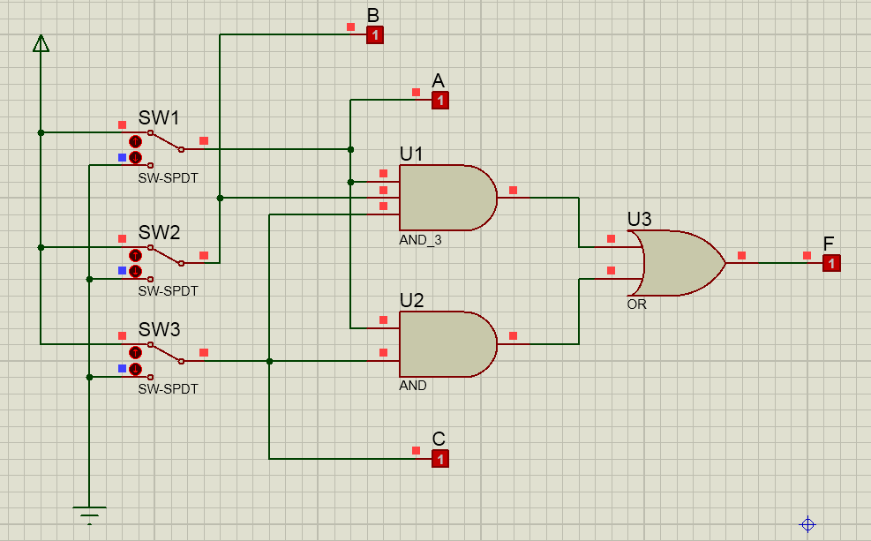  
b).Fungsi Boolean : F=ABC+AC  
c).Tabel kebenaran

|  |  |  |  |
| --- | --- | --- | --- |
| A | B | C | F |
| 0 | 0 | 0 | 0 |
| 1 | 0 | 0 | 0 |
| 0 | 1 | 0 | 0 |
| 1 | 1 | 0 | 0 |
| 0 | 0 | 1 | 0 |
| 1 | 0 | 1 | 1 |
| 0 | 1 | 1 | 0 |
| 1 | 1 | 1 | 1 |

d)Karnaugh map

|  |  |  |  |  |  |
| --- | --- | --- | --- | --- | --- |
|  | | AB | | | |
| 00 | 01 | 11 | 10 |
| C | 0 | 0 | 0 | 0 | 0 |
| 1 | 0 | 0 | 1 | 1 |

e)Penyerderhanaan Fungsi Boolean : F=AC  
f) 

percobaan 2   
a).Membuat kombinasi gerbang logika   
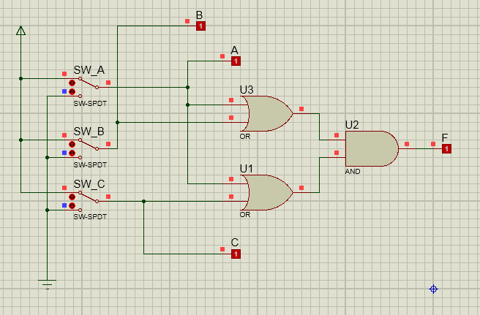  
b).Fungsi Boolean : F=(A+B).(A+C)  
c).Tabel kebenaran

|  |  |  |  |
| --- | --- | --- | --- |
| A | B | C | F |
| 0 | 0 | 0 | 0 |
| 1 | 0 | 0 | 1 |
| 0 | 1 | 0 | 0 |
| 1 | 1 | 0 | 1 |
| 0 | 0 | 1 | 0 |
| 1 | 0 | 1 | 1 |
| 0 | 1 | 1 | 1 |
| 1 | 1 | 1 | 1 |

d)Karnaugh map

|  |  |  |  |  |  |
| --- | --- | --- | --- | --- | --- |
|  | | AB | | | |
| 00 | 01 | 11 | 10 |
| C | 0 | 0 | 0 | 1 | 1 |
| 1 | 0 | 1 | 1 | 1 |

e)Penyerderhanaan Fungsi Boolean : F=A+BC  
f)   
 percobaan 3  
a).Membuat kombinasi gerbang logika   
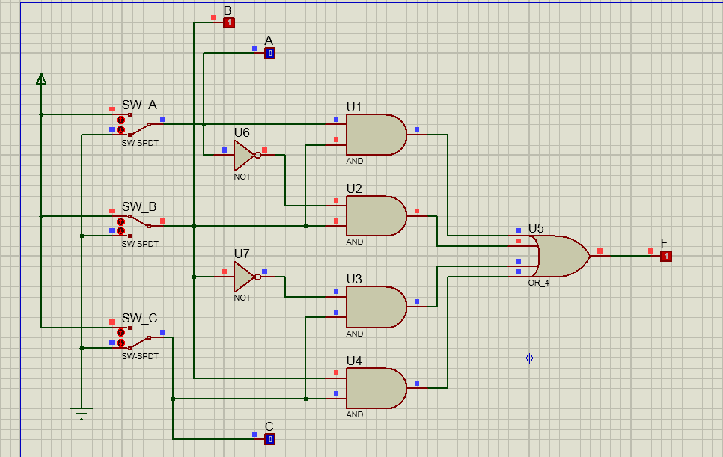  
b).Fungsi Boolean : F=AB+A’B+B’C+BC  
c).Tabel kebenaran

|  |  |  |  |
| --- | --- | --- | --- |
| A | B | C | F |
| 0 | 0 | 0 | 0 |
| 1 | 0 | 0 | 0 |
| 0 | 1 | 0 | 1 |
| 1 | 1 | 0 | 1 |
| 0 | 0 | 1 | 1 |
| 1 | 0 | 1 | 1 |
| 0 | 1 | 1 | 1 |
| 1 | 1 | 1 | 1 |

d)Karnaugh map

|  |  |  |  |  |  |
| --- | --- | --- | --- | --- | --- |
|  | | AB | | | |
| 00 | 01 | 11 | 10 |
| C | 0 | 0 | 1 | 1 | 0 |
| 1 | 1 | 1 | 1 | 1 |

e)Penyerderhanaan Fungsi Boolean : F=BC  
f) 