Nama : Ainin Mayasyifa Alda

Nim :L200180195

Kelas :E

1. FCFS

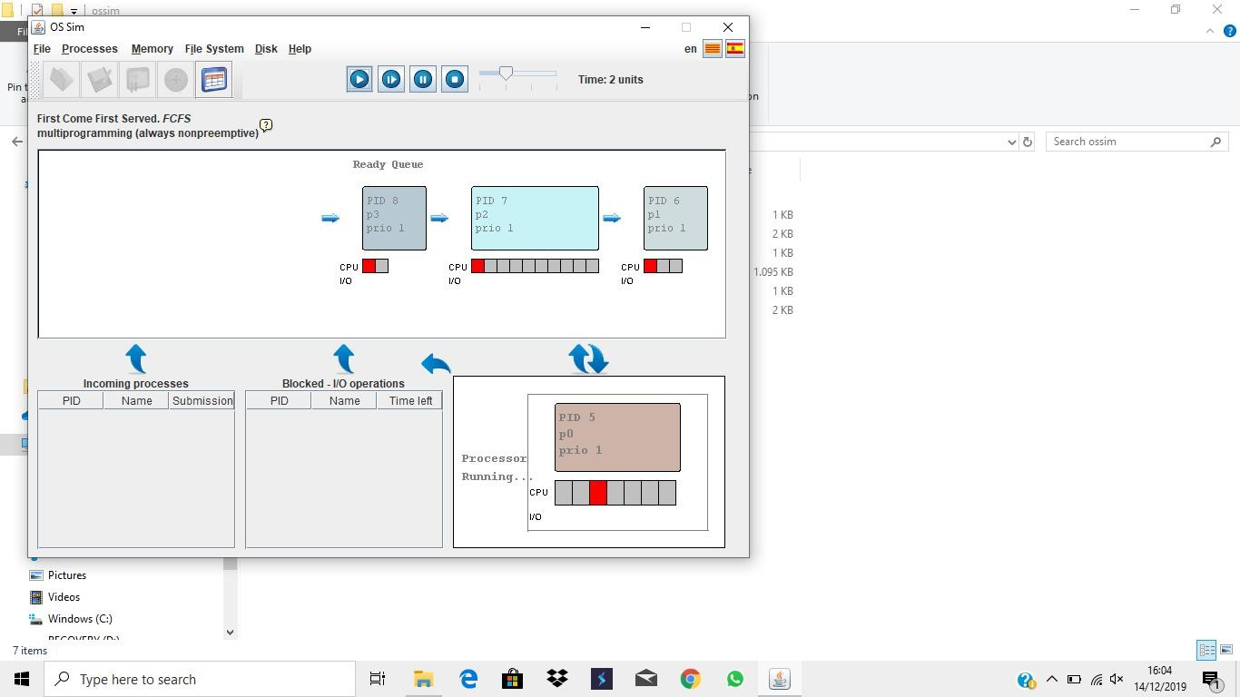

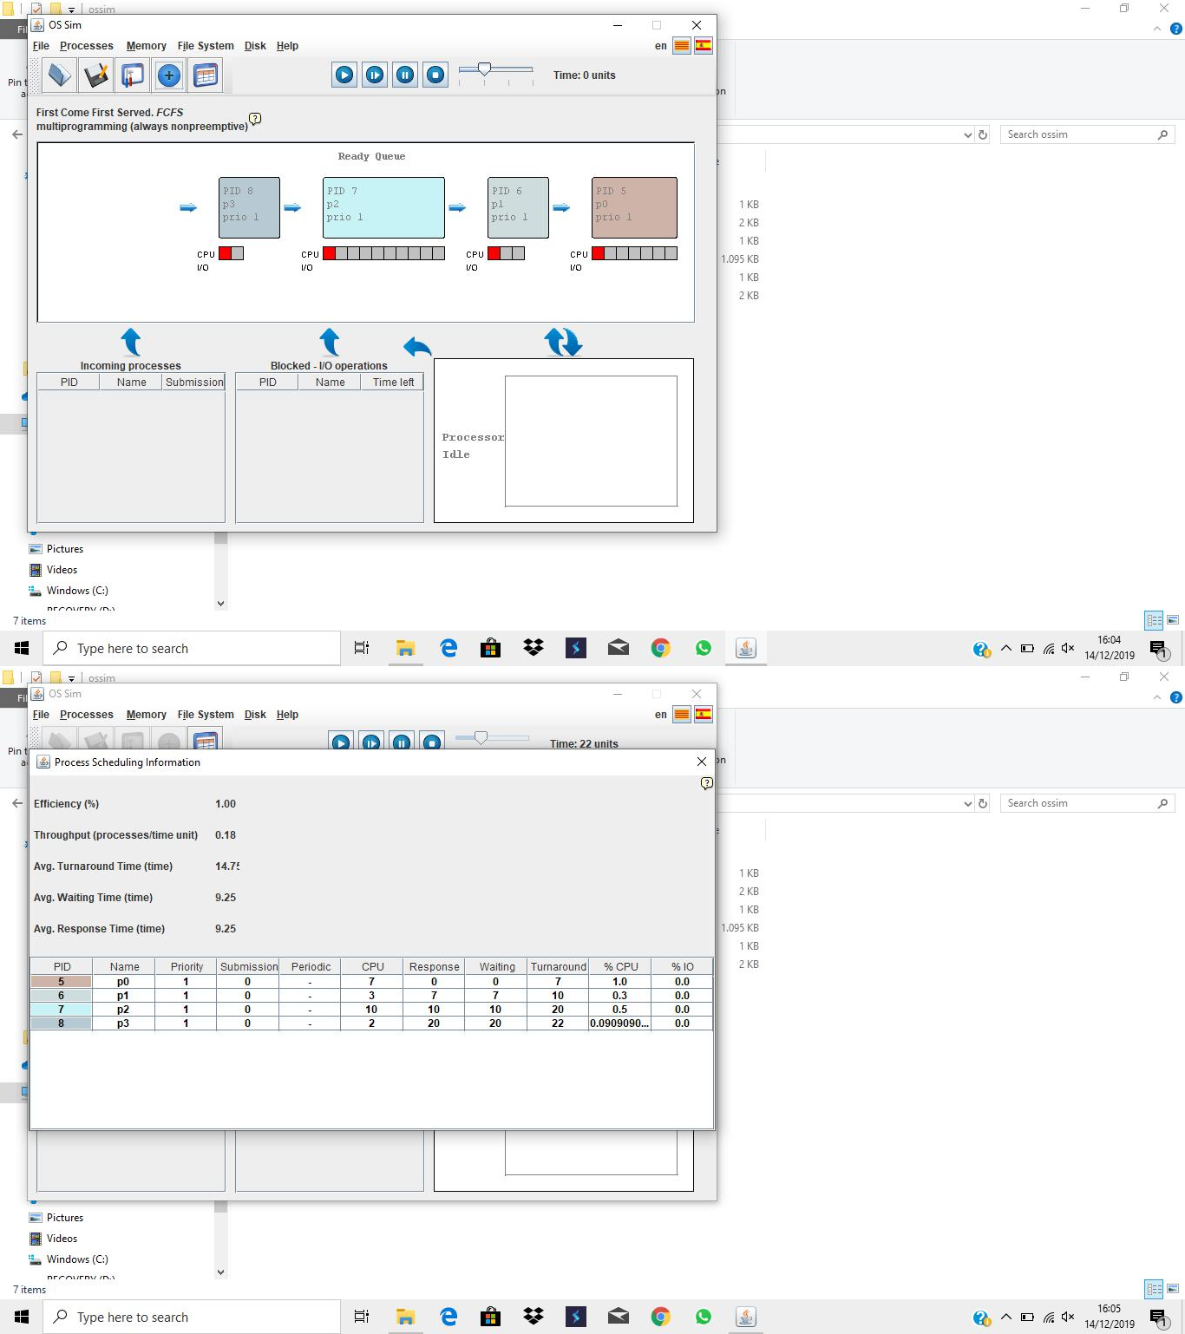

|  |  |
| --- | --- |
| process | Waiting time |
| P0 | 0 |
| P1 | 7 |
| P2 | 10 |
| P3 | 20 |
| Average Waiting Time | 9.25 |
| Average Turnaround | 14.75 |
| Average Respon | 9.25 |

1. )SJFS
2. Non-preemptive

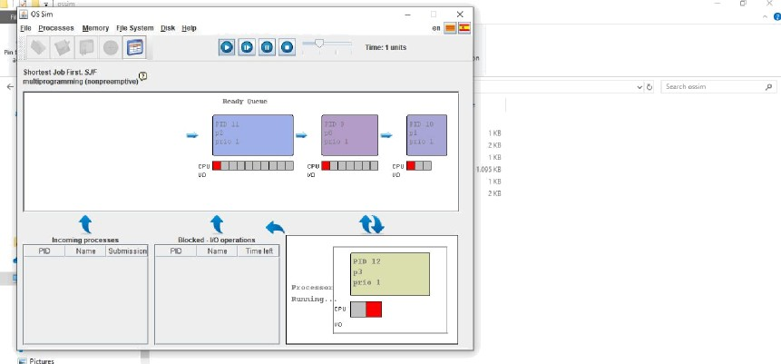

* + e e o ■ e GeI+ 

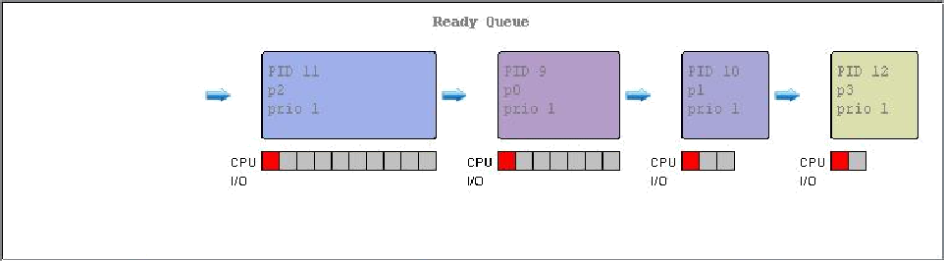1aS EB

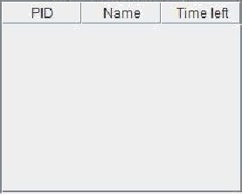

* + e e o ■ e G eI+



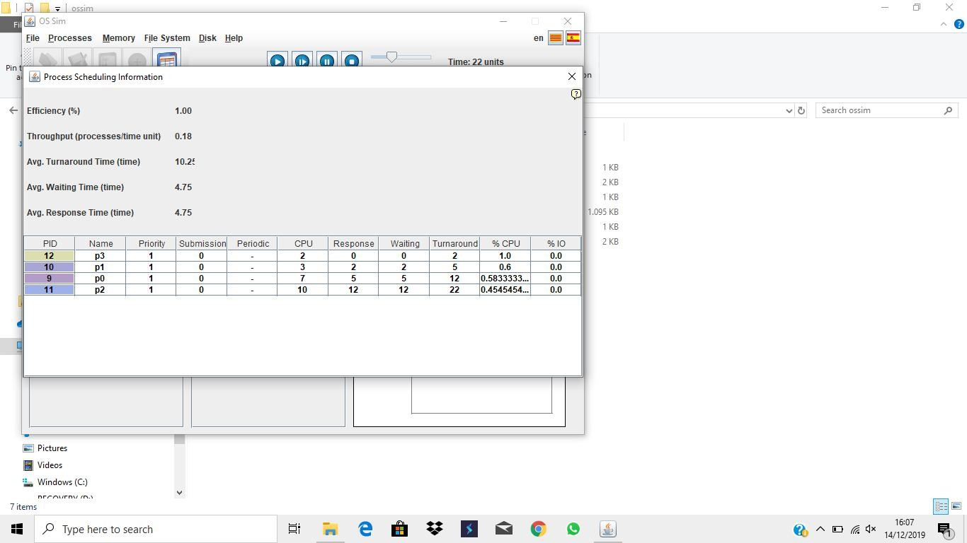

|  |  |
| --- | --- |
| process | Waiting Time |
| P0 | 5 |
| P1 | 2 |
| P2 | 12 |
| P3 | 0 |
| Average Waiting Time | 4.75 |
| Average Turnaround | 10.25 |
| Average Respon | 4.75 |

1. Premptive

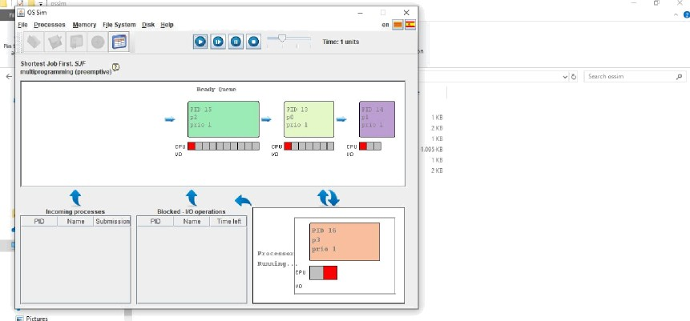

* + e e o ■ e GeI+ 

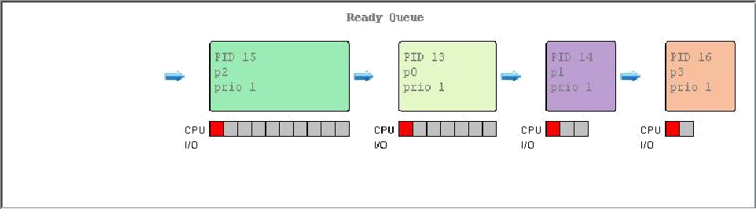1aS EB



* + e e o ■ e G eI+



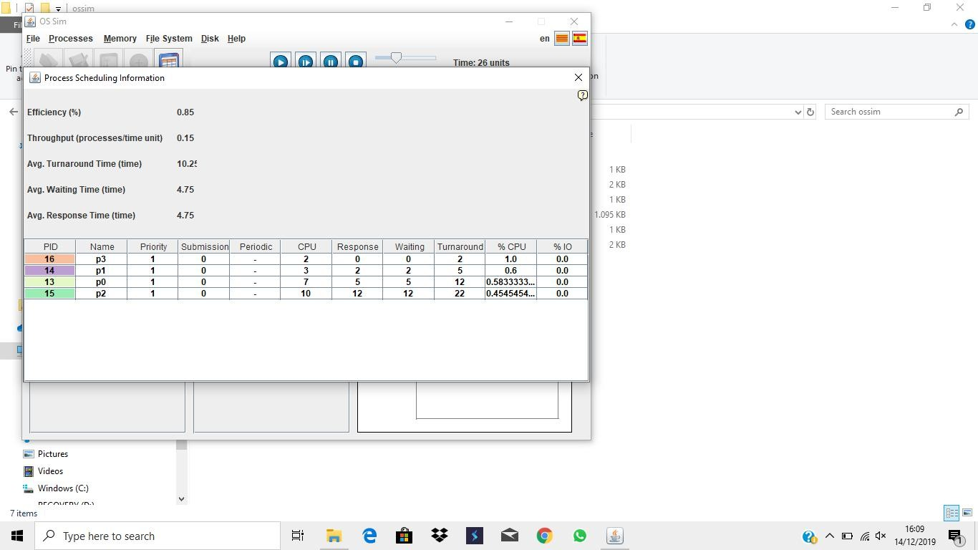

|  |  |
| --- | --- |
| Process | Waiting Time |
| P0 | 5 |
| P1 | 2 |
| P2 | 12 |
| P3 | 0 |
| Average Waiting Time | 4.75 |
| Average Turnaround | 10.25 |
| Average Respon | 4.75 |

1. ) PriorityScheduling

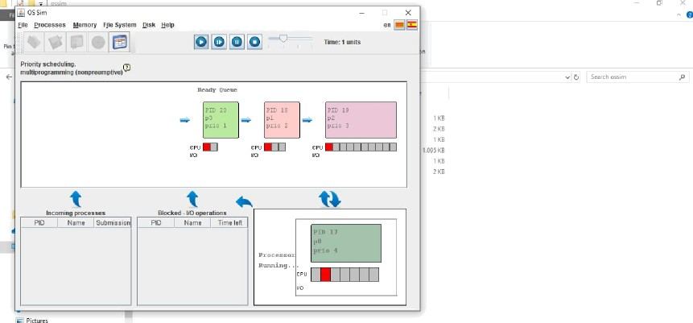

* + e e o ■ e GeI+ 

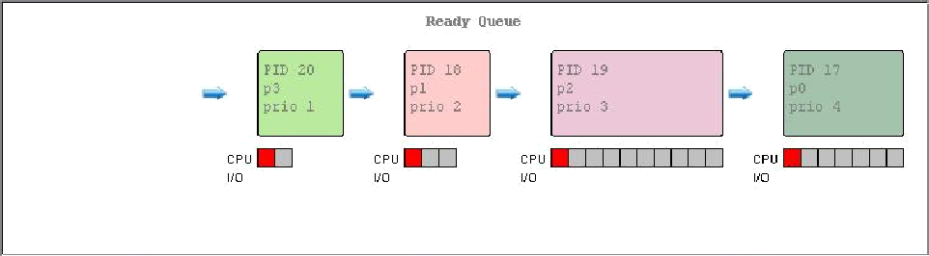

* + e e o ■ e G eI+



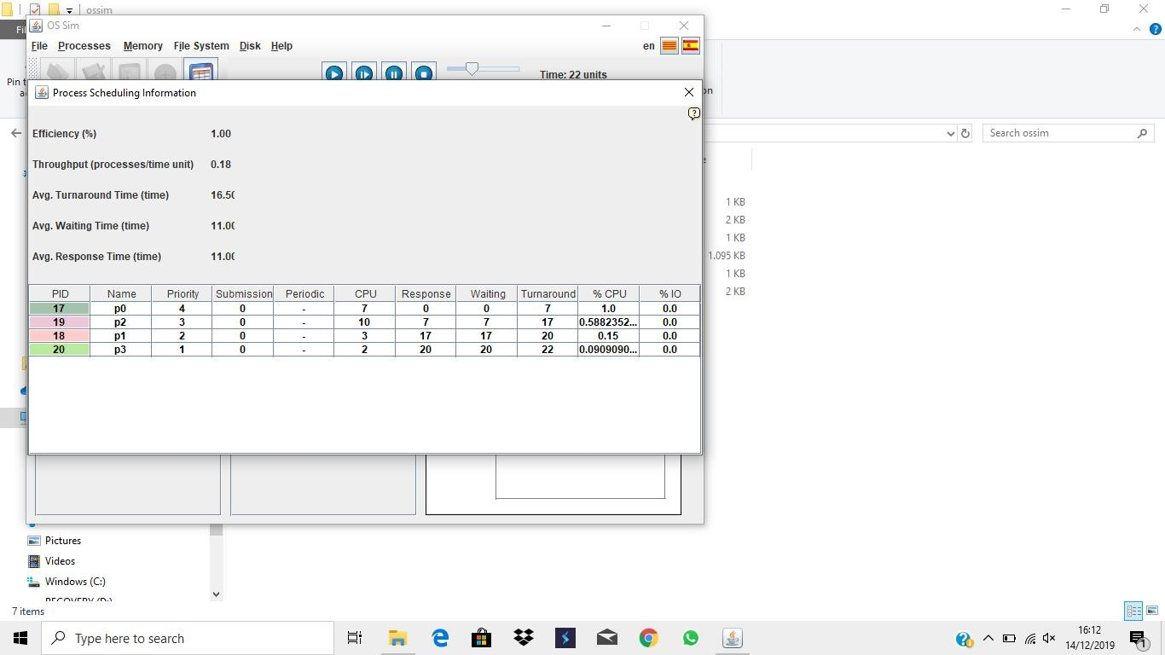

|  |  |
| --- | --- |
| process | Waiting Time |
| P0 | 0 |
| P1 | 9 |
| P2 | 12 |
| P3 | 7 |
| Average Waiting Time | 7.00 |
| Average Turnaround | 12.50 |
| Average Respon | 7.00 |

1. )Round-Robin Quantum =4



* + e e o ■ e GeI+ 



* + e e o ■ e G eI+





|  |  |
| --- | --- |
| process | Waiting Time |
| P0 | 9 |
| P1 | 4 |
| P2 | 12 |
| P3 | 11 |
| Average Waiting Time | 9.00 |
| Average Turnaround | 14.50 |
| Average Respon | 5.50 |