Nama : Rulla Selfiana

Class : X

NIM : L202173005

Modul 4

Kegiatan 1

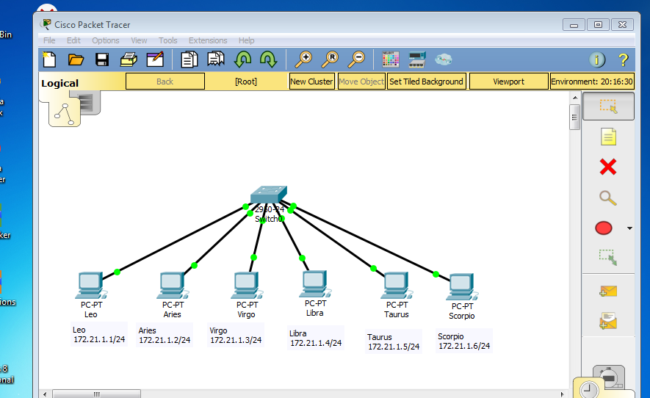

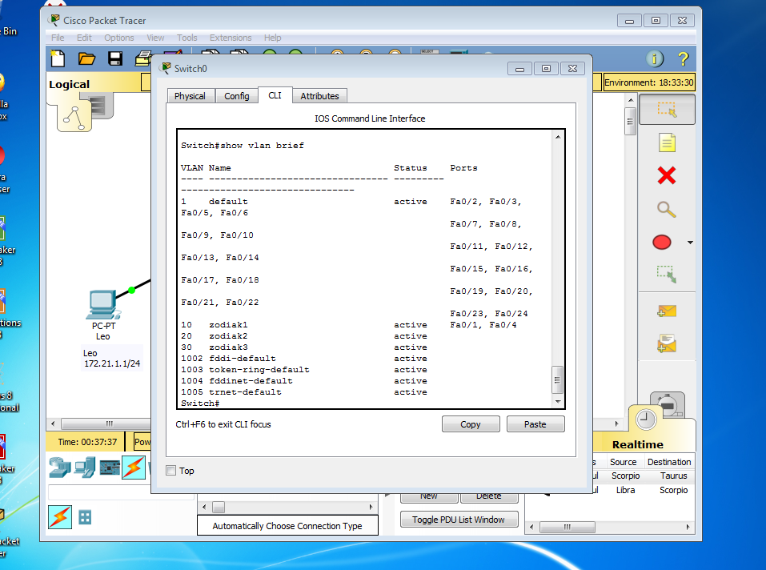

|  |  |  |  |  |  |
| --- | --- | --- | --- | --- | --- |
|  |  |  |  |  |  |
| **No** | **Variabel** |  | **Nilai** |  | |
|  |  |  |  |  | |
| 1 | Nomor VLAN | 10 | 20 | 30 | |
|  |  |  |  |  | |
| 2 | Nama VLAN | zodiak1 | zodiak2 | zodiak3 | |
|  |  |  |  |  | |
| 3 | Port | Fa0/1, Fa0/4 | Fa0/2, Fa0/5 | Fa0/3, Fa0/6 | |
|  |  |  |  |  | |
| 4 | Status | active | active | active | |
|  |  |  |  |  | |

Kegiatan B

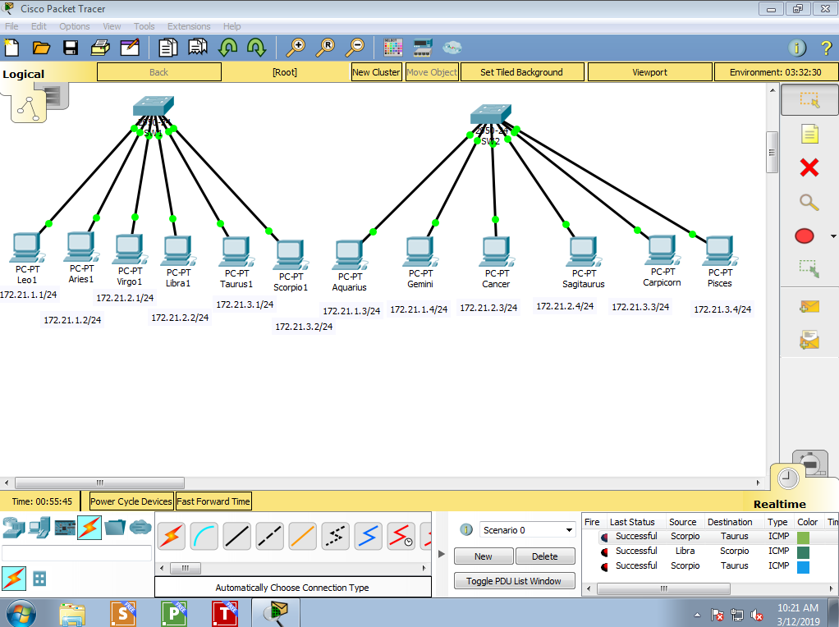

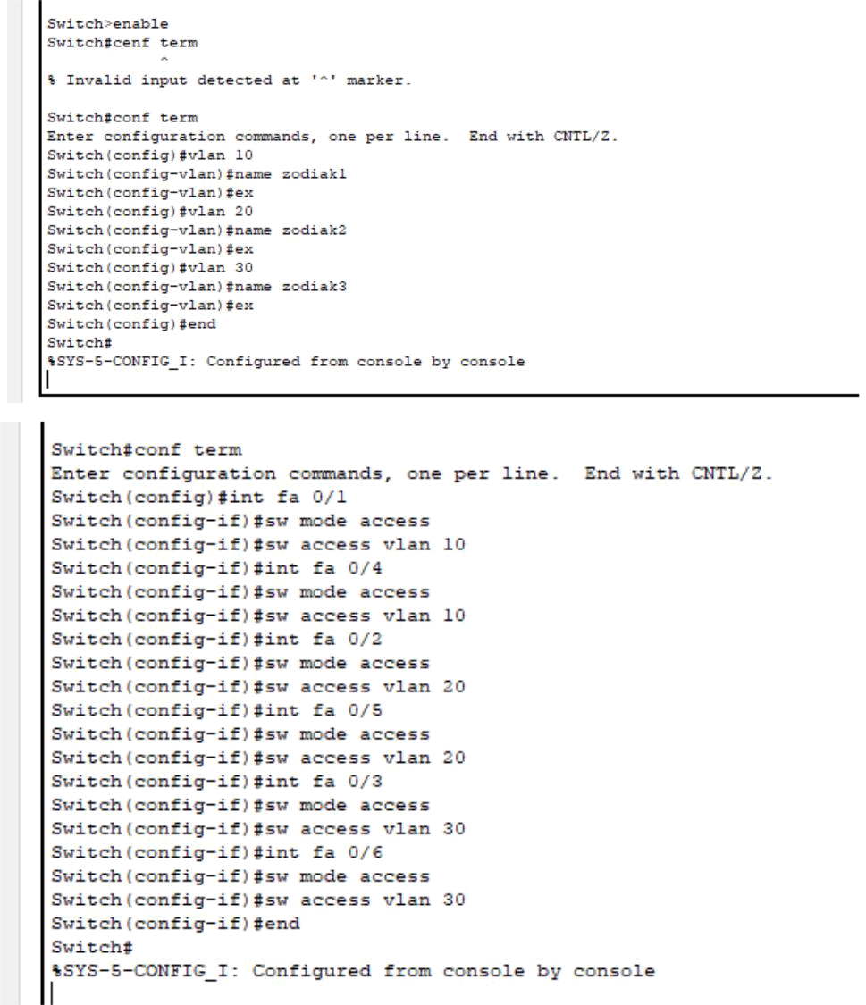

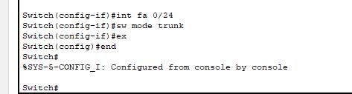

PING LEO TO PISCESS

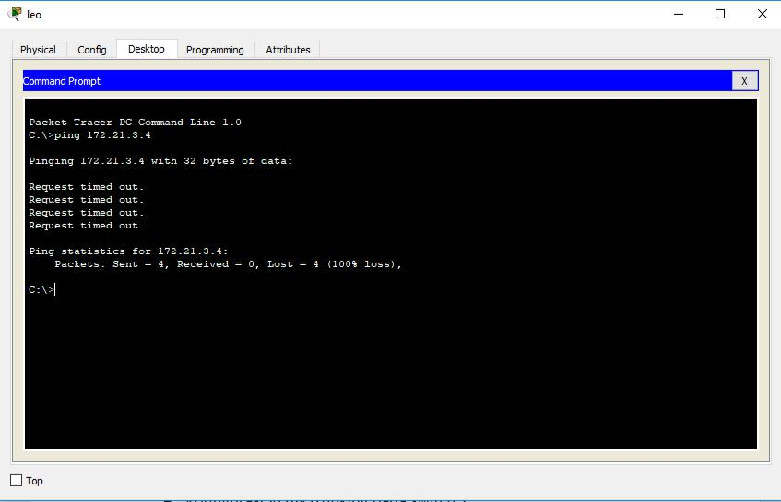

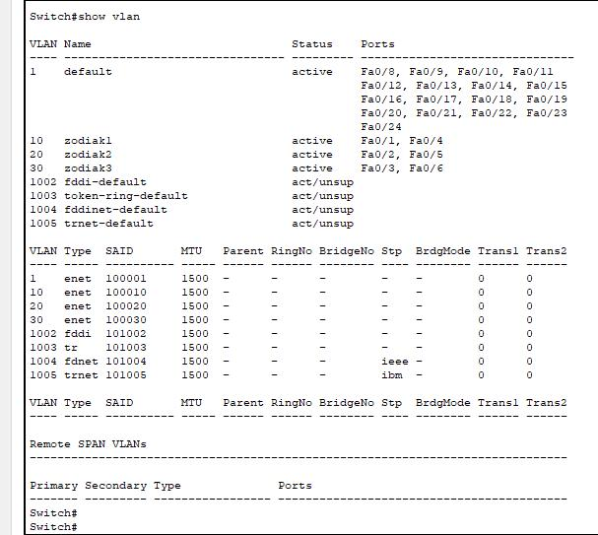

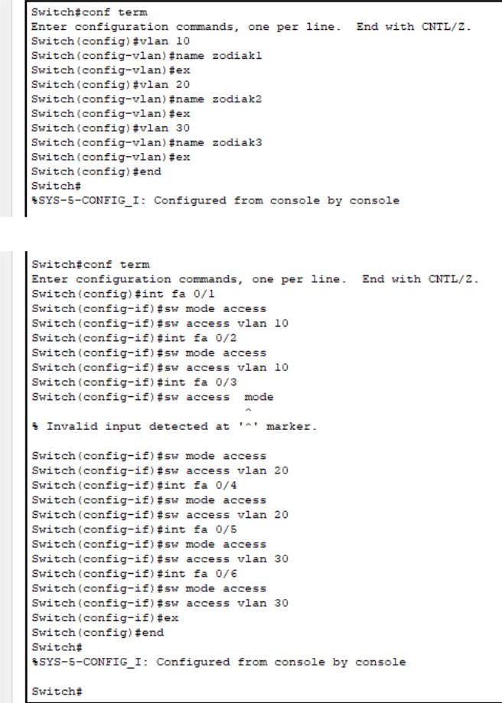

PING LEO TO ARIES

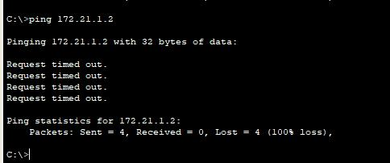

PING LEO TO AQUARIUS

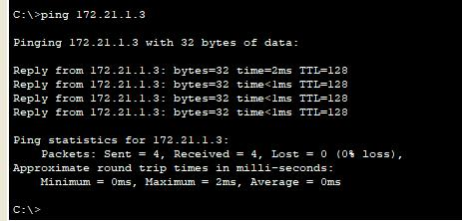

PING LEO TO CANCER

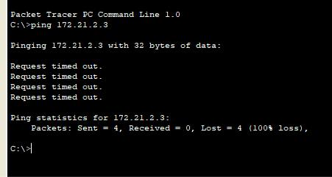

PING LIBRA TO LEO

