NAME : Rulla Selfiana

CLASS : X

NIM : L202173005

MODUL 3

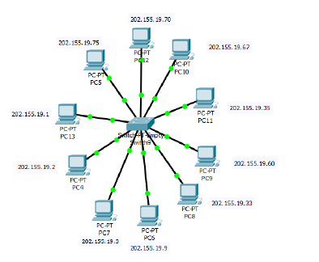

Subnet :

2x = 23 = 8 Subnet

Host :

2y – 2 = 25 – 2 = 30 Host

|  |  |  |  |
| --- | --- | --- | --- |
| **Subnet Address** | **IP Awal** | **IP Akhir** | **IP Broadcase** |
|  |  |  |  |
| 202.155.19.0 | 202.155.19.1 | 202.155.19.30 | 202.155.19.31 |
|  |  |  |  |
| 202.155.19.32 | 202.155.19.33 | 202.155.19.62 | 202.155.19.63 |
|  |  |  |  |
| 202.155.19.64 | 202.155.19.65 | 202.155.19.94 | 202.155.19.95 |
|  |  |  |  |