# 一. 算法目的

冠脉开口点预测

输入：DSA图像

输出：开口点坐标

# 二. 算法框架

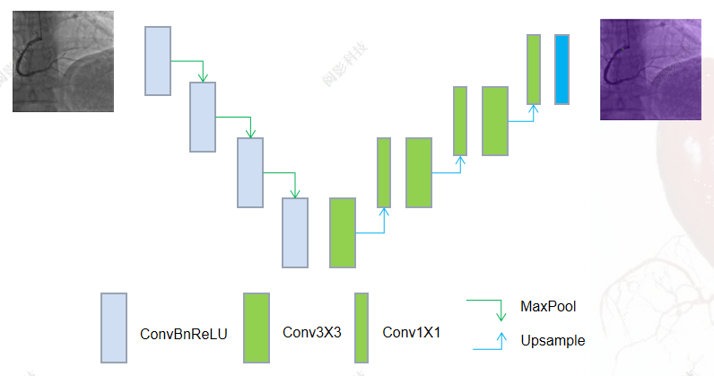

# 三. 数据集

**1.数据集特征**

|  |  |
| --- | --- |
| **特征** | **参数** |
| 模态 | DSA |
| numbers | 211 |
| dim | 2 |
| num_classes | - |
| pixdim | - |
| normalization | [0,255]->[0,1] |
| spatial_size | (512,512) |
| folds | 5 |
| train_set | 136 |
| val_set | 34 |
| test_set | 41 |
| Shuffle | - |
|  |  |

**2.数据增强**

|  |  |  |
| --- | --- | --- |
| **Transforms** | **Params** | **prob** |
|  |  | 0.2 |
|  |  | 0.2 |
|  |  | 0.3 |
|  |  |  |
|  |  |  |

# **四. 实验记录**

1. **汇总**

|  |  |  |  |  |  |  |
| --- | --- | --- | --- | --- | --- | --- |
| 版本 | 通道数 | Batch_size | Fold | Mean_dist | Max_dist | Med_dist |
|  | 16 | 4 | 0 | 3.2854 | 243.7724 | 1.0 |
| 1 | 3.8790 | 253.6710 | 1.0 |
| 2 | 5.1077 | 305.4865 | 1.0 |
| 3 | 6.0602 | 266.4301 | 1.0 |
| 4 | 5.3095 | 278.6270 | 1.0 |
| 8 | 0 | 4.4281 | 243.7724 | 1.0 |
| 1 | 4.3528 | 266.1766 | 1.0 |
| 2 | 5.9680 | 260.7393 | 1.0 |
| 3 | 3.9853 | 258.3118 | 1.0 |
| 4 | 6.8065 | 245.9045 | 1.0 |
| 32 | 4 | 0 | **2.2079** | 245.9776 | 0.0 |
| 1 | 3.3196 | 289.4305 | 0.0 |
| 2 | 3.2427 | 118.2286 | 0.0 |
| 3 | 2.7663 | 260.7758 | 0.0 |
| 4 | 4.0171 | 257.0992 | 0.0 |
| 8 | 0 | 2.3115 | **81.0062** | 0.0 |
| 1 | 3.1444 | 292.8003 | 0.0 |
| 2 | 3.7568 | 258.7682 | 0.0 |
| 3 | 4.5253 | 298.6051 | 0.0 |
| 4 | 3.9476 | 249.9460 | 0.0 |

1. **各版本记录**

**版本1**

（1）训练参数

|  |  |
| --- | --- |
| **训练** | **参数** |
| batch_size | 4 |
| learning_rate | 0.001 |
| epoches | 1000 |
| optimizer | Adam |
| loss | MSELoss |
| scheduler | WarmupCosineSchedule |
| patch_size | [512,512] |

（2）改进

Channels=32

（3）训练曲线

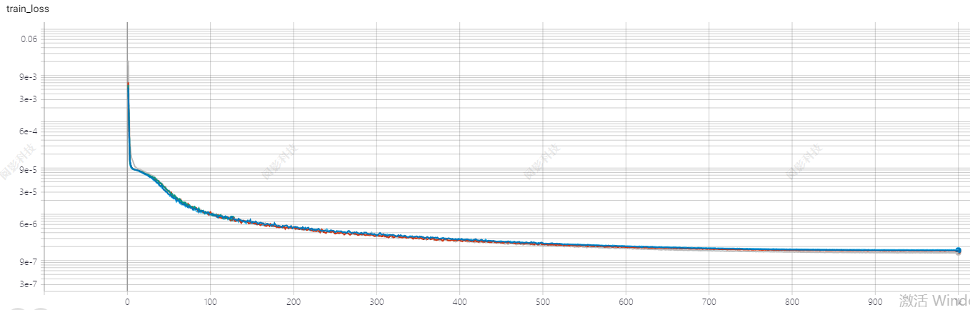

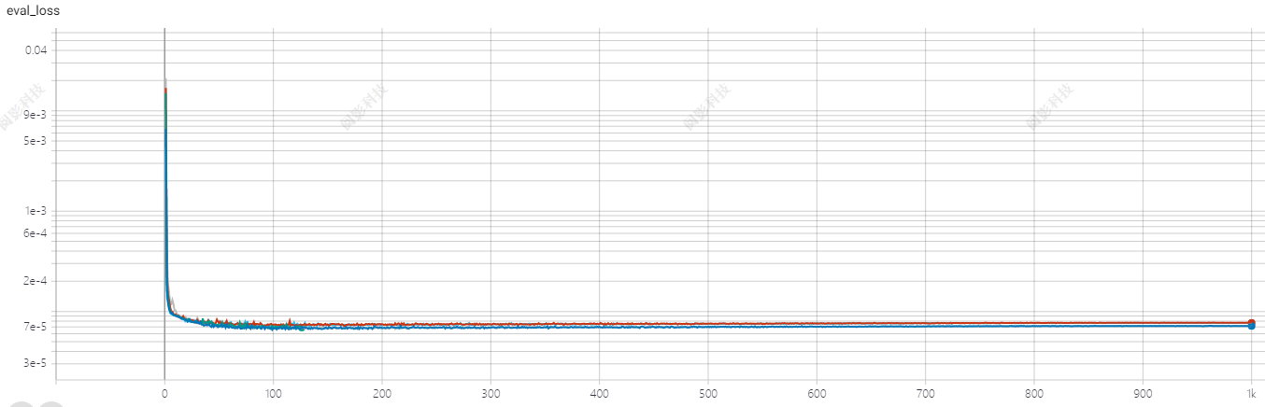

（4）实验结果

|  |  |  |  |  |  |
| --- | --- | --- | --- | --- | --- |
| Case | Loss | Dice | Precison | Recall | Jaccard |
| Mean | DiceCE | 0.8458 | 0.8467 | 0.8579 | 0.7386 |
| coDice |  |  |  |  |
| Remove | DiceCE | 0.8735 | 0.8892 | 0.8618 | 0.7766 |
| coDice |  |  |  |  |

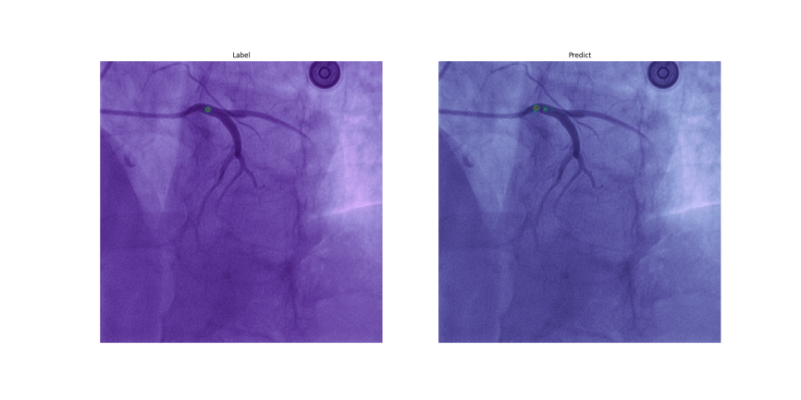

Dist=17.46424919657298

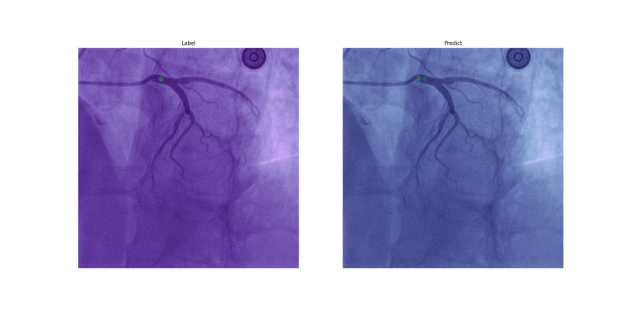

Dist=18.110770276274835

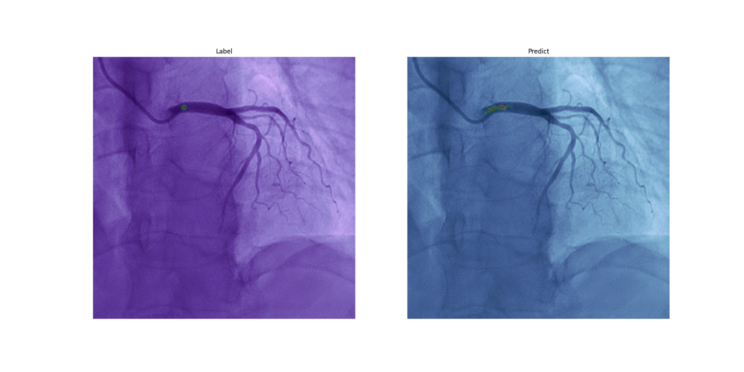

Dist=9.0

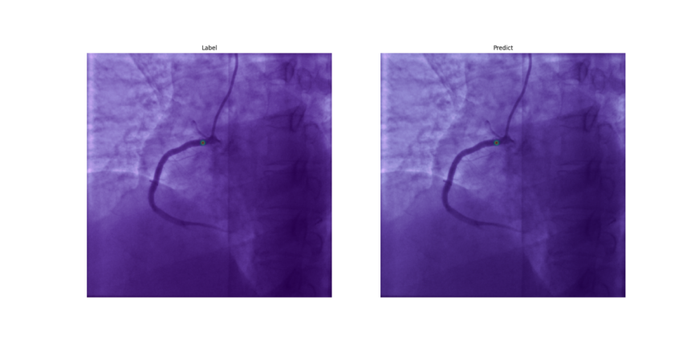

Dist=10.0

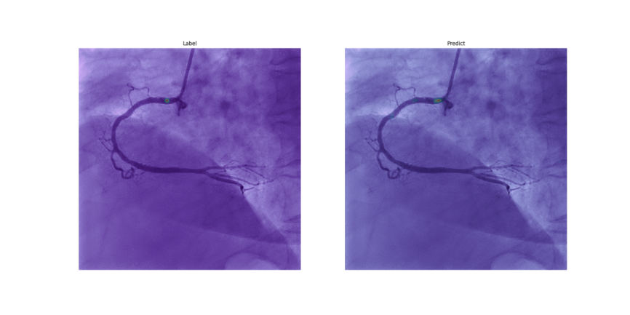

Dist=13.038404810405298

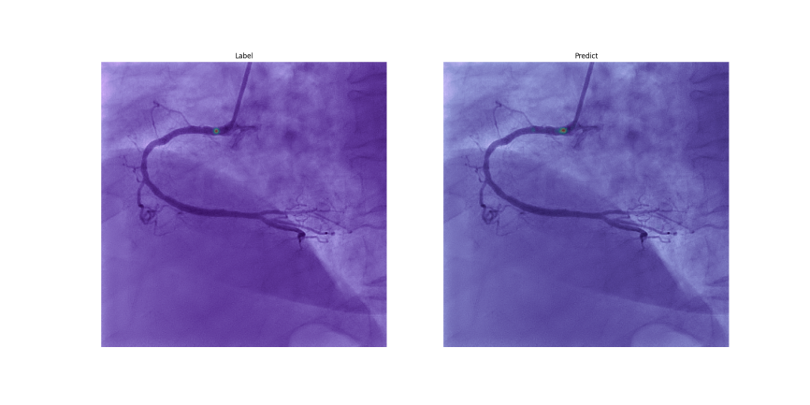

Dist=10.198039027185569

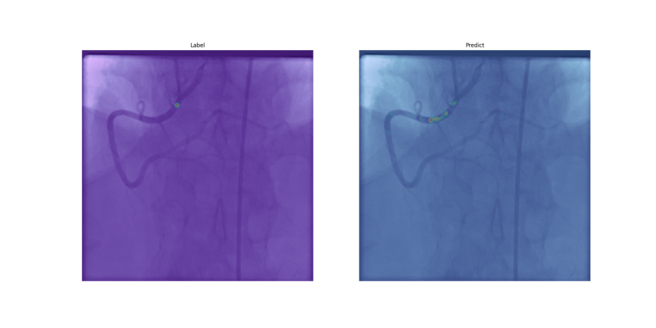

Dist=60.74537019394976

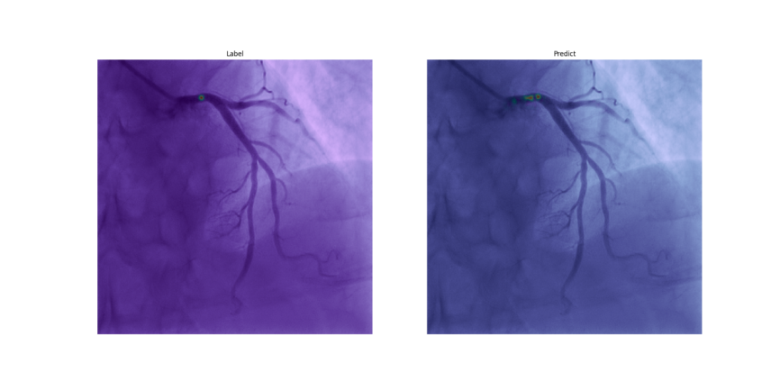

Dist=13.152946437965905

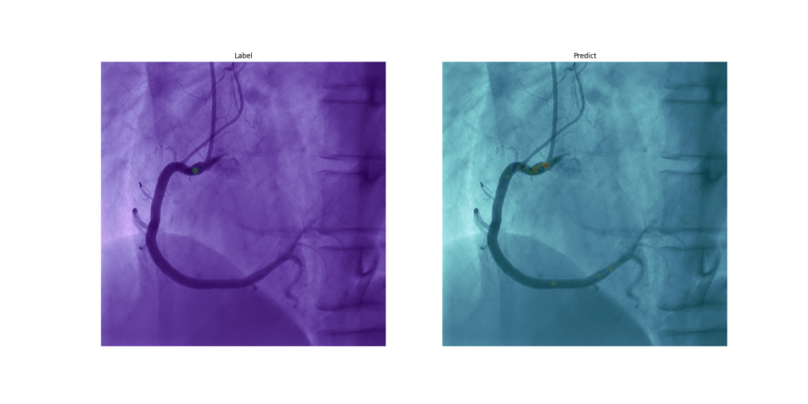

Dist=19.235384061671343

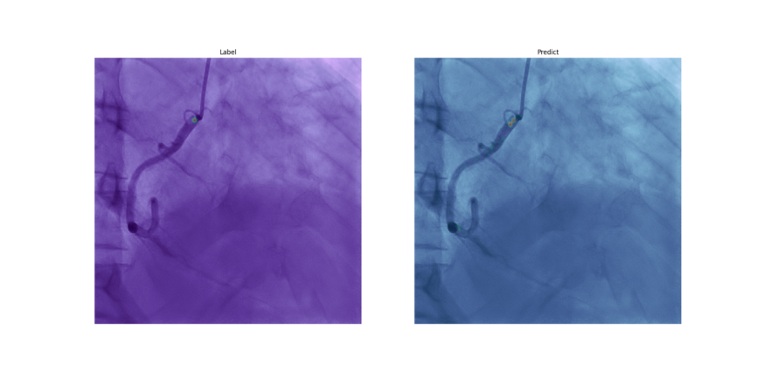

Dist=11.313708498984761

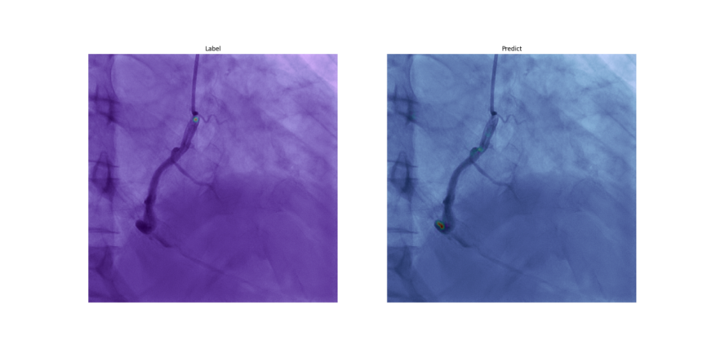

Dist=245.97764126033894

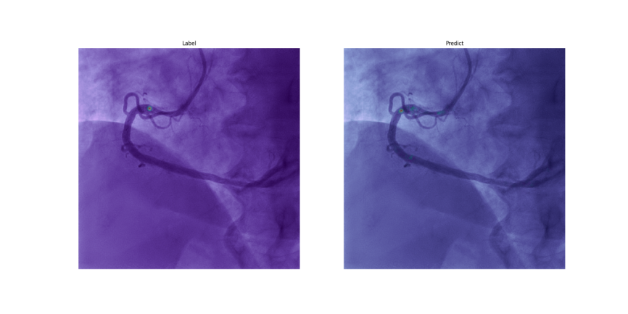

Dist=32.38826948140329

总共321个测试图像，

15例distance大于等于9，其余全部小于等于6

均值2.2078937421341953

中值0.0

最大值245.97764126033894

最小值0.0

去掉最大值剩余320个测试图像的均值1.4461132810062

（5）小结

（简单总结一下此版本的结果）