Lobna Ahmed El-Sayed Rakha

4221401

C1

* **self join:** a regular join, but the table is joined with itself.
* **implicit join:** a regular join, but the syntax is different.
* **self outer join:** a regular join, but the table is joined with itself.
* **natural join:** refers to joining two or more tables based on common columns.
* **cross join:** a type of join that returns the Cartesian product of rows from the tables in the join.
* **union:** used to combine the result-set of two or more select statements.

**Examples**

* Inner join

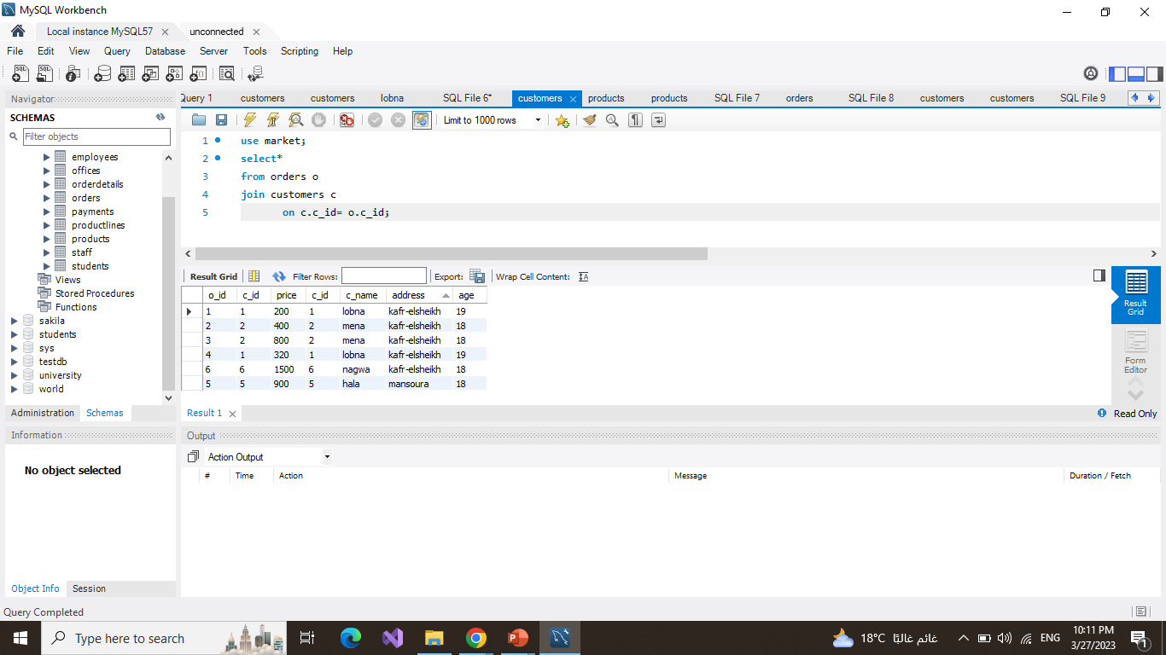

* **self join**

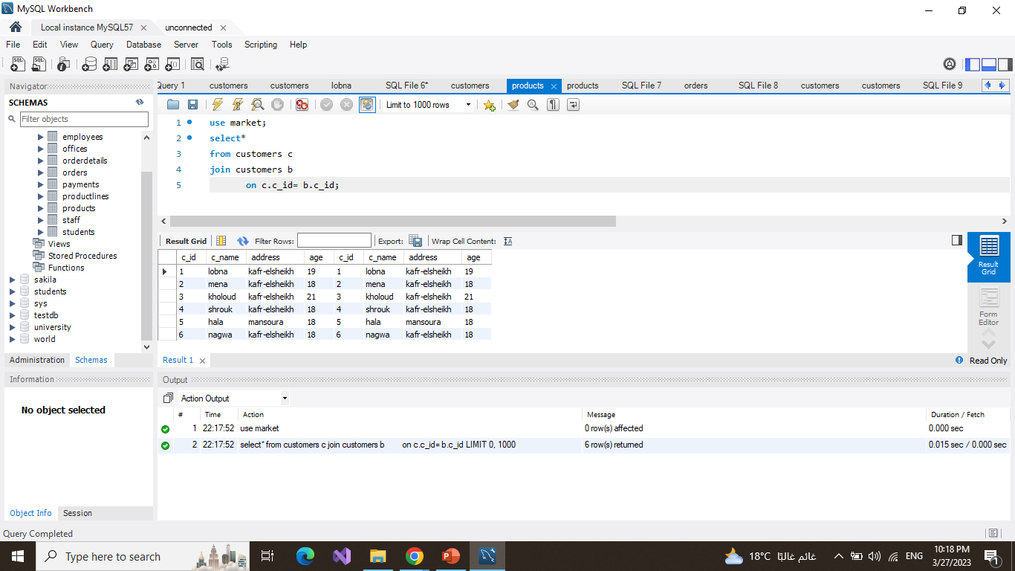

* 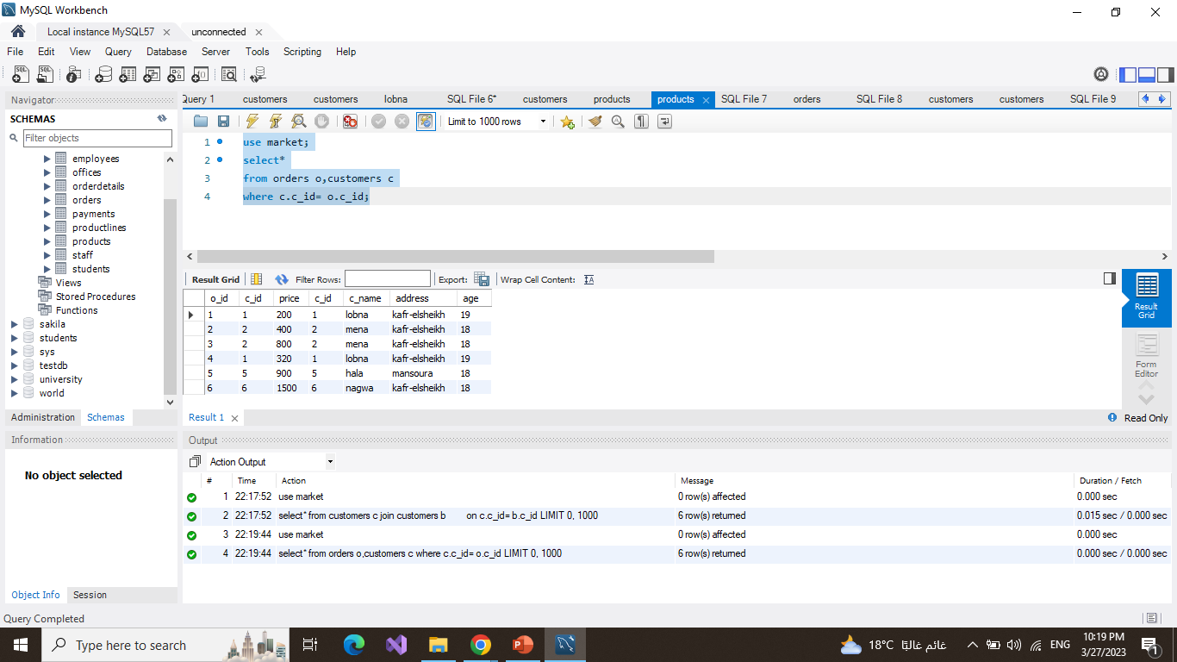**implicit join**
* **Left outer join**

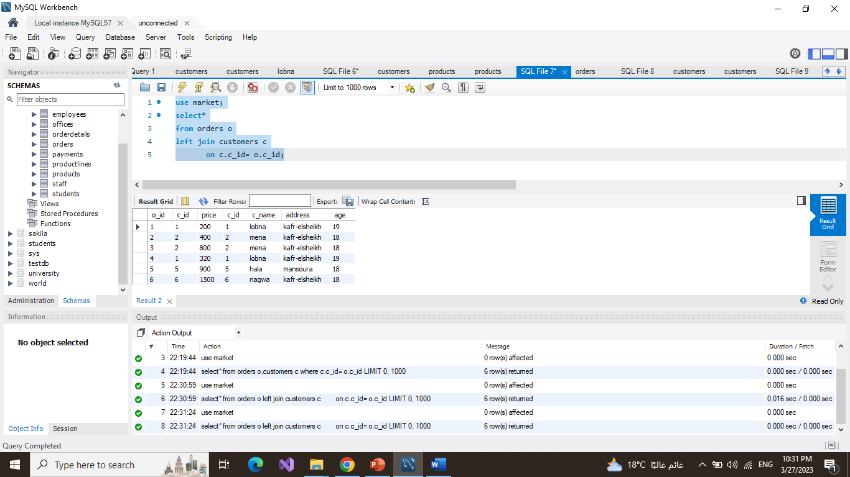

* **right outer join**

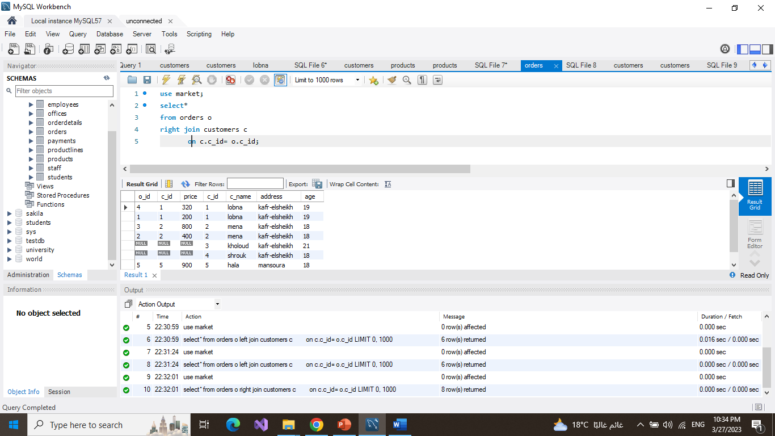

* **self outer join**

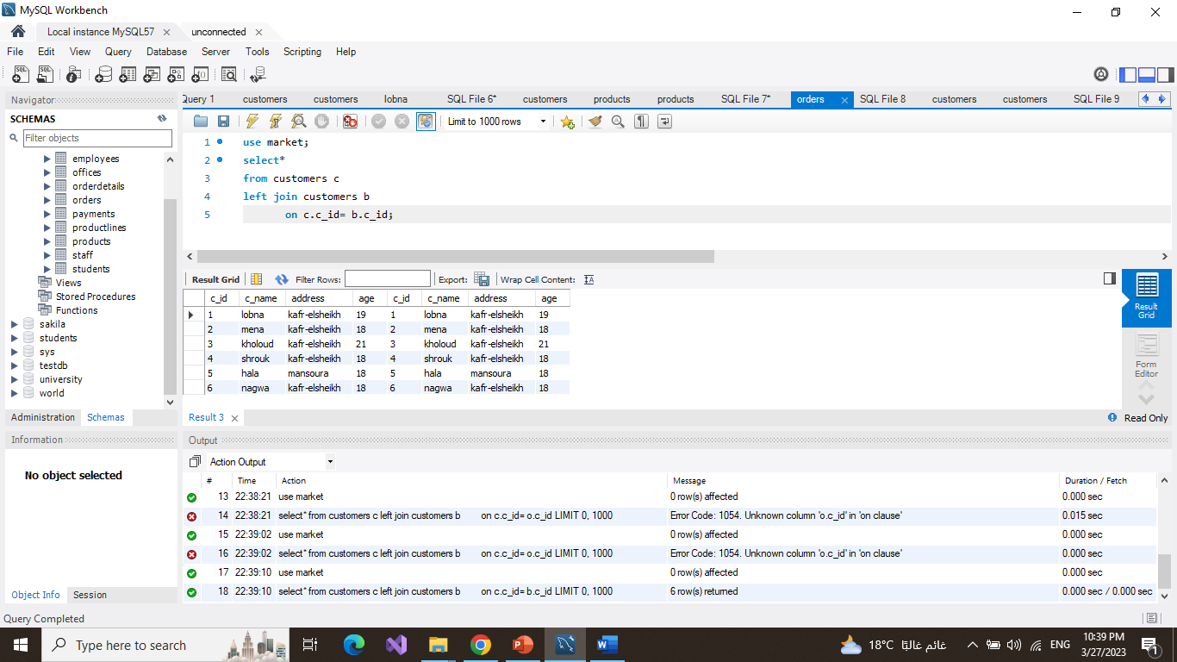

* 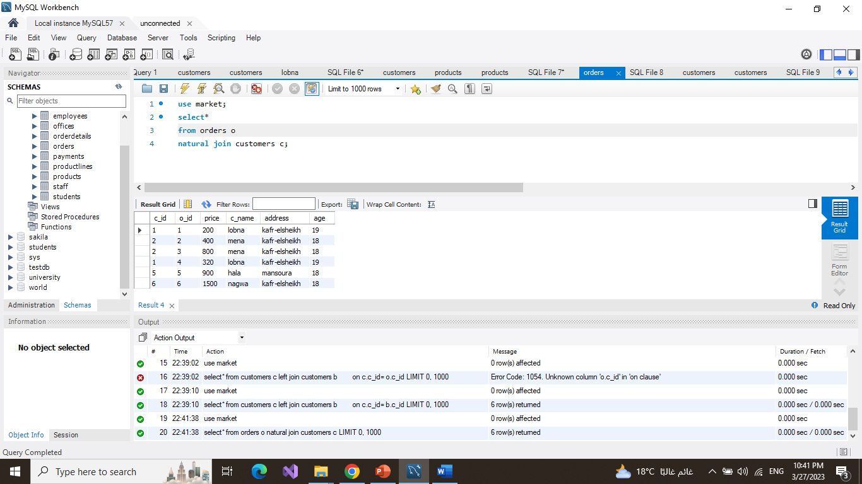**natural join**
* **cross join**

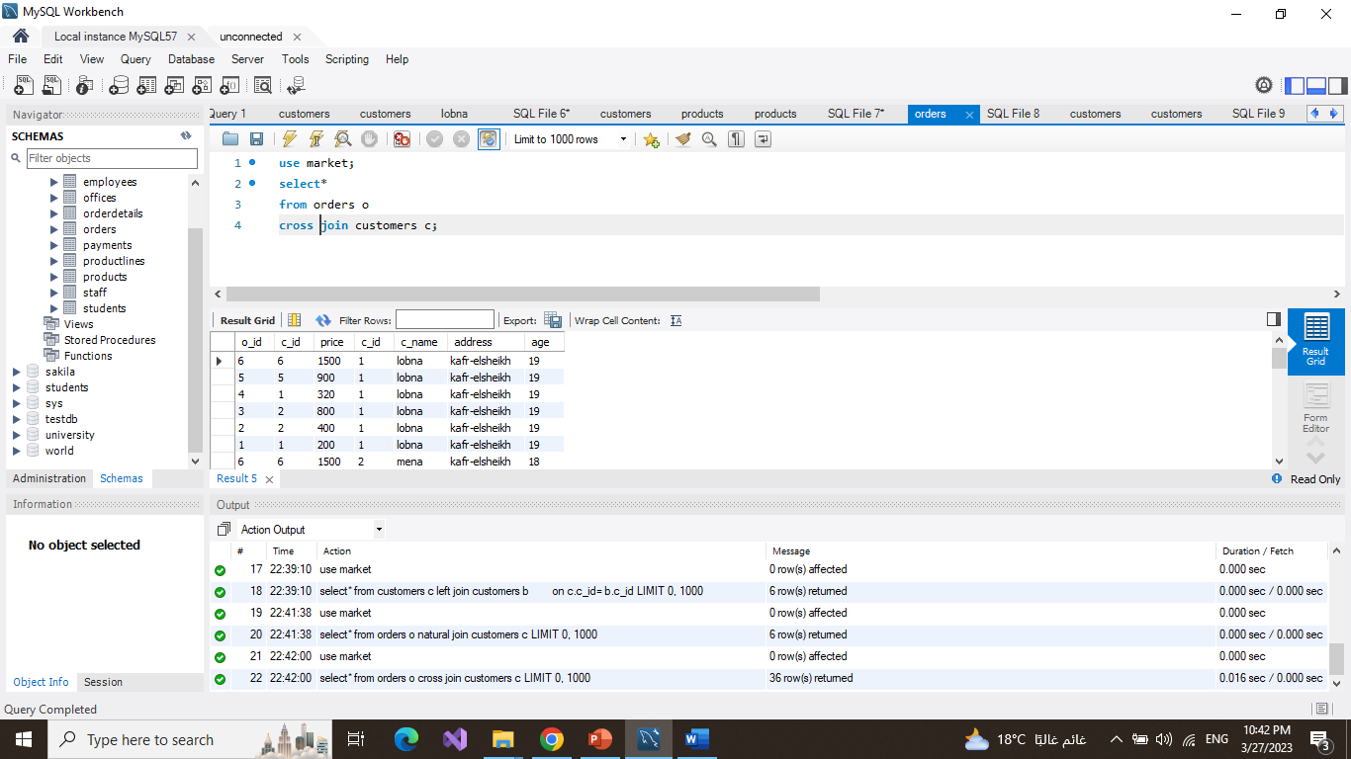

* 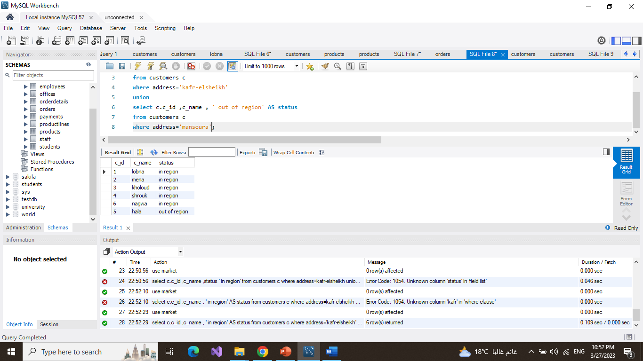**union**