GlamMatch
Personalized Styling & Salon Connector App
Subject: Software Engineering
Project: GlamMatch
Deliverable #3 — Iteration 2 / Sprint 2
Name | Roll Number
Anoushay Fatima | 24L-2585
Eman Adil | 24L-2589
Ayza Ahmed | 24L-2577

Date of Submission: April 2026

1. Project Title & Introduction

1.1 Project Title
GlamMatch — Personalized Styling & Salon Connector App

1.2 Introduction
GlamMatch is a web-based styling assistant that provides personalized color, wardrobe, and makeup recommendations based on a user’s skin tone, undertone, body type, and face shape. The platform also functions as a salon discovery and appointment booking system, connecting users with nearby beauty parlors.

Sprint 2 focuses on the Advanced Styling Features module. Building on the Core Styling System from Sprint 1 (user accounts, undertone quiz, color palette, body type quiz), this sprint introduces photo-based skin tone and undertone analysis, face shape detection from a selfie, personalized product recommendations with purchase links, wardrobe upload with outfit combination suggestions, and face shape–based style suggestions covering hairstyles, hijab styles, and earring shapes.

2. Sprint 2 Backlog

2.1 Module Name
Advanced Styling Features (Photo Analysis + Wardrobe + Recommendations)

2.2 User Stories Selected for Sprint 2
The following five user stories (US-06 to US-10) were selected for Sprint 2:

US # | Story ID | User Story Title | Priority
6 | US-06 | Upload selfie and get skin tone / undertone estimate | Must Have
7 | US-07 | Detect face shape from uploaded photo | Must Have
8 | US-08 | Receive makeup and clothing product recommendations | Should Have
9 | US-09 | Upload wardrobe items and get outfit suggestions | Should Have
10 | US-10 | Get face shape–based style suggestions (hairstyle, hijab & earrings) | Could Have

3. User Stories (Full Templates with Sub-Stories)

US-06: Upload Selfie and Get Skin Tone / Undertone Estimate

Story ID | US-06
As a... | logged-in user who wants faster, more accurate results
I want to... | upload a selfie so the system can automatically analyze my skin tone and undertone from the image
So that... | I receive photo-based personalized recommendations without filling out a questionnaire
Acceptance Criteria | 1. User can upload a JPG or PNG selfie from device 2. System extracts dominant skin tone (light / medium / deep / rich) 3. System classifies undertone as Warm, Cool, or Neutral 4. Result screen shows skin tone label, skin swatch, undertone label, and brief explanation 5. User is prompted: ‘Analyze then Delete’ or ‘Save Photo to Profile’ 6. Result is saved to user profile and used to generate the color palette 7. If image quality is too low, system prompts re-upload with helpful guidance
Priority | Must Have
Story Points | 8

Sub User Stories — US-06

Sub-Story | Title | Description
US-06a | Photo Upload Interface | As a user, I want a clear upload screen with gallery and camera options so I can easily select or take a selfie for analysis.
US-06b | Skin Tone Extraction | As a user, I want the system to detect my dominant skin tone and display it as a labeled swatch so I can confirm the result is accurate.
US-06c | Undertone Classification | As a user, I want my undertone (Warm/Cool/Neutral) determined from the photo with a short explanation so I understand what it means for my styling.
US-06d | Privacy Control | As a privacy-conscious user, I want to choose whether my photo is saved to my profile or deleted immediately after analysis so I control my data.

US-07: Detect Face Shape from Uploaded Photo

Story ID | US-07
As a... | logged-in user who has uploaded a selfie
I want to... | have the system automatically detect my face shape from the photo
So that... | I receive face-shape-specific hairstyle, hijab, and earring recommendations without answering extra questions
Acceptance Criteria | 1. System processes the selfie to detect face shape 2. System classifies face shape as: Oval, Round, Square, Heart, or Oblong 3. Result screen shows face shape name, outline illustration, and brief description 4. Face shape is saved to user profile 5. If detection confidence is low, a 4-question manual quiz fallback is offered 6. If no face is detected, an appropriate error message is shown with guidance
Priority | Must Have
Story Points | 8

Sub User Stories — US-07

Sub-Story | Title | Description
US-07a | Face Landmark Detection | As a user, I want the system to identify facial landmarks from my selfie so it can accurately calculate my face shape proportions.
US-07b | Shape Classification | As a user, I want to see my classified face shape (e.g., Oval) with a simple illustration and a friendly description on the results screen.
US-07c | Manual Fallback | As a user whose photo could not be analyzed clearly, I want to be offered a short 4-question quiz to determine my face shape so I am not left without a result.
US-07d | Result Storage | As a user, I want my face shape result saved to my profile so it is used consistently across all style recommendation sections.

US-08: Receive Makeup and Clothing Product Recommendations

Story ID | US-08
As a... | user whose skin tone, undertone, and body type have been determined
I want to... | receive specific makeup shade and clothing item recommendations with direct product links
So that... | I can easily discover and purchase products proven to suit my complexion and body type
Acceptance Criteria | 1. System shows at least 6 makeup product recommendations (foundation, blush, lipstick, eyeshadow) 2. Each product card shows: product name, brand, shade, color swatch, and ‘View Product’ link 3. System shows at least 4 clothing recommendations suited to undertone and body type 4. User can filter by category tab: Makeup / Clothing 5. User can save any product to a wishlist within the app 6. Recommendations auto-update if user retakes quiz or uploads a new photo
Priority | Should Have
Story Points | 8

Sub User Stories — US-08

Sub-Story | Title | Description
US-08a | Makeup Recommendations | As a user, I want a list of recommended makeup products that match my skin tone and undertone, each with a color swatch and external product link.
US-08b | Clothing Recommendations | As a user, I want clothing item suggestions in colors and silhouettes that suit my undertone and body type, with purchase links included.
US-08c | Category Filter | As a user, I want to switch between Makeup and Clothing tabs on the recommendations page so I can browse each category independently.
US-08d | Wishlist Saving | As a user, I want to save products to a personal wishlist so I can revisit them later without losing my selections.

US-09: Upload Wardrobe Items and Get Outfit Suggestions

Story ID | US-09
As a... | user who wants to make better use of clothes I already own
I want to... | upload photos of individual clothing items so the system can suggest outfit combinations from my existing wardrobe
So that... | I can create new outfits without buying new clothes, guided by color and style matching based on my undertone
Acceptance Criteria | 1. User can upload up to 20 clothing item photos 2. System detects the dominant color of each item 3. System asks: clothing type (top/bottom/dress/outerwear) and style (casual/formal/sporty) 4. User selects an event type and system suggests 3–5 outfit combinations 5. Outfit cards show combined items with a color compatibility badge 6. Hijab color pairing is shown alongside each outfit 7. User can mark favourite outfit combinations
Priority | Should Have
Story Points | 10

Sub User Stories — US-09

Sub-Story | Title | Description
US-09a | Wardrobe Upload | As a user, I want to upload photos of my clothing items and tag each with its type and style so the system builds my personal wardrobe catalog.
US-09b | Color Detection | As a user, I want the system to automatically detect the dominant color of each uploaded clothing item so I do not have to enter color information manually.
US-09c | Event-Based Outfit Suggestions | As a user, I want to select an event type (e.g., casual, formal) and receive 3–5 outfit combinations assembled from my uploaded wardrobe items.
US-09d | Hijab Pairing | As a user, I want each outfit suggestion to include a recommended hijab color that complements the outfit palette so my complete look is coordinated.

US-10: Get Face Shape–Based Style Suggestions (Hairstyle, Hijab & Earrings)

Story ID | US-10
As a... | user whose face shape has been determined (via photo or fallback quiz)
I want to... | receive style suggestions for hairstyles, hijab styles, and earring shapes that complement my face shape
So that... | I can make confident grooming and accessory choices that enhance my facial features
Acceptance Criteria | 1. System displays at least 3 hairstyle recommendations with illustrated examples 2. System displays at least 3 hijab draping styles suited to the face shape with illustrated examples 3. System displays recommended earring shapes (hoops, studs, drop, etc.) with visual examples 4. Suggestions are grouped into clearly labelled sections: Hairstyles, Hijab Styles, Earrings 5. Each suggestion card includes a short explanation of why it suits the user’s face shape 6. User can bookmark individual style suggestions to their profile
Priority | Could Have
Story Points | 5

Sub User Stories — US-10

Sub-Story | Title | Description
US-10a | Hairstyle Suggestions | As a user, I want illustrated hairstyle recommendations suited to my face shape with a brief explanation for each so I can make informed grooming choices.
US-10b | Hijab Style Suggestions | As a user, I want illustrated hijab draping styles that flatter my face shape so I can choose styles that visually balance my features.
US-10c | Earring Recommendations | As a user, I want recommended earring shapes and sizes suited to my face shape with visual examples so I can make smarter accessory choices.
US-10d | Bookmark Suggestions | As a user, I want to bookmark individual style suggestions to my profile so I can quickly revisit my favourite recommendations later.

4. Design

4.1 Activity Diagrams
Activity diagrams are drawn for the three main processes of Sprint 2.

4.1.1 Photo Upload & Skin Tone / Undertone Analysis (US-06)
Shows the flow from the user selecting a photo, system validating and processing the image, the analysis service extracting skin tone and undertone, displaying results, handling the privacy prompt, and storing the result to the profile.

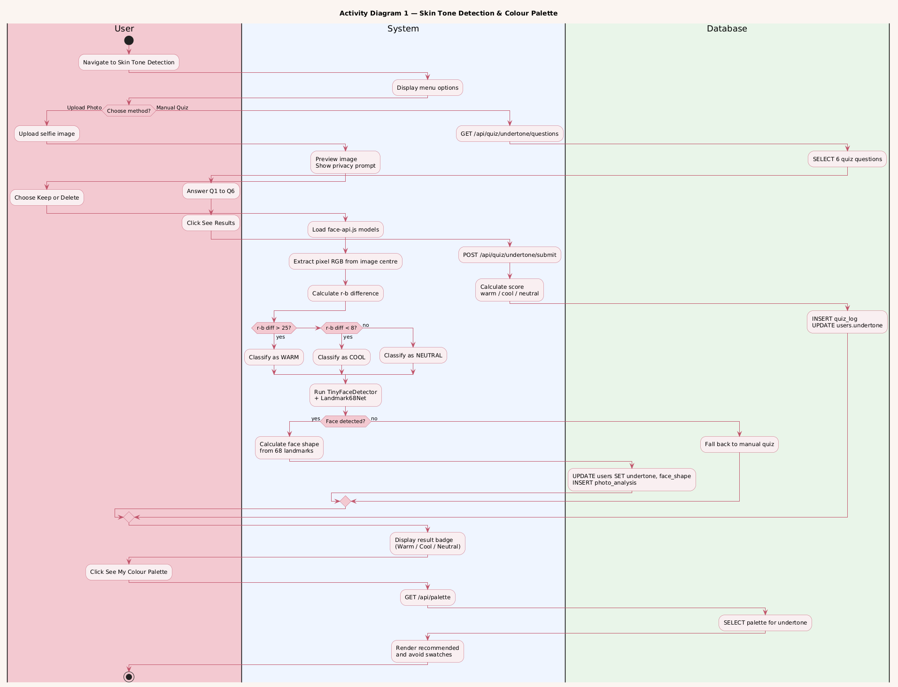

4.1.2 Wardrobe Upload & Outfit Suggestion (US-09)
Shows the flow from the user uploading a clothing item photo, system detecting its dominant color, user tagging the item, selecting an event type, the system generating outfit combinations, and the user bookmarking favourites.

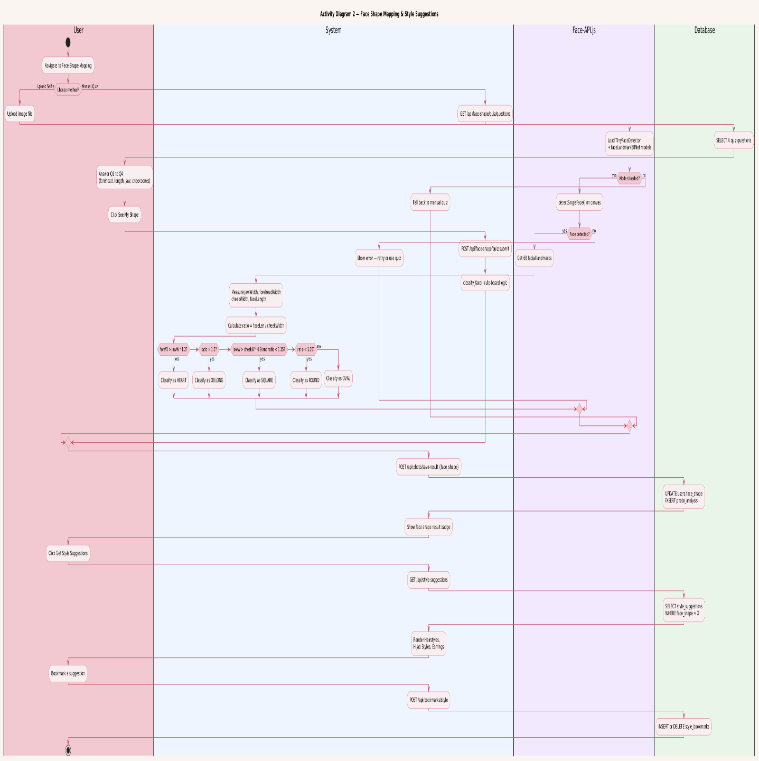

4.1.3 Face Shape Detection & Style Suggestions (US-07 & US-10)
Shows the flow from the system processing the selfie for face shape, classification or fallback quiz, displaying face shape result, and generating hairstyle, hijab, and earring suggestions linked to the detected shape.

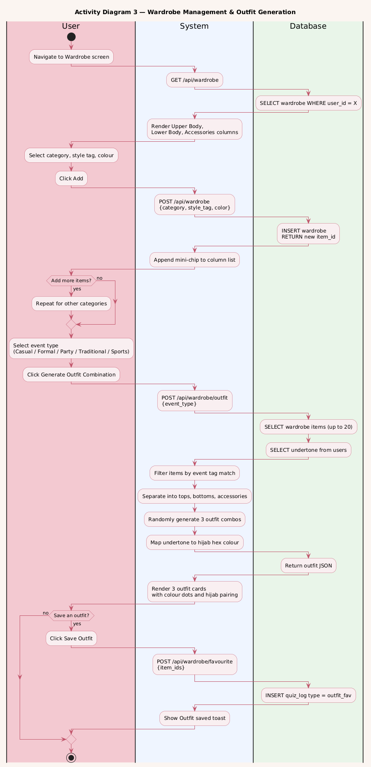

4.2 Use Case Diagram
The use case diagram below presents all actors and all use cases for the complete GlamMatch system as developed across Sprint 1 and Sprint 2.

Actors:
- User — primary actor; interacts with all styling, wardrobe, and salon features.
- Image Analysis Service — external/backend service that processes photos for skin tone and face shape.
- Admin — manages the product recommendation database and salon listings.

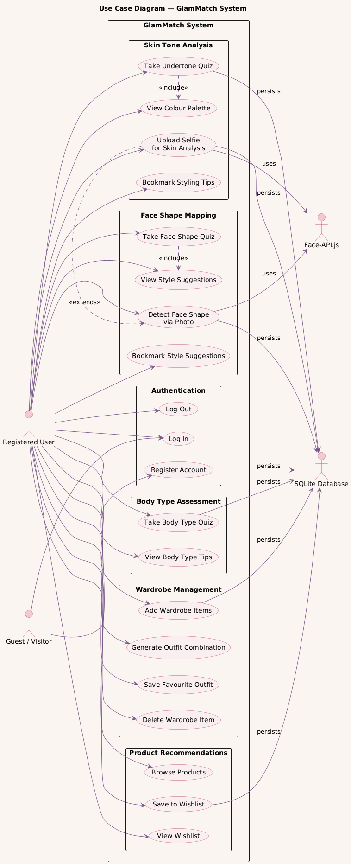

4.3 Sequence Diagrams
Sequence diagrams are provided for the three main activities of Sprint 2.

4.3.1 Sequence Diagram — Photo Upload & Skin Tone Analysis (US-06)
Participants: User → Frontend → Backend API → Image Analysis Service → Database. Shows the upload request, image forwarding, analysis response, profile update, and redirect to palette screen.

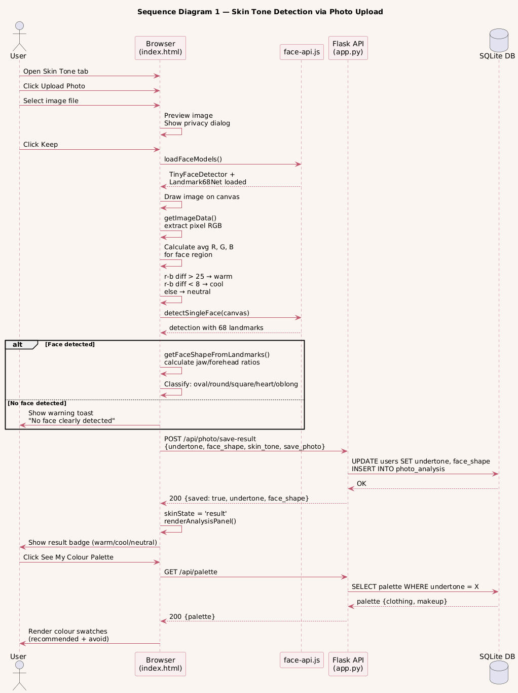

4.3.2 Sequence Diagram — Wardrobe Upload & Outfit Suggestion (US-09)
Participants: User → Frontend → Backend API → Color Detection Service → Database. Shows item upload, color detection call, tag submission, event selection, outfit generation, and wishlist save.

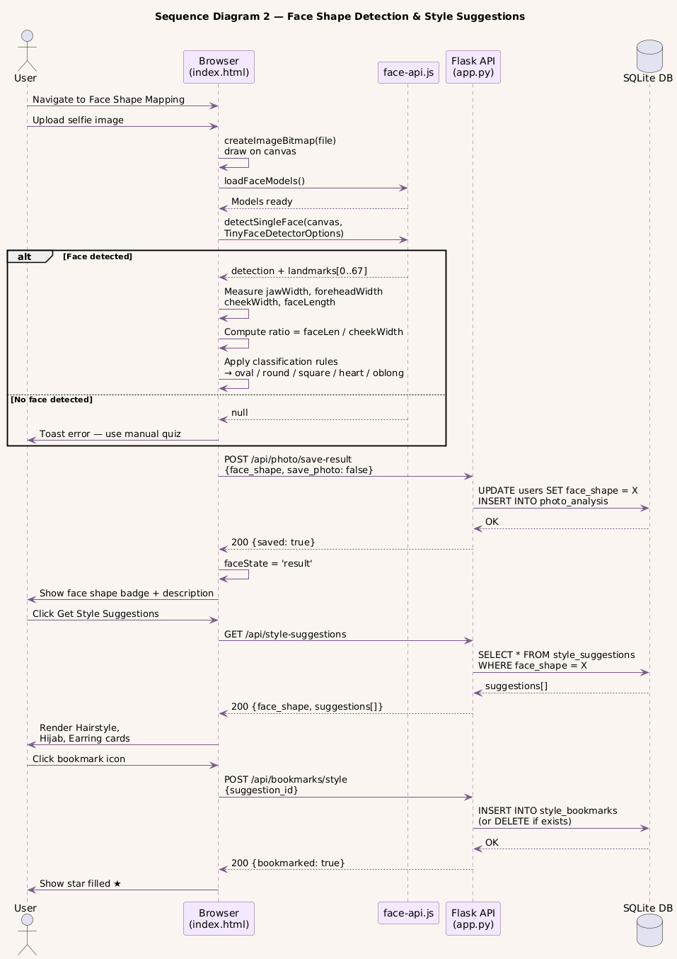

4.3.3 Sequence Diagram — Product Recommendations (US-08)
Participants: User → Frontend → Backend API → Recommendation Engine → Database. Shows profile data fetch, product lookup, tab rendering, and wishlist save interaction.

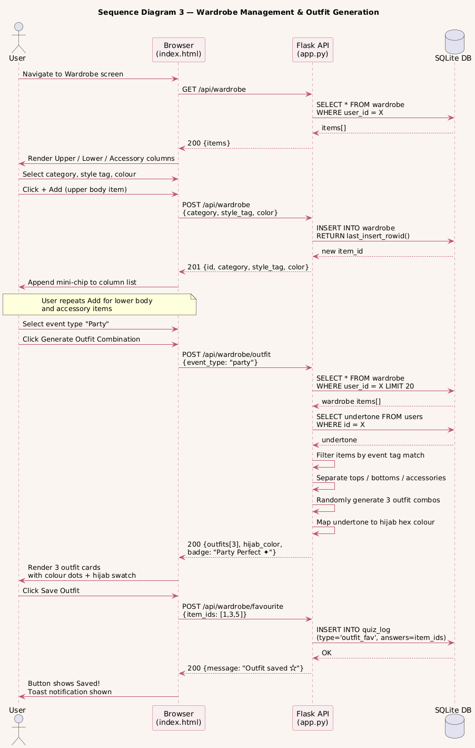

4.4 Class Diagram
The class diagram below shows all classes for Sprint 2 with their attributes, methods, and relationships.

Key classes and relationships:
- User — attributes: userId, name, email, passwordHash, undertone, skinTone, faceShape, bodyType
- Photo — attributes: photoId, userId, filePath, uploadDate, isDeleted | User 1—* Photo
- SkinToneResult — attributes: resultId, userId, skinTone, undertone, method (photo/quiz) | User 1—1 SkinToneResult
- FaceShapeResult — attributes: resultId, userId, faceShape, confidence | User 1—1 FaceShapeResult
- WardrobeItem — attributes: itemId, userId, photoPath, dominantColor, clothingType, style | User 1—* WardrobeItem
- OutfitSuggestion — attributes: suggestionId, userId, itemIds[], eventType, hijabColor, isFavourite | OutfitSuggestion aggregates WardrobeItem
- ProductRecommendation — attributes: productId, category, undertone, bodyType, brand, shadeName, swatchColor, productLink
- Wishlist — attributes: wishlistId, userId, productId, savedAt | resolves User M—N ProductRecommendation

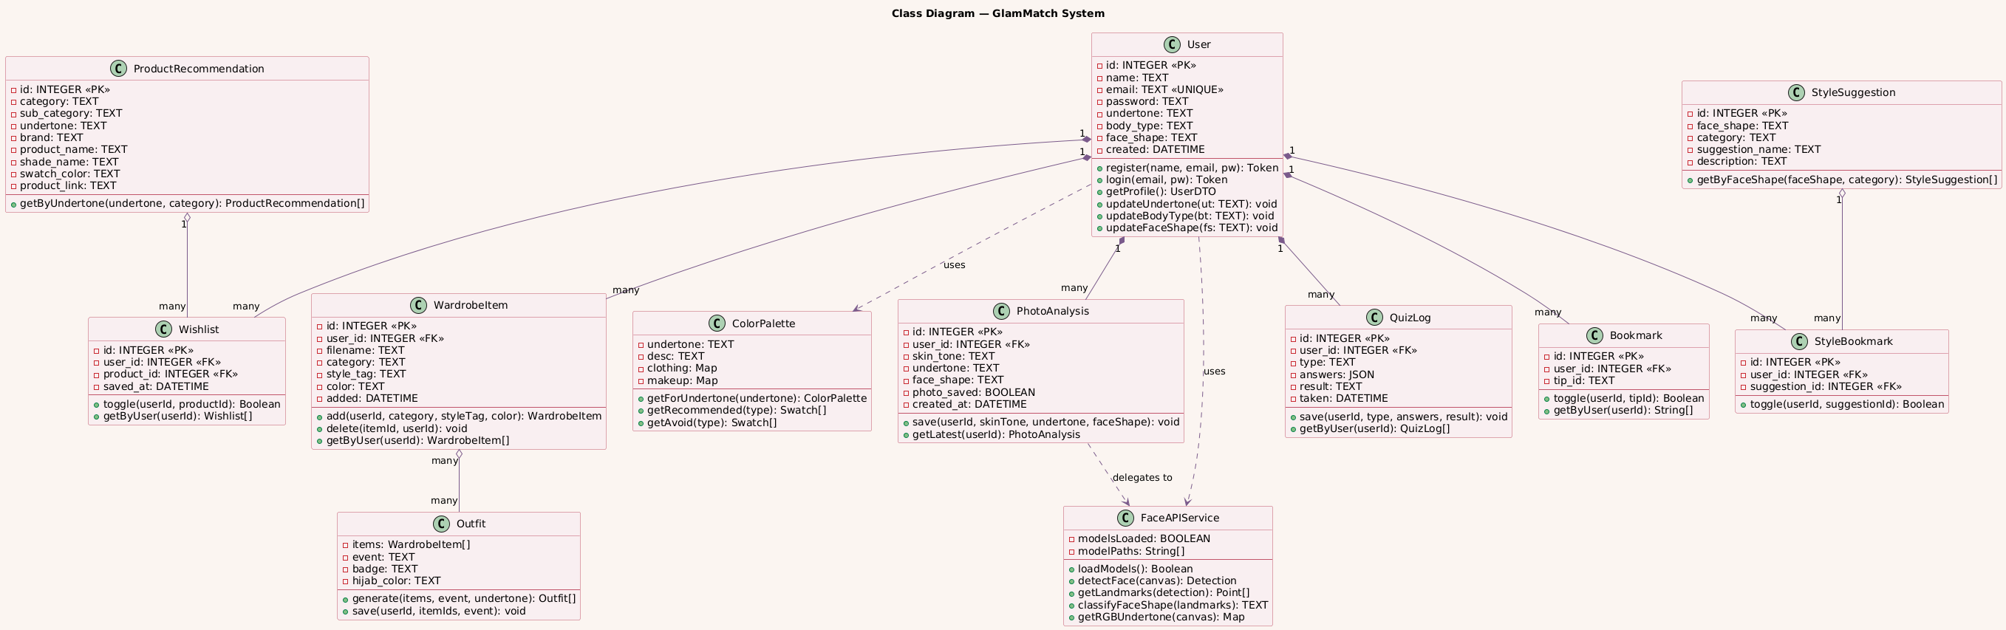

5. Scrum Board — Trello Screenshots
Three Trello board screenshots are provided showing sprint progression from start to completion.

Screenshot 1 — Sprint Start: All US-06 to US-10 in ‘To Do’

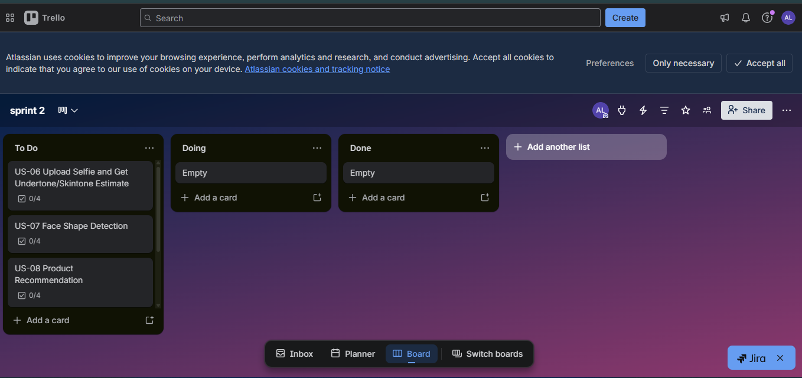

Screenshot 2 — Mid Sprint: US-06 & US-07 Done, US-08 In Progress

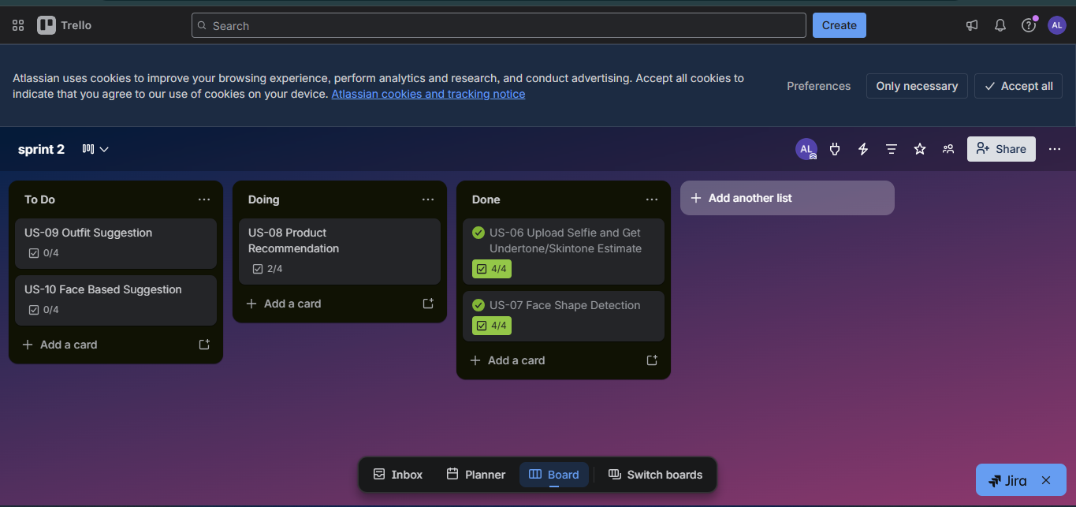

Screenshot 3 — Sprint End: All Stories Completed

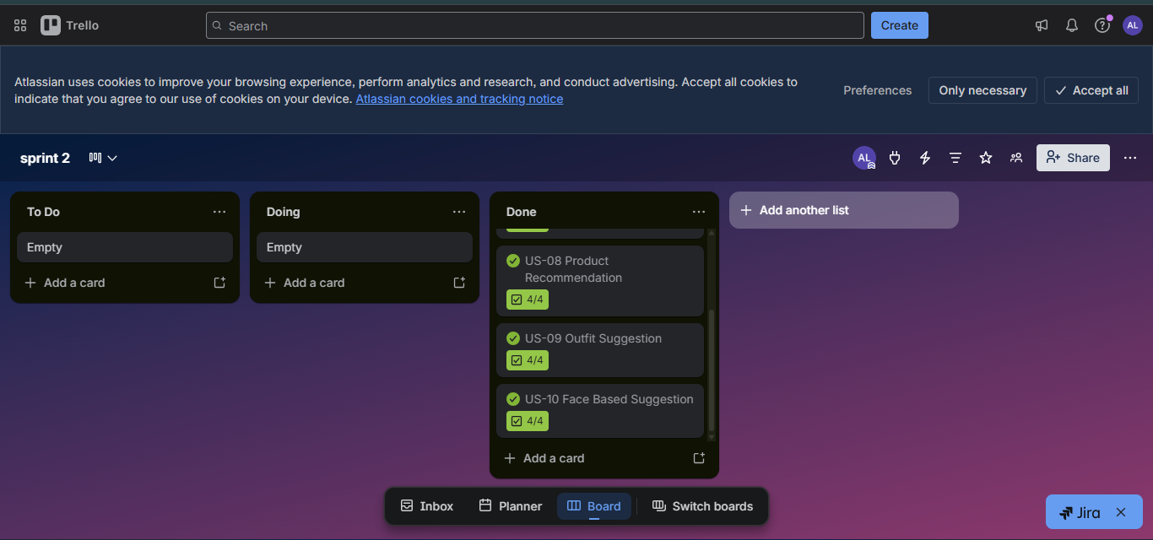

6. Work Division

Member | Role | Sprint 2 Contributions
Ayza Ahmed (24L-2577) | Project Lead + Requirements Engineer | Sprint 2 planning and Trello backlog setup, writing user stories US-06 to US-10, sub-stories and acceptance criteria, NFR definitions, report compilation and formatting, work division.
Eman Adil (24L-2589) | Backend + AI Integration Developer | Photo upload and image analysis API integration (skin tone, face shape), wardrobe item CRUD endpoints, color detection service, outfit suggestion engine, product recommendation database queries, wishlist API, JWT-secured endpoints.
Anoushay Fatima (24L-2585) | Frontend Developer + UI/UX + QA Tester | UI design and implementation of Photo Upload, Analysis Results, Product Recommendations, My Wardrobe, Outfit Suggestions, and Style Suggestions screens; test case writing for US-06 to US-08; Trello snapshot management.

7. Implementation Screenshots
The following screens were implemented as part of Sprint 2. Insert actual screenshots from the deployed or prototype application below each description.

7.1 Photo Upload Screen
The Photo Upload screen presents a circular upload area with gallery and camera options. Illustrated guidance on ideal selfie conditions is shown below the upload area.

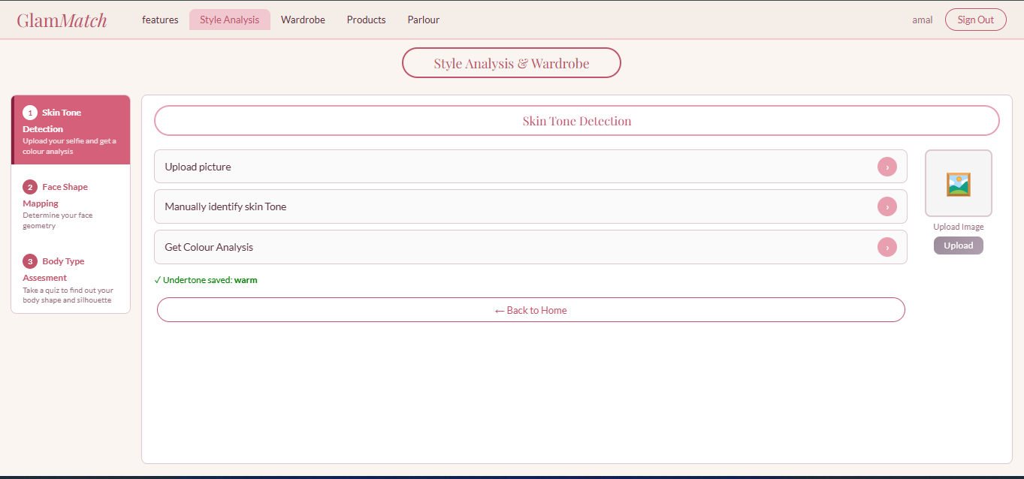

7.2 Analysis Results Screen (Skin Tone + Face Shape)
Shows two result cards: Skin Tone card (tone label, undertone, skin swatch) and Face Shape card (shape name, outline illustration, description). Privacy prompt is shown at the bottom.

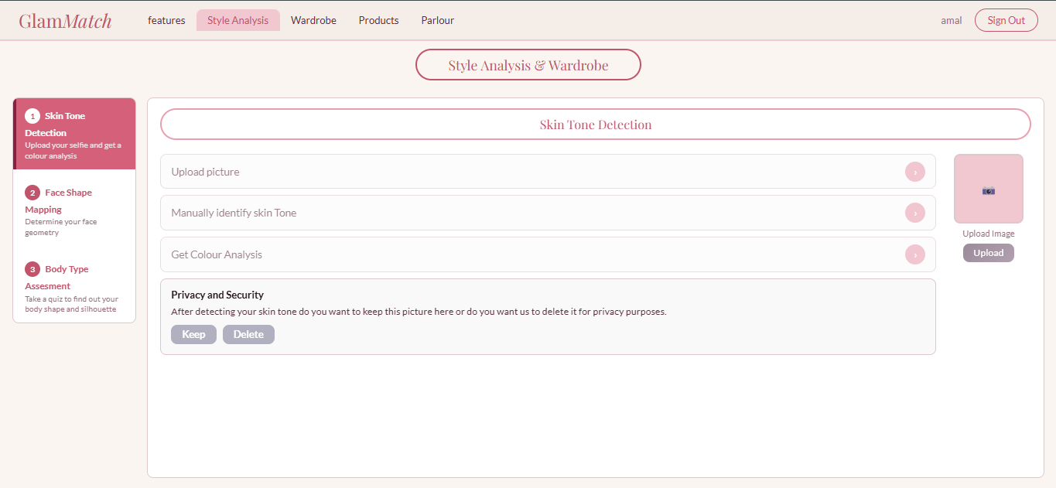
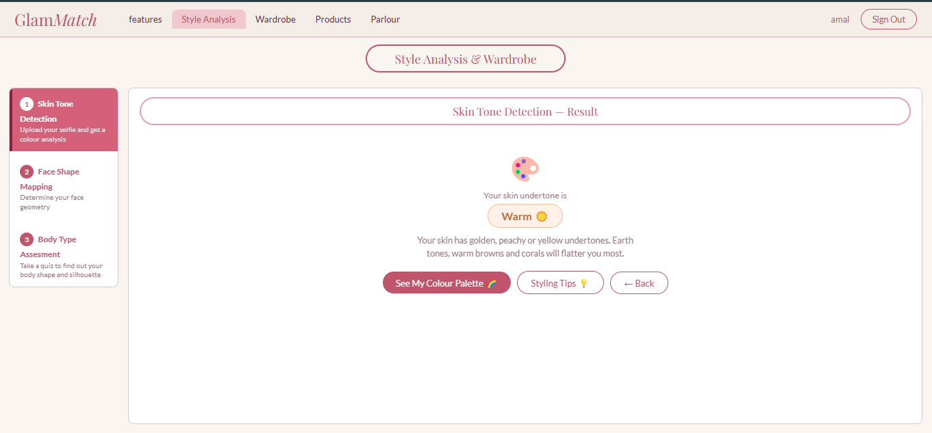
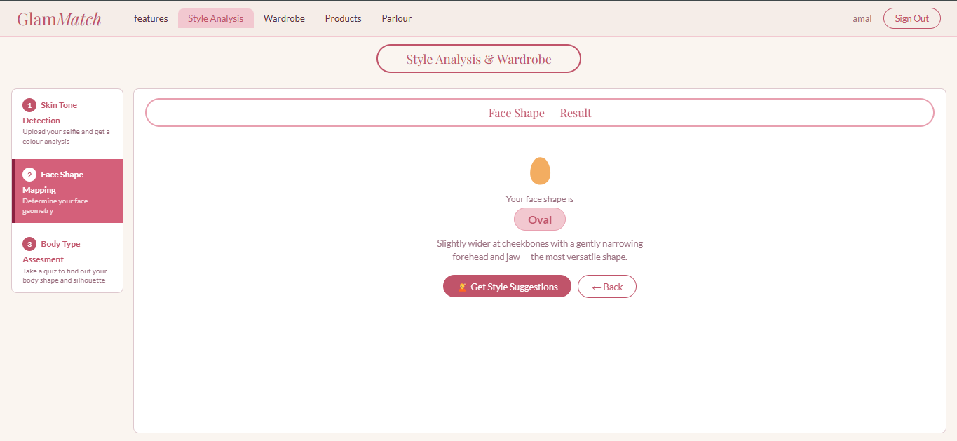

7.3 Product Recommendations Screen
Tabbed layout showing Makeup and Clothing tabs. Each product card has a shade swatch or item image, product name, brand, and a ‘View Product’ button. Heart icon saves item to wishlist.

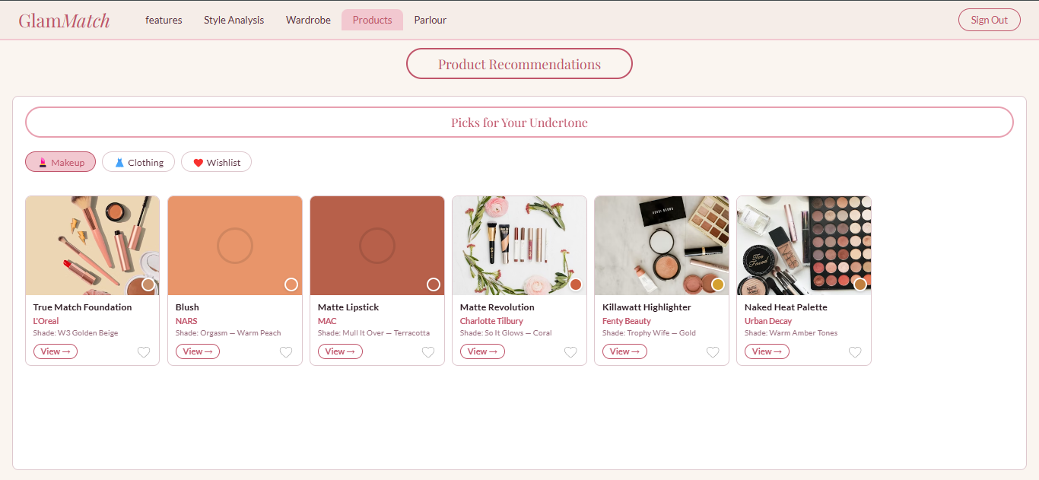
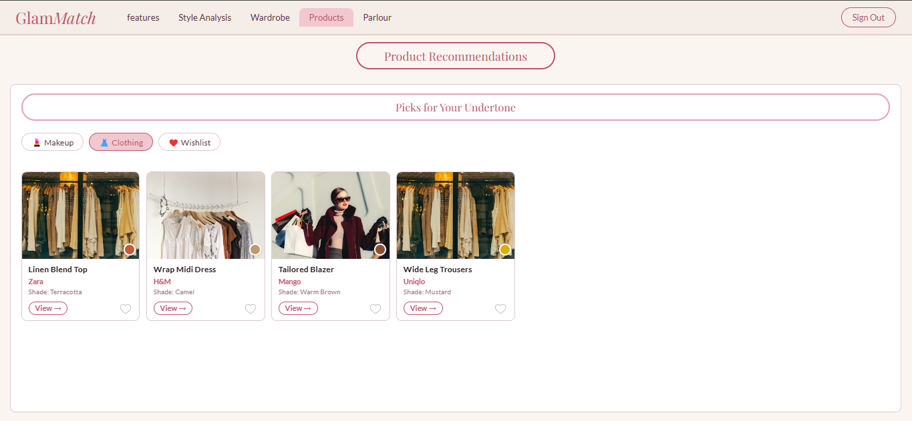

7.4 My Wardrobe & Outfit Suggestions Screens
My Wardrobe shows a grid of uploaded clothing items with dominant color badge on each. Outfit Suggestions shows event-type chips at top and outfit combination cards below.

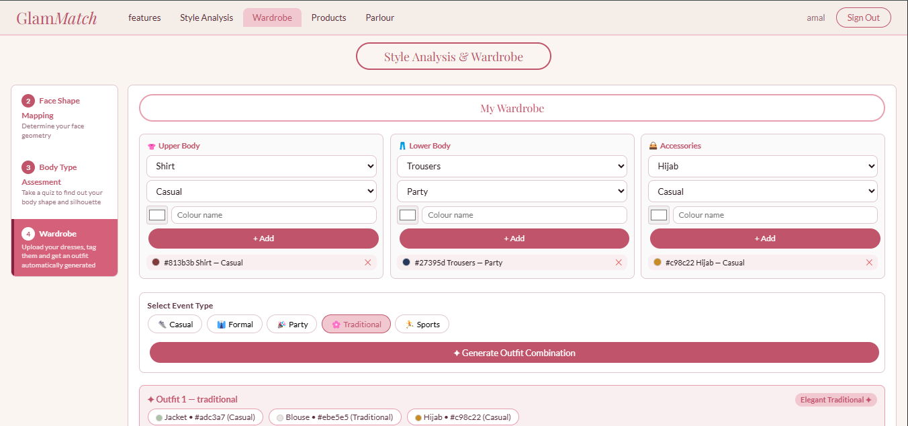
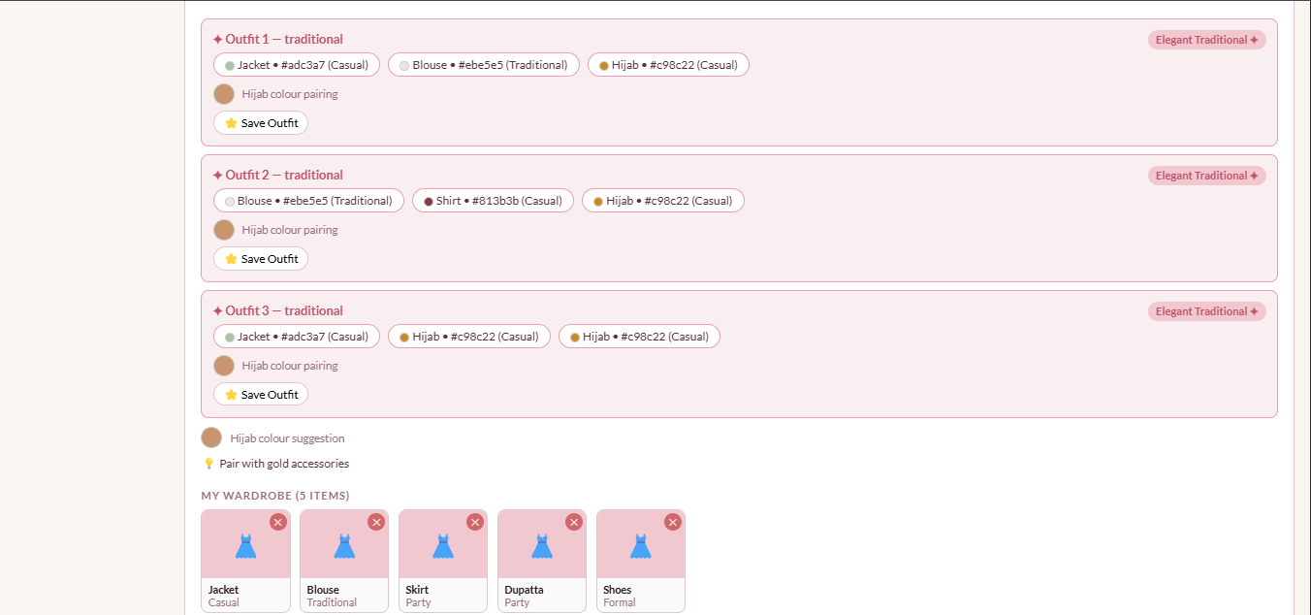

7.5 Style Suggestions Screen (Hairstyle, Hijab & Earrings)
Three accordion sections: Hairstyles, Hijab Styles, Earrings. Each section shows illustrated cards with a style name, visual example, and one-line explanation. Bookmark icon on every card.

