Problem 4: Commercial Banking, Lending, Payments and Compliance
Design report and implementation guide (OOP project, assessed concepts: classes and inheritance)
Prepared by | Khizar Rizwan
Roll number | ______________________________
Course and instructor | CS2012 Introduction to Object-Oriented Programming, FAST-NUCES Lahore; Bilal Nadeem

The whole implementation is one file, banking_system.py (Python 3.9+, standard library only). It contains the domain model, a seeded demonstration of 16 scenarios, 73 automated tests and generators for the class and UML diagrams.
python banking_system.py # run the seeded demonstration
python banking_system.py --test # run the 73 automated tests
python banking_system.py --classes # print the inheritance tree and the counts
python banking_system.py --diagram docs # regenerate every diagram (SVG) from the code

Required submission item (brief, Problem 4) | Where
1. Domain research summary, sources and terminology | Section 1
2. Assumptions | Section 2 (A1 to A36)
3. Requirements interpretation | Section 3; 3.1 answers the brief's eight open questions; 3.2 maps every participant, research area and scope item of the brief to the model
4. Class diagram | Section 4: overview, four UML hierarchy diagrams, three association diagrams (docs/*.png); 4.1 six flowcharts of the main workflows; 4.2 four UML state machine diagrams
5. Implementation with at least 30 classes and 30 operations | Section 5; banking_system.py (71 business classes plus 6 supporting, 98 operations, 80 of them state-changing commands)
6. Explanation of every inheritance relationship | Section 6; 6.1 abstract classes and polymorphism; 6.2 inherited state machines
7. At least three tempting inheritances rejected | Section 7 (fourteen given); 7.1 compares the design with a plausible alternative
8. Seeded demonstration | Section 8; docs/demo_output.txt
9. At least five complex scenarios | Section 9 (sixteen given)
10. Limitations and scaling | Section 10
(Optional) user interface | Section 11: desktop GUI in banking_gui.py (staff console and digital banking)

1. Domain research summary

Sources consulted
- FATF, International Standards on Combating Money Laundering and the Financing of Terrorism (the FATF Recommendations), especially Recommendation 10 (customer due diligence) and Recommendations 24 and 25 (beneficial ownership of legal persons and arrangements).
- State Bank of Pakistan, AML/CFT/CPF Regulations for banks and DFIs, for local customer due-diligence and beneficial-owner practice.
- Basel Committee on Banking Supervision, Sound management of risks related to money laundering and financing of terrorism.
- ISO 20022 payment message concepts (payment initiation and status reporting), for the idea that a payment moves through statuses rather than simply "succeeding".
- Visa and Mastercard public dispute-resolution overviews, for the chargeback and dispute lifecycle.
- IFRS 9 guidance on modification of financial assets, for how a restructured loan relates to the original agreement.
- BIAN (Banking Industry Architecture Network) service landscape, for the separation between a product directory and a customer's product agreement.
- Martin Fowler, Analysis Patterns and his "Temporal Patterns" essays, for the Party/role separation and effective-dated records.

Key terminology learned
Term | Meaning, and how it shaped the model
KYC / CDD | Verifying who a customer is before a relationship starts. Modelled as IdentityDocument + VerificationCheck, checked as of a date, so a document that expires during onboarding blocks it.
Beneficial owner (UBO) | A natural person who ultimately owns or controls an organisation (commonly 25% or more). Must also be verified. BeneficialOwnership.
Mandate | The authority an organisation gives a person to operate its accounts, often with limits. Separate from being a director. Mandate with a validity Period.
Dual control (maker-checker) | Payments above a threshold need a second authorised signatory who is not the initiator. PaymentAuthorisation.
Delegated credit authority | Each credit role may approve financing only up to a limit; larger amounts go to a higher authority. Bank.CREDIT_LIMITS, checked in decide_application.
Double entry, trial balance | Every posting has equal and opposite legs, so all balances in the bank sum to zero. Customer accounts balance against the bank's own GeneralLedgerAccounts (vault cash, clearing, income, receivables).
Ledger vs available balance | Ledger balance = sum of posted entries. Available = ledger - holds + overdraft. A held payment reduces the available balance without posting.
Hold | Funds reserved but not yet debited (AccountHold).
Posting | Writing an immutable entry to the ledger (LedgerEntry). Balances are derived, never stored.
Reversal | The bank undoes all or part of one of its own postings by posting equal and opposite entries under a staff approval; the original remains, marked (partially) reversed. Reversal.
Issuer, acquirer, card scheme | In a card payment the customer's bank is the issuer, the merchant's bank is the acquirer, and the scheme (Visa, Mastercard, PayPak) connects them and sets the dispute rules. This bank is the issuer, so it holds no KYC on merchants. Merchant is a counterparty, not a Party.
Merchant refund | The merchant voluntarily sends money back (goods returned, order cancelled). It is a new credit through the scheme; the original purchase stays posted and simply has less left to dispute. MerchantRefund, deliberately not a Reversal.
Chargeback | After upholding a cardholder's dispute, the issuer claims the money back from the merchant through the scheme, quoting a scheme reason code (fraud, not received, not as described, duplicate, incorrect amount...). It is a reversal of the card payment with extra obligations, so Chargeback is a subclass of Reversal.
Dispute reason code | Schemes group disputes into reason categories that decide what evidence is needed. Every Dispute records one, and its chargeback carries it.
Standing order | A customer's recurring payment instruction. Authority is given once, when the instruction is created.
Conditions precedent | Requirements that must be met before approved financing can be disbursed. ApprovalCondition.
Amortisation schedule | The installment plan of principal and interest. RepaymentSchedule + Installment.
Arrears / DPD | Installments past due; they trigger collections. CollectionsCase.
Restructuring | Changing a loan's terms (tenor, rate) after default risk appears; overdue interest may be capitalised. A new schedule version, never an edit.
Service request | A routine customer instruction (block a card, request a statement), distinct from a complaint. ServiceRequest.
Product vs arrangement | The bank's product definition (what it sells) is different from a customer's instance of it (what the customer holds).
Sole trader | An individual trading under a business name with no separate legal personality; the person is liable. A Person in the SOLE_TRADER segment with a recorded trading name.
High-value (private banking) customer and EDD | Enhanced due diligence: higher-risk or high-value relationships also need the source of wealth evidenced. The PRIVATE segment requires a verified SOURCE_OF_WEALTH document.
Fixed-term deposit | Money placed for a fixed term at a fixed rate; paid out with interest at maturity, or broken early with interest forfeited and a penalty. FixedTermDeposit.
Card controls | Usage switches set by the cardholder or card operations (online, international, cash, merchant category). CardControl, with a validity period.
Biller / bill payment | An organisation the bank collects payments for (utility, telecom, tax). Biller, BillPayment with the customer's consumer reference.
Promise to pay | A collections outcome: the customer commits to pay an amount by a date; later marked kept or broken. PromiseToPay.
Record retention | Financial records must be kept for years after the relationship or product ends; "deletion" becomes archiving. archive_record, retention_until.

What the research changed in the design
The research was done before the class model was fixed, and several first ideas did not survive it. Each row is a design decision that would have been different without the source named.
First idea (before research) | What the research showed | Design adopted
Customer, Director and Signatory as subclasses of Person | CDD rules (sources 1 to 3) treat customer, controller, beneficial owner and authorised representative as roles of one natural person, each verified and time-bounded | One Person; CustomerRelationship, OfficerRole, BeneficialOwnership, Mandate as dated role objects (A1)
An organisation is verified when its own documents are | Beneficial-ownership rules (source 1, Recs. 24-25) require the people who own or control a legal person to be verified too, usually above 25% | Party.kyc_gaps is a template that includes connected_persons(); owners below 25% are recorded but do not block (A2)
A payment is either done or not done | Payment messaging (source 4) moves an instruction through statuses: accepted, pending, settled, rejected, returned | Declared lifecycles with AWAITING_AUTHORISATION, HELD_FOR_REVIEW, FAILED...; refused payments are kept as records (A7)
A disputed payment gets a refunded flag | Scheme dispute rules (source 5) separate an issuer's reversal, a merchant's voluntary refund and a chargeback with a reason code | Three classes: Reversal, Chargeback(Reversal), MerchantRefund; Dispute.reason (A27)
Restructuring edits the loan's installments | Loan modification guidance (source 6) treats a restructure as a modification of the original agreement whose history must remain | A new RepaymentSchedule version; the old one is SUPERSEDED and paid installments stay PAID (A13)
A product and a customer's account are one class | The BIAN landscape (source 7) separates the product directory from the customer's product agreement | ProductDefinition with versioned terms vs Arrangement that pins its version (A10)
Store the current value and overwrite on change | Temporal patterns (source 8): effective dating, audit logs and "as at" queries | Period, StatusHistory, versions and Correction; party_snapshot(party, date)
A card is a kind of account | Card issuing practice: a card is a credential linked to an account; replacements get new numbers and old transactions keep the old card | IssuedCard linked to a DepositAccount, with a replacement chain (rejected inheritance 2)

2. Assumptions
# | Ambiguity | Assumption adopted
A1 | Is a person who is both a customer and a signatory one record or two? | One Person record. "Customer", "director", "signatory", "owner" and "employee" are relationships to that person.
A2 | Beneficial ownership threshold | 25% or more. Owners below it are recorded but do not block onboarding.
A3 | When is KYC valid? | A party is verified on a date if it has a passing check against a document valid on that date. KYC is re-checked at onboarding and at account opening.
A4 | Charities | Need at least two trustees; trustees play the role directors play for companies.
A5 | Sole traders | A sole trader is legally the individual, so they are a Person in the SOLE_TRADER segment with a recorded trading name, not an Organization.
A6 | Large-transfer review | Digital transfers of PKR 1,000,000 or more are held for review and raise a fraud alert. Real banks use risk scores; a fixed threshold is a simplification.
A7 | Failed and declined payments | Stored as records with status FAILED / DECLINED and a reason. Never discarded.
A8 | Standing orders after a signatory leaves | The instruction belongs to the company, so it continues after the creator's mandate is revoked. Authority is checked when it is created.
A9 | Restrictions and bank-originated debits | Fees and loan postings made by the bank are not blocked by customer debit restrictions; customer-initiated debits are.
A10 | Product changes | Existing arrangements keep the terms version pinned at opening until the bank explicitly migrates them, which sends a Notice.
A11 | Discontinued products | "Closed to new sales" blocks new openings only. Existing arrangements are unaffected.
A12 | Lost vs stolen cards | A lost card may be reactivated if it has not been replaced. A stolen or replaced card never can; a found card is recorded and destroyed. Only a blocked card can be "found".
A13 | Restructuring | Overdue interest is capitalised into the new principal. The old schedule becomes SUPERSEDED; paid installments stay PAID. Settled agreements cannot be restructured.
A14 | Repayment allocation | Oldest installment first, interest before principal. A repayment larger than the total outstanding is refused (kept as FAILED) and changes nothing.
A15 | Deletion | Nothing with business history is deleted. "Delete" means a status change (closed, inactive, cancelled, superseded), a closed validity period, or archiving (A31, A32).
A16 | Branch closure | Customers, open accounts, staff and the branch's vault cash move to the receiving branch. opened_at_branch never changes; the servicing branch has a history. A closed branch cannot hire staff.
A17 | Single currency | All amounts are PKR, held as Decimal rounded to paisa.
A18 | Dual control | Set per mandate. Above the threshold a payment waits in AWAITING_AUTHORISATION until a different person with a valid payments mandate approves it; funds are checked again then. Only the initiator or another signatory may cancel it.
A19 | Savings interest | Credited at month-end on the lowest balance in the month, at the product's annual rate / 12. Current accounts earn no interest.
A20 | Sign convention | Credit positive, debit negative. Customer deposits show positive balances; bank assets (vault cash, loans receivable) negative.
A21 | Staff exit | An employee cannot leave while still relationship manager for active customers. Records they created keep naming them.
A22 | Customer exit | A relationship can end only when the customer holds no open products. The party record and all history remain.
A23 | Card reports | Reporting a card lost, stolen or damaged opens a ServiceRequest, which closes automatically when the replacement is issued.
A24 | Delegated credit authority | A credit officer may approve up to PKR 5,000,000 and a credit manager up to PKR 25,000,000. The decision keeps the role held at the time.
A25 | Card replacement after a card product is withdrawn | An existing cardholder can still get a replacement (their card is part of an existing arrangement); new cardholders cannot be issued the product.
A26 | Standing-order day | Days 1 to 28 only, so the day exists in every month.
A27 | Disputes | One open dispute per payment at a time; the disputed amount cannot exceed what is still standing, and the refund cannot exceed the disputed amount. Only customer payments can be disputed.
A28 | Account closure | Needs a zero balance, no funds on hold, no payment in progress and no live financing settling into the account. Closing cancels the account's cards and standing orders.
A29 | High-value customers | The PRIVATE segment requires enhanced due diligence: a verified source-of-wealth document in addition to identity. Organisations cannot use individual segments.
A30 | Term deposits | Funded once, from an account with the same holders; no withdrawals or top-ups before maturity. At maturity simple interest for the term and the principal go to the payout account and the deposit closes. Breaking early forfeits interest and charges the penalty rate in the pinned terms (1% in the demo).
A31 | Record retention | Records are retained at least 10 years after closure, settlement or the end of the relationship. A request to delete a financial record is always refused and logged, with the earliest destruction date.
A32 | Archive vs delete | Finished records can be archived: they leave the working lists but remain in every registry, report and history. The only real delete is a saved payee that no payment or standing order ever used.
A33 | Card controls | The cardholder or card operations may switch controls on and off; each control keeps its period. Controls apply to the card they were set on, not to its replacement.
A34 | Bill payments | Same authority, restriction and dual-control rules as transfers; they settle to a biller-settlement ledger. Large-transfer review does not apply to registered billers.
A35 | Collections | Collections cases are worked only by collections officers. A promise to pay is marked KEPT if the agreement has no overdue installment after the promised date, otherwise BROKEN, and a notice is sent.
A36 | Audit access | Only auditors and branch managers may run the approvals and authority audit, and each run is itself logged.

3. Requirements interpretation
Main records. Parties (people including sole traders and high-value customers, companies, charities) with their documents, checks, officer roles, ownerships and mandates; the customer relationship; branches, employees and role assignments; product definitions with versioned terms; customer arrangements (current, savings, fixed-term deposit, financing); immutable ledger entries, holds and restrictions; beneficiaries with versions; standing orders; transactions of several kinds; the bank's own general-ledger accounts; issued cards and their controls; billers; financing applications, conditions, schedules and installments; cases (service requests, disputes, complaints, fraud alerts, investigations, collections with promises to pay) with notes and evidence; statements, notices and an audit log.
Main workflows. Onboarding with KYC (enhanced for high-value customers) and relationship-manager assignment; account opening; cash deposits and withdrawals; own-account transfers; term-deposit placement, maturity and early break; beneficiary management and transfers with dual control; bill payments; standing orders; card issuance, controls, use, blocking and replacement; financing from application through delegated approval, conditions, disbursement, repayment, arrears, restructuring and settlement; collections contacts and promises; fraud and compliance review; disputes and complaints; audit review; product and branch lifecycle; archiving and retention.
Lifecycle changes the model must survive. Documents expire; staff and customers leave; people gain and lose authority; staff change role and branch; products stop being sold and change terms; beneficiaries change bank details; cards are replaced; loans are restructured; customer details are corrected; branches close.
Exceptional cases. Every refusal is a named rule (a BankingError subclass). Money movements that are refused are kept as FAILED or DECLINED transactions with the reason, because the attempt is itself a record the bank must keep.
Design principle used throughout. Any question of the form "what was true on date X?" must be answerable. Four techniques achieve this: validity periods (Period) for relationships, status histories (StatusHistory) for lifecycles, versions for things whose content changes (terms, beneficiaries, schedules) and counter-records for money (reversals instead of edits). Bank.party_snapshot(party, date) uses all four to rebuild what the bank knew about a customer on any past date.

3.1 Answers to the questions the specification does not answer
Question in the brief | Decision, and where it lives in the code
What is the relationship between a bank product definition and a customer's actual instance of that product? | Two different classes. ProductDefinition is what the bank sells, with versioned ProductTermsVersions and a sale status. An Arrangement (current, savings, term deposit, financing) is one customer's instance; it pins the terms version in force when it was opened and keeps its own terms history (A10).
Is a person who is both a customer and an organisational signatory one thing or two records? | One Person record. Being a customer is a CustomerRelationship; being a signatory is a Mandate; being a director an OfficerRole; being staff an Employee. Each is a separate object with its own validity period (A1; scenario 1, capacities_of).
How should authority that existed only during a time period be represented? | As an object with a Period [start, end). Revoking closes the period instead of deleting the mandate, and every payment stores the mandate it used, so authority_on(org, person, date) answers for any date (scenario 7).
Should a reversed transaction cease to exist or be counteracted by additional records? | Counteracted. A Reversal is a new transaction with its own date, amount, reason and approval that posts equal and opposite entries; the original stays, marked REVERSED or PARTIALLY_REVERSED (scenario 4).
What does deletion mean in a financial system where history matters? | Nothing with history is deleted. Ending something is a status change or a closed period; finished records can be archived (hidden from working lists, kept everywhere else) and must be retained at least 10 years; a deletion request is refused and logged. Only a payee that was never used can be deleted (A15, A31, A32; scenario 16).
Which similarities among savings facilities, transaction facilities, cards, financing, and investments justify inheritance and which do not? | Savings, current and term deposits all hold customer money with a ledger and balances, so they share DepositAccount, and each changes one behaviour (overdraft, withdrawal limit, fixed term). Financing shares only "a customer holds it under terms", so it is a sibling under Arrangement. A card holds no money, so it is not an arrangement subclass but a credential linked to an account. Investment-like placement is modelled as the fixed-term deposit; market-linked investments would be a further Arrangement subclass with position records (section 10).
How should an employee's current role differ from the role under which an old approval was made? | Roles are RoleAssignment periods on the Employee. An Approval copies the role and branch held at the moment of decision, so a promotion never rewrites old decisions (scenario 6: Zainab's decisions still read "Credit officer").
When a product changes terms, do old customers automatically inherit new terms? | No. Existing arrangements keep their pinned version until the bank migrates them explicitly, which sends a notice; the terms history shows which version applied on any date (A10; scenario 10).

3.2 Coverage of the brief
Participants named in the brief.
Participant | How the model represents them
Individual and organisational customers | Person, Company, Charity + CustomerRelationship; segments RETAIL, SOLE_TRADER, PRIVATE, SME, CORPORATE, NON_PROFIT
Authorised signatories and beneficial owners | Mandate (with limits and dual control), BeneficialOwnership (25% threshold)
Branch and customer-service staff | TELLER, RELATIONSHIP_MANAGER, BRANCH_MANAGER roles; ServiceRequest, Complaint
Cash and operations personnel | TELLER (cash via CashTransaction), OPERATIONS_OFFICER (disbursement, reversals)
Relationship managers | CustomerRelationship.rm_history; exit blocked while managing customers
Lending / credit officers | CREDIT_OFFICER, CREDIT_MANAGER with delegated limits; Approval
Card operations and payments staff | CARD_OPERATIONS (issue, replace, limits, controls, reversals); billers registered by payments operations
Fraud and compliance analysts | FraudAlert, ComplianceInvestigation, Restriction; COMPLIANCE_ANALYST role
Collections personnel | COLLECTIONS_OFFICER works CollectionsCases and records PromiseToPay
Auditors and management | AUDITOR / BRANCH_MANAGER run approvals_and_authority_audit; daily_report, trial_balance
External merchants, billers and payment counterparties | Merchant (category and country, linked to every card payment made there; record_merchant); Biller + BillPayment; Beneficiary versions for payees; every transaction names its counterparty()

Research areas and scope items.
Brief item | Where it is covered
KYC; person vs organisation vs owner vs authorised representative | IdentityDocument, VerificationCheck, Organization.kyc_gaps, EDD for PRIVATE; scenarios 1, 14
Retail and business product categories | Current, savings, fixed-term deposit, working-capital financing, debit card (ProductDefinition.CATEGORIES)
Deposit concepts: balances, statements, holds, closures | DepositAccount ledger/available balance, AccountHold, Statement, close_account; scenarios 2, 12
Payment lifecycle, beneficiaries, scheduled payments | Statuses INITIATED, AWAITING_AUTHORISATION, HELD_FOR_REVIEW, POSTED, FAILED, REVERSED...; Beneficiary versions; StandingOrder; bill payments; scenarios 2, 5, 8, 15
Cards: issuance, replacement, status, limits, controls, transaction linkage | IssuedCard chain, limit history, CardControl, CardPayment.card, search_transactions; scenarios 3, 10, 15
Financing: application to settlement | FinancingApplication ... settle_financing; scenario 6
Branch operations, employee/customer relationships | Branch, Employee, RoleAssignment, RM history; scenarios 11, 13
Fraud alerts, compliance cases, restrictions, review outcomes, evidence | FraudAlert, ComplianceInvestigation, Restriction, CaseEvidence snapshots; scenarios 2, 5, 9
Disputes, complaints, reversals, refunds, case histories | Dispute (with a scheme reason code), Complaint, Reversal, Chargeback(Reversal), MerchantRefund, repost_card_payment; scenarios 4, 15
Fees, statements, notices, customer service requests | FeeCharge (pinned terms), Statement, Notice, ServiceRequest
Record retention when customers, signatories, employees or products change | Periods, status histories, archive and retention rules; scenarios 7, 10, 12, 13, 16
Historical reporting and audit of approvals and authority changes | party_snapshot, transaction_story, approvals_and_authority_audit; scenarios 7, 16

4. Class model
77 classes plus 7 business-rule error classes. 71 of the 77 are business classes; the other 6 are supporting infrastructure (Period, StatusChange, StatusHistory, Lifecycle, AuditEvent, and the Bank application service). The brief discounts artificial classes, so the business count is the one to judge, and python banking_system.py --classes prints both.
All diagrams are generated from the live classes by python banking_system.py --diagram docs: the attributes and methods are read from the source code itself, so the diagrams cannot drift from the implementation.
Figure 1. Overview: the four inheritance hierarchies and the standalone classes (arrow points to the parent class)
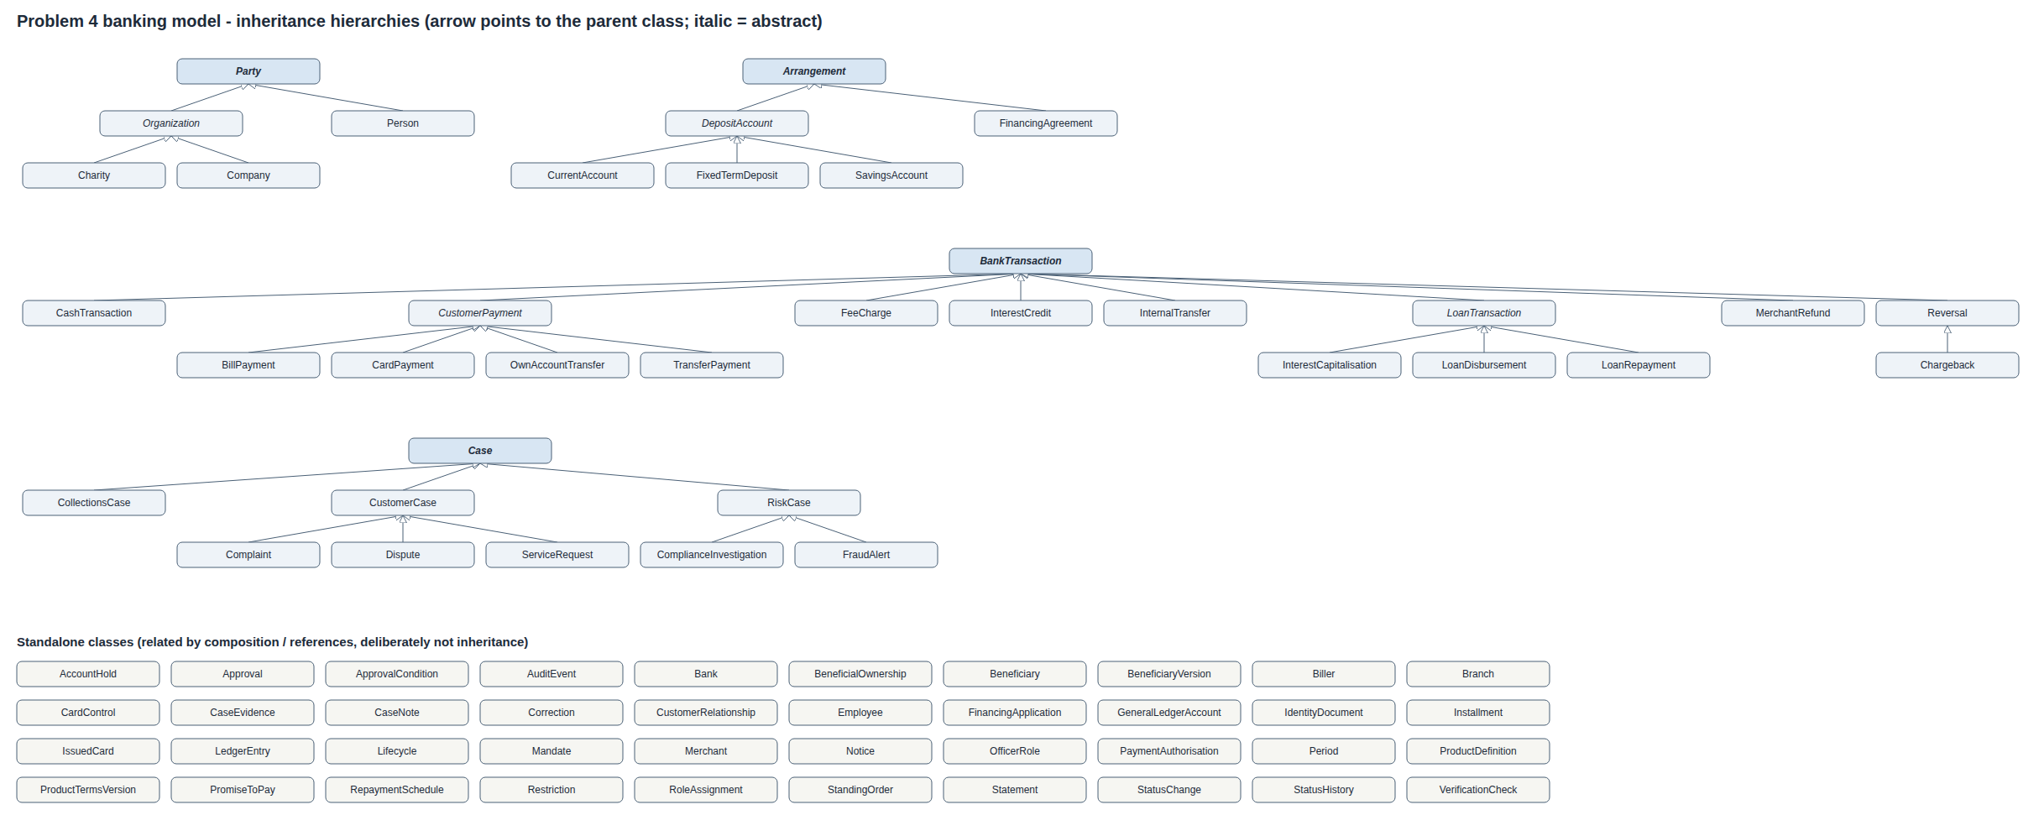
Figures 2 to 5. UML class diagrams, one per hierarchy. Each box shows only what that level adds: + class constants, - attributes set in that class's own __init__, and methods. Methods marked [override] (in red) replace or extend the parent's version. This is the visual answer to "why does the shared information belong at this level?" (section 6).
Figure 2. Party hierarchy
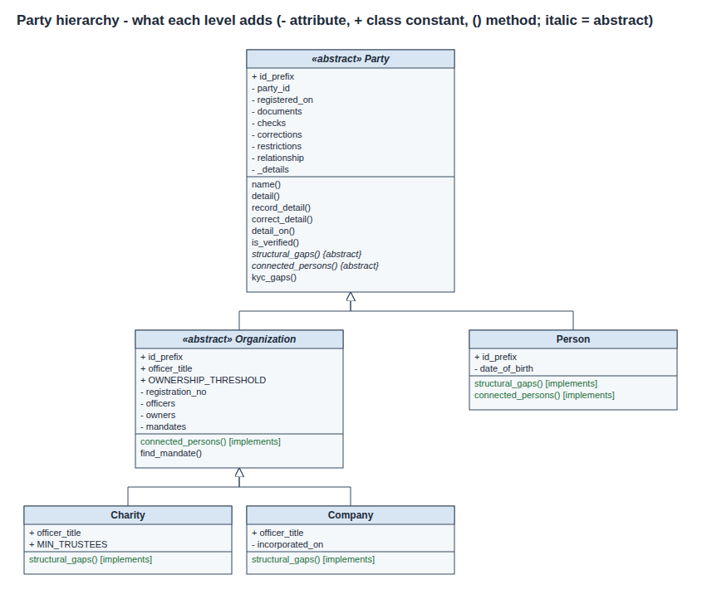
Figure 3. Arrangement hierarchy
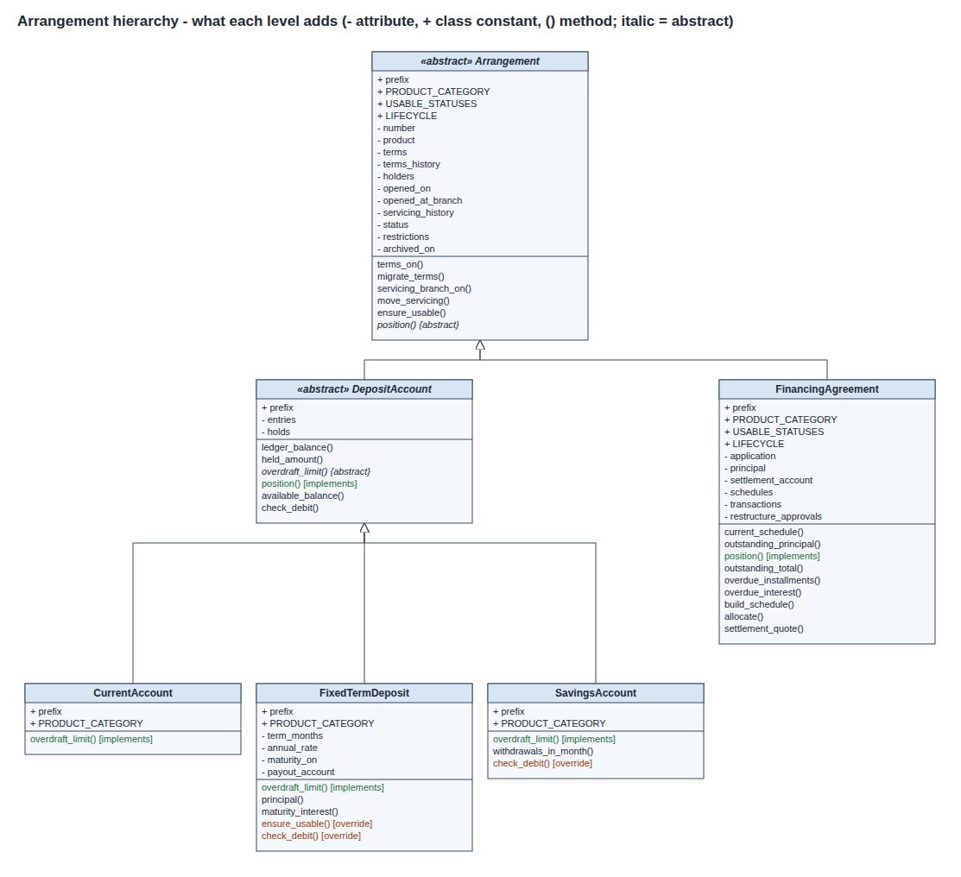
Figure 4. BankTransaction hierarchy
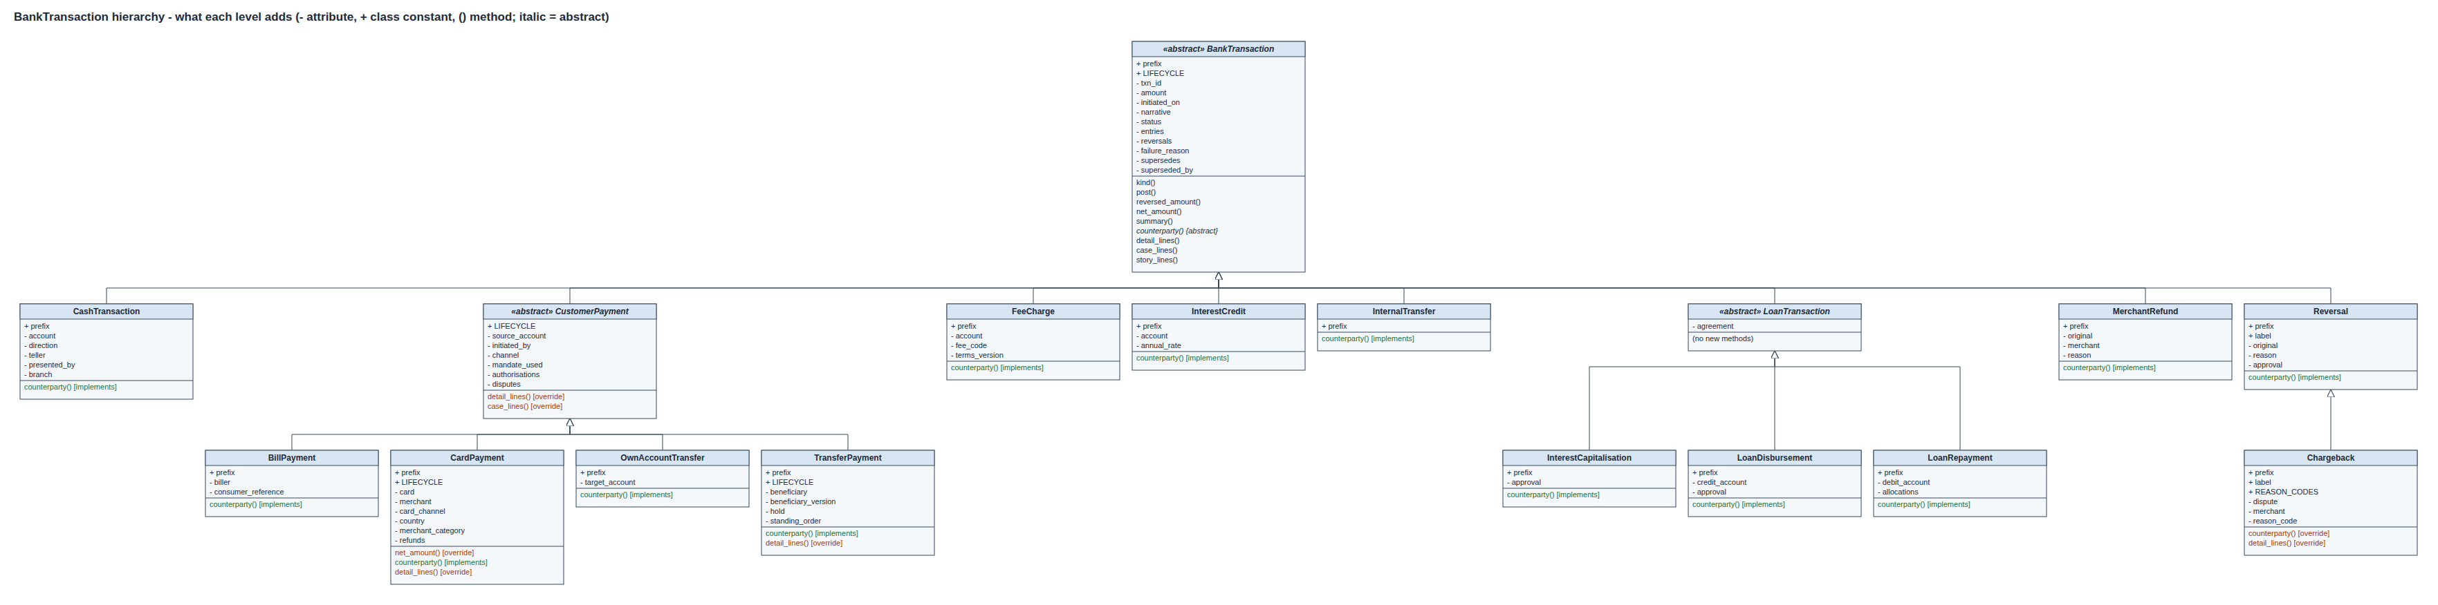
Figure 5. Case hierarchy
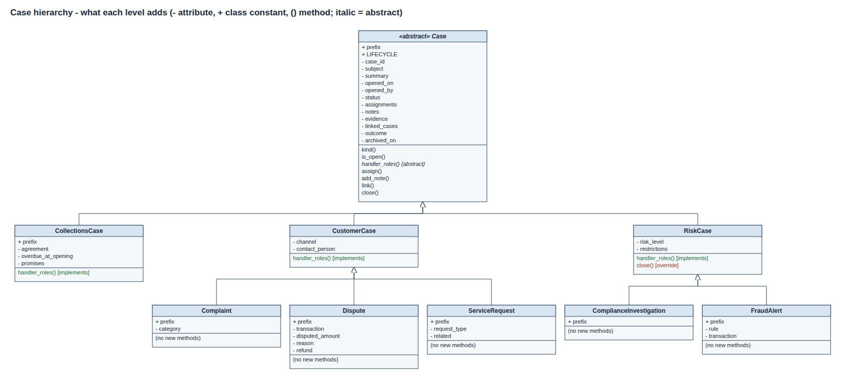
Figures 6 to 8. Associations (filled diamond = the owner keeps a dated history of these; arrow = reference)
Figure 6. Parties, roles and staff
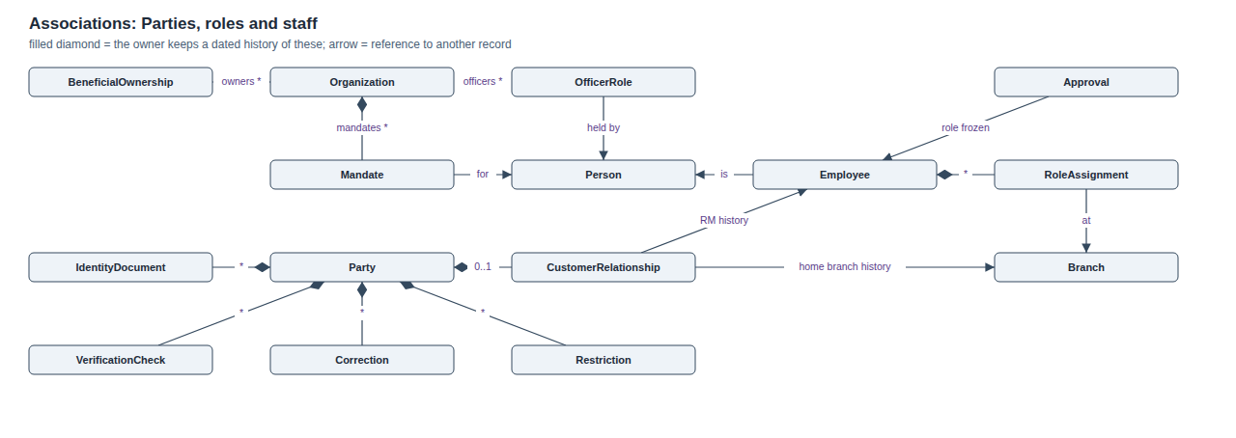
Figure 7. Products, accounts and payments
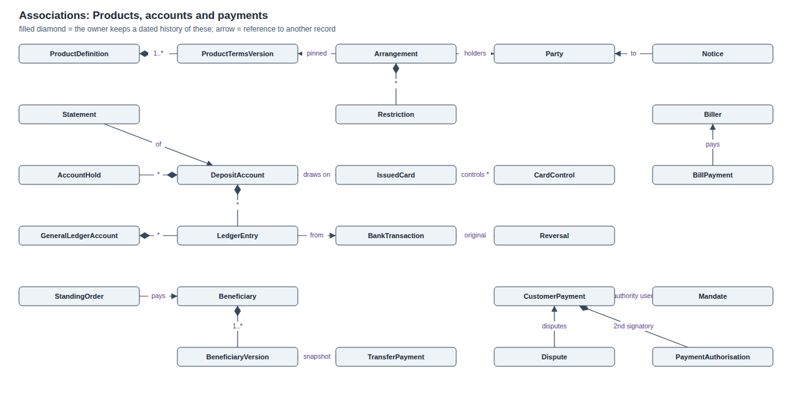
Figure 8. Lending and cases
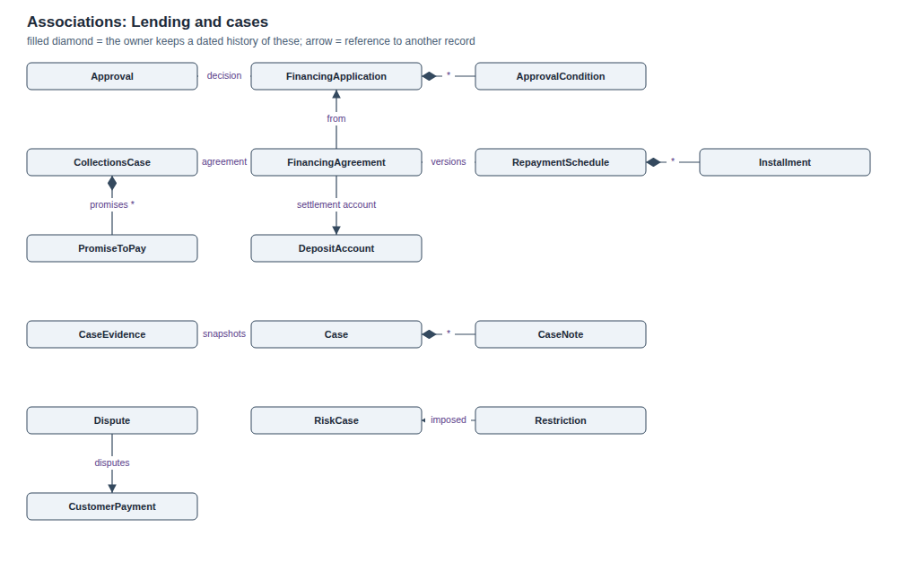
Key associations (composition and references; these are the relationships that were deliberately not modelled as inheritance):
From | To | Kind | Why it matters
Organization | OfficerRole, BeneficialOwnership, Mandate | owns a history of | Roles start and end without deleting anything
OfficerRole, Mandate, BeneficialOwnership | Person | refers to | One person, many capacities
Party | IdentityDocument, VerificationCheck, Correction, Restriction | owns a history of | KYC and corrections are dated
Party | CustomerRelationship | 0..1 | Being a customer is a relationship, not a type
CustomerRelationship | Branch, Employee | period history | Home branch and RM on any date
Employee | Person, RoleAssignment | refers to / history | Employees can also be customers; roles change
Approval | Employee | freezes role and branch | Old decisions show the role held then
ProductDefinition | ProductTermsVersion | 1..* | Terms are versioned
Arrangement | ProductTermsVersion | pinned + history | Old customers keep old terms until migrated
DepositAccount, GeneralLedgerAccount | LedgerEntry | owns | Balances are derived
LedgerEntry | BankTransaction | produced by | Every entry is explainable
Beneficiary | BeneficiaryVersion | 1..* | Payee details are versioned
TransferPayment | BeneficiaryVersion | snapshot | Old payments keep the details used
CustomerPayment | Mandate, PaymentAuthorisation | authority used | Authority provable after revocation
IssuedCard | DepositAccount, IssuedCard | draws on / replaces | Replacement chain
IssuedCard | CardControl | owns a history of | Controls in force on any date
BillPayment | Biller | pays | Biller can be retired without touching past payments
CollectionsCase | PromiseToPay | owns | Promises are marked kept or broken, never edited
FixedTermDeposit | DepositAccount | payout account | Where principal and interest go at maturity
Reversal | BankTransaction | original | Counter-record, not an edit
FinancingApplication | Approval, ApprovalCondition | decision, conditions | Evidence of why the bank lent
FinancingAgreement | RepaymentSchedule -> Installment | versions | Restructure supersedes, never edits
Case | CaseEvidence, CaseNote, linked Cases | owns | Evidence snapshots survive corrections
RiskCase | Restriction | imposed | A risk case cannot close while its restrictions are live

Complete class list by area:
Area | Classes
Time, lifecycles and audit | Period, StatusChange, StatusHistory, Lifecycle, AuditEvent
Parties and KYC | Party, Person, Organization, Company, Charity, IdentityDocument, VerificationCheck, Correction, OfficerRole, BeneficialOwnership, Mandate, PaymentAuthorisation, CustomerRelationship
Bank organisation | Branch, Employee, RoleAssignment, Approval
Bank's own books | GeneralLedgerAccount
Products | ProductDefinition, ProductTermsVersion
Arrangements | Arrangement, DepositAccount, CurrentAccount, SavingsAccount, FixedTermDeposit, FinancingAgreement, LedgerEntry, AccountHold, Restriction
Financing | FinancingApplication, ApprovalCondition, RepaymentSchedule, Installment
Payments | Beneficiary, BeneficiaryVersion, StandingOrder, Biller, Merchant, BankTransaction, CustomerPayment, TransferPayment, CardPayment, BillPayment, OwnAccountTransfer, CashTransaction, FeeCharge, InterestCredit, Reversal, Chargeback, MerchantRefund, InternalTransfer, LoanTransaction, LoanDisbursement, LoanRepayment, InterestCapitalisation
Cards | IssuedCard, CardControl
Cases | Case, CaseNote, CaseEvidence, CustomerCase, ServiceRequest, Dispute, Complaint, RiskCase, FraudAlert, ComplianceInvestigation, CollectionsCase, PromiseToPay
Communications | Statement, Notice
Application service | Bank
Rule violations | BankingError, KycIncomplete, AuthorityError, RestrictionViolation, ProductNotAvailable, InsufficientFunds, InvalidStateError

4.1 Behaviour: the main workflows as flowcharts
The class diagrams above show the structure. These six flowcharts show the behaviour: the order in which the code checks each rule and where a refusal ends the flow. Each one was traced from the method it describes, so the order of the decisions is the order of the checks in banking_system.py / banking_gui.py. They are drawn from code by tools/make_flowcharts.py using the standard flowchart symbols (ISO 5807):
Symbol | Shape | Meaning in these charts
Terminator | Rounded "stadium" (green) | Start or normal end of the flow
Terminator | Rounded "stadium" (red) | The flow ends because a rule refused it (error raised, or the record kept as FAILED / DECLINED / REJECTED)
Process | Rectangle | One step the code performs
Decision | Diamond | A yes / no rule; every diamond has exactly one Yes and one No exit
Input / output | Parallelogram | Data coming in (an instruction) or going out (a printed report, a banner)
Predefined process | Rectangle with double sides | A named Bank operation described elsewhere (for example post(), verify_party())
Data store | Cylinder | Stored records: ledger entries and the append-only audit log

Flowchart 1. Program overview: what python banking_system.py does for each command-line option, and how the demonstration reaches a zero trial balance.
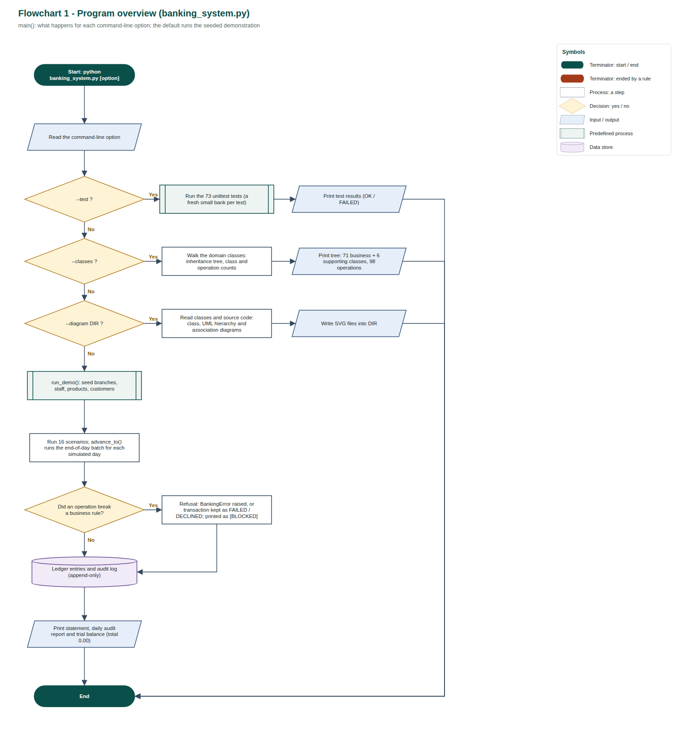
Flowchart 2. Customer onboarding and account opening: a failed document check is recorded (never deleted); KYC gaps block onboarding; an organisation needs its directors or trustees and owners verified first.
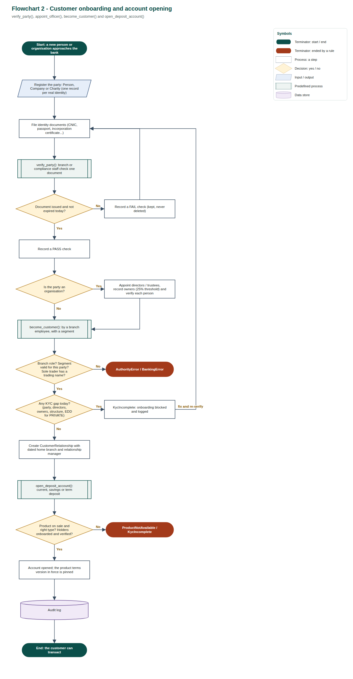
Flowchart 3. Transfer payment (initiate_transfer, authorise_payment, release_transaction): beneficiary, authority, funds, dual control and the PKR 1,000,000 compliance hold, in the order the code checks them.
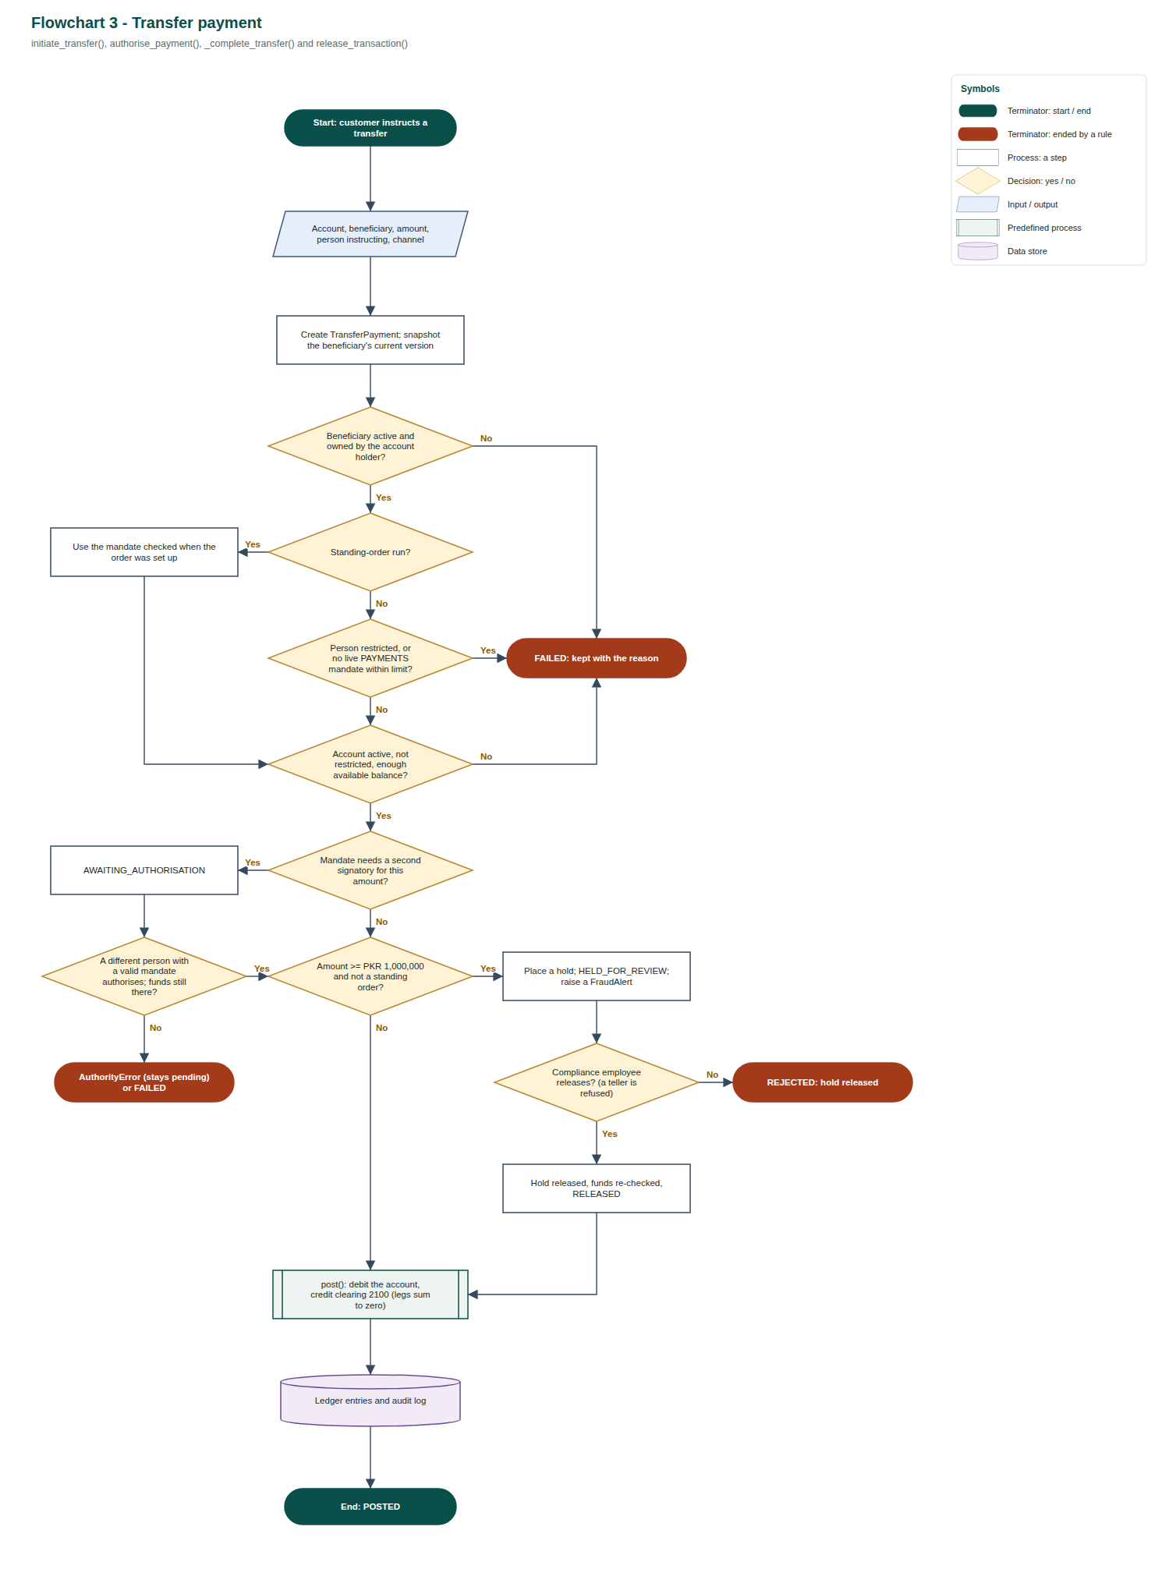
Flowchart 4. Card purchase (card_purchase): every refusal is a DECLINED payment kept with its reason; the card used is remembered so the history survives replacement.
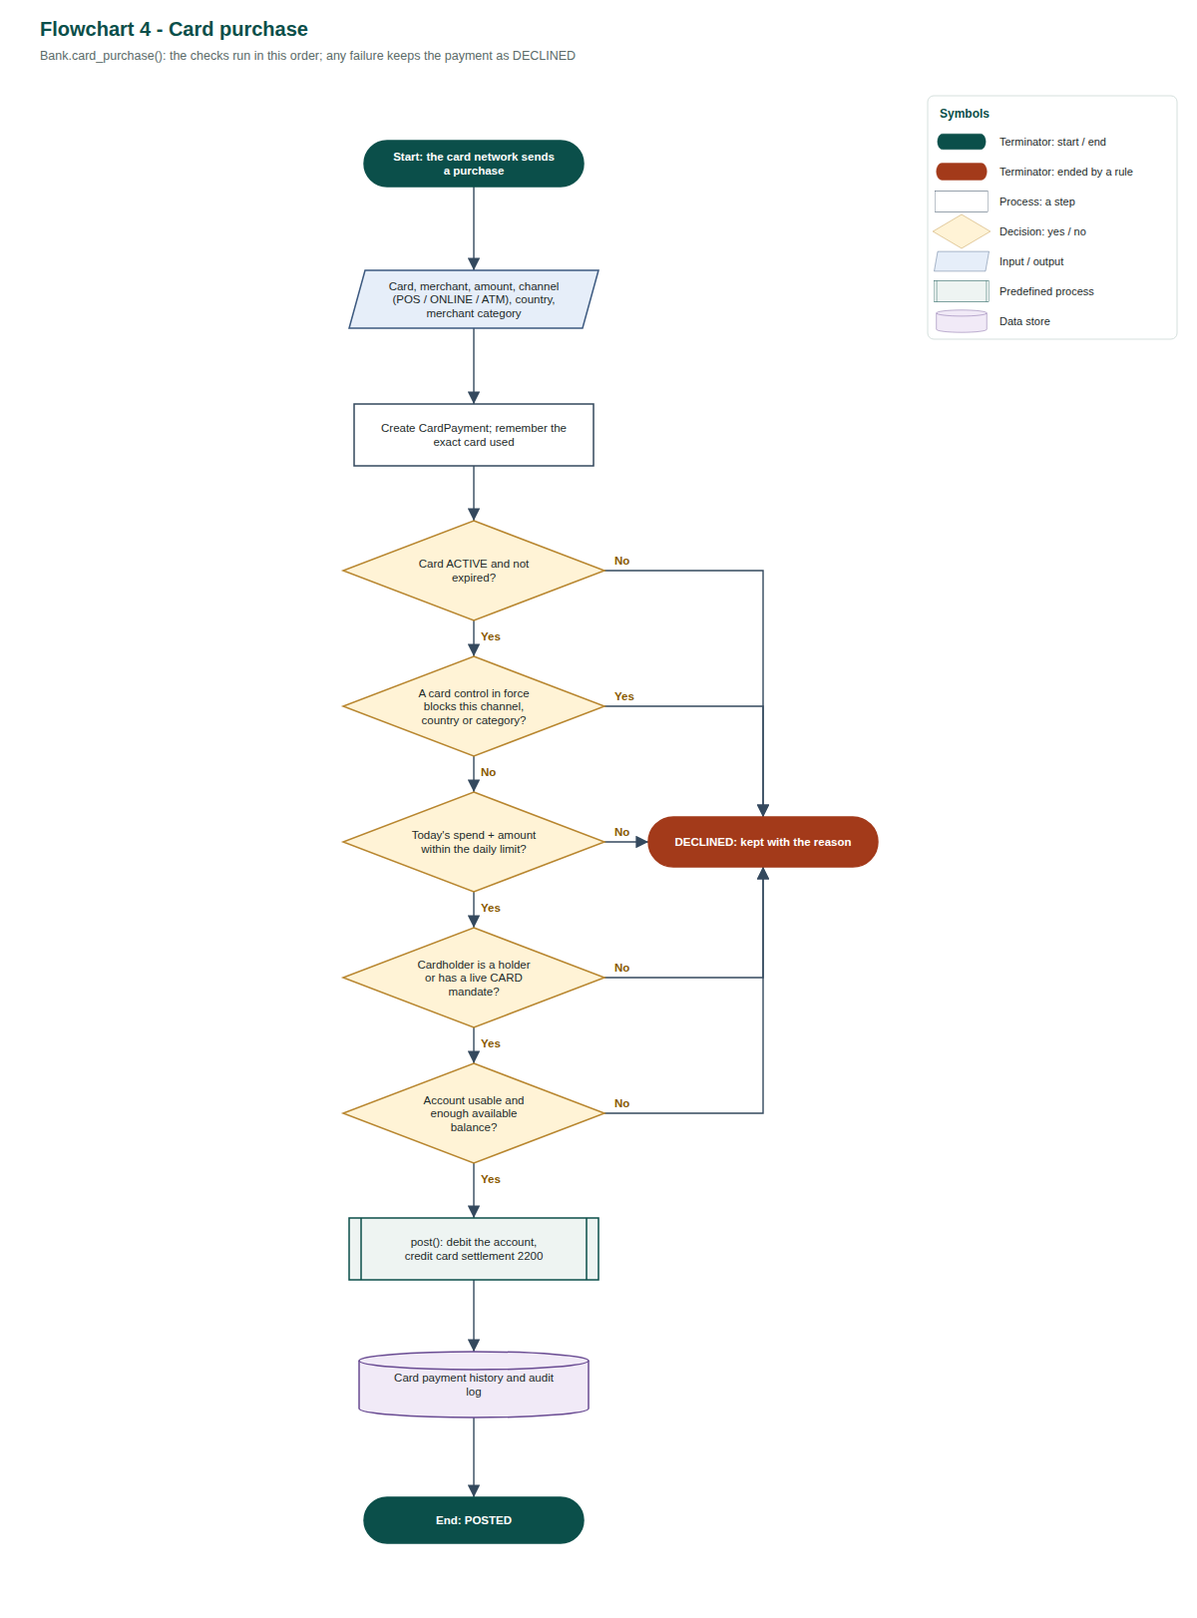
Flowchart 5. Financing lifecycle: delegated credit authority, conditions before disbursement, arrears and collections, restructuring (a new schedule version, the old one kept) and settlement.
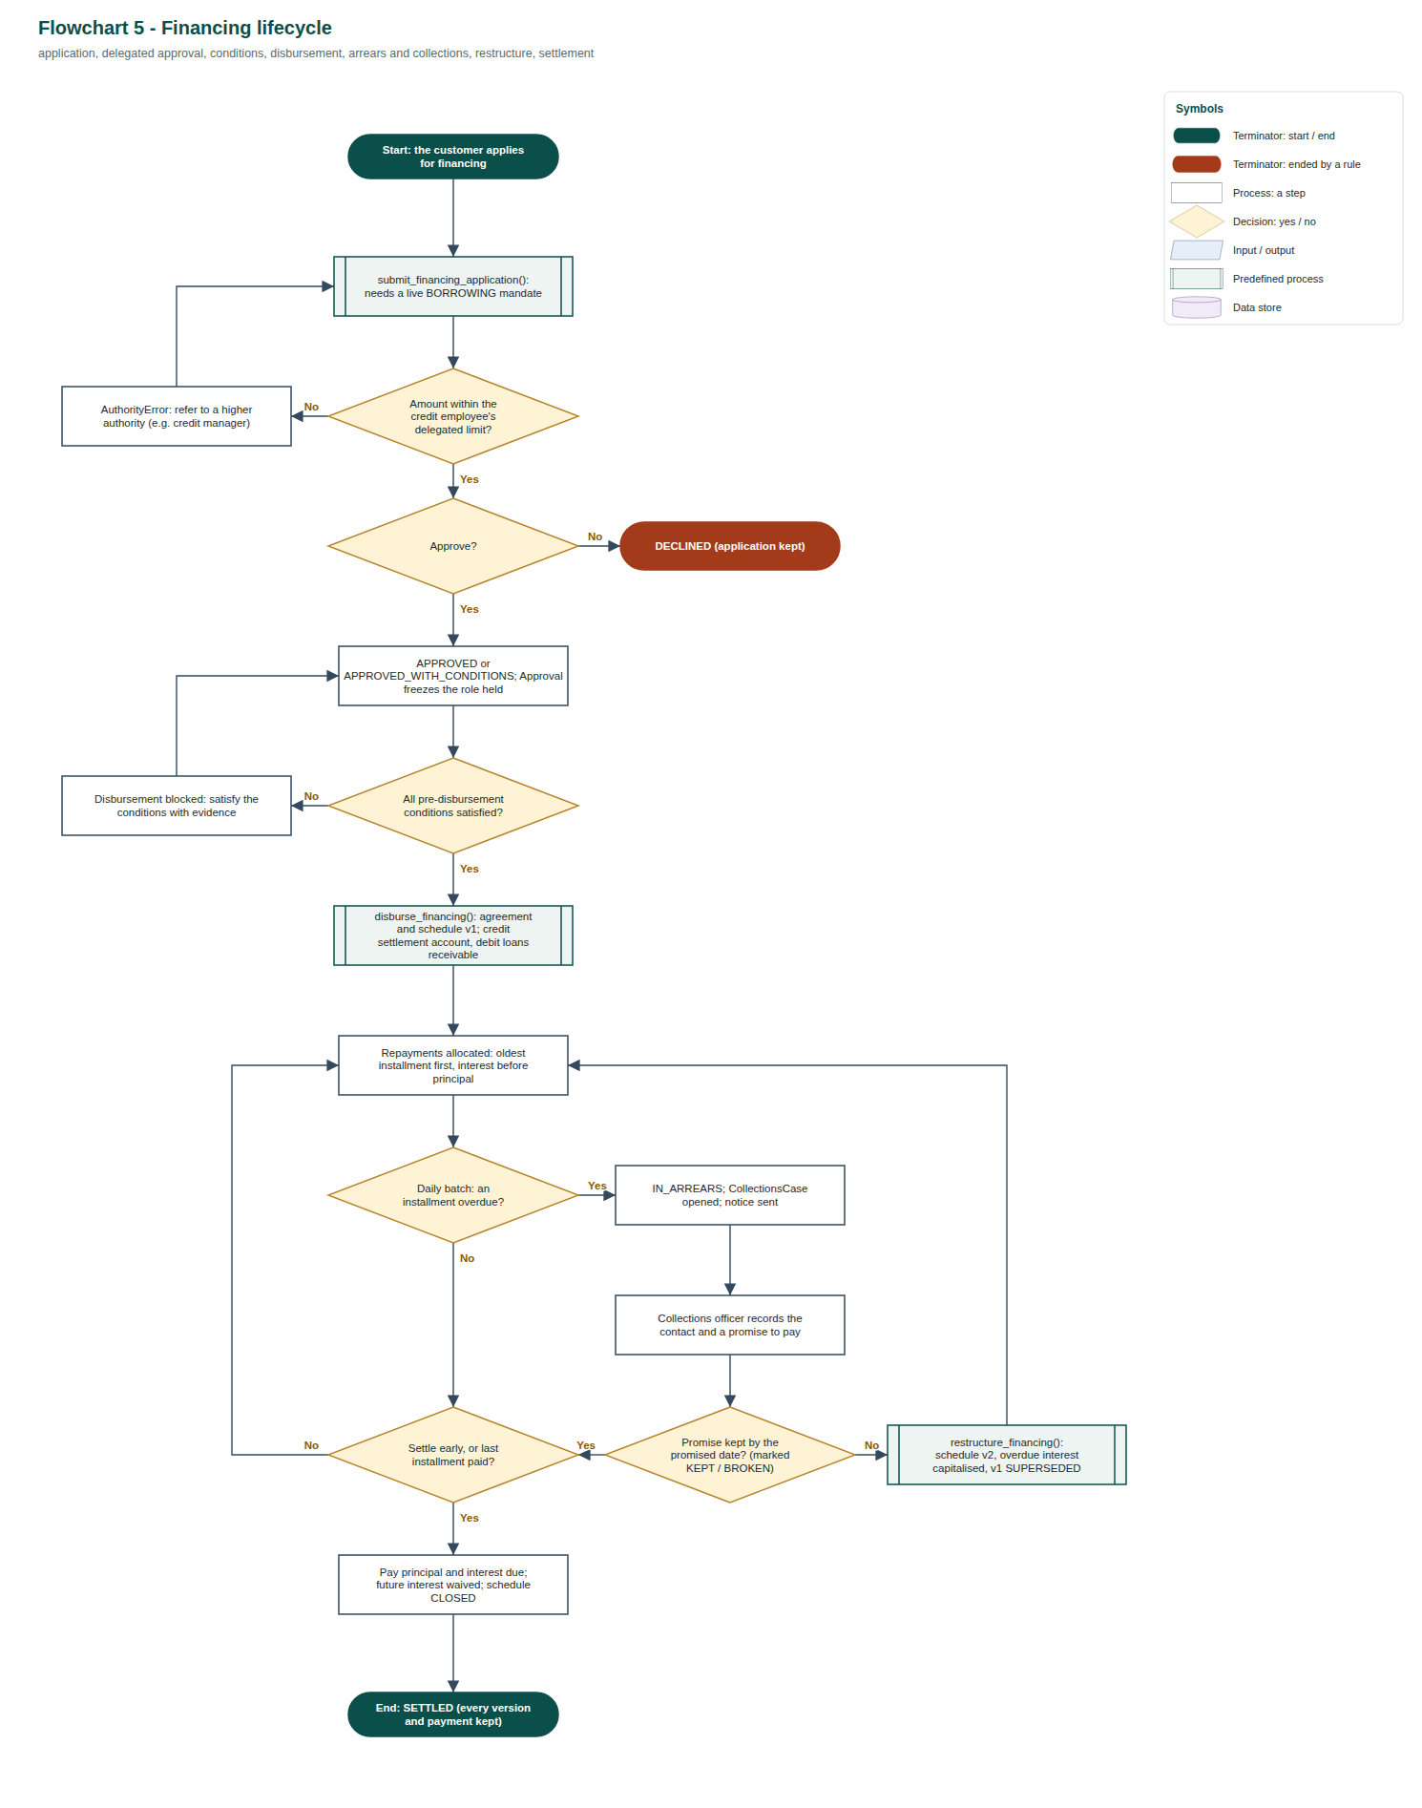
Flowchart 6. Desktop front end (banking_gui.py): sign in as staff or as a customer; every action calls one Bank operation and the result decides the banner colour; no rule lives in the GUI.
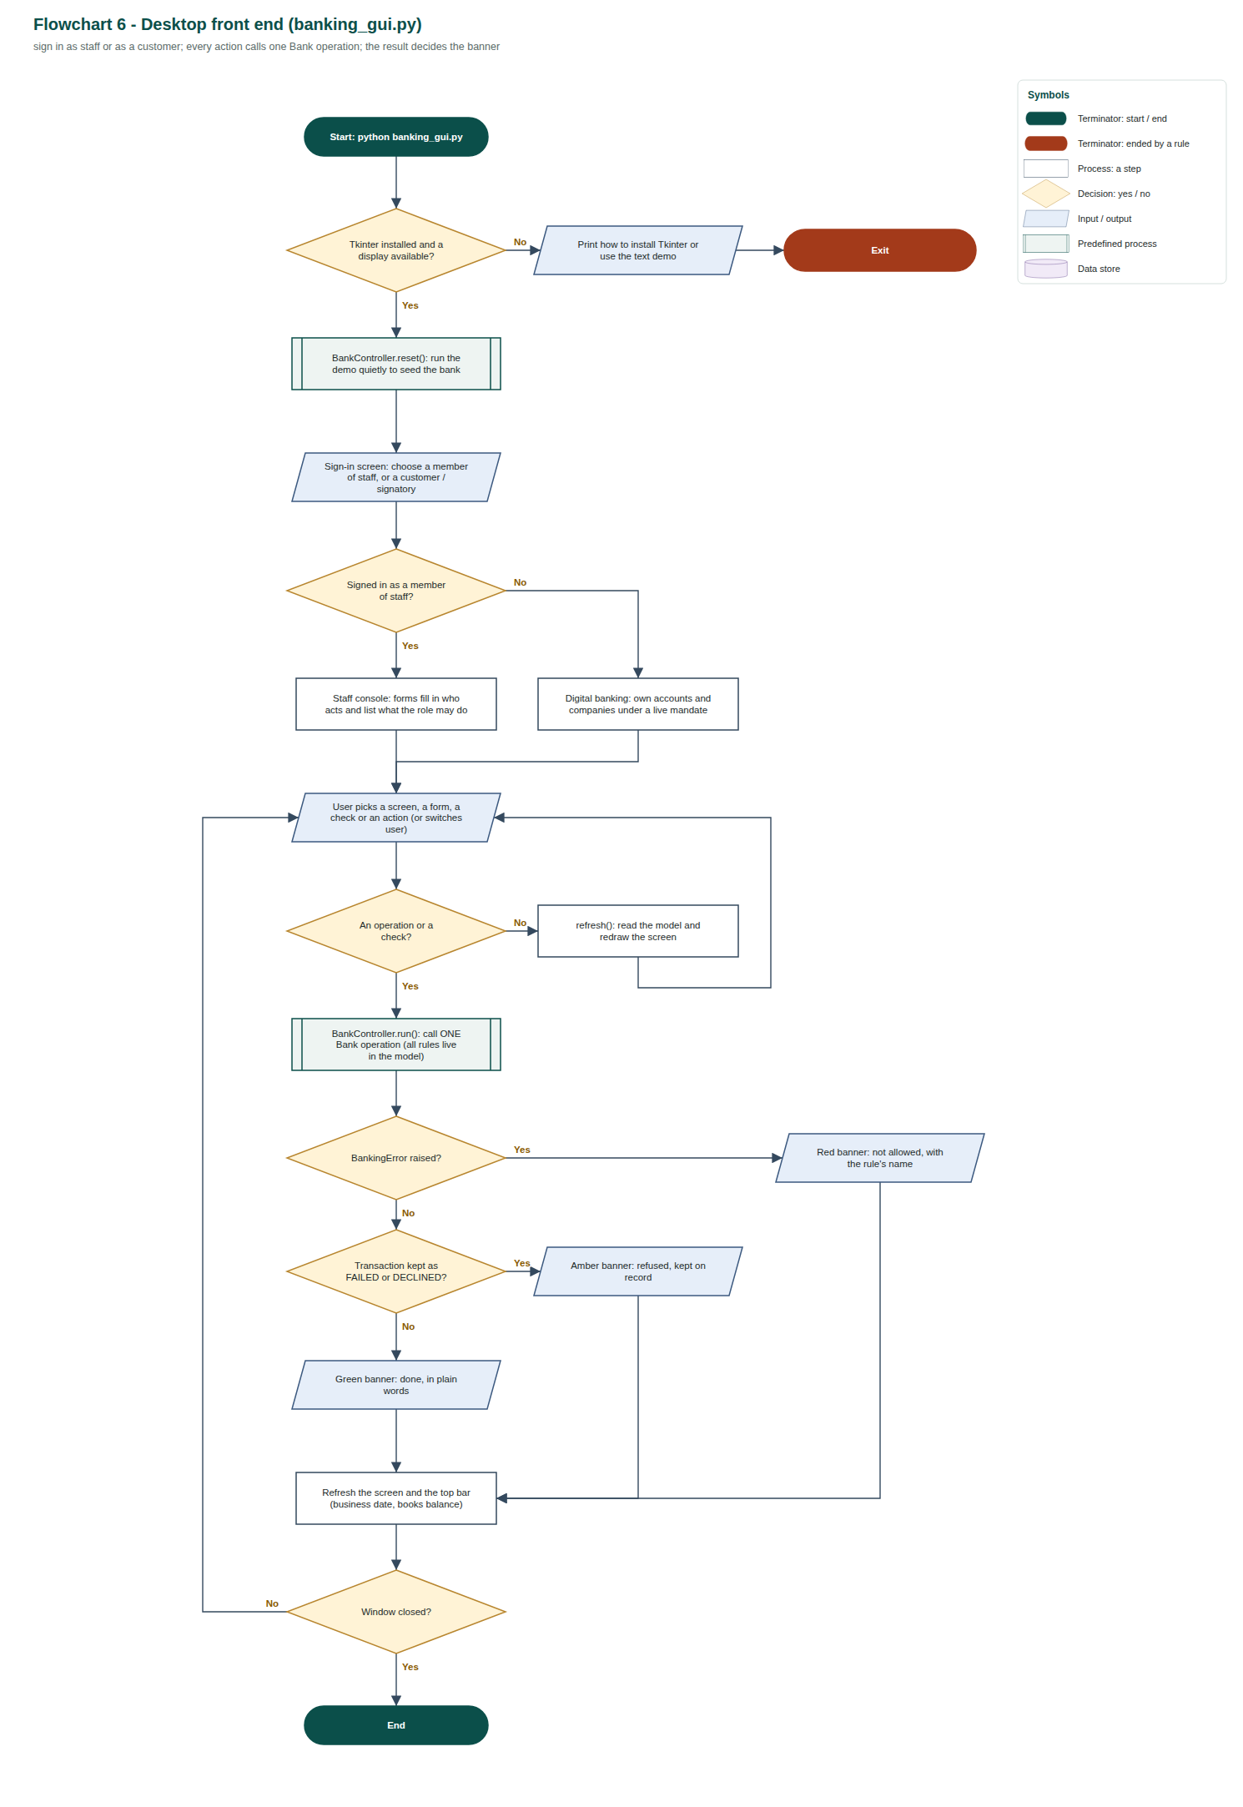

4.2 Lifecycles as UML state machine diagrams
The flowcharts show what an operation checks. These diagrams show what can happen to a record over its whole life. They are drawn by tools/make_state_diagrams.py directly from each class's LIFECYCLE declaration (section 6.2), the same object that StatusHistory enforces, so a move that is not on the diagram cannot happen in the code. Notation: filled circle = initial state, rounded rectangle = state, labelled arrow = transition with the operation that causes it, ringed circle = final state. In State machine 1 the colour of each state shows which class level introduced it.
State machine 1. TransferPayment: statuses inherited from BankTransaction (blue) and CustomerPayment (green), plus the compliance hold added by TransferPayment (amber).
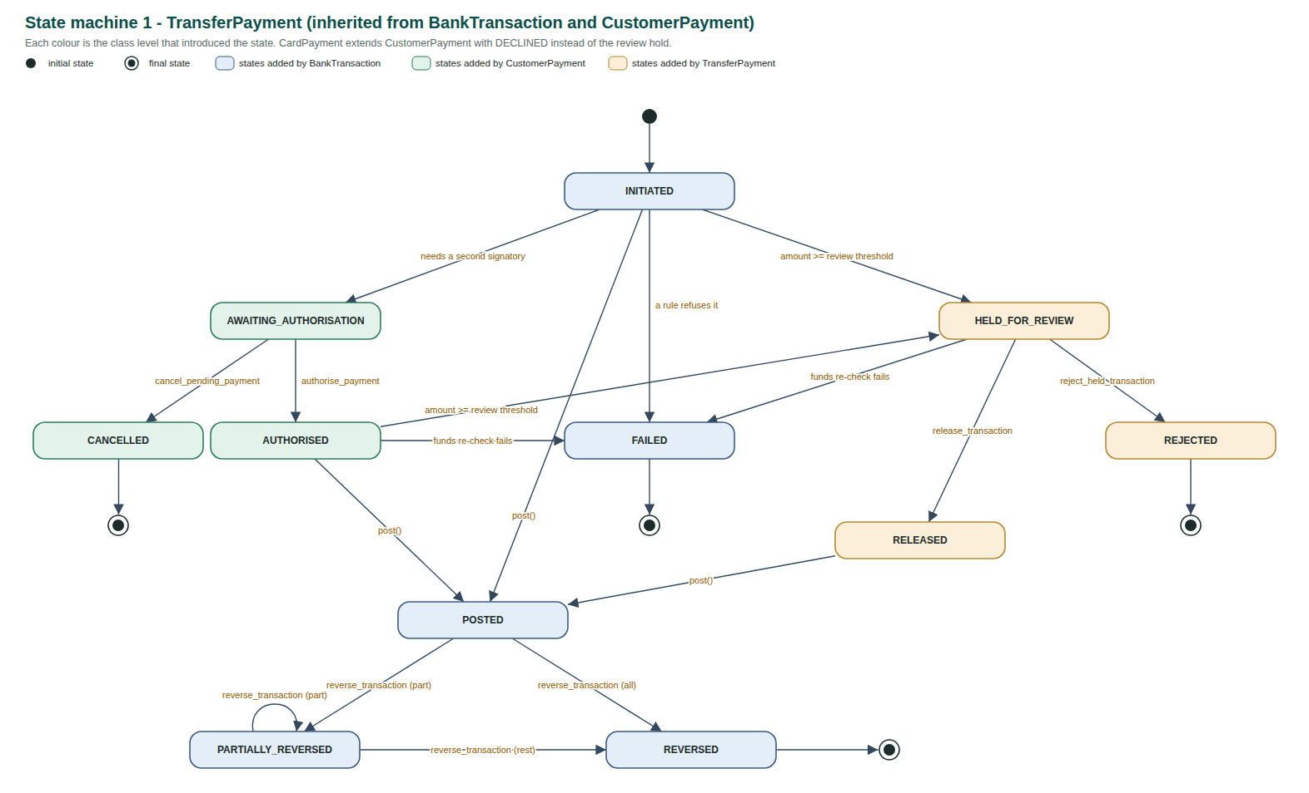
State machine 2. IssuedCard: only a card reported lost can be reactivated; a destroyed or cancelled card is final.
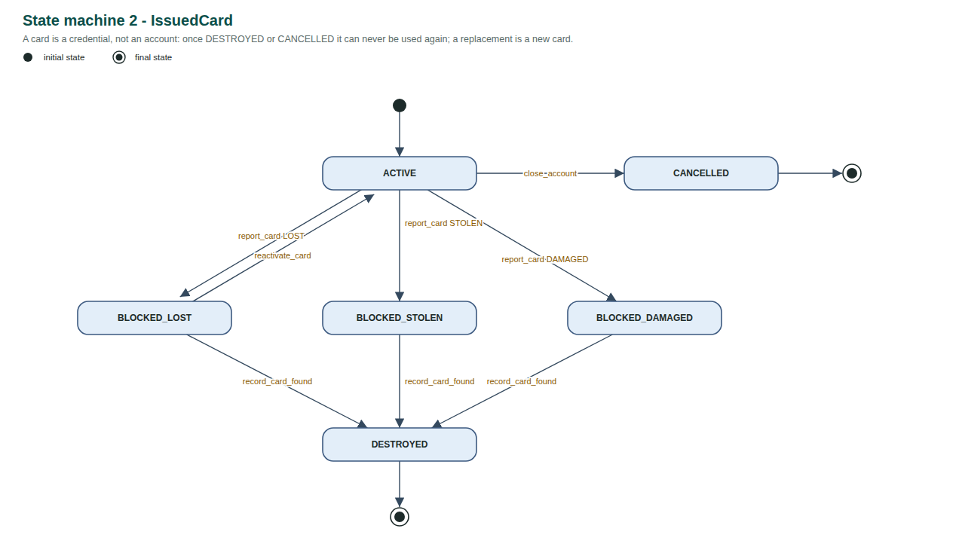
State machine 3. FinancingApplication and FinancingAgreement.
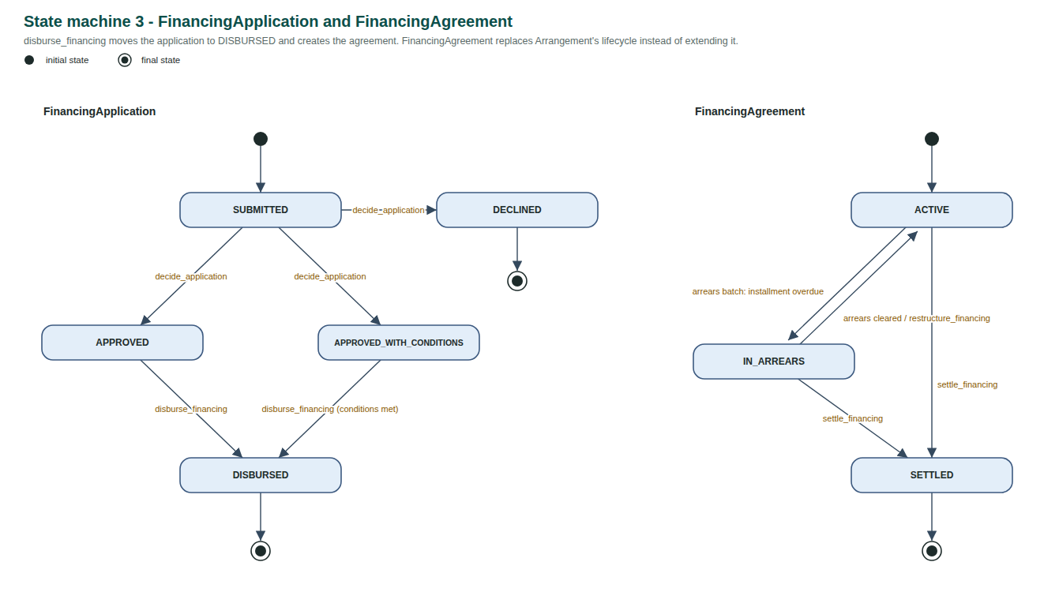
State machine 4. The other records with a lifecycle. Closing, ending, cancelling or deleting is always a move to a final state; the earlier statuses stay in the history.
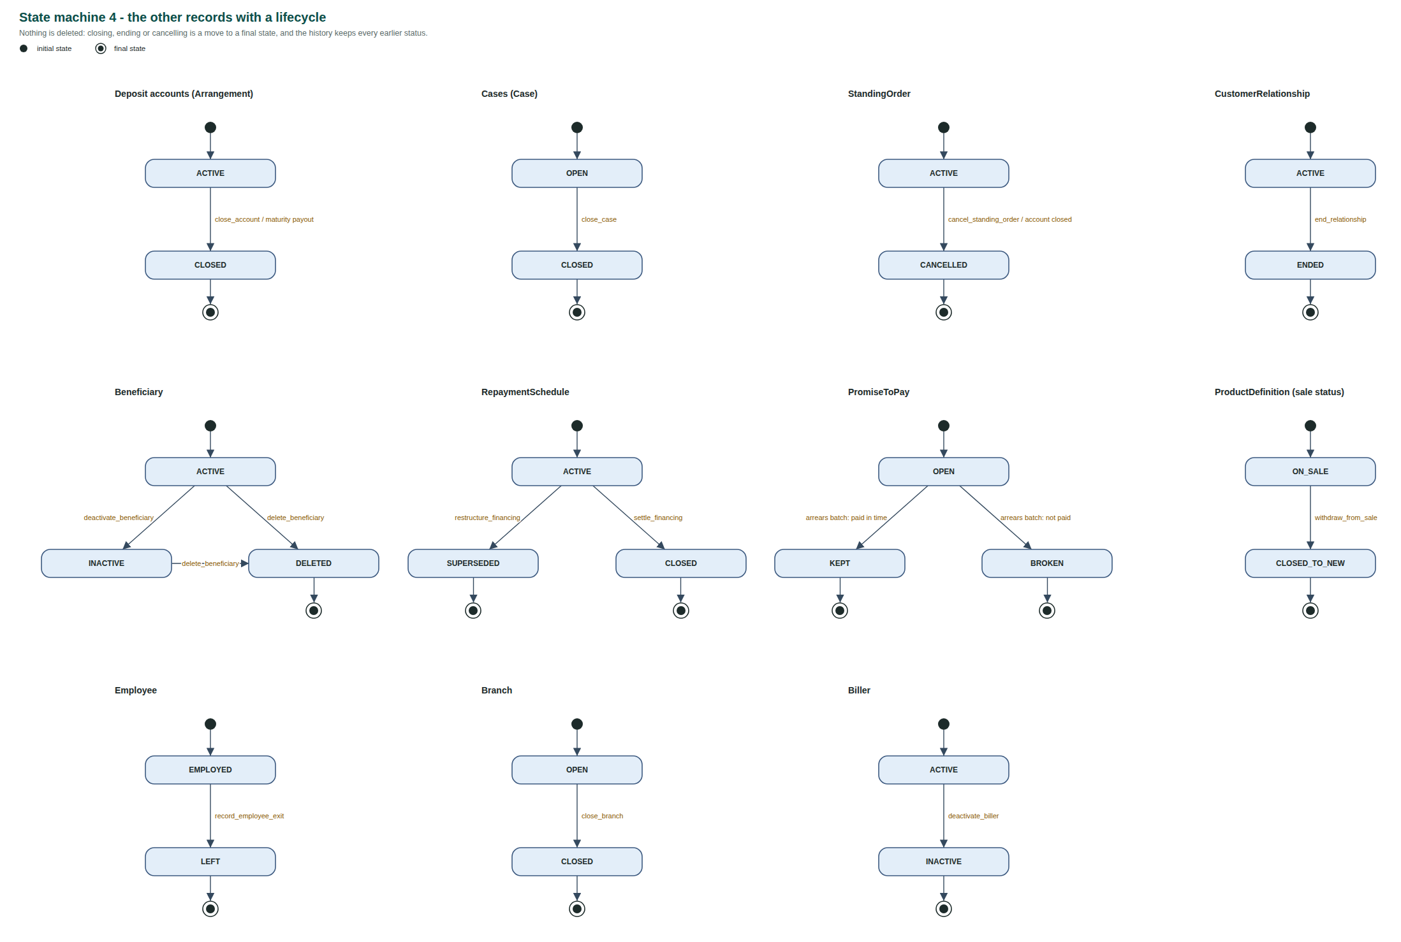

5. Implementation and operations
banking_system.py is organised in 16 numbered parts (model, service, demo, tests, diagram, command line), each with a header comment. Every class and every public operation has a docstring that states the rule it enforces.
Bank exposes 98 public operations. Each one checks the relevant rule, records the change as new data and writes an AuditEvent. The brief says trivial operations do not count, so they are classified honestly:
Kind | Count | Operations
Commands (create, update, assign, approve, cancel, transfer, close, retire, archive, delete, status change) | 80 | every operation in the table below except those in the next two rows
Batch processes run by the simulated clock | 6 | advance_to, run_standing_orders, run_arrears_check, charge_monthly_fees, credit_savings_interest, run_term_deposit_maturity
Views, historical queries and reports | 12 | authority_on, capacities_of, transaction_story, daily_report, trial_balance, relationship_history, party_snapshot, approvals_and_authority_audit, search_transactions, retention_until, active_customers, active_arrangements

Even counting only the 80 commands, the model is more than twice the brief's minimum of 30. The brief's verbs are all present: create (register_person, open_deposit_account), view (the query row), update (amend_beneficiary, correct_party_detail), delete (delete_beneficiary, request_deletion), assign (assign_case, assign_relationship_manager), cancel (cancel_pending_payment, cancel_standing_order), transfer (transfer_between_accounts, close_branch), approve (decide_application, authorise_payment), retire (withdraw_from_sale, deactivate_biller), archive (archive_record) and status management (report_card, impose_restriction).
Group | Operations
Branches and staff | open_branch, hire_employee, change_role, record_employee_exit, close_branch
Parties and KYC | register_person, register_company, register_charity, add_identity_document, verify_party, appoint_officer, end_officer_role, record_beneficial_owner, grant_mandate, revoke_mandate, correct_party_detail, become_customer, assign_relationship_manager, end_relationship
Products | define_product, revise_product_terms, withdraw_from_sale, migrate_terms
Accounts, deposits and cash | open_deposit_account, close_account, deposit_cash, withdraw_cash, transfer_between_accounts, break_term_deposit, run_term_deposit_maturity, charge_fee, charge_monthly_fees, credit_savings_interest, generate_statement
Payments | add_beneficiary, amend_beneficiary, deactivate_beneficiary, delete_beneficiary, initiate_transfer, authorise_payment, cancel_pending_payment, release_transaction, reject_held_transaction, reverse_transaction, repost_card_payment, create_standing_order, cancel_standing_order, run_standing_orders, register_biller, deactivate_biller, pay_bill
Cards | issue_card, record_merchant, card_purchase, merchant_refund, report_card, replace_card, record_card_found, reactivate_card, change_card_limit, add_card_control, remove_card_control
Financing and collections | submit_financing_application, attach_application_document, decide_application, satisfy_condition, disburse_financing, repay_financing, run_arrears_check, restructure_financing, settle_financing, record_collections_contact
Cases | raise_service_request, raise_fraud_alert, open_investigation, assign_case, add_evidence, impose_restriction, lift_restriction, log_complaint, open_dispute, resolve_dispute, close_case
Retention | archive_record, request_deletion, retention_until, active_customers, active_arrangements
History, audit and reporting | authority_on, capacities_of, transaction_story, search_transactions, daily_report, trial_balance, relationship_history, party_snapshot, approvals_and_authority_audit, advance_to (simulated clock with an end-of-day batch)

Every posting goes through BankTransaction.post, which refuses any set of legs that does not sum to zero. The demonstration ends with a trial balance that totals zero across all customer and bank accounts: a whole-system check that no scenario created or lost money.
Two conventions worth defending: payments that break a rule return a transaction with status FAILED or DECLINED (a failed payment is itself a record the bank must keep), while other rule violations raise a BankingError subclass (nothing should be created).
Automated tests. 73 independent tests (python banking_system.py --test). Each builds a small fresh bank and checks one rule or historical guarantee. They include one regression test for every defect fixed during the code review (docs/Code_Review.md), eleven tests for the features added after checking the model against every line of the brief (BriefCoverageTests), four tests that check the brief's own requirements from the code (at least 30 classes and 30 operations, multi-level inheritance, that the diagrams name only real classes, and that the whole demonstration runs with a zero trial balance), seven abstraction tests (AbstractionTests: the hierarchy roots cannot be instantiated, every leaf class is concrete, the polymorphic methods replace the old type checks, a merchant is a counterparty linked to every card payment made there, and every upheld card dispute in the demonstration became a Chargeback), two card tests from the research (CardRefundAndChargebackTests: a merchant refund is a new credit that leaves the purchase posted and limits what can still be disputed; a chargeback needs a scheme reason code and cannot itself be reversed) and four lifecycle tests (LifecycleTests: every status change in the demonstration followed its class's state machine, an illegal move is refused even when the Bank is bypassed, lifecycles are inherited and extended, and every state machine is well formed).

6. Inheritance relationships explained
Party -> Person / Organization -> Company / Charity (multi-level). Every party has an identity, documents, verification checks, corrections, restrictions and possibly a customer relationship, so these live in Party. Party.kyc_gaps is a template method: the party's own verification, then two abstract hooks, structural_gaps (rules about its make-up) and connected_persons (people whose verification it depends on). Person implements both as "nothing": a person has no governance structure and answers only for itself. Organization adds what only legal entities have (registration number, officers, beneficial owners, mandates) and implements connected_persons as its active officers and owners at or above 25%, which gives the stricter KYC rule for free. It is still abstract, because Company and Charity differ in real governance: a company needs an active director and a charity at least two trustees. Each implements structural_gaps with the rule true at that level. That is why the hierarchy has three levels rather than two.
Arrangement -> DepositAccount -> CurrentAccount / SavingsAccount / FixedTermDeposit (multi-level), and Arrangement -> FinancingAgreement. Everything a customer holds has a product, pinned terms and terms history, holders, an opening branch, a servicing-branch history, a status and restrictions: that is Arrangement. Only deposit accounts hold customer money, so ledger entries, holds and ledger/available balance belong to DepositAccount. A current account adds an overdraft (overrides overdraft_limit); a savings account adds a monthly withdrawal limit (overrides check_debit); a fixed-term deposit adds a term, rate and maturity date, refuses debits before maturity (overrides check_debit) and accepts only one credit, the placement (overrides ensure_usable). All three still reuse the parent's ledger and balance logic unchanged. A financing agreement is also an arrangement (terms, holders, status), but it holds no customer money; it has schedules and installments instead, so it sits beside DepositAccount, not under it.
BankTransaction -> CustomerPayment -> TransferPayment / CardPayment / BillPayment / OwnAccountTransfer (multi-level). Every transaction has an amount, a status history, ledger entries and reversals. A customer payment is one a customer (or their representative) instructed, so it records who initiated it, the channel and the mandate used, and it can be disputed. Transfers add a beneficiary-version snapshot and a possible hold; card payments add the exact card, merchant, channel, country and merchant category (which card controls check); bill payments add the biller and consumer reference; own-account transfers add the target account. All four are disputable and subject to the same mandate and restriction rules because they inherit what makes them customer payments.
BankTransaction -> LoanTransaction -> LoanDisbursement / LoanRepayment / InterestCapitalisation (multi-level). All three belong to a financing agreement and move the bank's loans-receivable balance. A disbursement carries its approval, a repayment its installment allocations, and a capitalisation records overdue interest added to principal on restructuring (no customer cash moves, but the books must change).
BankTransaction -> CashTransaction / FeeCharge / InterestCredit / Reversal / MerchantRefund / InternalTransfer. These are transactions (they post and have statuses) but share nothing further with each other. A reversal is a transaction in its own right, not a flag on the original. A merchant refund is money the merchant sends back through the card scheme; it points to the purchase and its merchant. InternalTransfer is a bank-initiated movement no customer instructed (vault cash on branch closure, term-deposit payout).
BankTransaction -> Reversal -> Chargeback (multi-level). Everything a reversal has, a chargeback has too: an original transaction, counter-entries that mirror it, a staff approval, the rule that it cannot itself be reversed, and the effect of marking the original (partially) reversed. So Chargeback inherits all of it, and Bank._counter_post is shared by both. What a chargeback adds is only true at that level: it exists only for a card payment, only because a Dispute was upheld, it is claimed from a specific Merchant through the card scheme, and it carries the scheme reason code. resolve_dispute therefore posts a Chargeback for a card payment and a plain Reversal for any other customer payment. The level was found by research (source 5), not by looking for shared fields.
Case -> CustomerCase -> ServiceRequest / Dispute / Complaint; Case -> RiskCase -> FraudAlert / ComplianceInvestigation (multi-level); Case -> CollectionsCase. All cases have a subject, status history, assignments, notes, evidence and links. Customer cases arrive through a service channel from a contact person. Risk cases are bank-initiated, carry a risk level and the restrictions they imposed, and override close() so they cannot close while those restrictions are in force. This split lets the scenario keep the branch complaint and the compliance investigation as separate, linked records.
BankingError -> specific errors. Every rule violation is a banking error; the subclasses let the demonstration and the tests name which rule stopped an action.

6.1 Abstract classes and polymorphism
The brief states that abstraction, abstract base classes and polymorphism are not assessed. They are used here only where they make an inheritance decision enforceable rather than merely described: the level of the hierarchy that is abstract is exactly the level this report argues is "not a real thing on its own".
A real bank never holds "a party", "an arrangement", "a transaction" or "a case" that is not some specific kind, so the root of each hierarchy is an abstract base class (Python abc). Trying to create one raises TypeError, and a new subclass that forgets a required method cannot be instantiated at all. Each abstract method is one whose answer genuinely differs by class:
Abstract class | Abstract method | Implemented by | Replaces
Party | structural_gaps(), connected_persons() (hooks of the kyc_gaps template) | Person; Organization (connected persons); Company, Charity (structure) | An Organization.kyc_gaps override
Organization | structural_gaps() (still open) | Company, Charity | A do-nothing default
Arrangement | position(): money held or owed | DepositAccount (ledger balance, held), FinancingAgreement (principal, owed) | A type check in the GUI
DepositAccount | overdraft_limit() | CurrentAccount (from terms), SavingsAccount and FixedTermDeposit (zero) | A silent zero default
BankTransaction, CustomerPayment, LoanTransaction | counterparty(): who is on the other side | all 12 concrete transaction classes | (new)
Case | handler_roles(): staff allowed to work it | CustomerCase, RiskCase, CollectionsCase | An isinstance chain in Bank.assign_case

BankTransaction.story_lines() is also a template method: common lines first, then the hooks detail_lines() (extended by CustomerPayment, then by TransferPayment and CardPayment with super()) and case_lines() (disputes, only on customer payments). Bank.transaction_story used to test the transaction's type three times; it is now one line, return txn.story_lines(), and a test checks that neither it nor assign_case contains isinstance. In the UML diagrams, abstract classes and methods are in italics (the UML convention) and each method is marked {abstract}, [implements] (fills in a parent's abstract method) or [override] (replaces or extends a parent's working method).

6.2 Inherited state machines
Each class with a status declares its lifecycle once, as a LIFECYCLE class constant: the initial status, every allowed move labelled with the operation that causes it, and the final statuses. StatusHistory enforces it on every change, so an illegal move (a destroyed card becoming active again, a posted payment going back to pending) is refused wherever it is attempted, even by code that bypasses the Bank. Lifecycles are inherited like any other class attribute: CashTransaction uses BankTransaction's unchanged, CustomerPayment extends it with dual control (AWAITING_AUTHORISATION, AUTHORISED, CANCELLED), TransferPayment extends that with the compliance hold and CardPayment with DECLINED. FinancingAgreement instead replaces Arrangement's lifecycle, because a loan is never "closed" like an account; it is settled. The state diagrams in section 4.2 are drawn from these declarations.

7. Tempting inheritance relationships that were rejected
- `Customer(Person)`, `Signatory(Person)`, `Employee(Person)`. The same human can be all of these at once and change over time (Ayesha is a retail customer, a director, an owner and a signatory for two organisations). Subclasses would force duplicate records and break history when a role ends. Roles are time-bounded objects pointing to one Person.
- `IssuedCard(DepositAccount)`. A card looks account-like (limits, status, transactions) but holds no money, and many cards can point to one account. A card is a credential linked to an account.
- `FinancingAgreement(DepositAccount)`. Both are "accounts" in everyday speech, but a loan has no ledger of customer funds, no available balance and no holds. Both inherit from Arrangement instead.
- `ReversedTransfer(TransferPayment)` or a `reversed = True` flag. A reversal has its own date, amount (it can be partial), approver and reason, and can happen more than once. It is a separate Reversal transaction pointing to the original.
- `FraudAlert(ComplianceInvestigation)`. An alert is an automated signal that may be a false positive; an investigation is a human-led case that can link several alerts.
- A universal `BaseRecord` superclass for every class. It would share only id and created_on: inheritance to avoid typing fields. Shared lifecycle behaviour comes from composition (StatusHistory, Period).
- A parallel product hierarchy (`CurrentProduct`, `SavingsProduct`, ...). Product definitions differ only in term values, not behaviour, so one ProductDefinition with a category and versioned terms is enough. Behaviour differs in the arrangements, which is where the hierarchy is.
- `GeneralLedgerAccount(DepositAccount)`. Both have entries and a balance, but a GL account has no holder, product, terms, restrictions or customer status. The shared idea is only "has entries".
- Merging `PaymentAuthorisation` into `Approval`. Both are "someone said yes", but an Approval is a bank employee acting in a staff role, frozen at decision time, while a PaymentAuthorisation is a customer's signatory acting under a mandate. They follow different rules and must never be confused in an audit.
- `SoleTrader(Organization)`. A sole trader has no separate legal personality, so this would misrepresent liability and KYC (A5).
- `Biller(Organization)` or `Merchant(Party)`. Billers and merchants are counterparties, not customers: the bank holds no KYC, mandates or relationship for them. Making them parties would pull in documents, checks and restrictions that never apply. Biller and Merchant are small standalone classes. A shared Counterparty superclass for the two was also rejected: they share only a name, and their rules differ (a biller has a collection arrangement and can be deactivated; a merchant is recorded as the card network presents it, with the category and country that card controls check).
- Card controls as extra card statuses (`BLOCKED_ONLINE`, ...). A card can have several controls at once, each switched on and off at different times, and a control is not the card's lifecycle state. Separate CardControl objects with periods keep the status meaningful and the control history answerable.
- `MerchantRefund(Reversal)`. A refund also gives money back and points to the original purchase, so it looks like a reversal. But the merchant starts it, no bank employee approves it, and the purchase is not undone: it stays POSTED, and only the amount the customer can still dispute goes down. Inheriting from Reversal would give it an approval it does not have and would mark the purchase reversed. It is a sibling under BankTransaction. Chargeback passed the same test that MerchantRefund failed.
- `Chargeback` as a flag or a `reason` field on `Reversal`. A chargeback needs a dispute, a merchant and a reason code that an ordinary reversal must not have. As optional fields on Reversal, every reversal would carry three empty attributes and no rule could insist they are filled. A subclass makes them mandatory exactly where they apply.

7.1 Why this design is better than a plausible alternative
The most plausible alternative, and the one most legacy systems resemble, is an account-centric model: a Customer class with personal details and flags (is_director, is_signatory, is_blocked), an Account class with a type field for current, savings, loan and card, and transactions that are edited or deleted when they are corrected. It is simpler and would satisfy the minimum class count. The table tests both designs against the brief's critical cases.
Critical case in the brief | Account-centric alternative | This design
A person is a customer and represents several organisations | Duplicate customer rows, or one row with flags that cannot say which organisation | One Person with several dated role objects
Posted, reversed, re-posted, disputed | The amount is edited; the original posting is lost | Reversal, a linked re-post and a Chargeback, each a separate record
Product withdrawn but valid for existing customers | A single is_active flag either blocks existing accounts or keeps selling | Sale status on ProductDefinition; arrangements pin their terms version
Signing authority lost; history must still show it | is_signatory = False erases the past | Mandate with a Period; payments store the mandate used
Restricted, then cleared | is_blocked toggled; no record of when or why | Restriction objects with periods and a RiskCase
Card replaced several times | One card_number field overwritten | IssuedCard chain; each payment keeps its card
Loan restructured after payments | Installments rewritten in place | Schedule versions; paid installments stay PAID
Beneficiary details change | Old transfers now show the new details | BeneficiaryVersion snapshot on each transfer
Branch closes | Accounts re-pointed; the original branch is lost | opened_at_branch fixed; servicing branch history
Case evidence later corrected | Evidence reads the corrected value | Frozen CaseEvidence snapshot and Correction records

The alternative fails all ten. The cost of this design is more classes and the discipline of never updating in place. That is the right trade for a bank, where "what did we know, and who was allowed to do it, on that date?" is a routine question from auditors, regulators and courts. The design also uses inheritance less than the alternative's type field invites: only where behaviour really differs by level (the four hierarchies of section 6), with dated composition everywhere else.

8. Seeded demonstration
run_demo() creates one bank with three branches, ten staff (including a collections officer and an auditor), eight products, twenty people (ten of them staff), a sole trader, a high-value customer, one company, one charity, eight deposit accounts (including two term deposits), five cards, two billers, beneficiaries, a standing order and a financing facility. It then runs a simulated calendar from January 2026 to August 2027; the daily batch runs standing orders, arrears checks, promise-to-pay checks, term-deposit maturities, month-end fees and savings interest automatically. The full output is in docs/demo_output.txt: 109 transactions, 10 cases, 294 audit events, 28 refused actions, each naming the rule, and a zero trial balance.
The seeded company matches the brief's scenario: two directors (Ayesha, Bilal), one beneficial owner (Sara, 40%; Ayesha's 10% is recorded but below the 25% threshold), and three employees with different powers (Hamza pays with dual control above PKR 1m, Noor may only view, Usman may use a card). Ayesha and Bilal already bank personally.
The run leaves three items of live work at the end: a PKR 1,200,000 transfer waiting for a second signatory, a PKR 1,100,000 transfer held for compliance review, and an open card dispute.

9. Complex scenarios demonstrated
# | Scenario | What breaks the normal flow | Brief's critical case
1 | Business onboarding | A director's CNIC expires between verification and onboarding; a charity has too few trustees | Customer is personal and a representative of several organisations
2 | Large transfer | Needs a second signatory (initiator and view-only user refused); held for review; a teller cannot release it; customer complains at the branch while compliance investigates separately; released | Temporary hold, separate cases
3 | Card lifecycle | Card stolen, replaced with a lower limit, thief declined, card found and destroyed, second replacement | Card replaced multiple times
4 | Card correction and dispute | Posted, reversed, re-posted at a new amount, disputed ("not as described"), partially upheld as a Chargeback claimed from the merchant; a second dispute and a second resolution are refused | Posted, reversed, re-posted, disputed
5 | Customer restriction | Debit block stops a transfer and the standing order; the director's personal account is unaffected; the case cannot close until the block is lifted | Temporarily restricted then cleared
6 | Financing | Unauthorised applicant blocked; credit officer's delegated limit forces an 8m request to be declined; disbursement blocked by conditions; an overpayment is refused without changing anything; missed installment opens a collections case, worked by the collections officer (a teller is refused); the customer's promise to pay is broken; restructure; approver promoted; early settlement; restructuring the settled loan refused | Restructured after installments paid
7 | Director leaves | Old transfer still proves valid authority on its date; new attempt fails; standing order continues; the "time machine" rebuilds the company as at 11 Apr 2026 | Person loses signing authority
8 | Beneficiary change | Old transfer shows old bank details | Beneficiary changes after old transfers
9 | Data correction | Compliance evidence keeps the address as it was; the record shows the value on any past date | Case references data later corrected
10 | Product lifecycle | Product closed to new sales; terms revised; old account keeps the old fee until migrated with a notice; a withdrawn card product still allows a replacement for an existing cardholder but not a new card | Product no longer sold but still valid
11 | Branch closure | Customers, accounts, staff and PKR 80,000 of vault cash move; historical branch still answerable; hiring at the closed branch refused | Branch closes, customers and staff transferred
12 | Savings rules | Third monthly withdrawal refused; closure refused with a balance (including month-end interest); closed later with entries retained | Deletion vs closure
13 | People leave | A relationship manager cannot resign until customers are handed over; old KYC checks still name him; a customer with an open account cannot leave; one with no products can | Record retention when customers and employees change
14 | Sole trader, high-value customer, term deposits | Sole trader refused without a trading name; high-value customer refused until source of wealth is verified; withdrawal and top-up of a term deposit refused; one deposit broken early with a penalty, the other paid out at maturity | Customer types in the brief's background; savings vs investment facilities
15 | Card controls, merchant refund, bills, card search | Online and gambling controls decline purchases; someone other than the cardholder cannot lift a control; control history shows what was in force on each date; a merchant refunds a returned part (the purchase stays posted) so disputing the full amount is refused; view-only user refused a bill payment; large tax bill waits for a second signatory; one search finds payments on all three cards in the chain | Card controls; billers; card replaced multiple times, old transactions searchable
16 | Audit and retention | A teller cannot run the audit; the auditor lists every 2026 approval with the role held then and every authority change; deleting a closed account is refused with its retention date; finished records are archived, not deleted; only a never-used payee can be deleted | Audit of approvals and authority changes; what deletion means

All ten critical cases listed in the brief for Problem 4 are covered, and scenarios 14 to 16 cover the remaining participants and scope items (section 3.2). The run ends with a statement, an end-of-day audit report ("what changed, who, why") and a zero trial balance.

10. Limitations and scaling
Current limitations. Single currency. Term deposits pay simple interest and have no rollover option. Card controls do not carry over to a replacement card. Only debit cards: a credit card would be a revolving credit Arrangement with its own statement cycle, which is not modelled. Chargebacks are final when posted; real schemes allow provisional credit to the customer and a merchant's re-presentment ("second presentment"), which would be further statuses on Chargeback. Savings interest is a simple month-end calculation (no daily accrual, tax withholding or Islamic profit-sharing weights). A fixed review threshold rather than risk scoring. A small chart of accounts. In-memory storage only, with reference numbers held in a module-level counter. No concurrency or rollback across several objects. Simplified loan maths (equal principal, monthly interest on the outstanding balance, no penalty charges). Dual control supports exactly two signatories rather than configurable rules such as "any two of A, B, C". Two credit authority levels only. There is no authentication: the GUI's sign-in chooses a person without a password, each operation is told who is acting, and the model then checks that person's authority.
If the bank became much larger. Records would move to a database with effective-dated tables (the Period and version classes map directly to valid_from / valid_to columns). The Bank class would split into separate services (customers, payments, cards, lending, compliance) communicating through events, because one object cannot own every registry. The acting person would come from authentication, with role-based permissions. The ledger would become a full general ledger with a larger chart of accounts, and monitoring would use rules and scoring models rather than one threshold.
If the business model changed. Islamic banking products (for example Murabaha or Ijarah) would be new Arrangement subclasses, because their obligations differ structurally from interest-bearing loans; this is where the Arrangement level pays off. Investment or wealth products would also become new arrangement types with their own position records. Multi-currency would need a Money value class and FX transaction types.

11. Desktop front end (optional GUI)
The brief assesses classes and inheritance, so the front end exists to make the model usable, visible and testable, never to hold business rules. banking_gui.py is pure Python (Tkinter and ttk from the standard library). It imports banking_system.py and does not change it: every button calls exactly one Bank operation, so every rule, refusal and audit entry is the model's own. A refusal names the rule that stopped it, and a refused payment is shown as "refused, kept on record" because the model keeps it as failed or declined.
Two ways in, as in a real bank. The program opens on a sign-in screen (Figure 9). There are no passwords, because this is a simulation, but who you are matters, because the model checks that person's authority on every action.
- Staff console. Sign in as a member of staff. The top bar shows who you are and your role and branch. Forms no longer ask "registered by / approved by": you are recorded automatically as the member of staff. The Operations screen lists the forms your role may perform, with a search box; ticking "also show what my role may not do" brings back the rest, so a refusal can still be demonstrated (for example a teller trying to release a held payment).
- Digital banking (the brief's "online channels"). Sign in as a customer or a company signatory. You see your own accounts and every company account you hold a live mandate for, with what the mandate allows. You can pay a payee, pay a bill, move money between accounts, add a payee, approve or decline colleagues' payments that need a second signatory, switch card controls on and off, report a card lost or stolen, dispute a card payment and raise complaints or service requests. Noor, a view-only signatory, sees the company account; when she tries to pay, the model refuses and keeps the attempt on record, exactly as for a payment made at a branch.
Designed to be read. Status and role codes are shown in plain words ("Awaiting 2nd signatory", "Relationship manager") while the model keeps its exact codes. A record's status history is drawn as a row of coloured steps, each with the date it began (green: in good standing; red: refused or blocked; amber: waiting on someone; blue: in progress; grey: finished and kept for history), so "Active 20 Feb 2026 -> Blocked (stolen) 10 Mar 2026 -> Destroyed 12 Mar 2026" reads at a glance. Tables size their columns to their content, amounts are right-aligned, and the tables inside a record's details re-fit when the window or the divider is resized. A statement opens in its own window and is itself logged. The sidebar uses line icons drawn from canvas shapes, so the program needs no image files and looks the same on Windows, macOS and Linux. The Overview has three charts (largest depositors, customer payments per month, payment outcomes), a queue of payments that need attention with the actions to clear them, and an activity feed written as sentences ("Hamza Sheikh paid by card CRD-TX-011").
Fourteen console screens in two sections. Bank (12 screens) is what staff would use. Teaching & simulation (Class model, Scenario log) holds two aids a real staff application would not have; they are kept because the brief describes the model as being for teaching and simulation, and they let an examiner see the inheritance tree and the seeded scenarios from inside the running program. The Operations screen has 80 forms in ten groups, enough to run every workflow of the brief's operational scenario by hand, plus 14 guided rule checks:
Group | Forms | What can be done
Customers | 15 | Register people, companies and charities; file and verify documents; directors, trustees and beneficial owners; onboard; open accounts; grant and revoke mandates; correct details; assign an RM; end a relationship
Accounts | 6 | Open and break term deposits; close accounts; fees; statements; move to the latest terms
Payments | 15 | Payees and their versions; transfers, bills, own-account transfers; authorise, cancel, release, reject; reversals; standing orders; billers
Cash | 2 | Deposits and withdrawals at the counter
Cards | 12 | Issue, use, report, replace, find, reactivate; limits and controls; merchants, merchant refunds and corrected re-postings
Cases & compliance | 11 | Restrictions; disputes with reason codes and their resolution (chargeback or reversal); complaints; service requests; alerts; investigations; evidence snapshots; assigning and closing cases
Lending | 9 | Apply, decide with conditions (within delegated limits), attach documents, satisfy conditions, disburse, repay, restructure, settle, record collections contacts
Organisation | 5 | Open and close branches; hire, change role and record exits
Products | 3 | Define products, publish new terms, withdraw from sale
Records | 2 | Archive; request deletion (always refused, with the retention date)

Counterparties lists merchants, billers and payees with every payment made to or from them. Reports answers historical questions directly: which mandates a person held for an organisation on a past date, the auditors' approvals-and-authority report (refused for a teller, and itself logged) and everything that happened on a given day. The Class model screen marks abstract classes, lists the methods each subclass must implement and prints each class's lifecycle.
Built with the same OOP ideas it demonstrates.
Class | Inherits from | Role
BankingApp | tk.Tk | The window: sign-in screen, staff console or digital banking; sidebar, top bar and result banner
SignInScreen, DigitalBanking | tk.Frame | Choosing who you are; the digital-banking shell with its tabs
Page | ttk.Frame | A console screen with a title, build() and refresh()
MasterDetailPage | Page | A list on the left and the selected record's details on the right
CustomersPage, AccountsPage, TransactionsPage, CardsPage, CounterpartiesPage, CasesPage, StaffPage, ProductsPage, ClassModelPage | MasterDetailPage | Each declares its columns and implements rows() and show()
DashboardPage, OperationsPage, BooksPage, ReportsPage, ScenarioLogPage | Page | Screens with their own layouts
CustomerView | ttk.Frame | A digital-banking screen for the signed-in person; act() runs one operation as that person
HomeView, PayView, ApprovalsView, CardsView, HelpView | CustomerView | My accounts; pay and transfer; approvals; my cards; help and requests
Chart | tk.Canvas | Title, empty state and redraw on resize; subclasses implement draw()
BarChart, ColumnChart, DonutChart | Chart | The three dashboard charts
DataTable, DetailView, ScrollFrame | ttk.Frame | Self-sizing table, rich text pane and scrolling area
Panel, StatCard, Banner | tk.Frame | Card, dashboard tile and result strip
TimelineCanvas, IconBadge, Avatar | tk.Canvas | Validity periods as ribbons; icon badge; initials
OperationSpec, BankController, CurrentBank, Outcome, Theme, Icons | - | A form definition that knows which roles may use it; the only object that talks to the model; a stand-in that follows "Reset data"; a result in words; colours, fonts and styles; drawn icons

MasterDetailPage and CustomerView follow the same reasoning as the model's hierarchies: every list screen (or every digital-banking screen) shares its layout and behaviour, and only what differs is written in the subclass. Chart -> BarChart / ColumnChart / DonutChart is a small template: the base class draws the title and the empty state and redraws on resize, and each subclass draws only its own marks.
tools/gui_smoke_test.py drives every guided check, all 80 forms, three stories typed into the forms (onboarding; the financing lifecycle from application to early settlement; a card purchase, merchant refund, dispute and chargeback), every report, a signed-in teller (who sees only a teller's forms and is recorded automatically) and a digital-banking story (Noor is refused as view-only, Hamza starts a payment that needs a second signatory and switches a card control, Ayesha approves it, a complaint is logged, a statement is produced and shown). It runs on GitHub for every push and fails if anything crashes, an outcome is not the expected one, or the books stop balancing.
Figure 9. Sign in: a member of staff for the console, or a customer or company signatory for digital banking.
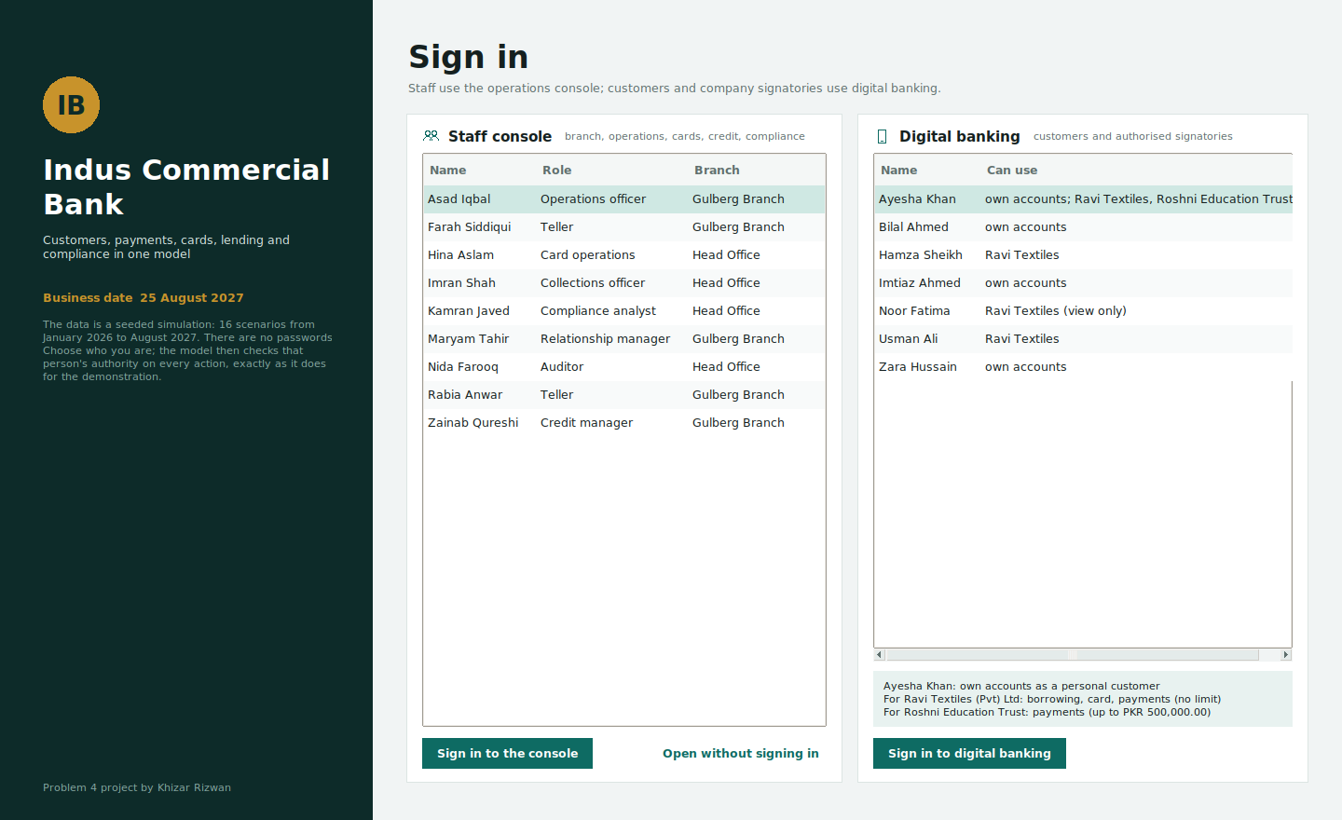
Figure 10. Overview, signed in as a compliance analyst: tiles, charts, the payments that need attention (release and reject act as the signed-in officer) and the activity feed.
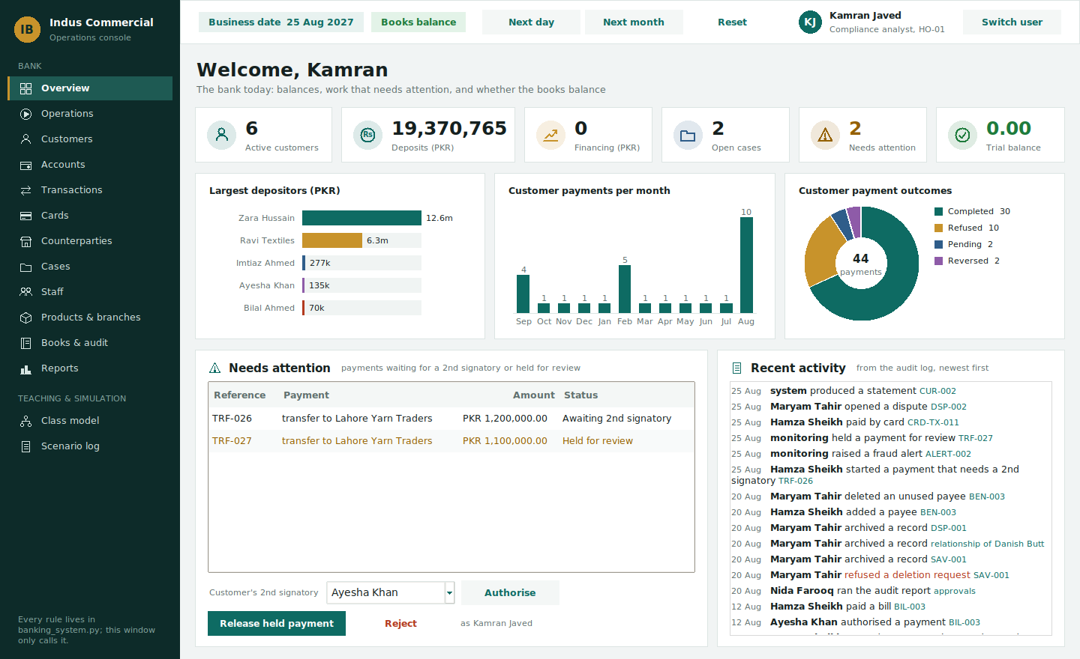
Figure 11. An operation form for a signed-in relationship manager: only her role's forms are listed, and she is recorded as the member of staff without being asked.
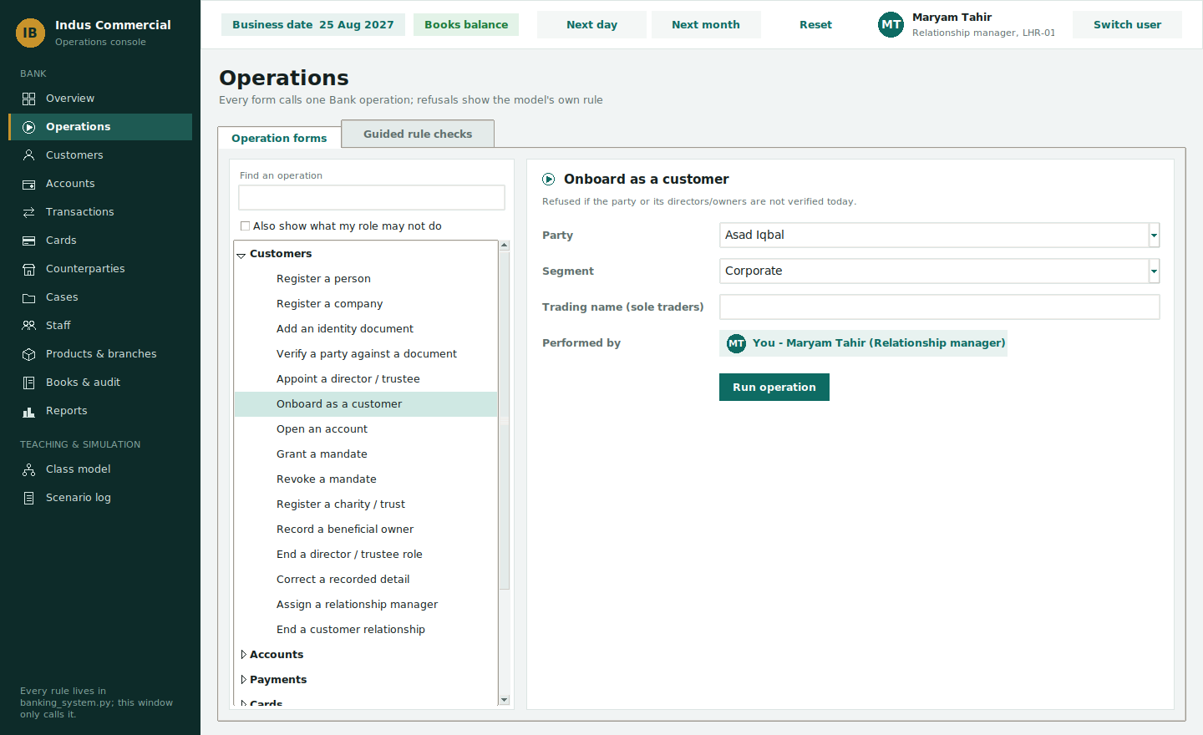
Figure 12. Guided rule checks: each runs one real operation and shows the model's answer.
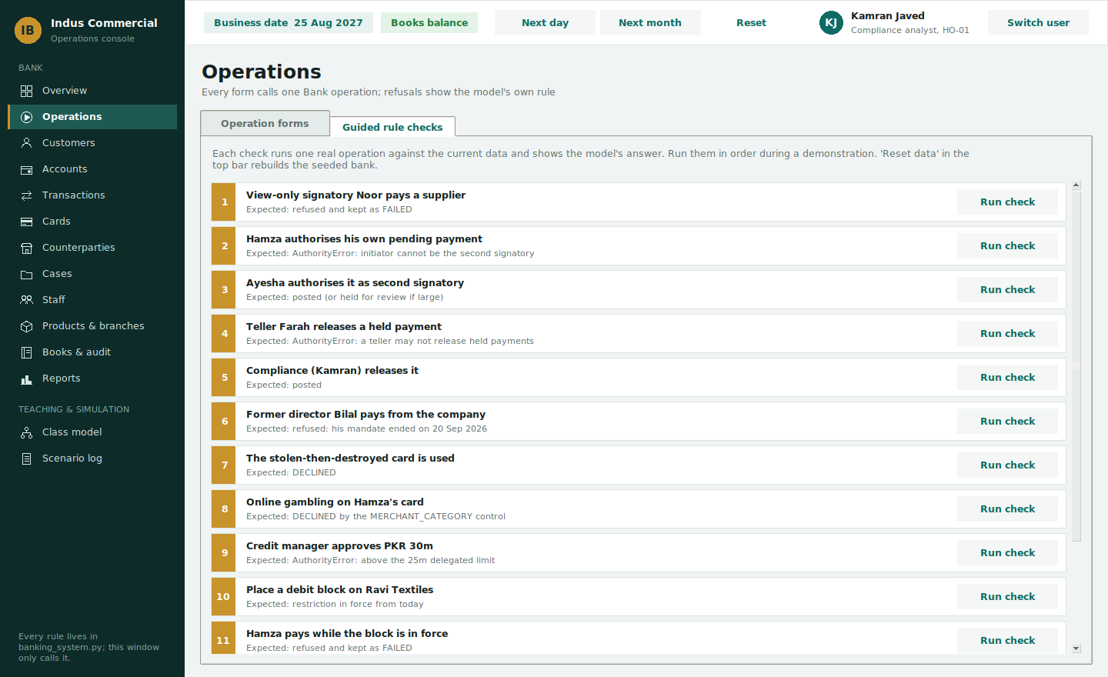
Figure 13. One customer, many dated roles: capacities, timeline ribbons and the time machine.
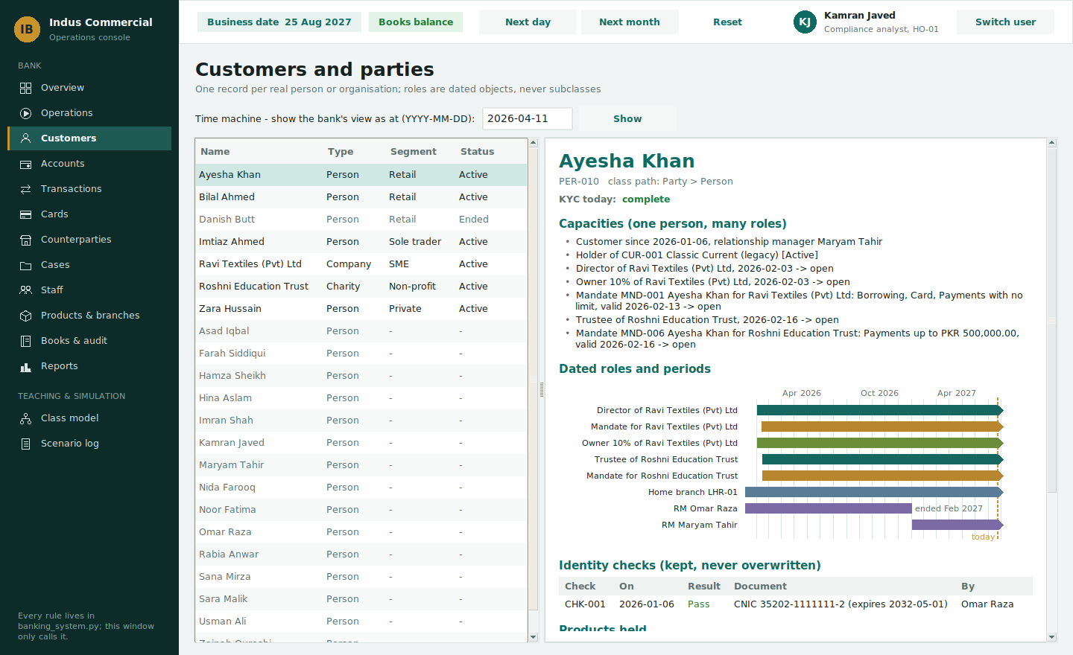
Figure 14. Card replacement chain: every payment on every card in the chain stays searchable.
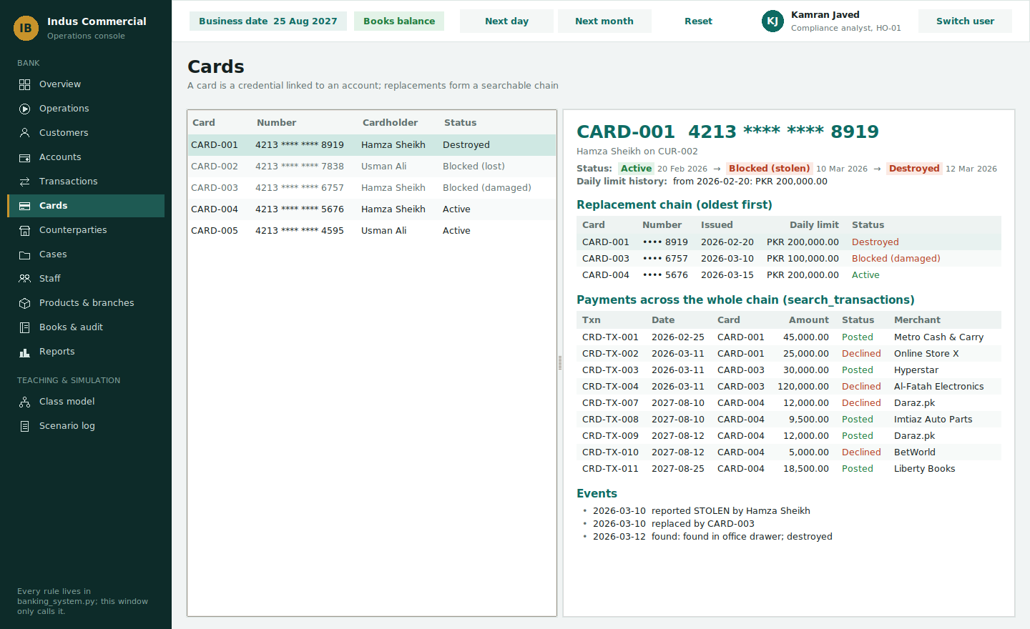
Figure 15. Books and audit: the trial balance totals zero; the audit log records what changed, who did it and why.
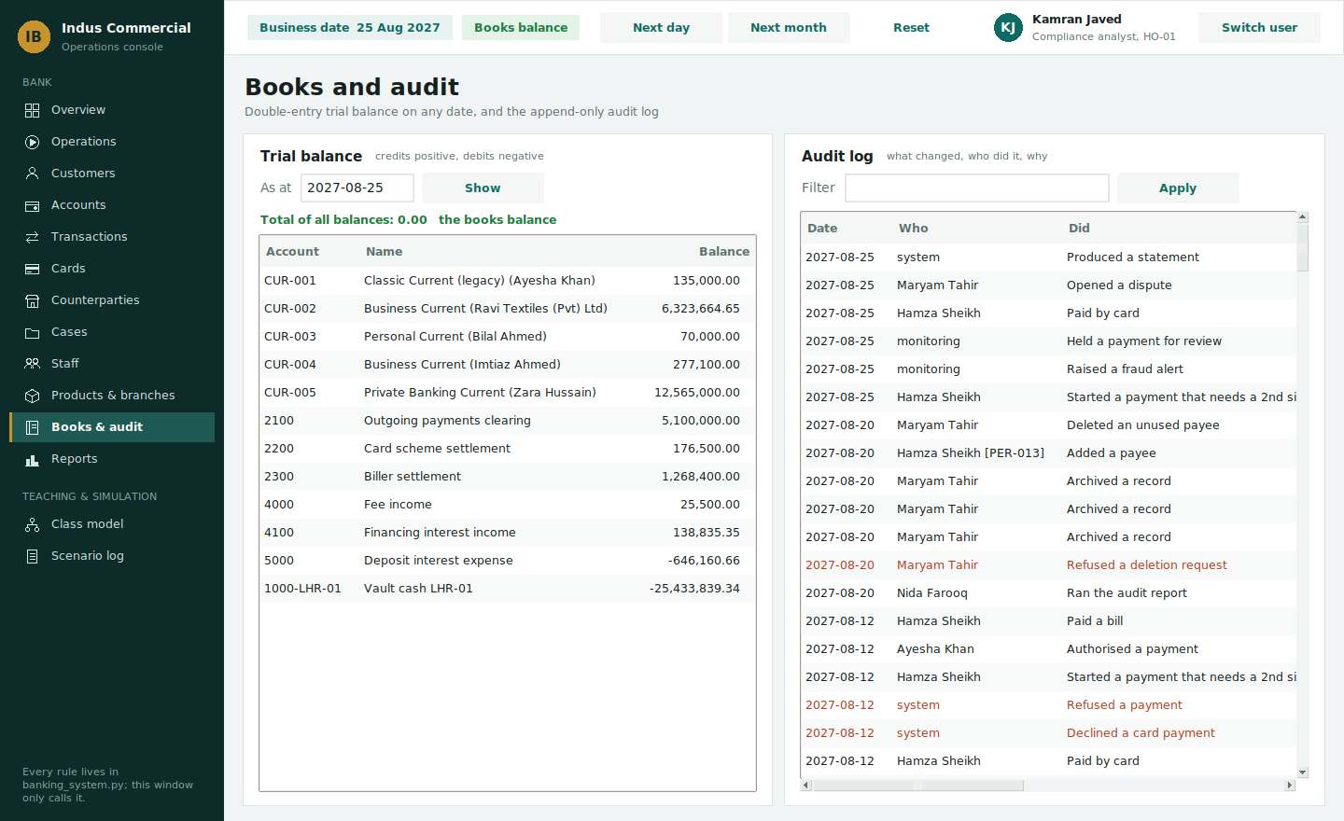
Figure 16. Reports: what Bilal could do for Ravi Textiles on 11 April 2026, while he was still a director. The same question for August 2027 answers "no mandate in force".
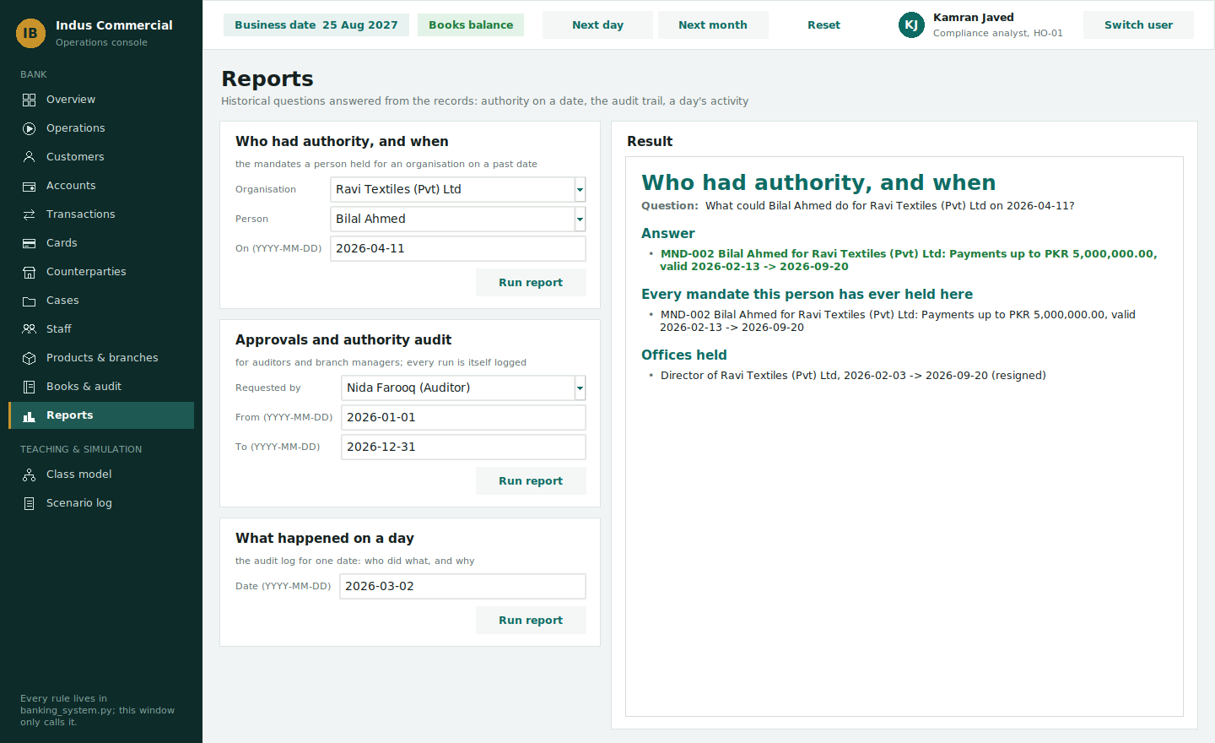
Figure 17. Counterparties: a merchant is a standalone counterparty, not a Party; its page shows the card used and the merchant refund on its payment.
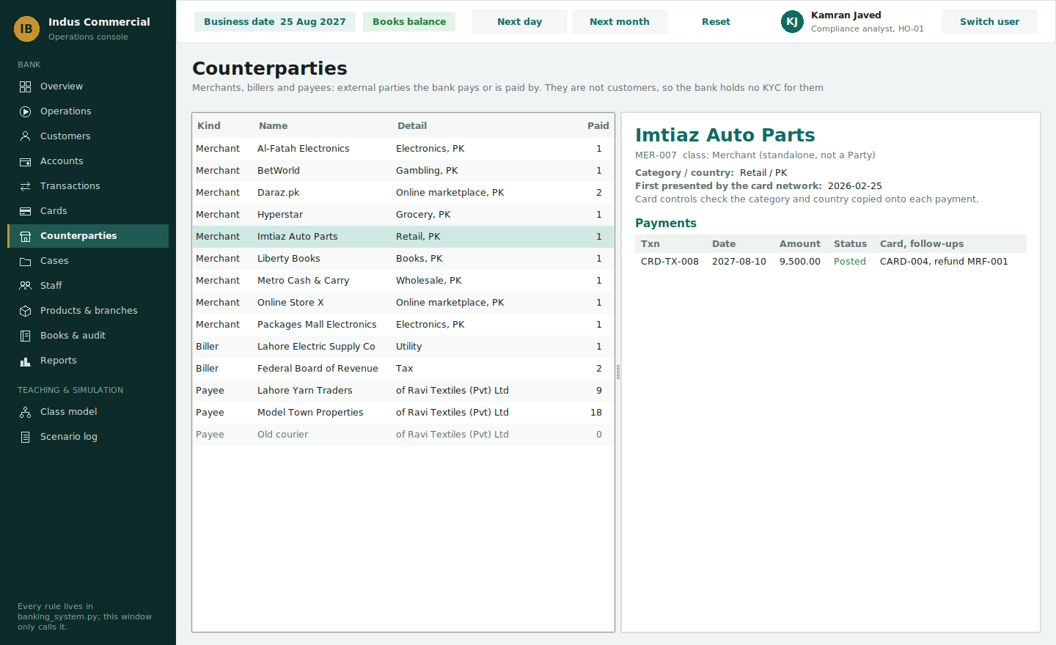
Figure 18. Class model (teaching section): CustomerPayment is marked abstract, with what it adds, the lifecycle it declares and its subclasses.
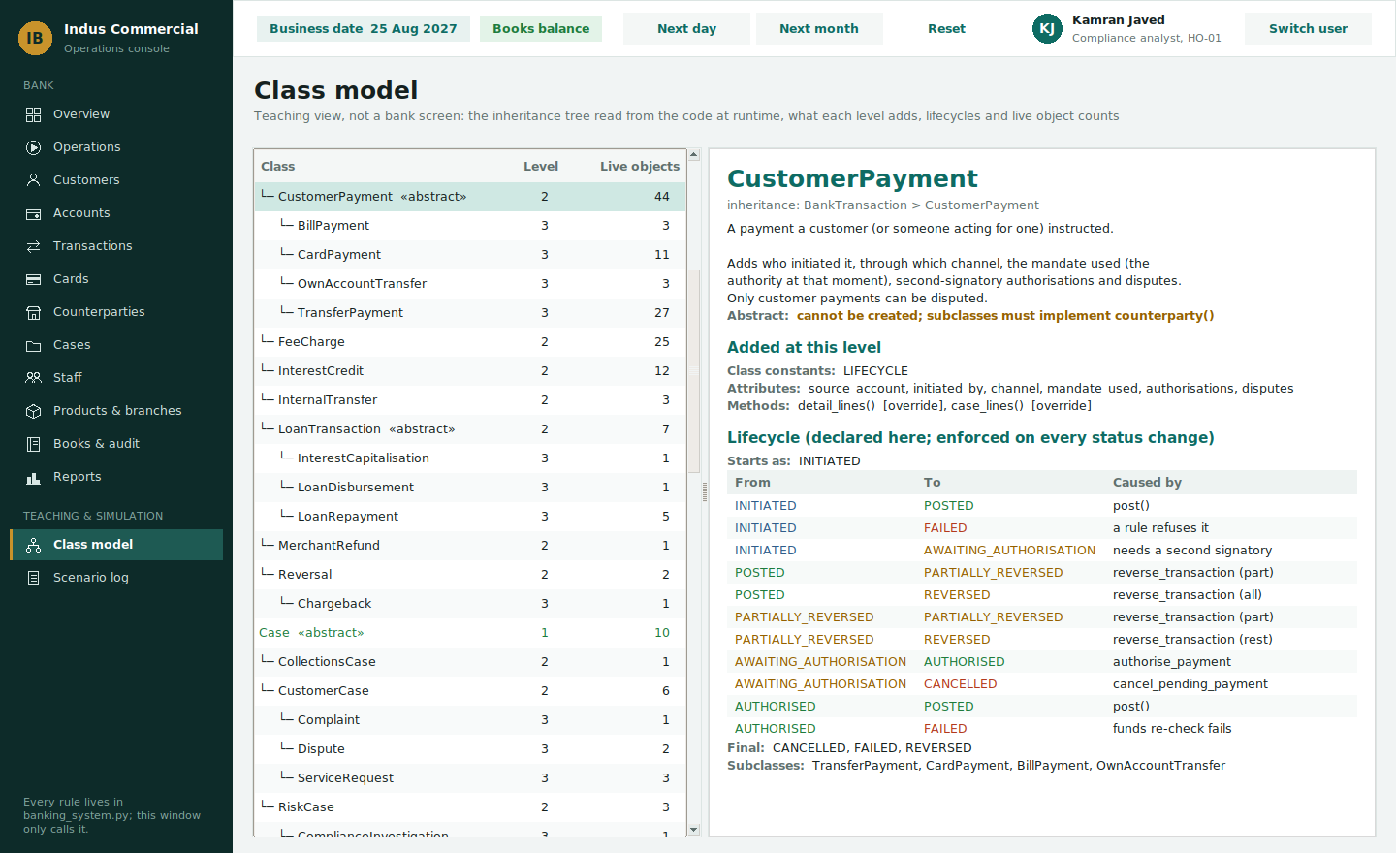
Figure 19. Digital banking, signed in as Hamza: the company account he may use, with what his mandate allows, and its recent activity.
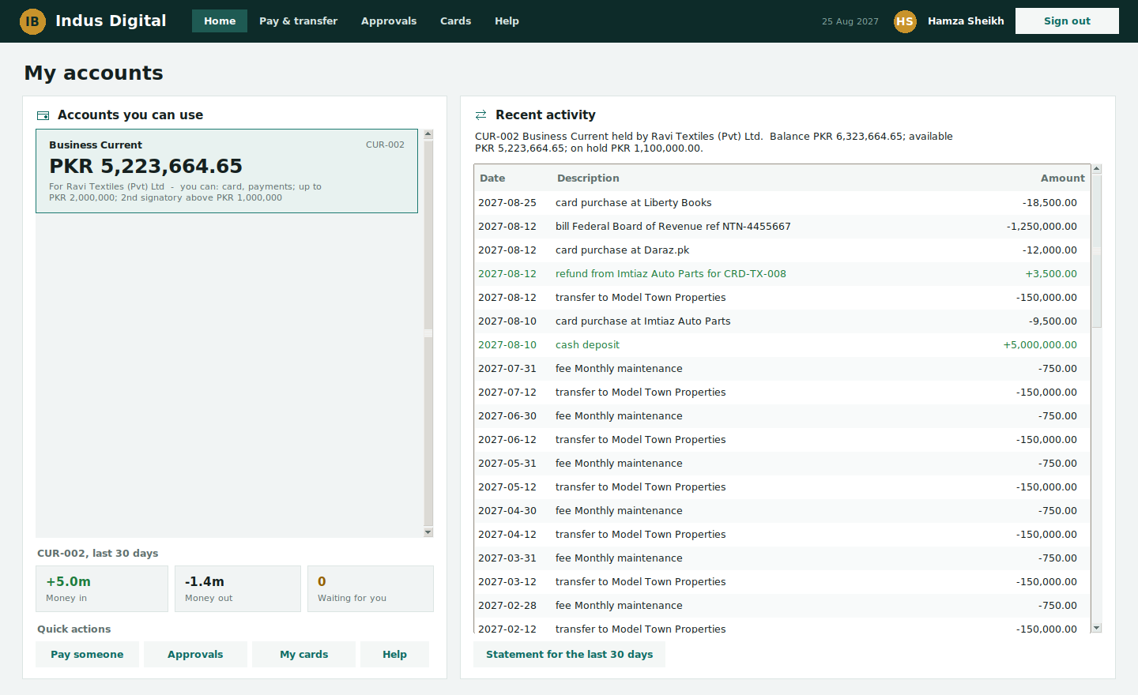
Figure 20. My cards: the card, its controls (switched on and off by the cardholder) and every payment across the replacement chain, with a dispute button.
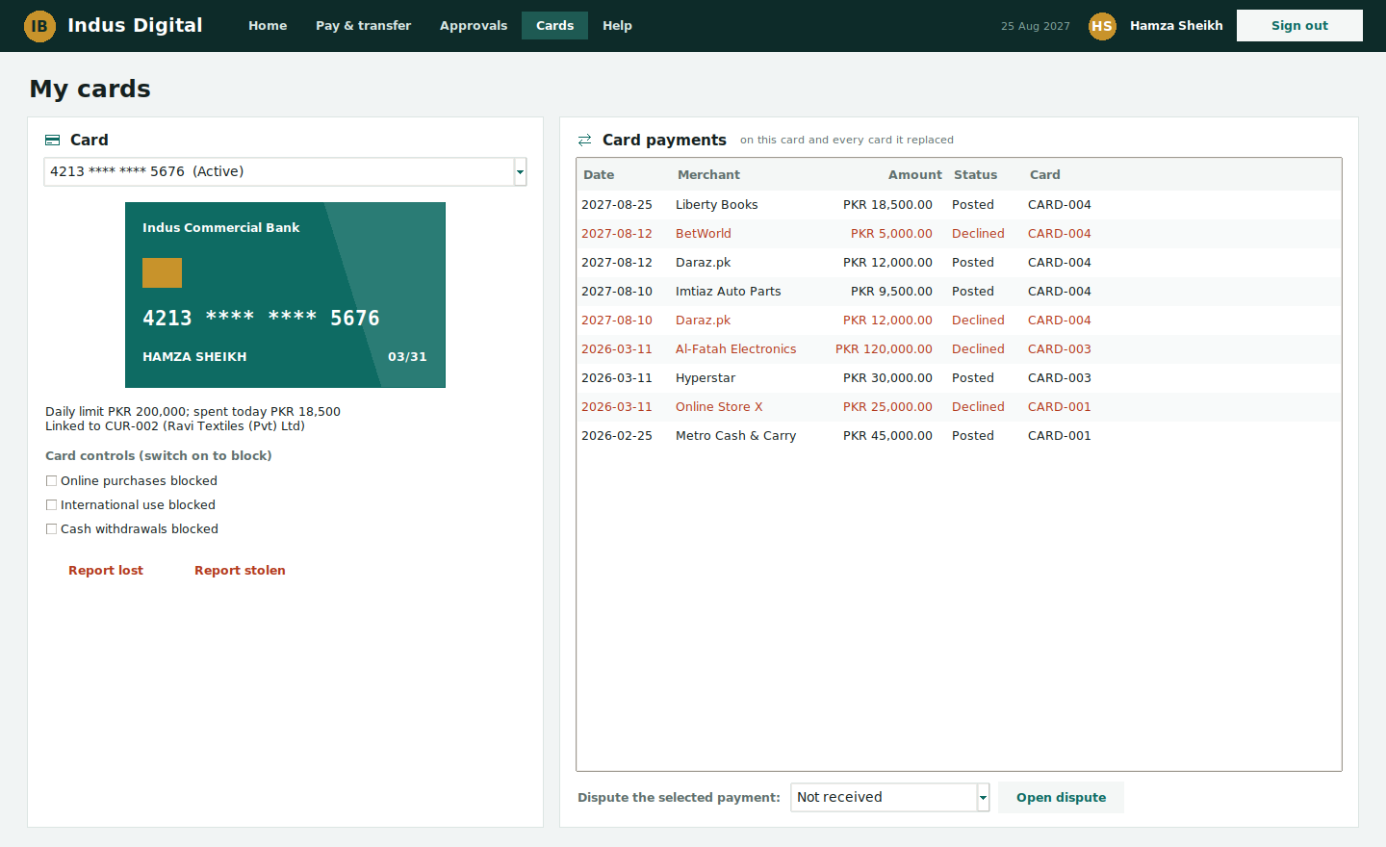
Figure 21. Approvals, signed in as Ayesha: Hamza's PKR 1,200,000 payment waits for her as the second signatory; the model refuses Hamza approving his own.
