**PROJECT REPORT**

**On**

**Tour Booking Application**

Submitted in partial fulfilment of the requirement for the Course BEE (22CS026) of

**COMPUTER SCIENCE AND ENGINEERING**

**B.E. Batch-2022**

**in**

**Jan -2025**



|  |  |  |  |
| --- | --- | --- | --- |
| **Under the Guidance of:** | | **Submitted By:** | |
| Mrs.Prennu Mittan | | Chirag | |
|  | | Roll. No. 2210991463 | |
|  | | Dimple | |
|  | | Roll. No. 2210991517 | |
|  | | Dev Miglani | |
|  | | Roll. No.2210991488  Divyansh  Roll No.2210991535 | |
|  | |
|  | |

DEPARTMENT OF COMPUTER SCIENCE AND ENGINEERING

Chitkara University, Punjab

**CERTIFICATE**

This is to be certified that the project entitled “Roameo” has been submitted for the Bachelor of Computer Science Engineering at Chitkara University, Punjab during the academic semester July 2024- December-2024 is a Bonafede piece of project work carried out by “Chirag Roll. No. 2210991463, Dimple Roll. No. 2210991517, Dev Miglani, Roll. No.2210991488 and Divyansh Roll No.2210992531.of the student group 18.” towards the partial fulfilment for the award of the course Integrated Project (CS 203) under the guidance of “Mrs.Prennu Mittan” and supervision.

Sign. of Project Guide:

Mr. Prennu Mittan

**CANDIDATE’S DECLARATION**

We Chirag Roll. No. 2210991463, Dimple Roll. No. 2210991517, Dev Miglani, Roll. No.2210991488 and Divyansh Roll No.2210991535. of Group 18, B.E.-2022 of the Chitkara University, Punjab hereby declare that the Integrated Project Report entitled “Tour booking Application” is an original work and data provided in the study is authentic to the best of our knowledge. This report has not been submitted to any other Institute for the award of any other course.

|  |  |  |  |
| --- | --- | --- | --- |
| Sign. of Student | Sign. of Student | Sign. of Student | Sign. of Student |
| Chirag | Dimple | Dev Miglani | Divyansh |
| ID No…2210991463…………. | ID No…2210991517………….. | ID No…2210991488…….. | ID No…2210991535…….. |

|  |
| --- |
|  |

Place: Rajpura Date:

25/11/24

**ACKNOWLEDGEMENT**

It is our pleasure to be indebted to various people, who directly or indirectly contributed in the development of this work and who influenced my thinking, behaviour and acts during the course of study.

We express our sincere gratitude to all for providing me an opportunity to undergo Integrated Project as the part of the curriculum.

We are thankful to “Mrs. Prennu Mittan” for his support, cooperation, and motivation provided to us during the training for constant inspiration, presence and blessings.

We also extend our sincere appreciation to “Mrs.Prennu Mittan” who provided his valuable suggestions and precious time in accomplishing our integrated project report.

Lastly, we would like to thank the almighty and our parents for their moral support and friends with whom we shared our day-to day experience and received lots of suggestions that improve our quality of work.

|  |  |  |  |
| --- | --- | --- | --- |
|  |  |  |  |
| Chirag | Dimple | Dev Miglani | Divyansh |
| ID No…2210991463 | ID No…2210991517 | ID No…2210991488…….. | ID No…2210991517…….. |

# 

# **1.Abstract:**

"Tour booking Application" is an innovative tour booking application designed to streamline the travel planning process. Utilizing the MERN stack (MongoDB, Express.js, React, Node.js), the platform offers users a seamless experience to search and filter tours based on specific criteria such as location, maximum people, and distance. Users can review tours, book them through a secure payment gateway, and manage their profiles. For tour operators, the application includes an admin panel to efficiently manage tour listings and user accounts. By integrating advanced search functionality with a secure and user-friendly interface, " Tour booking Application " aims to bridge the gap between travellers and tour providers, ensuring a reliable and enjoyable booking experience for all users.

#### 1.Keywords:

* Tour Booking
* MERN Stack
* Travel Planning
* Secure Payment
* Admin Panel
* User Reviews

# **2.Introduction:**

Tour booking Application is a comprehensive tour booking application designed to streamline the process of planning and reserving travel experiences. Built using the MERN stack, the application offers users the ability to search for tours, filter results based on location, maximum group size, and distance, and read or leave reviews. With a focus on user convenience and security, Tour booking Application also includes features like secure payment processing, allowing users to book their tours confidently. An admin panel is integrated into the system to manage tours and users, ensuring smooth operations and an excellent user experience.

#### 2.1. Background:

The tourism industry has seen a significant shift towards online platforms, where travellers seek convenience and efficiency in planning their trips. However, many existing tour booking platforms lack comprehensive filtering options and user-centric features, leading to a fragmented user experience. Recognizing the need for a more intuitive and robust solution, Tour booking Application was conceptualized to fill this gap. The project aims to provide a seamless and secure platform where users can easily search for and book tours that meet their specific needs. By leveraging the MERN stack, Tour booking Application combines modern web technologies with a focus on scalability, security, and user satisfaction, offering a solution that caters to both travellers and tour operators.

**2.2. Problem Statement:**

In the current digital landscape, travellers face challenges in finding and booking tours that precisely match their preferences. Existing tour booking platforms often offer limited search and filtering capabilities, making it difficult for users to find tours based on specific criteria such as location, group size, and distance. Additionally, the lack of secure payment methods and user-friendly interfaces hampers the overall booking experience. There is a need for a comprehensive solution that allows users to efficiently search, filter, review, and securely book tours, all within a single, intuitive platform. Tour booking Application addresses these challenges by providing a streamlined, user-centric tour booking application.

# 

# **3.Software and Hardware Requirement** **Specification:**

#### 3.1. Methods:

The development of the Tour booking Application. application utilizes the MERN stack (MongoDB, Express.js, React.js, Node.js) for a full-stack solution. The project follows an agile development methodology, allowing for iterative progress and regular feedback. The application is built using a RESTful API architecture, enabling seamless communication between the frontend and backend. Git is used for version control, ensuring efficient collaboration among team members.

#### 3.2. Programming/Working Environment:

* **Frontend**: React.js is used for building the user interface, providing a dynamic and responsive experience. HTML, CSS, and JavaScript are used alongside React.js for styling and functionality.
* **Backend**: Node.js, along with Express.js, serves as the backend framework. It handles routing, middleware, and API requests.
* **Database**: MongoDB is used as the database, providing a flexible and scalable NoSQL environment to store user data, tour details, and reviews.
* **Development Tools**: Visual Studio Code (IDE), Git (Version Control), Postman (API testing), and GitHub (Repository hosting).

# 

**3.3 Requirements to Run the Application:**

**Hardware Requirements:**

* Processor: Intel Core i3 or equivalent
* RAM: 4GB or higher
* Storage: Minimum 10GB of free disk space
* Operating System: Windows **10,** macOS, or Linux

**Software Requirements:**

* + - * Node.js (v14.x or higher)
      * MongoDB (v4.x or higher)
      * NPM (v6.x or higher)
      * React.js (v17.x or higher)
      * Browser: Google Chrome, Firefox, or any modern browser
      * Text Editor: Visual Studio Code or any moderncodeeditor

**4.SnapShots**

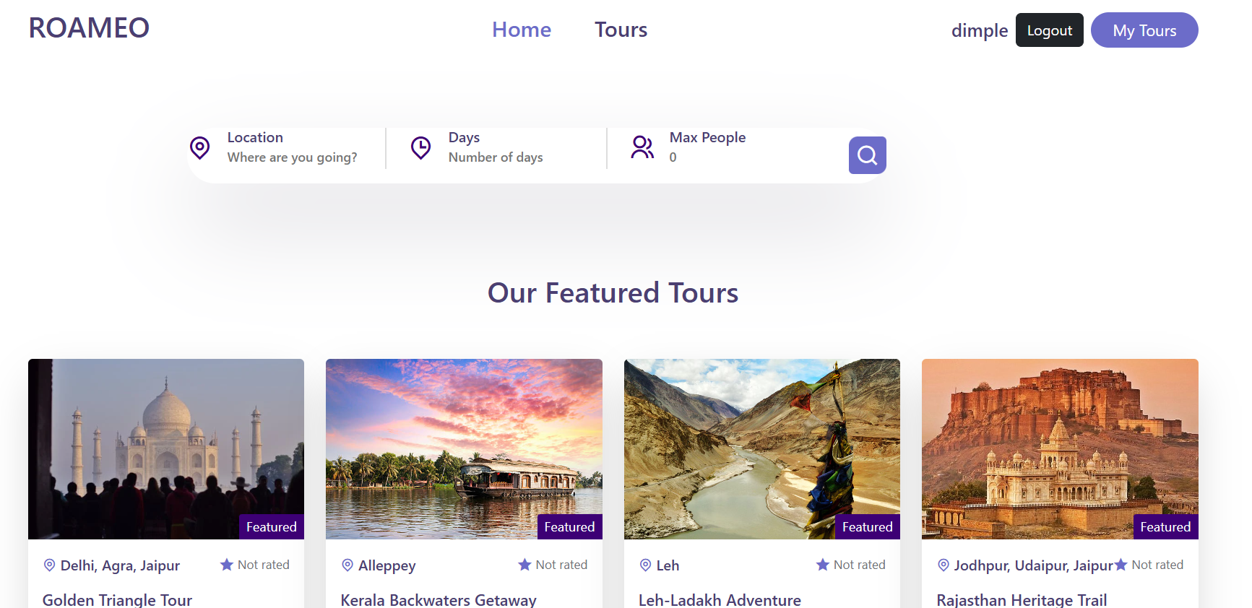

**4.SnapShots**

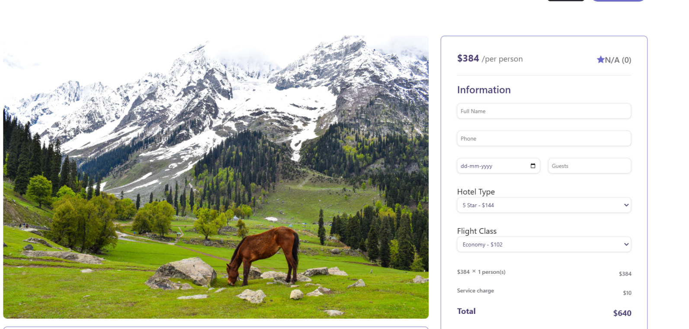

**4.SnapShots:**

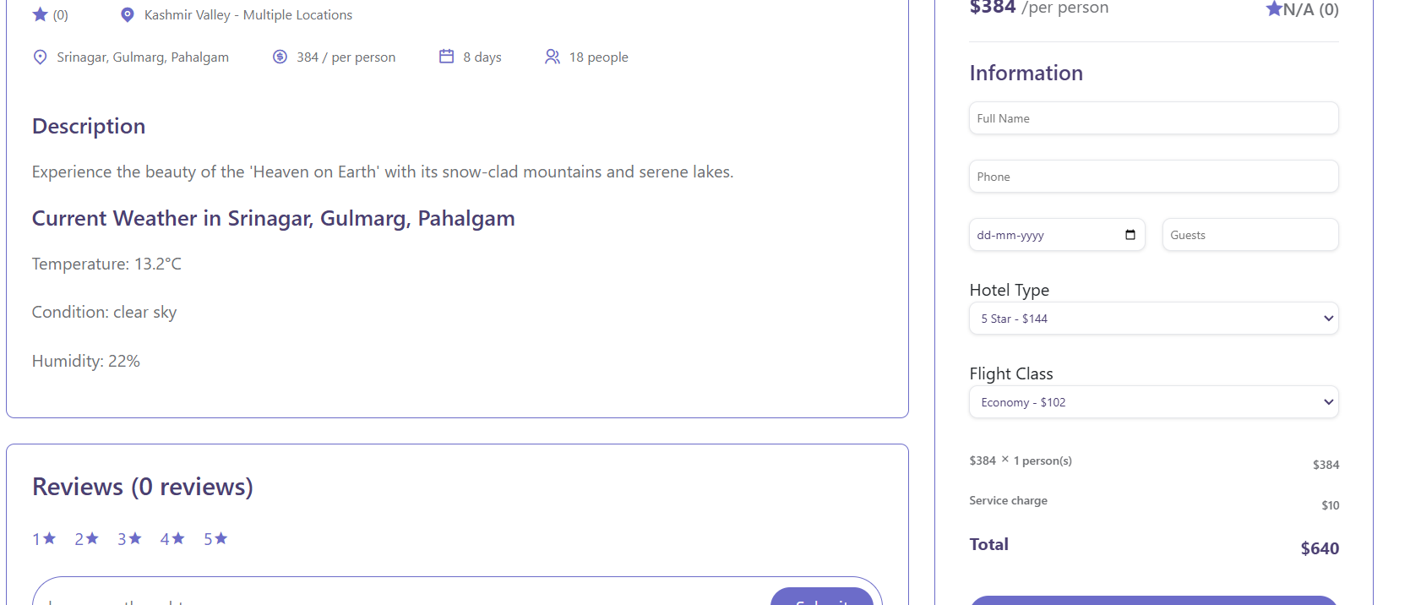

# **5.System Testing:**

System testing for the Shred fitness app will involve a comprehensive evaluation of the integrated platform to ensure all features operate as intended. This will include testing key functionalities such as personalized workout plans, nutritional guidance, progress tracking, and user interface interactions. Performance tests will assess the app's responsiveness and load times, while security tests will focus on safeguarding user data and preventing vulnerabilities. Usability testing will ensure that the app is intuitive and user-friendly across various fitness levels. Any issues identified during testing will be addressed promptly to ensure that Shred is stable, secure, and optimized for users before deployment.

# **6.Conclusion:**

Tour booking Application provides a streamlined and secure platform for booking tours, with features like advanced search filters and secure payments. It offers users a smooth experience from discovering tours to finalizing bookings. The application's successful implementation and thorough testing ensure reliability and effectiveness, making it a valuable tool for modern travellers.

# **7.Future Scope:**

The future scope of Tour booking Application includes several exciting enhancements aimed at expanding its functionality and improving user experience:

* Flight Booking: Integrating flight booking capabilities to provide a comprehensive travel solution, allowing users to book flights in conjunction with their tours, creating a seamless travel experience.
* Hotel Booking: Adding hotel booking features to enable users to find and book accommodations alongside their tours, making Tour booking Application a one-stop platform for all travel needs.

# 

# **8.References:**

* MongoDB Documentation. "NoSQL Database for Modern Applications." MongoDB, 2024. https://www.mongodb.com
* React.js Official Documentation. "A JavaScript Library for Building User Interfaces." Meta, 2024. https://reactjs.org
* Node.js Documentation. "JavaScript Runtime Built on Chrome's V8 JavaScript Engine." OpenJS Foundation, 2024. https://nodejs.org